Smart Farming- Revolutionizing farming with hybrid technology for disease detection, crop protection and high yield production
DR. ANKIT GARG1 , ADITYA MITTAL2 , KRISHNA SAI SRI AASRITHA LINGAM2 , MADHAV AGARWAL2 , AND
UDIT VERMA2
1Assistant Professor, Electronics and Communications Engineering Division, NETAJI SUBHAS UNIVERSITY OF TECHNOLOGY, NEW DELHI-110078
2Student, Electronics and Communications Engineering Division, NETAJI SUBHAS UNIVERSITY OF TECHNOLOGY, NEW DELHI-110078 Compiled April 26, 2023

Agriculture is a critical sector of the economy and plays a significant role in the development of any country. Recently, the sector has witnessed a transformational shift driven by the need for food security, increased productivity, and sustainability. However, the ever-growing population, unpredictable weather patterns, and limited resources pose significant challenges to agriculture. With the advent of new technologies such as IoT, big data, and AI, there is an opportunity to address these challenges and enhance the efficiency of agricultural practices, leading to sustainable agriculture and food security. To this end, this project aims to develop an end-to- end web application that offers various services critical to the agriculture sector, including crop recommendation, crop price estimation, plant disease detection, crop health prediction, and crop yield prediction. The scope of the models is drastically improved, such that the model is trained to be used all over India, rather than working on one crop or region. The application leverages the use of pertinent, dense, and representative data, which is meticulously scoured and scraped from relevant sources such as the official Government of India websites. The proposed solution addresses the limitations of current agricultural practices by providing real-time information to farmers, enabling them to make informed decisions, leading to better yields and improved profits. Finally, algorithm optimization is performed, leading to significant accuracy improvements, and a minimum accuracy of 93% for each of the models is achieved.
http://dx.doi.org/10.1364/ao.XX.XXXXXX

INTRODUCTION
  - Motivation and Research Gap
The motivation for this project lies in the fact that agriculture is the biggest industry in India, and the backbone of the country’s economy, providing liveli- hoods to millions of farmers. Revolutionizing the agricultural sector with the help of technology has the potential to have a massive impact on the coun- try’s development. Moreover, with the increasing availability and usage of smartphones, even in rural areas, there is an opportunity to leverage AI, ML, and web technologies to provide farmers with easy solu- tions for their basic farming challenges. Even a small
increase in efficiency in such a large industry can have a significant impact. However, the research gap in this field includes limited data availability for the development of efficient models, limiting the scope of the models, and most research being very niche, i.e., focused on a specific type of crop that may not be generalizable to other areas and crops. Additionally, there is an opportunity to improve the accuracy of existing models. This project aims to bridge this gap and provide farmers with an effective and compre- hensive solution to their agricultural challenges.
The aim is to develop an integrated solution for farmers by providing inference-based recommenda- tions for crop management. The primary focus is to

ensure that the developed models were trained on a diverse and representative dataset for different crop varieties across India. The importance of maintaining a high level of accuracy in all models, to prevent any adverse effects on the farmers. Furthermore, creating relevant and up-to-date datasets is a crucial aspect of this research project. The solution developed is aimed to provide farmers with an accessible and com- prehensive platform that combines multiple services, which include crop yield prediction, disease detec- tion, pesticide management, crop recommendation, and price prediction. This research aims are provid- ing an inference-based solution in contrast to all the information-based solutions available for the farmers. The main beneficiaries of this solution were farm- ers in India, who could use the platform to make informed decisions and optimize their crop yield.
  - Crop Recommendation:
crop recommendation is a crucial aspect that has been addressed through precision agriculture. One of the primary challenges faced by Indian farmers is the incorrect selection of crops based on soil require- ments, resulting in reduced productivity. Precision agriculture utilizes research data on soil characteris- tics, crop yield, and soil types to provide farmers with crop recommendations based on site-specific parame- ters. With the help of ML algorithms, we can build a predictive model that recommends the most suitable crops to grow on a particular farm. The model can be trained on large datasets of soil and crop yield data to develop accurate recommendations. The proposed solution has the potential to overcome the limitations of traditional agricultural practices, improve the pro- ductivity of farmers, and contribute to sustainable agriculture.
  - Crop Yield prediction:
Crop yield prediction is essential for farmers to make informed decisions regarding crop selection, harvest timing, and storage. Accurate forecasting of crop yield well ahead of the harvest time would enable the farmers to take suitable measures for selling and storage, which can prevent financial losses. How- ever, the fluctuations in prices make creating a stable and robust forecasting solution a necessity. Machine learning algorithms can be used to develop accurate crop yield prediction models by analyzing data from
various sources such as weather patterns, soil qual- ity, and historical yield data. These models can help farmers improve their decision-making and increase productivity.
  - Crop Price Prediction:
The forecasting of crop prices is a crucial aspect for supply chain planners and policymakers as it pro- vides an estimation of market factors like demand and supply. In countries like India, where the crop prices are manually entered every day, it is prone to errors like incorrect data or no access to data for many days. Additionally, the fluctuations in prices add to the complexity of creating a stable and robust forecasting solution. In this regard, a crop price pre- diction model is presented, which considers various features such as the market location from state to district levels, the season, the type and variety of the crop and the previous year’s prices. Such a model can assist the decision-makers in taking appropriate actions and enable smallholder farmers to get a fair price for their products.
  - Plant Disease Detection:
Plant diseases can have severe consequences on crop quality and quantity, particularly for smallholder farmers who rely on healthy plants for their liveli- hood. Traditionally, the monitoring and analysis of plant diseases required manual inspection, which is time-consuming and labor-intensive. However, advancements in image processing techniques have made it possible to use plant leaf images for the de- tection of disease symptoms. The process of disease detection involves image acquisition, pre-processing, segmentation, feature extraction, and classification. By utilizing these techniques, plant diseases can be detected earlier and more accurately, allowing for prompt action to prevent further damage to crops.
  - Pesticide Management:
Effective management of pesticides is essential to ensure a good harvest. Factors such as water avail- ability, soil fertility, and pest control can significantly affect crop productivity. While some of these factors are beyond a farmer’s control, the use of pesticides can be managed to ensure the best possible outcome. However, if not used correctly, pesticides can have negative effects on crop yield and quality. Overuse of

pesticides can lead to crop failure and pose risks to human health. Therefore, it is essential to maintain the right dosage and frequency of pesticide use. Our data analysis is based on crops harvested by various farmers at the end of the harvest season to ensure the appropriate amount of pesticides used and to mini- mize the risks associated with overuse.

RELATED WORK
  - Crop Recommendation:
To help farmers choose crops wisely, a number of ma- chine learning-based crop recommendation systems have been created in recent years. The best crop for a given region can be predicted using machine learning algorithms like K-Nearest Neighbor (KNN), Deci- sion Tree (DT), Random Forest (RF), and Support Vector Machine (SVM), according to various factors like soil characteristics, climate, and topography, ac- cording to a study conducted by K. R. K. Reddy et al. (2020)[1]. With an accuracy of 96.5%, the results demonstrated that the RF algorithm performed the best.
Similar to this, B. N. Panda et al ( 2021)[2] pro- posed a crop recommendation system that makes use of machine learning algorithms like Naive Bayes (NB), Decision Tree (DT), and Artificial Neural Net- work (ANN) to predict the best crop for a given re- gion based on factors like soil type, rainfall, tem- perature, and humidity. With an accuracy of 90%, the results demonstrated that the ANN algorithm per- formed the best.

  - Crop Yield prediction:
Sarfraz et al. (2012)[3] carried out one of the initial investigations in this field by employing fuzzy logic to forecast the production of wheat crops. The fuzzy logic model was trained using climatic and soil char- acteristics, and the study attained an 84% prediction accuracy.
Deep learning methods were employed by Wang et al. (2020)[4] in a more recent work to forecast maize crop yield. The study used convolutional neu- ral networks (CNNs) and long short-term memory (LSTM) networks to examine satellite images and climate data, respectively. The results showed that the deep learning approach outperformed traditional
regression models.

  - Crop Price Prediction:
[5]A crop price prediction model was implemented by utilising a deep neural network (DNN) and a long short-term memory (LSTM) model in a study by P. Singh and P. R. Pardasani (2021). Data on various crops, market prices, and additional elements includ- ing weather, transportation costs, and governmental policies were all employed in the study. When it came to predicting paddy prices, the LSTM model outperformed the DNN model with an accuracy of 86.32%.
[6]M. Hossain et al. (2021) suggested using multi- ple linear regression (MLR) to predict crop prices. To forecast future prices, the study examined price data for rice together with a number of other variables, in- cluding production, consumption, and imports. The MLR model was 88.5% accurate in predicting rice price movements.

  - Plant Disease Detection:
[7]Similar to this, A. Singh et al. (2020) presented a CNN- and transfer learning-based deep learning- based plant disease detection system. The technol- ogy had a 97.5% accuracy rate for spotting illnesses on tomato leaves. [8]Using a hybrid feature extrac- tion method and SVM classifier, M. A. I. Amin et al. (2020) suggested a machine learning-based method- ology for plant disease diagnosis. The proposed ap- proach detected tomato leaf diseases with a 98.9% accuracy rate.

  - Pesticide Management:
[9]A crop pesticide management system based on machine learning techniques, such as Support Vector Machine (SVM), K-Nearest Neighbour (KNN), and Decision Tree (DT), was proposed by S. Kumar et al. in 2021. On the basis of elements including soil type, crop type, and weather conditions, the system forecasts the quantity of pesticide needed for a cer- tain crop. The SVM system predicted the need for pesticides with the highest accuracy, 88%.
[10]Using machine learning algorithms like Deci- sion Tree (DT), Random Forest (RF), and Support Vector Machine (SVM), P. M. Bhatnagar et al. (2021) created a pesticide management system that suggests

the best pesticide for a given crop based on vari- ous factors like crop disease, weather, and soil type. The system’s accuracy with the SVM algorithm was 85.6%, demonstrating its potential for use in pesticide management.

PROPOSED MODELS
  - Random Forest Regression for crop yield prediction
To solve this problem we take from the user several inputs like state name, district name, crop year, crop name and area of the field and based on this input we apply our model and provide a estimated yield in kilograms per hectare. We made our own dataset as there was no data available especially for India. We scrapped data through the official government website. Then we applied several machine learning models to it like Random forest regression, Support vector regression and linear regression and out of these the best results were given by Random forest regression. As this is a regression problem we cannot calculate its accuracy as data is continuous so we calculated the mean square error whose value should be as close to 0 as possible for a better result. To iden- tify the features that are most suitable and to improve accuracy of the model we used feature selection tech- nique like correlation coefficient and plotting the heat map of features along with target variable.

  - Random Forest Regression for crop price prediction
To solve this problem of price recommendation for farmers we took input 5 parameters that are State, district, market area, commodity and variety. Based on these inputs we predicted the crop price per quintal of produce. This will help the farmers to get fair price of their produce without being cheated by the middleman who tend to take advantage of the farmers. To get the best accuracy we used several machine learning models out of which random forest regressor produced the best results. Models used were Ada Boost, XG Boost and Random forest Regression. To further optimise the model parameter scaling was used which increased the models accuracy. Apart from this we label encoded the string values so that it can be given as input to model. The dataset was
also analysed and cleaned. Since this is a regression problem we do not have accuracy here, we have mean square error which should be as close to 0 as possible for a better model.

  - Gaussian Naive Bayes for crop recommen- dation
To solve this problem we take input various parame- ters like Nitrogen content in soil, Phosphorus content in soil, Potassium content in soil, ph value of soil, humidity in %, rainfall in mm, and temperature in Celsius. By taking these site specific parameters as input we reduce the chance of wrong crop selection thus the farmer gets benefitted. We took a dataset, cleaned it and made it usable for our model by encod- ing the columns and applied various models to it like KNN, random forest classification, logistic regres- sion, Gaussian naïve Bayes, support vector classifi- cation, out of which Gaussian naïve Bayes gave the best results. For feature selection and optimization we used correlation coefficient and heat map.

  - MobileNet for crop disease detection
To solve the problem of crop disease detection we took input image the image and detected the disease. For this we used a dataset containing 87K RGB im- ages of healthy and diseased crop leaves which is categorised into 38 different classes. The total dataset is divided into a ratio of 80/20 of training and val- idation sets preserving the directory structure. We used transfer learning using the pre-trained model MobileNet and fine tuned it on the collected dataset. The MobileNet model is a model trained on the Ima- geNet dataset which contains over a million images. The image file uploaded by the user is loaded and the generated model is used to predict the class cor- responding to the respective species and disease is displayed to the user. We trained the model for 10 epochs with 150 steps per epoch and got a value accuracy of 93.2%.

  - Light Gradient Boosting Machine for pesti- cide management
To solve this problem we took input estimated insects count (per square meter), category of crop, category of soil, pesticide usage, number of doses per week, number of weeks used, number of weeks quit, season.

Based on this we predict the crop health i.e. whether it will be alive or damaged due to pesticides or other reasons. For the prediction of crop health we have used dataset of 150K samples provided by the Gov- ernment of India on their official website. The model used is LGBM classifier which gave an accuracy of 97.95%. It is a classification problem since we are predicting only whether the crop is alive or not.

RESULTS
  - Crop Yield Accuracy
Table 1 shows model name and MSE for crop yield.

Table 1. Crop Yield Accuracy
Model Mean Square Error Random forest regression 0.11
Support vector regression 1.38
Linear regression 1.37

  - Crop Recommendation Accuracy
Table 2 shows model name and accuracy for crop recommendation.

Table 2. Crop Recommendation Accuracy

Model | Accuracy
Gaussian naïve Bayes | 99.5%
Logistic regressions | 94.5%
Support vector machine | 96.1%
K-nearest neighbours | 97.4%

  - Crop Price Recommendation
Table 3 shows model name and accuracy for crop price recommendation.

  - Crop Disease Detection
Figure 1 shows training and validation curve for crop disease detection.
Table 3. Crop Price Recommendation
Model Accuracy Random forrest regression 0.29
ADA Boost 0.56
XG Boost 0.53

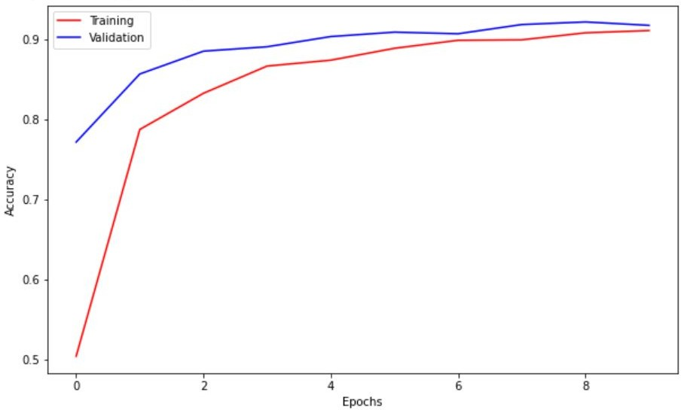
Fig. 1. Training and validation comparison with respect to Accuracy and Epochs.
  - Pesticide Management
For Pesticide Management the model was able to achieve an accuracy of 97.9575% as shown in figure 2.

Fig. 2. Accuracy achieved using LGBM.

  - Integrated Web Application
We have developed an integrated web app that utilises all the proposed models and provides a all-in-one interface for all the features mentioned in this paper. Figure 3 and Figure 4 are some of the snippets of the web application developed.

CONCLUSION AND FUTURE SCOPE
The project on plant disease detection, crop yield pre- diction, crop recommendation, crop price recommen- dation, and pesticide management has the potential to be further developed to serve a larger audience. In

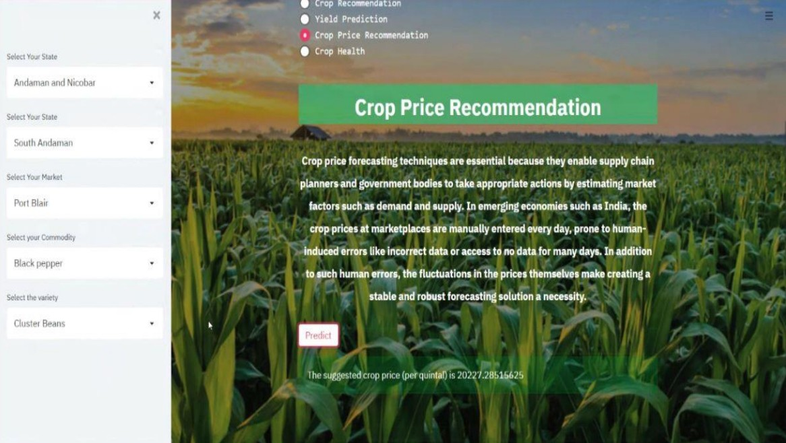
Fig. 3. Snippet of Crop Price Recommendation Output in the web app

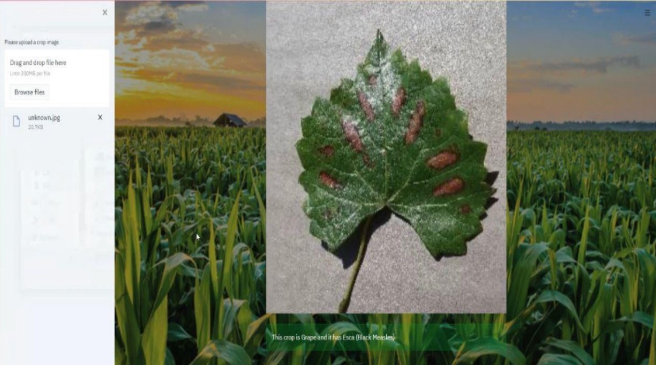
Fig. 4. Snippet of Plant Disease Output in the web app

the future, more crops can be added to the existing dataset to cater to the needs of farmers cultivating different types of crops. The models can also be optimized to consider various other factors like soil quality, weather, and geographical location. Another area of future development is to improve the website’s user interface and user experience to ensure that it is easily accessible and understandable to farmers who may have limited technical knowledge. Furthermore, integrating the models with mobile applications can provide more accessibility to farmers in remote loca- tions. Overall, the project has immense potential for growth and expansion, with the opportunity to create an even more robust system for assisting farmers in their day-to-day decision-making

REFERENCES
- K. R. K. Reddy, K. R. M. Reddy, and K. Prasad, "A Machine Learning Approach for Crop Recom-
mendation System," in Proceedings of the Fourth International Conference on Signal Processing, Com- munication and Networking, 2020, pp. 38-42.
- B. N. Panda, A. K. Pradhan, and S. K. Pradhan, "Machine Learning-Based Crop Recommendation System Using Weather Parameters and Soil Informa- tion," Journal of Intelligent Systems, vol. 30, no. 3, pp. 523-535, 2021.
- Sarfraz, M. S., Kiani, A. K., Mahmood, T., and Riaz, A. (2012). Fuzzy logic approach for wheat yield prediction. Journal of Agricultural Science, 4(3), 182.
- Wang, Y., Lu, Y., Huang, H., Liu, H., and Zhang, X. (2020). Maize yield prediction using con- volutional neural network and long short-term mem- ory. Computers and Electronics in Agriculture, 178, 105758.
- P. Singh and P. R. Pardasani, "A Deep Learning Approach for Crop Price Prediction," International Journal of Advanced Science and Technology, vol. 30, no. 1, pp. 596-602, 2021.
- M. Hossain, M. R. Uddin, and M. A. Hossain, "A Multiple Linear Regression (MLR) Based Model for Predicting the Price of Rice," in Proceedings of the 4th International Conference on Advances in Sci- ence, Engineering, Technology and Healthcare, 2021, pp. 1-6.
- A. Singh, S. K. Singh, and R. S. Rawat, "Deep learning based plant disease detection using transfer learning," Journal of Intelligent Systems, vol. 30, no. 4, pp. 851-863, 2020.
- M. A. I. Amin, M. Z. Islam, and A. S. M.
M. Hossain, "Plant Disease Detection Using Hybrid Feature Extraction and SVM Classifier," in Proceed- ings of the 2020 IEEE Region 10 Symposium (TEN- SYMP), 2020, pp. 1256-1259.
[9]S. Kumar, V. Kumar, and P. Kumar, "A Machine Learning-Based Crop Pesticide Management System for Precision Agriculture," Journal of Intelligent Sys- tems, vol. 30, no. 4, pp. 631-643, 2021.
[10]P. M. Bhatnagar, A. Garg, and M. Kaur, "A Machine Learning-Based Pesticide Management Sys- tem for Crops," in Proceedings of the International Conference on Smart Technologies in Computing, Communications and Electrical Engineering, 2021, pp. 315-325

