HUMMER BOT FOR ASSISTANCE IN AIRPORT
Dr. R. Arravind¹, J. Aswath², L. Hariharan³, V. Navin kumar⁴
¹Head of the department, Paavai Engineering College, Nammakal.
²UG, Aeronautical Engineering, Paavai Engineering College, Nammakal.
³UG, Aeronautical Engineering, Paavai Engineering College, Nammakal.
⁴UG, Aeronautical Engineering, Paavai Engineering College, Nammakal.

ABSTRACT: Machine learning methods, TensorFlow, and the Flask API were used to implement multiple illness analysis. Python pickling is used to save model behavior, while Python unpickling is used to load the pickle file. The significance of this research is that it analyses the and includes all the parameters that produce the condition, making it possible to detect the maximal impact. All running technologies have been on the verge of getting replaced by a great system that provides very specific, efficient, and quick access and controlling for the devices as per user demand. That is nothing but IoT that stands for ‘Internet of Things’. It deals with bringing control of devices over internet. The internet of things (IoT) is the network of physical devices, vehicles, buildings& items embedded with electronics, software, sensors, actuators, and network connectivity that enable these objects to collect and exchange data. Our project aims at connecting the unconnected, evolving the machine-to-machine communication. Being at one place user will get access over all the machineries in the industry.

It makes the whole system automated. We propose efficient industry automation system that allows user to efficiently control industry appliances/machines over the internet. Filling is a task carried out by a machine that packages liquid products such as cold drinks or water. Traditional methods of bottle filling involved placing bottles onto a conveyor and filling only one bottle at a time. This method is time consuming and expensive. In industries to reduce manual overhead we have implemented Internet of Things (IoT) in Industry to monitor as well as to inform the responsible person to take appropriate measures partially fulfilling our requirements. Artificial Intelligence could be used to control and monitor the industry. IoT is not a technology basically it is an “Industry Specific Implication.

Keywords: Machine Learning, sensors, embedded with electronics, IOT.

I INTRODUCTION

Machine learning is a method of data analysis that automates analytical model building. It is a branch of artificial intelligence based on the idea that systems can learn from data, identify patterns and make decisions with minimal human intervention. Because of new computing technologies, machine learning today is not like machine learning of the past. It was born from pattern recognition and the theory that computers can learn without being programmed to perform specific tasks; researchers interested in artificial intelligence wanted to see if computers could learn from data. The iterative aspect of machine learning is important because as models are exposed to new data, they can independently adapt. They learn from previous computations to produce reliable, repeatable decisions and results. It’s a science that’s not new, but one that has gained fresh momentum.

While artificial intelligence (AI) is the broad science of mimicking human abilities, machine learning is a specific subset of AI that trains a machine how to learn. Watch this video to better understand the relationship between AI, IOT and machine learning. You'll see how these two technologies work, with useful examples and a few funny asides. Resurging interest in machine learning is due to the same factors that have made data mining and Bayesian analysis more popular than ever. Things like growing volumes and varieties of available data, computational processing that is cheaper and more powerful, and affordable data storage. All of these things mean it's possible to quickly and automatically produce models that can analyze bigger, more complex data and deliver faster, more accurate results even on a very large scale. And by building precise models, an organization has a better chance of identifying profitable opportunities or avoiding unknown risks.

II LITERATURE SURVEY
In the last decade, improvements in medical imaging, exponential increase in computational power of affordable computing platforms, and greater availability of imaging data sets, for example, have increased opportunities to develop machine learning approaches to automate detection, classification, and quantification of IOT devices. Machine learning uses a series of steps to identify, train, and test computer algorithms to identify a feature of interest. Some of these techniques have been applied to classify brain magnetic resonance imaging or computed tomography scans, comparing patients with planning and healthy controls, and to distinguish different types or stages of create cerebrovascular, and accelerated features of aging. However, the recent rapid increase in publications using different machine learning techniques in different populations, types of images, and criteria make it difficult to obtain an objective view of the current accuracy of machine learning. We undertook this systematic review to critically appraise the accuracy of machine learning to differentiate healthy aging from MCI from and predict the future risk

III ARCHIETURE DIAGRAM

Software architecture involves the high-level structure of software system abstraction, by using decomposition and composition, with architectural style and quality attributes. A software architecture design must conform to the major functionality and performance requirements of the system, as well as satisfy the non-functional requirements such as reliability, scalability, portability, and availability. Software architecture must describe its group of components, their connections, interactions among them and deployment configuration of all components.
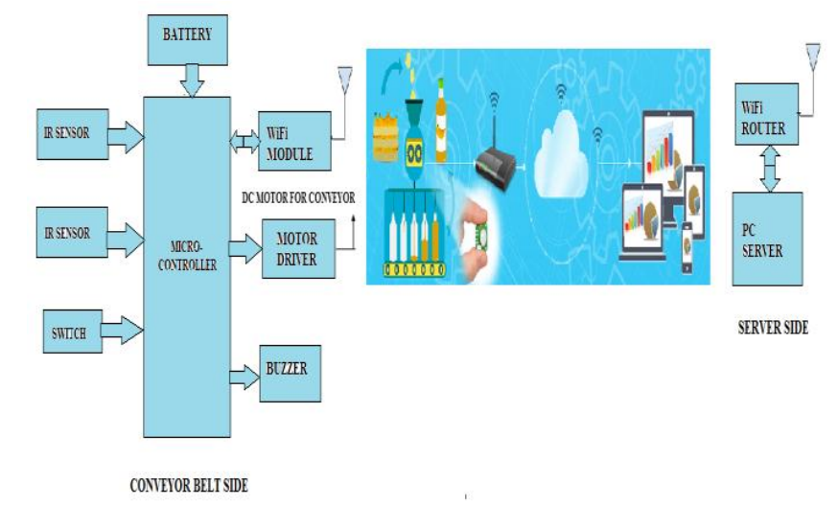
Figure. 1 Circuit Block Diagram

IV SYSTEM SPECIFICATION

HARDWARE REQUIREMENTS
    - Processor : Intel processor 2.6.0 GHZ

    - RAM : 4GB

    - Hard disk : 160 GB

    - Compact Disk : 650 Mb

    - Keyboard : Standard keyboard

    - Monitor : 15-inch color monitor

SOFTWARE REQUIREMENTS
    - Operating System : Windows OS

    - Language : PYTHON, AI& IOT.

    - IDE : PYCHARM

    - Back End : MY SQL

Python is an interpreted high-level inter- programming language for general-purpose programming. Created by Guido van Rossum and first released in 1991, Python has a design philosophy that emphasizes code readability, notably using significant whitespace. It provides constructs that enable clear programming on both small and large scales. In July 2018, Van Rossum stepped down as the leader in the language community. Python features a dynamic type of system and automatic memory management. It supports multiple programming paradigms, including object-oriented, imperative, functional, and procedural, and has a large and comprehensive standard library. Python interpreters are available for many operating systems.

C Python, the reference implementation of Python, is open-source software and has a community-based development model, as do nearly all of Python's other implementations. Python and C Python are managed by the non-profit Python Software Foundation. Rather than having all its functionality built into its core, Python was designed to be highly extensible. This compact modularity has made it particularly popular as a means of adding programmable interfaces to existing applications. Van Rossum's vision of a small core language with a large standard library and easily extensible interpreter stemmed from his frustrations with ABC, which espoused the opposite approach.

While offering choice in coding methodology, the Python philosophy rejects exuberant syntax (such as that of Perl) in favor of a simpler, less-cluttered grammar. As Alex Martelli put it: "To describe something as 'clever' is not considered a compliment in the Python culture. “Python’s philosophy rejects the Perl "there is more than one way to do it" approach to language design in favor of "there should be one and preferably only one by obvious way to do it".

Python's developers strive to avoid premature optimization and reject patches to non-critical parts of C Python that would offer marginal increases in speed at the cost of clarity. [ When speed is important, a Python programmer can move time-critical functions to extension modules written in languages such as C, or use PyPy, a just-in-time compiler. C Python is also available, which translates a Python script into C and makes direct C-level API calls into the Python interpreter. An important goal of Python's developers is keeping it fun to use. This is reflected in the language's name a tribute to the British comedy group Monty Python and in occasionally playful approaches to tutorials and reference materials, such as examples that refer to spam and eggs (from a famous Monty Python sketch) instead of the standard for and bar.

Python’s initial development was spearheaded by Guido van Rossum in the late 1980s. Today, it is developed by the Python Software Foundation. Because Python is a multiparadigm language, Python programmers can accomplish their tasks using different styles of programming: object oriented, imperative, functional, or reflective. Python can be used in Web development, numeric programming, game development, serial port access and more.

The official MySQL Workbench is a free integrated environment developed by MySQL AB, that enables users to graphically administer MySQL databases and visually design database structures. MySQL Workbench replaces the previous package of software, MySQL GUI Tools. Like other third-party packages, but still considered the authoritative MySQL frontend, MySQL Workbench lets users manage database design & modeling, SQL development (replacing MySQL Query Browser) and Database administration (replacing MySQL Administrator).

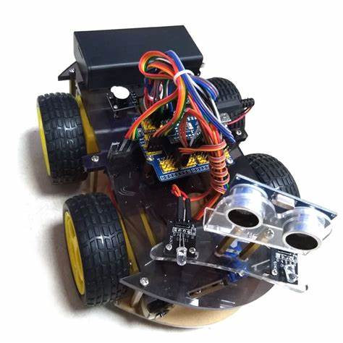
Figure 2. Hummer Bot
V SOURCE CODE

Support Vector Machine is a supervised machine learning algorithm used for both classification and regression. Though we say regression problems as well its best suited for classification. The objective of algorithm is to find a hyper plane in an N-dimensional space that distinctly classifies the data points. The dimension of the hyper plane depends upon the number of features. If the number of input features is two, then the hyper plane is just a line. If the number of input features is three, then the hyper plane becomes a 2-D plane.

It becomes difficult to imagine when the number of features exceeds three is a function that takes low dimensional input space and transforms it into higher-dimensional space, i.e., it converts not separable problem to separable problem. It is mostly useful in non-linear separation problems. Simply put the kernel, it does some extremely complex data transformations then finds out the process to separate the data based on the labels or outputs defined.

VI ASSEMBLING AND PROGRAMMING
Support Vector Machine is a supervised algorithm based on machine learning which can be used for both classification and regression problems. However, it's far ordinarily used in classification work. In this work, plot each data item as a point in n-dimensional space with the value of every feature being the count of a particular coordinate. Then, we perform classification by finding the hyper-plane that differentiates the two classes very well. Support Vectors are simply the co-ordinates of individual observation. Support Vector Machine is best for segregates the two classes (hyper-plane/ line). The hyperplane is the line with the biggest margin to both groups.
VII RESULT AND DISCUSSION

Before conducting tests, the team made necessary assumptions to obtain feasible results. Some assumptions made include ideal weather conditions during flight, ignore force endured due to take-off acceleration, assume that battery charges/discharges at constant rate. Knowing the device requirements, the team set up for prototypes testing. After testing, the team reviewed the performance to see if any specifications were not met.

The design team first validated the individual components of the device before assembling the device so that a better understanding of the outcome would be hypothesized Overall, the results were as expected and produced promising numbers. It produced far greater results in correlation to the cost of production. According to the results, the prototype satisfies the specifications and thus successfully demonstrates concept feasibility. The piezoelectric transducer output is in AC waveform.

VIII CONCLUSION
Nowadays we need everything computerized. Earlier we can only monitor the situations with the help of cameras. In industries to reduce manual overhead we have implemented Internet of Things (IoT) in Industry. As sometimes it will be late in this process, and it will harm to property as well as life. For this purpose, we are developing a system for Automation using IoT with the help of Artificial Intelligence to make system automated. The system developed uses basic conveyor belt mechanism for bottle size detection and counting number of bottles. This system also gives us flexibility for controlling conveyor belt from computer side. The main part of the project is the industrial automation, which makes the industry to run through internet. To control this action, we create a web page where we give the input that is click on the button sitting at one place on your web page and getting your machinery start in your industry.

The web page appears on users PC and internet is connected to the machines through Wi-Fi modem. There at the receiver side motors are connected to the application to drive them. The motors are controlled with the help of a Microcontroller. The Board we are using are free scale Arm Embed Board KL25Z which controls the robotic arm. The user interface which is used to control the robotic arm is made on a web page or an app. The control is given via the internet to the Wi-Fi module. This acts as the receiver and gives the received signal to the microcontroller (KL25Z). The microcontroller will act as per the given instructions. The controller board is already connected to the server through the Wi-Fi module.

The signal which is given to the industrial machine is sent through the internet and hence we can access it from any place. However, the web page or the app must require a login ID and a password for security reasons, for a person to control the industrial appliance. The happenings in the industry during the absence of manual attention can be seen through an ICA.

REFERENCE
- Kumar, Naresh, et al. "Efficient automated diagnosis using machine learning models." Journal of Healthcare Engineering 2021 (2021).

- Bhavsar, Kaustubh Arun, et al. "Medical diagnosis using machine learning: a statistical review." Computers, Materials and Continua 67.1 (2021): 107-125.

- Moreno-Ibarra, Marco-Antonio, et al. "Classification of s Using Machine Learning Algorithms: A Comparative Study." Mathematics 9.15 (2021): 1817.
- Myszczynska, Monika A., et al. "Applications of machine learning to diagnosis and treatment of neurodegenerative s." Nature Reviews Neurology 16.8 (2020): 440-456.

- Cheng, Fu-Yuan, et al. "Using machine learning to predict ICU transfer in hospitalized COVID-19 patients." Journal of clinical medicine 9.6 (2020): 1668.

- Richens, Jonathan G., Ciarán M. Lee, and Saurabh Johri. "Improving the accuracy of Robotic function with causal machine learning." Nature communications 11.1 (2020): 1-9.

- Qayyum, Adnan, et al. "Secure and robust machine learning: A survey." IEEE Reviews in Biomedical Engineering 14 (2020): 156-180.

- Ray, Susmita. "A quick review of machine learning algorithms." 2019 International conference on machine learning, big data, cloud and parallel computing (COMITCon). IEEE, 2019.

- Balyen, Lokman, and Tunde Peto. "Promising artificial intelligence-machine learning-deep learning algorithms in ophthalmology." The Asia-Pacific Journal of Ophthalmology 8.3(2019): 264-272

- Pellegrini, Enrico, et al. "Machine learning of neuroimaging for assisted di of cognitive impairment and a: a systematic review." Alzheimer's & a: Diagnosis, Assessment & Monitoring 10 (2018): 519-535.

- Li Da Zu” Internet of Things in Industries: A Survey” IEEE Transactions on Industrial Informatics, vol. 10, no. 4, November 2019

- Sadeque Reza Khan Professor Dr. M. S. Bhat “GUI Based Industrial Monitoring and Control System ``IEEE paper, 20120.

