Kidney Stone Detection using Deep Learning techniques.
P. Srinivasulu, M. Tech (PhD), Asst. Professor, Dept. of E.C.E, Sir CRRCOE.
A. Ravi Kumar, M. Tech, Asst. Professor, Dept. of E.C.E, Sir CRRCOE.
M. R. V. S. Ganesh Pavan, N. Srinivas, K. Kartheek, M. Mahesh Babu, K. Benny.
Under graduates of Dept. of E.C.E, Sir CRRCOE.
Abstract:
Kidney stones have become a major issue in recent years, and if they aren't detected quickly, they can create problems that call for surgery to remove the stone. Kidney stone detection is generally performed manually by humans on medical images. Specialists are needed for the interpretation and full diagnosis of these images. This process is time consuming and subjective as it depends on the physician. By designing a computer aided algorithm, it helps in diagnosing kidney stones easily. Deep Learning algorithms that use non-contrast abdominal CT scans may be used to identify stones and minimise the amount of work involved in manual detection. image processing techniques are applied on raw CT scan image Dataset. To identify kidney stones, we used CNN and Random Search on the dataset. Random Search algorithm is used to determine the deep learning model's ideal parameter values. This model now has a 98.3% accuracy rate.
Keywords :- CNN, Hyperparameter Tuning, Computed Tomography (CT), Median Blur, OpenCV, Random Search, Relu, XResNet50.
Introduction:

There is a growing incidence of kidney stone illness, with renal calculi, or kidney stones, forming solid masses within the kidney. Although anybody, even children, may get kidney stones, many cases go unnoticed until severe abdominal pain or odd urine colour is present. Symptoms may also include fever, discomfort, and nausea. Small ureteral stones may dissolve on their own, but bigger stones may need interventional therapy, such as endoscopic or extracorporeal shock wave lithotripsy. Unfortunately, Many kidney stones are difficult to detect early phases that might injure the kidney as they develop. Millions of people have kidney failure every year as a result of the major causes, which include diabetes, hypertension, and glomerulonephritis. Kidney stones can be classified by location as kidney (nephrolithiasis), ureter (ureterolithiasis), and bladder (cystolithiasis).
Medical imaging has become an essential tool in biological and clinical research, allowing clinicians to visualize the inner organs of patients. Ultrasound images, Non-contrast Computed Tomography (NCCT or CT-Scan), MRI, and X-ray are all possible options NCCT is widely used to make a diagnosis of acute flank pain. While radiologists typically employ a manual procedure to detect the stones from a CT image, advances in image processing have made it possible to get accurate results without requiring human involvement. However, the increasing use of CT for suspected urolithiasis has led due to a rise in the imaging volume, lengthened turnaround times, an increase in radiologists workload, and prolonged hospital stays. To address these issues, this work employed Kidney-urine-belly CT scans to create a kidney screening tool that is semi-automatic and uses digital image processing. Image segmentation, classification, and detection in medicine are just a few of the many applications where Deep Learning models have been employed successfully. To automatically find kidney and ureteral stones, DL methods are utilised in the field of urology. The CT scan information is a grayscale 3D image, with each pixel's value being closely related to the kind of substance that is present there. Kidney stones are made of a specific chemical mixture, leading to the value of the pixels a kidney stone takes up in a particular range. However, This particular mixture of materials is also used to build other parts of the human body, with bone and other material concentrations having pixels that are similar in range to kidney stones.
Literature Survey:
Nagireddi Amrutha Lakshmi et al., have proposed a model for kidney stone detecting from ultrasound images. Ultrasound images are prone to noise because of its low contrast. Image pre-processing consists of smoothening, sharpening and enhancement. Gaussian Filtering was used during pre-processing phase which is used to smoothen the image. Canny Edge detection was used to extract the useful information from the image. By using the Conventional Neural Networks, the model has obtained an accuracy between 70-80%.
Stalina S et al., applied Image processing methods on CT Scan images. According to the author, filtering and image enhancement are used in image processing. The picture is smoothed using filtering. There are many different filters, including average and weighted average filters, Median filter and the Guassian filter. Because it is the greatest way to get rid of impulse noise or salt and pepper noise, the author of this research used a median filter. The intensities of the image can be changed with the use of image enhancement techniques. Because CT scan pictures are of poor quality, image enhancement should be carried out. The author changed the pixel intensity by a process called histogram equilization. The author employed the Thresholding approach to divide the picture into several sections in order to extract the required characteristics during the image segmentation process.
Anushri Parakh et al. assessed the effectiveness of pretrained models enhanced with labelled Unenhanced abdominopelvic CT images when used with various scanners. Prior to being normalised such that all scans were orientated upward, all of the pictures were initially processed using a variety of image processing techniques. The photographs were then changed from colour to grayscale. Following that, a cascade model made up of two CNNs was developed using the photos. Models that have already been trained, such ImageNet and Grey Net, make up the initial (CNN-1) model. The pictures were shown to CNN-1, which aids in detecting the urinary tract, first during the training phase 4, and then to CNN-2 for categorization into the presence or absence of stones.

Mehmet Baygin et al., have created an automated system to aid clinicians in precisely detecting kidney stones. In this paper, a transfer learning algorithm (ExDark19) for detecting kidney stones is proposed. The most informative features were extracted using iterative neighbourhood component analysis (INCA), and these features were then fed into KNN to detect kidney stones using a k-fold cross validation approach. The proposed ExDark19 model has achieved good results with the hold out validation method.
Methodology:
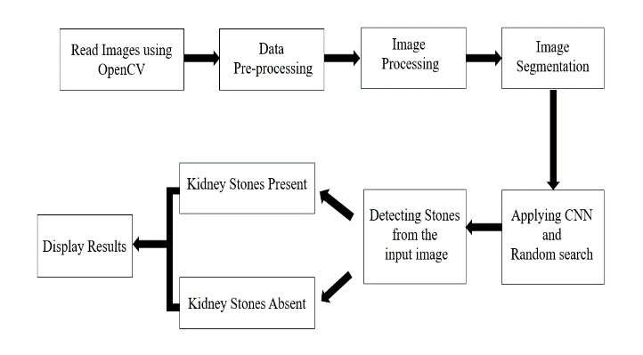
Image processing:
In image processing we applied two techniques
Median Filter:
The Median filter is a commonly used image processing technique used to remove noise from an image. It is a nonlinear filter that replaces the value of each pixel with the median value of its neighbouring pixels. The median filter is often used in image processing applications where preserving the edges of an image is critical.
In Python, the OpenCV library provides ‘medianblur()’ function for applying the Median filter.

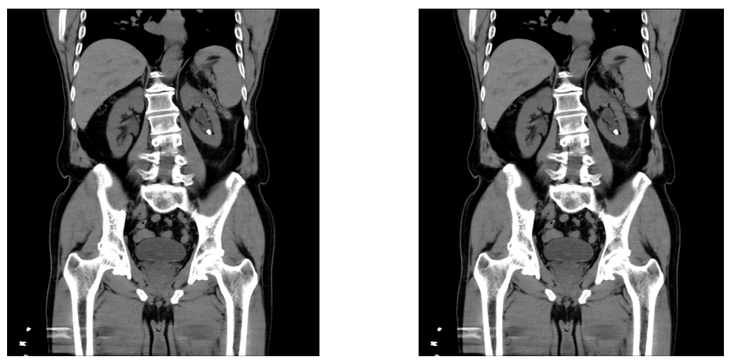
Fig. Median filter output
Syntax: cv2.medianBlur(src, ksize)
Here, src is the source image and ksize specifies the size of the filter.
Power Law Transformation:
Power Law Transformation, also known as gamma correction, is a commonly used image processing technique used to adjust the brightness and contrast of an image. It is a nonlinear transformation that maps the pixel values of an input image to a new range of values based on a power law function.
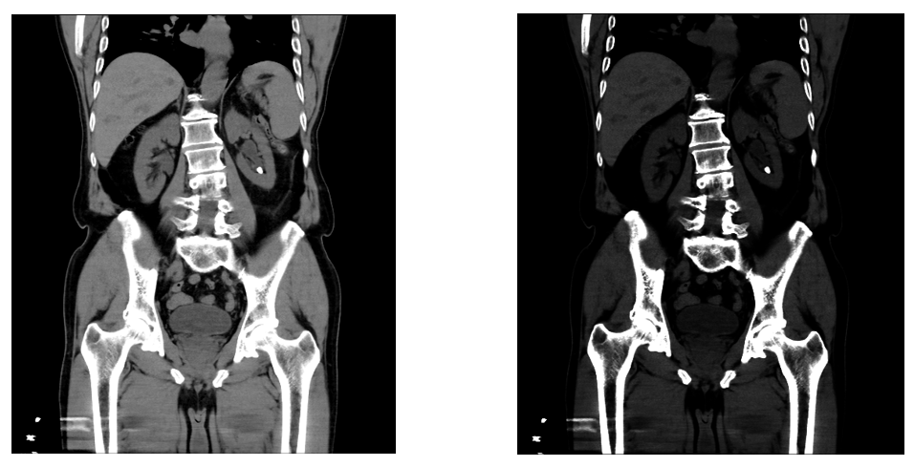
Fig. Power law transformation output
Image Segmentation:
Image segmentation is the process of breaking an image up into different parts or segments with the goal of making the representation of an image more clear-cut and simpler to examine.
Some of the common techniques used for image segmentation include thresholding, clustering, edge detection. We used thresholding technique.

Thresholding:
Thresholding is a technique used in image processing to separate an image into two parts, usually as foreground and background. In Python OpenCV, thresholding is performed by converting an input grayscale image into a binary image. The Thresholding value depends on the pixel's intensity; pixels with intensities below it become zero, while those with intensities above it become 255.
The threshold value was chosen to be 100.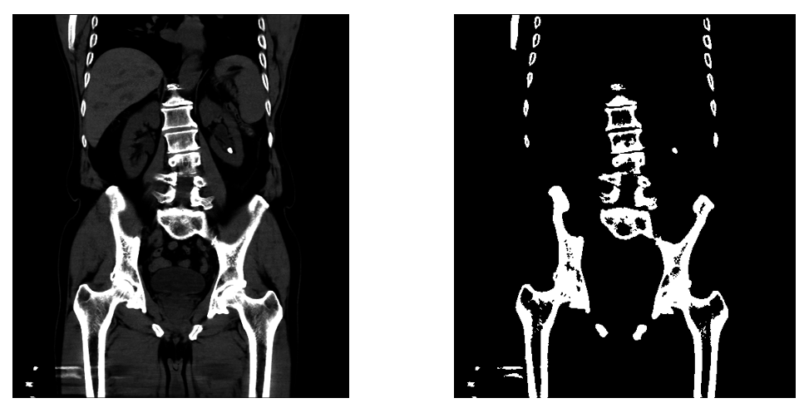
Fig. Thresholding Output
Deep learning model:
For building the model, Convolutional Neural Network(CNN) algorithm is employed. A CNN is a type of deep neural network that is commonly used for image recognition and processing. It consists of multiple layers that perform convolution, pooling, and nonlinear activation functions to extract and classify features from images. CNNs are highly effective in recognizing patterns and have been widely used in various applications such as image classification, object detection, and facial recognition.
Random search is a technique used for optimizing the hyperparameters of a convolutional neural network. Random search involves randomly sampling a set of hyperparameters and evaluating the performance of the resulting model. This process is repeated multiple times, and the best set of hyperparameters is selected based on the performance of the corresponding models. By finding the optimal hyperparameters, the CNN model can improve its ability to extract meaningful features from images, leading to improved accuracy in image recognition and classification tasks.
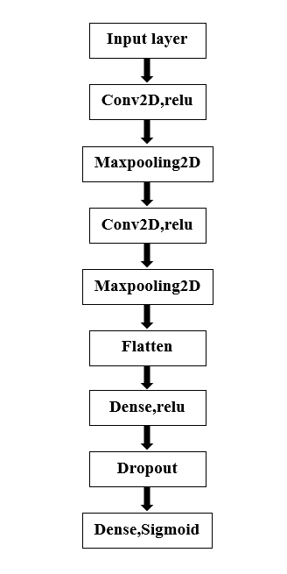
Fig. Model Architecture
Results:
The model is tested on 15 unseen images.
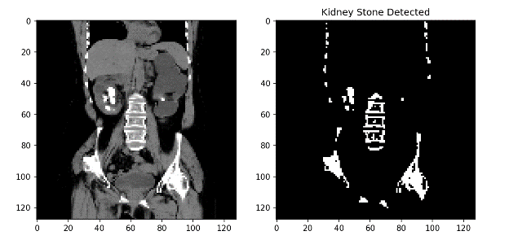
Fig. Output 1 (Kidney Stone Detected)
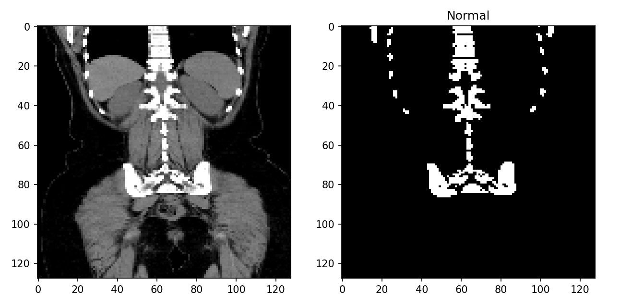
Fig. Output 2 (Normal)
Conclusion matrix:
True positive  95 | False positive  0
False negative  3 | True negative  82

$$Accuracy=\frac{(TP+TN)}{TP+FP+FN+FN}$$
$$Accuracy=\frac{(95+82)}{95+0+3+82}=0.983$$
Accuracy comparison:
The accuracy for the SVM is approximately 94 percent, the accuracy for the KNN is about 93 percent, and the accuracy for the CNN is about 98 percent. After using image processing techniques on the pictures, the CNN is trained using those images. Random Search was used to find the model parameters.
Algorithms | CNN | KNN | SVM
Accuracy | 98.3% | 93.8% | 94.4%
Table. Accuracy comparison
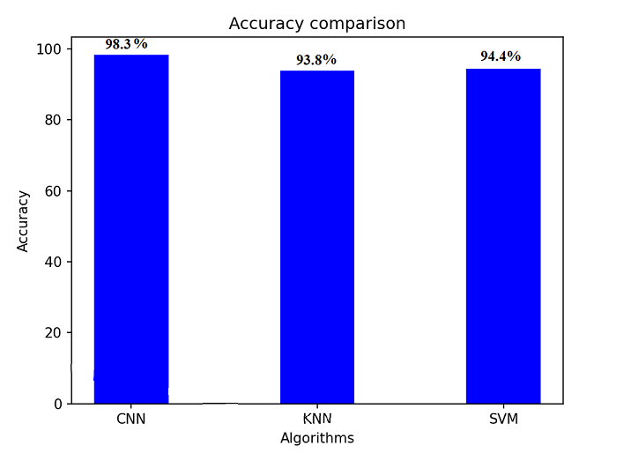
Fig. Accuracy plot
Conclusion:
The development of an automated system for identifying Kidney Stones is completed which is quite efficient. Our project incorporates the use of Convolutional Neural Network and Random search in its design which improved accuracy. An innovative approach for extracting essential features through image processing resulted in a reduction in processing time for the detection system. The model has acquired a accuracy of 98.3%.
References:
Stalina S, Aditi S, Anuja R, Prof. Pooja L Gohel, “Kidney Stone Detection Using Image Processing onCT Images”, ISSN NO: 2249-7455.
Längkvist, Martin & Jendeberg, Johan & Thunberg, Per& Loutfi, Amy & Lidén, Mats. (2018). “Computer aided detection of ureteral stones in thin slice computed tomography volumes using Convolutional Neural Networks” Computers in Biology and Medicine.
Kadir Yildirim, Pinar Gundogan Bozdag, Muhammed Talo, Ozal Yildirim, Murat Karabatak, U.Rajendra Acharya, “Deep learning model for automated kidney stone detection using coronal CT images” , 2021.
M.Akshaya, R.Nithushaa, N.Sri Madhava Raja, S.Padmapriya “Kidney Stone Detection Using Neural Networks” IEEE 2020.
Parakh, A., Lee, H., Lee, J. H., Eisner, B. H., Sahani, D. V., & Do, S. (2019). Urinary stone detection on CT images using deep convolutional neural networks: Evaluation of Model Performance and generalization. Radiology: Artificial Intelligence.
Prema T. Akkasaligar, Sunanda Biradar, Veena Kumbar “Kidney stone detection in computed tomography images” IEEE 2017.
Daniel C. Elton, Evrim B. Turkbey, Perry J. Pickhardt, Ronald M. Summers “A deep learning system for automated kidney stone detection and volumetric segmentation on noncontrast CT scans” 2021.
Mehmet Baygin, Orhan Yaman, Prabal Datta Barua, Sengul Dogan, Turker Tuncer, U. Rajendra Acharya “Exemplar Darknet19 feature generation technique for automated kidney stone detection with coronal CT images” 2021.
M.S.Abirami, T.Sheela, “Improved Speedup Performance in Automated Segmentation of Kidneys on Abdominal CT Images and Extracting its Abnormalities” IJPAM 2017.
Verma, J., Nath, M., Tripathi, P. et al. Analysis and identification of kidney stone using Kth nearest neighbour (KNN) and support vector machine (SVM) classification techniques. Pattern Recognit. Image Anal. 27, 574–580 (2017).

