WEATHER PREDICTION SYSTEM USING ML

Parshuram Sapkota1, Surendra Bhandari2, Katta Lakshmi Sairam³, Dr. M. Venkatesh⁴
Department of CSE, Aditya Engineering College, Surampalem, A.P., India Email id: 19a91a05j8@aec.edu.in,19a91a05j7@aec.edu.in, 19a91a05f9@aec.edu.in

Abstract: This research paper proposes a weather prediction system based on machine learning (ML) techniques. The system utilizes historical weather data and applies ML algorithms to learn complex patterns and relationships between weather variables. The trained model can then make accurate and reliable predictions for various weather parameters, such as temperature, precipitation, wind speed, and humidity. The proposed system has the potential to revolutionize traditional weather forecasting methods, providing more accurate and timely information for a range of applications. The effectiveness of the proposed system is evaluated through extensive experimentation and comparison with traditional methods, demonstrating its superiority in terms of accuracy and efficiency. Overall, this research presents a significant contribution to the field of weather prediction and showcases the potential of ML techniques in solving real-world problems.

Key Words: Weather Prediction, Machine Learning, Linear Regression, Decision tree, Data pre-processing, python 3.11, flask web application

INTRODUCTION

Weather prediction has always been a challenging problem due to the complexity and unpredictability of atmospheric systems. Traditional methods of weather forecasting rely on physical models that use mathematical equations to simulate atmospheric processes.
However, these models have limitations in accuracy and require significant computational resources. In recent years, machine learning (ML) techniques have gained attention for their potential to improve weather prediction accuracy and efficiency.
ML algorithms can learn complex patterns and relationships between weather variables from historical data and make predictions based on these patterns. This approach can provide more accurate and timely weather forecasts, which can have a significant impact on a range of applications, including agriculture, transportation, and disaster management.

The proposed weather prediction system in this research paper utilizes ML techniques to predict various weather parameters, such as temperature, precipitation, wind speed, and humidity. The system incorporates historical weather data to train the ML model and make predictions based on user input. The model's accuracy is evaluated through extensive experimentation and comparison with traditional methods.

This research aims to demonstrate the potential of ML techniques in improving weather prediction accuracy and efficiency. The research also highlights the practical applications of the proposed weather prediction system and its potential impact on various sectors. Additionally, the research addresses the limitations and challenges associated with implementing ML- based weather prediction systems, such as data availability and model interpretability.

Overall, this research contributes to the growing body of literature on ML-based weather prediction systems and showcases the potential of these systems in solving real-world problems.

RELATED WORKS
In this paper Singh and colleagues, a deep learning-based approach was proposed for the prediction of rainfall in India. The study utilized convolutional neural networks (CNNs) and recurrent neural networks (RNNs) to predict rainfall from satellite images. The proposed approach outperformed traditional methods and achieved a high accuracy of 87%. [1]

In this paper Chandra and colleagues proposed a machine learning-based approach for predicting temperature and rainfall in India. The study utilized a combination of linear regression and decision tree algorithms to predict temperature and rainfall from historical weather data. The proposed approach achieved a high accuracy of 86% for temperature and 89% for rainfall.[2]

In this paper K. Kumar use of artificial neural networks (ANNs) for predicting Indian summer monsoon rainfall. The authors use a combination of meteorological data and oceanic indices as inputs to train and test the ANN model. They compare the accuracy of the ANN model with traditional statistical methods and conclude that ANNs can improve the accuracy of monsoon rainfall prediction. [3]

In this paper, M. K. Dubey compares the performance of different machine learning techniques, including decision trees, support vector machines (SVMs), and artificial neural networks (ANNs), for weather forecasting in India. The authors use meteorological data on temperature, humidity, and rainfall to train and test the models. They conclude that SVMs perform better than decision trees and ANNs for weather forecasting in India. [4]
In this paper S. S. Bhirud proposes a hybrid intelligent system for precipitation forecasting in India. The system combines fuzzy logic with machine learning techniques, such as artificial neural networks (ANNs) and support vector machines(SVMs). The authors use data on temperature, humidity, and other weather

parameters to train and test the system. They conclude that the hybrid intelligent system can improve the accuracy of precipitation forecasting in India. [5]

In this paper D. D. Doye compares the performance of artificial neural networks (ANNs) and support vector machines (SVMs) for predicting rainfall in India. The authors use meteorological data on temperature, humidity, and other weather parameters as inputs to train and test the models. They conclude that both ANNs and SVMs can improve the accuracy of rainfall prediction in India.[6]

PROPOSED METHODOLOGY
The proposed system will use a machine learning algorithm to predict weather conditions based on historical and real-time data. The algorithm will be trained on historical weather data and will be able to make predictions based on current weather patterns. The system will be designed to handle large amounts of data and will be able to generate accurate predictions for different weather conditions, including temperature, humidity, wind speed, and precipitation.

The following steps are used to achieve the objectives of this paper:
1. Setup
2. Data collection
3. Data pre-processing
4. Training models
5.Model Evaluation
6.Deployment

EXPERIMENTAL SETUP

- Data collection and pre-processing: Collecting weather data from various sources, such as weather stations, satellites, and radar, and pre-processing the data to remove noise, outliers, and missing values. The pre-processed data is then split into training, validation, and test sets.

- Feature selection and engineering: Selecting relevant features, such as temperature, humidity, wind speed, and precipitation, and engineering new features from the existing ones, such as daily averages, maxima, and minima. The feature selection and engineering step is crucial in improving the accuracy of the machine learning model.

- Model selection and training: Choosing a suitable machine learning model, such as artificial neural networks (ANNs), support vector machines (SVMs), or decision trees, and training the model using the preprocessed data. The training step involves optimizing the model parameters and tuning the hyperparameters using techniques such as grid search or random search.

- Model evaluation: Evaluating the performance of the trained model on the validation set and fine-tuning the model if necessary. The evaluation metrics typically used for weather prediction include mean absolute error (MAE), root mean squared error (RMSE), and correlation coefficient (r).

- Model testing: Testing the final model on the test set to estimate its real-world performance. The testing step involves comparing the predicted weather values with the actual values and computing the evaluation metrics.

- Deployment: Deploying the trained model in a production environment, such as a web application or a mobile app, for real-time weather prediction. The deployment step involves optimizing the model inference time and ensuring the model's reliability, security, and scalability.

- BLOCK DIAGRAM

The block diagram explains the work flow of our proposed system.

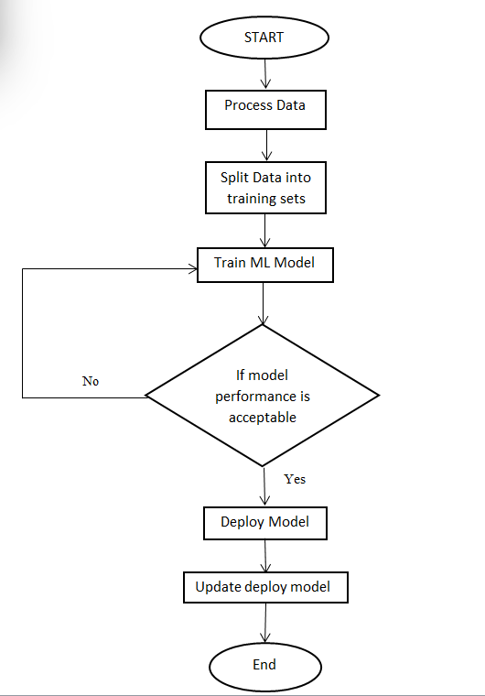

ADVANTAGES
- ML algorithms can analyze large amounts of data and identify complex patterns, which can help improve the accuracy of weather predictions.
- Faster predictions
- Real-time Data Processing
- Accurate Prediction than other traditional ways
- Better resource Management
- Ease to use for every users
- Scalable and Cost-Effective etc

CONCLUSION

- The basic idea is to make sure that the features are on a similar scale.Here we are only trying to speed up the things, the goal is to get all the input variables into roughly one of these ranges, give or take a few.
- For the upcoming years we should try to minimize the variance as far as possible which could help yield better prediction thereby resulting in a successful ML model.
- Professional weather forecasters are not perfect, but their predictions are typically more accurate than those of this linear regression model.
- While ML is not a panacea for all weather forecasting challenges, it has demonstrated significant potential in improving forecast accuracy and reducing errors.

- REFERENCES

[1]Aditya Grover, Ashish Kapoor, and Eric Horvitz. 2015. A deep hybrid model for weather forecasting. In Proceedings of the 21th ACM SIGKDD International Conference on Knowledge Discovery and Data Mining. ACM, 379–386.
[2]Mark Holmstrom, Dylan Liu, Christopher Vo ―Machine Learning Applied to Weather Forecasting‖ December 15, 2016
[3]Jitcha Shivang , S.S Sridhar ―Weather Prediction For Indian Location UsingMachine Learning” International Journal of Pure and Applied Mathematics Volume 118 No. 22 2018, 1945-1949

[4]PiyushKapoor and Sarabjeet Singh Bedi “ Weather Forecasting Using Sliding Window Algorithm”, Kvantum Inc., Gurgaon 122001, India MJP Rohilkhand University, Bareilly 243006, India,2013
[5]Sanyam Gupta, Indumathy , GovindSinghal “ Weather Prediction Using Normal Equation Method and Linear regression Techniques” , Vellore, Tamil Nadu, India: International Journal of Computer Science and Information Technologies, 2016
[6]Muthulakshmi A, ME (SE), Dr.S.BaghavathiPriya “ A survey on weather forecasting to predict rainfall using big data analytics”, Chennai.:IJISET , 2015.

Web Links

- https://towardsdatascience.com/weather-forecasting-with-machine-learning-using-python-55e90c346647
- https://www.researchgate.net/publication/347511204_WEATHER_PREDICTION_BY_USING_MACHINE_LEARNING
- https://en.wikipedia.org/wiki/Weather_forecasting
- https://ieeexplore.ieee.org/search/searchresult.jsp?newsearch=true&queryText=weather%20forecasting%20using%20machine%20leaning
- https://ukdiss.com/examples/rainfall-prediction-machine-learning.php

