CLOUD WITH BIG DATA ANALYTICS

Submitted by –
Nutan Prabhakar Patil
MSc IT Part 1
Department of CS & IT
PCP – JMF’s Vande Mataram Degree College
of Art, Commerce & Science, Dombivli [W]
College – Iinstitute of Distance and Open Learning,Mumbai, Maharashtra - University of Mumbai

Under The Guidance Of -
Prof.. Vanita Lokhande
Department of CS & IT
PCP – JMF’s Vande Mataram Degree College
of Art, Commerce & Science, Dombivli [W]

Abstract –

This paper introduces the characteristics, trends and challenges of big data. In addition to that, it investigates the benefits and the risks that may rise out of the integration between big data and cloud computing.
Big Data is a collection of data that is huge in volume, yet growing exponentially with time. It is a data with so large size and complexity that none of traditional data management tools can store it or process it efficiently.
Big data is currently one of the most critical emerging technologies. Big Data are used as a concept that refers to the inability of traditional data architectures to efficiently handle the new data sets.
The 4 V’s of Big data –
- Volume
- Velocity
- Variety
- Veracity
Cloud computing is based on the concepts of consolidation and resource pooling, but big data systems are built on the shared nothing principle, where each node is independent and self-sufficient. Integrating big data with cloud computing technologies, businesses and education institutes can have a better direction to the future. The capability to store large amounts of data in different forms and process it all at very large speeds will result in data that can guide businesses and education institutes in developing fast. Nevertheless, there is a large concern regarding privacy and security issues when moving to the cloud which is the main causes as to why businesses and educational institutes will not move to the cloud.

Keywords - Big data, Cloud Computing, Analytics

Introduction –

Big Data is a data analysis methodology enabled by a new generation of technologies and architecture which support high-velocity data capture, storage, and analysis. Data sources extend beyond the traditional corporate database to include email, mobile device output, sensorgenerated data, and social media output. Big Data requires huge amounts of storage space. While the price of storage continued to decline, the resources needed to leverage big data can still pose financial difficulties for small to medium sized businesses. A typical big data storage and analysis infrastructure will be based on clustered network-attached storage (NAS). Clustered NAS infrastructure requires configuration of several NAS “pods” with each NAS “pod” comprised of several storage devices connected to an NAS device.
The series of NAS devices are then interconnected to allow massive sharing and searching of data. Cloud computing is an extremely successful paradigm of service oriented computing, and has revolutionized the way computing infrastructure is abstracted and used.
Three most popular cloud paradigms include:
• Infrastructure as a Service (IaaS)
• Platform as a Service (PaaS)
• Software as a Service (SaaS).
The concept however can also be extended to Database as a Service or Storage as a Service. Elasticity, pay-peruse, low upfront investment, low time to market, and transfer of risks are some of the major enabling features that make cloud computing a universal paradigm for deploying novel applications which were not economically feasible in a traditional enterprise infrastructure setting.
One requires new expertise in the areas of data management and systems management who understands how to model the data and prepare them.
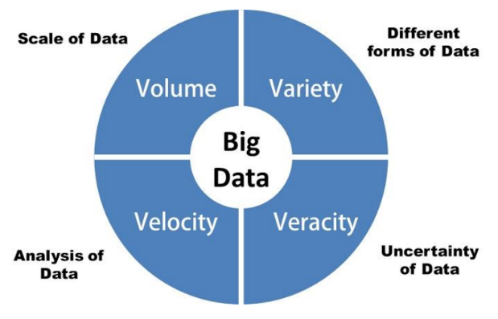

Data storage using cloud computing is a viable option for small to medium sized businesses considering the use of Big Data analytic techniques. Cloud computing is ondemand network access to computing resources which are often provided by an outside entity and require little management effort by the business.

Big Data: General Concept and Definition

Big Data are used as a concept that refers to the inability of traditional data architectures to efficiently handle the new data sets. Characteristics that force a new architecture to achieve efficiencies are the data set-at-rest characteristics volume, and variety of data from multiple domains or types; and from the data-in-motion characteristics of velocity, or rate of f low, and variability. Each of these characteristics results in different architectures or different data lifecycle process orderings to achieve needed efficiencies. A number of other terms (often starting with the letter ‘V’) are also used, but a number of these refer to the analytics and not big data architectures, as shown in Figure.
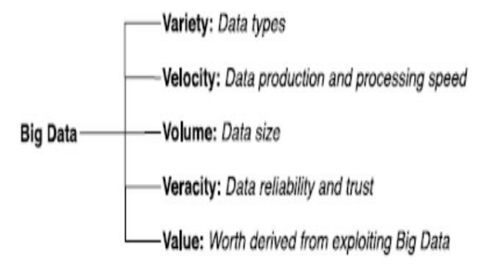
Fig: Some V’s of Big Data

The new big data paradigm occurs when the scale of the data at rest or in motion forces the management of the data to be a significant driver in the design of the system architecture. Fundamentally the big data paradigm represents a shift in data system architectures from monolithic systems with vertical scaling (faster processors or disks) into a horizontally scaled system that integrates a loosely coupled set of resources.

Types Of Big Data

Following are the types of Big Data:
• Structured
• Unstructured
• Semi-structured
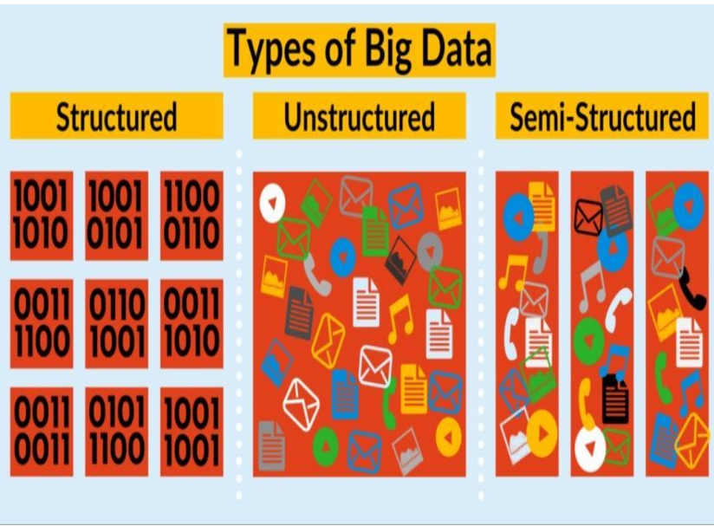

Structured
Any data that can be stored, accessed and processed in the form of fixed format is termed as a ‘structured’ data. Over the period of time, talent in computer science has achieved greater success in developing techniques for working with such kind of data (where the format is well known in advance) and also deriving value out of it. However, nowadays, we are foreseeing issues when a size of such data grows to a huge extent, typical sizes are being in the rage of multiple zettabytes.

Unstructured
Any data with unknown form or the structure is classified as unstructured data. In addition to the size being huge, un-structured data poses multiple challenges in terms of its processing for deriving value out of it. A typical example of unstructured data is a heterogeneous data source containing a combination of simple text files, images, videos etc. Now day organizations have wealth of data available with them but unfortunately, they don’t know how to derive value out of it since this data is in its raw form or unstructured format.

Semi-structured
Semi-structured data can contain both the forms of data. We can see semi-structured data as a structured in form but it is actually not defined with e.g. a table definition in relational DBMS. Example of semi-structured data is a data represented in an XML file.

Moving Data Management to Cloud
A data management system has various stages of data lifecycle such as data ingestion, extract-transform-load (ETL), data processing, data archival, and deletion. Before moving one or more stages of data lifecycle to the cloud, one has to consider the following factors:
1. Availability Guarantees: Each cloud computing provider can ensure a certain amount of availability guarantees. Transactional data processing requires quick real-time answers whereas for data warehouses long running queries are used to generate reports. Hence, one may not want to put its transactional data over cloud but may be ready to put the analytics infrastructure over the cloud.
2. Reliability of Cloud Services: Before offloading data management to cloud, enterprises want to ensure that the cloud provides required level of reliability for the data services. By creating multiple copies of application components the cloud can deliver the service with the required reliability of service.
3. Security: Data that is bound by strict privacy regulations, such as medical information covered by the Health Insurance Portability and Accountability Act (HIPAA), will require that users log in to be routed to their secure database server.
4. Maintainability: Database administration is a highly skilled activity which involves deciding how data should be organized, which indices and views should be maintained, etc. One needs to carefully evaluate whether all these maintenance operations can be performed over the cloud data. Cloud has given enterprises the opportunity to fundamentally shift the way data is created, processed and shared. This approach has been shown to be superior in sustaining the performance and growth requirements of analytical applications and, combined with cloud computing, offers significant advantages.

Manage Big Data in Cloud Computing Environments
Cloud Computing is an environment based on using and providing services. There are different categories in which the service-oriented systems can be clustered. One of the most used criteria to group these systems is the abstraction level that is offered to the system user. In this way, three different levels are often distinguished: Infrastructure as a Service (IaaS), Platform as a Service (PaaS), and Software as a Service (SaaS)

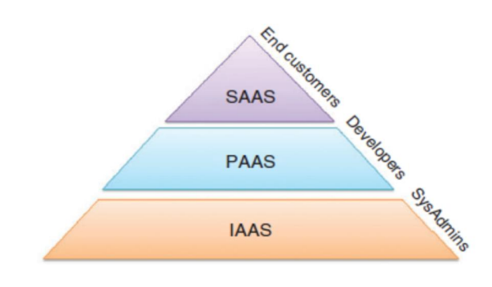

Cloud Computing offers scalability with respect to the use of resources, low administration effort, flexibility in the pricing model and mobility for the software user. Under these assumptions, it is obvious that the Cloud Computing paradigm benefits large projects, such as the ones related with Big Data and BI.
In particular, a common Big Data analytics framework is depicted in Figure 3. Focusing on the structure of the data management sector we may define, as the most suitable management organization architecture, one based on a four-layer architecture, which includes the following components :
1. A file system for the storage of Big Data, i.e., a wide amount of archives of large size. This layer is implemented within the IaaS level as it defines the basic architecture organization for the remaining tiers.
2. A DBMS for organizing the data and access them in an efficient way. It can be viewed in between the IaaS and PaaS as it shares common characteristics from both schemes. Developers used it to access the data, but its implementation lies on a hardware level. Indeed, a PaaS acts as an interface where, at the upper side offers its functionality, and at the bottom side, it has the implementation for a particular IaaS. This feature allows applications to be deployed on different IaaS without rewriting them.
3. An execution tool to distribute the computational load among the computers of the cloud. This layer is clearly related with PaaS, as it is kind of a ‘software API’ for the codification of the Big Data and BI applications.
4. A query system for the knowledge and information extraction required by the system’s users, which is in between the PaaS and SaaS layers.

Advantages of Big Data Applications :
The big data application refers to the large scale distributed applications which usually work with large data sets. Data exploration and analysis turned into a difficult problem in many sectors in the span of big data. With large and complex data, computation becomes difficult to be handled by the traditional data processing applications which triggers the development of big data applications.
Google’s map reduce framework and apache Hadoop are the defector software systems for big data applications, in which these applications generates a huge amount of intermediate data. Manufacturing and Bioinformatics are the two major areas of big data applications.
Big data provide an infrastructure for transparency in manufacturing industry, which has the ability to unravel uncertainties such as inconsistent component performance and availability. In these big data applications, a conceptual framework of predictive manufacturing begins with data acquisition where there is a possibility to acquire different types of sensory data such as pressure, vibration, acoustics, voltage, current, and controller data.
The combination of sensory data and historical data constructs the big data in manufacturing. This generated big data from the above combination acts as the input into predictive tools and preventive strategies such as prognostics and health management Another important application for Hadoop is Bioinformatics which covers the next generation sequencing and other biological domains.
Bioinformatics which requires a large scale data analysis, uses Hadoop. Cloud computing gets the parallel distributed computing framework together with computer clusters and web interfaces. In Big data, the software packages provide a rich set of tools and options where an individual could map the entire data landscape across the company, thus allowing the individual to analyses the threats he/she faces internally.
This is considered as one of the main advantages as big data keeps the data safe. With this an individual can be able to detect the potentially sensitive information that is not protected in an appropriate manner and makes sure it is stored according to the regulatory requirements.

Advantages and Risks and Challenges of Big Data and Cloud computing integration
Advantages
There are many advantages of integrating cloud computing to big date. Big data raises the need for multiple servers because of the massive data and size it works on, and it demands high velocity and variability. These multiple servers work in parallel to provide the big data high requirements.
Cloud computing already uses multiple servers and allow resource allocations. Because of that, it is a great fit to build the big data on these cloud multi-servers and make use of the resource allocation availability provided by the cloud environments which would result in a better efficiency for big data analysis. Using cloud system as a storage for big data would improve the performance for both.
As cloud systems are mainly based on remote multi-servers which makes it feasible to handle massive amounts of data simultaneously. This feature allows advanced analytics techniques to enable the big data to deal with massive amounts of data. The integration between cloud computing and big data would result in cost reduction. While big data requires clusters of servers and volumes to support the massive amount of data.
Cloud computing systems can work as the structure for all of these servers and volumes instead of creating new ones for big data which also provides more flexibility and scalability and eliminates the huge investments that would be invested on the big data computers and servers. In addition to that, using cloud computing provides faster provisioning to big data as provisioning servers in the cloud is so easy and feasible. So, based on the processing requirements of the big data, the cloud environment used can be scaled accordingly. This fast provisioning is really important for big data as the value of the data rapidly decrease over time.
In general, cloud computing complements big data and provides convenient, ondemand and shared computing environment with minimal management effort and reduced overhead. It also makes the environment more robust, automated and provides multi-tenancy.
In addition to all of that, the integration between both, makes big data resources more controllable, monitored and reported. Moreover, this integration enables reducing the complexity and improving the productivity. All of these advantages make the cloud based approaches are the right models for deploying big data.

Risk and Challenges
Despite all of these advantages of the integration between cloud computing and big data, there are some challenges and risks that should be considered while deploying big data on a cloud environment.
The fundamental issue that should be considered is the security of the big data cloud environment. There are some security vulnerabilities that rise because of this integration between both and creating a new unfamiliar platform. One of the most known Big Data cloud security vulnerability is platform heterogeneity.
There are many Big Data deployments that requires deploying a new plat-form in the cloud while the existing security tools and practices of the cloud will not work for such platforms and new security tools are needed to be developed to work with these new Big Data platforms. These security tools could include authentication, access control, encryption, intrusion detection, and event logging and monitoring. In addition to the security policies, the Big Data consolidation plans should be taken into consideration while the integration with the cloud environment.
Another challenge is the nature of data and its location, as in Big Data, the data can be in different locations. The cloud environment may include these locations or not. The type of processing that should be applied to the data, the parallelism of the processing, and where the processing should take place either the data is moved to a processing environment or the processing is performed on the location of the data. All of these are also challenges that should be taken into consideration while deploying the Big Data to a cloud system environment. In addition to that, another challenge is the optimization of the Big Data cloud topology as it specifies the configuration, the size of the clouds, clusters and nodes that should be included to reach the optimal Big Data cloud model.
On the other hand these challenges have been overcome, if not in a direct manner, to allow the idea of the cloud and big data integration become the more practical answer instead of investing countless thousands of dollars in creating an environment suitable to operate the large amount of processing required as well as accommodate terabytes of data.

Methodology
Several solutions were proposed to store and retrieve large amounts of data demanded by Big Data, some of which are currently used in Clouds. Internet-scale file systems such as the Google File System (GFS) attempt to provide the robustness, scalability, and reliability that certain Internet services need. Other solutions provide object-store capabilities where files can be replicated across multiple geographical sites to improve redundancy, scalability, and data availability. Examples include Amazon Simple Storage Service (S3), Nirvanix Cloud Storage, OpenStack Swift and Windows Azure Binary Large Object (Blob) storage.
Although these solutions provide the scalability and redundancy that many Cloud applications require, they sometimes do not meet the con- currency and performance needs of certain analytics applications. One key aspect in providing performance for Big Data analytics applications is the data locality. This is because the volume of data involved in the analytics makes it prohibitive to transfer the data to process it.
This the preferred option in typical high performance computing systems: in such systems, that typically concern performing CPU-intensive calculations over a moderate to medium volume of data, it is feasible to transfer data to the computing units, because the ratio of data transfer to processing time is small. Nevertheless, in the context of Big Data, this approach of moving data to computation nodes would generate large ratio of data transfer time to processing time. Thus, a different approach is preferred, where computation is moved to where the data is. The same approach of exploring data locality was explored previously in scientific workflows and in Data Grids. In the context of Big Data analytics, Map Reduce presents an interesting model where data locality is explored to improve the performance of applications. Hadoop, an open source Map Reduce implementation, allows for the creation of clusters that use the Hadoop Distributed File System (HDFS) to partition and replicate data sets to nodes where they are more likely to be consumed by mappers.
In addition to exploiting concurrency of large numbers of nodes, HDFS minimizes the impact of failures by replicating data sets to a configurable number of nodes. It has been used by to develop an analytics platform to process Face- book’s large data sets.

Reference
[1] Villars, R. L., Olofson, C. W., & Eastwood, M (June, 2011). Big data: What it is and why you should care. IDC White Paper. Framingham, MA: IDC.
[2] Coronel, C., Morris, S., & Rob, P. (2013). Database Systems: Design, Implementation, and Management, (10th. Ed.). Boston: Cengage Learning.
[3] White, C. (2011). Data Communications and Computer Networks: A business user’s approach, (6th ed.). Boston: Cengage Learning

