Power station simulator
- Mrs. P. B. Khedkar, 2. Pallavi Gajbhare, 3. Rukmini motkewar, 4.Asmita mahabale

1.Lect. Government polytechnic Nanded , - 431602
2,3,4. Students, Government polytechnic Nanded – 431602

Abstract : In this project we are design a Power Simulator measuring of electrical quantities and protecting of devices from overvoltage conditions and Earth fault condition in a three -phase power supply. The main components are described in detail,including motor, Generator, Transformer And Rectificer to build the system in which an ammeter and voltmeter to read voltage and current measurement from Circuit A rectifier is an electrical device that converts alternating current (AC), which periodically reverses direction, to direct current (DC), which flows in only one direction.

Key words : Power , Simulator , Current Sensor , Ardiuno, DC motor , Relay circuit.

1. INTRODUCTION

Power, in the most general sense, refers to the ability or capacity to do something or to exert control or influence over someone or something. In the context of electrical engineering and physics, power specifically refers to the rate at which energy is transferred or work is done.

A simulator, on the other hand, is a computer program or system that mimics the behavior of a real-world process or system. In the context of electrical engineering, a power simulator is a computer program or system that models the behavior of power systems, including electrical grids, power plants, and other components of the power infrastructure. Power simulators are used to study and analyze the behavior of these systems under different conditions and to develop strategies for managing and improving their performance.Power system simulation involves modeling power generation equipment, planning the integration of power plants onto the electric grid, and performing generator control system parameter estimation.
The system can be Energised by pressing yellow push button .
The fault can be repeated by switching the overload choke to other phase and operation of relay is corresponding phase .
The protection scheme can be arranged on balanced current principle by using relay .
To observe protection scheme as ststed in & connect the transformer .
Create the fault by pressing push button overload and observe the effect and operation .
2. Objectives

Some specific objectives of power simulators may include:

- Modeling and simulating the behavior of power grids, power plants, and other components of the power infrastructure.
- Identifying potential problems and weaknesses in power systems and developing strategies to address them.
- Analyzing the impact of new technologies, regulations, and policies on power systems.
- Developing and testing new control strategies for managing power systems.
- Optimizing the performance of power systems to increase efficiency, reliability, and cost-effectiveness.
- Training and educating engineers, operators, and other stakeholders on the operation and management of power systems.
- By achieving these objectives, power simulators can help ensure the safe, reliable, and efficient operation of power systems, which is essential for meeting the growing demand for energy around the world.

Literature survey :

- "Development of a Simulator for Gas Turbine Combined Cycle Power Plants," by H. Hashimoto, T. Kajita, and T. Fujii, published in the Journal of Engineering for Gas Turbines and Power in 2006.
- "Thermal Power Plant Simulator for Operator Training and Performance Evaluation," by A. C. Leal, A. M. Almeida, and R. J. Camara, published in the International Journal of Electrical Power and Energy Systems in 2008.
- "Modeling and Simulation of a Gas Turbine Power Plant," by H. A. El-Bakry, M. A. Habib, and S. A. El-Hamid, published in the Journal of Engineering Sciences Assiut University in 2009.
- "Simulation and Control of a Thermal Power Plant," by R. E. D. Nour and M. M. Salem, published in the International Journal of Computer and Electrical Engineering in 2011.

3. Components

- AURDINO
Arduino Nano is a small, compact and low-cost microcontroller board based on the ATmega328P microcontroller, which is the same microcontroller used in the popular Arduino UNO board. The Arduino Nano board is designed for easy and rapid prototyping of electronic projects, especially those with space constraints.

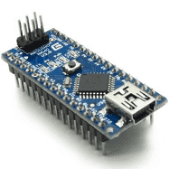

- CURRENT SENSOR
The ACS712 is a current sensor module that is used to measure the amount of electrical current flowing through a wire. It is designed to work with both AC and DC currents up to 5A, making it ideal for a wide range of applications, including power supplies, motor control, and energy monitoring.

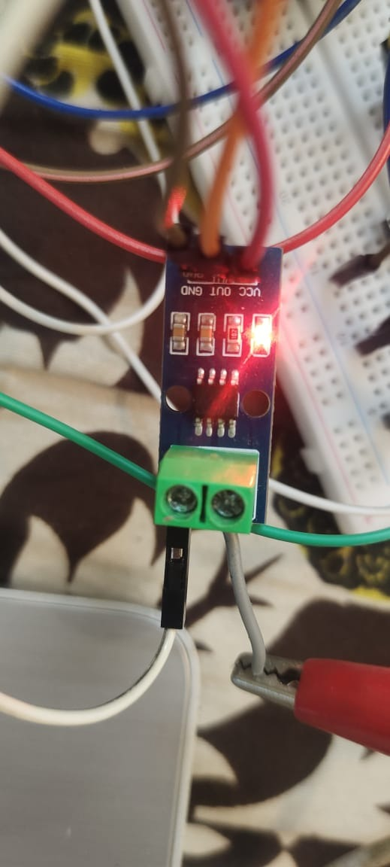

Pin Name | Description
VCC | Power Supply Input (+5V)
GND | Power Supply Ground
OUT | Active High Output

- 16*2 LCD Display
A 16x2 LCD display is a type of alphanumeric display commonly used in electronic devices such as digital clocks, calculators, and other embedded systems. It consists of 16 columns and 2 rows of characters, which allows it to display up to 32 characters at a time. Each character is typically made up of 5x8 or 5x10 pixels, and the display can be controlled by a microcontroller or other digital circuit to show different characters and symbols.

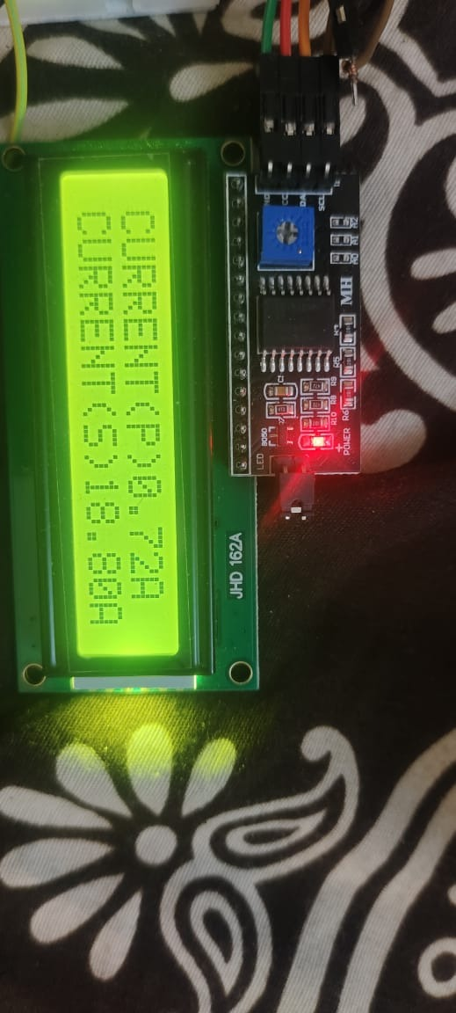

Pin Name | Description
VCC | Power Supply Input
GND | Power Supply Ground
OUT | Active High Output

- RELAY MODULE
A relay module is an electronic device that consists of one or more relays mounted on a printed circuit board (PCB) along with support components such as transistors, diodes, and resistors. Relays are electro-mechanical switches that are used to control electrical circuits by opening or closing contacts when an electrical signal is applied to the coil of the relay.

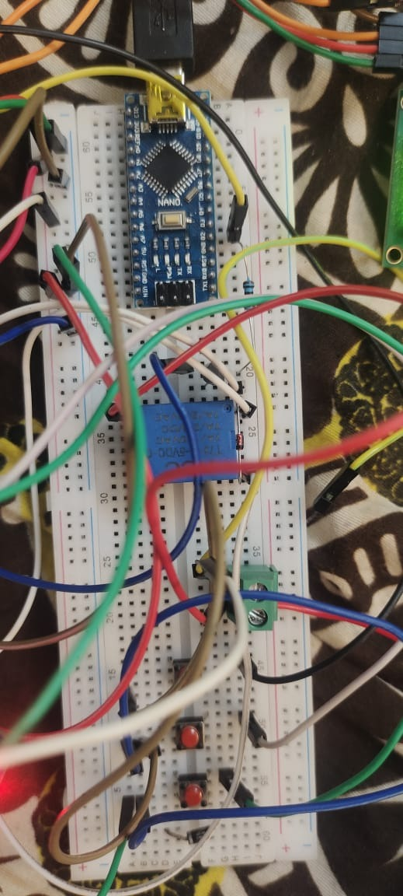

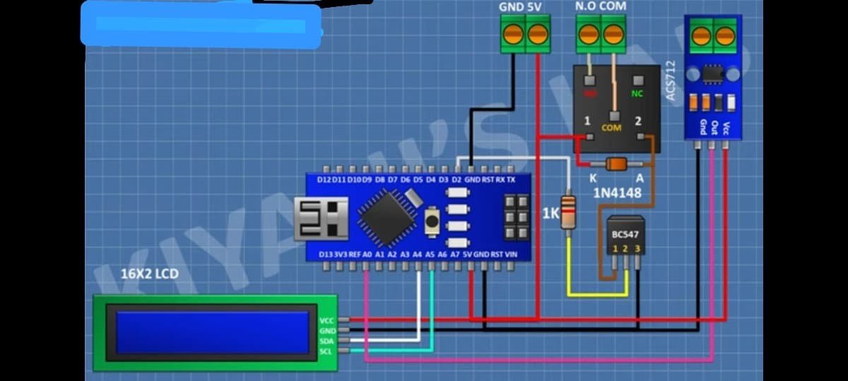

5. BLOCK DIAGRAM

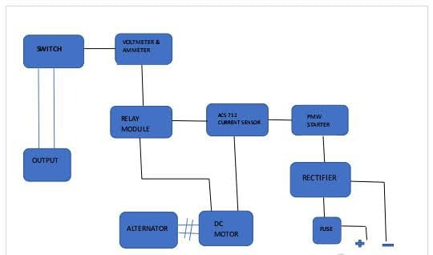

6. WORKING OF POWER SIMULATOR
Power station simulator is a device which protects the circuit against the overload and earth fault .
the power station simulator is provide protection against overload and earth fault to the system equipment .
it is necessary to protect the system from such fault . the power simulator avoids the occurance of faults within permissible time period as soon as possible .
this simulator that we made , it is a very economical and usefull device and it also easy to handle.
The device works automatically in faulty situation by using the aurdino in the system . it is efficient to avoid convenience and accidents & safety.
The single phase AC supply is given to the rectifier . the rectifier converts alternating current (AC) into direct current (DC).
The dc supply is given to the relay circuit , current sensor sense the current of motor and gives signal to the ardiuno and ardiuno gives signal to the relay module . when the load is high then motor will automatically trip. the current is higher than the actual current then the 16*2 LCD display shows current reading.

7. Advantages of simulator

- Improved system performance: By simulating power systems, engineers can identify potential issues and optimize system performance. This can lead to more efficient operation, reduced downtime, and improved reliability.

- Reduced cost and risk: Power simulators allow engineers to test different scenarios and strategies without the need for physical testing. This can save time and money while reducing the risk of accidents or failures.

- Enhanced safety: Power systems can be dangerous, and testing them in the real world can put workers at risk. By using a power simulator, engineers can test safety procedures and identify potential hazards without putting anyone in danger.

- Improved training: Power simulators can be used to train operators and engineers on how to respond to different scenarios. This can help ensure that personnel are prepared to handle emergencies and other unexpected events.

- Increased understanding: Power simulators provide a detailed understanding of how power systems work, which can help engineers design better systems and make more informed decisions.

8. Actual photo of simulator

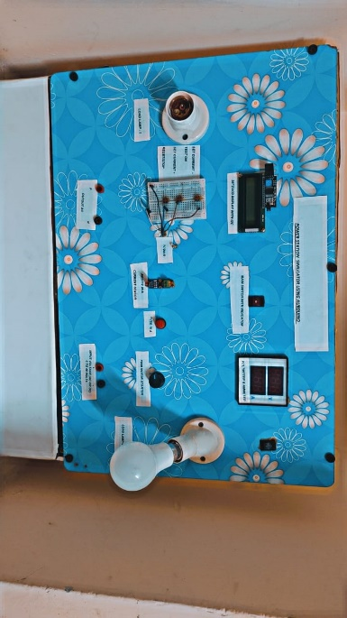

9. Conclusion & future scope

The power station simulator is provide protection against overload and earth fault to the system equipment .
it is necessary to protect the system from such fault . the power simulator avoids the occurance of faults within permissible time period as soon as possible .
this simulator that we made , it is a very economical and usefull device and it also easy to handle.
The device works automatically in faulty situation by using the aurdino in the system . it is efficient to avoid convenience and accidents & safety .

Results : the power station simulator required 10watt load to overload the simulator using ardiuno. The rated given to the circuit is 4.70 Ampere .


Rukmini Motkewar Pallavi Gajbhare

10. Reference

Thermoflow - https://www.thermoflow.com/products.htm (1987)
APROS - https://www.apros.fi/ (1989)
ProSimPlus - https://www.prosim.net/products/prosimplus (1990)
PowerWorld Simulator - https://www.powerworld.com/products/simulator (1996)
Kongsberg Digital SimGenics - https://www.kongsberg.com/digital/products-and-services/simulators/simgenics/ (2013)


P.B. Khedkar


Asmita Mahabale

