ARDINO BASED TRANSMISSION LINE EARTH FAULT DETECTION AND CONTROL

Lecturer: Vilas Sarwadnya, Author : Vishal Sadhu Wawle, Rushikesh Dashrath Dakhore, Pradip Vijay Rathod

ABSTRACT: In electricity journey the generation of transmission, distribution, utilization of electrical power is called electrical technology in power generation transmission and distribution many components are involved. So there are many types of electrical faults or faults like in transmission lines occurs in transmission system like line to line faults and line to ground fault in power system etc. In this project, I will show you the prototype of fault detection system. Mainly occurred in transmission line our project accurately detect the fault occur on ground fault from source system and display on control panel by using aurdino In this project we use sensing device which is present on the line even though ground unsymmetrical fault was occurred it will show on display. Aurdino is a heart of our project it will detects the fault, analysis and classifies these faults and Then, the fault information is shown on lcd display

INTRODUCTION
As we seen our surrounding the fault occurred in the transmission line is very common in rainy season and it is very dangerous for us. The electrical power system is growing in size and complexity in all sectors such as generation, transmission, distribution, distribution so in this complex network fault is happened which results in several economic losses and reduce reliability of electrical system. We take care to resolve this fault as soon as possible, if we failed to resolve this then it can cause complete black our or grid failure.
Generally the 70% to 90% of faults on overhead lines, most of the faults occurred due to lighting smiles, storm, flashover these is very harmful for the society. In transmission line this type of line to ground fault there are many types of faults. Due to faults power failure and also damage the electric equipment.

LITERATURE REVIEW
Manohar Singh: In this paper clarified to the Transmission line protection is very important thing in current scenario, because in power system 85 to 87% of power system faults are occurring in transmission lines. Classify the perfect technique, to detect the fault in transmission line to ground fault
Anurag D. Borkhade: Clam file to the proper detection of faults is cleared in transmission line is needful. In these paper detection and classification off sure these faults is done losed on the ware let analysis or power system translators. Wt has the ability to decompose current and voltage signal. In this method used ware let, which shows light signal, and provide more features.
Rajeev Valunjker 2017: Clarified that the paper aims to design auroredoser for three-phase system with data acquisition system that says this method is very handy to detect the fault on transmission lines. This system will reduce the human efforts off closing the circuit breaker. This pater shows the in such many solve the problems faced in transmission line and consumers bt using the method, we can easily detect the fault and resolve it and problem solved in real line very useful for the future

SOFTWARE AND HARDWARE PLATFORM
Hardware for the project:
Infrared sensor, power supply, 16/2
LED display, Arduino UNO Jumpers. 1. Microcontroller, Volt regulator, Rectifier ,Transformer, Lcd 16*2,Basic electronic components, Plywood,Mains scod,Switch board, Mosfet,Transmission pole, Rest,cap.diode, Relay module,Preset

Software for the project:
Arduino UNO (C Programming).

COMPONENT SELECTION

TRANSFORMER :-
The transformer is an electrical device which step up or step down the magnitude of voltage. The function of transformer in this project is to step down the 230volt AC supply into 12 Volt AC supply.

RECTIFIER :-

Single-phase circuits or multi-phase circuit comes under the rectifier circuits. For domestic applications single-phase low power rectifier circuits are used and industrial HVDC applications require single-phase rectification. The most important application of a PN junction diode is rectification and it is the process of converting AC to DC.

AURDINO UNO :-
aurdino In this project we use sensing device which is present on the line even though Ground was

occurred it will show on display. Aurdino is a heart of our project it will detects the fault, analyses and classifies these faults and Then, the fault information is shown on lcd display

16/2 LED display :-
The led display is used to get the readings. The use of led display in this project is to indicate the fault massage on the screen

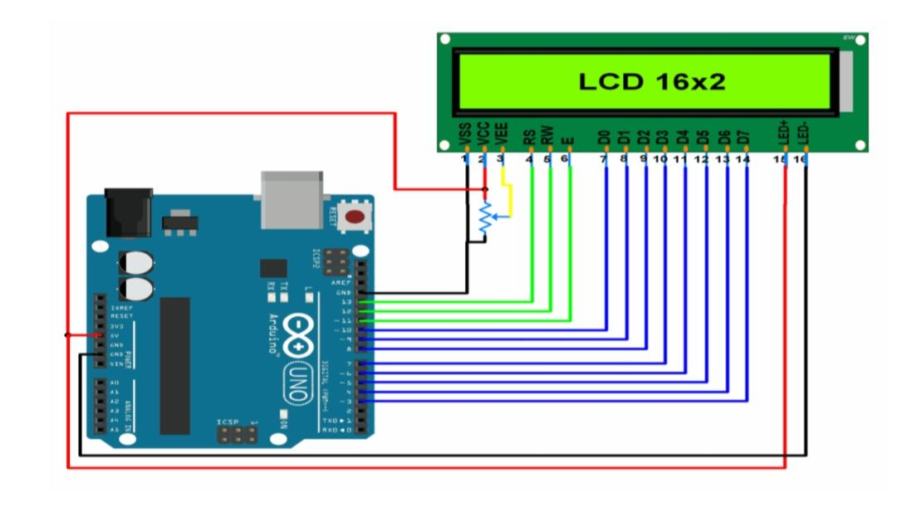
.

TECHNICAL APPRAISAL OF PROJECT

A . WORKING Methodology :-
This project contain ht line pole with phase and ground line demonstration.Using steap-down transformers and rectifiers, we can convert ac to step down dc. When switch is on dc power goes in voltage regulator ic though microcontroller and lcd.When any fault is create like phase to phase by using small dc transformer power supply, the relay can be operated according to the fault occur. Also the provide signals to microcontroller.The microcontroller can analyse signals and provide respective fault message to print on lcd display.If phase to Earth fault then lcd print phase to gnd fault message will print EARTH fault.

SPECIFICATION
1. Detect the exact fault phase to ground
2. Human efforts minimizes
3. Improve the system performance.

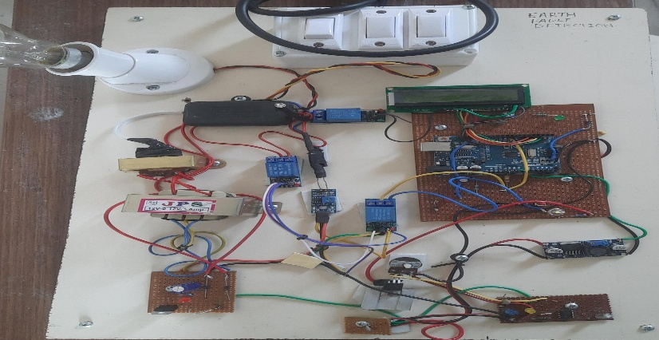

FIG.NO.3 CIRCUIT OF THE PROJECT

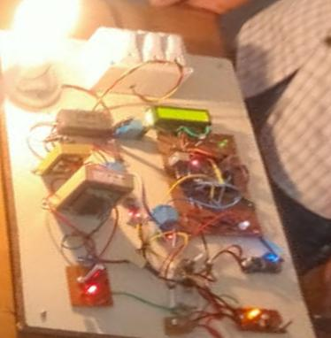

FIG NO 4. ACTUAL STEP OF THE PROJECT

RESULT
In this project, design is very reliable and effective. The main objective of these prototype model human efforts decreased. In addition, damage the electrical equipment. To ensure stability and reliability of power system is boost system is stronger and strong the economic growth.In addition, we find the exact phase to ground(EARTH fault)problem in the transmission line.

CONCLUSION
In this project, a model design and demonstrate phase and ground problem and to solve the problems faced by consumer with help of using Arduino. We can easily detect the type fault this prototype model is very effective. Avoid the future problem in transmission line problem..

REFERENCE
1) Fault Detection and Classification In Three Phase Transmission Line Using Signal Processing (Dr.D.Kavitha, May 2018)
2) Dhawale, Vishvadeep J., Vishal Dake, and Prafulla A. Desale. "Blocking the Distance Relay 3rd Zone Operation during Power Swings by DTLR Enhancement in MATLAB/Simulink." International Journal of Electronic and Electrical Engineering. Vol. 7. No. 7. International Research Publication House, 2014. 757-765.
3) Transmission and fault detection and classification (Manohar singh, Dr.B.k panigrahi, Dr.R.P Maheshwari, Member I EEE)
4)Transmission line fault detection using wavelet transform (Anurag.D.Borkhade, Assistant Professor)
5) Aurdino based autorecloser for three phase AC system(Rajeev valunjkr 2017)
6) Aurdino based underground and overhead cable fault detection (Aditya sharma , Himanshu sharma, Md Irfhan Ahmed Nov 2017).

Future Scope
The future implications of the project are very great considering the amount of
Time and resources it saves. The project we have undertaken can be used as a
Reference or as a base for realizing a protection scheme to be implemented in other
Transmission lines of higher level. Also the current system can be made to work
With conventional SCADA or other Communication Services like GSM to
Operate remotely.
