Cryptocurrency Trading Bot
Hussain Amreliwala¹, Aashna Chauhan², Omkar Pawar³, Yash Wadhekar⁴, Anuradha Kapoor⁵
¹Student at Department of Information Technology Atharva College Of Engineering Mumbai, Maharashtra
²Student at Department of Information Technology Atharva College Of Engineering Mumbai, Maharashtra
³Student at Department of Information Technology Atharva College Of Engineering Mumbai, Maharashtra
⁴Student at Department of Information Technology Atharva College Of Engineering Mumbai, Maharashtra
⁵Professor at Department of Information Technology Atharva College Of Engineering Mumbai, Maharashtra

---------------------------------------------------------------------***---------------------------------------------------------------------
Abstract - Cryptocurrencies and its trading have grown in popularity in recent years, with millions of crypto investors and traders exchanging crypto in a profitable and seamless manner. Various advantages are providing over traditional manual trading by crypto bots, one such is automated trading. This project attempts to address these concerns by creating an automated cli cryptocurrency bot that uses the Binance API and implementing mean reversion algorithm by calculating SMA30 and SMA90 of the cryptocurrency to produce buy and sell signals and trade effectively. By automating the trading process with the Binance API, the proposed Crypto Trading Bot project aims to enhance the way cryptocurrency traders operate. It will automate trades based on established or custom parameters. Traders will be able to explore the project's user-friendly command-line interface. The project's cli will enable traders to see various indicators, backtest strategies, and buy and sell automatically by integrating with binance api. This project provides a tool for traders looking to simplify their operations and maximize their profits in the highly competitive and dynamic world of cryptocurrency trading. The Crypto Trading Bot project is a distinct profitable solution for bitcoin traders. It is an extremely useful tool for cryptocurrency traders.

Key Words: Binance, Cryptocurrency, Mean Reversion, SMA30, SMA90

1.INTRODUCTION

Over the past few years, cryptocurrencies have become the latest investment and money management craze. An industry once reserved for trading stocks or other traditional market segments has seen competition in the up-and-coming crypto market, where Bitcoin is the biggest store of wealth. This leads to high volatility for wealth generation. Hundreds of different cryptocurrencies are currently traded. This project is an automated cli based crypto bot that connects to the binance api and is designed to monitor, analyse and execute transactions in various cryptocurrencies using a mean reversion algorithm. Mean-reversion strategies [5] work on the assumption that there is an underlying stable trend in the price of an asset and prices fluctuate randomly around this trend . Therefore, values deviating far from the trend will tend to reverse direction and revert back to the trend. That is, if the value is unusually high, we expect it to go back down and if it is unusually low, go back up.
With the increasing number of cryptocurrencies and the volatility of the markets, trading has become more complex and difficult to navigate. Most traders trade in crypto currencies in a traditional manner.

Given the extreme volatility of the crypto market, a crypto trading bot can help beginners and advanced traders manage risk more easily, while providing flexibility and discipline in trading. Automated crypto trading bots can also remove human error from the equation and trade the crypto market flawlessly faster than anyone else. This project has the potential to effectively eliminate the complexity and confusion associated with trading different strategies and potentially increase the chances of booking profit by utilizing various opportunities.

2. PROBLEM STATEMENT

Given the fact that the crypto market is a 24/7 global market, it makes it next to impossible for the traders to diversify risks, track market swings, decrease mistakes, and maintain trading discipline 24 hours a day. Human emotions [2] are usually one of the biggest obstacles to a successful trading. Markets are sometimes irrational and do not follow the expected path. Usually, our greed takes over and we lose investments and don't book the profits when we should take it. To remove the human variable, we need to automate trading by creating applications that trade on our behalf in a more intelligent manner. Market shifts can often happen quickly and unexpectedly. The average trader will not be able to process information regarding what is currently happening in the markets until the shift has started to or already happened. The crypto bot will process huge amounts of information much faster and accurately respond to sudden shifts in a quick manner. Analyzing huge amounts of historical data of a coin traditionally would be difficult.

3. MOTIVATION
Cryptocurrency and crypto trading have grown in popularity in recent years, with millions of individuals investing in digital assets such as Bitcoin, Ethereum, and others throughout the world. In fact, in 2023, the total market value of cryptocurrencies is around $1 trillion [6]. With such a big and continuously expanding industry, there is a high need for tools that can assist investors in making educated decisions and maximizing earnings.
This is where a crypto bot comes in: an automated trading program that can analyse market movements, anticipate future trends, and execute transactions on the user's behalf.

Crypto bots offer significant benefits over traditional manual trading, including the capacity to run continuously without human involvement, handle massive volumes of data rapidly and correctly, and execute deals at breakneck rates. The idea of creating an algorithm that would trade on its own and perform well is interesting both personally and professionally [3]. The advantages have spurred us to create and an application that helps crypto investors and traders to trade crypto in profitable and efficient hassle-free manner.

4. SCOPE OF PROJECT

The project aims to develop a cli based crypto bot that will be connected with Binance API, written in Python, and uses the mean reversion algorithm for trading. The bot will analyze both live and historical data of various cryptocurrencies available on the Binance exchange to identify potential trading opportunities. It will execute trades automatically when specific threshold conditions are met based on the mean reversion algorithm, which may include factors such as price trends, trading volume, and technical indicators. The primary objectives of the crypto bot are to automate trade and increase profitability, reduce risks associated with cryptocurrencies. The bot will operate 24/7, without the need for human intervention, to take advantage of market opportunities as they arise.

5. METHODOLOGY
Python:
Python is a high-level, interpreted, interactive and object-oriented scripting language. Python is designed to be highly readable. It uses English keywords frequently whereas other languages use punctuation, and it has fewer syntactic constructions than other languages. Python is a MUST for students and working professionals to become a great Software Engineer specially when they are working in Web Development Domain. I will list down some of the key advantages of learning Python:
- Python is Interpreted − Python is processed at runtime by the interpreter. You do not need to compile your program before executing it. This is similar to PERL and PHP.
- Python is Interactive − You can actually sit at a Python prompt and interact with the interpreter directly to write your programs.
- Python is Object-Oriented − Python supports Object-Oriented style or technique of programming that encapsulates code within objects.

Binance Client:
Binance offers a REST API that developers may use to incorporate trading and account management functions into their apps. The Binance API allows developers to connect with their account details, make and cancel orders, receive market statistics and account balances, and more via both authenticated and unauthenticated API calls. To access the Binance API, developers must first register a Binance account and get an API key and secret. The API key and secret are used to authenticate API calls and must be kept private to maintain the user's account's security.

Binance has a WebSocket API in addition to the REST API, allowing applications to get real-time updates on market data and account information. The WebSocket API is perfect for real-time data applications such as trading bots, charting apps, and more.

6. PROPOSED SYSTEM
The proposed system for the Crypto Bot is divided into three parts:
1. signal generator 2.risk allocation 3.execution

Signal Generator: The first stage involves using signal generation where the bot applies a mean reversion algorithm to determine probable buy and sell signals The bot analyses signals that are generated based on historical price data of the cryptocurrency being traded, and analyse these signals to estimate the likely direction of the price movement based on SMA30 and SMA90.

Risk Allocation: Once the signals have been generated, the bot advances to the risk allocation stage. In this stage, the bot determines the ideal size of the position depending on the user's specified parameters such as minimum price change, buy threshold, sell threshold, and portfolio size. This helps to control risk and limit losses in the event of an unfortunate market change.

Execution: Finally, the bot performs trades based on the generated signals and risk allocation calculations. To execute trades automatically, the bot connects to the Binance API using the API key and secret key. The execution step guarantees that transactions are done fast and effectively depending on the signals and the risk that has been allocated.

7. USE CASE DIAGRAM
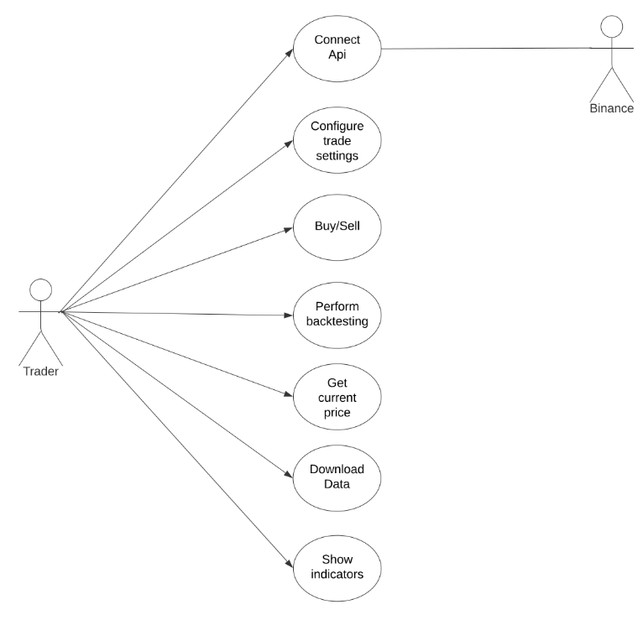
Fig -1: Illustrates Use-Case Diagram for Our Crypto Bot System

- The use case diagram in Fig-1 shows the different interactions and functions that can be performed by the users of the crypto bot. The two main actors in the diagram are the user, binance api.
- The user can perform several actions, including connecting with api configuring personal trade settings, buy sell various crypto coins, perform backtesting, get current price of coin, download historical data such as closing opening price, high and low, volume etc, see various indicators such as bollinger bands, moving average.
- The binance api provides data to the bot which the bot uses to compare and send signal. Overall, the use case diagram illustrates the functionality and user interactions of Crypto Trading Bot.

8. ARCHITECTURE OF SYSTEM

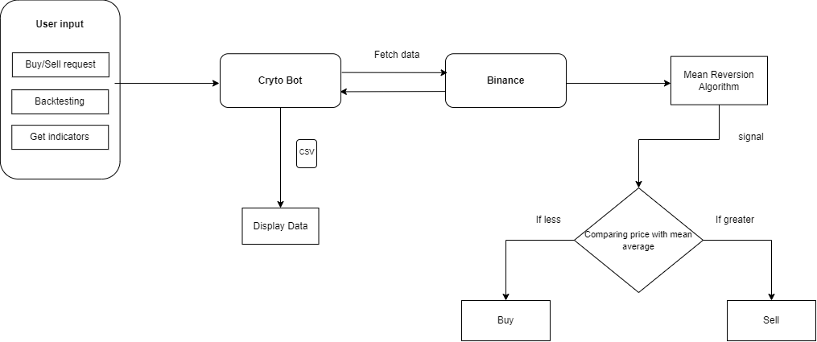
Fig -2: Proposed Architecture Design of System Bot

In our architectural design, shows the overall working of the bot. We are first establishing connection of bot with the binance api through user api and secret keys. Once the connection is established and wallet is connected the user can select from the menu driven various options such as buy/sell currency, perform backtest for testing strategy, get indicators such as moving average. When the user enters the input choice for buy/sell the bot fetches live data price of coin and historic data and takes user settings into consideration. The bot allows users to set specific parameters as per their parameters.

Mean reversion algorithm is then applied based on historic data and user parameters. The bot then checks if the price is less than the mean average it generates buy signals and once bot has bought crypto and checks if price is greater than the mean and then it will generate a sell signal and the bot will sell it. When the user selects the get indicators it displays various types of indicators such as bollinger, stochastic and moving average. The historical price data of opening closing prices, volume of currency is stored and displayed in a csv file.

9. IMPLEMENTATION
Binance API Key Generation: The first step is to generate a Binance API key that will allow you to connect with the Binance API. The API key and secret were safely saved in a file.

To interface with the Binance API and do backtesting, libraries like as python-binance, pandas, and numpy must be installed.

In Python code, a mean reversion algorithm based on the SMA30 and SMA90 is defined. The algorithm sells when the price is higher than the mean and buys when the price is lower than the mean.

Backtesting: The algorithm was evaluated using past Binance data. The python-binance package was used to access historical data, and pandas was used to generate SMA30 and SMA90 values.

Graphs: Matplotlib and plotly were used to construct graphs of the SMA30, SMA90, moving average, and the price of the crypto asset.

The Binance API was utilized to access live pricing data as well as historical data such as open prices, closing prices, and volume. For further examination, the data was saved in a CSV file.

CLI Interface: To allow users to communicate with the trading bot, a command-line interface was developed. For the SMA30 and SMA90 computations, users enter criteria such as the crypto asset to trade, the amount to invest, and the period, buy threshold, sell threshold, minimum price change

10. ADAVANTAGES
- Continuous operation: The crypto bot can operate continuously, evaluating market data and automatically executing trades. This improves efficiency while stripping the need for human monitoring and trading.

- Speed: The bot can process massive volumes of data in seconds and perform trades. This is especially useful in a market where prices fluctuate rapidly.

- Accuracy: This project is programmed to execute trades based on established or custom parameters and follow a certain trading strategy. This eliminates the possibility of human mistake and can lead to more accurate trading.

- Backtesting: Backtesting may be done utilizing historical data, allowing for algorithm efficiency and the detection of possible flaws.

- Trading without emotion: The bot can execute trades without being affected by emotions like fear, greed, or panic. This can assist traders in avoiding emotional decisions.

- A crypto bot may work 24 hours a day, seven days a week, allowing traders to capitalize on chances in marketplaces that operate in different time zones.

- Reduced burden: A cryptocurrency bot can assist traders minimize their workload by automating monotonous chores like monitoring market conditions and performing trades.

11. RESULTS
The crypto bot has been able to conduct successful trades using mean reversion algorithm, as seen by the graph supplied, demonstrating that the algorithm has been effective in detecting profitable trading opportunities.
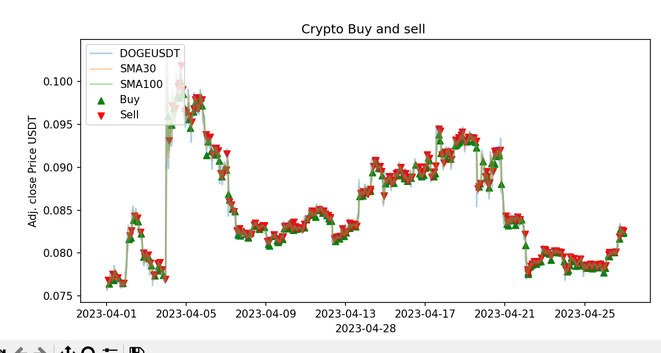
Fig -3: Shows Buy and Sell by The Bot Using Mean Reversion

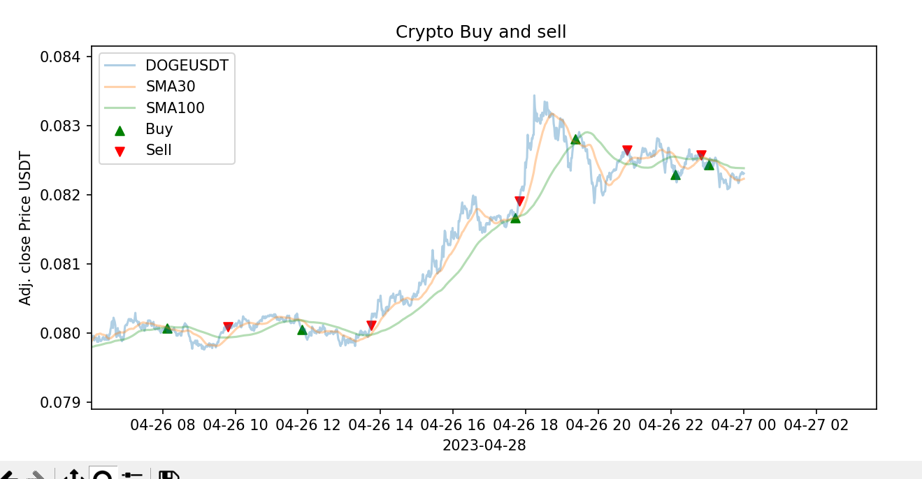
Fig -4: Shows Buy and Sell by The Bot for Doge Coin

12. CONCLUSIONS

The Crypto Trading Bot project is an innovative and beneficial solution for cryptocurrency traders wanting to automate their trading. The project employs the mean reversion strategy to automate cryptocurrency trading on the Binance platform. It also has tools for backtesting and data analysis, as well as the option to download data in CSV format. The initiative has an impact on the bitcoin trading business as it gives traders with a strong tool to capitalize on market swings and execute deals swiftly and precisely. It also assists traders in reducing human errors and emotions, which improves overall trading success. There are still aspects that can be improved. For example, the project might be enhanced by integrating more technical indicators and trading techniques to provide traders more alternatives and flexibility. Furthermore, enhanced graphical user interfaces and user experiences, as well as more comprehensive testing and debugging, might boost the project's accuracy and reliability. Overall, the Crypto Trading Bot project is a valuable tool for bitcoin traders.

13. FUTURE SCOPE
The Crypto Trading Bot project has a lot of potential for growth and development in the future. Integration with several exchanges is one possible future scope for the project, which would considerably increase the product's value for traders. Extending the project's capabilities to incorporate additional prominent exchanges like Coinbase or Kraken would provide traders more alternatives and trading chances. Another area for development is the incorporation of a database to hold trade data for better analysis and decision-making. In addition, implementing microservices and hosting the product on the cloud-based platform would boost accessibility and scalability. Traders would be able to get notifications and alerts on their mobile devices if a Telegram bot was integrated. Furthermore, moving beyond mean reversion tactics and including machine learning algorithms like as sentiment analysis or neural networks might increase the bot's accuracy and effectiveness. Finally, allowing users to customize their preferred strategy depending on their preferences and trading styles will increase the project's flexibility and user satisfaction tremendously. By constantly enhancing the project's features and capabilities, it has the potential to become an invaluable tool for crypto traders wishing to automate their trading.

ACKNOWLEDGEMENT

We are very thankful to Hon. Shri Sunil Rane sir for his constant motivation. We are grateful to our Director Dr. P.N. Nemade sir and Principal Dr. Ramesh Kulkarni sir for their guidance and cooperation. We are also thankful to our VPs & HOD Deepali Maste ma’am and guide Prof Anuradha Kapoor ma’am for their constant support.

REFERENCES

- Medha M, Sahil M, Satyam M, Vanita M: 2021 Algorithmic Trading Bot In: ITM Web of Conferences 40, 03041 (2021) ICACC-2021

- Aisha P, Sau L Ang, Chia Y: 2021 Automated Cryptocurrency Trading Bot implementing DRL In: Pertanika J. Sci. & Technol. 30 (4): 2683 - 2705 (2022)

- Krishnamurthy: 2018 Mean Reversion + Beta-Zero Targeting In: https://papers.ssrn.com/sol3/papers.cfm?abstract_id=3124271

- Madhu B R; Harshavardhan P; Madhumathi M; Y Achyuth Reddy; Nikitha Chowdary K: 2019 Algorithmic Trading Using Mean Reversion Indicators In: IJCSMC, Vol. 8, Issue. 6, June 2019, pg.7 – 13

- Mean Reversion Algorithm: https://medium.com/auquan/mean-reversion-simple-trading-strategies-part-1-a18a87c1196a

- Market Cap in 2023: https://www.coingecko.com/research/publications/total-crypto-market-cap

