RESEARCH PAPER
TOPIC - Cyndesi - All in one OTT Platform

BAISAKHI Maam (baisakhi_2015@cms.ac.in)
SHALYA ACCAMMA Maam (accamma_cg@cms.ac.in)

TEAM MEMBERS -
JAYANT KUNDALIYA (jayant_kundaliya2021@cms.ac.in)
V DARSHAN SAJJAN (darshan_sajjan2021@cms.ac.in)
VARUN RAMESH (varun_ramesh2021@cms.ac.in)
SHOURYA CHARAN (shourya_charan2021@cms.ac.in)
MOHAMMED NAVEED (mohanmmed_naveed2021@cms.ac.in)

Cyndesi - All in one OTT Platform
Abstract
OTT (Over the Top) platforms have seen a meteoric rise in users over the past decade and more so due to the pandemic. There have been several new OTT platforms established to help consumers choose their favourite series, movies or services and this brings a problem of choice to consumers. Many consumers feel that subscribing to many platforms and loyalty programs are a hassle as each may have different amounts and will be renewed on different dates. Cyndesi is an all in one platform that manages subscriptions in one roof and helps making subscribing to various platforms/programmes an hassle free experience.
Keywords - OTT (Over the Top) Platforms, Loyalty Programmes, Consumer Spending on OTT, Demographics on OTT
Introduction
Overview
A brief history about OTT platforms - Over the top services have been in India since 2008, the first Indian OTT platform was BIGFlix, it was launched by Reliance Entertainment. Over the top gained significant change in India after Ditto TV and Sony Liv were launched in the Indian market around 2013.
Currently India has around 45 OTT services, the most popular being Netflix, Amazon Prime, Sony LIV, Zee5 and Voot offering monthly and yearly subscription services at an average price of Rs,299 to Rs.499 per month.
On the topic of subscriptions, we have seen a rise of subscriptions among apps like Swiggy and Zomato too, both have their own premium memberships that offer free delivery, extra discounts and restaurant offers.
Cyndesi is an all in one subscription platform where we combine all the services and offer different packages at a rate that is affordable to the masses. An example of one of our package, the starter package offers three OTT platform subscriptions and two Online Food Delivery Platform subscriptions, all the subscriptions when taken individually will cost at an approximate Rs.1711 per month, whereas when taken through Cyndesi, the individual can get all these subscriptions and loyalty programmes for Rs.999 per month.

Formulation of the Problem
The problem we found out when doing the questionnaire is that the majority of our sample is ready to switch platforms if they find the same content or benefit from a subscription that costs less than what they are currently paying.
There are a lot of OTT platforms and loyalty programmes which bring the problem of choice to subscribers, the following are the three main problems we experienced when using subscriptions.
1. Individual subscriptions cost a lot, they are attractive when looked at from an individual subscription standpoint while the average consumer uses more than one OTT platform which adds the cost to well over a thousand Indian rupees.
2. Hassle in remembering subscription dates, we take subscriptions as and when we like and when we have more than one active subscription, we are bound to forget one or two that may renew and we are stuck paying the monthly fee without having any interest of using it.
3. We have seen many security related issues that crop up when dealing with individual subscriptions, some service providers have data leak which are potentially harmful to subscribers as it leaves their data out to prying hands and can harm the subscribers mentally or physically.
Objectives of the Study
Main motto of the study was to explore how likely would potential customers be willing to switch to an all in one platform that offers customised packages based on their budgetary or content requirements that is offered at a discount.
The secondary objectives of the study are
1. To discover how many platforms and loyalty programmes are used by individuals among various age groups.
2. To understand the current market situation over the usage of the subscriptions by the individuals who are currently working in offline mode.
3. To learn about the amount of funds an individual sets aside each month for their online content and loyalty program needs.
Review of Literature
According to the research conducted by epra journals (www.eprajournals.com) the world's future of entertainment consumption is evolving quickly, which has caused an unexpected rise in internet streaming video services in India. Although India has taken a longer time to get ott services, with evolving 5G data networks and many technological advancements, it definitely made these ott services all across everywhere and made it very cheaper.
Ms. Kaneenika Jain who is a assistant Professor at S.S. Jain Subodh Management Institute has told that there has been a drastic change in all over India and about 1.3 billion of India's population are using many online services everyday, it holds a rank above the USA in the market for ott. The main ott’s in India are Prime Video, Hotstar, Netflix, Youtube, etc.
Just to give you a quick rundown of how the major players in the market typically operate, we have Netflix, Amazon, Alt Balaji and YouTube. Netflix mainly shows the huge budget movies and shows, Prime video releases the films of its own production, whereas hotstar focuses on sports channels and US shows. Netflix has been rapidly expanding its regional library and adding independent regional films to target a very specific demographic.
The report given by Redseer says that the India holds a rank amongst ten, but China has a subscriptions of around 500 million, which holds the top rank among ott market globally. In India, the users showed a very good interest in binge videos, there was rise about 20% in India in ott market as the big firms like Prime Video and Netlix, etc, has took a big step towards expanding the market into a huge industry, It made the youth very attracted to ott’s, some of the platform’s like Amazon gives a discount for youth generation(50% discount for persons between 18-25) which has brought a large numbers of youths dragged into market. India also took 2nd place in video audience, overtaking US and Brazil, despite the fact that the country’s streaming ecosystem is still in its infancy.
Internet accessibility, connection speed, government digitization initiatives, and the proliferation of smartphones in all areas which make up around 40% and 60% of India respectively, restrain the number of subscriptions in that country. India's urban population watches over four hours of television every day, compared to three hours, thirty minutes for those living in rural areas.
According to Inc42.com, there are 95 OTT platforms in India right now for streaming audio, video, music, and podcasts. Since early March 2020, Indian users' average time spent on OTT platforms has climbed by 40–60%. The rapid increase of Smartphones and wifi television has led to an increase in OTT video content consumption both inside and outside the home.
Secondary data from several studies in India revealed varying findings, although Netflix, Hotstar, Prime and Zee5 emerged as the pioneers of the industry. Out of 280 respondents, the primary data in this study showed that, in order, Amazon Prime Video (38%), Netflix (29%), Voot (4%), and JioCinema (1%) were the top video streaming services.
The sample used in this study was somewhat tiny in comparison to the whole of the people who have an entry to ott platforms, therefore larger samples could be used in future studies. It would be encouraging to topic specifically devoted to internet difficulties, including speed of the internet and lag problems in the future. These issues could not be addressed within the parameters of this study. Several more supporting elements, including pricing strategy, licences, telecom tie-ups, and technological breakthroughs, can be seen from various angles.
The development of industries like online apps, entertainment, etc. has been greatly impacted by awareness of and usage of technology. Improved connection to people could have more options available, the devices and the ease of watching the content how much time they want and whatever they want makes it very inexpensive and the educational entertainment, Localised Content and Less Breaks and Ads Content Customization.

EFFECT OF COVID-19 -
As a result of the pandemic, many ott’s have seen a considerable boost in terms of more numbers of interested users. As a result, they are seeking to satisfy viewers' increased thirst for amusement. The average time spent by a person has increased by 40 minutes.
An average of 17,000 memberships are being added to digital services every day since some of them announced that they would be under lockdown. All of these platforms have agreed to switch from high (1080p) to standard (480p).
Five factors, including content and viewing habits, service fees, modifications brought on by incentives or offers, convenience, and connection, are proposed by empirical findings and discussion to have an impact on consumers' entertainment choices. Logistic regression supported the power of these factors, which made convenience, service pricing, and viewing preferences the three most important factors.
Low competitive prices, developing quality, creating unique, localising, adaptability in changes, and encouraging sales are examples of resilient OTT techniques. After these actions were taken, customers' OTT usage went from being sporadic to being frequent.
It also uncovered the diverse OTT experiences of customers which also brought in few operators, and raised rivalry. Notwithstanding this knowledge, it is uncertain how subscription-based OTT platforms leveraged consumer behaviour data, new usage habits, and resilience-building techniques during the pandemic. It created a new lifestyle among people.
These lean and agile OTT players are being adopted at an ever-increasing rate thanks to technological advancements like smartphones, extreme wifi service, ease of apps and tailored services brought a shift towards their "freemium" type . Although they use the network and equipment of telecom operators, demanding ongoing capital expenditure, the gain for the companies does not happen only through the services but also the data charges. The mobile data or wifi which we pay goes directly as a profit to them.They will be tied up with companies for these services, they provide and are starting to pose a real and quantifiable threat to their revenue is, however, what the telcos find most concerning.
The result of telecom companies' messaging and call profit is greatly considered to be growing. With relation to their effect on data, telecoms' revenue have recognised significant considerations to consider. Our study seeks to connect these things to changes in attitude and realise essential components thereof that any effort to adjust to the dynamic environment which has foundations in recognising what is the root of drifting a customers to increase the profit.
By combining offerings, we can make using OTT services less alluring due to the potential for financial savings. In text chat services, for instance, attempting to collect a sum of money from customers in the form of a fixed fee for the message before charging data based on actual consumption. Hence, operators can increase their revenue and lessen the threat of OTT services by bundling a mobile data pack with a messaging subscription at a reasonable fee. But, for a certain length of time, this would only assist the operator maintain a certain amount of client loyalty.
Content bundling is another creative technique for an operator to entice customers to use data or mb driving apps (Prime video) by packaging them by standard call or voice plans. This will lead to greater internet use. This improves the quality by removing the fear factor that prevents customers from subscribing to an extra service by using a restricted usage by time or by rather than data billing.
In the United States, 53% of Wi-Fi connected households utilise at least one over-the-top streaming service, with Netflix being the most popular option.
Although 75% of these households choose Netflix as their top option, there is a substantial number of competitors knocking on Netflix's door. YouTube has a 53% range, Amazon has a 33% range, and Hulu has a 17% range.
India has become a emerging market as it is growing rapidly in ott services. It could overtake many countries and can hold a 6th rank having a rise of 25% by 2025.
RESEARCH GAP
Identified that many people have more than 3 OTT Platform and loyalty programme subscriptions while there aren’t many services around that provide all in one roof, Cyndesi will be able to bridge this gap and offer an all in one platform for subscriptions across top OTT Platforms and loyalty programmes.

RESEARCH METHODOLOGY
RESEARCH OBJECTIVES
Since more people use these services to access digital content and services, subscription-based applications have grown in popularity in recent years. These programs provide users with an easy way to get a range of goods and services at a consistent, recurring price. But, subscription-based applications must satisfy the expectations of their users and offer a superior user experience to compete in this cutthroat industry. As a result, there are a number of research goals that can assist companies in creating successful subscription-based services.
1. Recognizing client requirements and preferences
Understanding the demands and preferences of the users of subscription-based services is one of the most crucial research goals. For this, it might be necessary to do market research to analyse what features users value most, what they are ready to pay for, and what they are looking for in a subscription-based program. This study can assist companies in creating goods and services that satisfy client demands and set them apart from the competition.
2. Assessing the acquisition and retention of customers
Customers must be attracted and kept for subscription-based applications to succeed. As a result, researching customer acquisition and retention tactics to ascertain the most efficient strategies for bringing in new subscribers and keeping existing ones may be a research goal for these applications. Businesses can enhance client retention rates and establish effective marketing strategies with the aid of the research.
3. Analysing price structures
For subscription-based apps, price is crucial, and various pricing structures can be applied. Choosing the best pricing strategy for a particular application can be difficult, though. Examining various pricing strategies and identifying the variables that affect customers' willingness to pay, such as price, value proposition, and competition, could be a research goal for subscription-based services. This study can assist companies in creating price plans that successfully draw in and keep clients.
4. User experience evaluation
The success of subscription-based applications depends on the user experience. Customers may cancel their subscriptions if they find the application frustrating or difficult to use. As a result, research objectives for subscription-based services may be analysing the user experience, identifying areas for improvement, and figuring out how the user experience influences client retention. This research can assist companies in creating applications that are simple to use and offer a top-notch user experience.

SCOPE OF STUDY -
- Reviewing customer feedback
Customers' opinions are a valuable source of data for companies creating subscription-based products. Businesses can learn what their users like and hate about the application by examining customer feedback, and they can utilize this knowledge to guide product development and raise customer happiness. Analysis of user input and use of it to enhance the service and boost client retention may be a research goal for subscription-based applications.
- Market trends evaluation
Businesses should keep abreast of the most recent trends and advancements because the market for subscription-based applications is always changing. Finding market trends and comprehending how they can affect subscription-based apps, such as alterations in consumer behaviour or upcoming technology, maybe a research goal for such applications. This study can assist companies in staying ahead of the curve and creating appealing and relevant applications for their intended users.
- A competitive advantage's identification
Firms must recognize their competitive advantages because the market for subscription-based applications is quite competitive. Finding competitive advantages, such as special features, pricing structures, or customer service, and figuring out how they affect customer acquisition and retention, could be a study goal for subscription-based apps. This study can assist companies in creating powerful marketing plans that set them apart from the competition.
- Understanding the impact of external factors
Subscription-based apps may be significantly impacted by outside variables like the state of the economy or changes in regulatory requirements. Understanding how external influences may affect subscription-based applications and creating measures to counteract any potential negative consequences may be research goals for these applications. This study can assist companies in creating efficient backup plans.

RESEARCH APPROACH
Several research approaches can be used to study subscription-based applications. The appropriate approach will be based on the research objectives, the resources, and the nature of the application studied. Below are some possible research approaches:
1.Surveys and Questionnaires
One approach is to use surveys and questionnaires to collect data from a large number of users. This can provide quantitative data on customer preferences, satisfaction, and other factors. Surveys can be administered online or through mobile apps and can be used to collect data on pricing, user experience, features, and other relevant information.
2.User Testing and Observation
Another approach is to conduct user testing and observation to gain insights into how users interact with the application. This approach involves observing users as they perform tasks within the application and collecting data on their behaviour and feedback. User testing can be conducted in a laboratory setting or the user’s natural environment and can provide valuable qualitative data on the user experience.
3.Interviews and Focus Groups
Interviews and focus groups are other approaches to gathering qualitative data on user needs, preferences, and behaviour. These methods involve conducting structured or semi-structured interviews or group discussions with users or potential users of the application. Interviews can be conducted in person or over the phone, while focus groups typically involve a group of users or potential users discussing their experiences and opinions.
4.Secondary Data Analysis
Secondary data analysis involves analysing existing data sources such as social media, reviews, or customer feedback to gain insights into user behaviour and preferences. This approach can provide a cost-effective way to gather data, especially when the application has a large user base or a long history of customer feedback.
5.A/B Testing
A/B testing involves randomly dividing users into two or more groups and providing each group with a different version of the application. This approach allows researchers to compare the effectiveness of different features or designs in a controlled environment. A/B testing can provide valuable data on user behaviour, preferences, and willingness to pay.
6.Case Studies
Case studies involve in-depth analysis of a single subscription-based application or a group of applications. This approach can provide detailed insights into the application’s business model, pricing strategy, user acquisition and retention strategies, and other factors. Case studies can be conducted using a variety of data sources, including interviews with the company’s management team, financial statements, and user feedback.
QUANTITATIVE METHOD
Subscription-based apps and quantitative research methods are related because quantitative research methods are commonly used to study subscription-based apps. Subscription-based apps are a type of business model where users pay a recurring fee to access the app's features or content. To ensure the success of a subscription-based app, it is essential to understand user behaviour and preferences, pricing strategies, and other factors that can impact user acquisition and retention.
Quantitative research methods are used to gather numerical data on user behaviour, preferences, and attitudes. These methods allow researchers to analyse data using statistical techniques to identify patterns and trends in user behaviour. By using quantitative research methods, researchers can gather insights into how users interact with subscription-based apps, which features are most important to them, and what pricing strategies are most effective.
For example, surveys and questionnaires can be used to collect data on user satisfaction, pricing preferences, and other relevant factors. This data can be analyzed using statistical techniques to identify trends in user behavior and preferences. Usage data analysis can be used to track how users interact with the app and identify which features are most commonly used. A/B testing can be used to compare different versions of the app to determine which version is most effective.
Overall, subscription-based apps and quantitative research methods are closely related because quantitative research methods are essential for studying subscription-based apps and understanding user behaviour and preferences. By using these research methods, app developers can make data-driven decisions that can lead to better user experiences and higher user retention rates.
RESEARCH QUESTIONS

- Is there a significant need for an all in one service that motivates users to retain and add to more subscriptions towards OTT platforms?
- Does usage of many OTT platforms and loyalty programs affect the retention rate of customers?
- What are the factors that determine the spending of customers towards OTT platforms and loyalty programs?

QUESTIONNAIRE
Name
Email
Your answer
Age
Your answer
How many OTT Platforms do you use?
Your answer
How much does it cost to subscribe to all those OTT Platforms?
Under Rs. 1000
Under Rs. 1500
Under Rs. 2000.
Do you use any loyalty programs from Swiggy or Zomato?
Yes
No
Would a discount at the overall price on all the subscriptions promote you to switch platforms?
Yes
No
How often do you use these platforms monthly?
3-4 Days a month
10-15 Days a month
25 Days a month
DATA ANALYSIS AND INTERPRETATION
AGE FACTOR OF THE TARGET MARKET?



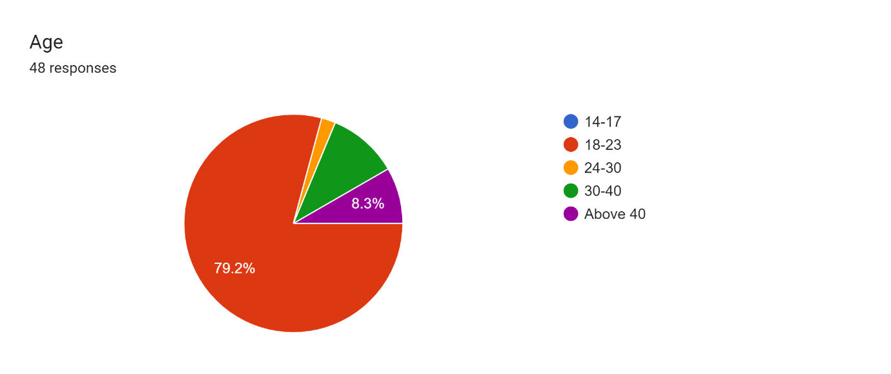
INTERPRETATION- The subscription model is more famous in the 18-23 age group as compared to other age group as this age group is more likely to try new products and software than others.
LIKENESS OF SUCH MODELS?
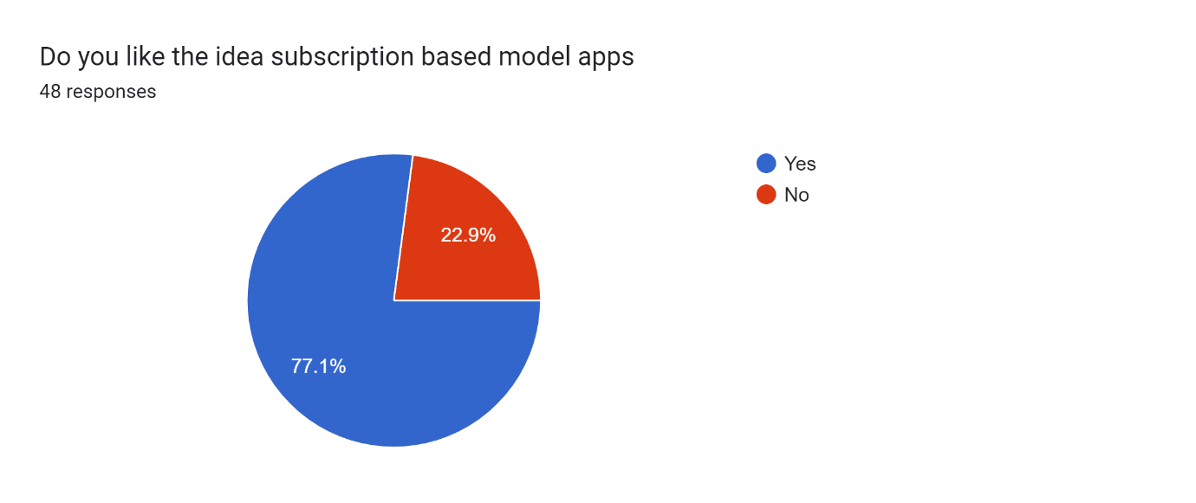
INTERPRETATION- People want to use these models and their experience till date has been good.

POPULARIZATION OF INDUSTRY IN THIS MODEL?
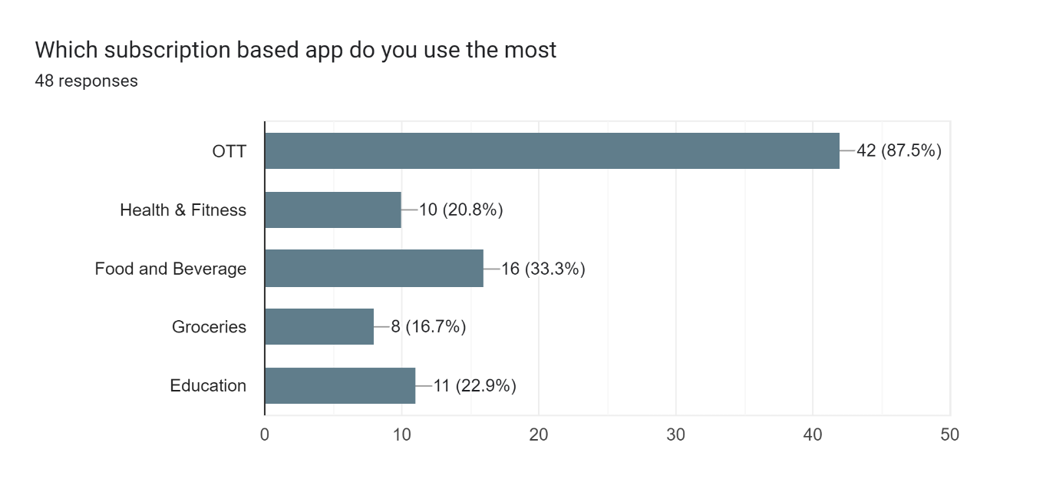
INTERPRETATION- The pandemic had given the model a big booster and due to which the entertainment industry OR OTT platforms have outshined due to the awaited movies released in the OTT platforms.
SUBSCRIPTION PLATFORMS USED BY AN INDIVIDUAL?
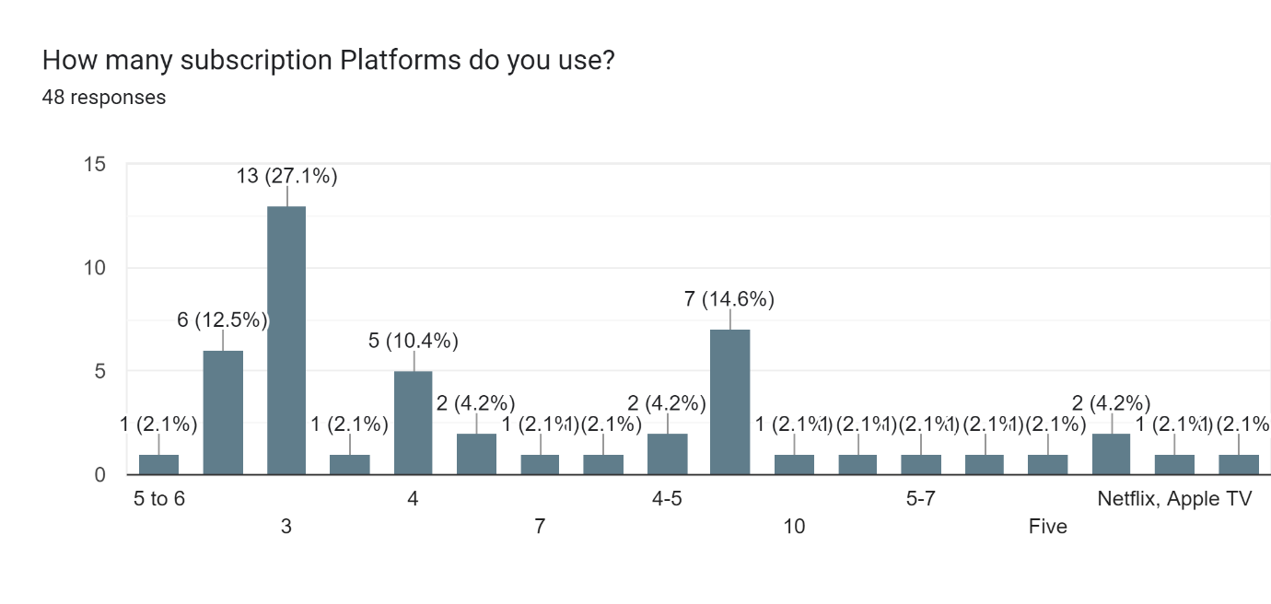
INTERPRETATION- As the increase in industry using this subscription model people are also using them that is the reason people are using more then a dozen of applications.
PRICE FACTOR?
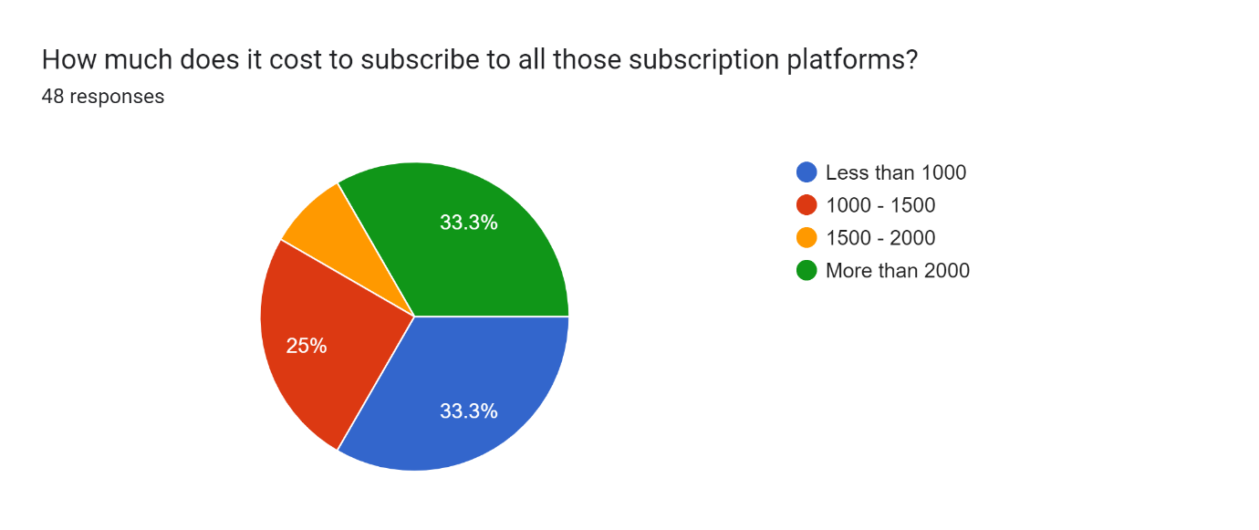
INTERPRETATION- As the increase in industry using this subscription model people are also using them that is the reason people are using more then a dozen of applications. Due to which the amount is also high.

WILL OUR INITIATIVE BE ACCEPTABLE IN THE MARKET?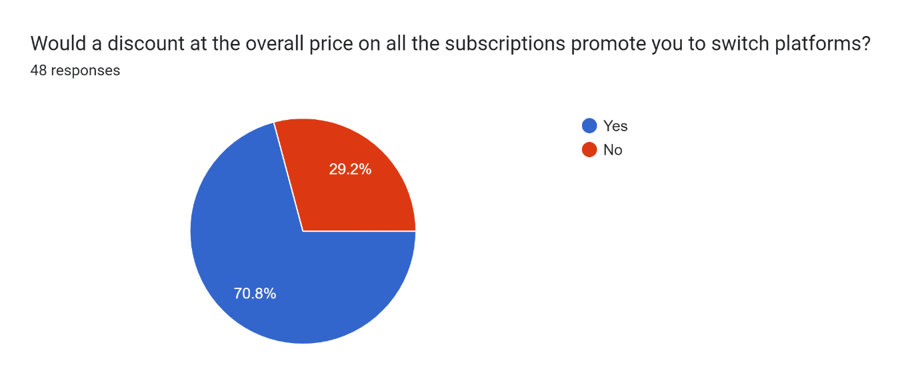
INTERPRETATION- As the increase in industry using this subscription model people are also using them that is the reason people are using more then a dozen of applications. This is the selling proposition of our application.
MOST SELLING PLAN?
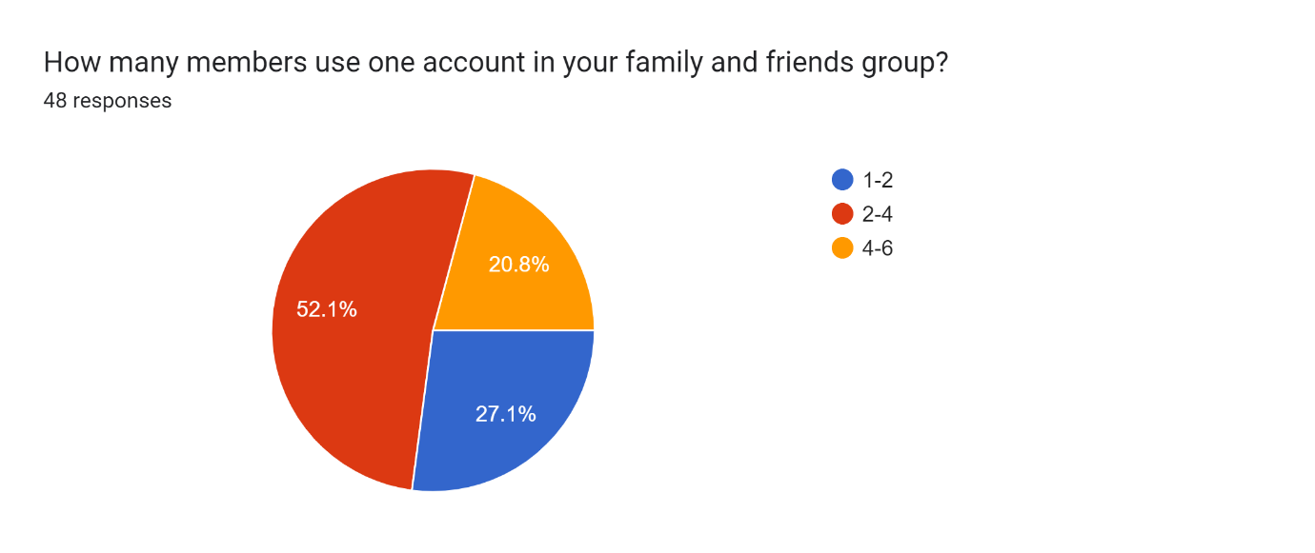
INTERPRETATION- As the increase of nuclear family we can see why there is a demand of 2-4 group based brochure.

TIME SPENT BY USERS?
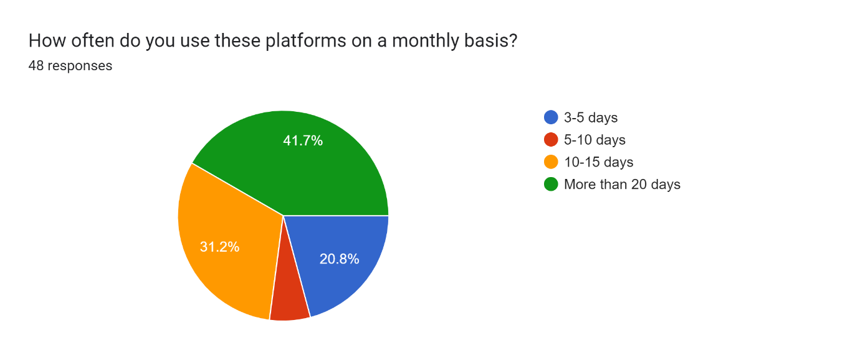
INTERPRETATION- This is the great factor for us to give us the confidence in being at the right industry and model.

Summary and Conclusion -
The study paper comes to the conclusion that the user-friendliness and content richness of OTT platforms are important elements in their use and promotion. For people, price sensitivity is important. The platform is stronger than usual due to cost effect. Users become more aware of costs thanks to it, which promotes the platform. Individuals find closure on the OTT platform when they are living comfortably and are satisfied with their own lives. Everything is made possible with mobile phones thanks to programmes with individual control over time, place, and length. As we give the platform which could provide all the ott’s , it could be attracted very much to young generations and because of the cheaper price, everyone would like to buy these kind of subscription. This platform is simple to use with a mobile device. It increases an individual's overall control. At the moment, this younger generation is the one who uses mobile phones the most. Hence, a variety of psychological factors may have an impact on OTT consumption. Future research might compare the generation and their propensity for using OTT platforms. Also that there is a relatively higher demand for Netflix. exposure to global trends and material, in addition to other factors that affect platform audiences.

References -
Primary data - The data was collected by questionnaires, we got around 45 responses, it was through online mode(google forms).
Secondary data -
Bilbil, E. T. (2018). Methodology for the regulation of Over-the-top (OTT) Services: The need of a multi-dimensional perspective. International Journal of Economics and Financial Issues, 8(1), 101.
Chakraborty, D., Siddiqui, M., Siddiqui, A., Paul, J., Dash, G., & Dal Mas, F. (2023). Watching is valuable: Consumer views–Content consumption on OTT platforms. Journal of Retailing and Consumer Services, 70, 103148.
Charbonnier, D., Ott, P., Jonsson, M., Cottier, F., & Ko¨ bke, T. (2009, January). Experimental and numerical study of the thermal performance of a film cooled turbine platform. In Turbo Expo: Power for Land, Sea, and Air (Vol. 48845, pp. 1027-1038).
Chatterjee, M., & Pal, S. (2020). Globalization propelled technology often ends up in its microlocalization: Cinema viewing in the time of OTT. Global Media Journal: Indian Edition, 12(1).
Chen, H. H. (2016, June). Platform strategies perspective on the OTT messaging services: A case study of WeChat and Line. In annual conference of International Telecommunication Society, Taipei, Taiwan.
Dhiman, D. (2023). A Critical Analysis of Vulgar Language on OTT Platforms: A Systematic Review. A Critical Analysis of Vulgar Language on OTT Platforms: A Systematic Review (March 28, 2023).
Fadrosh, D. W., Ma, B., Gajer, P., Sengamalay, N., Ott, S., Brotman, R. M., & Ravel, J. (2014). An improved dual-indexing approach for multiplexed 16S rRNA gene sequencing on the Illumina MiSeq platform. Microbiome, 2(1), 1-7.
Gangwar, V. P., Sudhagoni, V. S., Adepu, N., & Bellamkonda, S. T. (2020). Profiles and Preferences of OTT users in Indian Perspective. European Journal of Molecular & Clinical Medicine, 7(8), 5106-5142.
Gupta, G., & Singharia, K. (2021). Consumption of OTT media streaming in COVID-19 lockdown: Insights from PLS analysis. Vision, 25(1), 36-46.
Gupta, P. (2021). The factors effecting shift of Indian customers from TV series to web series-the future of OTT services in India. EPRA International Journal of Multidisciplinary Research (IJMR).
Ghalawat, S., Yadav, E., Kumar, M., Kumari, N., Goyal, M., Girdhar, A., & Agarwal, S. (2021). Factors influencing consumer’s choice of streaming over the top (OTT) platforms. Indian Journal of Extension Education, 57(3), 99-101.
Kour, G., & Chhabria, B. (2022). Understanding platform strategies for consumer stickiness on OTT platforms. Journal of Indian Business Research, (ahead-of-print).
Habib, S., Hamadneh, N. N., & Hassan, A. (2022). The Relationship between Digital Marketing, Customer Engagement, and Purchase Intention via OTT Platforms. Journal of Mathematics, 2022.
Haas, B. J., Papanicolaou, A., Yassour, M., Grabherr, M., Blood, P. D., Bowden, J., ... & Regev, A. (2013). De novo transcript sequence reconstruction from RNA-seq using the Trinity platform for reference generation and analysis. Nature protocols, 8(8), 1494-1512.
Holm, J. B., Humphrys, M. S., Robinson, C. K., Settles, M. L., Ott, S., Fu, L., ... & Ravel, J. (2019). Ultrahigh-throughput multiplexing and sequencing of> 500-base-pair amplicon regions on the Illumina HiSeq 2500 platform. MSystems, 4(1), e00029-19.
Jaiswal, S. N., & More, N. S. (2022). OTT Platforms-its future scope and regulation in india.
Jain, M. (2021). The Rise of OTT Platform: Changing Consumer Preferences. EPRA International Journal of Multidisciplinary Research (IJMR), 7(6), 257-261.
Johnson, B. A., Bhunia, A., Fei, H., Cohen, S. M., & Ott, S. (2018). Development of a UiO-type thin film electrocatalysis platform with redox-active linkers. Journal of the American Chemical Society, 140(8), 2985-2994.
Kim, J., Kim, S., & Nam, C. (2016). Competitive dynamics in the Korean video platform market: Traditional pay TV platforms vs. OTT platforms. Telematics and Informatics, 33(2), 711-721.
Koul, S., Ambekar, S. S., & Hudnurkar, M. (2021). Determination and ranking of factors that are important in selecting an over-the-top video platform service among millennial consumers. International Journal of Innovation Science, 13(1), 53-66.
Kumari, T. (2020). A study on growth of over the top (OTT) video services in India. International Journal of Latest Research in Humanities and Social Science (IJLRHSS), 3(9), 68-73.
Lobato, R., & Sarkar, P. (2019). The OTT TV box as a diasporic media platform. Media Industries Journal, 6(2).
Madnani, D., Fernandes, S., & Madnani, N. (2020). Analysing the impact of COVID-19 on over-the-top media platforms in India. International Journal of Pervasive Computing and Communications, 16(5), 457-475.
Malewar, S., & Bajaj, S. (2020). Acceptance of OTT video streaming platforms in India during covid-19: Extending UTAUT2 with content availability. Journal of Content, Community and Communication, 12, 89-106.Moochhala, Q. (2018). The future of online OTT entertainment services in India. Actionesque Consulting, Pune–India.
Menon, D. (2022). Purchase and continuation intentions of over-the-top (OTT) video streaming platform subscriptions: a uses and gratification theory perspective. Telematics and Informatics Reports, 5, 100006.
Nisal, K. S. (2021). The Convergence Model and Content Regulation of OTT Platforms In India: An Analytical Study. Sanshodhan, 10(1), 36-41.
Ohata, K., & Ott, H. C. (2020). Human-scale lung regeneration based on decellularized matrix scaffolds as a biologic platform. Surgery today, 50, 633-643.
Park, S., & Kwon, Y. (2019). Research on the Relationship between the Growth of OTT Service Market and the Change in the Structure of the Pay-TV Market.
Park, E. A. (2019). Prevalence of business models in global OTT video services: A cluster analysis. International Journal on Media Management, 21(3-4), 177-192.
Pandey, A., & Nair, H. (2023). Perception of New Information Technology Rules Towards OTT Platforms. Journal of Communication and Management, 2(01), 27-32.
Patel, M. K., Khadia, R., & Awasya, G. (2020). A Study: OTT Viewership in “Lockdown” and Viewer’s Dynamic Watching Experience. International Journal on Transformations of Media, Journalism & Mass Communication, 5(2), 10-22.
Patnaik, R., Shah, R., & More, U. (2021). Rise of OTT platforms: effect of the C-19 pandemic. PalArch's Journal of Archaeology of Egypt/Egyptology, 18(7), 2277-2287.
Patnaik, R., Patra, S. K., Mahapatra, D. M., & Baral, S. K. (2022). Adoption and Challenges Underlying OTT Platform in India during Pandemic: A Critical Study of Socio-Economic and Technological Issues. FIIB Business Review, 23197145221101676.
Palomba, A. (2022). Building OTT brand loyalty and brand equity: Impact of original series on OTT services. Telematics and Informatics, 66, 101733.
Periaiya, S., & Nandukrishna, A. T. (2023). What Drives User Stickiness and Satisfaction in OTT Video Streaming Platforms? A Mixed-Method Exploration. International Journal of Human–Computer Interaction, 1-17.
Rahul, M., & DineshBabu, S. (2021). A comparative study on ott platform censorship and policies in india. Annals of the Romanian Society for Cell Biology, 25(6), 11160-11167.
Revati Devaki, P. C., & Babu, S. D. (2021). The future of over-the-Top platforms after covid-19 pandemic. Annals of the Romanian Society for Cell Biology, 25(6), 11307-11313.
Parikh, N. (2020). The emergence of OTT platforms during the pandemic and its future scope.
Pitkänen, M., Kärkkäinen, T., Ott, J., Conti, M., Passarella, A., Giordano, S., ... & Spyropoulos, T. (2012). SCAMPI: Service platform for social aware mobile and pervasive computing. ACM SIGCOMM Computer Communication Review, 42(4), 503-508.
Prasad, S. S. (2022). Impact of OTT media on the society: insights from path analysis. Asia-Pacific Journal of Business Administration, 14(2), 185-198.
Sadana, M., & Sharma, D. (2021). How over-the-top (OTT) platforms engage young consumers over traditional pay television service? An analysis of changing consumer preferences and gamification. Young Consumers.
Sahu, G., Gaur, L., & Singh, G. (2021). Applying niche and gratification theory approach to examine the users' indulgence towards over-the-top platforms and conventional TV. Telematics and Informatics, 65, 101713.
Saini, N. (2020). Usage of OTT platforms during COVID-19 lockdown: trends, rationale and implications. PalArch's Journal of Archaeology of Egypt/Egyptology, 17(6), 4212-4222.
Saquib, M., Khalique, A., & Hussain, I. (2022). A study of recommendation system on OTT platform and determining similarity and likeliness among users for recommendation of movies. In Proceedings of Data Analytics and Management: ICDAM 2021, Volume 2 (pp. 537-546). Springer Singapore.
Sharma, K., & Lulandala, E. E. (2023). OTT platforms resilience to COVID-19–a study of business strategies and consumer media consumption in India. International Journal of Organizational Analysis, 31(1), 63-90.
Sundaravel, E., & Elangovan, N. (2020). Emergence and future of Over-the-top (OTT) video services in India: an analytical research. International Journal of Business, Management and Social Research, 8(2), 489-499.
TS, S., & Sumathy, M. (2021). User Perception Towards OTT Video Streaming Platforms in Kerala (With Special Reference to Thrissur). Analytical Commerce and Economics, 2(4), 27-32.
Tapias, L. F., & Ott, H. C. (2014). Decellularized scaffolds as a platform for bioengineered organs. Current opinion in organ transplantation, 19(2), 145.
Varghese, S., & Chinnaiah, S. (2021). Is OTT industry a disruption to movie theatre industry?. Academy of Marketing Studies Journal, 25(2), 1-12.
Wang, S. H., & Jung, Y. (2022). Influential Factors in Domestic OTT Platforms’ Choice of Foreign Content in South Korea. International Journal on Media Management, 24(4), 224-250.
1.http://bestmediainfo.com/2018/08/india-will-go-the-china-way-in-ottconsumption-
2. sudhanshu-vats-managing-director-viacom18/
3. http://bwpeople.businessworld.in/article/Entertainment-the-future-ofemployment-
4. How-emerging-digital-and-OTT-platforms-are-generating-more-jobs/05-09-
2018-159267/
5.https://www.pwc.in/industries/entertainment-and-media/global-entertainment-andmedia-
6. Times of India – http://timesofindia.indiatimes.com/articleshow/64488591.cms
7. Journal DOI URL: https://doi.org/10.36713/epra2013
8. Sundaravel, E. & N., Elangovan. (2020). Emergence and future of Over-the-top (OTT) video services in India. 8. 489-499.10.18801/ijbmsr.080220.50.
9. Rise of On-demand Content (2015), Report by Deloitte, www.deloitte.com/in
10. The Digital First Journey(2017), Report by KPMG, www.KPMG.com/in
11. Grewal D. and Levy M. (2017) Marketing, McGraw Hill Education, Chennai, fifth edition

Reference books -
1. Bradley N. (2010) Marketing Research – Tools & techniques, 2nd edition, Oxford Publishing
2. Mehta N. (2015) Behind a billion Screens – What Television tells us about Modern India, Harper Collins
3. Strangelove M. (2015) Post-TV Piracy, Cord-Cutting & the future of television, University of Toronto Press
4. Wolk A (2015) Over The Top – How the Internet is slowly but surely changing the television industry, Createspace Independent Pub

