DESIGN AND IMPLEMENTATION
OF A BIONIC ORNITHOPTER
Mr.D.MurugesanM.E.,Santhosh.R,Susiragul.R,Umashankar.N,Vishal.M

ABSTRACT
This project shows the flight simulation of flapping-wing air vehicles (ornithopters) based on a refined flapping-wing aerodynamic model; the modified strip theory (MST). Compared with conventional types of micro air vehicles (MAVs), flapping MAVs show more complicated flight behaviors due to their complex wing motions and aerodynamics. In this project, a flight dynamic model of an ornithopter is presented to analyze its stability and controllability. This project focuses on the stabilization and path-following control of the ornithopter by adjusting the flapping frequency and tail-wing’s elevation angle. In spite of its nonlinear and complex behavior, controlling the tail-wing pitch angle can be effective for the stabilization in longitudinal motion of the ornithopter. Ornithopter is one of UAV which utilizing bird flying concept as flight mechanism. This research begins with ornithopter design mechanism, mechanical, electrical and control design followed by manufacturing process. Kinematic and experimental analysis is used to obtain data from the ornithopter. The main purpose of this project is to design a spy device “Ornithopter”, which resembles a bird and helps in bringing a particular area under surveillance. This device (as it resembles a bird) can be used to survey an area without alerting the environment under survey. This reduces the involvement of human resources in risky fields such as survey of forest areas, national border surveillance etc.

KEYWORDS
Flapping Wings; Ornithopter, bio-inspired, flight simulation, wing flexibility

INTRODUCTION
As the potential missions of unmanned air vehicles (UAV) are increasing in both military and civilian purposes, a considerable number of studies have been reported on the micro air vehicles (MAVs) over the past few decades. Especially, a sort of MAVs driven by flapping wing is inspired by flying creatures: birds and insects. The flapping-wing flight inherently produces very complex aerodynamic forces so that their motions are highly nonlinear and difficult to be modeled and controlled. It is necessary to establish feasible stabilization and control strategy to develop a practical ornithopter system. Earlier studies on the control for flapping-wing flight mostly have adopted somewhat crude aerodynamic models, typically in the forms of force coefficients as function of angle of attack, obtained from experimental observation or simply assuming linear relationships between the force coefficients and the angle of attack. On the other hand, recent CFD-based models require too much computational resources, appearing not suitable for flight dynamics modeling and control. Therefore, it is necessary to establish an effective and reliable aerodynamic model to develop more systematic design and control processes of the flapping-wing vehicle. This study formulates an improved numerical dynamic model for the flight simulation of an ornithopter based on a refined aerodynamic model. Compared with fixed wing type MAVs, there are more parameters to be specified such as flapping frequencies, flapping angles, and dynamic pitch angles or wing deformations. We investigated the effects of these parameters on the stability and controllability of the ornithopter. Finally, some flight dynamics simulation results for ornithopters are presented.

PROPOSED METHOD
In this project, wing kinematics is used and further flight dynamics will also be used. Also, three channel transmitter and receiver is designed. In contrast to any fixed-wing aircraft, it is generally not desirable to include flight-derived and validated models in terms of aerodynamic derivatives by reason of high nonlinearity and partial discontinuity near stall condition. Instead the flight dynamics in an instant deal with resultant forces, moments, and the system response such as velocity, angular rate, and the attitude of the vehicle at that moment. In this model, the center of gravity is not placed on a specific point of the body due to the flapping motion. The relative position of center of gravity to the specific body point is computed directly from the instantaneous 16 mass distribution. Due to the wing motion the center of gravity is oscillating from the body’s point of view and the moment of inertia is being changed even in level flight trim condition. Then the coordinate of each mass is calculated with respect to the instant center of gravity position. The translational motion of center of gravity represents that of the whole vehicle. The angular rate is determined by the resultant moment about center of gravity.

The ornithopter mechanism is designed such that the wings move up and down and produce flapping along the wing chord due to the wing's elasticity. That means the structural elasticity along the chord direction is an important factor. Several other parts of the device are made firstly. The body parts of the ornithopter are printed using a 3D printer individually, and finally they are integrated together to form the finalized model which will resemble roughly like the image given below.Our project comprises of the modelling of the device, developing the transmitter and receiver for the ornithopter and making sure there are no possible errors while controlling the system. Circuit diagrams of the transmitter and receiver are given as follows. Detailed CAD designs are also as given below. The CAD designs are made for the parts of the ornithopter. First part is main frame which purpose as base where all the part adheres. Second part is gearbox design consist of brushless motor, pinion gear, reduction gear, gear couple, crank gear, crank, base 1, base 2 with right crank and left crank. Third and fourth part is ornithopter wing design and the last part is tail design. The diagram reveals CAD design for each part in more detail drawing.
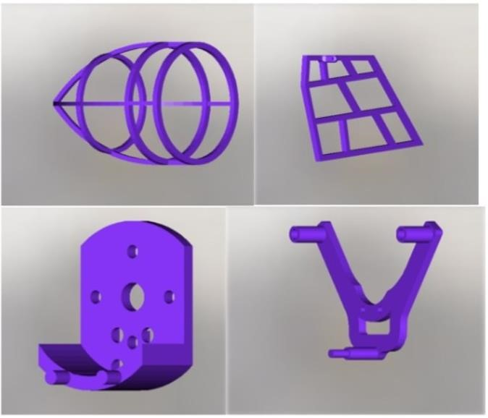

3D MODEL
3D printable models may be created with a computer-aided design (CAD) package, via a 3D scanner, or by a plain digital camera and photogrammetry software. 3D printed models created with CAD result in relatively fewer errors than other methods. Errors in 3D printable models can be identified and corrected before printing. The manual modeling process of preparing geometric data for 3D computer graphics is similar to plastic arts such as sculpting. 3D scanning is a process of collecting digital data on the shape and appearance of a real object, creating a digital model based on it. CAD models can be saved in the stereolithography file format (STL), a de facto CAD file format for additive manufacturing that stores data based on triangulations of the surface of CAD models. STL is not tailored for additive manufacturing because it generates large file sizes of topology optimized parts and lattice structures due to the large number of surfaces involved. A newer CAD file format, the Additive Manufacturing File format (AMF) was introduced in 2011 to solve this problem.
It stores information using curved triangulations.

3D PRINTING
Before printing a 3D model from an STL file, it must first be
examined for errors. Most CAD applications produce errors in output STL files, of the following types:
- Holes
- Faces normals
- Self-intersections
- Noise shells
A step in the STL generation known as "repair" fixes such problems in the original model. Generally STLs that have been produced from a model obtained through 3D scanning often have more of these errors as 3D scanning is often achieved by point to point acquisition/mapping. 3D reconstruction often includes errors. Once completed, the STL file needs to be processed by a piece of software called a "slicer", which converts the model into a series of thin layers and produces a G-code file containing instructions tailored to a specific type of 3D printer (FDM printers). This G-code file can then be printed with 3D printing client software (which loads the G-code, and uses it to instruct the 3D printer during the 3D printing process). Printer resolution describes layer thickness and
X–Y resolution in dots per inch (dpi) or micrometers (μm). Typical layer thickness is around 100 μm (250 DPI), although some machines can print layers as thin as 16 μm (1,600 DPI). X–Y resolution is comparable to that of laser printers. The particles (3D dots) are around 50 to 100 μm (510 to 250 DPI) in diameter.[citation needed] For that printer resolution, specifying a mesh resolution of 0.01–0.03 mm and a chord length ≤ 0.016 mm generates an optimal STL output file for a given model input file. Specifying higher resolution results in larger files without increase in print quality. Construction of a model with contemporary methods can take anywhere from several hours to several days, depending on the method used and the size and complexity of the model. Additive systems can typically reduce this time to a few hours, although it varies widely depending on the type of machine used and the size and number of models being produced simultaneously.

PRINTER REQUIREMENTS AND SETTINGS
PLA is a material that generally prints better in lower temperatures, in contrast to most other filaments, and is a great candidate for printing with an open build chamber. In some cases, operators printing PLA on printers with enclosed chambers may find benefit in allowing heat to escape from the chamber. A controlled-chamber is preferred for best success. PLA generally exhibits low thermal shrinkage, as well. While the ranges may not vary greatly from brand of material to another, operators should always check for the suggested printing parameters, provided by the material manufacturer. The machine manufacturer can also be a great resource for processing knowledge.

Extruder temperature | 190° - 230° C
Bed temperature | 50° - 70° C
Printing speed | 40 – 60 mm/s
Heated chamber | Not required

BLOCK DIAGRAM
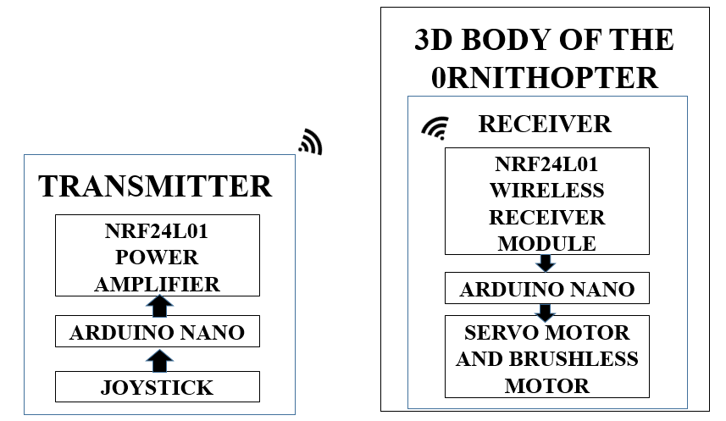

LIFTING FORCE CALCULATION

Length of the wing = 28 cm
Breadth of the wing = 14 cm
Considering the wing as a right angled triangle,
Surface area of the wing (S) = $\frac{1}{2}(b X h)$
= $\frac{1}{2}(28 X 14)$
=196 ${cm}^{2}$ or 0.0196 $m^{2}$
Wing load = $\frac{W}{S}= \frac{9.81}{0.0196}=500.51 ≃500 N/m^{2}$
Wing loading equation : $\frac{W}{S}=0.38 V^{2}$
Velocity (V) = $\sqrt{\frac{W}{S X 0.38}}$ = $\sqrt{\frac{500}{0.38}}$ = 36.27 m/s
Lifting force ${(F}_{L})=\frac{1}{2}C_{L}ρV^{2}$S
Density of air ($ρ$)= 1.225 kg/$m^{3}$
$C_{L}$ = 1.2
$$F_{L}=\frac{1}{2} X 1.2 X 1.225 X {36.27}^{2}X 0.0196$$
$F_{L}=$ 18.951 N

CONCLUSION

The ornithopter was designed from the ground up with the needs of research in mind. All components have been designed to be as lightweight and high performance as possible so as to maximize payload capacity and are intended to fail in predicable and field repairable ways. Manual and initial autonomous flight tests have been conducted and show that the ornithopter is capable of sustained flight with a full load of electronics and can be stabilized by simple controllers in common use in aircraft. The complete design compromises of mixtures of new and existed ideas collaborated together to provide a cost effective and optimized solution.

REFERENCES
- R. Zufferey et al., "Design of the high-payload flapping wing robot E-flap", IEEE Robot. Automat. Lett, vol. 6, no. 2, pp. 3097-3104, Apr, 2021.
- J. Rodríguez-Gómez et al., "The GRIFFIN perception dataset: Bridging the gap between flapping-wing flight and robotic perception", IEEE Robot. Automat. Lett., vol. 6, no. 2, pp. 1066-1073, Apr. 2021.
- F. Maldonado, J. Acosta, J. Tormo-Barbero, P. Grau, M. Guzm and A. Ollero, "Adaptive nonlinear control for perching of a bioinspired ornithopter", Proc. IEEE/RSJ Int. Conf. Intell. Robot. Syst., pp. 1385-1390, 2020.
- A. G. Eguíluz, J. P. Rodríguez-Gómez, J. Paneque, P. Grau, J. R. Martinez De-Dios and A. Ollero, "Towards flapping wing robot visual perception: Opportunities and challenges", Proc. IEEE Int. Workshop Res. Educ. Develop. UAS, pp. 335-343, 2019.
- A. Suarez, M. Perez, G. Heredia and A. Ollero, "Small-scale compliant dual arm with tail for winged aerial robots", 2019 IEEE/RSJ International Conference on Intelligent Robots and Systems (IROS), pp. 208-214, 2019.

