DISSERTATION REPORT
ON
PERFORMANCE MANAGEMENT OF SELF HELP GROUP WITH REFERNCE TO KUDUMBASHREE NGO UNIT.


SUBMITTED BY
PREETI DIXIT
Enrolment no. - GH-8223

In partial fulfilment of dissertation for the award of the degree of
MASTER’S OF BUSINESS ADMINISTRATION
ALIGARH MUSLIM UNIVERSITY, MALAPPURAM CENTRE

ABSTRACT

THIS STUDY EXPLORES THE PERFORMANCE MANAGEMENT OF KUDUMBASHREE AND ITS IMPACT ON WOMEN EMPOWERMENT IN KERALA. KUDUMBASHREE IS A PRACTICAL MODEL FOR STRENGTHENING THE SELF HELP GROUP (SHG) BASED POVERTY ALLEVIATION PROGRAMME.
India is one of the newly industrialised economies in the world, but the growth factor is unevenly distributed. Hence inclusive growth of India comes through the financial inclusion. To attain this objective, the Government is initiating various programmes. There are various microfinance institutions, Self Help Groups playing very important role in this regard. The Kudumbashree programme was initiated by Government of Kerala in 1998. The slogan of the mission is “Reaching out to families through women and reaching out to community through families”. The concept was developed by NABARD and Government of Kerala through joint initiative as a poverty eradication programme, women empowerment and rural development.
Kudumbashree now became benchmark for all other self-help groups in India. Though its efforts to engage women in civil society in development issues and opportunities, Kudumbashree in association with the local self-government of Kerala is charting out new meaning and possibilities for local economic development and citizen centric governance. The present study is a descriptive in nature based on survey method. Convenience sampling technique is used to collect data. 100 samples are collected through a structured questionnaire from members of Kudumbashree unit at ERNAKULUM PANCHAYAT BLOCK AND PERITHALMANNA. Data were analysed through simple statistical methods like percentage and chi-square technique . So, economic development of women leads to development of entire community. Based on the findings of the study some factors can be considered for effective performance of Kudumbashree units.
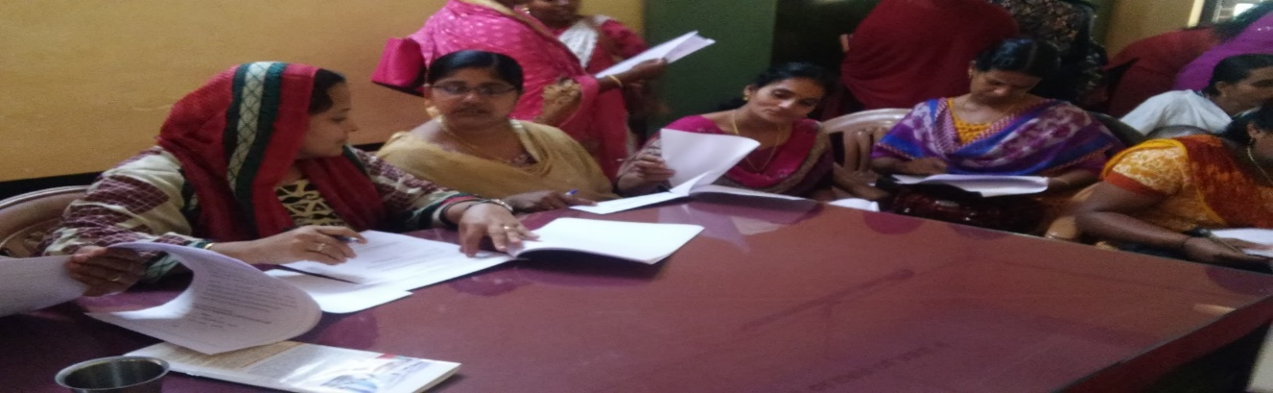
(THIS PICTURE REPRESENT GLIMPSES OF RESPONDENTS WHILE CONDUCTING SURVEY)
Acknowledgement

I bow to the almighty, who blessed me with understanding and learning and brought me out of nascence and illiteracy.
I feel immense pleasure in expressing my profound sense of reverence and gratitude to my Asst. professor MR. YASHIK SIR for their valuable and meticulous guidance, motivation constructive criticism, constant inspiration and supervision throughout the course of research.
My vocabulary fails in expressing ineptness to my parents, for their affection, inspiration unquestionable patience, and encouragements and unparalleled sacrifices and their valuable wishes for me, without which I couldn’t able to complete this report.
I am highly thankful to all the respondents and faculty of management without their support this research would not be successful.

CHAPTER -1
INTRODUCTION
ABOUT KUDUMBASHREE

Kudumbashree was launched by the Government of Kerala in 1998 with an aim to eradicate poverty in rural and urban areas of Kerala through community development schemes, under the leadership of Local Self Governments.
It is now considered as one of the largest women-empowering projects in India. The programme is linked to local self-government institution and it makes all the effort to alleviate poverty through an integrated approach involving effective union of resources and action. It combines different kind of activities like thrift and credit, micro enterprises, income generating activities and a wide range of welfare activities.
Kudumbashree, a community organization of Self Help Groups (SHGs) of women in Kerala, has been recognized as an effective strategy for the empowerment of women in rural as well as urban areas: bringing women together from all spheres of life to fight for their rights or for empowerment. The overall empowerment of women is closely linked to economic empowerment. Women through these SHGs work on a range of issues such as health, nutrition, agriculture, etc. besides income generation activities and seeking micro credit.
Kudumbashree differs from conventional programmes in that it perceives poverty not just as the deprivation of money, but also as the deprivation of basic rights. The poor need to find a collective voice to help claim these rights.
Kudumbashree was conceived as a joint programme of the Government of Kerala and NABARD implemented through Community Development Societies (CDSs) of Poor Women, serving as the community wing of Local Governments.
Kudumbashree is formally registered as the "State Poverty Eradication Mission" (SPEM), a society registered under the Travancore Kochi Literary, Scientific and Charitable Societies Act 1955. It has a governing body chaired by the State Minister of LSG.
There is a state mission with a field officer in each district. This official structure supports and facilitates the activities of the community network across the state. 

Three flowers of kudumbashree logo represents its three key organisational pillars namely , social empowerment , economic empowerment and wowen empowerment. The violet color represents female emancipication while green colour represents prosperity.
Months for generating a capital within the group. After that SHG can begin lending services to its members without any collateral security. The collected funds may then be lent back to the members to serve different purposes. Many SHG's are associated with banks for the delivery of micro-credit. The Reserve Bank of India has issued instructions permitting the nearest Commercial or Regional Rural Bank, or even a Cooperative Bank to open Savings Bank account for SHGs. Kudumbashree is thus granted the same privileges. It thus chooses to focus on three major aspects i.e.; Women empowerment, economic empowerment and social empowerment through the use of such allocated funds.
Kerala, the south-west region of India on the Malabar Coast is bordered by Karnataka to north and north-east, Tamil Nadu to the east and south, and Arabian Sea to the west. The state capital is Thiruvananthapuram. The Thiruvananthapuram Municipal Corporation administrates the city of Thiruvananthapuram, and is the largest city corporation in Kerala by area and population. The corporation is spread over 214.86 km2. Like with the corporation system of Kerala, Thiruvananthapuram Municipal Corporation too is further regionalized into wards. It functions with 100 wards and forms a strong ground for a study of Kudumbshree.

STRUCTURE OF KUDUMBASHREE

Kudumbashree has three tiers community based organization (CBO) for its effective administration and decentralized operations. Neighbourhood group (NHG) -This is the lowest tier consisting of 15 to 40 women members from poor families. Meetings are arranged on a weekly basis, in the house of one of the NHG members.
The Area Development Society (ADS) is the second tier. ADS are formed at ward level- panchayat, municipality or a corporation by joining 10-15 NHGs. The Community Development Society (CDS) is the highest tier formed by union of all the ADSs in the respective panchayat, in ‘rural’ or municipality and in ‘town’ or corporation in city areas. It monitors the thrift and credit activities of NHGs at these levels i.e. panchayat or municipality or corporation level.

WOMEN'S EMPOWERMENT

In many discussions and studies it is found that women have been treated as second class citizens of all across the globe. It is a fact that almost common everywhere, irrespective of the development index of a country, women have always been subjected to denied rights and support systems for their adequate functional growth.

This situation is caused due to loss of women’s self-dignity as human beings over time under such conditions. Women are not independent entities. Especially in Kerala, they are found to be fully associated and dependent on men particularly in addition to other aspects in the context of intellectual and professional capabilities.

One of the remedies then, is to improve the women status in society which has consequently become the goal of various Women empowerment schemes. Empowerment has been considered an effective tool to bring about changes in the socio-economic conditions of women.

A nation, society as well as the individual himself or herself, cannot progress adequately until the status of women in the region is improved, in the very least.

Gandhi (1930) written about the role of women in society that “to call woman the weaker sex is a libel; it is man's injustice to woman.

If by strength is meant brute strength, then, indeed, is woman less brute than man. If by strength is meant moral power, then woman is immeasurably man's superior. Has she not greater intuition,

Is she not more self-sacrificing, has she not greater powers of endurance, has she not greater courage? Without her, man could not be. If nonviolence is the law of our being, the future is with woman. Who can make a more effective appeal to the heart than woman?"
According to United Nations, Women’s empowerment definition has five major components:
Women’s sense of self-worth;
• Their right to have and to determine choices;
• their right to have access to opportunities and resources;
• their right to have the power to control their own lives, both within and outside the home;
• Their ability to influence the direction of social change to create a more just, social and economic order, both nationally and internationally.

ABOUT SELF HELP GROUP:
Self-help group is an informal and voluntary group of people with equal status/mind-set, formed for fighting for common causes like poverty, illiteracy, violence and deprivation of basic necessities of life.
"Self-help group is a registered or unregistered group of micro entrepreneurs with a homogenous social and economic background, Voluntarily coming together to save small amounts regularly and mutually agreeing to contribute to a common fund to meet their
Emergency needs on mutual help basis.''

A self-help group (SHG) is a small economically homogenous and affinity group of rural poor generally not exceeding 20 members voluntarily coming together; To save small amounts regularly, To mutually agree to contribute to a common fund, To meet their emergency needs, To have collective decision making, To solve conflicts through collective leadership and mutual discussion, To provide collateral free loans with terms decided by the group at market driven rates.
Self-help groups have become an important instrument in the delivery of micro finance services like savings and credit for the poor, especially women. Self-help is one of the attributes of co-operation, as a form of economic organisation; besides economic self-sufficiency it also envisaged propagation of a value system. Since the poor do not have enterprise as individuals it has to be realised at the group level the delivery system has to fill the gap. The poor can improve their economic
situation primarily on the basis of self-help.
An SHG may be defined as an informal association consisting of 20 or less members and created voluntarily to reap socio economic benefits on the basis of mutual help, affinity solidarity and joint responsibility. The benefits include obtaining easy savings and credit
facilities and pursuing income generating and other social activities

SELF HELP GROUP IN INDIA
Indian Initiatives
First official interest in informal group lending in India took shape in 1986-87, when NABARD supported an action –research project “Savings and Credit Management of Self Help Groups of Mysore Resettlement and Development Agency (MYRADA). NABARD undertook a survey of 43 NGOs spread over 11 states in India to study the possibilities of collaboration between the banks and SHGs in the mobilization of rural savings and improve credit delivery (NABARD, 1995).

Micro financing by non-formal financial institutions was already started in 1974 by SEWA owned by the women of petty trade groups established on co-operative principles in Gujarat. Working Women’s Forum (WWF) started promoting women’s co-operatives in Tamil Nadu from 1980.
Shreya’s of Kerala got involved in micro finance in 1988 with the objective of promoting co-operative habits of thrift and self-management of People’s Bank (HDFC, 1997).
In 1991, encouraged by the survey results, NABARD advised commercial banks to extend credit to SHGs under a pilot project of NABARD. Later the scheme was extended to Cooperatives and Regional Rural Banks also. To formalize the system further the RBI constituted a Working Group in 1994, (NABARD, 1995)
Since 1996, the SHGs have become a regular feature of the Indian financial system. They are small, informal, homogenous groups with less than twenty members. The group size is maintained small to keep them away from the bureaucracy and unnecessary administrative expenditure. It also helps them to stay away from corruption by and large. The lesser number promotes direct democracy within the group (Stiglitz, 1990). Repayment of credit also tends to fall in larger groups as the magnitude of free rider problem is high.
(Dahal, 1985) Joint liability provides 53 incentives for prompt repayment and helps in selection, monitoring and enforcement functions of credit delivery system. The SHG was seen as a link between the financial institutions and the cultivator in the initial years.
Later the SHG metamorphosed into an alternate support institution for the farmer with differently shaded roles ranging from disseminator of new technology to a social institution to build up the leadership qualities in the individual member. Presently even the most conservative development practitioner cannot ignore the rapid pace of progress achieved by the SHGs, especially in creating credit linkages for people outside the formal channels of credit.
NABARD estimated that by the end of 2003, about 80 million clients across the globe will be serviced by approximately 2900 such institutions and reported that 13 per cent of all the clients and 16 percent of the poorest clients would be from India under the SHG Linkage programme of the National Bank for Agriculture and Rural Development (NABARD).

SHGs (SELF HELP GROUPS) IN KERELA:

The traditional role of the SHGs in majority of the Indian states has been in the field of credit delivery. In Kerala SHGs have so far played only minimal role in the arrangement of credit. This could be because of the higher literacy rate in the state (Cheriyan,Omana, 2003; Kudumbasree,2004).
Shedding the traditional role, the SHGs have started emerging as an alternative institutional structure for productive economic 56 endeavors.
A majority of the SHGs in the state have started becoming productive by engaging themselves in micro enterprises (Unnikrishnan, 2004).
This shows that there is a flurry of activities in this sector in Southern India, mobilizing 84 percent of the total accounts through the SHGs. The greater spread of the micro-credit sector is reflected in the performance of formal banking sector in southern region as well. The non SHG Microfinance Intermediaries also are concentrated in South India.

CHAPTER -2

2. LITERATURE REVIEW

Manjusha (2010) assessed the level of empowerment achieved by the womenfolk of Ulladan Tribe of the North Paravur Taluk in Ernakulam District of Kerala. The study is an attempt through Kudumbshree units. The findings show that a significant change has come about in the socio-economic life of the women folk in the Taluk. Change was also observed in the political avenues as well as the general skills of the respondents through the Kudumbshree Units. The study suggested that for future development, training and awareness programmes should be conducted for empowering the poor women in that area.

Kenneth and Seena (2012) studied the impact of various programmes that were introduced in order to raise the women from below poverty line in Puthanvelikkara Grama Panchayat of Ernakulum, Kerala. The Questionnaire method was adopted in this study for collecting primary data. The results of the study show that economic development is the base for other developments and Kudumbshree units drastically changed economic independence of the women and their living status.

Beevi and Devi (2011) conducted a study with an aim to assess the role of Self Help Groups in empowering rural women and to identify the major constraints faced by women in Kollam District of Kerala. The study revealed that micro-enterprises are a practicable pathway for improving the economic status. Some factors like education, income and mass media contact were positively and significantly related to the role of the SHGs.

The effectiveness of the SHGs in promoting women empowerment was found to be limited by only factors like hesitation to take up innovative scheme; difficulty in playing dual roles by women; lack of confidence, team spirit, effective leadership, managerial skills, working capital and transportation. These thus were found to be the major constraints faced by SHGs.

Jaya (2004) evaluated the functioning of SHGs and identified the factors contributing to the successful functioning and sustainability of groups in Kerala. This was achieved through an exploratory study of selected SHGs in the district of Malappuram in Kerala. The findings of the study show that SHG intervention has indeed improved the living standards. Interestingly, it also inculcated saving and loan repayment habits and brought about a positive change in attitudes and social skills of 52% of the respondent women folk thereby leading to empowerment.

Minimol and Makesh (2012) did a study to identify the level of personal, social, economic and financial empowerment achieved by the members through SHGs. The data was collected from a sample of 200 members of 18 SHGs located within three villages of Cherthala Taluk of Alappuzha, Kerala. Primary data were collected by employing a structured interview schedule, through participant observation, and direct personal discussions with the members of various SHGs. The study concluded that the concept of SHGs for rural women empowerment has not yet run its full course in attaining its objective.

Kavitha et.al (2011) conducted a study on the general acumen of effectiveness of group functioning by the members of women self-help groups (SHGs) in goat farming, operating under Kudumbashree, in Thrissur district, Kerala. The findings of the study showed that majority of the respondents (76%) perceived the effectiveness of their group functioning as medium. The functioning of the group in terms of official procedures (mean score 1.96) was perceived most effective by the members, followed by that of interpersonal relationships (mean score 1.93) and entrepreneurial activities (mean score 1.76). The study brought to light the need for entrepreneurial training in goat farming along with provision of resources like good quality breeds, grazing land, feed, market and veterinary care for success of the group’s fun.

CHAPTER -3
RESEARCH METHODOLOGY

OBJECTIVE OF THE STUDY

- TO EVALUATE THE PERFORMANCE OF SHG (SELF HELP GROUP).
- TO EVALUATE THE IMPACT OF WOMEN OF SHG ON SOCIAL AND ECONOMIC STATUS AND ITS MEMBERS.

RESEARCH SCOPE:

The study was conducted in Perinthalmanna and elamkulum block in the District of Kerala, on the members who claimed to be the members of Kudumbashree unit. There are 15 SHGs in that ward, out of which 7 SHGs (i.e., 50%) are selected for the study purpose.
Data for this study was gathered in April 2018 by primary data collection method through questionnaire administered among members of SELF HELP Groups of Kudumbashree. Basically each self help group is consists of 20-40 female members in a group.

SAMPLE SIZE:

100 Samples were used for the study.

SOURCES OF DATA:

The primary data were collected with the help of a questionnaire framed keeping in view the objectives of the study. The questionnaire consists of five categories, i.e. Category-1, Category -2, Category-3, Category -4 and Category -5. The Category -1 include background details of the respondents and the Category-2 include information related to the Economic activity and marketing, Category -3 deals with Perception of training , Category -4 include information related to savings while Category -5 include information related to loan and repayment of the members of self help Groups. To supplement the primary data, the secondary information was collected from internet and various Journals.

STATISTICAL TOOL USED:

For the purpose of data analysis, statistical package for social sciences (SPSS) version 21 was used. Simple statistical tool like percentages were used to analyse the collected data and chi-square independence test is also performed to test the independence between two categorical variables.

Chi-square Test
Chi-square test is one of the important nonparametric tests that is used to compare more than two variables for a randomly selected data. The expected frequencies are calculated based on the conditions of null hypothesis. The rejection of null hypothesis is based on the differences of actual value and expected value.
The data can be examined by using the two types of Chi-square test, which is given below:
1. Chi-square goodness of fit test
It is used to observe that the closeness of a sample matches a population. The Chi-square test statistic is,
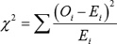
With k-1 degrees of freedom.
Where Oi is the observed count, k is categories, and Ei is the expected counts.
2. Chi-square test for independence of two variables
It is used to check whether the variables are independent of each other or not. The Chi-square test statistic is,
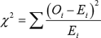
With degrees of freedom.
Where Oi is the observed count, r is number of rows, c is the number of columns, and Ei is the expected counts

DATA ANALSIS AND INTERPRETATION:
As mentioned above, the study is based on a sample of 100 respondents.

CATEGORY -1
ABOUT THE MEMBERS OF SELF HELP GROUP

- Frequency Table

MALE OR FEMALE
 |  | Frequency | Percent | Valid Percent | Cumulative Percent
Valid | FEMALE | 100 | 100.0 | 100.0 | 100.0

BAR CHART

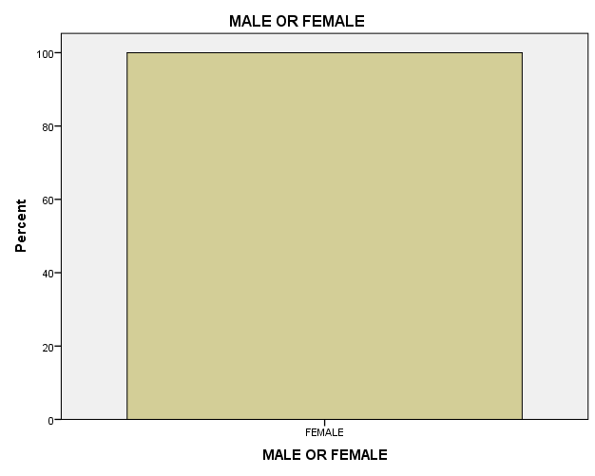
DATA INTERPRETATION:

The above data interprets that all the respondents are female. Basically, each Self-help group consists of 20-40 female in a group.

- FREQUENCY TABLE
AGE
 |  | Frequency | Percent | Valid Percent | Cumulative Percent
Valid | 19-25 | 7 | 7.0 | 7.4 | 7.4
Valid | 26-30 | 19 | 19.0 | 20.2 | 27.7
Valid | ABOVE 30 | 68 | 68.0 | 72.3 | 100.0
Valid | Total | 94 | 94.0 | 100.0
Missing | System | 6 | 6.0
Total |  | 100 | 100.0

BAR GRAPH

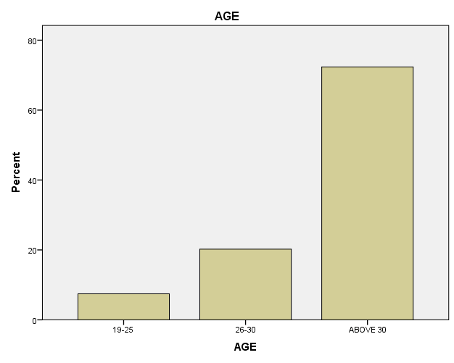

DATA INTERPRETATION:
The above data interprets that 7% of the members are between 19-25 years of age, 19 % of the members are between 26-30 years of age while 68% are above 30.
Frequency Table-3

RELIGION
 |  | Frequency | Percent | Valid Percent | Cumulative Percent
Valid | HINDU | 69 | 69.0 | 69.0 | 69.0
Valid | MUSLIM | 31 | 31.0 | 31.0 | 100.0
Valid | Total | 100 | 100.0 | 100.0

BAR GRAPH
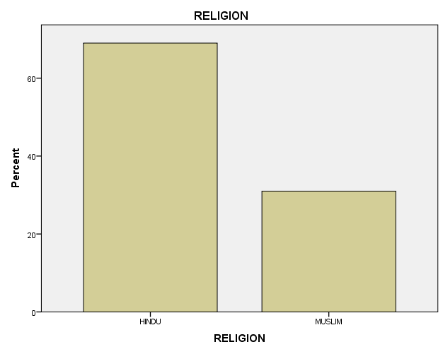

DATA INTERPRETATION:
The above data represents that 69% of the respondents are Hindus while 31% are Muslims.

Frequency Table-4
MARITAL STATUS
 |  | Frequency | Percent | Valid Percent | Cumulative Percent
Valid | MARRIED | 94 | 94.0 | 94.0 | 94.0
Valid | UNMARRIED | 2 | 2.0 | 2.0 | 96.0
Valid | WIDOW | 4 | 4.0 | 4.0 | 100.0
Valid | Total | 100 | 100.0 | 100.0

BAR GRAPH
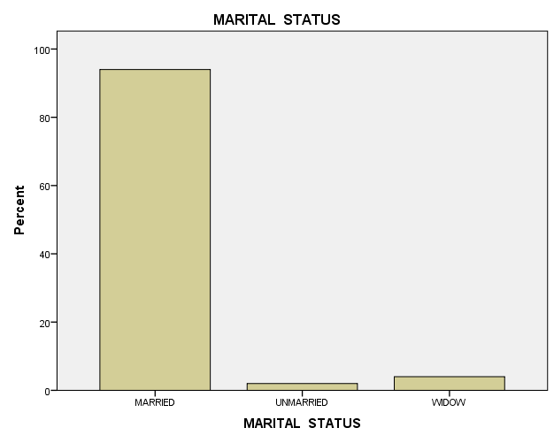
DATA INTERPRETATION
The above data represents that from the respondents 94% are married, 2% are unmarried and 4% are widow.

Frequency Table-5
LITERARY LEVEL
 |  | Frequency | Percent | Valid Percent | Cumulative Percent
Valid | ILLITERATE | 2 | 2.0 | 2.0 | 2.0
Valid | PRIMARY | 13 | 13.0 | 13.0 | 15.0
Valid | HIGH SCHOOL | 71 | 71.0 | 71.0 | 86.0
Valid | Graduate | 12 | 12.0 | 12.0 | 98.0
Valid | POST GRADUATE | 2 | 2.0 | 2.0 | 100.0
Valid | Total | 100 | 100.0 | 100.0

BAR GRAPH
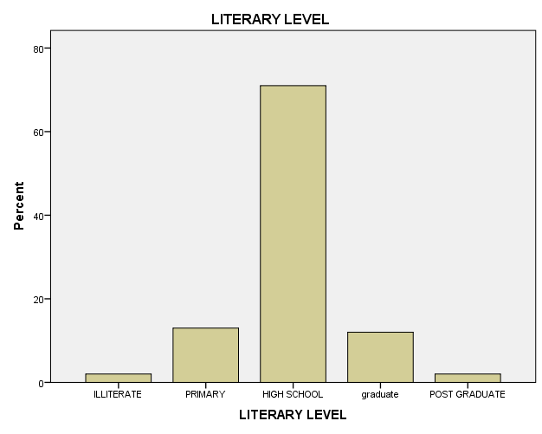

DATA INTERPRETATION
The above data interprets that 2% of the respondents are illiterate, 13% are primary, 71% are high school and 12% are graduate while 2% are post graduate.
Frequency Table -6
REASONS FOR FORMING SHG
 |  | Frequency | Percent | Valid Percent | Cumulative Percent
Valid | IMPROVE SOCIAL STATUS | 12 | 12.0 | 12.0 | 12.0
Valid | IMPROVE ECONOMIC STATUS | 27 | 27.0 | 27.0 | 39.0
Valid | SAVING HABITS | 16 | 16.0 | 16.0 | 55.0
Valid | FINANCIAL SUPPORT | 33 | 33.0 | 33.0 | 88.0
Valid | COMMUNITY DEVELOPMENT ACTIVITY | 3 | 3.0 | 3.0 | 91.0
Valid | INFLUENCE BY FRIENDS AND RELATIVES | 9 | 9.0 | 9.0 | 100.0
Valid | Total | 100 | 100.0 | 100.0

BAR GRAPH

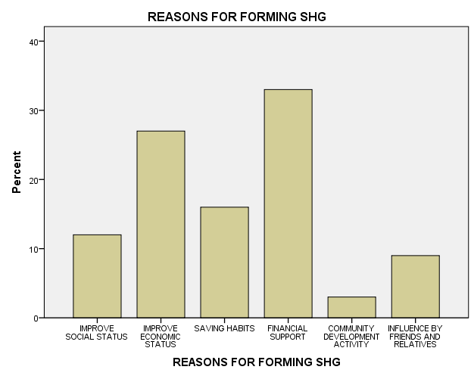
DATA INTERPRETATION
Above data interprets that 12% of the respondents joined SHG for improving their social status, 27% joined SHG to improve their economic condition, 16 % of the respondents joined it due to saving habits, and 33% joined it for financial support, 3% for community development while 9% of the respondents are influced by friends and family who are the members of SHG.

Frequency Table-7
ANNUAL INCOME OF SHG MEMBERS
 |  | Frequency | Percent | Valid Percent | Cumulative Percent
Valid | BELOW 50000 | 60 | 60.0 | 60.0 | 60.0
Valid | 50001-100000 | 36 | 36.0 | 36.0 | 96.0
Valid | 150001-200000 | 3 | 3.0 | 3.0 | 99.0
Valid | 200000& ABOVE | 1 | 1.0 | 1.0 | 100.0
Valid | Total | 100 | 100.0 | 100.0

BAR GRAPH:
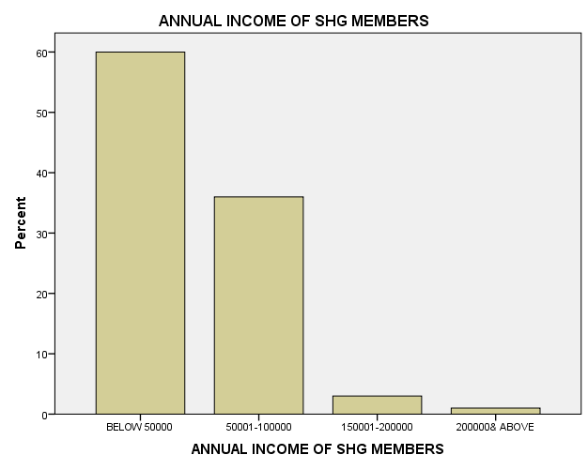
DATA INTERPRETATION:
The above data represents that the annual income of 60% of the respondents are below 50,000 .36% respondents income lies between fifty thousand to one lakh(50001-100000) while 3% respondents income lies between one lakh fifty thousand to two lakh per annum(150001-200000) .Only 1% respondents annual income is between 200000 & above.
Thus, it is clear that most of the members of SHG belongs to poor class whose annual income is less than 50,000.

FREQUENCY TABLE-8
CURRENT OCCUPATION
 |  | Frequency | Percent | Valid Percent | Cumulative Percent
Valid | AGRICULTURAL LABOUR/LABOUR | 22 | 22.0 | 22.0 | 22.0
Valid | OWN FIRM | 1 | 1.0 | 1.0 | 23.0
Valid | BUSINESS | 2 | 2.0 | 2.0 | 25.0
Valid | HOUSE WIFE | 75 | 75.0 | 75.0 | 100.0
Valid | Total | 100 | 100.0 | 100.0

BAR GRAPH:
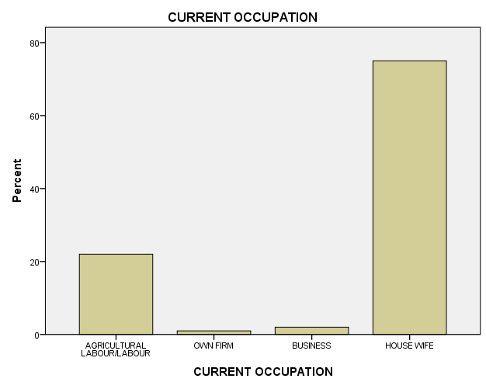

DATA INTREPRETATION:

Table-8 shows that the largest share of Kudumbshree members was found to be housewives (75%), followed by agricultural labour /labour (22%) forming the next largest share. Business women formed the next group (2%) while respondents having own firm (1%) came in fourth place respectively.

CATEGORY-2
ECONOMIC ACTIVITY AND MARKETING
Frequency Table-1
ARE YOU DOING ANY ECONOMIC AND SOCIAL MOBILISATION ACTIVITIES THROUGH YOUR SHG
 |  | Frequency | Percent | Valid Percent | Cumulative Percent
Valid | YES | 31 | 31.0 | 31.0 | 31.0
Valid | DON'T KNOW | 17 | 17.0 | 17.0 | 48.0
Valid | NO | 36 | 36.0 | 36.0 | 84.0
Valid | NOT ANSWERABLE | 16 | 16.0 | 16.0 | 100.0
Valid | Total | 100 | 100.0 | 100.0

BAR GRAPH
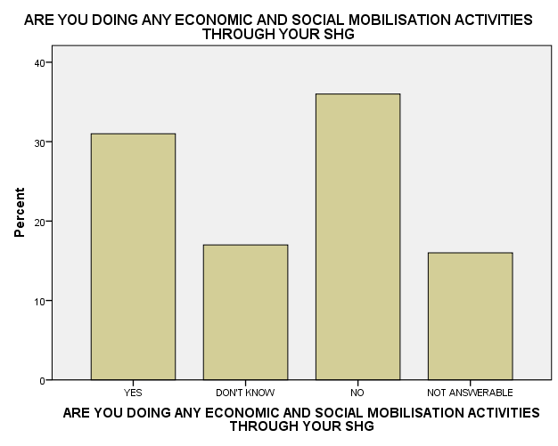
INTERPRETATION
Table -1 shows that 21% of the 100 respondents were agree that they are involved in economic and social mobilisation activities through SHG,17% don’t know about it.36% of the 100 respondents were not involved in such type of activities, while 16% thought that it is not answerable.
FREQUENCY TABLE: 2

WHAT TYPE OF ECONOMIC ACTIIVITY, YOU ARE DOING THROUGH YOUR SHG
 |  | Frequency | Percent | Valid Percent | Cumulative Percent
Valid | HOME NEED PRODUCTION | 38 | 38.0 | 38.0 | 38.0
Valid | PITY BUSINESS | 41 | 41.0 | 41.0 | 79.0
Valid | AGRICULTURAL AND ALLIED ACTIVITIES | 21 | 21.0 | 21.0 | 100.0
Valid | Total | 100 | 100.0 | 100.0
BAR GRAPH
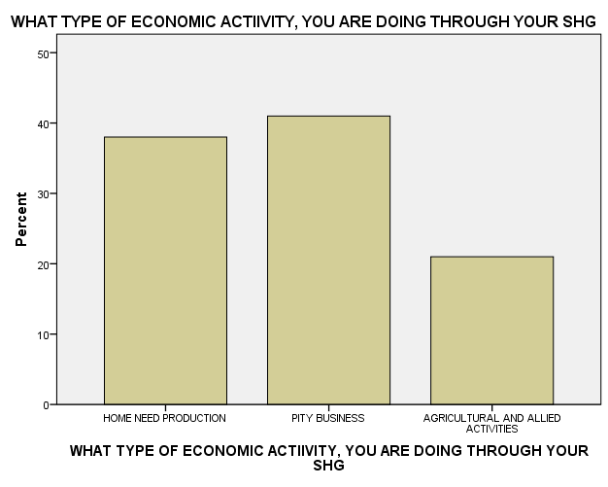
INTERPRETATION
Table -2 shows that 38% of the 100 respondents were involved in home need production, 41% are involved in pity business while 21% are doing agricultural and allied activities through their SHG.

FREQUENCY TABLE-3

WHETHER ANY MEMBER IS YOUR SHG ACQUIRED TRAINING REGARDING THE ABOVE ACTIVITY
 |  | Frequency | Percent | Valid Percent | Cumulative Percent
Valid | YES | 72 | 72.0 | 72.0 | 72.0
Valid | NO | 28 | 28.0 | 28.0 | 100.0
Valid | Total | 100 | 100.0 | 100.0
BAR GRAPH

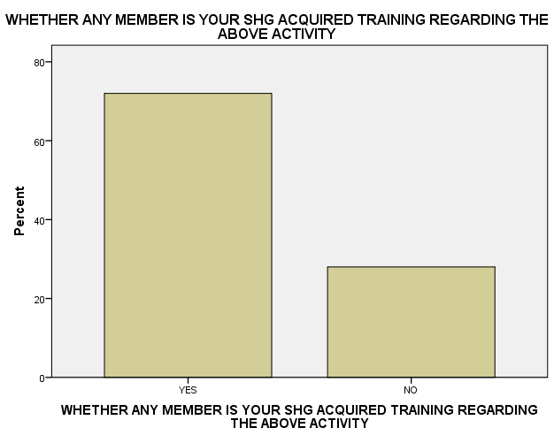

DATA INTERPRETATION
Table -3 shows that 72% of the 100 respondents are agree that the members of their SHG are acquired training regarding the above activity while 28% are disagree.

FREQUENCY TABLE -4
WHETHER ANY MEMBER IN YOUR SHG HAVING FOLLOWING QUALITIES
 |  | Frequency | Percent | Valid Percent | Cumulative Percent
Valid | LEADERSHIP | 41 | 41.0 | 41.0 | 41.0
Valid | MICRO-FINANCING | 51 | 51.0 | 51.0 | 92.0
Valid | DOCUMENTATION | 8 | 8.0 | 8.0 | 100.0
Valid | Total | 100 | 100.0 | 100.0
BAR GRAPH

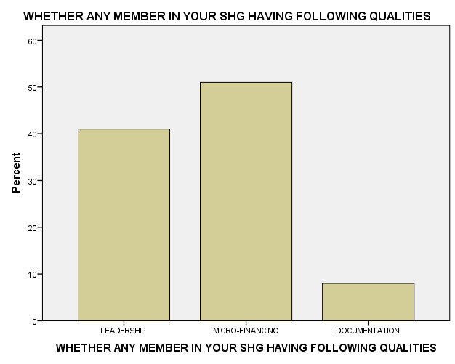

DATA INTERPRETATION
TABLE -4 represents that 51% of the 100 respondents are with the view that SHG members have micro –financing qualities , 41% are with the opinion that SHG members have leadership skills while 8% reveals that SHG members have documentation qualities.

CATEGORY -3
PERCEPTION OF TRAINING

FREQUENCY TABLE-1

HOW MANY MEMBERS USED TO ATTEND THE MEETINGS
 |  | Frequency | Percent | Valid Percent | Cumulative Percent
Valid | ONCE IN A WEEK/FORTNIGHT | 100 | 100.0 | 100.0 | 100.0

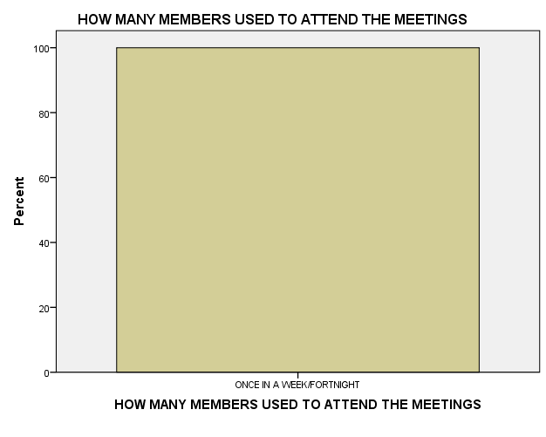

DATA INTERPREATATION
TABLE -1 OF 3RD CATEGORY reveals that SHG members used to meet once in a week i.e. (SUNDAY).

FREQUENCY TABLE -2

REGULARITY OF ATTENDANCE IN SHG BY ITS MEMBERS
 |  | Frequency | Percent | Valid Percent | Cumulative Percent
Valid | LESS THAN 50% | 2 | 2.0 | 2.0 | 2.0
Valid | 50%-60% | 1 | 1.0 | 1.0 | 3.0
Valid | 61%-75% | 3 | 3.0 | 3.0 | 6.0
Valid | MORE THAN 75% | 94 | 94.0 | 94.0 | 100.0
Valid | Total | 100 | 100.0 | 100.0

Bar graph
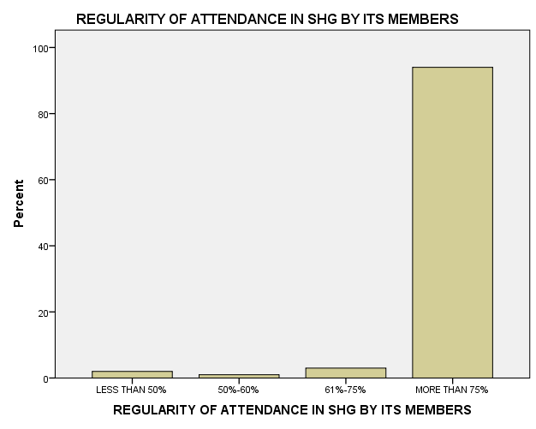

DATA INTERPRETATION
The above table-2 of 3rd category represents that 94% of the 100 respondents reveals that there is more than 75% regularity of attendance in SHG by its members.3% are with the view that regularity of attendance in their SHG is between 61%-75%, 2% are with the view that less than 50% regularity of attendance by its SHG members while 1% with the view that it is between 50%-60%.

FREQUENCY TABLE-3

HOW YOU SELECT YOUR SHG LEADER
 |  | Frequency | Percent | Valid Percent | Cumulative Percent
Valid | BY ELECTION | 100 | 100.0 | 100.0 | 100.0

BAR GRAPH 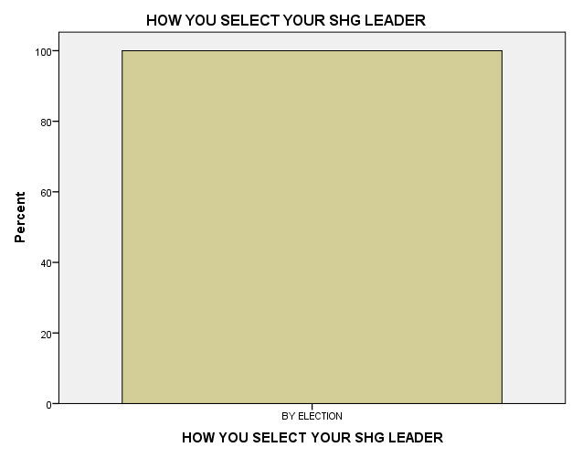

DATA INTERPRETATION
The above table-3 of 3rd category shows that 100% of the respondents reveals that they select their SHG leader through election.

FREQUENCY TABLE-4

THE TYPE OF TRAINING ORIENTATION GIVE TO MEMBERS
 |  | Frequency | Percent | Valid Percent | Cumulative Percent
Valid | CONDUCT OF TRAINING | 6 | 6.0 | 6.0 | 6.0
Valid | MAINTAINCE OF RECORD | 39 | 39.0 | 39.0 | 45.0
Valid | COMMUNITY PARTICIPATION | 36 | 36.0 | 36.0 | 81.0
Valid | COMMUNICATION | 19 | 19.0 | 19.0 | 100.0
Valid | Total | 100 | 100.0 | 100.0

BAR GRAPH 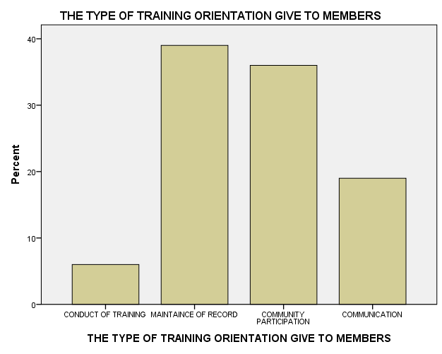
DATA INTERPRETATION
The above table shows that 39 % of the respondents believe that the type of training orientation give to its SHG members is maintained of records, 36% believes that the training orientation given to its members is community participation while 19% are it is related to communication and 6% reveals that it is related to conduct of training.

FREQUENCY TABLE-5
INCASE OF ORIENTATION TRAINING, WHO IS SPONSORING THAT
 |  | Frequency | Percent | Valid Percent | Cumulative Percent
Valid | LINE DEPARTMENT | 1 | 1.0 | 1.0 | 1.0
Valid | NGO | 45 | 45.0 | 45.0 | 46.0
Valid | OTHER COMMUNITY ORGANISATION | 54 | 54.0 | 54.0 | 100.0
Valid | Total | 100 | 100.0 | 100.0

BAR GRAPH
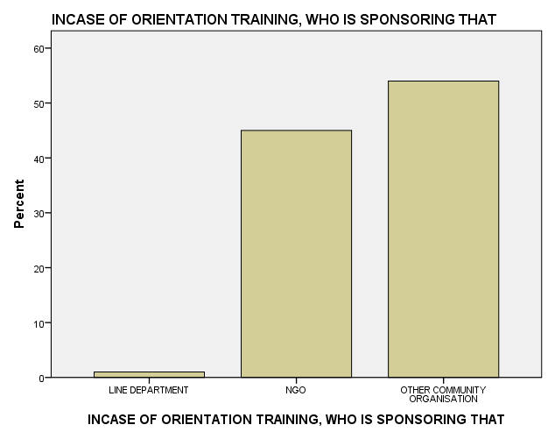

DATA INTERPRETATION
The above table represents that majority (51%) of the respondents reveals that other community organization sponsoring their orientation training , 45% of the respondents reveals that it is NGO that sponsor their orientation training while 1% reveals it is line department.

CATEGORY-4

Frequency Table-1

HOW MUCH YOU ARE SAVING REGULARY
 |  | Frequency | Percent | Valid Percent | Cumulative Percent
Valid | LESS THAN 10,000 | 53 | 53.0 | 53.0 | 53.0
Valid | LESS THAN 20,000 | 30 | 30.0 | 30.0 | 83.0
Valid | LESS THAN 30,000 | 17 | 17.0 | 17.0 | 100.0
Valid | Total | 100 | 100.0 | 100.0

BAR GRAPH
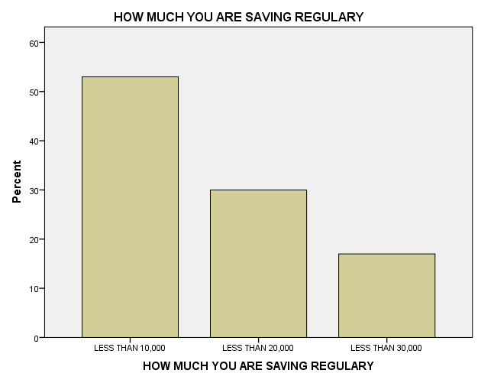

DATA INTERPRETATION
TABLE-1 OF CATEGORY-4th represents that majority i.e. 53% of the respondents are saving regularly less than 10,000 through their SHG. another dominant group (30%) reveals that they save less than 20,000 regularly though their SHG while only 17% saving less than 30,000 regularly though their SHG.

FREQUENCY TABLE-2

HOW THE MEMBERS ARE DEPOSITING SAVING
 |  | Frequency | Percent | Valid Percent | Cumulative Percent
Valid | DEPOSITING SHG ACCOUNT | 37 | 37.0 | 37.0 | 37.0
Valid | CONTRIBUTE IN REGULAR MEETING | 63 | 63.0 | 63.0 | 100.0
Valid | Total | 100 | 100.0 | 100.0

BAR GRAPH
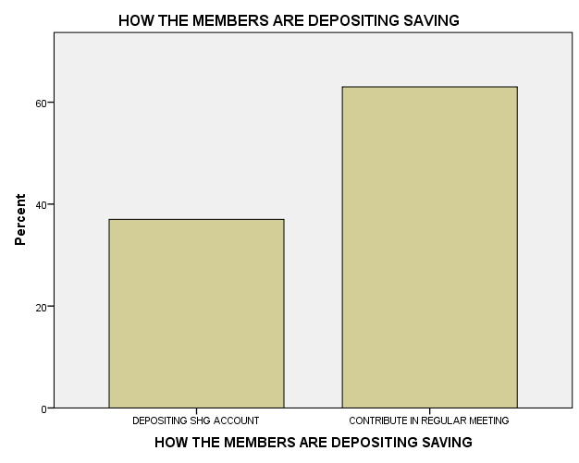
DATA INTERPRETATION
The above table -2 of 4th category shows that 63% of the respondents reveals that the members contribute saving in a regular meeting while 37% are saving through depositing in SHG accounts.

FREQUENCY TABLE-3

WHAT IS THE PURPOSE OF SAVING
 |  | Frequency | Percent | Valid Percent | Cumulative Percent
Valid | TO MEET FUTURE REQUIREMENT | 42 | 42.0 | 42.0 | 42.0
Valid | TO MAINTAIN ECONOMIC STABILITY | 30 | 30.0 | 30.0 | 72.0
Valid | TO REPAYMENT OF LOAN | 28 | 28.0 | 28.0 | 100.0
Valid | Total | 100 | 100.0 | 100.0
BAR GRAPH
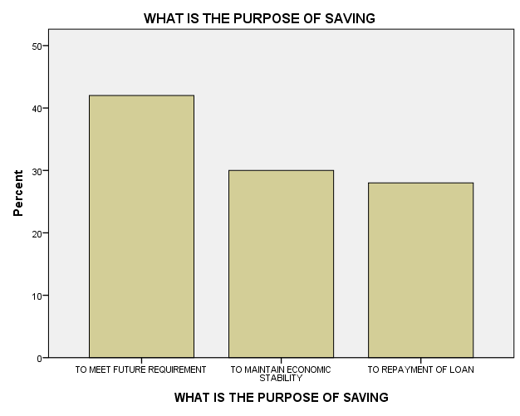

DATA INTERPRATATION:
The above table shows that the 42% of the respondents reveals that the purpose of saving is to meet future requirement, 30% respondents are with the view that the purpose of saving is to maintain economic stability, while 28% used to save for repayment of loan.

CATEGORY -5

Frequency Table-1

WHETHER YOU TAKE LOAN FROM ANY BANK OR FINANCIAL INSTITUTION
 |  | Frequency | Percent | Valid Percent | Cumulative Percent
Valid | YES | 72 | 72.0 | 72.0 | 72.0
Valid | NO | 28 | 28.0 | 28.0 | 100.0
Valid | Total | 100 | 100.0 | 100.0

BAR GRAPH
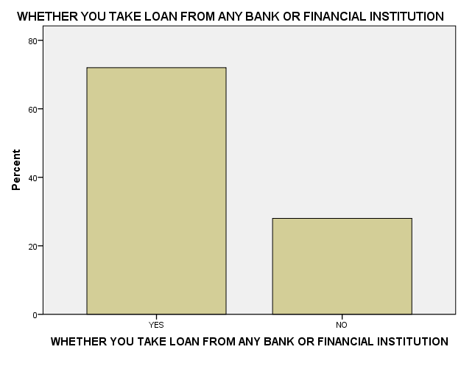

DATA INTERPRETATION
Table -1 of category 5th represents that 72% of the respondents takes loan from any bank or financial institute while 28% didn’t take any kind of loan.

FREQUENCY TABLE-2

WHAT IS THE PURPOSE OF LOAN
 |  | Frequency | Percent | Valid Percent | Cumulative Percent
Valid | GROUP ACTIVITIES | 10 | 10.0 | 13.5 | 13.5
Valid | RE-PAYMENT | 21 | 21.0 | 28.4 | 41.9
Valid | INDIVIDUAL ECONOMIC ACTIVITIES | 35 | 35.0 | 47.3 | 89.2
Valid | CONSUMER PERCEPTION | 5 | 5.0 | 6.8 | 95.9
Valid | DON'T KNOW | 3 | 3.0 | 4.1 | 100.0
Valid | Total | 74 | 74.0 | 100.0
Missing | System | 26 | 26.0
Total |  | 100 | 100.0

BAR GRAPH
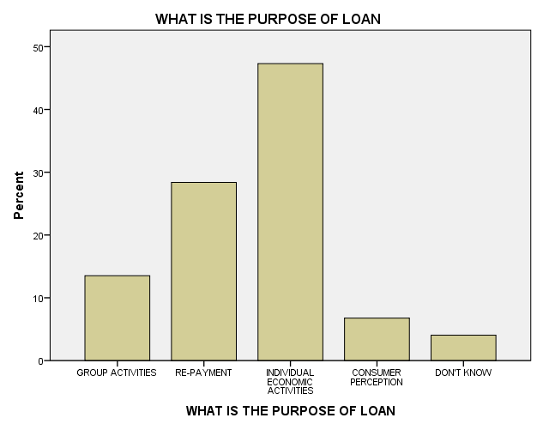

DATA INTERPRETATION
The above table -2 of 5th category represents that 35% of the 100 respondents take loan for individual economic activity, 21% take loan for repayment purpose, 10% for group activity , 5% of the respondents take loan for consumer perception while 3% don’t know.
FREQUENCY TABLE-3

DO YOU REPAY YOUR LOAN REGULARLY
 |  | Frequency | Percent | Valid Percent | Cumulative Percent
Valid | YES | 61 | 61.0 | 82.4 | 82.4
Valid | NO | 13 | 13.0 | 17.6 | 100.0
Valid | Total | 74 | 74.0 | 100.0
Missing | System | 26 | 26.0
Total |  | 100 | 100.0

BAR GRAPH
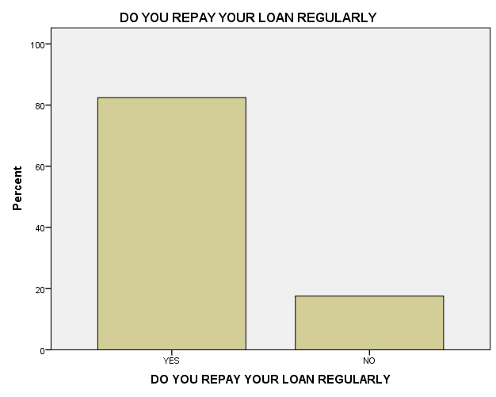
DATA INTERPRETATION :
The above table-3 of 5th category shows that 61% of the respondents repay their loan regularly while 13% didn’t pay their loan reguraly.

FREQUENCY TABLE-4

INCASE,IF NO , THEN WHAT ARE THE REASONS
 |  | Frequency | Percent | Valid Percent | Cumulative Percent
Valid | USED FOR PERSONAL CONCEPTION | 3 | 3.0 | 25.0 | 25.0
Valid | DIDN'T GET PAID ON TIME | 5 | 5.0 | 41.7 | 66.7
Valid | USED THE LOAN TO REPAY THE OLD DEBT | 4 | 4.0 | 33.3 | 100.0
Valid | Total | 12 | 12.0 | 100.0
Missing | System | 88 | 88.0
Total |  | 100 | 100.0
BAR GRAPH
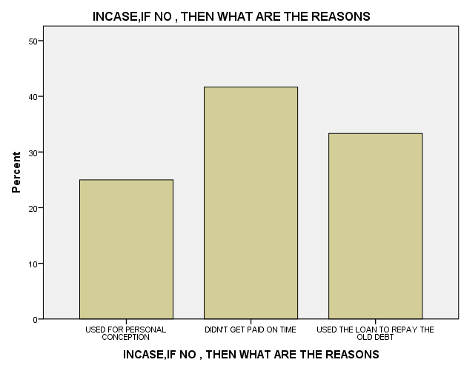

DATA INTERPRETATION
The above table-4 of 5th category represents that the members who didn’t pay loan reguraly i.e ( 13% of the respondents ) due to this reasons ,3% of the respondent reveals that they used it for personal reasons 5% of the respondent didn’t paid on time while 4% of the respondents used the loan to repay old debt.
CHI SQUARE TEST
Cross table

Case Processing Summary
 | Cases
 | Valid |  | Missing |  | Total
 | N | Percent | N | Percent | N | Percent
RELIGION * REASONS FOR FORMING SHG | 100 | 100.0% | 0 | 0.0% | 100 | 100.0%

RELIGION * REASONS FOR FORMING SHG
Cross tabulation
 |  |  | REASONS FOR FORMING SHG |  |  |  |  |  | Total
 |  |  | IMPROVE SOCIAL STATUS | IMPROVE ECONOMIC STATUS | SAVING HABITS | FINANCIAL SUPPORT | COMMUNITY DEVELOPMENT ACTIVITY | INFLUENCE BY FRIENDS AND RELATIVES | Total
RELIGION | HINDU | Count | 9 | 16 | 10 | 25 | 2 | 7 | 69
RELIGION | HINDU | Expected Count | 8.3 | 18.6 | 11.0 | 22.8 | 2.1 | 6.2 | 69.0
RELIGION | MUSLIM | Count | 3 | 11 | 6 | 8 | 1 | 2 | 31
RELIGION | MUSLIM | Expected Count | 3.7 | 8.4 | 5.0 | 10.2 | .9 | 2.8 | 31.0
Total |  | Count | 12 | 27 | 16 | 33 | 3 | 9 | 100
 |  | Expected Count | 12.0 | 27.0 | 16.0 | 33.0 | 3.0 | 9.0 | 100.0

Chi-Square Tests
 | Value | df | Asymp. Sig. (2-sided)
Pearson Chi-Square | 2.752ª | 5 | .738
Likelihood Ratio | 2.747 | 5 | .739
Linear-by-Linear Association | .743 | 1 | .389
N of Valid Cases | 100
a. 5 cells (41.7%) have expected count less than 5. The minimum expected count is .93.

Symmetric Measures
 |  | Value | Approx. Sig.
Nominal by Nominal | Phi | .166 | .738
Nominal by Nominal | Cramer's V | .166 | .738
N of Valid Cases |  | 100

INFERENTIAL STATISTICS:
NULL HYPOTHESIS (H0) = There is significance association between two categorical variables i.e. religion and reasons for forming SHG.
OBSERVED HYPOTHESIS (H1) = There is no signicant association between the two variables.
CHI SQUARE STATISTICS:
^{X2 =}
APA STYLE WRITE UP OF RESULTS:

FINDINGS
- The highest number of respondents i.e. 68 percentage fell in the above 30 age slab, 19 percentage in 26-30 age slab and 7 percentage of the total 100 respondents fell between the ages 19-25 years.
- The education level of women tabulated in Table -2 shows that 71 percentages are high school, 13% have primary literacy level, 2% are illiterate, and 12 % have graduation while 2 percentage of the total 100 respondents are post graduates.
- The study reveals that all the respondents are female. Basically, each Self-help group consists of 20-40 female in a group.
- This study reveals that 69% of the respondents are Hindus while 31% are Muslims. Thus, there is no biasness in the SHG on the basis of religion.
- This study reveals that the member’s marital status is married, unmarried and widow. Thus, it is not open a specific marital status but for all.
- The study reveals that there are various reasons of members to join SHG in which 12% of the respondents joined SHG for improving their social status, 27% joined SHG to improve their economic condition, 16 % of the respondents joined it due to saving habits, and 33% joined it for financial support, 3% for community development while 9% of the respondents are influced by friends and family who are the members of SHG.
- This study reveals that the annual income of 60% of the respondents are below 50,000 .36% respondents income lies between fifty thousand to one lakh(50001-100000) while 3% respondents income lies between one lakh fifty thousand to two lakh per annum(150001-200000) .Only 1% respondents annual income is between 200000 & above.
Thus, it is clear that most of the members of SHG belongs to poor class whose annual income is less than 50,000.
- In this study we come to know that the largest share of Kudumbshree members was found to be housewives (75%), followed by agricultural labour /labour (22%) forming the next largest share. Business women formed the next group (2%) while respondents having own firm (1%) came in fourth place respectively.
- In this study, 21% of the 100 respondents were agree that they are involved in economic and social mobilisation activities through SHG.
- This study shows that 38% of the 100 respondents were involved in home need production, 41% are involved in pity business while 21% are doing agricultural and allied activities through their SHG.
- This study represents that 51% of the 100 respondents are with the view that SHG members have micro –financing qualities , 41% are with the opinion that SHG members have leadership skills while 8% reveals that SHG members have documentation qualities.
- This study reveals that SHG members used to meet once in a week i.e. (SUNDAY).
- This study represents that 94% of the 100 respondents reveals that there is more than 75% regularity of attendance in SHG by its members.3% are with the view that regularity of attendance in their SHG is between 61%-75%, 2% are with the view that less than 50% regularity of attendance by its SHG members while 1% with the view that it is between 50%-60%.
- This study reveals that the members select their SHG leader through election.
- This study shows that 39 % of the respondents believe that the type of training orientation give to its SHG members is maintained of records, 36% believes that the training orientation given to its members is community participation while 19% are it is related to communication and 6% reveals that it is related to conduct of training
- In this study majority (51%) of the respondents reveals that other community organization sponsoring their orientation training , 45% of the respondents reveals that it is NGO that sponsor their orientation training while 1% reveals it is line department.
- In this study TABLE-1 OF CATEGORY-4th represents that majority i.e. 53% of the respondents are saving regularly less than 10,000 through their SHG. another dominant group (30%) reveals that they save less than 20,000 regularly though their SHG while only 17% saving less than 30,000 regularly though their SHG
- In this study Table -2 of 4th category shows that 63% of the respondents reveals that the members contribute saving in a regular meeting while 37% are saving through depositing in SHG accounts.
- In this study 42% of the respondents reveals that the purpose of saving is to meet future requirement, 30% respondents are with the view that the purpose of saving is to maintain economic stability, while 28% used to save for repayment of loan.
- The study reveals that members are finding easy access to loan compared to the other avenues.
- The majority of the members utilising loan amount for self-employment and other personal matters.
- The recovery status of loan is quite good. This shows the credibility of members of the group.

SUGGESTIONS

.
CONCLUSION
SHGs are being recognized today in this region as the most effective means for socio-economic development of the rural poor. Most of the studies carried out so far regarding the effect of self-help group towards the women empowerment show a positive trend. The SHG brings socio solidarity and social, economic betterment to the poor peoples.

reference
[1] Local self-government department, govt. of Kerala, India. (Nod) retrieved February 22, 2014, from http://lsgkerala.gov.in/
[2] kudumbashree. (n.d.). Retrieved February 5, 2015, from http://www.kudumbashree.org/
annexure
Questionnaire
Dear Sir/ Madam,
I am pleased to introduce myself as a MBA student as a part of my dissertation, I am conducting a study on performance management of self-help group (SHG) with reference to kudumbashree NGO unit.
So, I hereby request you kindly spare your valuable time to fill this questionnaire, which will help me in my project work. (Please √ marks the relevant box or write wherever necessary).
All the information provided by you will remain confidential.
Part-I: Personal Profile of Respondents

Name: ………………………………………

Husband’s/Father’s name: ………………………………….

Address: …………………………………………………………

Sex: ……………………………………………………………….

a. Male b. female

Age: ……………………………………………………………….

- Below 18 b.)19-25 c ) 26-30

Education: ………………………………………………………..

a. Illiterate
b. Primary
c. High School
d. Graduate
CATEGORY -1
ABOUT SELF HELP GROUP
- NAME OF THE BLOCK …………………………………
- NAME OF THE VILLAGE ………………………………
- NAME OF THE GROUP ……………………………….....
- YEAR OF SHG ESTABLISHMENT ………………………

- RELIGION OF THE MEMBERS
a. Hindu b. Muslim c. Christian
7. MARITAL STATUS OF THE MEMBERS
a. Married b. Unmarried c. Widow
8. LITERARY LEVEL OF MEMBERS

a. Illiterate
b. Primary
c. High School
d. P.U.C
e. Degree
9. REASONS FOR FORMING SHG
a. improve social status
b. improve economic status
c. saving habits
d. financial support
e. community development activities
f. influence by friends and relatives
10. ANNUAL INCOME OF SHG MEMBERS
a. Below 50,000 b. 50,001-1, 00,000
c. 1,50,001-2, 00,000 d. 2,00,001 & Above

11. CURRENT OCCUPATION
a. Agricultural labour / labour b. Own firm
c. Business d. House wife

CATEGORY -2
ECONOMIC ACTIVITY AND MARKETING

- ARE YOU DOING ANY ECONOMIC AND SOCIAL MOBILISATION ACTIVITIES THROGH YOUR SELF HELP GROUP (SHG)
- Yes c. no
- Don’t know d. not answerable.

- WHAT TYPE OF ECONOMIC ACTIVITY , YOU ARE DOING THROUGH YOUR SELF HELP GROUP.
- Home need production
- Pity business
- Agricultural and allied activities
- WHETHER ANY MEMBER IS YOUR SHG ACQUIRED TRAINING REGARDING THE ABOVE ACTIVITY
- Yes b. No

- WHETHER ANY MEMBER IN YOUR SHG HAVING FOLLOWING QUALITIES
- Leadership b. micro – financing c. documentation

CATEGORY -3
PERCEPTION OF TRAINING

- HOW MANY MEMBERS USED TO ATTEND THE MEETINGS
FREQUENCY | NO. OF MEMBERS
- No specific interval
- Once in a year
- Fortnight
- Monthly

- REGULARITY OF ATTENDANCE IN SHG BY ITS MEMBERS
- Less than 50%
- 50%-60%
- 61%-75%
- More than 75%
- HOW YOU SELECT YOUR GROUP LEADERS
- By elections
- By relating system
- Don’t know
- THE TYPE OF TRAINING ORIENTATION GIVE TO MEMBERS
- Conduct of traing
- Maintance of record
- Community participation
- Communication
- INCASE OF ORIENTATION TRAINING , WHO IS SPONSORING THAT
- Line department
- NGO
- Other community organisation.

CATEGORY -4
SAVINGS
- HOW MUCH YOU ARE SAVING REGULARLY
a. less than rs. 10,000
b. less than rs. 20,000
c . less than rs. 30,000
2. HOW THE MEMBERS ARE DEPOSITING SAVING
a. Collect house to house
b. Depositing SHG account
c. Contribute in regular meeting
3. WHAT IS THE PURPOSE OF SAVING
a. To meet the future requirement
b. To maintain economic stability
c. to repayment of loan

CATEGORY -5
LOAN AND REPAYMENT

- WHETHER YOU TAKE LOAN FROM ANY BANK OR FINANCIAL INSTITUTION
- Yes b. No

- WHAT IS THE PUPOSE OF LOAN
a. Group activities
b. Re-payment
c. Individual economic activities
d. Consumer perception
e. Don’t know

- DO YOU REPAY YOUR LOAN REGULARLY
- Yes b. No

- INCASE , IF NO , THEN WHAT ARE THE REASONS
- Business was not possible
- Used for personal conception
- Did not get paid on time
- Used the loan to repay the old debt.

