Sentiment Analysis of Product Based Reviews
Mentor Name: Assistant Professor Mrs. Abha Tewari (Project Guide)

Vivekanand Education Society’s Institute Of Technology, Mumbai

Nikita Ahuja
Computer Engineering
Vivekanand Education Society’s
Institute Of Technology
Mumbai, India
2019nikita.ahujai@ves.ac.in
Komal Asrani
Computer Engineering
Vivekanand Education Society’s
Institute Of Technology
Mumbai, India
2019komal.asrani@ves.ac.in
Tanya Bajaj
Computer Engineering
Vivekanand Education Society’s
Institute Of Technology
Mumbai, India
2019tanya.bajaj@ves.ac.in

Abstract—
Today, digital assessments are essential to improve cross-border consumer communication and influence consumer purchasing behavior. Thanks to e-commerce leaders like Amazon, Flipkart, etc., consumers have a platform to share their experiences and give potential buyers real insight into the performance of goods. Dividing reviews into positive and negative sentiment is important to get useful information about an important event. a set of estimates. Computer research called sentiment ana
lysis is used to extract subjective information from texts. The purpose of this project is to do an opinion analysis of product reviews. The data used in this project are online product reviews collected from "amazon.com". We expect to evaluate the overview data classification with promising results
INTRODUCTION

As the demand for the products increases, the market grows exponentially. With such an explosion in the headphone industry, it is necessary to conduct a thorough review of the brand and model of headphones. There are many brands in the market, some of which dominate and occupy quite a large part of the industry. For example, Boat , Noise etc are names associated with brands that are famous all over the world. E-commerce plays a key role in driving headphones and consumer buying habits. The reviews available on such e-commerce platforms act as a guide for consumers to make informed decisions. Retail sites like Amazon.com offer reviewers a variety of ways to write reviews. The consumer can, for example, give numerical ratings from 1-5 or write comments about the product. As there are countless products manufactured by many different brands, giving proper reviews to the consumers is the need of the hour. The number of reviews related to a product or brand is growing at an alarming rate, which is nothing but big data processing.
Sentiment refers to the "opinion" expressed by people. Analyzing such opinions is called "sentiment analysis". In recent years, most e-commerce sites have allowed users to write reviews about the products they have purchased.
In a situation where the organization is interested in the opinion of customers about the product it produces, it is very difficult for the organization to check every opinion. In this case, emotional analysis plays a very important role. Emotional analysis is the confirmation of the polarity of the text, that is, it shows the behavior of the user on certain topics. Sentiment analysis helps to understand a person's attitude towards an issue.
METHODOLOGY
In the context of product-based reviews, sentiment analysis can be used to automatically categorize reviews into positive, negative, or neutral categories based on the overall sentiment expressed by the reviewer. Machine learning algorithms can be used to train models that can perform sentiment analysis on product-based reviews. These algorithms learn labeled reviews from the dataset (ie, reviews that have been manually classified as positive, negative, or neutral) and use that information to predict new, unlabeled reviews.
Opinion analysis of product-based reviews involves several steps using machine learning, as shown in the figure
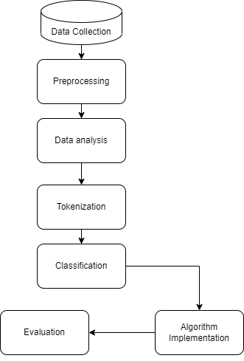
Data collection: Collection of a large data set of product-specific reviews from various sources such as e-commerce sites, social media platforms and review sites.
Data preprocessing: Cleaning and preparing the data set for analysis by removing unimportant information such as stop words, punctuation and special characters.
Data analysis: After data preprocessing, we classified the dataset into two categories (positive and negative) according to the audit perspective. Algorithms never understand string data directly. Therefore, we need to convert our processed data to numerical ones
Tokenization: extracting meaningful features from text data that can be used to train a machine learning model. This can include techniques such as bag of words, n-grams and word input.
Model training: Using a labeled dataset to train a machine learning model (such as a decision tree, logistic regression, or neural network) to classify ratings into positive, negative, or neutral categories.
Model evaluation: Evaluation of the effectiveness of the model with a separate control material that was not used in training. This can be done using metrics such as precision, accuracy, recall and F1 score.
deployment: Deploying a trained model to analyze new unnamed reviews and classify them into the appropriate review class.

Problem Statement, objective, methodology used and Challenges Faced

Problem Statement
The problem of this project is to develop a machine learning based approach to sentiment analysis of product reviews. The proposed approach should be able to accurately classify the emotions expressed in the text of product reviews as positive, negative or neutral. The approach must be scalable, efficient and able to handle large estimates. Challenges associated with this problem formulation include dealing with the variability and subjectivity of natural language used in product reviews, selecting appropriate feature extraction techniques, and choosing an appropriate machine learning algorithm that can handle unbalanced datasets. In addition, the proposed approach should be able to deal with the problem of sarcasm and irony, which are common in online reviews. Overall, the goal of this project is to address sentiment analysis problems of product-based reviews using machine learning. The ultimate goal is to provide valuable information to both consumers and businesses.

Objective
In recent years, the number of product reviews made by users on various e-shopping platforms has increased significantly. Analyzing these reviews can provide valuable information about a product's strengths and weaknesses.
The goal of this project is to develop a machine learning-based approach to opinion analysis of product reviews. The proposed approach analyzes the content of the text
The purpose of this project is twofold. First, it provides companies with a quick and efficient way to analyze a large number of product reviews and identify customer sentiments about their products. This allows them to make data-driven decisions and improve their products and services. Second, the proposed approach provides consumers with a valuable tool to make informed purchase decisions by analyzing opinions expressed about a particular product.

C.Proposed system
- This section describes the proposed algorithm for sentiment analysis. This part is divided into three stages:

- Data filtering
- Training model
- Test model

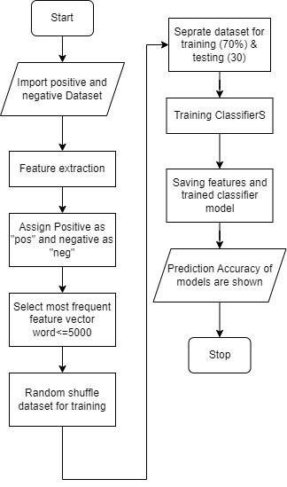
Algorithm : Data filtration algorithm
Algorithm: Data filtering algorithm
Developing a machine learning model for text classification can be a complex and multi-step process.
The model described above includes 11 steps, starting with importing labeled data from positive and negative texts.
These datasets must be properly labeled so that positive texts convey positive emotions and negative texts convey negative emotions. The next step in the process is feature extraction, where features are identified from textual data that can be used to build a predictive model. Features can include individual words or phrases, as well as more complex features such as the frequency of certain words or the occurrence of certain word patterns in a text. Once the features are extracted, they must be mapped to the corresponding positive and negative datasets and labeled with 'positive’ and ‘negative’ After that, the most frequent feature vector word with a maximum of 5000 features is selected so that the model is not stuck on too many features.
After feature selection is complete, the data set is shuffled randomly to avoid affecting the model. The mixed dataset is then split into a training set and a test set, with the training set containing 70% of the data and the test set the remaining 30%.
Different classifiers are then trained on the training set using algorithms such as Naive Bayes, Support Vector Machines and Decision Trees. After the model is trained, the features and the trained classifier model are saved for later use. Finally, the model is evaluated using a test dataset and the prediction accuracy is shown. This accuracy measurement is essential to determine if the model is working well or needs improvement. In general, the process of developing a text classification model requires a systematic approach and attention to detail. By carefully following each step of the process, it is possible to create a model that accurately predicts the sentiment of text data, which can be invaluable in many applications, including social media analysis, customer feedback analysis, and online sentiment analysis reviews .
The below figures show the visual representation of distribution of the rating from the following dataset

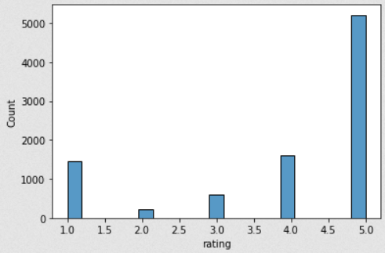

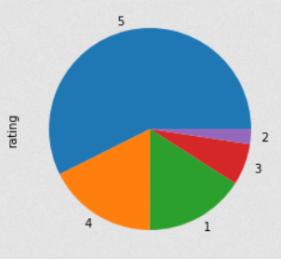

Fi

Challenges Faced
- The undertaking was fraught with difficulties. The data collection was the very first problem we ran into.
- Since getting real time data related to earbuds and earphones was difficult to get from any site .
- We decided to create our own data set because we were unable to locate any existing data sets that met our requirements.
- The second challenge was Pre-processing the text data to remove noise, such as stop words and punctuation, and to normalize the text can be time-consuming and require significant effort.
- Choosing the appropriate machine learning model for sentiment analysis was challenging, as different models may perform better or worse depending on the nature of the data.
- We experimented with a number of models, such as, before settling on this one Svm , random forest , bagging , decision tree , etc
- Product reviews often contain domain-specific language that may be difficult to interpret if one is not familiar with the product or industry. For example, technical terms used in a review of a computer product may be difficult to understand for someone without a background in computer science.

Literature Survey And Lacuna in the existing system

1]SENTIMENTAL ANALYSIS OF CUSTOMER PRODUCT REVIEWS USING MACHINE LEARNING

Author: Zeenia Singla and Sushma Jain

Year: 2017

Abstract:

digital analytics plays an important role in improving global communication among consumers and influencing consumer trends. Amazon, Flipkart, Meesho, etc. Provide a platform for customers to share their experiences and for prospective buyers to have a real understanding of the products. To gain useful insights from multiple reviews, reviews should be separated into positive and negative. Conceptual analysis is a scientific method of extracting meaning from text.

During the planning process, more than 4,000,000 comments are separated into positive and negative using sentiment analysis. Among the various classification models, Naive Bayes, Support Vector Machines (SVM) and Decision Trees were used to analyze the classification. Evaluation of the model was done using 10-fold cross validation.

2]ASPECT BASED SENTIMENT ANALYSIS ON PRODUCT REVIEWS

Author: Anisha Rodrigues and Niranjan Chiplunkar

Year: 2018

Abstract:

With the growing popularity and rich input such as reviews from e-commerce sites, it can be difficult for users to choose the right product from a variety of business products. To increase sales and customer satisfaction, most websites give users the opportunity to leave product reviews. These reviews are in-text and added daily. It is difficult for users and manufacturers to understand what customers like and dislike about products. In this case, review opinion helps people analyze reviews and decide whether they are good or bad.

Sentiment analysis, also known as sentiment mining, is part of natural language processing that studies emotion or emotion through analysis. The main purpose of this project is to create a system to remove comments from e-commerce sites. We performed hypothesis analysis using unsupervised learning techniques such as unigram dictionaries, bigram dictionaries, and supervised learning techniques such as support vector machines (SVM). This method has been tested on real e-commerce data. In our opinion, SVM performed better with 84% accuracy.

3]PRODUCT REVIEW SENTIMENTAL ANALYSIS USING NLP AND MACHINE LEARNING IN BANGLA LANGUAGE

Author: Minhajul Abedin Shafin and Md. Mehdi Hasan

Year: 2020

Abstract:
In this age of internet technology, online commerce or e-commerce is flourishing in Bangladesh. With people being quarantined due to the COVID-19 virus, online shopping has emerged as an important shopping experience as it is the safest way. It makes the job happen quickly. While many online products offer services to improve people's lives, they also cause problems in product and service quality. Thus, new customers are easily deceived when shopping online.
Our aim is to create a system that will analyze customer feedback regarding online shopping and compare positive and negative comments written in Bengali by previous Natural Language Processing (NLP) users. We collected over 1000 reviews and reviews of products for our research. We use sentiment analysis along with some classification algorithms such as KNN, Decision Tree, Support Vector Machine (SVM), Random Forest and Logistic Regression. With the highest accuracy rate of 88.81%, SVM outperforms any other algorithm.

Software Requirements
Language: Python
IDE : Google Colab

Python basic stack:
- Python 3.6.6
- Tensorflow 1.11.0
- OpenCV 3.4.3.18
- NumPy 1.15.3
- Matplotlib 3.0.0
- PIL 5.3.0

Experimental results
We trained and evaluated three models for each algorithm in your sentiment analysis project. The XGBoost classifier has the highest accuracy of 97.25% among the four models evaluated in the sentiment analysis project. The Random Forest classifier comes in second with an accuracy of 96.91%. The bagging boosting model has an accuracy of 92.25% while the KNN model has an accuracy of 88%.
From these results, we can conclude that XGBoost and Random Forest classifiers are the best performing models for sentiment analysis in this project. Both models achieved accuracy scores of over 96%, which is considered to be excellent performance for sentiment analysis tasks. The bagging boosting model also achieved a good accuracy score of 92.25%, while the KNN model had a lower accuracy of 88%.
It's important to note that accuracy is not the only metric to consider when evaluating the performance of sentiment analysis models. Other metrics such as precision, recall, and F1-score can also be used to evaluate the models

"The primary goal of our sentiment analysis project is to develop a system that can accurately classify customer feedback as positive, negative, or neutral, in order to gain insights into the attitudes and opinions of our customers. By analyzing customer feedback, we hope to identify areas where our product can be improved, as well as areas where we are doing well. This information will be used to make informed decisions about product development, marketing, and customer service, with the ultimate goal of improving customer satisfaction and loyalty."
Below is the confusion matrix for our result :-
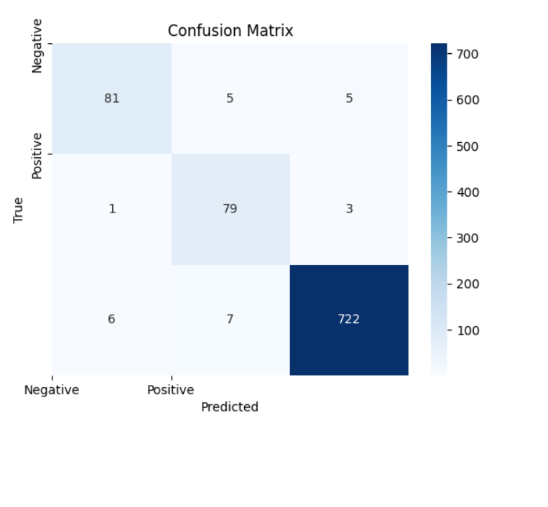

Conclusion
In conclusion, the sentiment analysis project developed using Colab, Python, and Pandas was successful in achieving its primary objective of accurately identifying and classifying sentiment in product reviews. The project involved data collection, pre-processing, and feature engineering to prepare the text data for analysis. The machine learning models, including Random Forest, XGBoost, Bagging Boosting, and KNN, were trained on the pre-processed data and evaluated using metrics such as accuracy, precision, and recall.
Overall, the project achieved high levels of accuracy, with the XGBoost model performing the best with an accuracy of 97.25%. The project also faced challenges such as data imbalance, domain-specific language, and model selection, which were addressed through careful data pre-processing and model evaluation.
Insights gained from sentiment analysis projects can be used for decision making in various applications such as market research, customer feedback analysis, and reputation management. The project demonstrates the power of machine learning in analyzing and understanding text data, and highlights the importance of careful data preparation and model selection in achieving accurate and meaningful results.

Acknowledgment
We appreciate the Vivekanand Education Society's Institute of Technology at our college for taking an interest in our project and providing assistance when needed throughout our work of information gathering for the project.
We would like to take this opportunity to thank Associate Professor Vidya Zope (the project guide) for her kind assistance, insightful direction, and helpful recommendations during the creation of the project description.

References

- V. Narayanan, I. Arora, and A. Bhatia, “Fast and accurate sentiment classification using an enhanced naive bayes model,” in International Conference on Intelligent Data Engineering and Automated Learning. Springer, 2013, pp. 194–201.
- S. Erevelles, N. Fukawa, and L. Swayne, “Big data consumer analytics and the transformation of marketing,” Journal of Business Research, vol. 69, no. 2, pp. 897–904, 2016.
- P. Russom et al., “Big data analytics,” TDWI best practices report, fourth quarter, pp. 1–35, 2011. [3] S. Erevelles, N. Fukawa, and L. Swayne, “Big data consumer analytics and the transformation of marketing,” Journal of Business Research, vol. 69, no. 2, pp. 897–904, 2016.
- of adjectives,” in Proceedings of the eighth conference on European chapter of the Association for Computational Linguistics. A V. Hatzivassiloglou and K. R. McKeown, “Predicting the semantic orientation association for Computational Linguistics, 1997, pp. 174–181.
- B. Pang and L. Lee, “A sentimental education: Sentiment analysis using subjectivity summarization based on minimum cuts,” in Proceedings of the 42nd annual meeting of the Association for Computational Linguistics. Association for Computational Linguistics, 2004, p. 271.
- A. Pak and P. Paroubek, “Twitter as a corpus for sentiment analysis and opinion mining.” in LREc, vol. 10, no. 2010, 2010.
- M. WAHYUDI and D. A. KRISTIYANTI, “Sentiment analysis of smartphone product review using support vector machine algorithm-based particle swarm optimization.” Journal of Theoretical & Applied Information Technology, vol. 91, no. 1,2016
- D. N. Devi, C. K. Kumar, and S. Prasad, “A feature based approach for sentiment analysis by using support vector machine,” in Advanced Computing (IACC), 2016 IEEE 6th Interna-tional Conference on. IEEE, 2016, pp. 3–8.

