VERIFICATION OF NETWORK THEOREM KIT

Y.S.KATKE, Pratik holkar, Vishnu bomwad 3, Basweshwar goge 4, Arvind gundajwar5

1Professor, 1,2,3,4,5 Students, Department Electrical Engineering, Government Polytechnic Nanded, Maharashtra, India

---------------------------------------------------------------------***---------------------------------------------------------------------

Abstract - A theorem is developed for finding the steady-state voltage between two points 0 and 0' of a network having the following characteristics. Any number of (linear bilateral) impedances meet at the junction 0'. The voltages from 0 to the opposite ends of these impedances are known. Electric circuit theorems are always beneficial to help find voltage and currents in multi-loop circuits. These theorems use fundamental rules or formulas and basic equations of mathematics to analyze basic components of electrical or electronics parameters such as voltages, currents, resistance, and so on. These fundamental theorems include the basic theorems like Superposition theorem, Tellegen’s theorem, Norton’s theorem, Maximum power transfer theorem, and Thevenin’s theorems. Another group of network theorems that are mostly used in the circuit analysis process includes the Compensation theorem, Substitution theorem, Reciprocity theorem, Millman’s theorem, and Miller’s theorem.

- INTRODUCTION

Network Theorems is a compact, ready to use experiment board and has been designed specifically for the study and verification of network theorems in DC circuits. In network analysis, the fundamental roles are ohm's law and Kirchhoff's laws. These laws may be applied to analyze any circuit configuration bat for solving complex circuits, use of "Network theorems" is much better because it simplifies the analysis of complicated circuits. It is a useful product for students to study and verify Norton's Maximum Power Transfer, Tevenin's. ,and Superposition Theorems.

This product explains corresponding theorems in very easy way. and Norton's Thevenin's and Maximum Power Transfer Theorems are explained in a single circuit so that student can compare these theorems with each other. Superposition and Reciprocity theorems are also explained in a single circuit. The product is designed and presented in such a way that student can easily measure all the electrical parameters like voltage, current and resistance
LITERATURE SURVEY: The review of literature pertaining to the subject is undertaken tounderstand the better prevailing aspects in the field of IPv4/IPv6 Transition. This effort has been made to search available literature from Books, RefereedInternational Journals, Reputed International/National Conference papers, Symposium papers, Book chapters, Internet data etc relevant to the study. Thedetails of some of the reviews that have been made for the research work are summarized below. For the last twenty five years, many Researchers, Scientists have been actively engaged in proposing and developing a new flexible transition scheme and they have published many research papers in National and International Journals and filed plenty of patents. It has made a notable contribution to the research group to do further research on the transition of IPv4 IPv6. The Research work has identified many works which are carried out in approbating Economical andTechnical expenditures for the Transition of IPv4/IPv6. Ang Li, Maoke Chen, Yong Cui(2006) have Introduced a new solution for routing IPv4 in IPv6 backbone without explicit. The details of the design and possible solutions are Illustrated in 3 steps from the simplest to the complicated: A Basic design for an Intra domain environment, An Access network transition scheme and an Inter-domain solution. They had also proposed a new technique of forwarding IPv4 traffic in IPv6-only back bone is developed. Abdurazzag Ali Aburas and Zainab Senan Mahmod (2008) have proposed the transition from IPv4/ IPv6 as it will take some years to be complete especially at the end-user side. Until the fully transition has completed, the IPv6connectivity between end-user sites can be completed using IPv6-over-IPv4

COMPONENT SELECTION:
TRANSFORMER:- The transformer is used for connecting this system directly to 500MA AC. It steps down DC 12-0-12V and 9-0-9v dc . A transformer is an electrical device that transfers electrical energy at one voltage from one circuit to other at a different voltage merely by magnetic coupling; the transfer of energy doesn’t involve any kind of motion.

BRIDGE RECTIFIRE: Bridge Rectifiers are circuits that convert alternating current (AC) into direct current (DC) using diodes arranged in the bridge circuit configuration. Bridge rectifiers typically comprise of

four or more diodes. The output wave generated is of the same polarity irrespective of the polarity at the input. Bridge rectifiers are in the same class of electronics as half-wave rectifiers and full-wave rectifiers. Figure 1 shows such a bridge rectifier composed of four diodes D1, D2, D3, and D4 in which the input is supplied across two terminals A and B in the figure while the output is collected across the load resistor RL connected between the terminals C and D. Now consider the case wherein the positive pulse appears at the AC input i.e. the terminal A is positive while the terminal B is negative. This causes the diodes D1 and D3 to get forward biased and at the same time, the diodes D2 and D4 will be reverse biased.

CAPACITOR: Capacitor is a passive component used to store charge. The charge (q) stored in a capacitor is the product of its capacitance (C) value and the voltage (V) applied to it. Capacitors offer infinite reactance to zero frequency so they are used for blocking DC components or bypassing the AC signals. Uses include, coupling the various stages of audio system, tuning in radio circuits etc. These are used to store energy like in a camera flash.

DIODE: In electronics, a diode is a two-terminal electronic component with asymmetric conductance; it has low (ideally zero) resistance to current in one direction, and high (ideally infinite) resistance in the other. A semiconductor diode, the most common type today, is a crystalline piece of semiconductor material with a p–n junction connected to two electrical terminals. A vacuum tube diode has two electrodes, a plate (anode) and a heated cathode. Semiconductor diodes were the first semiconductor electronic devices. The discovery of crystals' rectifying abilities was made by German physicist Ferdinand Braun in 1874. The first
semiconductor diodes, called cat's whisker diodes, developed around 1906, were made of mineral crystals such as galena. Today, most diodes are made of silicon, but other semiconductors such as selenium or germanium are sometimes used Control unit component

DC BUCK CONVERTER:- buck converter or step-down converter is a DC-to-DC converter which steps down voltage (while stepping up current) from its input (supply) to its output (load). It is a class of switched-mode power supply. Switching converters (such as buck converters) provide much greater power efficiency as DC-to-DC converters than linear regulators, which are simpler circuits that lower voltages by dissipating power as heat, but do not step up output current.[1]

making them useful for tasks such as converting a computer's main supply voltage, which is usually 12 V, down to lower voltages needed by USB, DRAM and the CPU, which are usually The buck converter is a ubiquitous DC-DC converter that efficiently converts a high voltage to a low voltage efficiently. Efficient power

conversion extends battery life, reduces heat, and allows for smaller gadgets to be built. The buck converter can be used in lots of coolapplications..

POTENTIOMETER:- The measuring instrument called a potentiometer is essentially a voltage divider used for measuring electric potential (voltage); the component is an implementation of the same principle, hence its name The POT Potentiometer is a passive electronic component that has two end terminals with a resistive element and the sliding contact called the wiper acts as the third terminal
Potentiometers are very useful in changing the electrical parameters of a system. It is a single turn 10k Potentiometer with a rotating knob. These potentiometers are also commonly called as a rotary potentiometer or just POT in short.

RESISTER’S: he circuit in the previous section is not a very practical one. In fact, it can be quite dangerous to build (directly connecting the poles of a voltage source together with a single piece of wire). The reason it is dangerous is that the magnitude of electric current may be very large in such a short circuit, and the release of energy may be very dramatic (usually in the form of heat).
Usually, electric circuits are constructed in such a way as to make practical use of that released energy, in as safe a manner as possible.
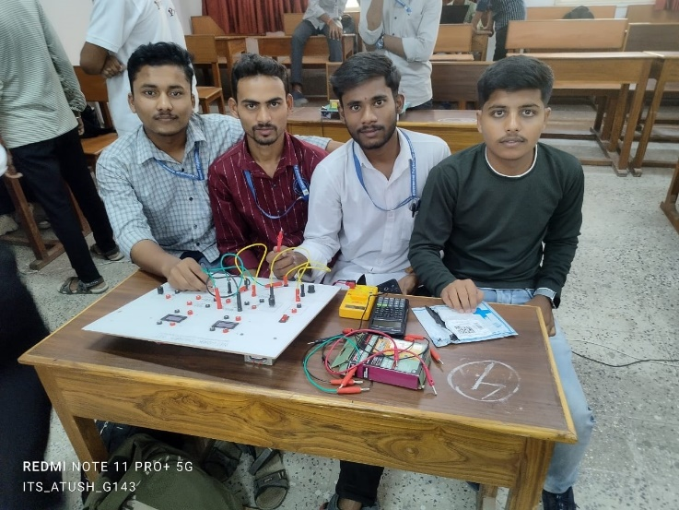

SCHEMATIC DIAGRAM:
There are of our project as follows:
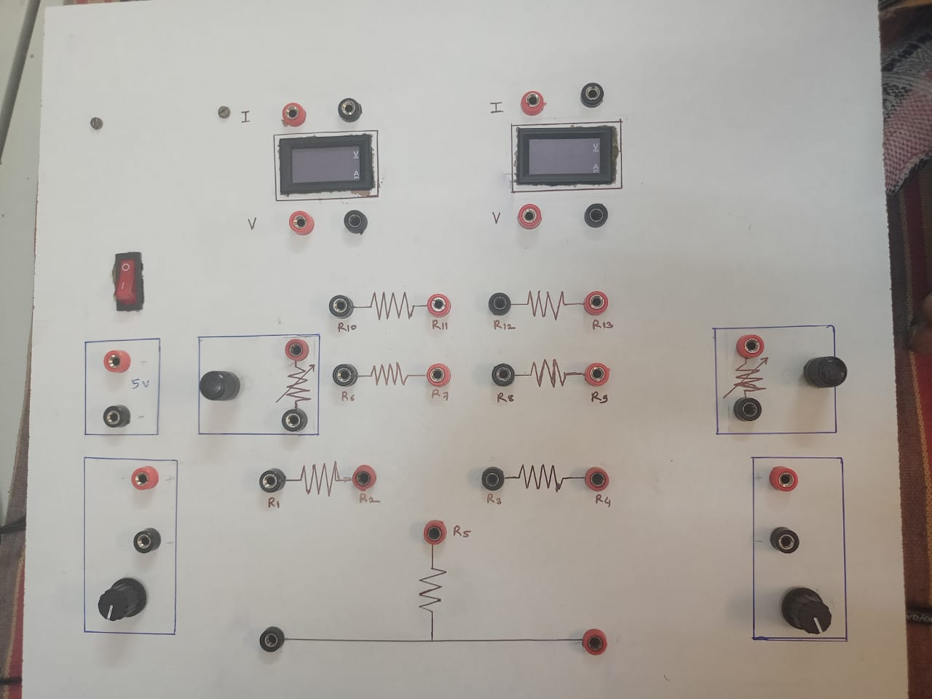
  - Network Theorem: Network Theorems is a compact, ready to use experiment board and has been designed specifically for the study and verification of network theorems in DC circuits. In network analysis, the fundamental roles are ohm's law and Kirchhoff's laws. These laws may be applied to analyze any circuit configuration bat for solving complex circuits, use of "Network theorems" is much better because it simplifies the analysis of complicated circuits. It is a useful product for students to study and verify Norton's Maximum Power Transfer, Tevenin's. , and Superposition Theorems. This product explains corresponding theorems in very easy way. and Norton's Thevenin's and Maximum Power Transfer Theorems are explained in a single circuit so that student can compare these theorems with each other. Superposition and Reciprocity theorems are also explained in a single circuit. The product is designed and presented in such a way that student can easily measure all the electrical parameters like voltage, current and resistance

Follow these steps in order to find the Thevenin’s equivalent circuit, when only the sources of independent type are present.
- Step 1 − Consider the circuit diagram by opening the terminals with respect to which the Thevenin’s equivalent circuit is to be found.
- Step 2 − Find Thevenin’s voltage V_{Th} across the open terminals of the above circuit.
- Step 3 − Find Thevenin’s resistance R_{Th} across the open terminals of the above circuit by eliminating the independent sources present in it.
- Step 4 − Draw the Thevenin’s equivalent circuit by connecting a Thevenin’s voltage V_{Th} in series with a Thevenin’s resistance.

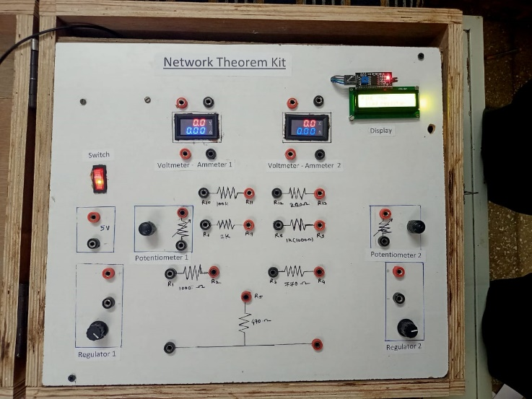
- Actual project kit:

4. Advantages of Network Theorem:
- Internal Resistance Rs should be zero.
- Supplies constant voltage to the load.
- Whatever current is across load.
- Can supply any amount of Voltage.
- across load,
- Voltage depends only on RL.
- Internal Resistance Rs should be minimum.
- Vs changes with the current

5. DISADVANTAGES:
Not applicable to unilateral network.
There should not be magnetic coupling between the load and circuit, to be replaced by thevenin's theorem.
In the load side, there should not be controlled sources, controlled fr some other part of circuit

5. RESULT: The total current through any portion of the network is equal to the algebraic sum of the currents produced independently by each source. Thevenin's theorem states that any two terminal linear network or circuit can be represented with an equivalent network or circuit, which consists of a voltage source in series with a resistor. It is known as Thevenin's equivalent circuit.

6. CONCLUSION :- Three possible cases of maximum power transferred to a load in a circuit where only one resistance is variable, have been brought out. Only in of the cases when the load resistance is variable the maximum power transfer theorem can be applied. In other two cases, when the load resistance RL is fixed, power has to be calculated from the first principle. Conditions for maximum power transfer have been derived for these cases. A case when both the Thevenin Voltage and Thevenin Resistance are variable has been studied in detail. The maximum/minimum power is obtained when either R = 0 (short circuit) or ∞ (open circuit). When RL is positive it absorbs the power; while negative it delivers the power to the circuit. Either power can be infinite, constant irrespective of the variable resistance, and finite for specific values of RL. This result has been stated in the form of a theorem. Theory has been explained with the help of typical examples. A generalized maximum power theorem has been stated and proved by two different methods.
In the text books, while solving the circuits with controlled source using POS, controlled sources are not deactivated. Thus POS has not been applied in ‘true sense’ to circuits with dependent sources. It has been shown here that POS can be applied in the ‘true sense’ to such circuits also, but with Source is deactivated, its controlling variable should not be zeroed.

7. REFERANCE:
- https://www.allaboutcircuits.com/textbook/direct-current/chpt-10/introduction-network-theorems/
- https://www.elprocus.com/basics-of-network-theorems-in-electrical-engineering/
- https://www.tutorialspoint.com/network_theory/network_theory_thevenins_theorem.htm
- https://www.quora.com/What-are-the-advantages-and-disadvantages-of-using-Th%C3%A9venins-theorem
- https://www.google.com/amp/s/www.geeksforgeeks.org/advantages-and-disadvantages-of-computer-networking/amp/
- https://m.youtube.com/watch?v=x7QRAM5w1K8

