HOUSE PRICE PREDICTION SYSTEM USING RIDGE
REGRESSION & LASSO REGRESSION

Ruchi Banerjee Parul Madewar Neha Yadav Department. of IT Department of IT Department of IT
ruchi.banerjee.it@ghrce.raisoni.net parul.madewar.it@ghrce.raisoni.net neha.yadav..it@ghrce.raisoni.net

Prof. Sonali Guhe
Asst. Prof Dept of Information Technology
G H Raisoni College of Engineering, Nagpur

ABSTRACT
The government, financial institutions, real estate market, as well as homeowners, all depend on accurate house price predictions. Multicollinearity, however, is a typical occurrence in multivariate analysis and has a significant impact on the model. Since both the Ridge and Lasso regression models can handle multicollinearity, this study compares their performance. Construction and comparison of the Ridge and Lasso regression models have been conducted. The performance of the model is evaluated using adjusted r-squared and standard errors. This comparison analysis discovered that the Lasso regression model outperforms the Ridge regression model.

KEYWORDS
Machine Learning, lasso regression, ridge regression, House Price Prediction, Mean Squared Error.

- INTRODUCTION
Machine Learning has become a popular technology today. Due to the increasing population and migration from rural to urban areas to seek financial opportunities, the demand for housing is on the rise. However, some people may become victims of fraudulent practices such as monetary losses due to lack of knowledge about the actual prices of houses. There are different Machine Learning algorithms such as ridge regression and lasso regression that can predict the prices of houses. Typically, the training of the prediction model is done using 80% of data from the random city datasets, and the rest 20% is employed for testing. This study employs diverse approaches i.e. features, labels, reduction techniques, and attribute combinations to detect missing attributes and explore new correlations. These findings suggest that house price prediction is a budding area of research that necessitates knowledge in machine learning.

The assessment will be conducted to assess the accuracy of predicting the prices of houses. This is because numerous regression algorithms not rely on particular features but also on unfamiliar parameters that contribute to the prediction. A house's selling price is influenced by a number of elements, including the geographical location, available amenities, and specific house specifications, such as the size. Additionally, the house's valuation may change according to its location, with larger houses located in desirable areas commanding higher prices than those in rural areas.

- LITERATURE STUDY
Here a random city was selected to investigate the affecting parameters causing the cost of a house. The size of the property in square feet, location, and available amenities were identified as important aspects that affect the selling price of a house. The study utilized multiple linear regression (Least Squares), Lasso regression, SVM, random forest, and support vector machine to predict asset pricing. The study reviewed 14 articles to detect the attributes that affect the selling price of a house, and found the square meters of the house and the total number of bathrooms and bedrooms, were the the most essential factors in determining a house's price. The study also revealed that an increase of 100 square feet in the floor space of a house can lead to a 2.6% increase in its value. The accurate prediction of house prices has always been a point of interest for buyers, sellers, and bankers, and various researchers worldwide have contributed to developing theories in this area.

- ALGORITHM’S PROPERTIES
To build a model for predicting housing prices, the study employs the ridge regression and lasso regression techniques. Prior to building the model, the data must undergo pre-processing to address outliers and missing values. Outliers are removed from the observations, and missing values are replaced with zero and none for numeric and categorical variables, respectively.For model building the data set is partitioned into the training data set which is for training model and for model validation is test set. The efficiency of the lasso and ridge regression models is evaluated using measures such as adjusted r-squared and root mean sq. error.

- METHODOLOGY

- Lasso Regression
Robert Tibshirani invented the Lasso, also known as the Least Absolute Shrinkage and Selection Operator, as a regularised regression method in 1996. The efficiency of Lasso in feature selection and normalisation is well established. It involves introducing a bias term and a penalty term based on the absolute value of the slope, rather than squaring it as in Ridge regression. The mathematical formula for Lasso is explained as:
𝐿= 𝑀𝑖𝑛(𝑠𝑢𝑚 𝑜𝑓 𝑠𝑞. 𝑟𝑒𝑠𝑖𝑑𝑢𝑎𝑙𝑠 + 𝛼 ∗ |𝑠𝑙𝑜𝑝𝑒|)
Here alpha is a setting property that regulates the severity of the penalty period. 𝛼 ∗ |𝑠𝑙𝑜𝑝𝑒| is the penalty term and Min(sum of sq. residuals) is the least squared error. Simply said, the adjustment parameters have lower values. The total of the coefficients' absolute values is known as the |𝑠𝑙𝑜𝑝𝑒|.

Rotation Estimation is still a popular technique for comparing and assessing the performance of various machine learning algorithms. Each block of the data is utilized to test the method, while the remaining blocks are used for model tutoring and prediction. The results are then combined, and the best performing block is chosen for assessing. In this analysis, rotation estimation is used to give an estimate of 𝛼. A value of 𝛼 is equal to 0 results in least squared error, while a non-zero value of 𝛼 takes into account the magnitudes of the coefficients and tends to zero coefficients. The relationship between the top bound of the summation for coefficients t and the alpha 𝑎 is inverse. Since 𝑡 tends to infinity, when the tuning parameter 𝑎 approaches 0 and 𝑡 equals 0, the coefficients reduce to 0 and 𝑎 achieves infinity.

Lasso can be helpful in enhancing the predictability and interpretability of a regression model by assigning zero to redundant or unimportant components. During feature selection, after the compression procedure, variables whose coefficients still have non-zero values are chosen to be part of the model. The ability to select features and reduce overfitting is also known as lasso.

- Ridge Regression
Hoerl devised the L2-norm normalised regression method known as Ridge Regression in 1962, it regulates collinearity and preserves variables in a regression model. Multicollinearity frequently results in the least square estimation being biased and its variances being highly inaccurate in multiple linear regression. By introducing a slight bias to the regression model, ridge regression reduces the standard errors and shifts the least square coefficients closer to the parameter space's origin. The formula for ridge regression is as follows:
𝑅= 𝑀𝑖𝑛(𝑠𝑢𝑚 𝑜𝑓 𝑠𝑞. 𝑟𝑒𝑠𝑖𝑑𝑢𝑎𝑙𝑠 + 𝛼 ∗ 𝑠𝑙𝑜𝑝𝑒² )
Here, Ridge adds the penalty term 𝛼 ∗ 𝑠𝑙𝑜𝑝𝑒² and the least squared error Min(sum of sq. residuals).

The summation of squared residuals is reduced when using the least squared error approach to determine parameter values. The tuning parameter 𝛼 controls both the length of slope and severity of the penalty in the case of Ridge Regression, which also minimizes the sum of squared residuals. Asymptotically, increasing causes the slope to decline. The severity of the penalty term is determined using the Cross-validation method, similar to Lasso. By compressing the parameters, Ridge makes the prediction less sensitive while also reducing variance. Additionally, it is an effective method for reducing multicollinearity in multiple linear regression, which can cause least square estimation to be biased and result in significantly off-mark variances.

V. RESULT
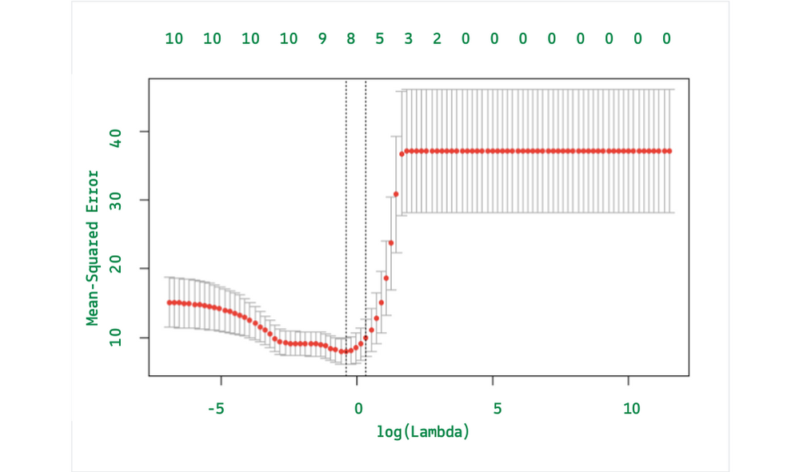

The figure shows log λ=-1, the value large lambda, and a high mean squared error. The mean squared error reduces and stays flat as the log λ approaches -7. The optimum value of λ lasso regression is 0.0006282506.

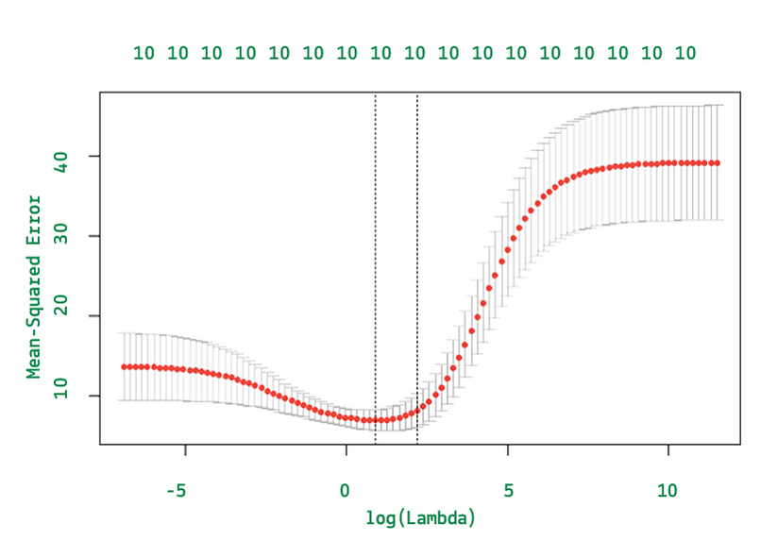
The figure shows log λ=5, the value of large lambda, and a high mean squared error. The mean squared error reduces and stays flat as the log λ approaches -2. The optimum value of λ Ridge Regression is 0.03200439.

Table 1. Ridge & Lasso Regression model comparison
 | Ridge | Lasso
Root Mean Sq. Error | 0.1333758 | 0.1225351
Adjusted R- Squared | 0.8897963 | 0.9010418

According to the results presented in Table 1, the Lasso regression model outperforms the Ridge regression model, exhibiting a lower root mean square error and a higher adjusted R-squared value. This suggests that Lasso regression is the more effective method for predicting house prices using this dataset.

CONCLUSION
The study conducted a comparison between the performance of the Ridge and Lasso regression models. The results indicate that by exhibiting a lesser root mean square error and a higher adjusted R-squared value, the Lasso model outperforms the Ridge model. Specifically, the Lasso model's adjusted R-squared score of 0.90 indicates that the model's 18 predictor variables can account for 90% of the variation in the sale price of a house. This higher adjusted R-squared value suggests that a model of regression using lasso is more effective in predicting the cost to sell a house.

The Lasso regression model has identified the size, condition, age, and location of the house as the most significant variables for predicting the house price. The location variable has been shown to have a big impact on the price of the house, with houses located in medium-density and commercial zones having lower prices than those located in other areas. Additionally, the model has found that the price of a house tends to increase with its size, both in terms of the number of rooms and the overall area, as well as its condition, with new houses generally being more expensive than older ones.

REFERENCES
- Turk R. Housing price and household debt interactions in Sweden. International MonetaryFund. 2015 Dec.
- Marelli E, Choudhry M, Signorelli M. Youth and total unemployment rate: The impact of policies and institutions. Rivista internazionale di scienze sociali. 2013 Jan; 121(1): 63-86
- Ernst E, Saliba F. Are house prices responsible for unemployment persistence?. OpenEconomies Review. 2018
- https://www.ijraset.com/research-paper/house-price-prediction-using-ml
- https://www.kaggle.com/code/ammar111/house-price-prediction-an-end-to-end-ml-project#:~:text=Goals%20of%20the%20Study,to%20choose%20the%20best%20model
- https://www.diva-portal.org/smash/get/diva2:1456610/FULLTEXT01.pdf
- R T. Regression shrinkage and selection via the lasso. Journal of the Royal Statistical Society: Series B (Methodological). 1996 January; 58(1): 267-288.
- Fonti V. Feature Selection using LASSO. VU Amsterdam Research Paper in Business Analytics. 2017 Mars: p. 1-25.
- Friedman J, Hastie T, Tibshirani R. The elements of statistical learning. New York: Springer series in statistics. 2001.
- Clark AE, Troskie CG. Ridge Regression – A Simulation Study. Communications in Statistics - Simulation and. 2006: p. 605-619.
- Yahya WB OJ. A note on ridge regression modeling. Electronic Journal of Applied Statistical Analysis. 2014 Oct : p. 343-361.
- J. Manasa, R. Gupta, and N. Narahari, “Machine learning based predicting house prices using regression techniques,” in 2020 2nd International conference on innovative mechanisms for industry applications (ICIMIA). IEEE, 2020, pp. 624–630.

