DATA CLASSIFYING TECHNIQUES TO CLASSIFY SATELLITE IMAGES
K. Yeswanth Nagendra Kumar
Under Graduate Scholar,
Department of Electronics and
Communication Engineering,
Sir C R Reddy College of Engineering,
Vatluru, Eluru.
yeswanth94405@gmail.com

K. Sri Lekha
Under Graduate Scholar,
Department of Electronics and
Communication Engineering,
Sir C R Reddy College of Engineering,
Vatluru, Eluru.
karnatisrilekha2002@gmail.com

J. Gopi Priya
Under Graduate Scholar,
Department of Electronics and
Communication Engineering,
Sir C R Reddy College of Engineering,
Vatluru, Eluru.
priyajasti24@gmail.com

K. Satish Kumar
Under Graduate Scholar,
Department of Electronics and
Communication Engineering,
Sir C R Reddy College of Engineering,
Vatluru, Eluru.
kemburisatishkumar@gmail.com

M. Sirisha
Under Graduate Scholar,
Department of Electronics and
Communication Engineering,
Sir C R Reddy College of Engineering,
Vatluru, Eluru.
muvvasirisha5@gmail.com

V. Veerraju
Assistant Professor,
Department of Electronics and
Communication Engineering,
Sir C R Reddy College of Engineering,
Vatluru, Eluru.
rajuvee2@gmail.com

Abstract – Several approaches, including machine learning-based Support Vector Machine (SVM), Extended Local Binary Patterns (ELBP), and Convolutional Neural Networks (CNN) have been used to classify satellite photos into various categories. The proposed approach not only classifies satellite images but also identifies features of other classes such as rugby balls, deserts, forests, seas, etc. The proposed method overcomes the challenges of varying features and high levels of noise in satellite images. Unlike other classification methods, the proposed CNN – based approach classifies images without feature extraction. This method involves the segmentation of the input test image and is then followed by the extraction of local binary patterns using the proposed ELBP method. The Extended Local Binary Pattern is employed because LBP cannot distinguish patterns of distinct satellite photos and other types of images. After obtaining the features, SVM is utilized to categorize the test image’s class. The proposed CNN-ELBP-SVM classifier method achieved a 98% accuracy rate in recognizing satellite images and the experimental results obtained using MATLAB 2019a are superior to those of other available methods.
Keywords – Image Processing, Extended Local Binary Patterns, Support Vector Machine, Convolutional Neural Network, Satellite Imagery, Machine Learning Supported MATLAB 2019a.
- INTRODUCTION
Satellite image processing involves using tools or techniques to remove unwanted parts or features from the image, which are referred
to as channels [10]. Filters are not limited to the frequency domain and many other methods exist for isolating specific features without operating in the frequency domain. However, one major drawback of filtering is that it results in the loss of associated data. A Fourier-based approach to combining satellite images is an alternative way to eliminate certain frequencies from the original image. There are various ways to categorize filters, but they are complex and do not easily lend themselves to a hierarchical system based on content.
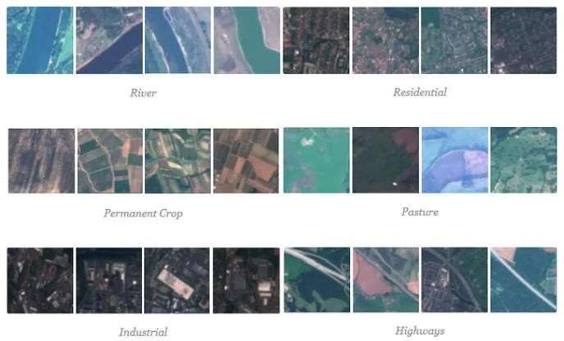
Fig 1: Classification Model

According to their characteristics, images are often classified into three categories: “handcrafted feature-based methods” focus on properties such as color and shape information that are relevant to remote sensing images, while “unsupervised feature learning-based methods” aim to learn basic functions such as the bag of words model used for feature encoding [11]. The satellite pictures vary generally as far as the textural contrasts, and shading varieties, and are very mind-boggling because of the presence of these varieties. Thus applying preparation methods on the satellite information is very troublesome. Additionally, the satellite information is caught from significant distances and is influenced by the presence of undesirable impedances which influences the nature of the picture.

Training phase

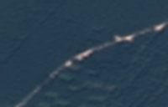
Features vector extraction using CNN

Preprocessing

Training image dataset

- LITERATURE REVIEW
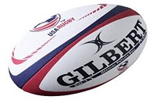
[1] T.-T. Ng, S.-F. Chang, J. Hsu, and M. Pepeljugoski, “Columbia photographic images and photorealistic computer graphics dataset,” work on the photographic images versus photorealistic computer graphics classification problem, which is a subproblem of the passive-blind image authentication research and works on the various datasets.
Classification model

ELBP Feature
Comparison

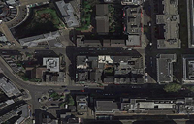
[3] J. Chen, X. Kang, Y. Liu, and Z.J. Wang, “Median filtering forensics based on convolutional neural networks,” works on applying CNNs in median filtering image forensics. In contrast to traditional CNN models, the initial layer of our CNN architecture is a filter layer that receives an image as input and returns the median filtering residual (MFR). Then, we get a variety of characteristics for additional categorization by switching between convolutional layers and layer pooling to develop hierarchical representations. In various experiments, we evaluate the suggested methodology. The findings indicate that the suggested strategy significantly improves performance, particularly in cut-and-paste forgery detection.
Testing phase

Features vector extraction using CNN

Testing features

[9] Dang-Nguyen proposed an asymmetry-information-based method to discriminate between natural and CG human faces with a threshold, and this feature can be added to other feature sets to improve their performance by using Binary categorizing using SVM. To distinguish between natural and CG faces in videos.
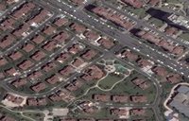

Preprocessing

[10] developed an SVM-based method by examining the spatial temporal variation of their 3D models. The underlying idea is that the variations in real faces are more complex than those in CG faces. The latter often follows repetitive or fixed patterns. For general cases, in which we wish to distinguish between Nis and CG images of various scenes that are not limited to those depicting human beings, the most common strategy is to use machine-learning-based methods with multidimensional feature extraction and classifier training.
Testing Images

Decision

[7] The process of classifying satellite images depends on the object or semantic meaning of the image, and classification can be divided into three main categories: methods based on low features, and other methods based on high scene features. The simplest type of texture feature or shape feature is used as the first method of classification that relies on low features. The most popular low-feature methods are local binary patterns or features based on histograms, as in the paper [8], where the researcher used the texture with LBP as a classification tool. The approaches based on mid characteristics are appropriate for a variety of complicated image types and structural types [4]. Ways with high features in comparison to others can be considered the most successful ways for complicated images [6].
- PROPOSED SYSTEM
By using a CNN model, the proposed strategy seeks to increase the accuracy of image classification. To achieve this, the Residual Network (ResNet50) was selected for assessment due to its reliable performance. ResNet50 is an abbreviation for Residual Network comprising 50 layers. In the early days of deep learning models, researchers believed that deeper networks would result in better performance. However, this theory was disproved when a 52-layer deep network produced inferior outcomes compared to networks with 20-30 layers.
Fig 2: Satellite Image Classification Block Diagram

- METHODOLOGY

In recent years, a variety of methods have been developed for classifying satellite images, such as Random Forest, Speed Up Robust Features (SURF), and K-means clustering. One of the primary issues in this area is that satellite photos might have a variety of properties, making classification difficult. Furthermore, most satellite images are prone to noise, which further complicates the classification process. This study aims to overcome these challenges and successfully classify satellite images [11]. To achieve this, the machine learning-based Support Vector Machine (SVM), Extended Local Binary Patterns (ELBP), and Convolutional Neural Network (CNN) techniques were employed to classify satellite images into distinct categories.

- Extended Local Binary Patterns (ELBP):
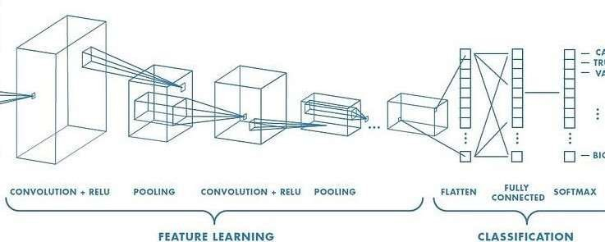

A method for enhancing the discriminative power of Local Binary Patterns (LBP) is the Extended Local Binary Patterns (ELBP). In contrast to LBP, ELBP encodes the precise variations in grey values utilizing extra binary units in addition to binary comparisons between the center pixels and neighboring pixels [15]. The ELBP feature is composed of a number of LBP codes at various values that represent the difference in grey values between the center pixel and its surrounding pixels. The first layer of ELBP is the original LBP code encoding the sign of the grey-value difference. The subsequent layers encode the absolute value of the difference. To encode the absolute value of the grey-value difference, each value is first represented in binary, and all binary values at a given layer result in additional Local Binary Patterns. Each binary bit is assigned a weight, and the ELBP code for the corresponding layer is generated using the same weight scheme for all binary bits. For instance, L1 is composed of (11010011)2 and has a decimal value of 211, L2 is composed of (01000000)2 and has a decimal value of 64, L3 is composed of (00110110)2 and has a decimal value of 54, and L4 is composed of (11101010)2 and has a decimal value of 234. While the first layer LBP may not be sufficiently discriminative when describing similar local textures, the information encoded in the additional layers can be utilized to distinguish them. However, a drawback of ELBP is that it greatly increases feature dimensionality.
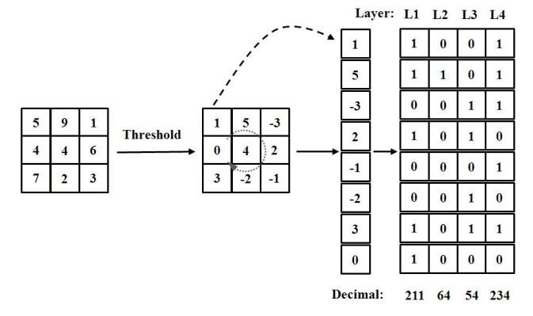

Fig 3: An example of the ELBP operator

- Convolutional Neural Network (CNN):
The CNN-based approach has demonstrated impressive classification accuracy and resilience to common post-processing techniques, owing to its carefully constructed and executed model. However, in this particular section, we seek to delve deeper and uncover the tacit information embedded within the data that cannot be effectively conveyed through the quantitative assessment measures outlined. To this end, we utilize a range of advanced and suitable visualization methods that pertain to CNNs, in order to gain insight into the nuanced distinctions between Nis and CG images that have been learned by the CNN technique [5].
Previous attempts at using CNNs for image steganalysis and forensics overlooked an important aspect, which we aim to address in this study. Specifically, we examine the filters that the CNN has learned at its first layer, which directly takes in raw pixel data and is therefore more easily interpretable than the subsequent layers. It is common for CNNs trained on natural images for computer vision tasks to learn kernels resembling the Gabor filter and color blobs in the first layer. These kernels, being linear filters, can be analyzed [13]
Fig 5: The structure of a Convolutional Neural Network
using the fast Fourier transform (FFT), a powerful tool in signal processing. The first layer kernels are organized into groups of three, corresponding to the three-color channels of B, G, and R. Interestingly, we observe that many kernels [2] in the first layer exhibit a drop in performance when constrained to a certain range of frequency, suggesting that the band-pass information within that range may be more information distinction Nis from CG images than the high-frequency information.
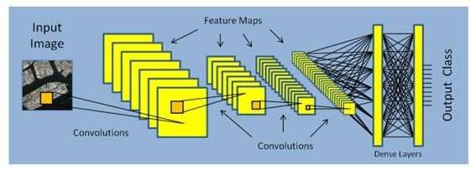
Fig 5: The structure of a Convolutional Neural Network

(c) Support Vector Machine (SVM):
The support vector machine (SVM) is a supervised machine learning technique used for classification and regression tasks [14]. It is regarded as one of the most robust methods for classification. SVM operates by estimating a line, known as a hyperplane, that separates two classes of data. The technique identifies the points closest to the hyperplane from both classes and these points are referred to as support vectors. The margin is then calculated as the distance between the hyperplane and support vectors. The objective of SVM is to maximize this margin. The optimal hyperplane is the hyperplane that has the maximum margin.
The SVM technique is primarily designed for binary classification problems. However, it can also be extended to handle multiclass classification by breaking down the problem into a series of binary classification sub-problems. In this approach, the data is separated into multiple groups, with each group representing a unique binary classification problem. The same principles that apply to binary classification are then used to determine the optimal hyperplane for each group. By combining the results from each of these binary classifications, the SVM technique can ultimately make predictions for multiclass classification problems.
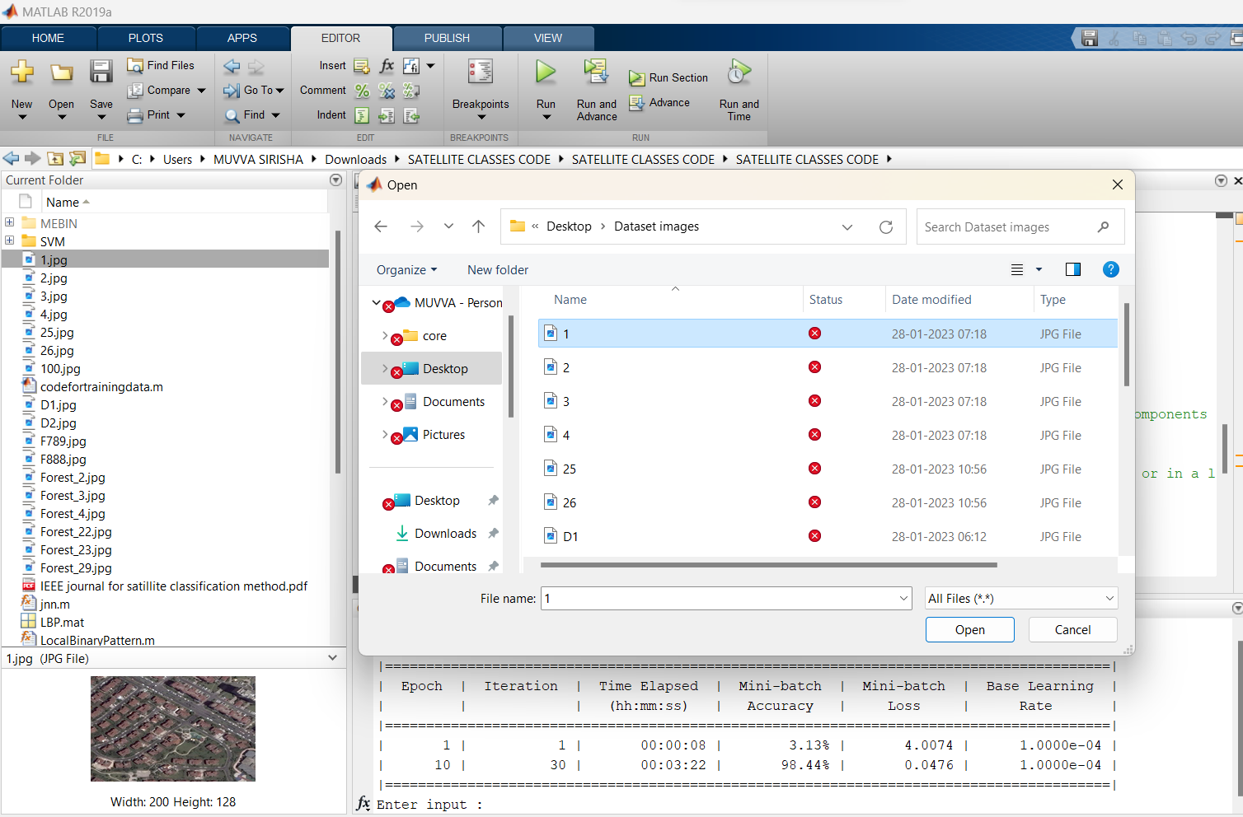
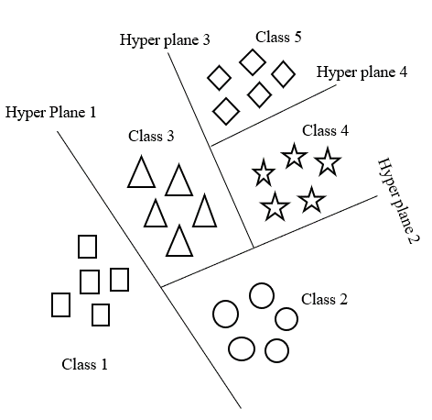

Fig 6: Multi-Class SVM
- RESULTS
The proposed work was evaluated on 100 simulated satellite test image classes using a combination of machine learning features, including ELBP, CNN, and SVM classifiers. In total, the proposed Image Classification Method was able to correctly classify 98 out of 100 satellite images, resulting in an overall accuracy of 98%.
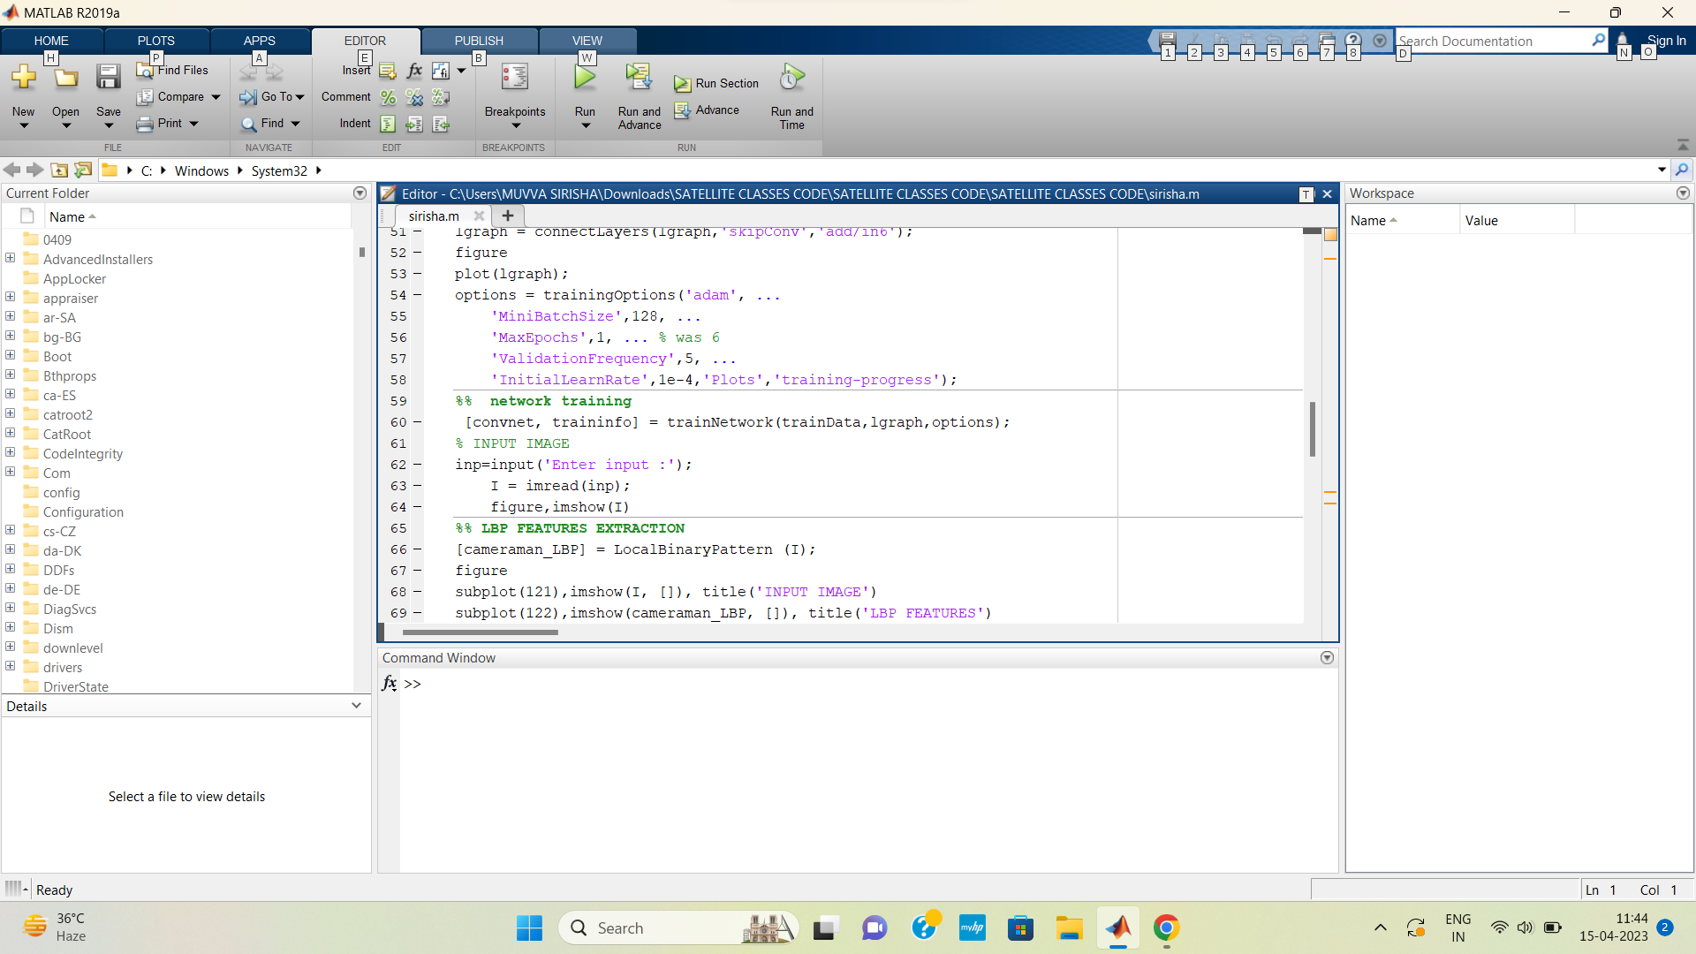
Fig 7: MATLAB 2019a
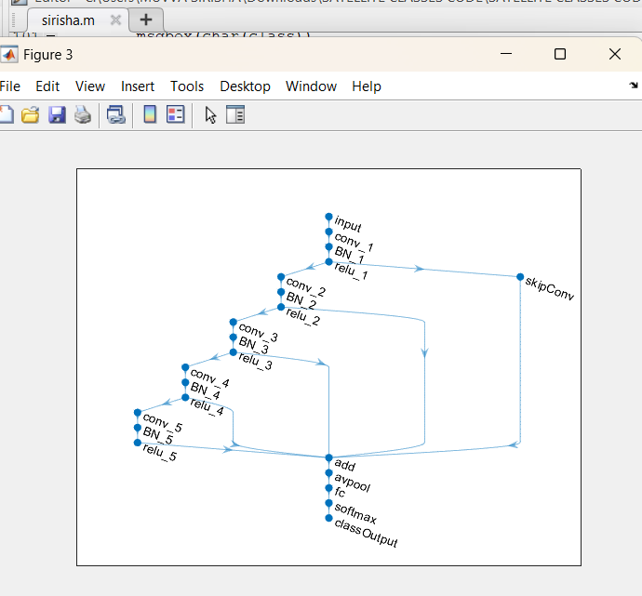
Fig 8: Classification using CNN

Fig 9: Training of Satellite image
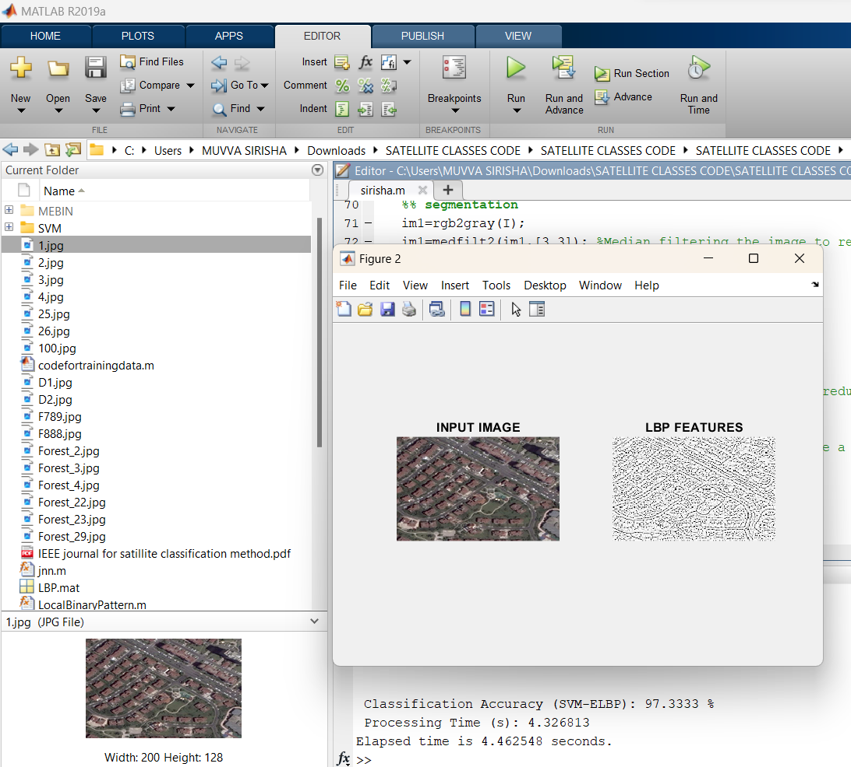
Fig 10: Extraction of ELBP
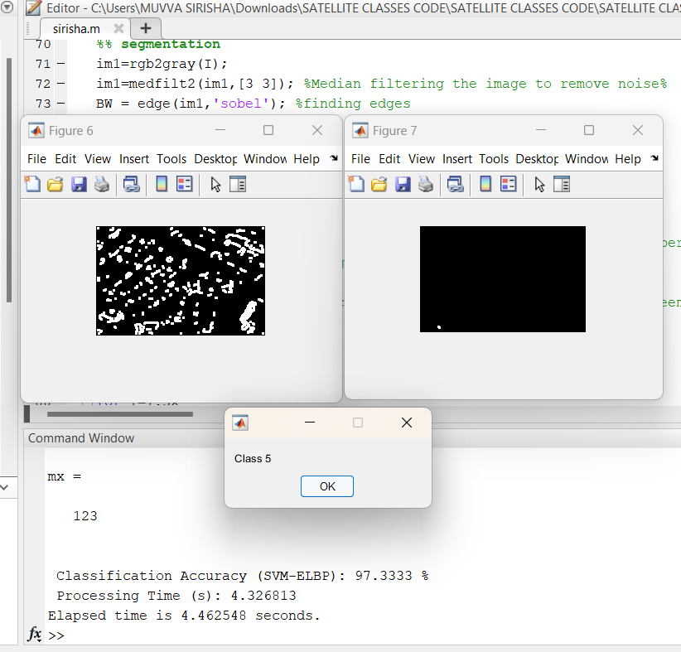
Fig 11: SVM Classification
Fig 12: Satellite image trained as Class 5
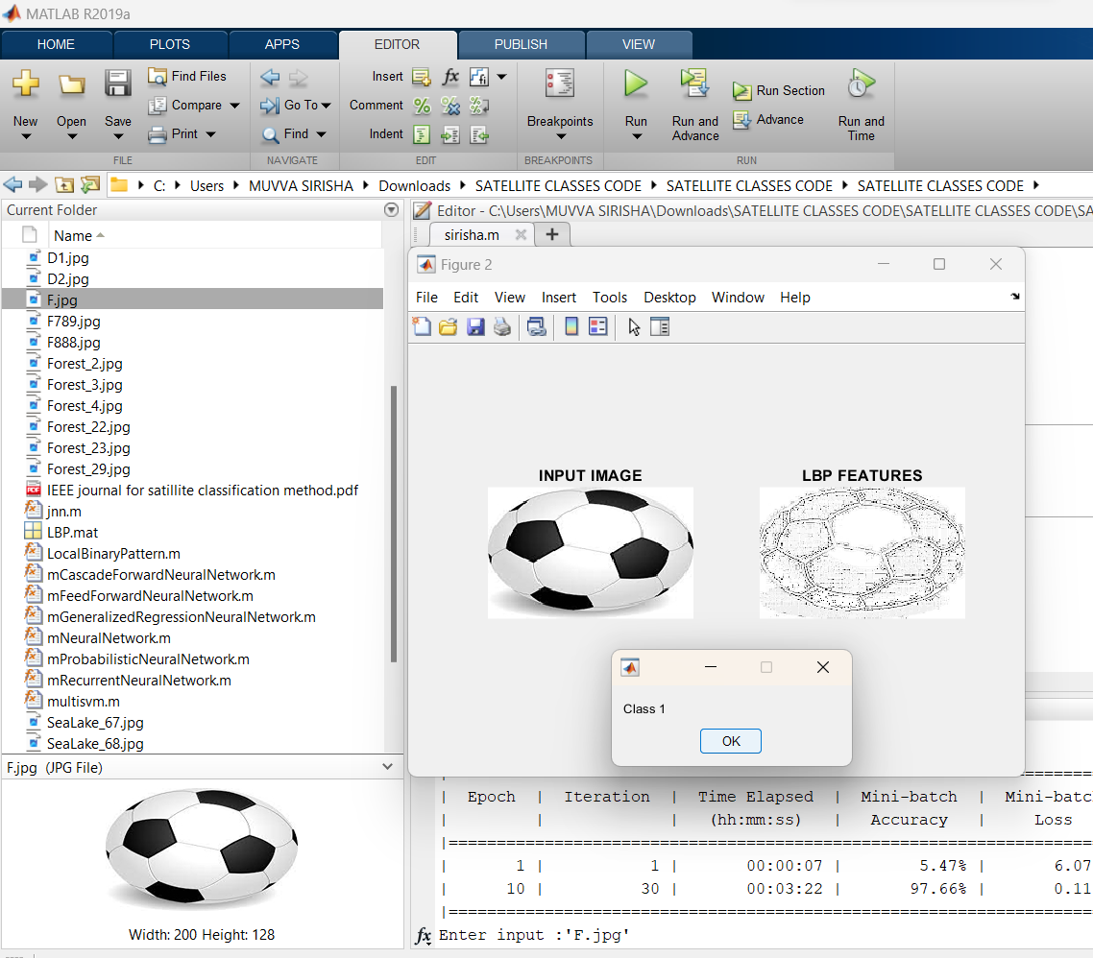
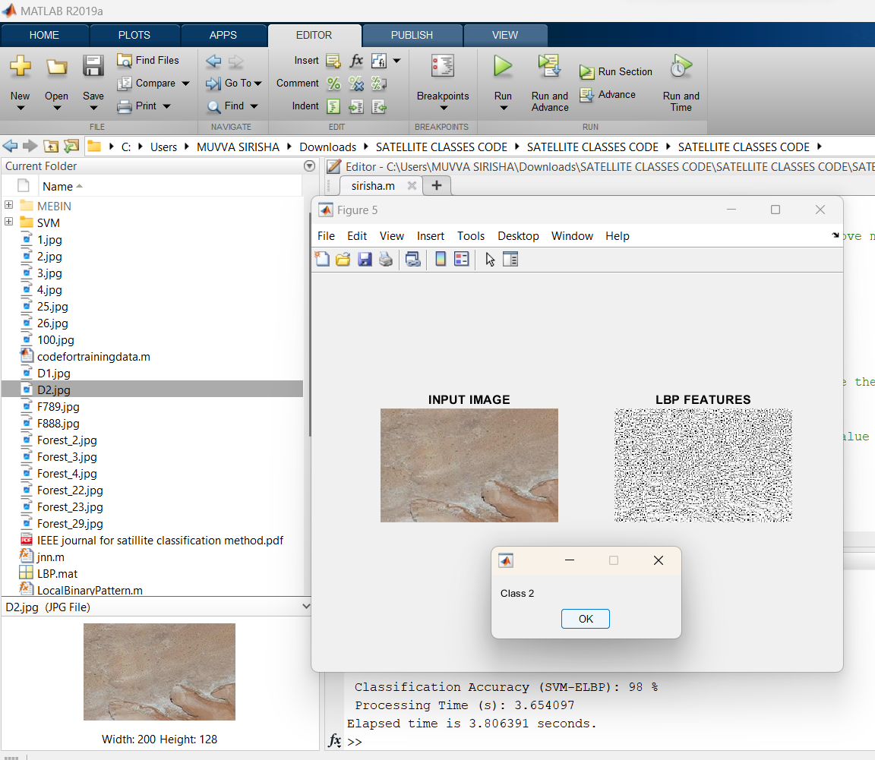
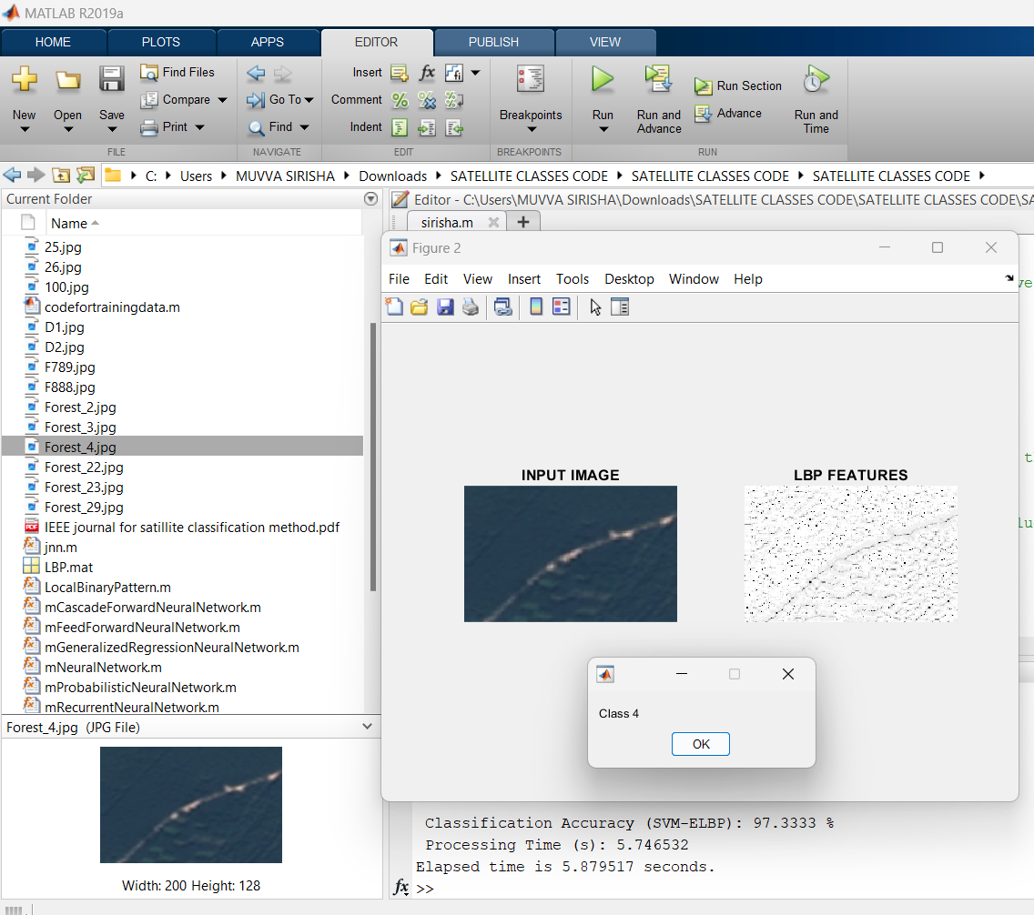
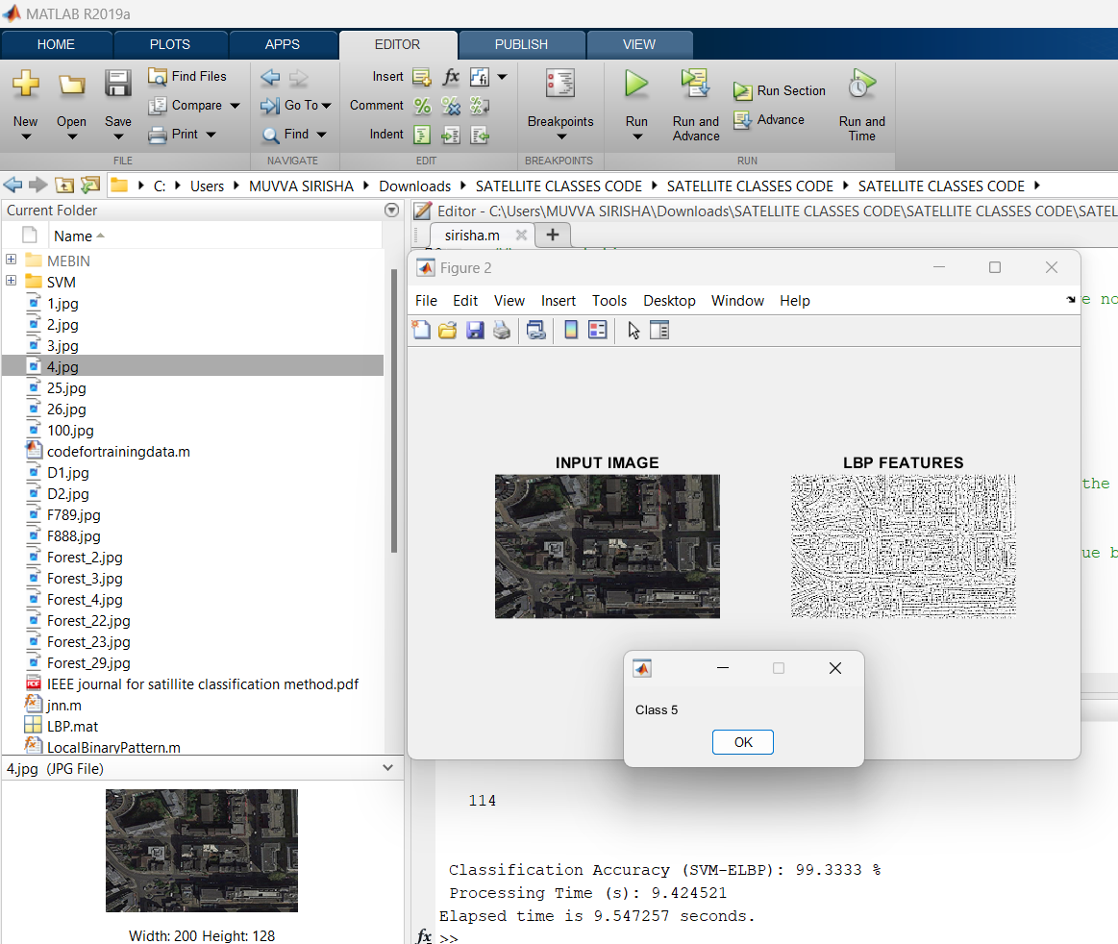
Fig 13: Forest image trained as Class 4
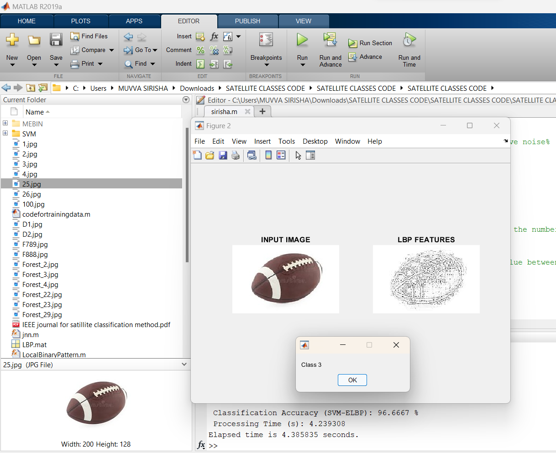
Fig 14: Rugby-ball image trained as Class 3
Fig 16: Football image trained as Class 1
Fig 15: Desert image trained as Class 2

Table 1 Comparative Results
Work | Method | Average  Accuracy  Observe
Proposed  CNN-ELBP-SVM | CNN, ELBP, and SVM Classifier | 98
ELBP-SVM | ELBP and /RKSVM Classifier | 94
Anju Asokan  [10] | Random Forest (RF) with SVM | 88
Sehla Loussaief  [11] | Speed Up Robust Features and K-mean Clustering | 89
Mohd Azlan  Abdul [12] | DNN and Tensorflow | 94
Andreas  Kolsch [13] | CNN and Extreme Learning Machines | 90
- CONCLUSION
Satellite images are taken from the Bhuvan website for input images. The focus of this paper is to present a machine-learning framework for satellite image classification that utilizes convolutional neural networks (CNNs) and features extracted from four pre-trained CNN models. The paper discusses various techniques and algorithms incorporated into the proposed framework. Additionally, the paper highlights the application of cutting-edge AI to image classification. The Bag of Features approach is used for input image encoding, with the Extended Local Binary Pattern (ELBP) method employed for image feature extraction. Results from experiments demonstrate that utilizing ELBP as the local feature extractor technique for image vector representation and RKLBP as the classifier results in the highest prediction accuracy. Finally, SVM Classifies the class of the test image.
- REFERENCES

- T.-T. Ng, S.-F. Chang, J. Hsu, and M. Pepeljugoski, “Columbia photographic images and photorealistic computer graphics dataset,” ADVENT, Columbia University, Tech. Rep. 205-2004-5, 2004.

- B. Bayar and M. C. Stamm, “A deep learning approach to universal image manipulation detection using a new convolutional layer,” in Proceedings of the ACM Workshop on Information Hiding and Multimedia Security, 2016, pp. 5–10.

- J. Chen, X. Kang, Y. Liu, and Z. J. Wang, “Median filtering forensics based on convolutional neural networks,” IEEE Signal Processing Letters, vol. 22, no. 11, pp. 1849– 1853, Nov. 2015.

- R. Girshick, J. Donahue, T. Darrell, and J. Malik, “Rich feature hierarchies for accurate object detection and semantic segmentation,” in Proceedings of the IEEE Conference on Computer Vision and Pattern Recognition, 2014, pp. 580– 587.

- Y. Qian, J. Dong, W. Wang, and T. Tan, “Deep learning for steganalysis via convolutional neural networks,” in Proceedings of the IS&T/SPIE Electronic Imaging, vol. 9409, 2015, pp. 94 090J1–94 090J10.

- H. Farid and M. J. Bravo, “Photorealistic rendering: How realistic is it?” Journal of Vision, vol. 7, no. 9, p. 766, June 2007.

- B. Mader, M. S. Banks, and H. Farid, “Identifying computer-generated portraits: The importance of training and incentives,” Perception, vol. 46, no. 9, pp. 1062–1076, Sep. 2017.

- D.-T. Dang-Nguyen, G. Boato, and F. G. B. De Natale, “Identify computer-generated characters by analyzing facial expressions variation,” in Proceedings of the IEEE International Workshop on Information Forensics and Security, 2012, pp. 252–257.

- D.-T. Dang-Nguyen, G. Boato, and F. G. B. De Natale, “Discrimination between computer generated and natural human faces based on asymmetry information,” in Proceedings of the European Signal Processing Conference, 2012, pp. 1234–1238.

- A. Asokan and J. Anitha, "Machine Learning-based Image Processing Techniques for Satellite Image Analysis -A Survey," 2019 International Conference on Machine Learning.

- Sehla Loussaief, Afef Abdelkrim, Machine Learning framework for image classification, Special issue on Advancement in Engineering Technology Advances in Science, Technology and Engineering Systems Journal Vol. 3, No. 1, 01-10 (2018).

- Mohd Azlan Abu, Nurul Hazirah Indra, Abdul Halim Abd Rahman, Nor Amalia Sapiee1 and Izanoordina Ahmad, A study on Image Classification based on Deep Learning and Tensorflow, International Journal of Engineering Research and Technology.

- Andreas Kolsch, Muhammad Zeshan Afzal, Markus Ebbecke, Marcus Liwicki, Real-Time Document Image Classification using Deep CNN and Extreme Learning Machines, arXiv:1711.05862v1 [cs.CV] 3 Nov 2017.

- https://www.javatpoint.com/machine-learning-support-vector-machine-algorithm

- https://en.wikipedia.org/wiki/Local_binary_patterns

