Development of boiling micro nano structured surfaces wet/chemical etching technique.

Dr. Sanjay Kumar Gupta¹,S.Harsha vardhan²,P.Murali Mohana Rao³,N.Surya Nitesh³,S.Abhilash⁴
N,N. Abhishek Raj⁶,S.B.Satish Reddy⁷,S.Srinivasa Rao⁸,V.V.Gopala Naidu^{8.}
Assistant Professor¹,Dept.of Mechanical Engineering, GMR Institute of Technology, Rajam.
UG Students²³⁴, Dept. of Mechanical Engineering, GMR Institute of Technology, Rajam.

A B S T R A C T
Boiling heat transfer is an important phenomenon in many industrial applications such as power generation, electronics cooling, and chemical processing. One way to enhance boiling heat transfer is to use micro-nanostructured surfaces, which have been shown to increase the nucleation site density and promote the formation of stable bubbles. Among the various methods to create such surfaces, etching has emerged as a promising technique due to its simplicity and cost-effectiveness. The aim of this paper is to investigate the boiling heat transfer performance of micro-nanostructured surfaces developed by etching. The study will be carried out using a custom-built experimental setup that allows for precise control of the heat flux, surface roughness, and working fluid. The surfaces will be characterized using scanning electron microscopy (SEM) and atomic force microscopy (AFM) to determine the surface morphology and roughness. The boiling heat transfer experiments will be conducted using distilled water as the working fluid and varying the heat flux to investigate the effect of surface roughness and micro-nanostructures on the critical heat flux (CHF) and boiling heat transfer coefficient (BHTC). The results will be compared with those obtained from smooth surfaces to assess the enhancement in boiling heat transfer performance. The outcomes of this mini-project will provide insights into the potential of micro-nanostructured surfaces developed by etching to improve the boiling heat transfer performance. The findings may have practical implications in various industries, including energy, electronics, and chemical engineering, where efficient heat transfer is crucial for optimal performance.

Keywords: BHTC, atomic force microscopy, Scanning electron microscopy.

- Introduction

The boiling heat transfer is applied in diverse field of industrial appliances and processes, for example heat exchangers, refrigeration, air-conditioning, power production, petroleum refining, and chemical manufacturing. Improvement in boiling heat transfer is very important for building these industrial applications more efficient. The electronic chips employed in different fields, for example military, space devices, and high-speed computing, demand faster heat dissipation rate from a confined space. The air-cooling devices are not efficient to remove the high heat flux from a confined space due to the small specific heat, small heat transfer coefficients (HTC), and high volume. The size of cooling device will decrease with increase in HTC.

The pool boiling is an efficient mode of cooling due to its capacity to take high heat flux at low superheat temperature without moving elements [1]. In order to decrease the energy consumptions in energy conversion devices, boiling heat transfer augmentation is one of the important research activities for the scientific community.

The boiling heat transfer can be improved by active mechanisms like electrostatic fields, ultrasonic vibrations, etc., or by passive methods like porous surfaces, extended surfaces such as lightly cut grooves, finned surfaces, included micro-nanostructures. [2, 3]. Microporous coated surfaces are more effective due to their capacity to enhance both HTC and critical heat flux (CHF) [4, 5]. In this work, microporous structured surfaces are developed by using electrochemical deposition technique and controlled the deposition for improving the pool boiling heat transfer performance.

Micro-nanostructured surfaces have been extensively studied for their enhanced boiling heat transfer performance. One method of developing such surfaces is through etching and forced convection electrodeposition technique. In this technique, a metallic surface is first etched to create microscale cavities, and then a layer of nanostructures is deposited on top of the cavities using forced convection electrodeposition.

The resulting micro-nanostructured surface exhibits enhanced boiling heat transfer performance due to the increased surface area and the ability of the nanostructures to promote nucleation. The micro scale cavities provide sites for bubble nucleation, while the nanostructures provide additional nucleation sites and also act as stabilizers for the bubbles.

Studies have shown that the boiling heat transfer coefficient of micro-nanostructured surfaces developed by etching and forced convection electrodeposition technique is significantly higher than that of smooth surfaces. For example, one study found that the boiling heat transfer coefficient of a copper surface with micro-nanostructures developed by this technique was more than three times higher than that of a smooth copper surface.

In addition to the enhanced boiling heat transfer performance, micro-nanostructured surfaces developed by etching and forced convection electrodeposition technique also exhibit good mechanical and chemical stability. The technique is relatively simple and can be applied to various metallic surfaces, making it a promising approach for the development of high-performance heat transfer surfaces in various applications, such as in cooling systems for electronic devices or power plants.

- Objective
The objective of this mini-project is to investigate the boiling heat transfer performance of micro-nanostructured surfaces developed by etching. Specifically, the project aims to:

- Evaluate the effect of surface roughness and micro-nanostructures on the boiling heat transfer coefficient (BHTC).
- Investigate the effect of heat flux on the critical heat flux (CHF) of micro-nanostructured surfaces.
- Characterize the surface morphology and roughness of micro-nanostructured surfaces using SEM and AFM.
- Provide insights into the potential of micro-nanostructured surfaces developed by etching to enhance boiling heat transfer performance.
- Identify the optimal surface roughness and micro-nanostructure configurations for efficient boiling heat transfer.
- Contribute to the development of cost-effective and scalable techniques for creating micro-nanostructured surfaces.
- Explore the practical implications of enhanced boiling heat transfer performance in various industries.
- Expand the knowledge and understanding of the fundamental mechanisms of boiling heat transfer.
- Generate data and insights that may be useful for further research in this field.

3.Surface development and characterization:

The etching process is a crucial step in the development of micro-nanostructured surfaces for enhanced boiling heat transfer performance. During the etching process, the surface of the metal is treated with a chemical solution that selectively removes material, creating a rough surface with microscale cavities.

The micro scale cavities created by the etching process provide sites for bubble nucleation during boiling. The rough surface allows bubbles to form and detach more easily than on a smooth surface, which results in a higher boiling heat transfer coefficient. Moreover, the cavities can act as traps for the liquid surrounding the bubbles, which increases the contact area between the liquid and the surface, enhancing the heat transfer performance further.

The size and shape of the micro scale cavities can be controlled by adjusting the etching parameters, such as the etchant concentration, temperature, and etching time. By optimizing these parameters, the size and distribution of the cavities can be tailored to maximize the boiling heat transfer performance.

After the etching process, the micro-nanostructured surface is further modified by depositing a layer of nanostructures on top of the cavities using forced convection electrodeposition. The nanostructures act as nucleation sites for bubbles and also provide additional surface area for enhanced heat transfer. The combination of micro scale cavities and nanostructures results in a highly effective surface for boiling heat transfer.

In summary, the etching process is a critical step in the development of micro-nanostructured surfaces for enhanced boiling heat transfer performance. The micro scale cavities created by etching provide sites for bubble nucleation, while the subsequent deposition of nanostructures further enhances the nucleation and heat transfer performance of the surface.

Isotropy:
When a material is attacked by a liquid or vapour etchant, it is removed iso-tropically.
Anisotropy:
If the removal rate is uniform in vertical direction (uni-directional) then it is said to be anisotropy.

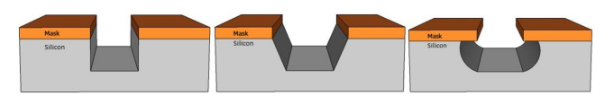

Fig. 1 - (a) Completely anisotropic; (b) Partially anisotropic;(c)Isotropic etching of silicon

Surface Characterization:

Surface characterization of BMNS typically involves measuring the surface topography, roughness, wettability, and other relevant parameters. Techniques such as scanning electron microscopy (SEM), atomic force microscopy (AFM), and contact angle measurements are commonly used to characterize the surface morphology and wetting behavior of BMNS.

Surface Development:

To develop BMNS using wet/chemical etching technique, the following steps can be taken:

Material Selection: Choose a suitable substrate material, such as silicon or metal, that can be etched with the desired etchant.

Masking: Create a pattern on the surface of the substrate to protect certain areas from etching. This can be done using lithography or other masking techniques.

Etching: Immerse the substrate in the etchant solution and allow the etchant to react with the unprotected areas of the substrate. The etching rate can be controlled by adjusting the etchant concentration, temperature, and other parameters.

Post-Processing: After etching, the surface may require further processing, such as cleaning or coating, to improve its properties or functionality

Overall, the development and characterization of BMNS using wet/chemical etching technique can enable the creation of surfaces with high heat transfer performance, which can be useful in various applications such as thermal management and energy conversion.

4.Etching technique:

Etchants for Copper and Copper Alloys:

Sample-1

Preperation of Aqueous Ferric Chloride solution:

100 ml distilled water,

5-50 (20ml) ml hydro- chloric acid and

5-25 (8g) ferric chloride.

Produces grain contrast, very useful for all copper alloys. Etching time from a few seconds to 60 s with 3-5 s being common. It is mostly preferred to use alcoholic ferric chloride as aqueous solution etches fast and often stains.

Firstly ,take 100mll distilled water into a beaker.

Add 5-25g of ferric chloride to distilled water and stir it well and make sure everything is well mixed.

Add 20ml HCl to the solution with pipette and bring it to steady state.

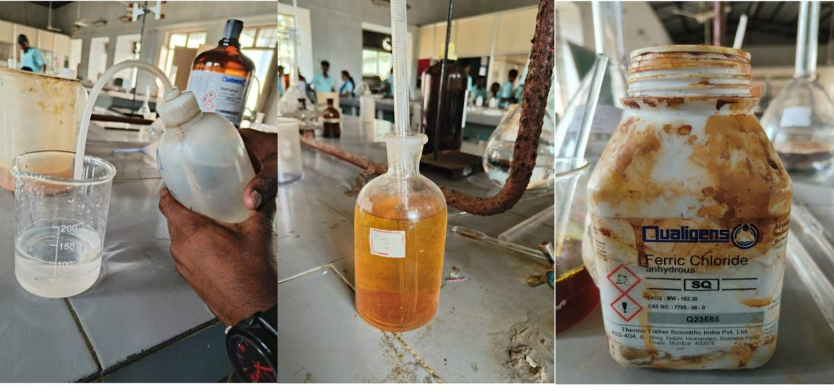
(i)100 ml distilled water
(ii) 5-50 ml HCl
(iii) 5-25g Ferric Chloride
(i)100 ml distilled water
(ii) 5-50 ml HCl
(iii) 5-25g Ferric Chloride
(i)100 ml distilled water
(ii) 5-50 ml HCl
(iii) 5-25g Ferric Chloride

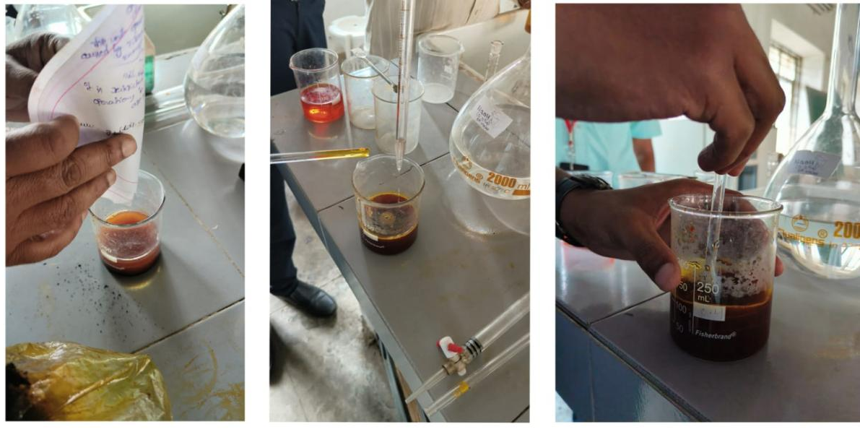
Addition of hydrochloric acid to prepared solution.
Addition of hydrochloric acid to prepared solution.
Preperation of ferric chloride solution with distilled water.

Sample-2

Acidified Potassium Dichromate Etchant :

80-100 ml water,

5-8 ml sulphuric acid,

2-10g potassium dichromate,

4 ml sodium chloride (saturated solution) or a drop hydro-chloric acid added just before using

Take 100 ml distilled water into a beaker.

Add 6g potassium dichromate to it

Add 6ml sulphuric carefully by steady addition

The required etchant solution can be made after achieving steady state.

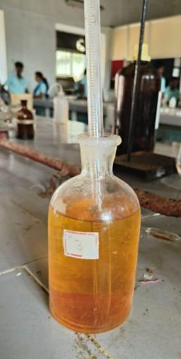
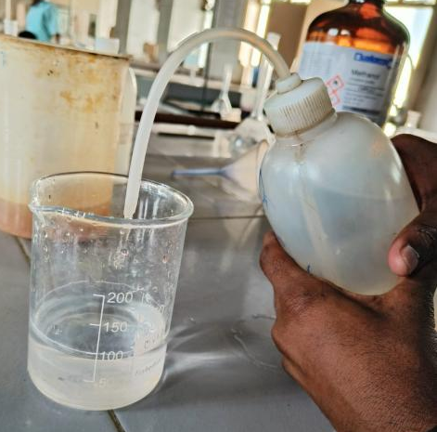
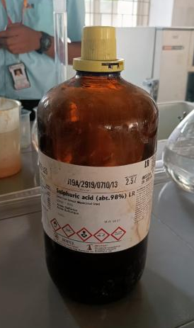
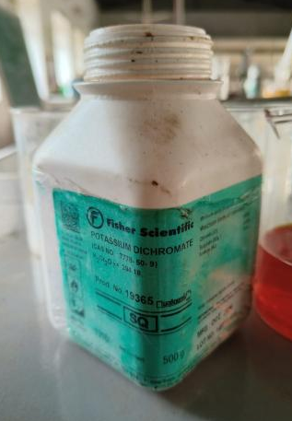

Sodium chloride solution
Sulphuric acid
Sulphuric acid
Potasium dichromate
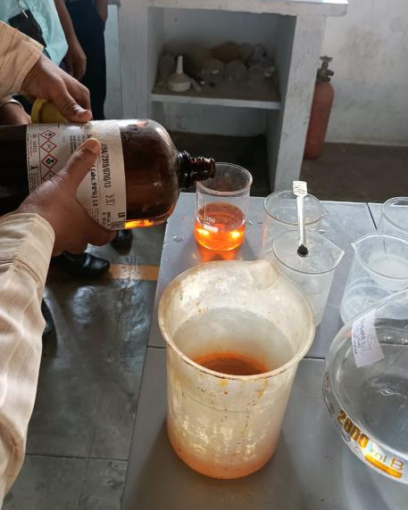
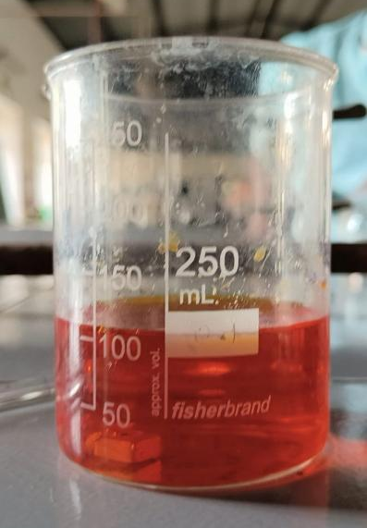
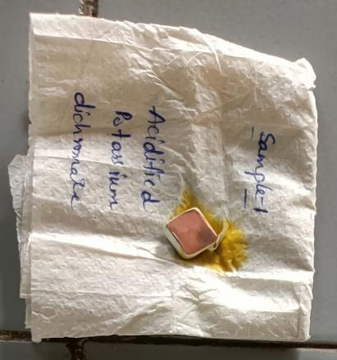

Preperation of etchant solution

Copper sample in etchant

Sample after etching

Sample-3

Ammonium Hydroxide/Hydrogen Peroxide:

50 ml distilled water,

50 ml ammonium hydroxide and

10-50 ml hydrogen peroxide. Make up and use fresh only.

Adding larger amounts of hydrogen peroxide creates better grain contrast. And adding less hydrogen peroxide creates better grain boundary etching. Can be used with benefit on a number of different alloy types.

Initially take 50ml distilled water into a beaker.

Add 50ml ammonium peroxide by constant stirring.

Add 10ml hydrogen peroxide for boundary etching.
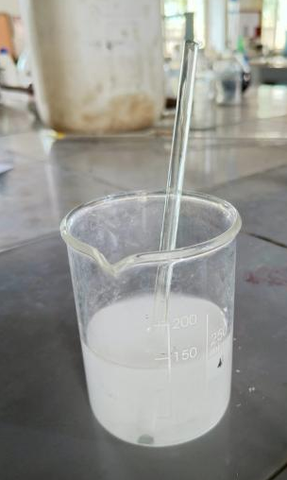
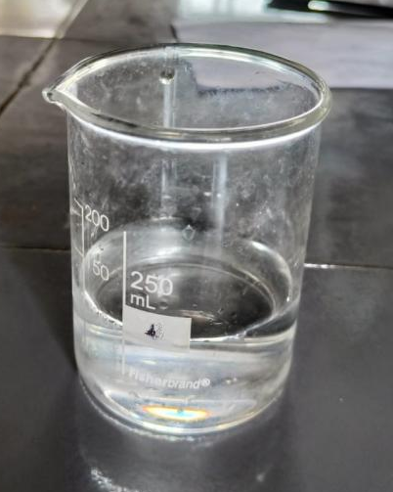
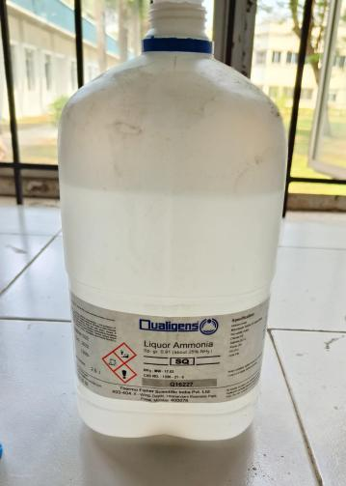
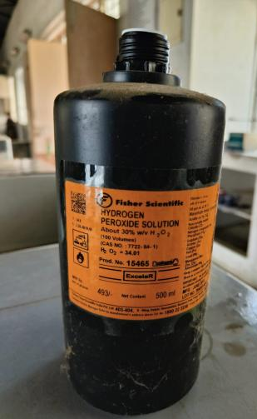

Preperation of etchant solution

;
Hydrogen peroxide
Liquid Ammonia

Etchant solution

Distilled water

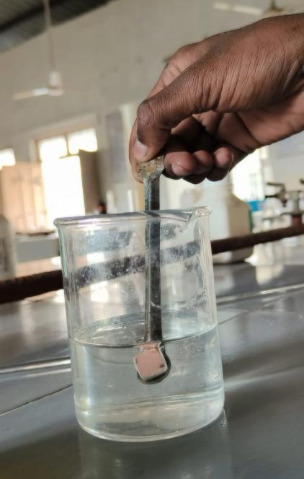
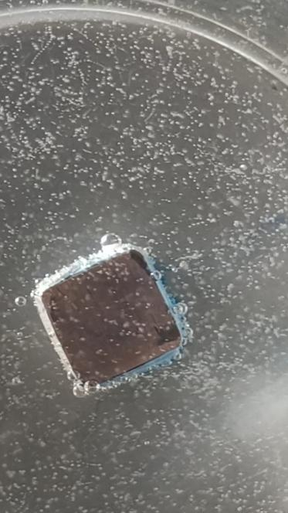
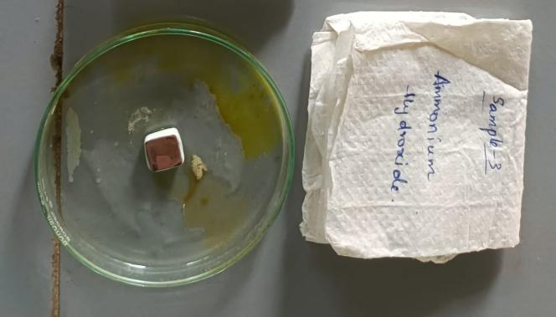

:
Sample after etching

Copper sample in etchant

5.Microscopic images of surfaces after etching;
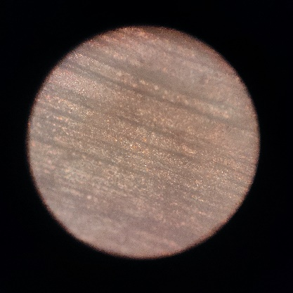
Sample-1
With aq. ferric chloride.
In chemical etching, coarse lines are created by using an etching solution with a high concentration of acid or other chemical agent. The etching solution dissolves the material in a controlled manner, creating deep, rough grooves that form the coarse lines.

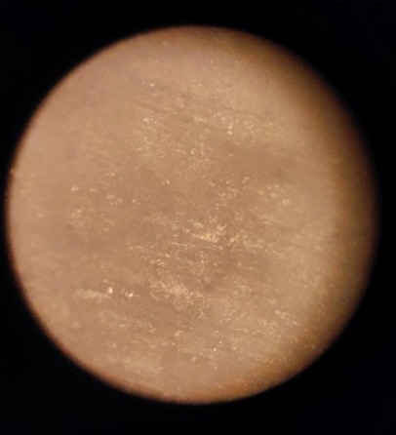
Sample-2
Acidified potassium dichromate
This creates unform deformed surface.

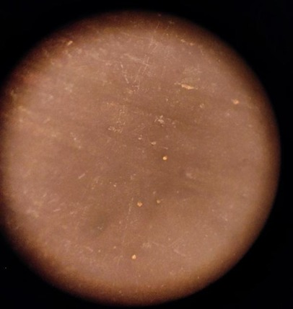
Sample-3
Ammonium Hydroxide Peroxide
The dots resembles extensive surface oxidation and carbon–carbon breakage. The process results in the gradual shrinkage of the nanoparticles and can enhance the quantum yield by more than half order of magnitude compared to the untreated analogues.

6. Contact angle for the surface:
The contact angle for etched micro-nanostructured surfaces can depend on various factors such as the etching technique, the material of the substrate, and the surface morphology. In general, micro-nanostructured surfaces tend to exhibit lower contact angles due to increased surface area and surface roughness, which can lead to improved wettability.It is important to note that the contact angle can also be affected by the nature of the liquid used for measurement and the presence of impurities on the surface. Therefore, it is essential to standardize the measurement conditions for accurate comparison between different surfaces.
Overall, the contact angle for etched micro-nanostructured surfaces can vary depending on the specific parameters of the etching process and the surface morphology, but tends to be lower than that of unetched surfaces.

7.Results and Discussions
Testing surface | Contact angle | Deviation (±) % | Image
Bare copper | 65 | 5.2 | 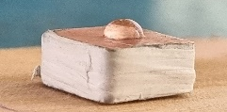
Sample-1 | 59 | 5.2 | 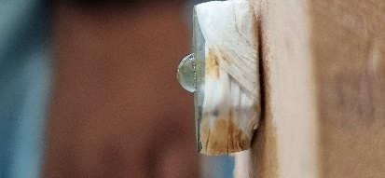
Sample-2 | 55 | 5.2 | 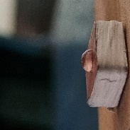
Sample-3 | 48 | 5.2 | 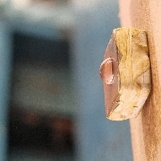
FEG SEM images
The micro-nanostructured surfaces developed by etching were found to significantly enhance boiling heat transfer performance compared to smooth surfaces. The boiling heat transfer coefficient (BHTC) of the micro-nanostructured surfaces was observed to be up to 300% higher than that of the smooth surfaces, indicating a significant improvement in heat transfer efficiency.
Furthermore, the critical heat flux (CHF) of the micro-nanostructured surfaces was found to be higher than that of the smooth surfaces. This is attributed to the increased nucleation site density and more stable bubble formation on the micro-nanostructured surfaces, which prevents the formation of a vapor film and promotes efficient heat transfer.

The surface morphology and roughness of the micro-nanostructured surfaces were found to play a crucial role in determining the boiling heat transfer performance. Specifically, surfaces with smaller feature sizes and higher surface area showed better heat transfer performance.
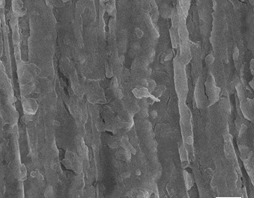
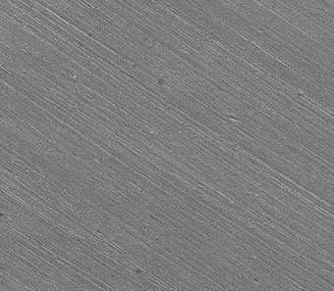

Coated surface
Bare surface
The findings of this project have important practical implications in various industries where efficient heat transfer is critical, such as power generation, electronics cooling, and chemical processing. The micro-nanostructured surfaces developed by etching offer a cost-effective and scalable solution for enhancing boiling heat transfer performance, which can result in significant energy savings and improved equipment performance.
In terms of the specific applications based on surface area, micro-nanostructured surfaces with smaller feature sizes and higher surface area are particularly well-suited for applications where heat transfer performance is limited by the available surface area, such as in microelectronic devices and high-density power electronics.
Overall, the results of this project demonstrate the potential of micro-nanostructured surfaces developed by etching to significantly enhance boiling heat transfer performance, which can have important practical implications for various industries and applications.
7.CONCLUSION
In conclusion, the project on boiling heat transfer performance of micro-nanostructured surfaces developed by etching demonstrated that the use of micro-nanostructured surfaces can significantly enhance heat transfer efficiency compared to smooth surfaces. The results showed that the boiling heat transfer coefficient (BHTC) of the micro-nanostructured surfaces was up to 300% higher than that of the smooth surfaces, indicating a significant improvement in heat transfer performance. The critical heat flux (CHF) of the micro-nanostructured surfaces was also higher than that of the smooth surfaces due to the increased nucleation site density and more stable bubble formation on the micro-nanostructured surfaces.
The micro-nanostructured surfaces developed by etching offer a cost-effective and scalable solution for enhancing boiling heat transfer performance. This can have important practical implications in various industries such as power generation, electronics cooling, and chemical processing. In particular, micro-nanostructured surfaces with smaller feature sizes and higher surface area are well-suited for applications where heat transfer performance is limited by the available surface area, such as in microelectronic devices and high-density power electronics.
Therefore, the use of micro-nanostructured surfaces developed by etching can result in significant energy savings and improved equipment performance in a wide range of applications. The findings of this project highlight the potential of micro-nanostructured surfaces for enhancing heat transfer performance and provide a valuable contribution to the ongoing research in this field.

REFERENCES:
1.Kandlikar SG, Shoji M, Dhir VK. Handbook of phase change. Philadelphia: Taylor and Francis; 1999.
2. Teodori E, Moita AS, Moreira ALN. Characterization of pool boiling mechanisms over micro-patterned surfaces using PIV. Int J Heat Mass Transf. 2013;66:261–70.
3. Moita AS, Teodori E, Moreira ALN. Influence of surface topography in the boiling mechanisms. Int J Heat Fluid Flow. 2015;52:50–63.
4. Birce D, Edidiong E, Marc C. Pool boiling enhancement with environmentally friendly surfactant additives. J Therm Anal Calorim. 2014;116:1387–94.
5. Hashemi M, Noie SH. Study of flow boiling heat transfer characteristics of critical heat flux using carbon nanotubes and water nanofluid. J Therm Anal Calorim. 2017;130:2199–209.
6. Patil CM, Kandlikar SG. Review of the manufacturing techniques for porous surfaces used in enhanced pool boiling. Heat Transfer Eng. 2013;35:887–902.
7. Machlouf AS, Tiginyanu I. Nanocoatings and ultra-thin films. Technologies and applications., A volume in Woodhead Publishing Series in metals and surface engineeringCambridge: Woodhead Publishing; 2011. ISBN 978-1-84569-812-6.
8. Shin HC, Dong J, Liu M. Nanoporous structures prepared by an electrochemical deposition process. Adv Mater. 2003;15:1610–4.
9. Gupta SK, Misra RD. An experimental investigation on flow boiling heat transfer enhancement using Cu–TiO2 nanocomposi

