Microcontroller based Data Transmission System using Li-Fi Technology
1)Sheela Chinchmalatpure, 2)Kaushal Jadhav, 3)Satyajeet Jadhav, 4)Ketan Jain, 5)Sanika Jamdade, 6)Shardul Jeurkar
Department of Multidisciplinary Engineering
Vishwakarma Institute of Technology, Pune, 411037, Maharashtra, India

Abstract — Everyone is reliant on the internet today. When several devices are connected to the network, it can be unpleasant to have poor performance, whether you are using Wi-Fi at home, in a coffee shop, or when fighting for bandwidth at a meeting. German physicist Harald Haas developed a novel method known as "data through light" to address this issue. With this method, data is communicated using LEDs whose intensity changes more quickly than the human eye can perceive. He claims that the technology is based on the strength and capability of LEDs. We have created a prototype using Li-Fi technology and the Arduino Uno and Nano as the encoder and decoder devices. In this paper, we presented a Li-Fi technology paradigm in which information is sent from one end to the other using light. The prototype was tested at various distances between the light-emitting diode and the photodiode receiver, and the data transmission was successful.

Keywords —Visible Light Communication (VLC), Light Fidelity (Li-Fi), Wireless Fidelity (Wi-Fi), Data transfer, Light Emitting Diode (LED)

INTRODUCTION
Light Fidelity, often known as Li-Fi, is a sort of high-speed communication system which wireless system that uses visible light to transfer the data from one point to other. It corresponds to optical wireless communication. Data is transmitted by a Light Emitting Diode or LED bulb which has a variable intensity. Based on this variation the communication is of digital type. Li-Fi technology offers a wide range of uses where Wi-Fi is limited or constricted. It also aids in the elimination of the negative health effects produced by electromagnetic radiation such as radio waves used in Wi-Fi. Data transfer is secure because data cannot be hacked unless you can see the light. Data transfer is mostly in Gigabytes per second. Using light for the transmission of data is known as Li-Fi. Li-Fi is a advanced type of technology that offers high-speed for transferring the data which is identical to Wi-Fi since both are wireless, but Li-Fi is quicker, so we can transmit and receive data in less time. Light bulbs may be replaced with LEDs that use Li-Fi technology, revolutionizing the telecommunications sector. Nowadays, due to the wide-scale advancement of wireless type of technology, it requires a big quantity of data to be transmitted every day. Radio communication is important part in this process of communication.
The primary means of wireless transmission of data is through the use of electromagnetic waves, Radio waves. However, due to compact spectrum availability and penetration, the radio can support less bandwidth. To solve all these problems we can make use of the Visible Light Communication (VLC) technology for the data transmission. Wi-Fi supports indoor wireless coverage, Li-Fi can be ideal for wireless transmission of large amount of data in defined areas and do not face any issues like radio interference which can be seen in Wi-Fi. Li-Fi mainly focuses on sharing data between two endpoints. By adding a tiny microchip to each potential lighting item, two essential functions: illumination and wireless data transfer are merged. This prototype has the ability to tackle the basic problems affecting wireless communications today: cost, capacity, efficiency, and security. So in the future, we can, not only deploy billions of light bulbs, but also billions of Li-Fi APs (Access Points) can be deployed all over the world with LEDs. With this you can achieve a clean and bright future. This work presents a simplified form of a Li-Fi data transmission system that employs commercially available electrical components, thereby reducing the complexity, multiple incompatible standards, and new systems of these address any cost issues that arise.

Literature Review
LEDs can be controlled electrically based on the research into Visible Light Communication (VLC). Harald Hass, a professor at the University of Edinburgh who began his research in the VLC in 2004, demonstrated one of the Li-Fi-based prototype at the TEDx worldwide conference in Edinburgh in 2011. He used a table light with an LED bulb to broadcast a video of flowers blossoming and displayed on the screen.
Veneta Aleksieva et.al [1]. describes the comparison study of different Li-Fi prototypes. As all prototypes mentioned in the paper , it can be observed that all the prototypes have same goal like: Low price for Li-fi, data transmission rate should be higher (up to Gbps), the communication should be full duplex, multiuser, data should be transferred up to long distances ,low latency , it should more secure and cannot be hacked, the communication should be free of any type of interference.
Rahul R Sharma et al [2] discusses the basic idea of Li-Fi Communication Technology And gives possible solutions to replace Communication Technologies like Wi-Fi . Wi-Fi has problems like availability, efficiency And Li-Fi solves most of the solutions for those problems. There are some disadvantages of Li-Fi Light waves cannot transmit through opaque materials like Wi-Fi.
Amareshwar Karatagi et.al [3] describe a prototype in which solar panel is used as photoreceiver (instead of a photodiode), LED reflectors, built-in receiver IC ATmega8 and comparator IC lm358The device currently converts the Incoming packets into a light signal as a medium carrier in current technology, and the receiver is compressed and configured as a Li-Fi dongle (the company calls it Pure Li-Fi) which can provide data rates higher than 2 Gigabytes/second (up to 7 Gigabytes/second).
Li-Fi or Light Fidelity [4] describes, Li-Fi is a VLC technology that utilizes light as a medium for high-speed communication and adheres to IEEE standard IEEE 802.15.7. It is unique technology for providing high-density and wireless coverage of data in small areas, and it is especially useful in situations where radio wave interference is a problem. By utilizing the inexpensive cost of LEDs and lighting components, Li-Fi, which has already topped 1 Gbps in high speeds in the lab, delivers more bandwidth, efficiency, connection, and security than Wi-Fi.
M. Leba, S. Riurean and A. Lonica - [5] The huge majority of mobile data traffic is now consumed indoors, where light fidelity (Li-Fi), a type of visible light communication (VLC), provides several distinct advantages and efficient solutions to the numerous problems associated with wireless communication. This study summarizes most of the research, advances, and applications made thus far, as well as various implementations, obstacles, the VLC IEEE standard, data modulation techniques for the VLC, and a new type of optical communication technology which is wireless technology called Li-Fi.

III. PROPOSED METHODOLGY
Li-Fi is based on the straightforward idea that data is transferred when an LED blinks (turns on and off) rapidly. The value of the LED will be 1 when it is on and 0 when it is off. Binary digits are used to encrypt the data, which is then conveyed via a light source. This idea allows for the wireless transmission of data by sending a stream of 1s and 0s over a small distance. The receiver then receives the data and converts the light waves back into electrical signals, which the receiving device may then decode and comprehend. In the electromagnetic spectrum, radio waves have a bandwidth of up to 300 GHz, but visible light has a bandwidth of 300 THz, implies that the bandwidth of visible light is 10,000 times higher than the bandwidth of radio waves. Utilizing VLC not only increases speed but also minimizes radio wave interference (Visible Light Communication).
In our proposed system, we have incorporated parts like a solar panel that functions as a photo receiver, an LED for data transmission, an ATmega328 IC-based receiver, and a TIP122 12 V controller transistor. To receive the data, a constant 5V DC power supply is provided. While a separate 12V power supply for the transmitter board and 9 LEDs (connected in series) are used in the receiver section of the transmitter. Additionally, a variable has been used to modify the Receiver's threshold values. The Threshold value in this instance is determined by the total amount of ambient light. The receiver will assume that an LED is ON if its value is greater than the threshold value and OFF if it is below.

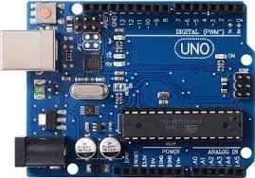

Fig.1. Microcontroller Used in project (Arduino board)

Since handling and programming the Arduino UNO is a little easier than those of other microcontroller families, we utilized it in the suggested approach. It requires the use of the free Arduino Integrated Development Environment (IDE). Arduino's programming language is called Arduino-C, and it is quite similar to the C programming language.

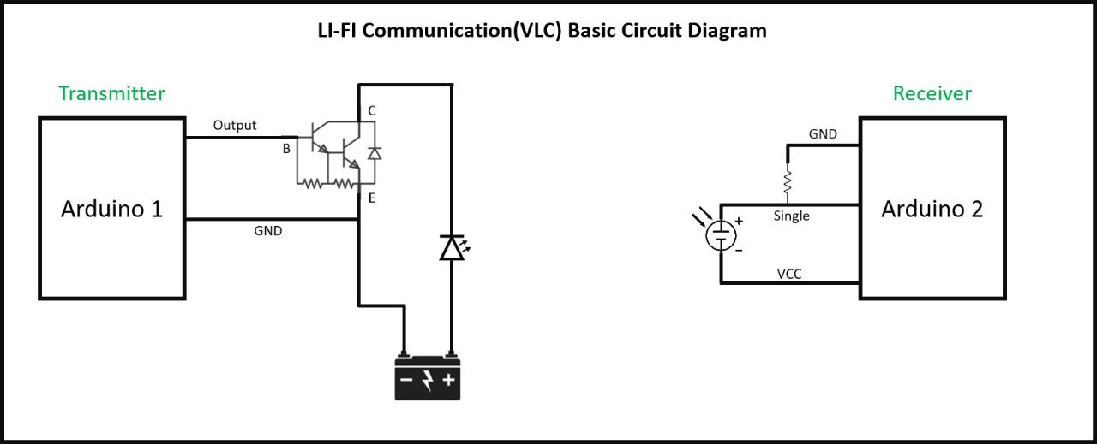

Fig.2. The proposed system's circuit diagram

Fig.2. Displays the circuit diagram for the transmitter and receiver. The suggested system is demonstrated using two Arduino board, a single one for the transmitter and a second one for the receiver, as well as a screen for displaying data on a serial monitor with designated ports. Using a separate power supply, the Arduino board is designed for controlling the transmitter signal part. Once the solar panel is positioned in front of the LEDs, which served as the transmitter. The information is then gathered by the solar panels and shown as the output on the serial monitor screen.

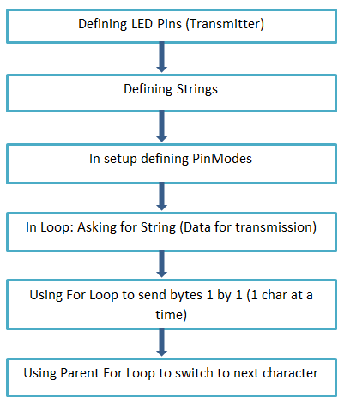
Fig.4. Algorithm for Transmitter Side

The transmitter side code scheme is shown in Figure 4. In general, the algorithm explains the reason behind how data is obtained from the user and then conveyed bit by bit.

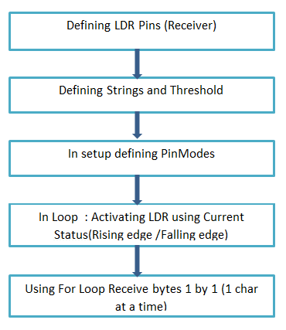
Fig.5. Algorithm for Receiver Side

The receiver side's method of code, which describes how the data is received bit by bit, is explained in Figure 5. The rising or falling edge is used to activate the LDR when the LED initially begins to blink. The LED and LDR will start operating concurrently when a predefined amount of time has passed. Data will therefore be transferred successfully.

Results and Discussions
This section displays some of the results obtained using the mentioned prototype and the real prototype design, which is meant to serve as a proof of concept. The prototype was tested in a variety of locations, including a dark room, a room with lights on, and an area with weak lighting. In every scenario mentioned above, the model performed flawlessly. There are no issues with the data transfer at all.

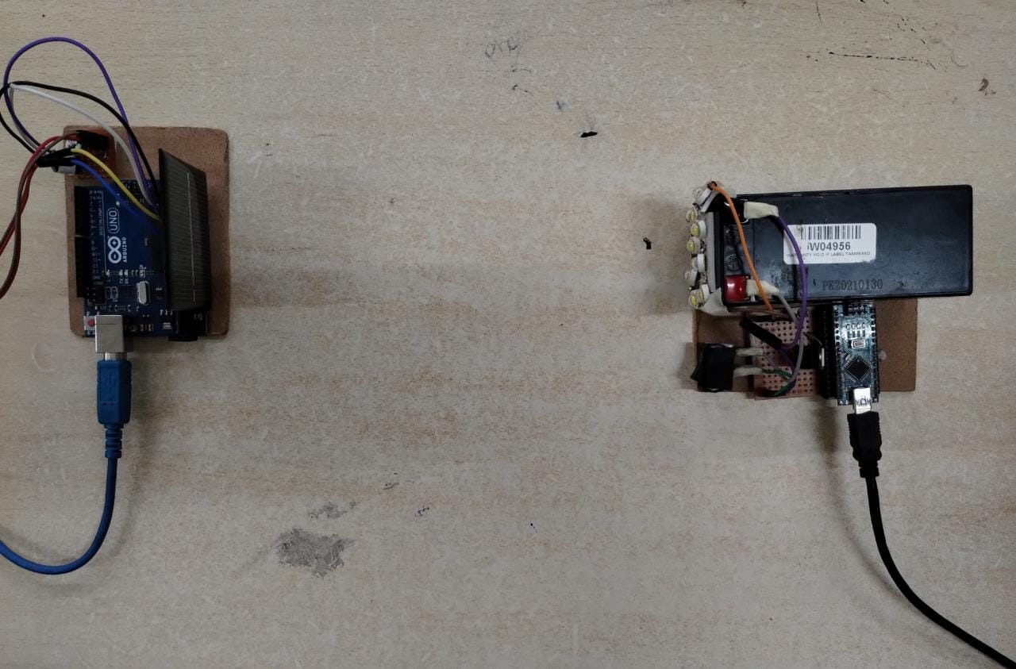
Fig.6. Prototype

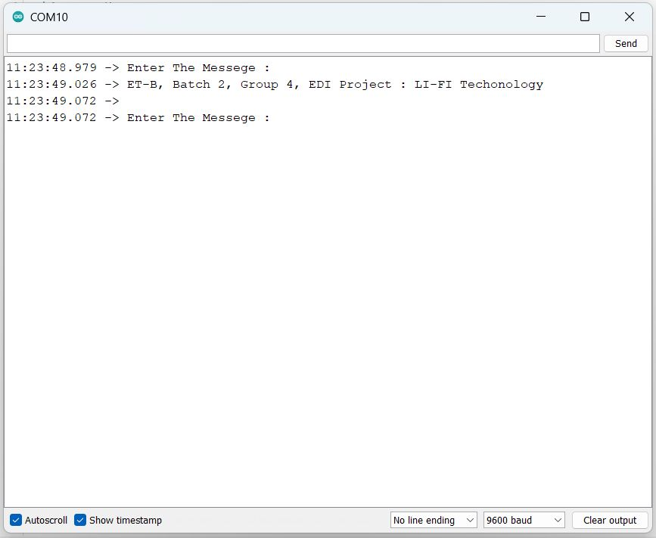
Fig.7. Input from Transmitter Side
The serial monitor of Arduino asks for message inputs, as user enters message it will get transmitted via transmitter.

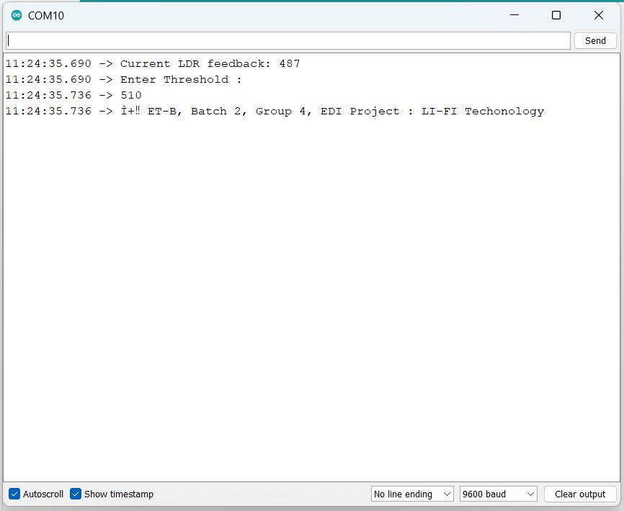
Fig.8. Output From receiver side
The Arduino serial monitor is depicted in figure 8; it is the serial monitor from the receiver's side, and it is obvious from the figure that it requests input from the user. When a message is entered into a serial monitor, light will be used to send the message from the transmitter to the receiver. The entered message is transmitted through light while being encoded in binary numbers.
The message is subsequently decoded from binary to the input data once the light hits the receiver's panel. The serial monitor then shows this message. The current light intensity will be displayed first, and we can enter the threshold intensity based on that (we can set that value either manually or automatically). The serial monitor will show the output data on the screen after you specify the threshold intensity. The model's output is depicted in Figure 9.

Sr.no | Parameters | Li-FI | Wi-Fi
1. | Speed | 100x faster than Wi-Fi.  Very high  (~ 1 Gbps) | Comparatively less than LIFI.  Low(100 Mbps – 1 Gbps)
2. | Connectivity | More than Wi-Fi (it is possible to connect multiple devices at a  time) | 8-10 devices at a time
3. | Safety | Li-Fi uses visible or non-visible light waves, which cause no harm to a human body (It can be used in hospitals where radio waves might be hazardous to patients.) | Wi-Fi transmit data through radio waves which are harmful for humans.
4. | Security | Li-Fi is secure and cannot be hacked. | Prone to hacking.
Table 1: Li-Fi and Wi-Fi technology comparison

Future Scope
The future of Li-Fi looks bright and promising with potential applications and making a revolution in the communication industry. With the growing need for high-speed internet, Li-Fi will play a significant role to meet this need in the future. In the future, it may be possible that we will be having internet with a speed of multi gigabits per second. Because light is omnipresent, it may be conceivable in the future to use every bulb to transfer the data. Also, Li-Fi is the most cost-effective options for delivering high-speed data transfer since it can be incorporated into already-existing lighting systems. As Li-Fi technology develops, communication technology will become safer, cleaner, and more cost-effective. There are some challenges like the line of sight requirement which should be considered while planning the deployment of Li-Fi technology.

- CONCLUSION
Despite significant drawbacks, Li-Fi has impacted practically all industries. Li-Fi is a relatively new technology, but it has already shown a lot of potential. With the use of readily available light sources like tube lights, lamps, street lights, etc., Li-Fi enables us to access the internet from anywhere—in streets, footpaths, homes, etc. Since LEDs flip quickly, they are inexpensive, widely accessible, and consume little power. As a result, it can be utilized to instantly transfer huge volumes of data. The technology is quick, safe, and suitable for usage in delicate locations like hospitals, airlines, and other places where radio frequency (RF) technology is impractical. Defense services will benefit from Li-Fi technology because their data is particularly private and confidential, and it will be challenging to hack, protecting data. Since Li-Fi signals function underwater, marine commandos who operate underwater are able to relay crucial commands to other locations, such as underwater or on land, etc. Li-Fi is substantially more secure because interference and hacking are less likely to occur. Future is promising and exciting with the help of Li-Fi.
References
- Veneta Aleksieva et.al, Comparison Study of Prototypes based on LiFi Technology , 978-1-7281-4754-3/19/$31.00 ©2019 IEEE
- Transmission of data through light Rahul R Sharma et.al, Int.J.Computer Technology & Applications,Vol 5 (1),150-154 IJCTA
- Positioning Li-Fi in Indoor for Large File Data Transfer For Faster Data Transfer, Connect with Li-Fi Amareshwar Karatagi et.al International Journal of Engineering Research & Technology (IJERT) ISSN: 2278-0181 Published by, www.ijert.org NCCDS - 2021 Conference Proceeding
- Nischay, 2017, A Review Paper on Li-Fi Technology, INTERNATIONAL JOURNAL OF ENGINEERING RESEARCH & TECHNOLOGY (IJERT) VIMPACT – 2017 (Volume 5 – Issue 23),
- M Leba, S Riurean, A Ionica (2017) Lifi- The path to a new way of communication. 2017 12th Iberian Conference on Information Systems and Technologies(CISTI).
- H. Poor, An Introduction to Signal Detection and Estimation. New York: Springer-Verlag, 1985, ch. 4.
- B. Smith, “An approach to graphs of linear forms (Unpublished work style),” unpublished.
- E. H. Miller, “A note on reflector arrays,” IEEE Trans. Antennas Propagat., to be published.
- J. Wang, “Fundamentals of erbium-doped fiber amplifiers arrays ,” IEEE J. Quantum Electron., submitted for publication.
- C. J. Kaufman, Rocky Mountain Research Lab., Boulder, CO, private communication, May 1995.
- Y. Yorozu, M. Hirano, K. Oka, and Y. Tagawa, “Electron spectroscopy studies on magneto-optical media and plastic substrate interfaces (Translation Journals style),” IEEE Transl. J. Magn.Jpn., vol. 2, Aug. 1987, pp. 740–741 [Dig. 9th Annu. Conf. Magnetics Japan, 1982, p. 301].
- M. Young, The Techincal Writers Handbook. Mill Valley, CA: University Science, 1989.
- J. U. Duncombe, “Infrared navigation—Part I: An assessment of feasibility (Periodical style),” IEEE Trans. Electron Devices, vol. ED-11, pp. 34–39, Jan. 1959.0
- N. Soni, M. Mohta and T. Choudhury, "The looming visible light communication Li-Fi: An edge over Wi-Fi," 2016 International Conference System Modeling & Advancement in Research Trends (SMART), 2016, pp. 201-205, doi: 10.1109/SYSMART.2016.7894519
- A. Ambika, M. Aswinkumar, M. Kamalesh, and K. Naveen, "Smart Toll Collection Using LiFi Technology," 2019 International Conference on Computation of Power, Energy, Information and Communication (ICCPEIC), 2019, pp. 236- 239, doi: 10.1109/ICCPEIC45300.2019.9082373.
- S. P. Bhanse and S. R. Pawar, "Li + Wi-Fi: The Future of the Internet of Things," 2018 3rd International Conference on Communication and Electronics Systems (ICCES), 2018, pp. 538-543, doi: 10.1109/CESYS.2018.8724051
- R. Hassan, M. S. Flayyih, A. Mahdi, A. Inn, A. S. Sadeq, and D. F. Murad, "Visibile Light Communication Technology For Data Transmission Using Li-Fi," 2020 2nd International Conference on Computer and Information Sciences (ICCIS), 2020, pp. 1-5, doi: 10.1109/ICCIS49240.2020.9257654
- Agyemang, J.O., Kponyo, J.J., &Mouzna , J. (2017). ‘Light Fedelity (Li-Fi) as an Alternative Data Transmission Medium in VANET’. European Modelling Symposium (EMS). C. Dineshkumar, M. Subramanian, JenorishMuthaya and V. Deepan.2018. Health monitoring system for automobile vehicles to enhance safety, International Journal of Vehicle Structures & Systems, 10(6).
- W.-K. Chen, Linear Networks and Systems (Book style). Belmont, CA: Wadsworth, 1993, pp. 123–135.
- Harald Haas; Liang Yin; Yunlu Wang; Cheng Chen, “What is LiFi?”. Journal of Lightwave Technology
- Monica Leba; Simona Riurean; Andreea Lonica, “LiFi — The path to a new way of communication”. 2017 12th Iberian Conference on Information Systems and Technologies (CISTI)

E Ramadhani and G P Mahardika, “The Technology of LiFi: A Brief Introduction” Published under licence by IOP Publishing Ltd
- Harald Haas; Tezcan Cogalan, “LiFi Opportunities and Challenges”. 2019 16th International Symposium on Wireless Communication Systems (ISWCS)
- Xiping Wu; Mohammad Dehghani Soltani; Lai Zhou; Majid Safari; Harald Haas, “Hybrid LiFi and WiFi Networks: A Survey”. IEEE Communications Surveys & Tutorials (Volume: 23, Issue: 2, Second quarter 2021)
- Sreelal Maravanchery Mana, Peter Hellwig, Jonas Hilt, Kai Lennert Bober, Volker JungnickelKlara Hirmanova, Petr Chvojka, Radek Janca, and Stanislav Zvanovec, “LiFi Experiments in a Hospital”. Optical Fiber Communication Conference (OFC) 2020
- Kanchan Tiwari Swami; Asmita A. Moghe, “A Review of LiFi Technology”. 2020 5th IEEE International Conference on Recent Advances and Innovations in Engineering (ICRAIE)
- Rozin Badeel, Shamala K. Subramaniam ,Zurina Mohd Hanapi and Abdullah Muhammed, “A Review on LiFi Network Research: Open Issues, Applications and Future Directions”. Special Issue Applications of Millimeter-Wave and Terahertz Technologies

