Fabrication and Testing of Eco-Bricks Making Machine
Prof. S. G. Bawane¹, Pratik Motghare², Sudhanshu Meshram³, Abhishek Wankhede⁴, Krutik Akre⁵, Gemant Padole⁶
¹ProfessorMech Engg., K. D. K. College of Engineering, Nagpur
^{2,3,4,5,6}Student, Dept. Of Mech Engg., K. D. K. College of Engineering, Nagpur

---------------------------------------------------------------------***---------------------------------------------------------------------
Abstract –This research presents the fabrication and performance test of eco-bricks making machine. In India huge amount of plastic are used for various purpose such as for making of water bottle, soda bottle and bags, etc. which are not disposable because of this various problem occur so we use plastic for making of bricks in various ways. After studying the problem, we developed the effective way to overcome the problem. Bottle brick are light in weight and withstand high amount of load or pressure. Eco-bricks, polyethylene terephthalate (PET) bottle filled with mixed inorganic waste, have become a low-cost construction material and a valid recycling method to reduce waste disposal in regions where industrial recycling is not yet available. Becauseeco-bricks are filled with mixed recovered material, potential recycling of its constituents is difficult at the end of its life.

Key Words:Plastic Waste, Eco-Brick Machine, Plastic Bottle, PET Bottle, Bottle Bricks, Better Recycling Option

1.INTRODUCTION

Over the past 70 years as huge has 8.3 billion metric tons of plastic has been produced, and in a usual cycle only 9 percent of produced plastic is recycled and 12 percent is incinerated, and the leftover 79 percent of produced plastic ends up in landfills or as waste, and in the biosphere, plastic does not decompose, and thus contaminates the Earth or our water bodies. Plastic in no way can be absorbed or consumed in ecological system and hence its presence disturbs the natural fabric of the current earthly ecosystem. Ecobricks pose a great potential solution for storage and effective application of waste single- use plastic. They are cheap, simple, and effective materials. They are strong and are immune to rot and water damage. They can act as insulators and are Earthquake resistant as well. Eco bricks are an Eco friendly and sustainable substitute for construction materials, they are PET bottles filled usually with inorganic waste, which are now a very cheap construction material, with twofold benefits. Eco bricks provide us a ground breaking and cheaper alternative to building materials, with an edge of providing storage solutions for the inorganic non-biodegradable waste we generate for human consumption. An ecobrick is a plastic bottle packed with used plastic to a set density. They serve as reusable building blocks. Ecobricks can be used to produce various items, including furniture, garden walls and other structures. Ecobricks are produced primarily as a means of managing consumed plastic by sequestering it and containing it safely, by terminally reducing the net surface area of the packed plastic to effectively secure the plastic from degrading into toxins and micro plastics. Ecobricking is a both an individual and collaborative endeavor. The ecobricking movement promotes the personal ecobricking process as a means to raise awareness of the consequences of consumption and the dangers. Any size of transparent polyethylene terephthalate (PET) plastic bottle can be used to make an ecobrick. The bottle and the packed plastic are clean and dry to prevent the growth of bacteria. Plastic is cut or ripped into small pieces then packed little by little, alternating between adding the plastic and compacting it, layer by layer. The bottle is rotated with each press to ensure the plastic is evenly compacted throughout the bottle. This helps prevent avoids and allows the packing to reach the requisite solidity needed for building block applications. Completed ecobricks are packed solid enough that they can bear the weight of a person without deforming—a density range between 0.33 g/ml and 0.7 g/ml. Maximizing density minimizes the flammability of the ecobrick while increasing its durability and re-usability. Plastic recycling is the reprocessing of plastic waste into new products. When performed correctly, this can reduce dependence on landfill, conserve resources and protect the environment from plastic pollution and greenhouse gas emissions. Although recycling rates are increasing, they lag behind those of other recoverable materials, such as aluminum, glass and paper. Since the beginning of plastic production in the 20th century, until 2015, the world has produced some 6.3 billion tons of plastic waste, only 9% of which has been recycled, and only ~1% has been recycled more than once. Additionally, 12% was incinerated and the remaining 79% disposed of to landfill or to the environment including the sea.

2. Components
1) Double Acting Pneumatic Cylinder: A double acting pneumatic cylinder has two parts that control the movement of the rod. The compressed air causes the rod to moving two directions by extending and retracting with the assistance of springs. This type of pneumatic cylinder is essential for any application that need control of movement in two direction.
2) Directional Control Valve: Directional control valve are used in pneumatic system to direct or stop the flow of compressed air or oil to their appliances. They are probably the most used elements in pneumatic systems and can be used for example to actuate a cylinder, a larger industrial valve or air tools. The valve can have two or more parts and fulfill various circuit function. The function and behavior of the valve can be indicated by a symbol. The symbol however doesn’t explain the construction of Directional control valves can be actuated by different means, such as manual actuation or solenoid actuation. These article focuses on the different directional solenoid valves for pneumatic systems.

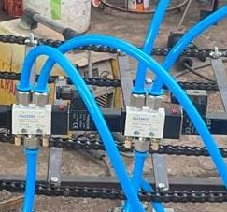

3) Air Compressor: An air compressor is a pneumatic device that converts power into potential energy stored in pressurized air (i.e. compressed air). By one of several methods, an air compressor forces more and more air into a storage tank, increasing the pressure. When the tanks pressure reaches its engineered upper limit, the oil compressor shuts off.
4) DC Motor: DC Motor is any of a class of rotary electrical motors that converts direct current (DC) electrical energy into mechanical energy. The most common types rely on the forces produced by induced magnetic field due to flow in current in the coil. Nearly all types of DC motors have some internal mechanism, either electro-mechanical or electronic, to periodically change the direction of current in part of the motor.
5) Conveyor Belt: A conveyor belt is the carrying medium of the belt conveyor system. It is used to carry a material. It transfers the plastic waste to double acting cylinder. The conveyor belt consists of roller which rotates continuously and it also rotates belt. It consists of two or more pulleys, with a closed loop of carrying medium that rotates about them.
6) Micro-controller: Micro-controller is a small computer on a single VLSI integrated circuit (IC) chip. A micro-controller contains one or more CPU’s (processor cores) along with the memory and programmable input/output peripherals. Microcontroller controls the speed of double acting pneumatic cylinder, the pressure of double acting pneumatic cylinder, rotation of conveyor belt.

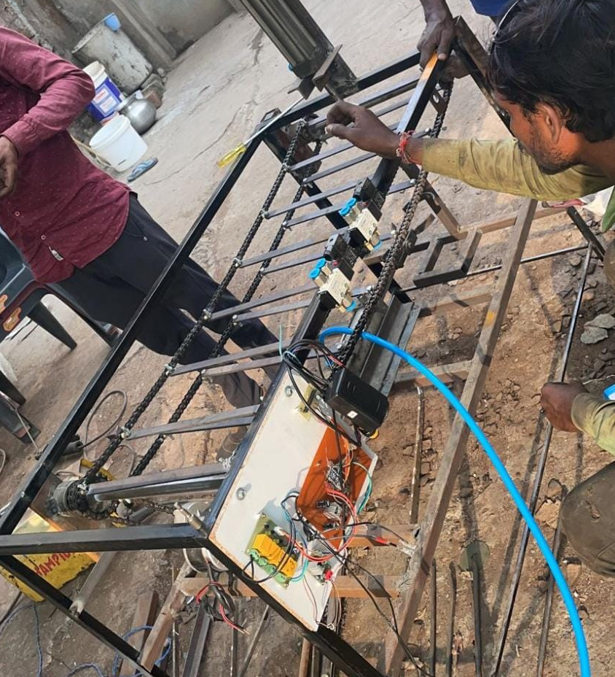

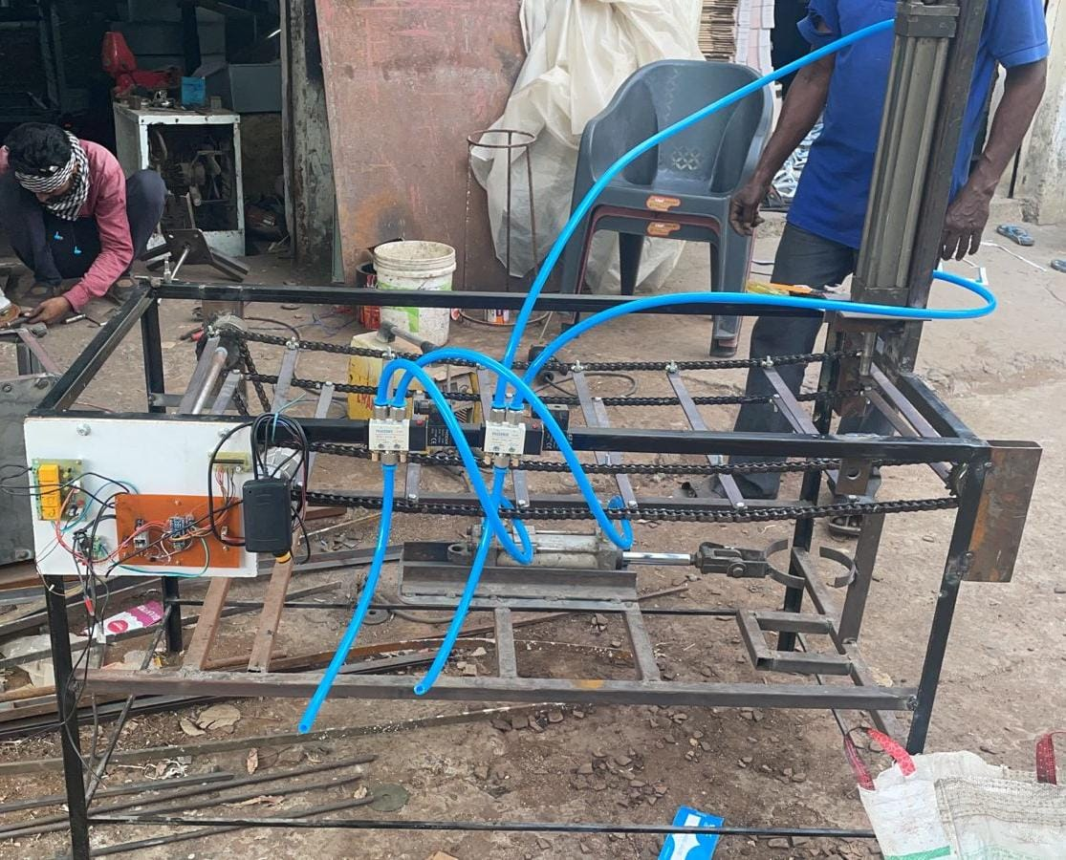
3. CALCULATIONS

- Power :-
Piston Area
Piston Diameter = 4inch
$$A=πr^{2}$$
= 3.1416*2²
= 12.56 inch²

Supply pressure is 100psi i.e., 6.89bar

1 bar = 14.50psi

=100-14.50
=85.5 bar

Force = P*A
= 85.5*12.56
= 1071.36 pounds

Force in ton = 1071.36/2000
F = 0.535 ton

i.e., F = 535 kg
F = 5248.55 N
- Velocity :-
RPM
The average speed of standard cylinder is about 1.5m/sec.

V = 0.025m
RPM = 572.95

N = $\frac{60}{2*π*r}$*V m/sec

Velocity Ratio = 1:2

V = $\frac{572.95}{2}$ = 286.47 rpm

V = r*w
w =$\frac{2*π*N}{60}$
= $\frac{2*π*286.47 }{60}$
w = 29.99 rad/sec

V = 0.175*29.99
= 5.24 m/sec
V = 18.86 km/hr
- Rolling Friction :-

F = μ*$\frac{ω}{r}$
F = Frictional Force
μ = Coefficient of friction
= 0.70 for rubber tyre
W = load (dead load) (588.6N)
r = radius of curvature (0.175 m)

F = 0.70*588.6/0.175
F = 2354.4 N
- Average :-
For 50l tank capacity
Volume of pneumatic cylinder
V = π*r²*h- piston area
= π*2²*6-π*2²*1
V = 62.83 /n³
V = 1.02 l
Number of strokes = 50/1.02*2
= 24.50 stroke per charge

Distance moved in one stroke
D = 0.314 km/min
Distance travelled in 24.50 strokes
= 7.69 km/charge

4. CONCLUSIONS

The testing procedure of Eco-Brick making machine for regulating the inserting force of plastic waste in bottles and calculating parameters of filling the bottles. The proposal made in this paper is very intensive and includes the problem of recycling of non-degradable plastic waste. Through this design we reduce manpower.

ACKNOWLEDGEMENT

With profound feeling of immense gratitude and affection, we would like to thank our guide, Department of Mechanical Engineering for his continuous support, motivation, enthusiasm, and guidance. His encouragement, supervision with constructive criticism and confidence enabled us to complete this Project. We also put forth our deepest sense of gratitude towards Principal, for constant motivation and providing necessary infrastructure. Finally, a special thanks to all the faculty members of the department for their cooperation throughout the Project work. Authors and Affiliations.
REFERENCES

- Antico, F. C., Wiener, M. J., Araya-Letelier, G., & Retamal, R. G. (2017). Eco-bricks: a sustainable substitute for construction materials. Revista de la Construcción. Journal of Construction, 16(3), 518-526.
- Pokale, S. S., Gund, P. H., Gholve, D. R., Lagad, S. K., & Chauhan, S. R. ECO-BRICK: A WASTE PLASTIC USED AS CONSTRUCTION MATERIAL.
- Dadzie, D. K., Kaliluthin, A. K., & Kumar, D. R. (2020). Exploration of waste plastic bottles use in construction. Civil Engineering Journal, 6(11), 2262-2272.
- Taaffe, J., O’Sullivan, S., Rahman, M. E., & Pakrashi, V. (2014). Experimental characterization of Polyethylene Terephthalate (PET) bottles Eco-bricks. Materials & Design, 60, 50-56.
- Mohana Priya, N., Nirmala, M., & Dhanalakshmi, G. (2018). Replacement of Bricks with Plastic Bottles in Construction. International Research Journal of Engineering and Technology, 5, 1551-1555.
- Simanshu, P., Pandey, S. G., & Wankhade, S. A. (2017). Waste plastic bottle as construction material. International advanced research journal in Science, engineering and technology (IARJET), Jawaharlal Darda Institute of Engineering and technology, Yavatmaltim, 4.
- Ariyani, D., Warastuti, N., & Arini, R. N. (2020). Ecobrick Method to Reduce Plastic Waste in Tanjung Mekar Village, Karawang Regency. Civil and Environmental Science Journal (CIVENSE), 4(1), 22-29.
- Taaffe, J., O’Sullivan, S., Rahman, M. E., & Pakrashi, V. (2014). Experimental characterization of Polyethylene Terephthalate (PET) bottle Eco-bricks. Materials & Design, 60, 50-56.
- Raj, S. M., Gopal, M. N., Kumar, T. P., Prasath, G. G., & ME, S. R. (2018). An experimental study on the strength and characteristics of eco-bricks from garbage dump.
- Fitri, R., Siregar, H. F., & Asmy, A. E. (2021). Valuation of Ecobricks as an Artificial Resource in Hardscape Materials. Budapest International Research and Critics Institute (BIRCI-Journal): Humanities and Social Sciences, 4(3).

