Abstract: Wireless Body Area Networks (WBANs) are expected to play a major role in the field of patient-health monitoring shortly. One of the challenges is to establish secure communication architecture between sensors and users, whilst addressing the prevalent security and privacy concerns. In this paper, we propose communication architecture for BANs and design a scheme to secure the data communications between implanted /wearable sensors and the data sink/data consumers (doctors or nurses) by employing Cipher text-Policy Attribute-Based Encryption (CP-ABE) and signature to store the data in cipher text format at the data sink, hence ensuring data security. Our scheme achieves a role-based access control by employing an access control tree defined by the attributes of the data. We also design two protocols to securely retrieve the sensitive data from a BAN and instruct the sensors in a BAN. We analyze the proposed scheme and argue that it provides message authenticity and collusion resistance, and is efficient and feasible. We also evaluate its performance in terms of energy consumption and communication/computation overhead.
Keywords: Wireless Body Area Networks, Encryption, data sink, secure data communication.
- INTRODUCTION
Wireless Body Area Networks (WBAN) comprise the body sensor nodes placed in the human body to gather and monitor patient data. Cryptographic procedures help in changing the original data into inconceivable information. Sensor hubs are extremely restricted in computational limits, memory, and power. The rapid advancement in the Internet of Things (IoT) has brought significant improvements in human life. IoT enables a connection between interrelated computing devices with the Internet that gathers information over the network without any person-to-person or person-to-computer interaction. It has broader applications, like wireless sensor networks, smart homes, smart transportation, intelligent healthcare systems, etc. Among these, the wireless body area network (WBAN) has become an essential application in the healthcare ecosystem. WBANs are useful in short-distance communication that consists of wearable sensor nodes responsible for monitoring the patient's health-related sensitive information such as heartbeat rate, body temperature, blood pressure, blood sugar, oxygen level, etc. This technology provides a high-quality convenient and reliable service using IoT devices.

2. LITERATURE REVIEW

2.1 Krithick J G, Nivedh T S, Siva Bharath S et al(2022) proposed to the IoT network facilitates healthcare data transmission for remote medical treatment, explored security risks related to unsecured data transmission, especially between IoT sensor devices and network routers, and then proposed an encrypted security solution initiated at IoT sensor devices. The proposed solution provides a cryptography algorithm embedded into the sensor device such that packets generated with patient's health data are encrypted right at the sensor device before being transmitted. The proof of concept has been verified by employing a lab setup with two-level encryption at the IoT sensor level and two-level decryption at the receiving end at the doctor's office. [1]

2.2. Mohd. Sultan Ahammad, Anichur Rahman et al.(2020) revealed that Now the generation of networking, the shape of new 4G wireless technologies such as LTE, WiMax which are all IP-based heterogeneous networks designed to greatly expand the accessibility and usability of any internet-connected system. The LTE technologies are portable, lightweight and nonproprietary. It also provides mobile devices with access to integrated communications standards that have minimum transmission costs and faster multimedia support. The proposed system has presented an innovative and new framework for M-Health services by using 4G LTE technology, which significantly welfares from the enhanced network capabilities of LTE wireless technologies, by enabling a wide range of Omni-cell software. This architecture can capable of allowing medical data applications to conduct data with mobile owners over a wireless network. [2]

2.3. Junaid Ahmed Zubairi, Syed Misbahuddin et al.(2018) proposed to that the MEDTOC (Medical Data Transmission Over Cellular Network) for transferring in-ambulance multiple patients' data to the hospital by UMTS. This system enables the transfer of vital signs to the hospital in a reduced and packed format using limited bandwidth wireless network. Medical data can be transmitted over a 3G cellular network using various modes and quality of service parameters available in UMTS. This could help the physicians in monitoring several patients who are either in transit or at a triage unit on a disaster site. [3]

- SYSTEM ANALYSIS
3.1 Existing Model
As a sensor that collects patient information, all it cares about is distributing the information to authorized doctors and other experts securely. However, there are challenges everywhere: Data should be transmitted in a secure channel, and we all know the challenges in securing wireless communication channels. Node authentication is the most fundamental step towards a BAN's initial trust establishment, key generation, and subsequent secure communications. There exists research that enables embedded sensors to establish a session key with each other by leveraging physiological signals such as Electrocardiograph (ECG). The most relevant existing research is along three lines: securing individual (implantable) devices within a BAN; securing the communications within a BAN; and identity-based cryptography for BANs.

Disadvantages
- The key distribution in symmetric encryption is challenging. And symmetric encryption is not a good choice for broadcasting a message because it involves some challenging issues, such as key management and access control. At the same time, due to the limitation of memory space in sensors, a data sink, which has considerably larger memory and computation power, is employed to store data
- Recent research disclosed that smartphones suffer from severe privacy concerns since many applications often cross the line and read sensitive data of their free will (for example, almost all apps read users' location).
- A patient's IPI information may be remotely captured by an ultra-wide-band (UWB) radar device. This leads to a significant security threat as an adversary with a UWB radar can first capture the IPI and then use it to compromise the patient's health information.

3.2 Proposed System
A novel encryption and signature scheme based on CP-ABE in this paper addresses the secure communication problem and provide the required security services mentioned above for BANs. A sensor can control the access to the data it has produced by constructing an access structure. The data requires that only doctors or experts in GWU hospital, Vascular Surgery Center or Cardiac Surgery Center can have the access right. Data are stored in cipher text format at the data sink and the trust we put on the data sink is now drastically decreased as the data sink does not have the key to decrypt the stored cipher text. However, the scheme belongs to the asymmetric encryption family, which implies a high computational cost. This problem is addressed by using the scheme to encrypt a session key and then the data is encrypted by symmetric encryption based on the session key.

Advantages

- We propose a framework that enables authorized doctors and experts to access a patient's private medical information securely.
- Instead of using software or another mechanism to perform access control, we use encryption and signature methods to provide a role-based encrypted access control.
- The sensor can control who has access to its data by constructing an access structure for the data.
- We minimize the trust that people usually put in the data sink by storing the data in the cipher text. The compromise of the data stored at the data sink does not necessarily indicate that the data is compromised.
- We evaluate the performance of the proposed scheme in terms of energy consumption and communication/computation overhead.
4. IMPLEMENTATION
4.1 Key Generation Center:
The KGC is used to perform system initialization, generate public parameters, and assign a secret key for each of the attributes a data consumer claims to have. The public parameters should be installed into the sensors before they are deployed in a BAN. A data consumer should be able to prove to the KGC that it is the owner of a set of attributes and the KGC will generate a secret key for each attribute. One can see that the secret keys are uniquely generated for the data consumer, which implies that random numbers need to be associated with the set of secret keys to prevent collusion attacks. Sensors have all public parameters, which means that each sensor can construct an access tree and encrypt its data according to the access tree. Once a data consumer's attributes satisfy the access tree, it should be able to decrypt the message using the corresponding secret keys.
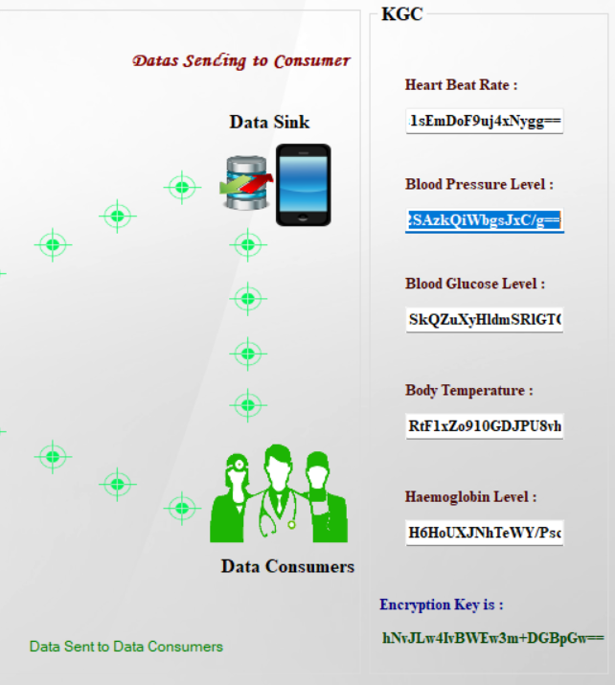
Fig 1.Key Generation Center
4.2 Sensors (Implanted and Wearable Sensors):
A BAN consists of wireless sensors called BAN devices either embedded on/near the surface or implanted in the deep tissue of a human body. These sensors are exploited to monitor vital body parameters. The BAN devices should have certain computation capabilities to encrypt the patient's data and store the cipher text in the data sink. When a doctor or a nurse needs the data, she/he needs to communicate with the data sink to retrieve the encrypted data
4.3 Data Sink:
A data sink, which could be the BAN controller or a mobile device such as a Smartphone, is used to store the patient's data. We apply attribute-based encryption, to encrypt the data and store the cipher text in the data sink according to the requirements of the BAN. After data consumers retrieve a data item from the data sink, they can decrypt the data as long as they possess the secret key for the corresponding attributes specified by the access tree of the data.
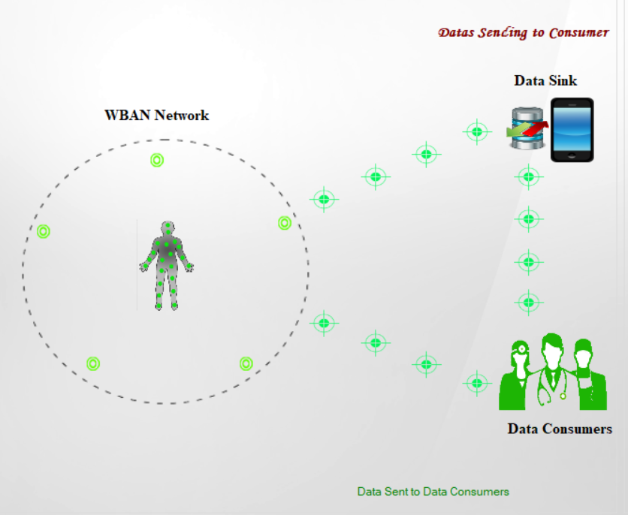
Fig 2. WBAN and Data Sink
4.4 Data Consumers:
Data Consumers refer to doctors and nurses or other experts. To decrypt a message, data consumers should have the attributes that satisfy the access tree specified by the data source. When the first time a data consumer joins the system, he needs to contact the KGC to obtain the secret key corresponding to the attributes he claims to have. The secret keys for a data consumer are uniquely generated by KGC, which typically associates a random number with each key, to enable the data consumer's ability to decrypt a message and simultaneously prevent collusion attacks.
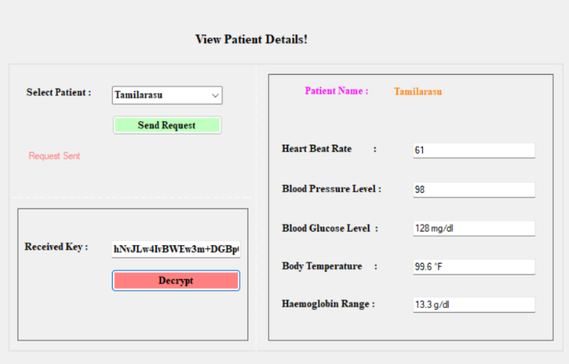
Fig 3. Data Consumer

5. CONCLUSION
Mobile Healthcare Emergency Platform access their medical records has revolutionized the way people to store data. To secure Body Area Network additional overhead occurred earlier not only saved money to the digitization of the health information discussed many symmetric.
The hybrid key security mechanisms of Asymmetric to WBAN with detail comparison approaches. Accomplish high consistency of PHI process compute to structure for medical Healthcare urgent situation. The privacy safeguard opportunistic computing projected a secure communication in urgent situation to comprehensive security investigation.
One-to-many encryption technique propose an efficient attribute-based encryption be in charge of rules in a WBAN satisfy convinced access. In medical Healthcare emergency minimizing the PHI privacy disclosure through widespread performance assessment and communication.

REFERENCES

- Krithick J G, Nivedh T S, Siva Bharath S, "DATA SECURITY IN HEALTHCARE USING IOT", 2022.
- Mohd. Sultan Ahammad, Anichur Rahman, "A Framework for M-Health Services Using 4G (LTE) Technology", 2020.
- Junaid Ahmed Zubairi, Syed Misbahuddin, "Emergency Medical Data Transmission Systems and Techniques", 2018.
- C. Hu, F. Zhang, X. Cheng, X. Liao, and D. Chen, “Securing communications between external users and wireless body area networks,” in Proceedings of the 2nd ACM workshop on Hot topics on wireless network security and privacy. ACM, 2013, pp. 31–36
- X. Liang, X. Li, Q. Shen, R. Lu, X. Lin, X. Shen, and W. Zhuang, “Exploiting prediction to enable secure and reliable routing in wireless body area networks,” in INFOCOM. IEEE, 2012, pp. 388–396.
- S. Ali, V. Sivaraman, and D. Ostry, “Zero reconciliation secret key generation for body-worn health monitoring devices,” in ACM Wisec. ACM, 2012, pp. 39–50.
- S. Pirbhulal, H. Zhang, S. C. Mukhopadhyay, C. Li, Y. Wang, G. Li, W. Wu, and Y.-T. Zhang, “An efficient biometric-based algorithm using heart rate variability for securing body sensor networks,” Sensors, vol. 15, no. 7, pp. 15 067–15 089, 2015
- Mobeen Khan, Muhammad Taha Jilani, "A security framework for wireless body area network based smart healthcare system", 2017.

