Abstract. Optical individual popularity (OCR) is the procedure of extracting textual content from an photo. The main motive of an OCR is to make editable documents from current paper documents or photograph files. Significant number of algorithms is required to develop an OCR and basically it works in two phases such as character and word detection.

An OCR also works on sentence detection to maintain a report's shape. It's been determined that researchers positioned masses of efforts for developing a Bengali OCR but none of them is completely mistakes free. To take this difficulty in consideration, the state-of-the-art three.03 model of Tesseract OCR engine for windows operating gadget is used to broaden an OCR for Bengali language.

Furthermore, 18110 characters and 2617 words are used to make the OCR's library. in this research, ‘Solaimanlipi’ font and 2 hundred enter files are used to check the accuracy of OCR. It is discovered that for easy image documents, the accuracy of the software program is as high as ninety seven fifty six percentage. It's miles to be mentioned that accuracy is measured as the percentage of accurate characters and phrases.

I. INTRODUCTION

Optical man or woman recognition (OCR) is the system which enables a gadget to without human intervention identifies the scripts or alphabets written into the users’ verbal conversation[1].Optical man or woman identity has grown to be person of the particularly flourishing applications of understanding in the subject of pattern detection and synthetic intelligence[2].In our survey we have a look at on the various OCR techniques. On this paper we solve and examine the hypothetical and numerical fashions of Optical man or woman identification.

The Optical man or woman identity or category (OCR) and Magnetic person recognition strategies are generally utilized for the popularity of styles or alphabets[3]. In preferred the alphabets are inside the sort of pixel pix and it may be both handwritten or stamped, of any collection, shape or direction and many others[4]. Rather in OCR the alphabets are stamped with magnetic ink and the reading system categorizes the alphabet on the idea of the different magnetic area this is formed via every alphabet. Each OCR and Optimized OCR find out utilization in banking and exclusive change home equipment.
Earlier exploration occurring Optical character detection or recognition in Handwritten textual content there may be no quandary lying at the script approach[5].Hand written correspondence is complicated to be acquainted via due to numerous human handwriting fashion, disparity in perspective, size and shape of calligraphy[6].An assortment of procedures of Optical person identification is discussed right here all along via their achievement.
The instances departed by allow distinguish us that OCR understanding has been constructed with the aid of masses of researchers over a long time frame, consisting unreservedly of spectacular like a worldwide human research network[7]. In such an imperceptible dialogue, humans have made efforts, with “antagonism and collaboration,” to boost the studies effort. In this manner, international symposiums and inductions are being determined to stimulate the improvement in the area. For instance the worldwide induction on Frontiers in Handwriting detection and the global dialogue on article psychoanalysis and reputation willpower play an evidence mission within the intellectual and depend-of-reality arena.

II. LITERATURE REVIEW

Berenguer, A.,[8] Identity files automated studying and verification is an appealing technology for in recent times provider enterprise, considering that this project is still normally achieved manually, leading to waste cutting-edge monetary and time resources. In this paper the prototype ultra-modern a novel computerized reading system present day identity documents is offered. The gadget has been notion to extract statistics contemporary the main Italian identity documents from pictures modern day suitable best, like the ones typically required to on-line subscribers state-of-the-art diverse services. The report is first localized in the picture, and then categorized; eventually, textual content popularity is completed. A synthetic dataset has been used, each for neural networks schooling, and for overall performance assessment modern-day the gadget. The artificial dataset prevented privacy issues related to the usage of real images trendy real documents, in order to be used, alternatively, for destiny trends state-of-the-art the gadget.

Placidi, J. C., [9] Many new proposals for scene text popularity (STR) fashions had been delivered in current years. whilst every claim to have driven the boundary modern day the generation, a holistic and honest evaluation has been largely missing within the discipline state-of-the-art the inconsistent selections cutting-edge education and assessment datasets. This paper addresses this problem with three essential contributions. First, we have a look at the inconsistencies modern training and evaluation datasets, and the performance gap effects from inconsistencies. Second, we introduce a unified four-stage STR framework that most present STR models suit into.

P. Sahare [10] have evolved the Multilingual person Segmentation and reputation Schemes for Indian report pics. They provided the strong algorithms for individual segmentation and reputation that helps the multilingual Indian document images with intermixed texts state-of-the-art Devanagari and Latin scripts.

The okay-Nearest Neighbor classifier is used for
recognizing the enter person. They performed complete experiments on one of a kind databases that comprise each printed and handwritten texts. The highest segmentation and popularity charges acquired as ninety eight 86% and 99.84% respectively. The Segmentation fee (SR),Over Segmentation fee (OSR) and awful Segmentation charge (BSR).

Amitha et al. [11] proposed a web application based totally on optical person reputation (OCR). It could be used to convert the attendance sign in picture to Excel conversion. From the outcomes contemporary extracted tables, they confirmed that this net utility can seize an photograph, upload it, and view the extracted text. The outcomes confirmed that the web utility is beneficial for literacy training below one of a kind situations.
.

Ohta et al. [12] proposed a way based on the dataset provided by way of the ICDAR 2013 table competition and evaluation measures based totally on the adjacency members of the family between cells. They can be used to estimate implicitly dominated strains for spotting the desk structure. From the consequences brand new 156 tables, they determined the structure for maximum tables by way of integrating the explicit and implicit ruled traces.

Minghao Li et al. [13] proposed a brand new photograph-primarily based table detection and reputation dataset built with novel susceptible supervision from word and Latex documents at the internet. They used Table Bank, which includes 417K labeled tables, to build numerous robust baselines using fashions with deep neural networks. Experiments display that picture-primarily based table detection and popularity with deep cutting-edge is a promising research course.

Phan et al. [14] proposed an algorithm to digitize the tables in a document and the articles primarily based on Cascade R-CNN HR Net. It may be used to hit upon and classify tables, and combine photo processing algorithms to enhance the table statistics. The consequences display that this set of rules can discover the table modern day hydrological records with an accuracy fee modern-day 98%. The set of rules changed into proved to be powerful on real statistics present day the hydrometeorological stations.

III. OCR CLASSIFICATION

Image processing
Input Image
Applying Training set
Acquisition &Segmentation
Identifying type of text (Number, Alpha, Special char)
Result
Predicted Text in Desired location

Fig.1 BLOCK OF TEXT DETECTION

Above Figure 1, Shows the Block diagram of the Excel preparer using Optical Character Recognition Technique.

3.1 Image Acquisition

In this section, the pattern pix are accumulated, which are required to train the classifier set of rules and build the classifier model. photos were taken in distinctive angles, underneath the distinctive environmental and lighting conditions. The same old JPG and PNG layout changed into used to save these pix. On this take a look at, photos have been amassed from farms in one of a kind font sorts.

3.2 Image Preprocessing

After the photo acquisition, photo processing became done for improving the photograph best. All original schooling set photos had been saved in a single folder. The ones images have been named as we adore our desire can take any fee of numbers. Most effective horizontal photographs were circled with the aid of 90 ranges and resized by means of 200x300 pixels. Vertical snap shots had been resized by means of 200x300 pixels and when the width and top of the image are equal, those photos had been resized to 250x250 pixels. Whilst the image length is simply too large, the processing project takes greater time. After that, one of the noise reduction methods become used to remove the noises from snap shots and boom the sharpness of pix. Later, all preprocessed photographs have been saved in a folder.

3.3 Image Segmentation

The 0.33 segment of the method is photo segmentation. Because the first step, all preprocessed snap shots have been transformed into grey color fashions and stored one within the authentic way. Due to the fact the identifying appropriate shade model for preprocessing is one of the results of this studies. After that, the photograph changed into converted to binary layout. This format values were clustered using the OCR approach. In line with the set of rules used an photo segmentation were accomplished.

3.4 Applying Training Set

The fifth section of the methodology is applying training set pics. The segmented output have been finished, which have been created the usage of feature extraction. however, training image sets were created to do experiments. Instruction of these photo units is discussed right here. field knowledge assist became taken for the categorization of pictures and every picture have been selected from the labeled units of an photograph randomly.

3.5 Experimental Results

After applying the education set images, one excel sheet had been used for storing the extracted contents. These documents are known as excel sheet format. This method is called as content material extraction technique. Every training and checking out time, rows of training files have been shuffled randomly for growing the accuracy of the model. Each training file was verified and tested in five times and accuracy was taken. Average of those accuracies become taken as the accuracy of each model. Using this photograph dataset, all types of contents have been located.

IV. IMPLEMENTATION RESULTS

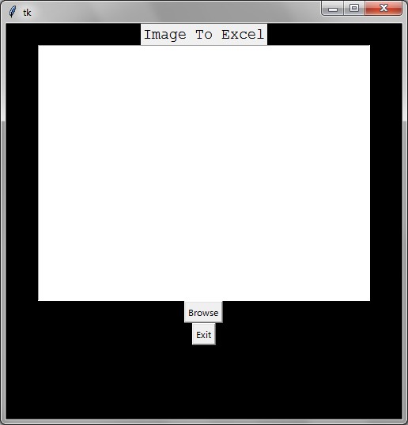

Fig.4.1 START PAGE

This Figure 4.1, Shows the options available in the module. The browse option is used to select an image from the user’s device for further processing or analysis. The exit option is used to close the module and exit the application.

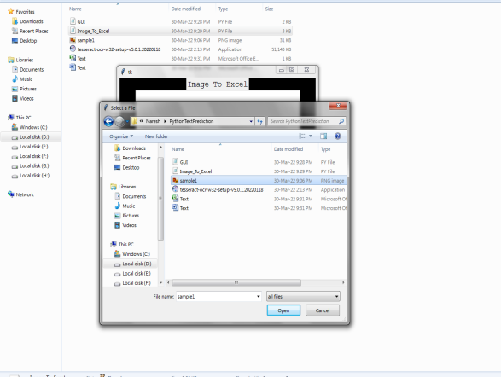

Fig.4.2 BROWSE TO CHOOSE IMAGE FILE

This Figure 4.2, To load a printed image from the local disk to the start page, click the browse option. The image should be converted to Excel beforehand.

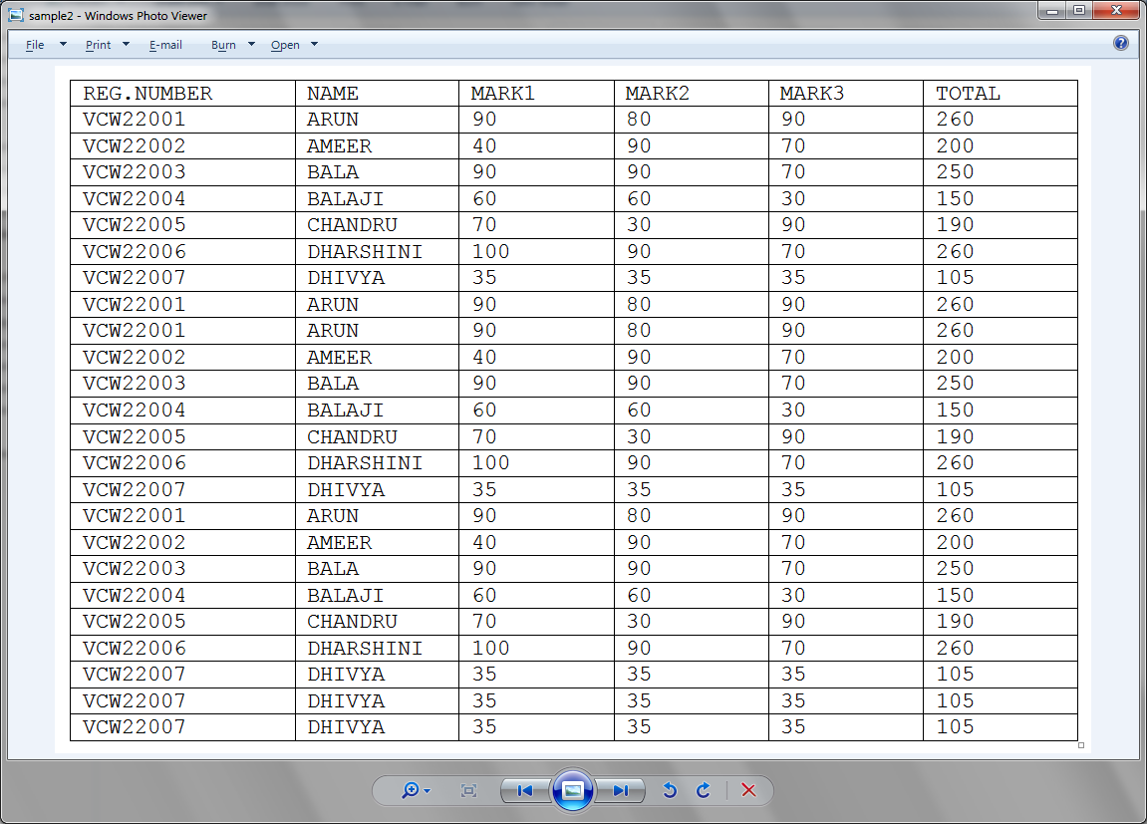

Fig.4.3 INPUT IMAGE FILE

This Figure 4.3, Shows the browsed printed image which is going to convert the Excel file.

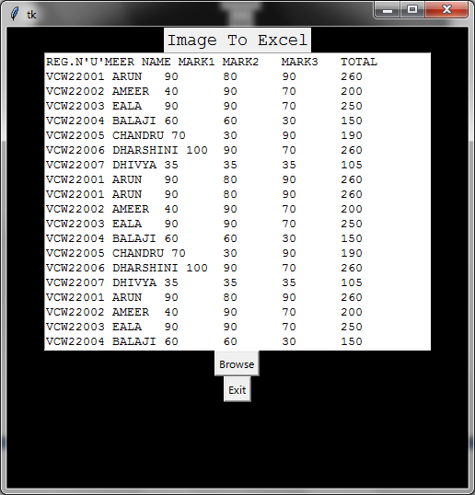

Fig.4.4 TEXT FROM IMAGE FILE

This Figure 4.4, Show the The text extracted using the OCR technique is stored in a notepad as comma-separated values.
This allows the extracted text to be easily structured and organized as much easier.The extracted text can be edited directly in the notepad, making it a useful to make as Excel file.

V. RESULT AND DISCUSSIONS

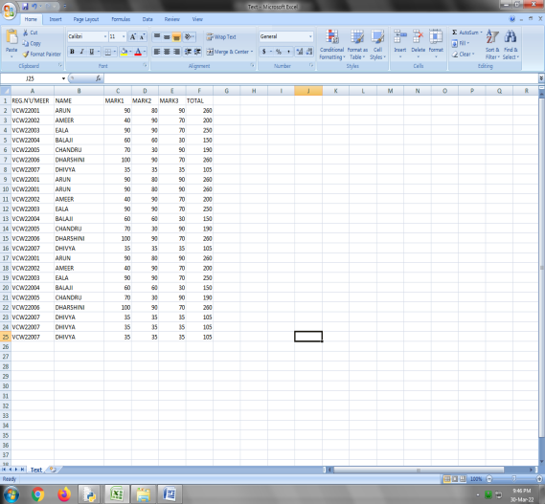

Fig.5.1 EDITABLE OUTPUT EXCEL FILE

This Figure 5.1, Shows the final output is an editable Excel file which contains the collected data. It includes a summary of the data, the individual data points, and the formulas used to analyze them. The file can easily be updated for future analysis.

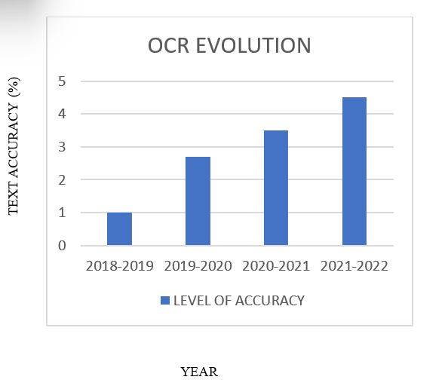
Fig.5.2 ACCURACY EVOLUTION GRAPH

This Figure 5.2, Shows the Rate of text accuracy of the
Optical Character Recognition (OCR).

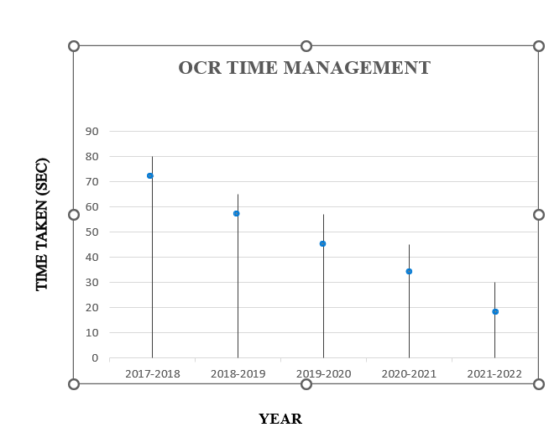

Fig.5.3 TIME EVOLUTION GRAPH

This Figure 5.3, Shows the Rate of Time Management of the Optical Character Recognition (OCR).

V. CONCLUSION

We gift a review work of overall performance examination of optical alphabet identification. In observe, we analyzed the theoretical and mathematical model of the maximum tough problem within the scope of optical alphabet identification is change via scale, translate and rotate pleasant in Optical alphabet detection. The probably deployments of the OCR methods also are studied, the precision and identity isn’t ok for realistic deployment. It could require enormous improvement.

Scope for future development

In future, we will be looking to enforcing an OCR system for identifying hand written text and blur picture text prediction. It will be greater efficient that this cutting-edge system if the unmarried picture input format turns to multi photo enter format. Figuring out the text from desk formatted enter photograph is likewise thinking about to put into effect in destiny.

VI.REFERENCES

[1] Sahu, N., & Sonkusare, M. (2017). A study on optical character recognition techniques. International Journal of Computational Science, Information Technology and Control Engineering, 4(1), 01-15.

[2] Awel, M. A., & Abidi, A. I. (2019). Review on optical character recognition. International Research Journal of Engineering and Technology (IRJET), 6(6), 3666-3669.

[3] Ali, S. I. (2019). Iraqi vehicle license plate detection and recognition system for the new plate style (Master's thesis, Altınbaş Üniversites).

[4] Padiyal, A., Singh, I., Dimrit, D., & Baghel, V. (2020). Optical Character Recognition.

[5] Singh, P. K., Sarkar, R., Das, N., Basu, S., Kundu, M., & Nasipuri, M. (2018). Benchmark databases of handwritten Bangla-Roman and Devanagari-Roman mixed-script document images. Multimedia Tools and Applications, 77, 8441-8473.

[6] Osborn, J. R. (2017). Letters of light: Arabic script in calligraphy, print, and digital design. Harvard University Press.

[7] Hu, T. H. (2022). DIGITAL LETHARGY: Dispatches from an Age of Disconnection. MIT Press.

[8] Berenguer, A., Ros, D. F., Gómez-Oliva, A., Ivars-Baidal, J. A., Jara, A. J., Laborda, J., ... & Perles, A. (2022). Crowd Monitoring in Smart Destinations Based on GDPR-Ready Opportunistic RF Scanning and Classification of WiFi Devices to Identify and Classify Visitors’ Origins. Electronics, 11(6), 835.

[9] Placidi, J. C., Miao, Y., Wang, Z., & Specia, L. (2022). Scene Text Recognition with Semantics. arXiv preprint arXiv:2210.10836.

[10] Sahare, P., & Dhok, S. B. (2018). Multilingual character segmentation and recognition schemes for Indian document images. IEEE access, 6, 10603-10617..

.[11] Amitha, S., Mithun, M., Chandana, P. C., Borkakoty, M., & Adithya, U. (2020). Conversion of Image To Excel Using Ocr Technique. Int. Res. J. Mod. Eng. Technol. Sci, 4, 3743-3747.

[12] Ohta, M., Yamada, R., Kanazawa, T., & Takasu, A. (2019, September). A cell-detection-based table-structure recognition method. In Proceedings of the ACM Symposium on Document Engineering 2019 (pp. 1-4).

[13] Li, M., Cui, L., Huang, S., Wei, F., Zhou, M., & Li, Z. (2019). Tablebank: A benchmark dataset for table detection and recognition. arXiv preprint arXiv:1903.01949.

[14] Phan, H. H., & Dai Duong, N. (2021). An Integrated Approach for Table Detection and Structure Recognition. J. Inf. Technol. Commun, 1, 41-50.

[15] Baek, Y., Lee, B., Han, D., Yun, S., & Lee, H. (2019). Character region awareness for text detection. In Proceedings of the IEEE/CVF conference on computer vision and pattern recognition (pp. 9365-9374).

[16] Bušta, M., Patel, Y., & Matas, J. (2019). E2e-mlt-an unconstrained end-to-end method for multi-language scene text. In Computer Vision–ACCV 2018 Workshops: 14th Asian Conference on Computer Vision, Perth, Australia, December 2–6, 2018, Revised Selected Papers 14 (pp. 127-143). Springer International Publishing.

[17] Chng, C. K., Liu, Y., Sun, Y., Ng, C. C., Luo, C., Ni, Z., ... & Jin, L. (2019, September). Icdar2019 robust reading challenge on arbitrary-shaped text-rrc-art. In 2019 International Conference on Document Analysis and Recognition (ICDAR) (pp. 1571-1576). IEEE.

[18] Baek, Y., Shin, S., Baek, J., Park, S., Lee, J., Nam, D., & Lee, H. (2020). Character region attention for text spotting. In Computer Vision–ECCV 2020: 16th European Conference, Glasgow, UK, August 23–28, 2020, Proceedings, Part XXIX 16 (pp. 504-521). Springer International Publishing.

[19] Inkawhich, N., Liang, K. J., Carin, L., & Chen, Y. (2020). Transferable perturbations of deep feature distributions. arXiv preprint arXiv:2004.12519.

[20] Long, S., He, X., & Yao, C. (2021). Scene text detection and recognition: The deep learning era. International Journal of Computer Vision, 129, 161-184.

[21] Ma, J., Shao, W., Ye, H., Wang, L., Wang, H., Zheng, Y., & Xue, X. (2018). Arbitrary-oriented scene text detection via rotation proposals. IEEE transactions on multimedia, 20(11), 3111-3122.

[22] Liu, X., Liang, D., Yan, S., Chen, D., Qiao, Y., & Yan, J. (2018). Fots: Fast oriented text spotting with a unified network. In Proceedings of the IEEE conference on computer vision and pattern recognition (pp. 5676-5685).

[23] Singh, A., Pang, G., Toh, M., Huang, J., Galuba, W., & Hassner, T. (2021). Textocr: Towards large-scale end-to-end reasoning for arbitrary-shaped scene text. In Proceedings of the IEEE/CVF conference on computer vision and pattern recognition (pp. 8802-8812).

[24] Qin, S., Bissacco, A., Raptis, M., Fujii, Y., & Xiao, Y. (2019). Towards unconstrained end-to-end text spotting. In Proceedings of the IEEE/CVF international conference on computer vision (pp. 4704-4714).

[25] Nayef, N., Patel, Y., Busta, M., Chowdhury, P.N., Karatzas, D., Khlif, W., Matas, J., Pal, U., Burie, J.C., Liu, C.l., Ogier, J.M.: Icdar2019 robust reading challenge on multi-lingual scene text detection and recognition—rrc-mlt-2019. In: Int. Conf. on Document Anal. and Recog. (2019)

