Exploring the Potential of Artificial Intelligence in Healthcare: Possibilities and Challenges
M S Eshwar¹
¹Btech CSE, The Northcap University
----------------------------------------------------------------***-------------------------------------------------------------

ABSTRACT
Artificial intelligence (AI) has the potential to revolutionize healthcare by offering personalized, accurate, and innovative solutions, but it poses challenges such as data privacy, regulatory compliance, and ethical considerations. This research paper provides a comprehensive review of the current state of AI in healthcare, its applications, benefits, challenges, and future prospects. The report emphasizes how AI has the potential to revolutionise healthcare delivery by enhancing patient outcomes, diagnosis, and treatment while lowering costs and increasing efficiency. With the ability to analyze vast amounts of medical data quickly and accurately, AI has enormous potential to provide personalized and timely care to patients. To ensure the appropriate and ethical use of AI in healthcare, however, there are important ethical and regulatory obstacles that must be addressed.

Keywords: Artificial Intelligence, Healthcare

INTRODUCTION
Artificial Intelligence (AI) is transforming various industries and has the potential to change healthcare by providing accurate and innovative solutions. Healthcare is an industry that generates a vast amount of data that can be used by AI to analyze and provide informative insights that can help in improving a patient’s outcomes and healthcare delivery. Moreover, it may be used to identify illnesses, forecast results, create treatment strategies, and enhance patient monitoring. Also, it can aid in cost reduction and help healthcare practitioners manage administrative tasks.

However, AI in healthcare creates challenges such as data privacy, regulatory compliance, and ethical considerations. Several individuals have expressed concerns about the precision and correctness of AI algorithms. There is also a need for clear guidelines and regulations to ensure that work takes responsible and ethical use of AI in healthcare.

This research paper aims to explore the current state of AI in healthcare. The paper will explore the potential of AI to transform healthcare delivery by improving treatment, diagnosis, and outcomes while reducing costs and increasing efficiency and correctness. The ethical and legal issues that must be taken into account to ensure the safe and responsible use of AI in healthcare are also covered in this essay. This research paper aims to contribute to our knowledge of the role of AI in healthcare and give useful information for healthcare providers and AI developers on how to address the challenges of integrating AI in healthcare.

LITERATURE REVIEW
"A Deep Learning System for Diagnosing Malaria from Blood Smear Images" by Rajaraman et al. (2018)
This article describes a deep-learning system that can accurately diagnose malaria using images of blood smears. The system achieved a sensitivity of 96.8% and a specificity of 97.3%, demonstrating the potential of AI to improve diagnostic accuracy in resource-limited settings.

“Ways artificial intelligence will transform primary care” by Lin, S.Y., Mahoney, M.R (2019)
This paper explains how businesses are utilizing AI to enhance their capacity for performance optimization through the usage of population health solutions for physicians. AI-powered robots are treating skin cancer, breast cancer, colorectal cancer, brain cancer, and cardiac arrhythmias with more accuracy than physicians and offering patients considerable benefits. For both patients and doctors, AI can automate some aspects of basic care with increased effectiveness and speed.
“Artificial intelligence in thoracic surgery: past, present, perspective and limits” by Nadikattu, R. R. (2017)
Recent advances in AI technology have improved thoracic surgery, particularly in radiology, pathology, and respiratory care. Deep Learning has been used to detect lung nodules on chest X-rays, outperforming many surgeons in classifying X-rays and detecting nodules. Robots are a tool that mimics the surgeon's skills and is not intended to be used as a replacement. These advancements have benefited surgeons as well as patients. AI innovations may boost surgeons' productivity and clinical outcomes.

“The Potential for artificial intelligence in Healthcare” by Thomas Davenport and Ravi Kalakota (2019)
Due to the complexity and growth of the data in the healthcare sector, artificial intelligence (AI) will be used increasingly frequently. Payers, providers, and life science companies all use different types of AI technology at the moment. Administrative activities, patient engagement and adherence, and recommendations for diagnosis and treatment are the three main areas into which applications may be categorised. The automation of a substantial portion of the healthcare workforce will take some time even though there are some situations in which AI can do healthcare activities just as well as or better than humans. This is because of implementation issues. The ethical issues raised by AI use in healthcare will also be looked at.

“The ethical implications of artificial intelligence in Healthcare” by Lee, J.Y., Choi, & Park (2021)

The paper by Lee, Choi, and Park (2021) discusses the ethical implications of using artificial intelligence (AI) in healthcare. The authors argue that while AI has the potential to transform healthcare, it must be used ethically and responsibly. They propose ethical principles such as transparency, fairness, privacy, and accountability to guide the development and use of AI in healthcare.

“The challenges and opportunities of artificial intelligence in Healthcare” by Wang, Y., Huang, C., Peng, Y., & Chen, H. (2020)

The paper by Wang, Huang, Peng, and Chen (2020) discusses the challenges and opportunities presented by the use of artificial intelligence (AI) in healthcare. They identify various applications of AI in healthcare, such as diagnosis and treatment planning, and discuss challenges such as data quality and privacy concerns. However, they also highlight opportunities such as improved diagnostic accuracy and reduced healthcare costs. The authors stress the need for interdisciplinary collaboration and data sharing to fully realize the potential of AI in healthcare.
“Artificial intelligence in healthcare: past, present and future” by Aung, Z., & Rudolph, A. E. (2020).
Aung and Rudolph's study from 2020 offers a thorough analysis of artificial intelligence (AI) in healthcare's past, present, and future. The writers go into the background and current uses of AI in healthcare, as well as the difficulties and possibilities that come with using it. To assure better healthcare results, they underline the necessity for interdisciplinary collaboration and responsible development and use of AI in healthcare.

TYPES OF AI OF IMPORTANCE TO HEALTHCARE
Artificial intelligence is made up of a variety of distinct technologies. The bulk of them has direct applications in the medical industry. These are some of the technologies listed below.
Machine Learning
Computers may learn from their experiences and develop without explicit programming thanks to the artificial intelligence technique known as machine learning. It entails creating algorithms and statistical models that allow machines to anticipate the future or make judgments based on correlations and patterns in data. It is a subset of Artificial Intelligence.
The type of machine learning that is most frequently used in the healthcare industry is precision medicine, which chooses which treatment procedures are most likely to be helpful for a patient based on a range of patient characteristics and the context of the therapy. Many training datasets with predefined outcome variables are needed for supervised training also known as precision medicine—applications.
The neural network is a more sophisticated kind of machine learning that has been used extensively in the field of health research since the 1960s. One of its many applications is predicting whether a patient would contract a certain disease. It analyses problems in terms of the weights of the variables, or the "features" that link inputs and results. Although the relationship to brain function is relatively hazy, it has been compared to how neurons perceive signals.
Deep Learning, a subtype of machine learning that includes training artificial neural networks to learn from and improve upon massive datasets, is one of the most sophisticated types of machine learning. It processes complicated data using numerous layers of linked nodes to provide predictions or judgments. Deep Learning and radiomics are used in healthcare to detect potentially cancerous lesions in radiological images, offering greater diagnostic accuracy than previous automated image analysis tools.

Natural Language Processing
Making it possible for computers to comprehend, interpret, and generate human language is the goal of the discipline of natural language processing (NLP), which falls under the umbrella of computer science and artificial intelligence. NLP techniques use statistical and machine learning models to analyze and process large amounts of textual data, such as social media posts, news articles, and customer feedback. Common applications of NLP include language translation, sentiment analysis, speech recognition, chatbots, and text summarization. Because natural language is complex and full of nuances, NLP research faces many challenges, including developing accurate models for understanding context, grammar, and idiomatic expressions. However, advances in Deep Learning and neural network architectures are enabling significant progress in this area.

Rule-Based Expert System
An artificial intelligence (AI) system known as a rule-based expert system employs a collection of if-then clauses or rules to make judgements or address issues in a given area. These rules are created by human experts and are based on their knowledge and experience in the field. The expert system uses the rules to analyze input data and draw conclusions or make recommendations based on the rules. Rule-based expert systems are commonly used in fields such as medicine, finance, and engineering, where a high degree of accuracy and consistency is required. They are constrained, nevertheless, by the fact that they are only able to respond in accordance with the pre-programmed rules and might not be able to adjust to novel or unexpected circumstances.
Physical Robots
Physical robots are becoming increasingly popular, with more than 200,000 installed worldwide each year. They are simpler to train and fulfil predetermined jobs. Moreover, when new AI capabilities are included into their "brains," they are growing wiser. Surgical robots, which were initially authorised in the United States in 2000, enable surgeons "superpowers" by improving their vision, capacity to perform accurate and less invasive incisions, ability to stitch wounds, etc. Among the main surgical procedures that use robotic surgery include head and neck surgery, prostate surgery, and gynecologic surgery.
Robotic Process Automation
By automating time-consuming and repetitive procedures, robotic process automation (RPA) has the potential to revolutionise healthcare by freeing up healthcare personnel to concentrate on patient care. Tasks like scheduling, claims processing, and data input may be automated with RPA. RPA can also aid by lessening the possibility of mistakes and inconsistencies, which can enhance the accuracy and quality of healthcare data. In addition, RPA can be used to integrate disparate healthcare systems and applications to improve data sharing and collaboration among healthcare providers. However, RPA implementation in healthcare must be carefully planned and executed to ensure regulatory compliance and address privacy and security concerns.

METHODOLOGY
DIFFERENT DEEP LEARNING
ARCHITECTURES APPLIED IN
HEALTHCARE
Different Deep Learning Architectures Applied In Healthcare
Neural Networks
The class of machine learning models known as neural networks was inspired by the structure and function of the human brain. They are made up of a network of linked processing nodes, or neurons that can teach themselves to identify patterns in data. In many different domains, including speech and image identification, natural language processing, and predictive analytics, neural networks have been utilized to address a wide range of issues.
Convolutional Neural Network
Convolutional Neural Networks (CNNs) are a subtype of deep neural networks that are often used in the classification, segmentation, and object detection of pictures. Several image-related tasks have shown the effectiveness of CNNs, which beat conventional machine-learning methods in terms of accuracy and speed.

CNNs use a sequence of convolutional layers to apply a set of learnable filters to the input picture in order to discover spatial patterns and features in images. Edges, corners, and textures are just a few of the qualities that the filters learn to recognise in an image. In order to increase the computational efficiency of the network, the output of each convolutional layer is then fed into a pooling layer, which shrinks the spatial dimensions of the feature maps.
Moreover, CNNs use fully connected layers at the network's end that enable the classification of the input picture. Through a technique known as backpropagation, the network's parameters are learned by altering the weights and biases of the neurons in each layer based on the differences between expected and actual outputs.

Recurrent Neural Networks
Recurrent neural networks (RNNs) are a subclass of neural networks widely used to analyse sequential data, such as time-series data and spoken language. RNNs may recognise temporal relationships in the input by utilising feedback links between the network's hidden layers. As a result, complicated sequential patterns and correlations that conventional machine learning algorithms would find difficult to capture can be modeled by RNNs.
Speech recognition, machine translation, and language modeling are a few of the tasks that RNNs are particularly good at. Nevertheless, a drawback of RNNs is that they may experience the vanishing gradient problem, which makes it challenging for the network to learn long-term relationships in the data.

While other neural networks, such as LSTMs, GANs, DBNs, Autoencoders, and Capsule Networks, also have various applications in medicine, CNNs and RNNs are currently the most commonly used ones in the field.

APPLICATION OF AI IN HEALTHCARE
Artificial Intelligence is utilized in a wide array of healthcare applications. It is used beyond medical imaging and diagnosis. For example, it can also be used to optimize hospital operations and patient control, by predicting the admission rate, managing staff levels, and forecasting equipment maintenance needs. It is also used to manage electronic health records (EHRs), where it can help improve the accuracy and completeness of patient records, enabling better decision-making by doctors. Also, AI can assist with decision-making by analyzing patients’ data to provide recommendations on treatment options. Also, it can help identify patients who may be at risk of developing certain conditions.
AI-powered chatbots are also used to provide support to healthcare providers by providing patients with access to basic medical information, thus improving patient engagement. These applications of AI in healthcare are just a few examples of how AI is transforming the healthcare sector by making it more data-driven, efficient, and patient-focused.
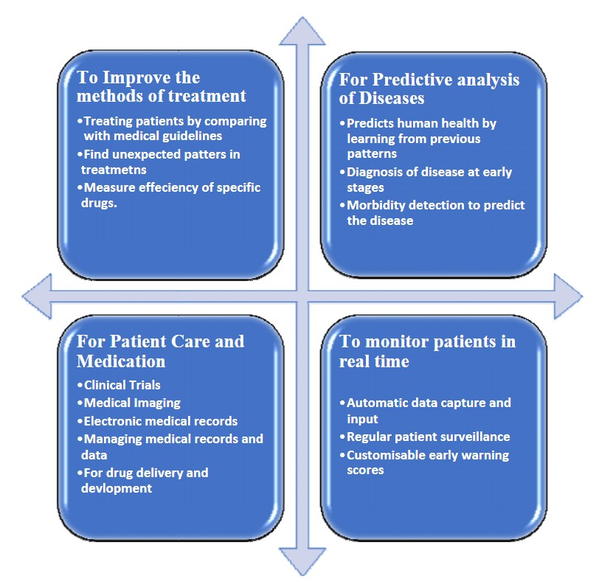
Fig-1 Application of AI

BENEFITS OF AI IN HEALTHCARE
AI has a lot of potential numerous and far-reaching benefits, including improving patient diagnostic accuracy, reducing medical costs, facilitating personalized treatment, and enabling early detection of diseases for patients. AI can reduce healthcare costs by optimizing resources and improving efficiency. Additionally, AI can help in patient engagement and satisfaction by providing easy access to different medical advice and information, as well as remote monitoring of patients from their homes and telemedicine.
AI can analyze large amounts of medical data, and by automating routine tasks, we can make healthcare automated so that healthcare professionals can focus on more complex and specialized tasks. Overall, AI has the ability to transform healthcare by improving the quality of healthcare, reducing the cost of healthcare, and increasing accessibility for patients
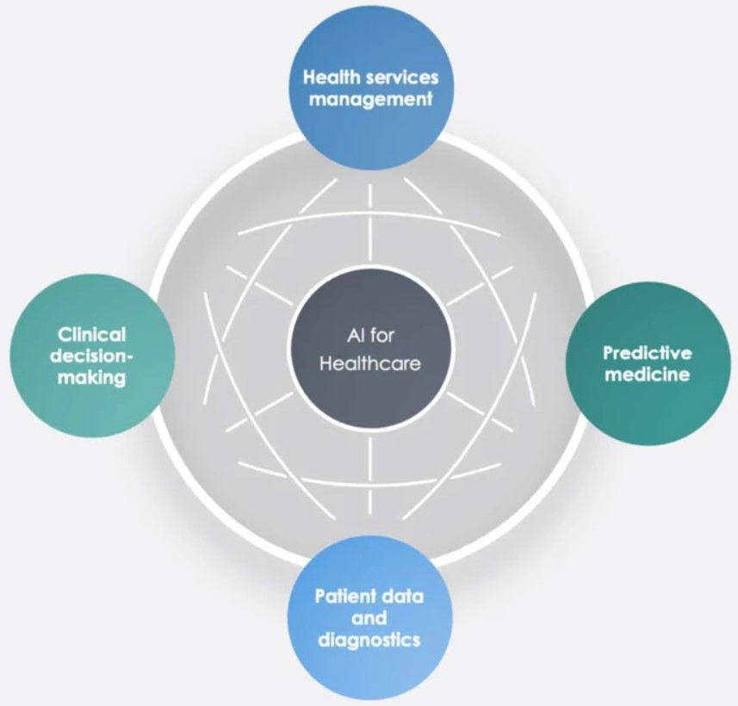
Fig-2 Benefits of AI in Healthcare

CHALLENGES OF AI IN HEALTHCARE
There are still a lot of problems that need to be tackled, even if AI has the potential to enhance healthcare. Because using AI involves using a lot of delicate medical data, protecting data privacy and security is one of the biggest problems. Because AI algorithms only employ pre-existing data, their usage may potentially raise questions about their correctness and dependability. Another concern is regarding the interoperability between different healthcare centers, which can hinder the sharing and analysis of data necessary for the effective use of AI systems. Other challenges include the need for specialized training and expertise to effectively develop and implement AI systems in healthcare. There is also a risk of job displacement as AI takes over more tasks traditionally performed by healthcare professionals. Another challenge is the need for AI to be transparent and explainable, especially when it comes to decision-making processes that can significantly impact patient care. Finally, there are concerns that AI may perpetuate existing biases or even introduce new ones. To fully utilise AI in healthcare while assuring its ethical and fair application, it will be essential to address these problems.

CONCLUSION

Artificial intelligence (AI) technologies are being used or evaluated for a range of activities in the healthcare and research sectors, including the diagnosis of diseases, the management of chronic conditions, the provision of services, and the creation of new drugs. AI may not be used to solve urgent health concerns due to the caliber of the already available health data and the fact that it does not yet possess some human attributes like compassion.
However, the integration of AI also presents various challenges that are necessary to be addressed. They include ethical concerns, security, and privacy issues. To guarantee that the advantages of AI in healthcare are achieved while reducing possible hazards, the collaboration between healthcare providers, politicians, and industry leaders is crucial.
The potential advantages of AI in healthcare cannot be overlooked, despite these difficulties. Artificial intelligence (AI) is already being used more and more in the field of healthcare, and this trend is projected to continue. To enhance patient outcomes and the general standard of healthcare, it is essential that industry leaders and healthcare providers continue to fund AI research and development. Future AI governance will face significant challenges in supporting and accelerating industrial innovation while also ensuring that AI is created and deployed in a transparent and in accordance with the public interest.
In summary, applications of AI in healthcare present a unique opportunity to improve patient care, reduce costs, and increase efficiency. While there are challenges that need to be addressed, the potential benefits of AI in healthcare are too significant to ignore. We must embrace this technology and work together to ensure that it is used ethically and responsibly to achieve the best possible outcomes for patients and healthcare providers.

REFERENCES
Sharma, Aneesh. (2021). ARTIFICIAL INTELLIGENCE IN HEALTH CARE. International Journal of Humanities, Arts, Medicine and Science. 5. 106-109.
Ramesh, A & Kambhampati, Chandra & Monson, John & Drew, Philip. (2004). Artificial intelligence in medicine. Annals of the Royal College of Surgeons of England. 86. 334-8. 10.1308/147870804290.
Guoguang Rong, Arnaldo Mendez, Elie Bou Assi, Bo Zhao, Mohamad Sawan, Artificial Intelligence in Healthcare: Review and Prediction Case Studies, Engineering, Volume 6, Issue 3, 2020.
Manne, Ravi & Kantheti, Sneha. (2021). Application of Artificial Intelligence in Healthcare: Chances and Challenges. Current Journal of Applied Science and Technology. 40. 78-89. 10.9734/CJAST/2021/v40i631320.
Nuffield council on Bioethics, Artificial Intelligence (AI) in healthcare and research (pdf)
Wang, Y., Huang, C., Peng, Y., & Chen, H. (2020). The challenges and opportunities of artificial intelligence in healthcare. Journal of Healthcare Engineering, 2020.
Lee, J. Y., Choi, J., & Park, J. H. (2021). The ethical implications of artificial intelligence in healthcare. Innovation (Abingdon), 23(2), 210-218.
Aung, Z., & Rudolph, A. E. (2020). Artificial intelligence in healthcare: past, present and future. The Lancet Digital Health, 2(1), e1-e3.

