SINGLE PHASE BIDIRECTIONAL INVERTER WITH MPPT’S FOR DC DISTRIBUTION APPLICATIONS

NEETHA H M^{[1]} | CHANDRU M^{[2]} | JEEVAN K^{[3]}
nitha-15@pestrust.edu.in | chandrudevanga63@gmail.com | jeevanmoriya5@gmail.com
Asst.Prof., Dept of EEE, | Dept of EEE, | Dept of EEE,
PESITM, Shivamogga | PESITM, Shivamogga | PESITM, Shivamogga
RUDRESH C^{[4]} | VIKAS S R^{[5]}
rudreshcrudra97@gmail.com | vikyshreya363@gmail.com
Dept of EEE, | Dept of EEE,
PESITM, Shivamogga | PESITM, Shivamogga

Abstract:
This study is focused on integration and operation of a single-phase bidirectional inverter with buck/boost maximum power point trackers (MPPTs) for dc-distribution applications. In a dc-distribution system, a bidirectional inverter is required to control the power flow between dc bus and ac grid, and to regulate the dc bus to a certain range of voltages. A droop regulation mechanism according to the inverter inductor current levels to reduce capacitor size, balance power flow, and accommodate load variation is proposed. Since the photovoltaic (PV) array voltage can vary from 0 to 12 V, especially with polycrystalline solar panel, the MPPT topology is formed with buck and boost converters to operate at the dc-bus voltage around 12V, reducing the voltage stress of its followed inverter.

Additionally, the controller can online check the input configuration of the MPPTs, equally distribute the PV-array output current to the MPPTs in parallel operation, and switch control laws to smooth out mode transition. Experimental results obtained from 2W system have verified the discussion and feasibility.
Keywords:
MPPT’S, Arduino Nano, Solar Panel, Bidirectional Inverter.
Introduction:
Renewable energy-based systems are rapidly growing. Many types of renewable energy, such as
photovoltaic (PV), wind, tidal, and geothermal energy, have attracted a lot of attention over the past decade .Among these natural resources, the PV energy is a main and appropriate renewable energy for low voltage dc-distribution systems, owing to the merits of clean, quiet pollution free, and abundant. In the dc distribution applications, a power system, including renewable distributed generators dc loads (lighting, DC motor, and DC socket etc), and a bidirectional inverter in which two PV arrays with maximum power point trackers (MPPT) are implemented. However, the i–v characteristics of the PV arrays are nonlinear, and they require MPPTs to draw the maximum power from each PV array. Moreover, the bidirectional inverter has to fulfil grid connection (sell power) and rectification (buy power) with power-factor correction (PFC) to control the power flow between dc bus and ac grid, and to.

Literature Survey:
Tsai-Fu Wu, Chai-Ling Kuo, Kun-Han Sun, Yu- Kai Chen, Yung-Ruei Chang, and YihDer Lee, proposed on “Integration and operation of a single phase bidirectional inverter with buck/boost MPPTs” [1]. In this paper they explained integration and operation of a single-phase bidirectional inverter with two buck/boost maximum power point trackers (MPPTs) for dc-distribution applications. The MPPTs have to draw maximum power from solar PV panels and given to dc to dc converter for getting required range of voltages.
Felix Thomas and Jaison Mathew, proposed on “Transformer-less Solar PV Inverter With Fuzzy Assisted MPPT for Standalone/Grid Connected System” [2]. In this paper they explained a transformer-less solar PV inverter system which integrates a solar panel, battery, dc link, dc load and the AC power grid is proposed.
Md Rokonuzzaman and Md Hossam-E-Haider proposed on “Design of a Peripheral Interface Controller Based MPPT Charge Controller ”[3]. This paper they presents a smart charge controller (SCC) that can extract maximum power from solar panel and could make instant decision to protect the system
J. M. Carrasco, L. G. Franquelo, J. T.
Bialasiewicz, E. Galvan, R. C. P. Guisado, Ma. A. M. Prats, J. I. Leon, and N. Moreno-Alfonso proposed on “Power-electronic systems for the grid integration of renewable energy sources: a survey”[4].In this paper they explained a review of the appropriate storage-system technology used for the integration of intermittent renewable energy sources is also introduced.
C.T. Ma, proposed on the “Design and
Implementation of a Bidirectional DC/DC Converter for BESS Operations “[5]. In this paper he explained a digital controller based dual active full bridge phase shift (DAFBFS) DC/DC power converter for performing advanced energy management and control functions in renewable energy based power generation systems.
Methodology:
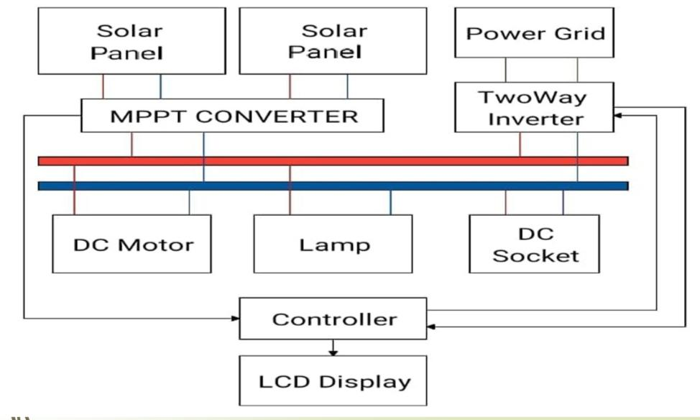

Fig 1. Configuration of a dc-distribution system
The block diagram shows the Integration and Operation of a Single-Phase Bidirectional Inverter with a Buck/Boost MPPT for DC-Distribution Applications. The block diagram consists of controller, MPPT, bidirectional inverter, solar panels , Dc bus. Solar panels is used to generate power. MPPT is used to buck/boost the power from the solar. Bidirectional inverter is used to supply the ac power to grid and to get back the power from ac supply. If in case power supply is low from the solar then two PV arrays with MPPT are implemented.
COMPONENTS
- Arduino Nano
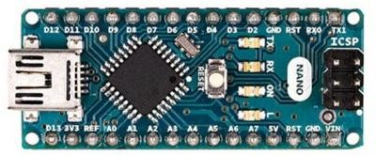
The Arduino Nano is a compact board similar to the UNO. The Arduino Nano is a small, complete, and breadboard-friendly board based on the ATmega328P (Arduino Nano 3.x).
- Solar Panel
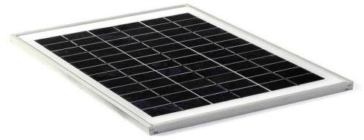

The 5W 12Volts 36-cell Solar Panel (41 x 30 cm) for DIY Projects is ready to use without requiring a frame or special modifications. We have chosen to sell these Polycrystalline solar cells because they are Laser cut to the proper size and encapsulated in the special sun and weather- resistant materials which give them unique characteristics. You will not regret using such high performance.
- MPPT
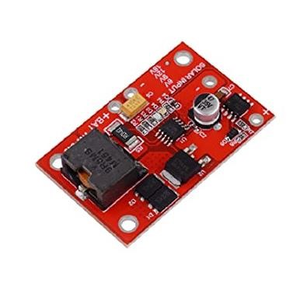
This is a maximum power point tracking (MPPT) solar charger for single-cell LiPo batteries. This MPPT solar charger provides you with the ability to get the most possible power out of your solar panel or other photovoltaic device and into a rechargeable LiPo battery. Set-up is easy as well, just plug your solar panel into one side of the solar charger and your battery into the other and you are good to start charging.
- Bidirection Inverter
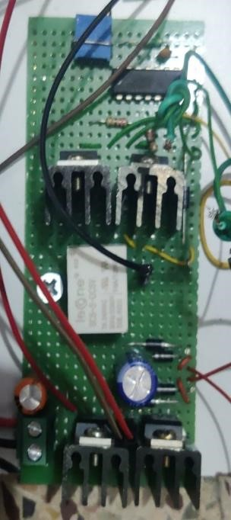
Bidirectional energy storage inverter is an inverter that can convert direct current into alternating current and alternating current into direct current, which is an important part of the energy storage system.


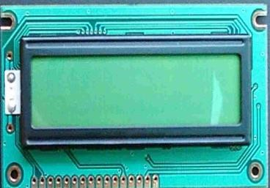
LCD Display

An LCD is a Liquid Crystal Display which displays electronic visual display. Among different types of LCD’s16×2 LCD module is a very common type of LCD module that is used in embedded projects.

LCD Pin Configuration
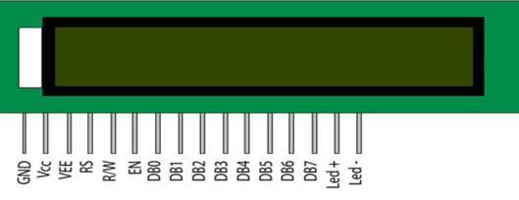
It is the logic state of these pins that make the module to determine whether a given data input is a command or data to be displayed.
Working:
To achieve the desired performance of the proposed PV inverter system, its operational principle is first presented and the control laws for the inverter operation are then derived. Block diagram shows a configuration of the proposed single-phase bidirectional inverter with two buck/boost MPPTs, which can fulfill either grid-connection mode or rectification mode with PFC. The proposed bidirectional inverter is a full-bridge configuration, which can fulfill grid connection and rectification with PFC. The inverter senses dc-bus voltage, line voltage and inductor current and uses the variable inductance, which is a function of inductor current, obtained with self-learning algorithm to determine the control for operating the inverter stably. When the output power from PV arrays is higher than load requirement, the dc-bus voltage increases; thus, the inverter is operated in grid-connection mode to inject the surplus power into ac grid. On the other hand, the inverter is operated in rectification mode with PFC to convert ac source to replenish the dc bus.
References:
- Tsai-Fu Wu, Chai-Ling Kuo, Kun-Han Sun, Yu- Kai Chen, Yung-Ruei Chang, and YihDer Lee, “Integration and operation of a single-phase bidirectional inverter with buck/boost MPPTs” IEEE
TRANSACTIONS ON POWER ELECTRONICS, VOL.28, NO.11, NOVEMBER 2013.
- Felix Thomas and J aison Mathew Dept. of Electrical and Electronics Engineering Government Engineering College, Thrissur Kerala, India, “Transformer-Less Solar PV Inverter With Fuzzy Assisted MPPT for Standalone/ Grid Connected System” 2020 IEEE Recent Advances in Intelligent Computational Systems (RAICS), December 0305,2020.
- Md. Rokonuzzaman and Md Hossam-E-Haider, “Design and Implementation of Maximum Power Point Tracking Solar Charge Controller”, Military Institute of Science and Technology (MIST), Mirpur Cantonment, Dhaka-1216.
- J. M. Carrasco, L. G. Franquelo, J. T. Bialasiewicz, E. Galvan, R. C. P. Guisado, Ma. A. M. Prats, J. I. Leon, and N. Moreno-Alfonso, “Powerelectronic systems for the grid integration of renewable energy sources: a survey,” IEEE Trans. Ind. Electron., vol. 53, no. 4, pp. 1002– 1016, Aug. 2006.
- C.T. Ma, “Design and Implementation of a
Bidirectional DC/DC Converter for BESS Operations” Proceedings of the International MultiConference of Engineers and Computer Scientists 2017 Vol II, IMECS 2017, March 15 - 17, 2017, Hong Kong

