IOT BASED VEHICLE INFORMATION STORAGE CONTAINER

TO PREVENT FAKE CLAIM INSURANCE
Thirumurugan R¹, Kamal Raj R², Karthikeyan P³, Mageshwaran D⁴
Assistant Professor¹, UG Students^{2,3,4,}

Department of ECE, S.A. Engineering College, Thiruverkadu, Chennai, Tamil Nadu, India.

Abstract - This paper discusses provided is a method of storing accident data for a vehicle, in which image data taken by a camera during driving is stored in real time. Recently, to acquire data for determining circumstances at the time of a vehicle accident and a fault between parties, research and development on a vehicle black box for recording driving data such as vehicle speed have been conducted actively. In particular, a vehicle accident data recording apparatus has recently attracted much attention, which records external circumstances at the time of an accident as image data by using a camera mounted in the vehicle and uses pre- and post-accident external image data as well as driving data, thereby finding out cause of the accident. The accident of the vehicle means an unexpected event which may cause damage to a body of the vehicle or of a passenger.

Keywords:IOT,cloud,data storage,accident info,sensor.

- INTRODUCTION

According to the World Health Organization, more than a million people in the world die each year because of transportation-related accidents . In order to react to this situation, the black box system draws the first step to solve this problem that crosses national boundaries and threatens the safety and health of people worldwide. Introduced to a part of the United States market in 1999, the black box system proved to be efficient . However in the latter case, the system was embedded in the vehicle. Therefore, in addition to improving the treatment of crash victims and the road status in order to decrease the death rate, constructing safer vehicles, and helping insurance companies with their vehicle accidents investigations, the main purpose of this paper is to develop a black box system that can be installed to any vehicle all over the world. Like flight data recorders in aircraft, “black box” technology can now play a key role in motor vehicle crash investigation..A significant number of vehicles currently on the roads contain electronic systems that record information in the event of a crash. That is why it is so important to have recorders that objectively track what goes on in vehicles before, during and after a crash as a complement to the subjective input that is taken usually from victims, eye witnesses and police reports.
Blackbox systems in vehicles has become increasingly popular. A blackbox system is a device that records data about the vehicle's performance, such as speed, acceleration, and braking, as well as any incidents or accidents that occur. This data can be used for a variety of purposes, including improving vehicle safety, identifying and addressing mechanical issues, and resolving disputes in the event of accidents.In this journal report, we will explore the process of creating a blackbox system for a vehicle using an Arduino microcontroller. The Arduino is a popular open-source microcontroller platform that can be used for a variety of projects, including those related to automotive applications.The blackbox system we will create will be designed to capture data related to the vehicle's performance, such as speed, acceleration, and braking, as well as GPS location data. The system will also include sensors to detect impacts or collisions, and will record data about these events as well.The purpose of this project is to demonstrate how a blackbox system can be created using affordable and readily available components, and to explore iot and benefits of such a system.

- EXISTING SYSTEM
A.EEPROM:The Black Box system used for vehicles. A full and detailed description was made for every part of this system. This paper has also offered a user friendly embedded program to analyze the data of the accident. The Black Box system built can be implemented in any vehicle. As soon as the driver runs the motor, this system will begin saving the events of the corresponding vehicle. The last are always saved in the EEPROM of the Black Box, and in case of an accident, an additional 10 seconds of events after this accident will be saved. The data saved can be retrieved only after the accident for privacy purposes. Using serial transmission the EEPROM and display it to the user. In addition, a detailed report will be given to the user containing the recorded data in the memory.

B.DATA LOGGERS:
Data loggers are designed to capture vehicle data while the vehicle is in normal operation, for later analysis. Data logging uses include: Engine and vehicle monitoring under normal operation, for the purpose of diagnosis or tuning. Some US auto insurance companies offer reduced premiums if OBD- II vehicle data loggers or cameras are installed - and if the driver’s behavior meets requirements. This is a form of auto insurance risk selection.

- SYSTEM REQUIRMENTS

ARDUINO UNO : Arduino Uno is a microcontroller board based on the ATmega328P (datasheet). It has 14 digital input/output pins (of which 6 can be used as PWM outputs), 6 analog inputs, a 16 MHz quartz crystal, a USB connection, a power jack, an ICSP header and a reset button. It contains everything needed to support the microcontroller; simply connect it to a computer with a USB cable or power it with a AC-to-DC adapter or battery to get started. You can tinker with your UNO without worrying too much about doing something wrong, worst case scenario you can replace the chip for a few dollars and start over again.

LIQUID CRYSTAL DISPLAY: A liquid crystal display (LCD) is an electronic display module that is widely used in various devices and circuits. The 16x2 LCD display is a very common and basic module that is preferred over seven segments and other multi-segment LEDs for several reasons. LCDs are economical, easily programmable, and have no limitation on displaying special or even custom characters, animations, and other features, unlike seven segments. A 16x2 LCD display means it can display 16 characters per line, and there are two such lines. Each character is displayed in a 5x7 pixel matrix, making it a compact and efficient display module. The LCD has two registers, namely, Command and Data. The Command register stores the command instructions given to the LCD, while the Data register stores the data to be displayed on the LCD in ASCII format.

VIBRATION SENSOR:Vibration Sensor is a high sensitivity non-directional vibration sensor. When the module is stable, the circuit is turned on and the output is high. When the movement or vibration occurs, the circuit will be briefly disconnected and output low. At the same time, you can also adjust the sensitivity according to your own needs. The vibration switch that opens when vibration is detected and closes when there is no vibration.

MQ-2 SENSOR:Sensitive material of MQ-2 gas sensor is SnO2, which with lower conductivity in clean air. When the target combustible gas exist, The sensor’s conductivity is more higher along with the gas concentration rising. Please use simple electro circuit, Convert change of conductivity to correspond output signal of gas concentration. MQ-2 gas sensor has high sensitivity to LPG, Propane and Hydrogen, also could be used to Methane and other combustible steam, it is with low cost and suitable for different application. Sensor is sensitive to flammable gas and smoke. Smoke sensor is given 5 volt to power it. Smoke sensor indicate smoke by the voltage that it outputs .More smoke more output. A potentiometer is provided to adjust the sensitivity. But when smoke exist sensor provides an analog resistive output based on concentration of smoke. The circuit has a heater. Power is given to heater by VCC and GND from power supply. The circuit has a variable resistor. The resistance across the pin depends on the smoke in air in the sensor. The resistance will be lowered if the content is more. And voltage is increased between the sensor and load resistor.
NODEMCU: The ESP8266 is the name of a micro controller designed by Espressif Systems. The ESP8266 itself is a self-contained Wi-Fi networking solution offering as a bridge from existing micro controller to Wi-Fi and is also capable of running self-contained applications.ESP-12E Wi-Fi module is developed by Ai-thinker Team. core processor ESP8266 in smaller sizes of the module encapsulates Tensilica L106 integrates industry-leading ultra-low power 32-bit MCU micro, with the 16-bit short mode, Clock speed support 80 MHz, 160 MHz, supports the RTOS, integrated Wi-Fi MAC/BB/RF/PA/LNA, on-board antenna. The module supports standard IEEE802.11 b/g/n agreement, complete TCP/IP protocol stack.

- WORKING
In this proposed method, ARDUINO UNO microcontroller is used to interface with the sensors and to the communication devices. The LCD is used to update the latest information in the LCD. The crash sensor, Temperature sensor and SD card are interfaced with the micro controller. The ESP8266 IOT module is used to update the information to the cloud. The GPS device is used to get the information of the location of the vehicle. The GSM is used to send the SMS to the owner and other rescue persons. In accident zone the black box system collect the information and store the information then give the valuable data. Whenever the accident occur we can find the perfect reason for the accident. The ESP32cam are used to collecting the live stream at local host for that accident.

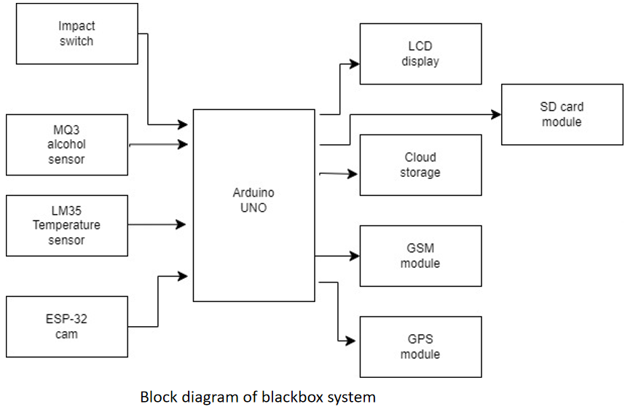

TELEGRAM BOT:
IoT using TelegramBot involves integrating the Telegram messaging platform with an IoT system to allow remote monitoring and control of IoT devices using a TelegramBot. This integration is achieved by creating a TelegramBot and connecting it to the IoT device, which is then controlled by commands sent through the TelegramBot.To implement IoT using TelegramBot, you will need to create a TelegramBot using the BotFather service and obtain an API key. Next, you will need to develop a program that interfaces with the IoT device and communicates with the TelegramBot using the Telegram API. The program should be designed to receive commands from the TelegramBot and perform specific actions on the IoT device based on those commands.

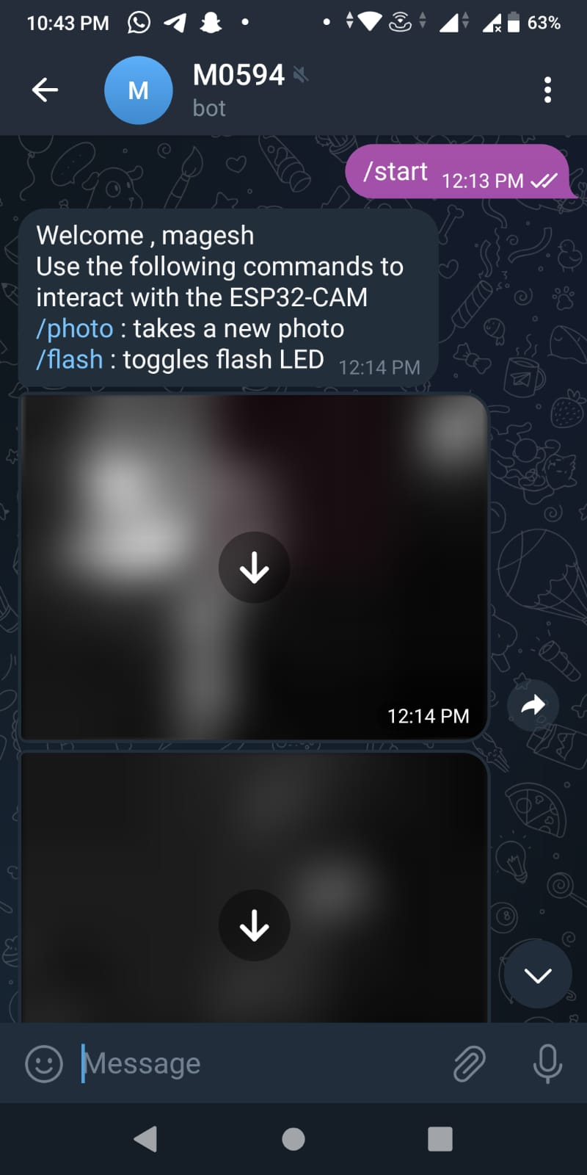

ADAFRUIT PLATFORM:
Adafruit IO is a cloud-based platform that provides a convenient and easy way to create dashboards for IoT projects. To create an Adafruit dashboard, the first step is to sign up for an Adafruit IO account and log in. Once you're logged in, you can create a new dashboard by clicking on the "Dashboards" button in the top navigation bar and selecting "Create a New Dashboard". You can then choose a name for your dashboard and select the appropriate block size (either 3x3 or 4x4 blocks).Next, you can add blocks to your dashboard by clicking on the "+" icon and selecting the type of block you want to add, such as a line chart, gauge, map, or other data visualization tool. Once you've added the blocks you need, you can configure each block by selecting the appropriate data source, topic, or feed, and customize the appearance and behavior of each block to suit your needs.After you've added all the necessary blocks, you can click on the "Publish" button to make your dashboard public or the "Save" button to keep it private. With your Adafruit dashboard created, you can now start sending data from your IoT device to Adafruit IO and visualizing it on your dashboard. You can use the Adafruit IO API or libraries to send and receive data from your device, and your dashboard will update in real-time to reflect the latest data from your IoT project. Overall, Adafruit IO is a powerful and user-friendly platform for creating IoT dashboards, and it's a great option for anyone looking to get started with IoT development.
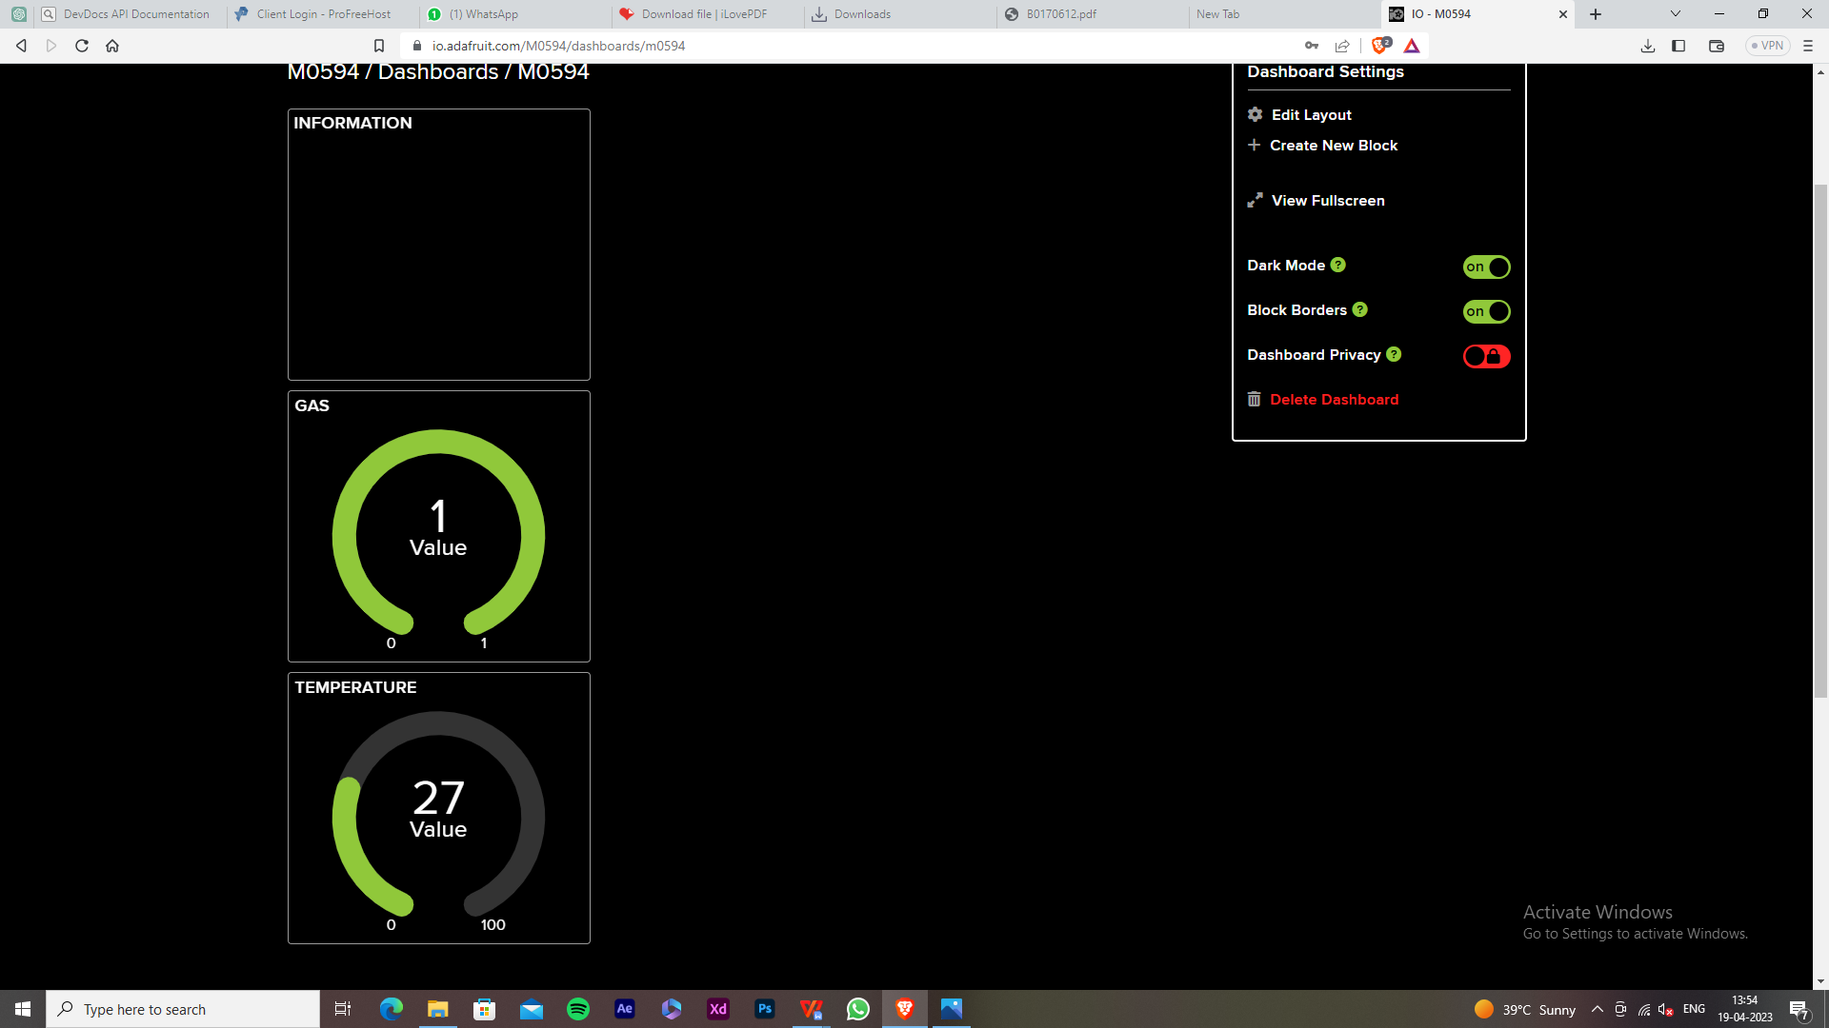

OUTPUT:
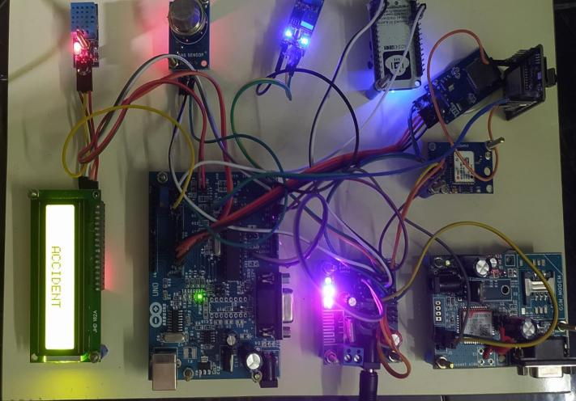

- CONCLUSION
In this paper, we proposed a black box based safety information gathering systemthat used to prevent the fake claiminsurance using the iot platform for secondary source of information recovery system. We can also added additional functionalities to the ordinary car black box such as license plate number and color recognition of neighboring vehicles and IOT functionality to receive the information request message and upload the stored information. We also show the simulation and implementation details of the proposed system.

- ACKNOWLEDGEMENT

We wish to express our gratitude to Prof. Thirumurugan R M.Tech, Assistant Professor, S. A. Engineering College Chennai for providing the facilities of the Institute and for his encouragement during the course of this work. We also express our deep gratitude to Prof. (Dr.) Tapas Bapu B R, Head of the Department of Electronics and Communication Engineering, S. A. Engineering College, Chennai for his guidance and support.

REFERENCES

[1]. D. Zhao et al., “Accelerated evaluation of automated vehicles safety in lane-change scenarios based on importance sampling techniques,” IEEE Trans. Intell. Transp. Syst., vol. 18, no. 3, pp. 595–607, Mar. 2017.
[2]. Traffic Safety Facts 2015, NHTSA, Washington, DC, USA, 2015.
[3]. T. Coughlin. The memory of cars. Forbes Jul. 2016. [Online]. Available: https://www.forbes.com/sites/tomcoughlin/2016/07/20/the-memory-ofcars/#3170f5c41b33
[4]. R. Girshick, “Fast R-CNN,” in Proc. ICCV, 2015, pp. 1440–1448.
[5]. S. Ren, K. He, R. Girshick, and J. Sun, “Faster R-CNN: Towards realtime object detection with region proposal networks,” in Proc. Adv. Neural Inf. Process. Syst., 2015, pp. 91–99.
[6]. K. He, G. Gkioxari, P. Dollar, and R. Girshick, “Mask R-CNN,” in Proc. ICCV, 2017, pp. 2961–2969.
[7]. W. Choi, “Near-online multi-target tracking with aggregated local flow descriptor,” in Proc. ICCV, 2015.
[8]. Y. Xiang, A. Alahi, and S. Savarese, “Learning to track: Online multi-object tracking by decision making,” in Proc. ICCV, 2015, pp. 4705–4713.
[9]. N. Wojke, A. Bewley, and D. Paulus, “Simple online and realtime tracking with a deep association metric,” in Proc. IEEE Int. Conf. Image Process. (ICIP), Sep. 2017, pp. 3645–3649.
[10]. R. Girshick, J. Donahue, T. Darrell, and J. Malik, “Rich feature hierarchies for accurate object detection and semantic segmentation,” in Proc. CVPR, 2014, pp. 580–587.
[11] .J. Long, E. Shelhamer, and T. Darrell, “Fully convolutional networks for semantic segmentation,” in Proc. CVPR, 2015, pp. 3431–3440.
[12]. V. Badrinarayanan, A. Kendall, and R. Cipolla, “SegNet: A deep convolutional encoder-decoder architecture for image segmentation,” 2015, arXiv:1511.00561. [Online]. Available: https://arxiv.org/ pdf/1511.00561.pdf uthorized licensed use limited to: Vel Tech Rangarajan Dr. Sagunthala R&D Institute of Science and Technology.

