THERMO HYDRAULIC PERFORMANCE OF THE RECTANGULAR SHELL AND TUBE HEAT EXCHANGER WITH DIFFERENT BAFFLE PLATE CONFIGURATIONS

ME19711 PROJECT PHASE-II REPORT

Submitted by

KANNAN M (191101071)
KAVIN RAJA V (191101076)
RAHUL K (191101111)

in partial fulfillment for the award of the degree of

BACHELOR OF ENGINEERING IN
MECHANICAL ENGINEERING



DEPARTMENT OF MECHANICAL ENGINEERING RAJALAKSHMI ENGINEERING COLLEGE (AUTONOMOUS), CHENNAI-602 105
APRIL 2022

RAJALAKSHMI ENGINEERING COLLEGE
(An Autonomous Institution Affiliated to Anna University Chennai)

BONAFIDE CERTIFICATE

Certified that this Phase–II Thesis titled “THERMO HYDRAULIC PERFORMANCE OF RECTANGULAR SHELL AND TUBE HEAT EXCHANGER WITH DIFFERENT BAFFLES CONFIGURATION” Is the Bonafide work of KANNAN M(2116191101071), KAVIN RAJA V(2116191101076), RAHUL K(2116191101111) who carried out the work under my supervision. Certified further that to the best of my knowledge the work reported here in does not form part of any other thesis or dissertation on the basis of which a degree or award was conferred on an earlier occasion on this or any other candidate.

Dr. S.P. Srinivasan  Professor and Head Department of Mechanical Engineering  Rajalakshmi Engineering College  Chennai- 602 105 | Mr. P.T. Dinesh Kumar  Assistant Professor  Department of Mechanical Engineering  Rajalakshmi Engineering College Chennai- 602 105

Certified that the candidate was examined in the “VIVA-VOCE” Examination held on ………………

INTERNAL EXAMINER EXTERNAL EXAMINER

ME19711 PROJECT PHASE-II REPORT

DEPARTMENT VISION
To provide a world class education in mechanical engineering through innovation, excellence in teaching and research

DEPARTMENT MISSION
M1. To impart high quality technical education and prepare Mechanical Engineers with all round knowledge of multi-disciplinary branches of Engineering and Technology.
M2. To foster skill sets required to be a global professional for industry, research and technology management.
M3. To provide consultancy to the neighbourhood industries. M4. To cultivate the spirit of entrepreneurship

PROGRAMME EDUCATIONAL OBJECTIVES
PEO I
To provide students with a sound foundation in the mathematical, scientific and engineering fundamentals necessary to formulate, analyze and solve engineering problems and to prepare them for graduate studies and for successful careers in industry.

PEO II
To impart students with skills for design, improvement and installation of Mechanical and allied integrated systems of men and material

PEO III
To educate the students on designing the modern mechanical systems and expose them to industrial practices for better employability and adaptability.

PEO IV
To install the values, skills, leadership and team spirit for comprehensive and wholesome personality, to promote entrepreneurial interest among students and to create a fervor for use of Engineering in addressing societal concerns.

PROGRAM OUTCOMES (POs)
Engineering Graduates will be able to:

- Engineering knowledge: Apply the knowledge of mathematics, science, engineering fundamentals, and an engineering specialisation to the solution of complex engineering problems.
- Problem analysis: Identify, formulate, review research literature, and analyse complex engineering problems reaching substantiated conclusions using first principles of mathematics, natural sciences, and engineering sciences.
- Design/development of solutions: Design solutions for complex engineering problems and design system components or processes that meet the specified needs with appropriate consideration for the public health and safety, and the cultural, societal, and environmental considerations.
- Conduct investigations of complex problems: Use research-based knowledge and research methods including design of experiments, analysis and interpretation of data, and synthesis of the information to provide valid conclusions.
- Modern tool usage: Create, select, and apply appropriate techniques, resources, and modern engineering and IT tools including prediction and modelling too complex engineering activities with and understanding of the limitations.
- The engineer and society: Apply reasoning informed by the contextual knowledge to assess societal, health, safety, legal and cultural issues and the consequent responsibilities relevant to the professional engineering practice.

- Environment and sustainability: Understand the impact of the professional engineering solutions in societal and environmental contexts, and demonstrate the knowledge of, and need for sustainable development.
- Ethics: Apply ethical principles and commit to professional ethics and responsibilities and norms of the engineering practice.
- Individual and team work: Function effectively as an individual, and as a member or leader in diverse teams, and in multidisciplinary settings.
- Communication: Communicate effectively on complex engineering activities with the engineering community and with society at large, such as, being able to comprehend and write effective reports and design documentation, make effective presentations, and give and receive clear instructions.
- Project management and finance: Demonstrate knowledge and understanding of the engineering and management principles and apply these to one’s own work, as a member and leader in a team, to manage projects and in multidisciplinary environment
- Life-long learning: Recognize the need for and have the preparation and ability to engage in independent and life-long learning in the broadest context of technological change.

PROGRAM SPECIFIC OUTCOMES (PSOs)

- To innovate a Mechanical System which meets the desired specifications and requirements using CAE tools.
- To explore alternate materials for automobile, manufacturing and process industries
- To lead a professional career in industries or an entrepreneur by applying Engineering and Management principles and practices.

COURSE OBJECTIVE

- To develop the ability to solve a specific problem right from its identification and literature review till the successful solution of the same.
- To train the students in preparing project reports and to face reviews and viva voce examination.

COURSE OUTCOME
- On completion the students can able to execute the proposed plan and identify and overcome the bottlenecks during each stage.
- On Completion of the project work students will be in a position to take up any challenging practical problems and find solution by formulating proper methodology.
- Students will obtain a hands-on experience in converting a small novel idea / technique into a working model / prototype involving multi-disciplinary skills and
/ or knowledge and working in at team.
- Students will be able to interpret the outcome of their project.
- Students will take on the challenges of teamwork, prepare a presentation in a professional manner, and document all aspects of design work

ABSTRACT

The thermohydraulic performance of a rectangular shell and tube heat exchanger with different baffle plate configurations was studied using both Computer-Aided Design (CAD) and Computational Fluid Dynamics (CFD) simulations. Three baffle plate configurations were considered: single segmental, double segmental.Firstly, the heat exchanger was designed in CATIA software, and the geometry was optimized to achieve the best performance. Then, the CFD simulations were performed using ANSYS Fluent software to study the flow and heat transfer characteristics of the heat exchanger with different baffle plate configurations. The working fluid was water, and the inlet temperature was set at 287K.The results of the CFD simulations showed that the double segmental baffle plate configuration had the highest overall heat transfer coefficient and the lowest pressure drop, followed by the single segmental baffle plate configuration. The helical baffle plate configuration had the lowest overall heat transfer coefficient and the highest pressure drop. The thermal performance of the heat exchanger was also evaluated using the effectiveness-NTU method, and the results were consistent with the CFD simulation results.The CATIA and CFD simulations provided a comprehensive understanding of the flow and heat transfer characteristics of the heat exchanger with different baffle plate configurations. The results showed that the double segmental baffle plate configuration is the most efficient design for achieving high heat transfer rates and low pressure drops. This study highlights the importance of using CAD and CFD simulations to optimize the design of shell and tube heat exchangers for better performance.

ACKNOWLEDGEMENT

We thank Mr. S. MEGANANTHAN, B.E., FIE., Founder & Chairman, Dr.THANGAM MEGANATHAN., M.A., M.Phil., Ph.D., Chairperson, and Mr. ABHAY SHANKAR M, B.E., M.S., Vice Chairman of Rajalakshmi Institution for providing a pleasant environment.
It’s our pleasure to express my sincere gratitude to our respected Principal
Dr. S.N MURUGESAN, Ph.D., for allowing us to do project work. We gratefully acknowledge and thank Dr. S.P. SRINIVASAN Ph.D., Professor & Head, Department of Mechanical Engineering for giving his constant Encouragement.
We thank our project coordinators Dr. P. CHANDRASEKAR, Ph.D., Professor, Department of Mechanical Engineering and Mr. K. LOGANATAHAN, Assistant Professor (SG), Department of Mechanical Engineering for their valuable suggestion throughout the phase of the project.
We thank our project guide Mr. P.T. DINESH KUMAR, Assistant Professor Department of Mechanical Engineering for his valuable guidance throughout this phase of the project. We also express our proud thanks to all the faculty members and lab technicians of the Mechanical Department who helped us to make this project work successfully.
By,
KANNAN M
KAVINRAJA V
RAHUL K

TABLE OF CONTENT

CHAPTER NO TABLE PAGE-NO
ABSTRACT
LIST OF TABLES
LIST OF FIGURES
- INTRODUCTION
1.1 Introduction of heat exchanger 1
1.1.1 Classification of heat exchanger 1
1.1.2 Types of heat exchanger 3
1.2Shell And Tube Exchanger 3
1.2.1 Shell 4
1.2.2 Channels or Head 4
1.2.3 Tubes 5
1.2.4 Tube Pitch 6
1.2.5 Baffles 6
    - Tie Rods and Spacers 7
1.3Working of shell and tube heat exchangers 8
1.3.1 Shell Side 8
1.3.2 Tube Side 9
1.3.3 Passes 9
1.3.4 Operating Shell and Tube 10
Heat Exchanger
2 LIERATURE REVIEW 11
2.1 Literature Survey 11
3 OBJECTIVE AND METHODOLOGY 15
3.1 Objectives 15
3.2 Methodology 15
4 DESIGN AND CALCULATION 17
4.1 Calculation 17
4.1.1 Thermophysical properties 17
of Material
4.1.2 Geometrical characteristics 17
of Heat Exchanger
4.1.3 Tube (Glycol) 18
4.1.4 Shell (Water) 18
4.1.5 Thermal Calculation 19
4.2 Design 20
4.2.1 2D Design of Shell and Tube 20
Heat Exchanger
4.2.2 Design of rectangular shell and 21
tube heat exchanger of single
segmental baffle plate
4.2.3 Design of rectangular shell and 23
tube heat exchanger of single
4.3 Solution Methods 23
4.4 Post Processing 26
4.5 Analysis 27
4.5.1 Analysis of rectangular shell and 27
tube heat exchanger of single
segmental baffle plate
4.5.2 Analysis of rectangular shell and 30
tube heat exchanger of double
segmental baffle plate

5 FABRICATION AND MATERIAL USED 32
5.1 Fabrication 32
6 RESULTS AND CONCLUSION 35
6.1 Results 35
6.2 Conclusions 35
7 REFERENCES 37
7.1 References 37

LIST OF FIGURE

FIGURE NO CONTENT PAGE NO
1.1 Parallel and Counter Flow 2
1.2 Shell and Tube Heat Exchanger Structur 4
1.3 Head Types 4
1.4 Tubes 5
1.5 Various Types of Tubes 6
1.6 Baffle Plates 6
1.7 Tie Rods and Spacers 7
1.8 Shell and Tube Heat Exchanger System 7
1.9 Shell Side Flow 8
1.10 Tube Side 8
1.11 Types of Passes 9
4.1 2d Diagram of Shell and Tube Heat Exchanger 20
4.2 Design of rectangular shell and tube heat exchanger 21
4.3 Outer shell 21
4.4 Flow of fluids 22
4.5 View of baffle plates 22
4.6 Rectangular shell and tube heat exchanger of double 23 segmental baffle plate
4.7 Double segmental baffle plate 23
4.8 Mesh size of 0.005 m 27
4.9 Streamline of cold flow (SSB) 28
4.10 Streamline flow of hot flow (SSB) 28
4.11 Vector flow (SSB) 29
4.12 Vector flow(SSB) 29
4.13 Streamline flow of cold flow (DSB) 30
4.14 Streamline flow of hot flow (DSB) 30
4.15 Vector flow (DSB) 31
4.16 Contour (DSB) 31
5.1 Front view of fabrication 33
5.2 Top view 33
5.3 Tube of heat exchanger 34

LIST OF TABLES
TABLE NO CONTENT PAGE NO
4.1 Thermophysical Properties of Material 17
4.2 Geometrical Characteristics of The Heat 18 exchanger

CHAPTER 1
INTRODUCTION
  - INTRODUCTION TO HEAT EXCHANGER
Heat exchangers are essential components in many industrial processes, enabling efficient transfer of thermal energy between fluids of different temperatures. One of the most common types of heat exchangers is the shell and tube design, which consists of a bundle of tubes enclosed in a shell, with baffles used to direct the flow of fluids and enhance heat transfer. The performance of shell and tube heat exchangers can be optimized by various design factors, including the geometry of the tubes and the baffle plate configuration.

In recent years, computational fluid dynamics (CFD) simulations have emerged as powerful tools for optimizing the design of heat exchangers, enabling the prediction of detailed fluid flow and heat transfer characteristics. In this study, we investigate the thermohydraulic performance of a rectangular shell and tube heat exchanger with different baffle plate configurations, designed using CATIA software and simulated using ANSYS Fluent.

The main objective of this study is to compare the heat transfer and pressure drop characteristics of the heat exchanger with three different baffle plate configurations: single segmental, double segmental, and helical. The performance of each configuration is evaluated using the overall heat transfer coefficient and pressure drop, as well as the effectiveness-NTU method. Through this study, we aim to identify the most efficient baffle plate configuration for achieving high heat transfer rates and low pressure drops in the shell and tube heat exchanger.

The rest of this report is organized as follows: the methodology section describes the heat exchanger design, simulation conditions, and CFD simulation setup; the results and discussion section presents the simulation results and compares the performance of the different baffle plate configurations; the conclusion and recommendations section summarizes the key findings and provides recommendations for future research. recommendations section summarizes the key findings and provides recommendations for future research

1.1.1Classification Of Heat Exchanger:
Heat exchangers are typically classified according to flow arrangement and type of construction. The simplest heat exchanger is one for which the hot and cold fluids move in the same or opposite directions. This heat exchanger consists of two concentric pipes of different diameters.

- parallel-flow arrangement. In the parallel-flow arrangement, the hot and cold fluids enter at the same end, flow in the same direction, and leave at the same end.
- counter-flow arrangement. In the counter-flow arrangement, the fluids enter at opposite ends, flow in opposite directions, and leave at opposite ends.
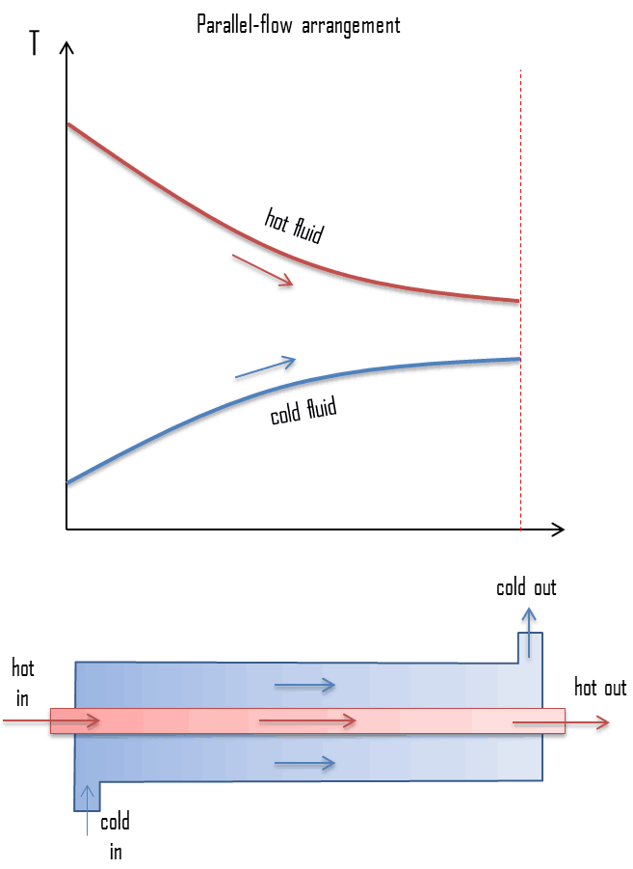
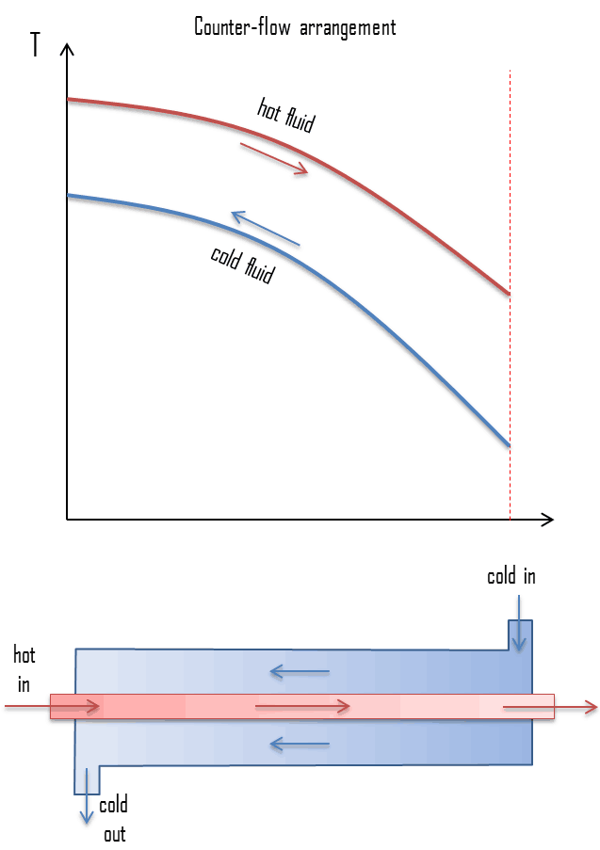
fig 1.1 Parallel and counter flow
Figure represents the directions of fluid flow in the parallel and counter-flow exchangers. Under comparable conditions, more heat is transferred in a counter-flow arrangement than in a parallel flow heat exchanger. The temperature profiles of the two heat exchangers indicate two major disadvantages in the parallel-flow design.
- The large temperature difference at the ends causes large thermal stresses.
- The temperature of the cold fluid exiting the heat exchanger never exceeds the lowest temperature of the hot fluid.
The design of a parallel flow heat exchanger is advantageous when two fluids are required to be brought to nearly the same temperature. The heat transfer surface in heat exchangers can be arranged in several forms
1.1.2Types Of Heat Exchangers:
Following are the types of heat exchangers used for almost all purposes:
- Shell and tube heat exchanger
- Tube in tube heat exchanger
- Double pipe heat exchanger
- Direct and indirect heat exchanger
- Plate heat exchanger
- Pillow plate heat exchanger
- Finned heat exchanger
- Adiabatic heat exchanger
- Phase change heat exchanger
- Microchannel heat exchanger
- Waste heat recovery unit type
- Condenser, boiler, and evaporator

1.2 Shell and Tube Heat Exchanger:
Shell and tube heat exchangers are engineered using sophisticated and technical computer design parameters. The components of the device include the shell, shell cover, tubes, channel, channel cover, tube sheet, baffles, and nozzles. The specifications and standards for STHEs have been established by the Tubular Exchanger Manufacturers Association (TEMA).
Prior to producing a shell and tube heat exchanger, there are several pieces of data manufacturers require such as flow rates, inlet and outlet temperatures, pressure, pressure drop, resistance factors, physical properties of substances to be processed, line sizes, and the shell diameter. Added to these basic factors are more technical requirements that are used to determine the best process to produce the correct heat exchanger for the application.

1.2.1 Shell
The shell of a shell and tube heat exchanger is made of pipe or welded metal plates using materials that can withstand extreme temperatures and that are corrosion resistant. The inner shell must be round with a consistent diameter to minimize space between the baffled outer edge and the shell.

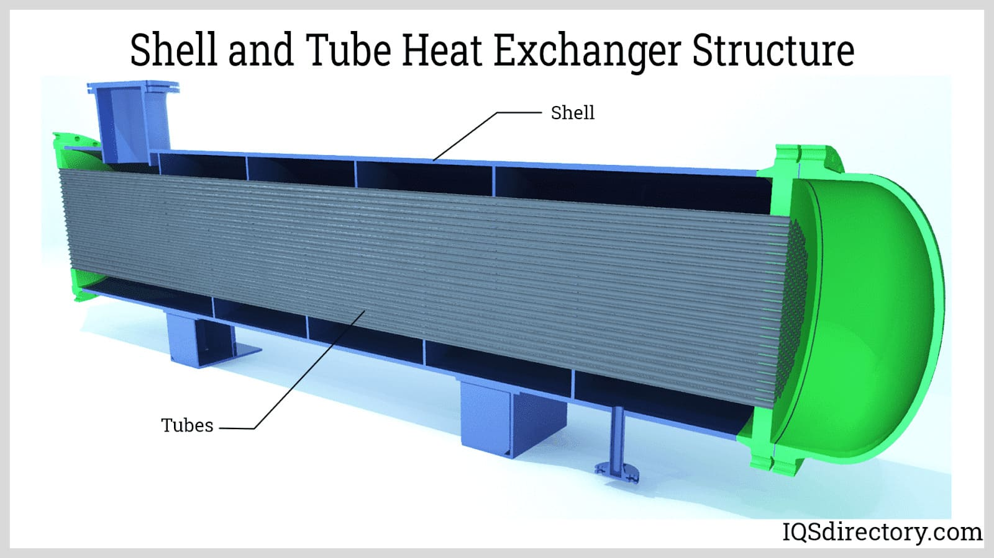
fig 1.2 shell and tube heat exchanger structure

1.2.2 Channels or Heads
The type of channel or head depends on the use of the shell and tube heat exchanger, with bonnet type heads being the most common for use in applications where the head does not have to be removed frequently. Removable cover channels, necessary for maintenance, are flanged or welded. When frequent examination of the channel and tubes is necessary, a removable channel cover is necessary.
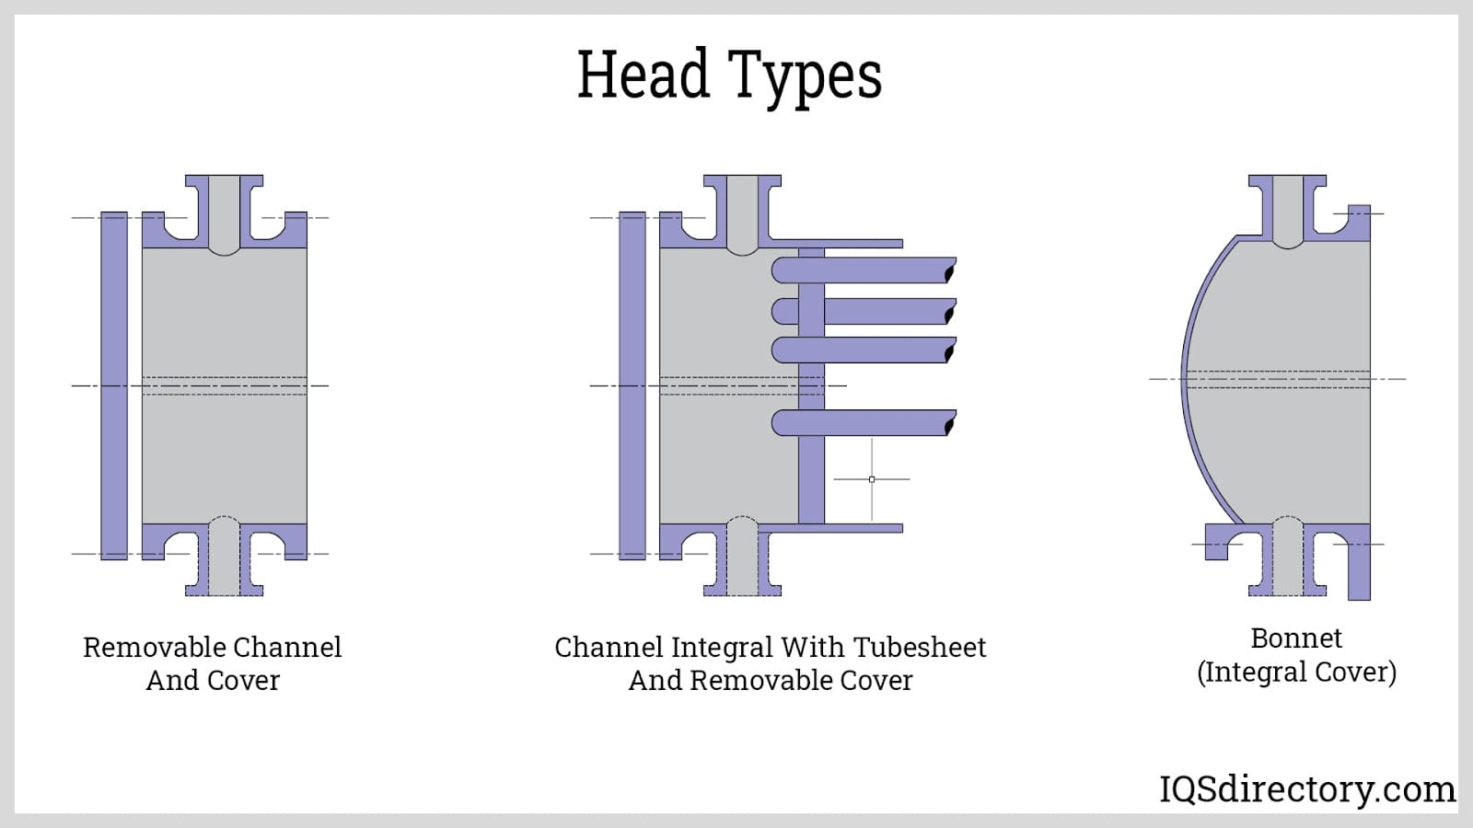
fig 1.3 head types

1.2.3 Tubes
Tubes of a shell and tube heat exchanger are welded or extruded and made from carbon steel, stainless steel, titanium, Inconel, or copper. Tube diameters of 0.625 inch (16mm), 0.75 inch (19mm), or one inch (25mm) are used in compact heat exchangers. The thickness of the tubes is chosen for pressure, temperature, thermal stress, and resistance to corrosion at lengths of 6 to 24 feet or 2 meters to 7 meters. Tubes that are longer reduce shell diameter and result in high shell pressure drop.

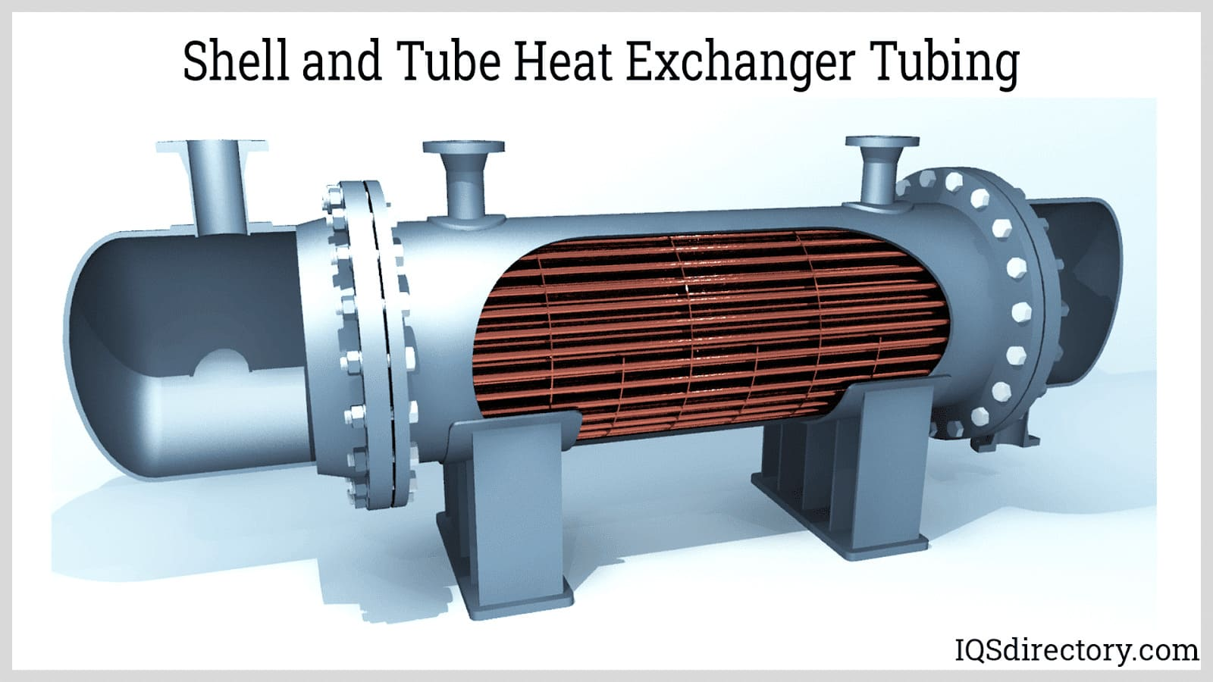
Fig 1.4 tubes

1.2.4 Tube Pitch
Tube pitch is the distance from the centre of a tube to the centre of an adjacent tube. Tubes are laid out in a triangular or square pattern with the square pattern configuration being the easiest to clean and producing the least amount of turbulence. The square pitch arrangement allows vapor to rise between the tubes, an advantage over triangular and rotated square pitch tubing.
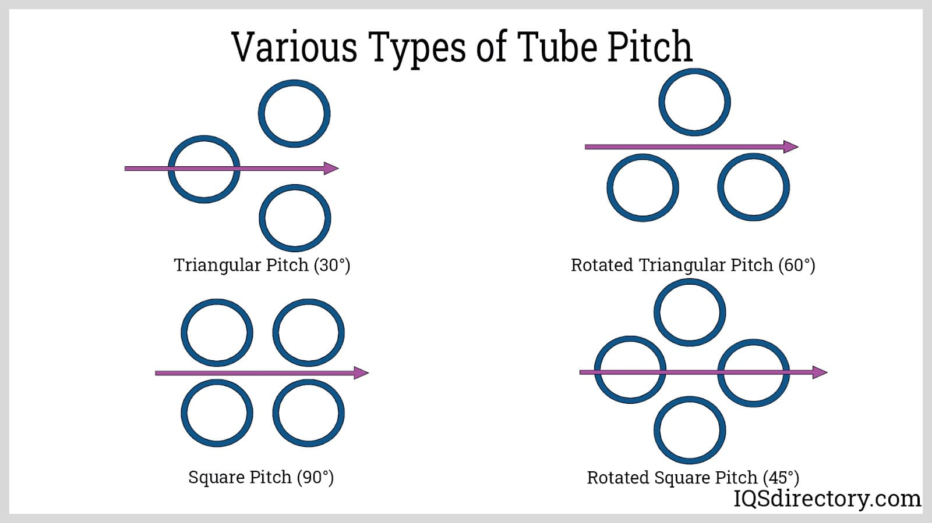
Fig 1.5 various types of tubes

1.2.5 Baffles
Baffles are used to direct the flow in the shell and tube sides such that the fluid velocity increases sufficiently to reach a high heat transfer coefficient and significantly reduce fouling, which is when unwanted materials form on the heat transfer surface. The accumulation of fouling increases heat transfer resistance and leads to poor heat exchanger performance. In horizontal shell and tube heat exchangers, the baffles support the tubes and prevent sagging or vibration damage.

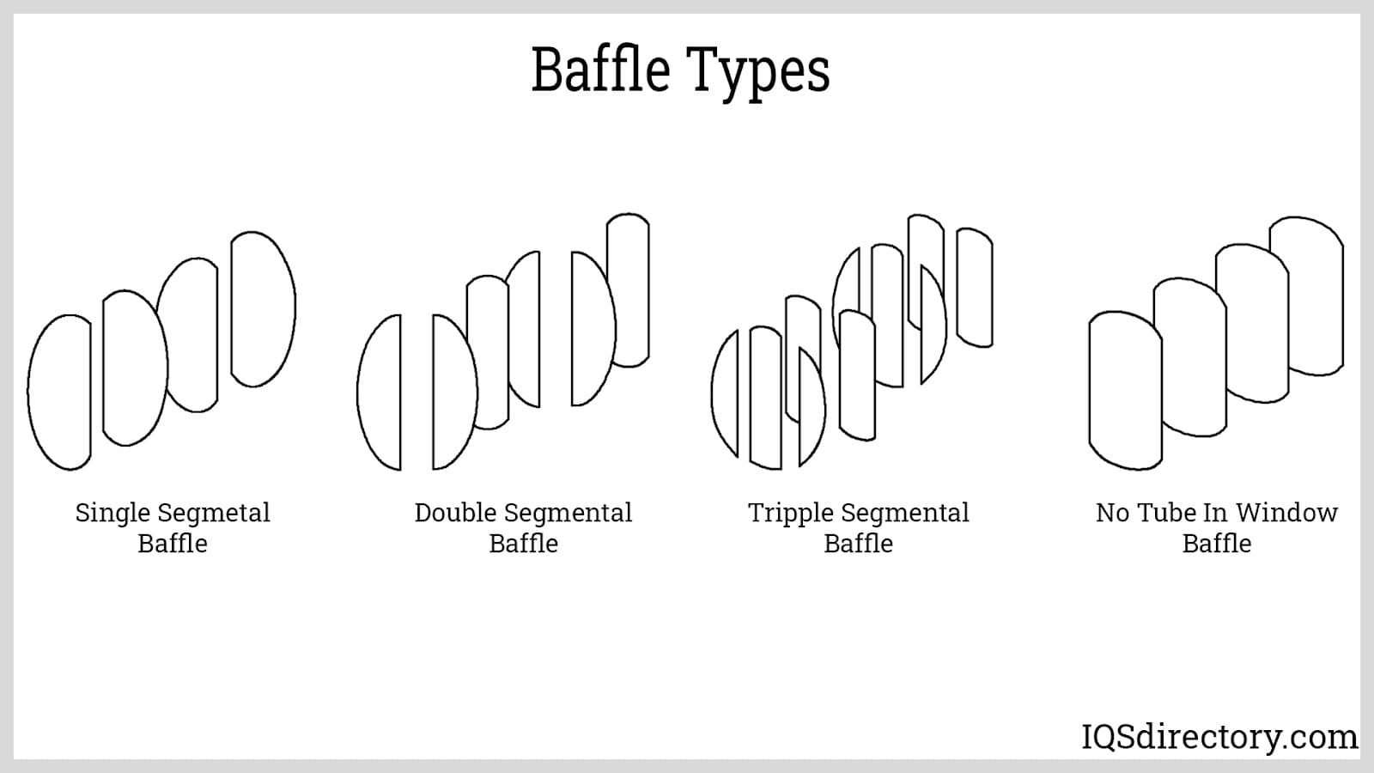
fig 1.6 baffle plate

1.2.6 Tie Rods and Spacers
Tie rods and spacers are supports and structural components designed to hold the baffles in place as well as maintain the space between the baffles. The number of rods and spacers is determined by the number of baffles and the diameter of the shell. Tie rods are screwed to the tube sheet and extend a bundles length to the last baffle.
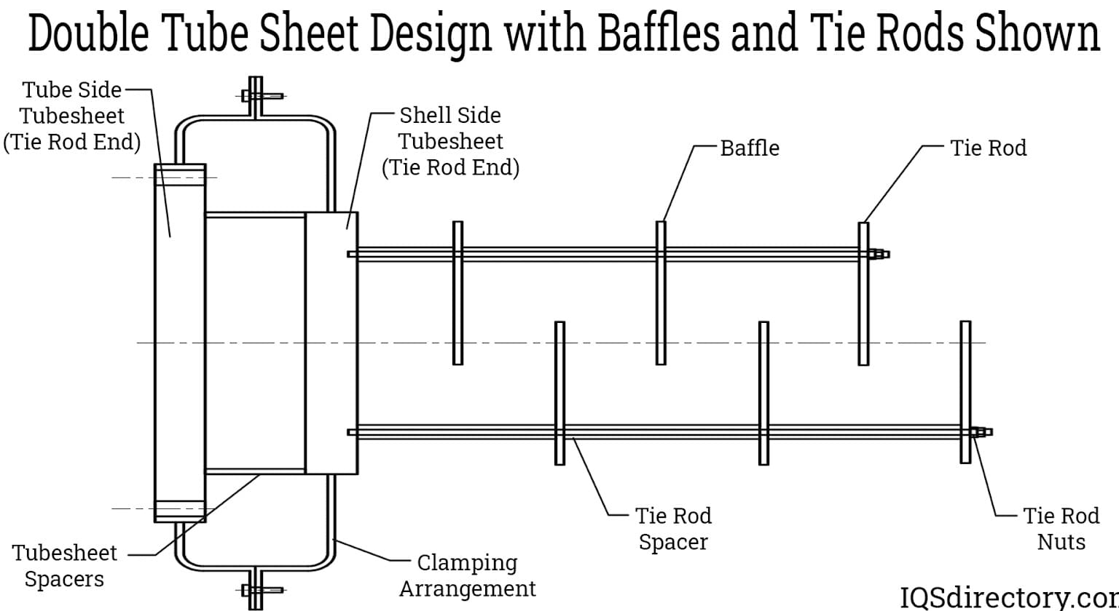
Fig 1.7 Tie Rods and Spacers
1.3 Working of Shell and Tube Heat Exchangers Work
The concept and operation of a shell and tube heat exchanger are rather simple and are based on the flow and thermal contact of two liquids. The name of a shell and tube heat exchanger serves as an explanation of the process, which is the exchanging of temperature between two fluids. In a heat exchanger, a heated or hot fluid will flow around a cold fluid and transfer heat in the direction of the flow of the cold fluid. In any situation where two pieces of material make contact, there will be an exchange or transfer of heat through a conductive surface. The process of a shell and tube heat exchanger provides a place for two fluids to exchange or transfer heat through conductive metals. In the shell and tube heat exchanger process, one fluid flows through the tubes. In the diagram below, which is of a straight tube shell and tube heat exchanger, the shell inlet for the shell fluid to enter is at the top with the inlet for the tube fluid at the bottom right. A shell and tube heat exchanger has two compartments or sections: the shell side and the tube side. When working with a will enter and on which the cold fluid will enter; this decision is referred to as lower pressure fluid enters through the shell inlet since the tubes are designed to handle high pressure.
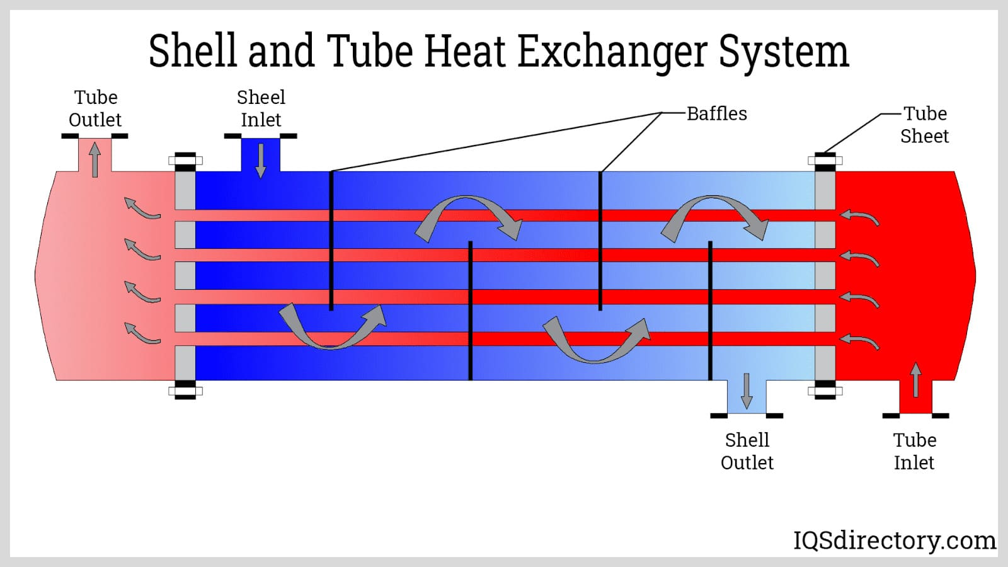
Fig 1.8 shell and tube heat exchanger system

1.3.1 Shell Side
When determining fluid flow for the shell side, it is important to know that the shell is more expensive to fabricate than the tubes, and it is more difficult to clean. The shell side has baffles that direct the flow of the fluid across the tube bundles.
Viscous fluids and fluids with a high flow rate are processed through the shell side where there is increased turbulence and an increased transfer coefficient that leads to improved heat transfer. Large temperature changes are normally performed on the shell side.
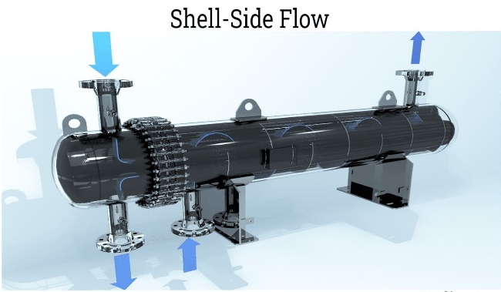
fig 1.9 shell-side flow

1.3.2 Tube Side
A necessity on the tube side is to create turbulent flow; this is achieved by installing turbulators inside the tubes through the holes in the tube sheet. Like the turbulence in the shell, the turbulence in the tubes increases the heat transfer capacity. A secondary function of the turbulators is to keep the inside of the tubes clean and unfouled. Tubes have lower turbulence and pressure drop and provide a streamlined flow.
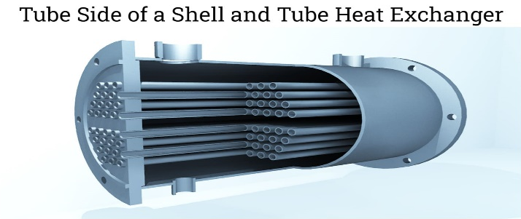
Fig 1.10 tube side

1.3.3 Passes
Shell and tube heat exchangers can have one, two, four, six, or eight passes, which are written 1-1, 1-2, 1-4, and so on. The first number is the number of shells. The second number is the number of passes. The number of passes is the number of times the fluid passes through the fluid in the shell. In a single pass heat exchanger, the fluid goes through the shell once. As the number of passes increases, the heat transfer coefficient increases.
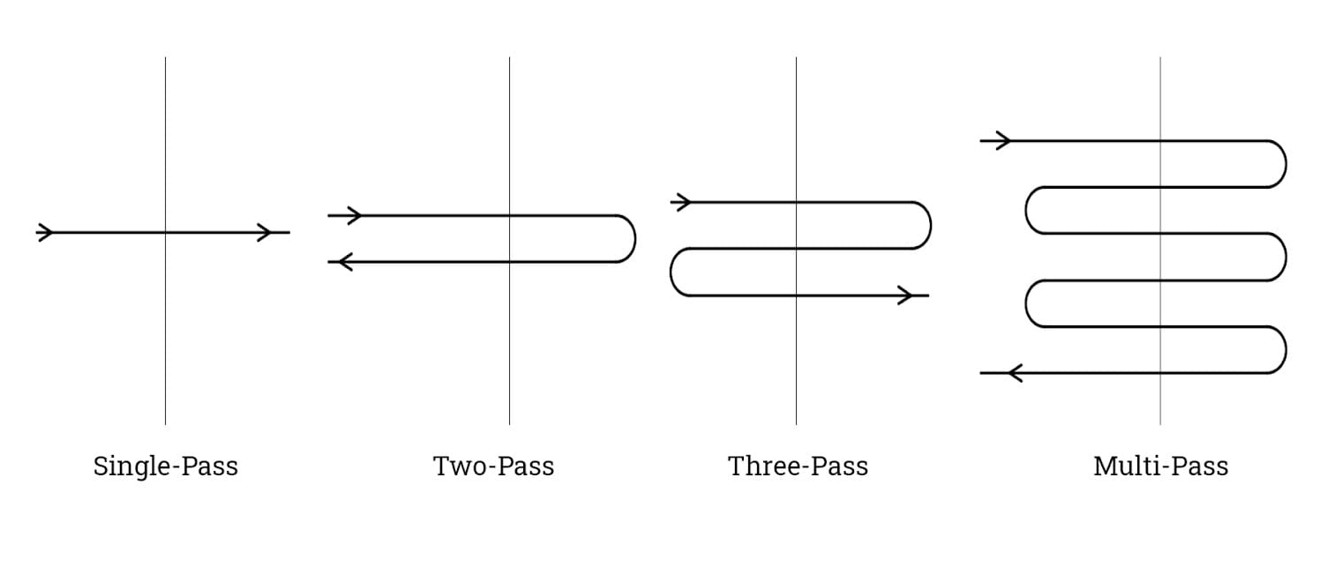
fig 1.11 types of passes

1.3.4 Operating Shell and Tube Heat Exchanger
As can be seen in the graphic, cold fluid enters through the tube or shell inlet and is heated by conductive heating in the tubes; it then exits processed. The image below is a two pass shell and tube heat exchanger. Turbulent flow in a shell and tube heat exchanger increases the heat transfer rate and avoids fouling in the tubes and shell walls. The constant turbulent flow has a self-cleaning effect that ensures continuous and optimum performance. Baffles that direct the flow in the shell create its turbulence while turbulators installed in the tubes create its turbulation. The heat exchange process is facilitated by thermal contact between the two fluids contained in the shell and tubes. One of the fluids leaves cooler while the other leaves warmer or hot.

CHAPTER 2
LITERATURE REVIEW
2.1 LITERATURE SURVEY:
Marwa Ben Slimene , Sebastien Poncet b, Jamel Bessrour et al. (2022)
Numerical simulations have been carried out to investigate the turbulent flows and coupled conductive/convective heat transfers in a glycol to water shell-and-tube heat exchanger (oneshell, one tube doing six passes). The refrigerant (glycol) flows in the tube, and a secondary fluid (water) flows in the shell. The k-ω SST model is used to close the system of equations in the turbulent regime. The present model is first favorably compared and validated against experimental and numerical researches for a concentric annular heated pipe for two radius ratios(R* = 0.1 and 0.5) at a bulk Reynolds number ReDh = 8900 and a Prandtl number Pr = 0.71. It is then extended to consider the shell-and-tube configuration with a rectangular shell. Its thermohydraulic performances in the tube side are quantified for different Reynolds numbers at the cold inlet ranging from 1.03 × 103 to 1.47 × 105. The performance of the heat exchanger is then enhanced by introducing baffles in the rectangular shell. The results are finally discussed in terms of three global performance metrics.
S.A.Marzouk M.M. AbouAl-Sood Magda K.El-Fakharany et al. (2022)
This study presents a numerical modeling of a shell and tube heat exchanger to analyze six various baffle configurations for increasing the thermal parameters performance and hydraulic parameters performance. The baffle configurations include conventional single segmental (CSS), staggered single segmental (SSS), Flower segmental (FS), hybrid segmental (HS), circular ring baffle (CR), and circular ring with holes (CRH) baffles. Flow of water field characteristics, pressure loss, and heat transfer performance, including effectiveness (ε) and the heat transfer coefficient (h) are studied with a variation of Reloads numbers from 10500 to 38500 to analyze the best performance. The effectiveness and the heat transfer coefficient increase with increasing the Reynolds numbers. The HS configuration results are the largest shell side pressure loss while HS and CR thermal influence on heat exchanger performance augmentation is found to be more significant compared to other configurations for all test cases. Compared to the CSS and SSS baffle configurations, the dead spaces and the recirculation zones are disappearing in both FS and HS configurations where the RCH is superior in overcoming the dead zones completely. The maximum values of the effectiveness and heat transfer coefficient of STHX are achieved in the case of CRH type with enhancement about 166% and 142% respectively, compared to CSS baffle. The CRH accomplished less friction losses than hybrid and ring baffles where the shell side pressure drop for HS was the highest value. The heat transfer coefficients per pressure loss of the RCH are about 138% higher than that of other configurations.
MS.SivahariShankar,P.MathanKumar,C.Rajaganapathy et al, (2022)
In recent days, wide variety of experiments had been carried out to analyze the effect of Nano fluid in improving the heat transfer rate of heat exchangers. Nano fluids prove to be a better option in enhancing heat transfer characteristics when compared to conventional fluids. Enhancement of heat transfer using Nano fluid mainly depends on type of nanoparticles, their size, their shape, types of base fluid as well as their concentration to which they are mixed with the base fluid. This research aims to investigate the effect of CuO / water Nano fluids on the enhancement of heat transfer inside a shell and tube heat exchanger at variable inlet temperature. Two different concentrations of 0.2% and 0.4% by volume concentration prepared by single step method has been used at various inlet temperature. The experimental setup consists of multi tube shell and tube heat exchanger with counter flow arrangement. Observation shows that there is significant increase in heat transfer with the increase in volume concentration of Nano particles. By maintaining a constant mass flow rate of 0.0456 kg/sec in both cold and hot side, heat transfer coefficient increases by 18%.
Mehmet SenanYılmaz,MuratÜnverdi,HasanKücük, at el (2022)
This study aimed to experimentally investigate the effects of Al₂O₃-water nanofluids with six different volume concentrations (0.02%, 0.1%, 0.2%, 0.4%, 0.6%, and 0.8%) instead of water as working fluid on heat transfer and pressure drop on the tube side of a mini-channel shell and tube heat exchanger (MC-STHE). The shell-side hot fluid flow rate was kept constant at 180 L/h, while the flow rate of the tube-side cold fluids ranged from 125 to 600 L/h. The convective heat transfer coefficient (CHTC) of the nanofluids increased in the transition and turbulent regions. The nanofluids also extended the transition region. The nanofluids had higher friction factors than water. The nanofluids had an optimal volumetric concentration and a flow rate of 0.4% and 375 L/h, respectively, at which the CHTC enhanced by 49%, while the friction factor increased by 21% compared to water. Compared to macrotube heat exchangers, the CHTC enhanced 3 to 7 times with the combined effect of the mini-channels and nanofluids in the shell-and-tube heat exchanger (STHE). Consistent with earlier studies (maximum TEF of 1.8), the thermal enhancement factor (TEF) for the optimal volumetric concentration Al₂O₃-water nanofluid in the MC-STHE was 1.6 at most under the same hydrodynamic conditions. The performance evaluation criterion (PEC) and the efficiency evaluation criterion (EEC) showed that there was no point (not enhancement) in using nanofluids instead of the base fluid (water) in the MC-STHE.
Ali Akbar AbbasianArani, Reza Moradi et al (2019)
This research focus on the fluid flow and heat transfer of water inside the segmental baffle shell and tube heat exchanger (SB-STHE) optimization using combined baffle and longitudinal ribbed tube configuration. Triangular and circular ribbed tubes are employed with disk baffle shell and tube heat exchanger (DB-STHE) and combined segmental-disk baffle shell and tube heat exchanger (CSDB-STHE). The fluid domain is simulated by SOLIDWORKS Flow Simulation (Ver. 2015). Obtained results are compared with experimental data and numerical results available in literature. Based on the obtained results under maximum mass flow rates (2 kg/s), the average value of shell-side heat transfer coefficient of DB-TR and CSDB-TR are 26.6% and 31.9% higher than DB-CR and CSDB-CR, respectively. To evaluate the performance, Q/ΔP is selected at the same flow rate. A 42.8%, 40.5%, 24.2% and 7.12% difference over conventional baffles are represented by DB-TR, CSDB-TR, CSDB-CR and DB-CR respectively. In another criterion named as Performance evaluation criterion a 39%, 37%, and 13% performance difference over conventional baffles are represented by disk baffle shell and tube heat exchanger with longitudinal triangular ribbed tube (DB-TR), combined segmental-disk baffle shell and tube heat exchanger with longitudinal triangular ribbed tube (CSDB-TR), and combined segmental-disk baffle shell and tube heat exchanger with longitudinal circular ribbed tube (CSDB-CR) respectively.
T. Kudra, A. Mujumdar, Handbook of Single-Phase Convective Heat Transfer. John Wiley & Sons, Inc. New York, NY. 1987.This handbook provides an overview of the theoretical and experimental aspects of single-phase convective heat transfer in heat exchangers, including shell and tube heat exchangers. It covers topics such as flow and thermal characteristics, design considerations, and performance evaluation. The handbook can be useful for understanding the basic principles of heat transfer in heat exchangers and for designing new heat exchangers.
J.R. Thome, G. Ribatski, M.L. Oliveira, R. Siqueira, Recent developments in flow boiling heat transfer in minichannels and microchannels. Int. J. Therm. Sci. 2004; 43: 853-862.This article provides a review of recent developments in flow boiling heat transfer in minichannels and microchannels, which are commonly used in compact heat exchangers. It discusses the challenges associated with designing and operating compact heat exchangers and highlights the need for advanced simulation tools to optimize their performance. The article can be useful for understanding the latest developments in compact heat exchangers and for identifying areas for future research.
Y. Zhang, W. Song, G. Liu, M. Tao, CFD simulation and experimental study of a shell-and-tube heat exchanger with helical baffles. Int. J. Heat Mass Transf. 2013; 64: 187-197.This article presents a CFD simulation and experimental study of a shell-and-tube heat exchanger with helical baffles, which are an alternative to segmental baffles. The study investigates the effects of the helix angle and the baffle spacing on the heat transfer performance of the heat exchanger. The results show that the helical baffles can enhance the heat transfer performance compared to segmental baffles, especially at low mass flow rates. The article can be useful for understanding the advantages and limitations of different baffle configurations in shell-and-tube heat exchangers
K. Velusamy, S. Vellingiri, A review on optimization of heat exchanger design parameters. Mater. Today: Proc. 2021; 45(2): 2890-2895.This article provides a review of optimization techniques used for designing heat exchangers, including shell and tube heat exchangers. It discusses the importance of optimizing heat exchanger design parameters such as the tube diameter, tube length, and baffle spacing to maximize the heat transfer performance while minimizing the pressure drop. The article can be useful for understanding the latest optimization techniques used in heat exchanger design.
S. K. Bharti, B. Chatterjee, A review on heat transfer enhancement techniques for shell-and-tube heat exchangers. Renew. Sustain. Energy Rev. 2017; 72: 1396-1415.This article provides a comprehensive review of heat transfer enhancement techniques for shell-and-tube heat exchangers. It covers various techniques such as using twisted tape inserts, wire coil inserts, and surface roughness enhancement to increase the heat transfer performance of the heat exchanger. The article can be useful for understanding the different techniques available to improve the heat transfer performance of shell-and-tube heat exchangers.
S. S. Patil, V. G. Pangarkar, Review on fouling in shell-and-tube heat exchangers. Braz. J. Chem. Eng. 2006; 23(3): 335-348.This article provides a review of fouling in shell-and-tube heat exchangers, which is a common problem that reduces the heat transfer performance of the heat exchanger. It covers various fouling mechanisms such as deposition, corrosion, and biological fouling, and discusses the factors that influence fouling such as fluid properties, surface roughness, and operating conditions. The article can be useful for understanding the causes and prevention of fouling in shell-and-tube heat exchangers.
C. K. Ahn, S. H. Kim, Heat transfer enhancement in a shell-and-tube heat exchanger using novel baffle configurations. Int. J. Heat Mass Transf. 2009; 52(9-10): 2235-2242.This article presents a numerical study of heat transfer enhancement in a shell-and-tube heat exchanger using novel baffle configurations such as delta-wing baffles and helical baffles. The study investigates the effects of these baffle configurations on the heat transfer performance of the heat exchanger and compares them to conventional segmental baffles. The results show that the delta-wing and helical baffles can significantly enhance the heat transfer performance of the heat exchanger compared to segmental baffles. The article can be useful for understanding the advantages and limitations of different baffle configurations in shell-and-tube heat exchangers.
S. S. Thipse, R. P. Ugwekar, V. B. Kakade, Heat transfer and flow characteristics of shell and tube heat exchanger using CFD: A review. Procedia Eng. 2013; 51: 481-490.This article provides a review of CFD simulations used for analyzing the heat transfer and flow characteristics of shell-and-tube heat exchangers. It covers various CFD modeling approaches such as steady-state, transient, and turbulent models, and discusses the factors that influence the accuracy of the simulations. The article can be useful for understanding the latest advancements in CFD simulations of shell-and-tube heat exchangers

CHAPTER 3
OBJECTIVE AND METHODODLOGY

OBJECTIVES
- To investigate the thermohydraulic performance of a rectangular shell and tube heat exchanger with different baffle plate configurations.
- To design the heat exchanger using CATIA software and optimize its geometry for better performance.
- To simulate the flow and heat transfer characteristics of the heat exchanger using CFD simulations with ANSYS Fluent software.
- To evaluate the thermal performance of the heat exchanger using the effectiveness-NTU method.
- To compare the performance of the different baffle plate configurations and identify the most efficient design for achieving high heat transfer rates and lowpressure drops.
- To highlight the importance of using advanced simulation tools like CATIA and CFD to optimize the design of shell and tube heat exchangers for better performance

METHODOLOGY
- Designing the heat exchanger geometry: The rectangular shell and tube heat exchanger was designed using CATIA software. The geometry was optimized to achieve the best performance.
- Defining the simulation conditions: The working fluid was water, and the inlet temperature was set at 80°C. The mass flow rate of the fluid was varied during the simulation to investigate the thermohydraulic performance of the heat exchanger.
- Performing CFD simulations: The CFD simulations were conducted using ANSYS Fluent software to study the flow and heat transfer characteristics of the heat exchanger with different baffle plate configurations. Three baffle plate configurations were considered: single segmental, double segmental, and helical.
- Evaluating the thermohydraulic performance: The thermohydraulic performance of the heat exchanger was evaluated using the overall heat transfer coefficient and pressure drop. The effectiveness-NTU method was also used to evaluate the thermal performance of the heat exchanger.
- Comparing the performance of different baffle plate configurations: The results of the CFD simulations and the effectiveness-NTU method were compared for the different baffle plate configurations to identify the most efficient design for achieving high heat transfer rates and lowpressure drops.
- Highlighting the importance of advanced simulation tools: The importance of using advanced simulation tools like CATIA and CFD for optimizing the design of shell and tube heat exchangers was highlighted based on the findings of the study.
- Overall, the methodology involved a combination of CAD design, CFD simulations, and performance evaluation to investigate the thermohydraulic performance of the rectangular shell and tube heat exchanger with different baffle plate configurations.

CHAPTER 4
DESIGN AND CALCULATION
4.1 Calculation
4.1.1Thermophysical Properties of Materials
Properties | Water | Glycol (MEG30%) | Steel
Density ρ (kg.m− 3) | 999 | 1057 | 7854
Specific heat capacity Cp (J.kg− 1.K− 1) | 4198 | 3611 | 434
Thermal conductivity λ (W.m− 1.K− 1) | 0.592 | 0.464 | 60.5
Dynamic viscosity μ (Pa.s) | 1.11 × 10− 3 | 3.465 × 10− 3 | _
Table 4.1
4.1.2Geometrical Characteristics of The Heat Exchanger
PARAMETERS | VALUES
Width of the shell [mm] | 100
Length of the shell [mm] | 1000
Inlet and outlet diameters of the shell tube [mm] | 27
Outer diameter of the tube [mm] | 17
Thickness of the tube wall [mm] | 2
Pitch of the tube [mm] | 150
Number of tubes [-] | 1
Length of the baffles [mm] | 180
Width of the baffles [mm] | 2
Spacing between two baffles [mm] | 160
Number of baffles | 6
Table 4.2

4.1.3 TUBE(GLYCOL)
Tube = Rectangular (one tube doing 6 pass)
Material = Carbon Steel Pipe
Tube Diameter(Dc) = 4.2mm
Velocity of cold inlet =1 to 10 m/s
Temperature cold inlet =-8`C
Reynolds num of cold inlet =14,703

4.1.4 SHELL(WATER)
Velocity Of Hot Inlet = 1m/s
Inlet temperature of hot inlet = 14`C
Reynolds num of hot inlet =60545
Modulus of elasticity =200Gpa
Melting point of steel =1450 to 1500`C
Poisson ratio =0.29
Prandtl number = 0.71

4.1.5 Thermal calculation
Ch = m * Cpc m = ρ * v =502.4 kg/s
= 502.4 * 3.611
= 1590.59
Cc = m * Cph
= 37966.7
Area of heat transfer ,Aout = nπDL
= 1 * 3.14 * 0.045 * 25.2
= 3.45

NTU = (Aout * U)/ m * Cp
=( 3.56 * 74.52 ) / 1590.59
= 0.166

From HMT databook:
For counterflow,effectiveness ε =[1-exp(-N(1-C))]/ 1- C exp(-N(1-C))]
Where,
C= Cmin/Cmax
ε = 0.148/0.96
= 0.154
ε = m *Cpc ( Tcout − Tcin) /m* Ccp ( Thin − Tcin)
0.154 = (T + 8)/22
Tcout = -4.612 ˙C
ΔTLMTD = ( Thout − TCout) − ( Thin − Tcin)
ln [Thout − TCout]/( Thin − Tcin)
= -12.178 / - 0.806
= 15.10

U = Q Ave /(Aout FΔTLMTD)
Q Ave = -12.178 / - 0.806
= 15.10

4.2 DESIGN
4.2.1 2D Diagram of Shell and Tube Heat Exchanger:

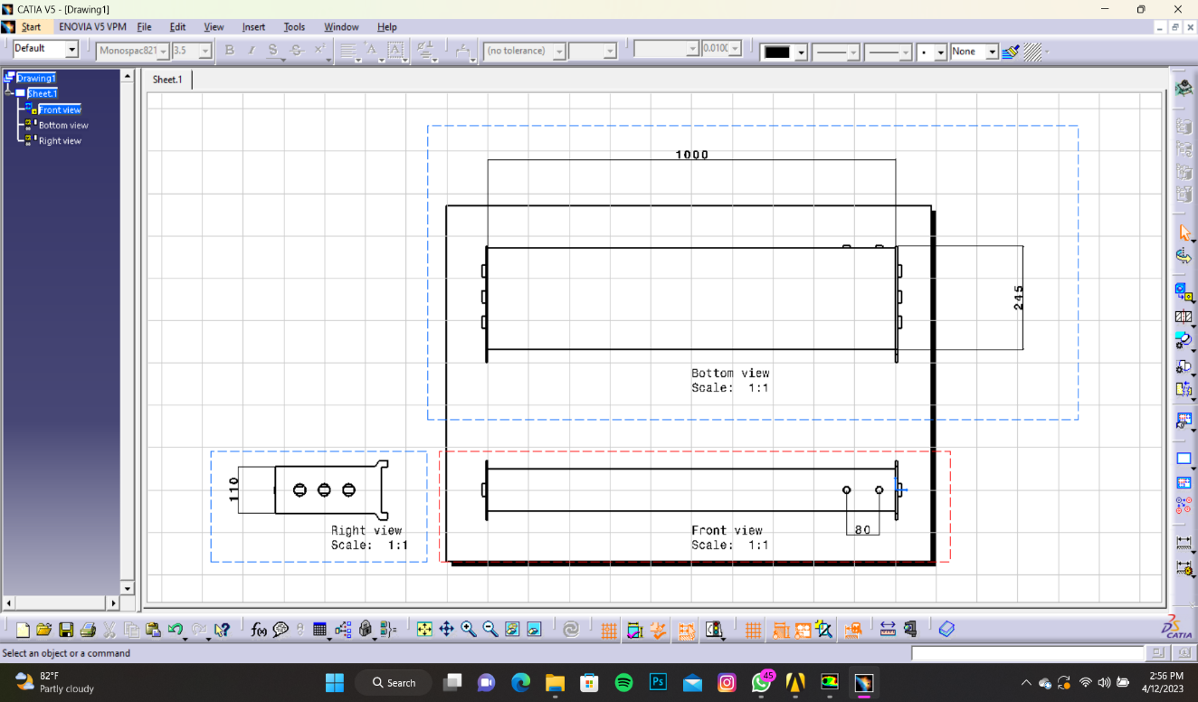
Fig 4.1 2D Diagram of Shell and Tube Heat Exchanger
4.2.2 Design of Rectangular Shell and Tube Heat Exchanger of single segmental baffle plate

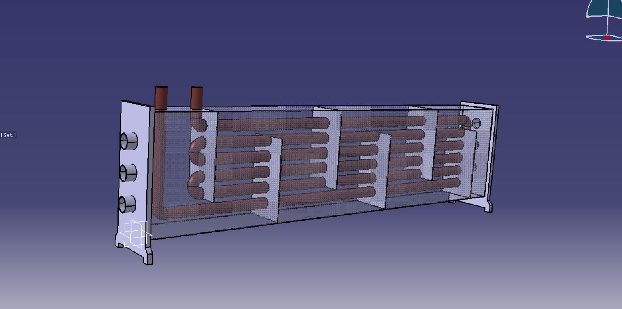
Fig 4.2 Design of Rectangular Shell and Tube Heat Exchanger

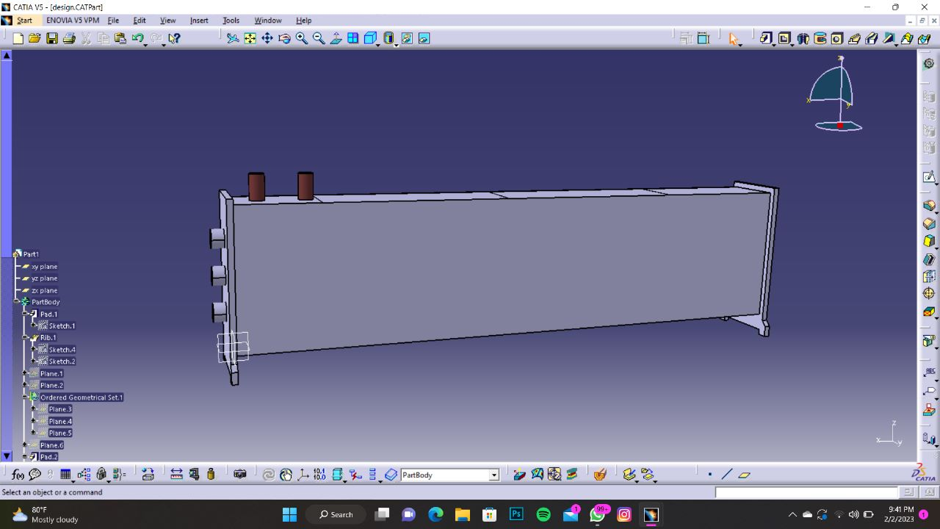
Fig 4.3 outer shell

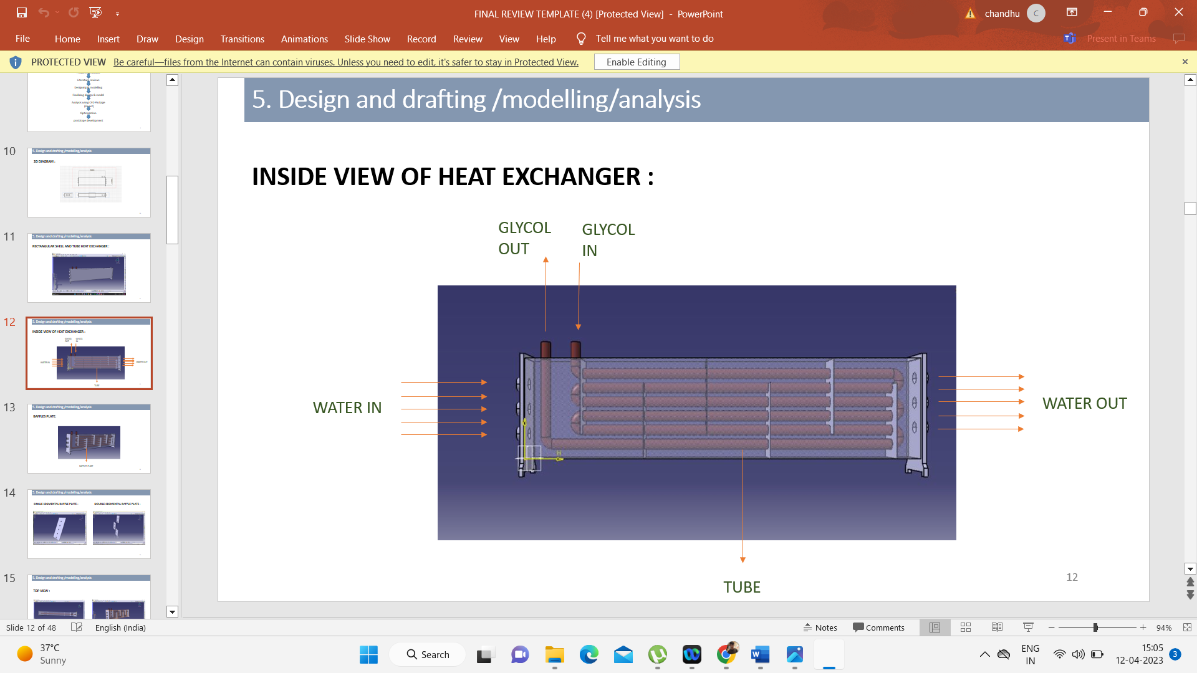
Fig 4.4 flow of fluids

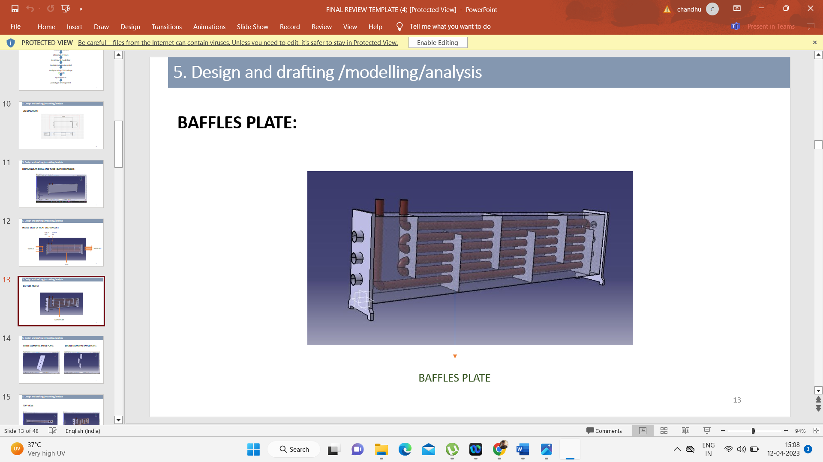
Fig 4.5 view of baffle plates

4.2.3Design of Rectangular Shell and Tube Heat Exchanger of double segmental baffle plate

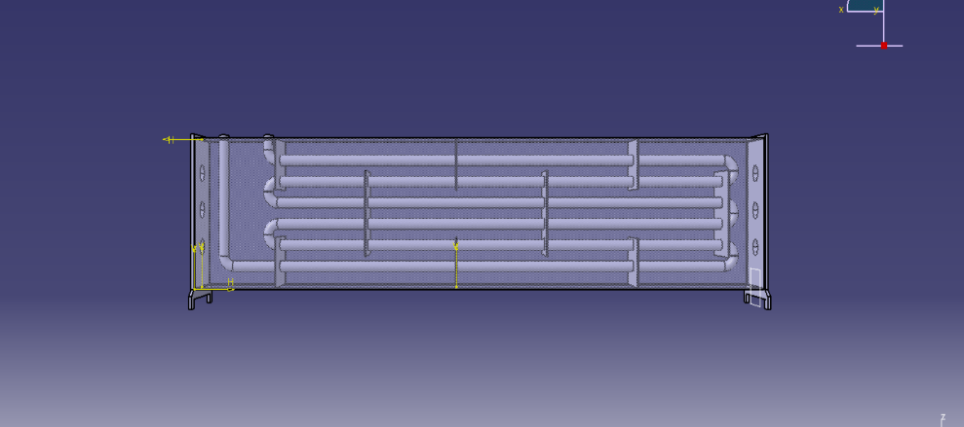
Fig 4.6 Rectangular Shell and Tube Heat Exchanger of double segmental baffle plate

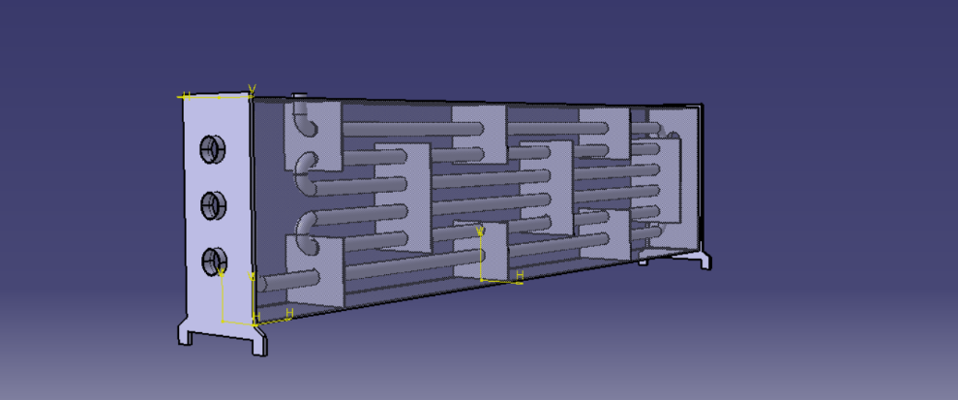
Fig 4.7 Double segmental baffle plate

4.3SOLUTION METHODS

The Navier-Stokes equations that govern the fluid flow inside the heat exchanger are solved numerically using a suitable solver such as the Reynolds-Averaged Navier- Stokes (RANS) equations or Large Eddy Simulation (LES). The choice of solver depends on the complexity of the flow behaviors inside the heat exchanger.

K Omega SST model

The SST k-omega turbulence model can be used to simulate the flow in a heat exchanger using Computational Fluid Dynamics (CFD). A heat exchanger is a device used for the separation of particles from a liquid suspension based on the difference in their densities. The flow in a hydrocyclone is complex, involving swirling motion, high shear, and turbulence, making it an ideal application for the SST k-omega model. The following is a detailed explanation of how to use the SST k-omega model for hydrocyclone simulation in CFD:
Governing Equations: The Navier-Stokes equations are used to model the flow in a hydrocyclone, and the Reynolds-averaged Navier-Stokes (RANS) approach is used to average the turbulent fluctuations. The SST k-omega model adds two additional
transport equations for turbulent kinetic energy (k) and the specific dissipation rate (omega). The governing equations for the SST k-omega model are:
Continuity equation:
∇⋅u =0 Momentum equation:
∂(ρu)/ ∂t +∇⋅(ρuu) = − ∇p+∇⋅τ Energy equation:
∂(ρE)/ ∂t +∇⋅(ρEu) = −∇⋅(q∇T) + ∇⋅(uτ) + ρϵ

Turbulent kinetic energy equation:

∂(ρk)/ ∂t + ∇⋅(ρku) = ∇⋅[(μ+( μ t/σk)∇k] − ρε + Pk Specific dissipation rate equation:
∂(ρ ω)/ ∂t +∇⋅(ρωu) = ∇⋅ [(μ+ μt/σω) ∇ω] + β∗ρε − Pω
u is the velocity vector, ρ is the fluid density,
p is the pressure,
τ is the deviatoric stress tensor,
E is the total energy per unit volume, T is the temperature,
q is the heat flux,
μ is the turbulent viscosity,
ε is the dissipation rate of turbulence kinetic energy
β is a constant.

K Epsilon RNG model:

The k-epsilon RNG (Re-Normalization Group) turbulence model is a commonly used two-equation model in Computational Fluid Dynamics (CFD) simulations of turbulent flows, including those in The RNG variant of the k-epsilon model includes additional terms in the turbulent viscosity and dissipation rate equations to account for the effects of turbulence anisotropy. The following is a detailed explanation of how to use the k-epsilon RNG model for hydrocyclone simulation in CFD:
Governing Equations: The Navier-Stokes equations are used to model the flow in a hydrocyclone, and the Reynolds-averaged Navier-Stokes (RANS) approach is used to average the turbulent fluctuations. The k-epsilon RNG model adds two additional transport equations for turbulent kinetic energy (k) and the specific dissipation rate (epsilon). The governing equations for the k-epsilon RNG model are:
Continuity equation:
∇⋅u = 0
Momentum equation:
∂(ρu)/ ∂t +∇⋅(ρuu) = − ∇p+∇⋅τ Energy equation:
∂(ρE)/ ∂t +∇⋅(ρEu) = −∇⋅(q∇T) + ∇⋅(uτ) + ρϵ Turbulent kinetic energy equation:
∂(ρk)/ ∂t +∇⋅(ρku) = ∇⋅ [(μ+μk/ σk) ∇k] − ρCϵ1(k2/ϵ) + ρSk

Specific dissipation rate equation:
∂(ρϵ)/ ∂t +∇⋅(ρϵu) = ∇⋅ [(μ+ μt/ σϵ) ∇ϵ] + ρCϵ2(k²/ϵ) −ρCϵ1(k³/ ϵ²) + ρSϵ

u is the velocity vector, ρ is the fluid density,
p is the pressure,
τ is the deviatoric stress tensor,
E is the total energy per unit volume, T is the temperature,
q is the heat flux,
μ is the turbulent viscosity,
ϵ1, ϵ2 is the constants that control the dissipation rate,
k, ε is the turbulent kinetic energy and specific dissipation rate, respectively.

4.4POST PROCESSING:

After the simulation is complete, the results are post-processed to analyze the flow behaviors and separation efficiency of the hydrocyclone. The post-processing involves the visualization of the flow patterns using contours, streamlines, and velocity vectors. The separation efficiency of the hydrocyclone can be calculated by analyzing the particle trajectories and comparing them to experimental data or empirical models. Some common post-processing techniques for heat exchanger in CFD simulations include:
      - Contour plots: Contour plots of velocity, pressure, turbulence intensity, and other flow parameters can be generated to visualize the flow behaviour inside the heat exchanger. Contour plots can be used to identify areas of high and low velocity, pressure gradients, and turbulence intensity, which can provide insights into the heat exchanger performance.
Streamlines: Streamlines can be generated to visualize the flow patterns inside the heat exchanger. Streamlines can be used to identify recirculation zones, vortex structures, and areas of high and low velocity. Streamlines can also be used to compare different design configurations of the heat exchanger.
      - Particle tracking: Particle tracking can be used to simulate the motion of particles in the heat exchanger and to visualize the trajectory of particles as they move through the heat exchanger. Particle tracking can be used to analyze the separation efficiency of the heat exchanger and to optimize the design of the heat exchanger.
      - Pressure drop analysis: Pressure drop analysis can be used to evaluate the pressure drop across the heat exchanger and to optimize the design of the heat exchanger for improved efficiency. Pressure drop analysis can also be used to evaluate the impact of operational parameters such as flow rate and inlet velocity on the performance of the heat exchanger.
      - Efficiency analysis: Efficiency analysis can be used to evaluate the separation efficiency of the heat exchanger and to optimize the design of the heat exchanger for improved performance. Efficiency analysis can also be used to evaluate the impact of operational parameters such as flow rate and inlet velocity on the separation efficiency of the heat exchanger.
Validation and comparison: Validation and comparison of simulation results with experimental data can be performed to assess the accuracy of the simulation and to identify areas for improvement. Comparison of simulation results with different design configurations can also be performed to optimize the design of the heat exchanger for improved performance
4.5 Analysis
4.5.1 Analysis of Rectangular Shell and Tube Heat Exchanger of single segmental
baffle plate
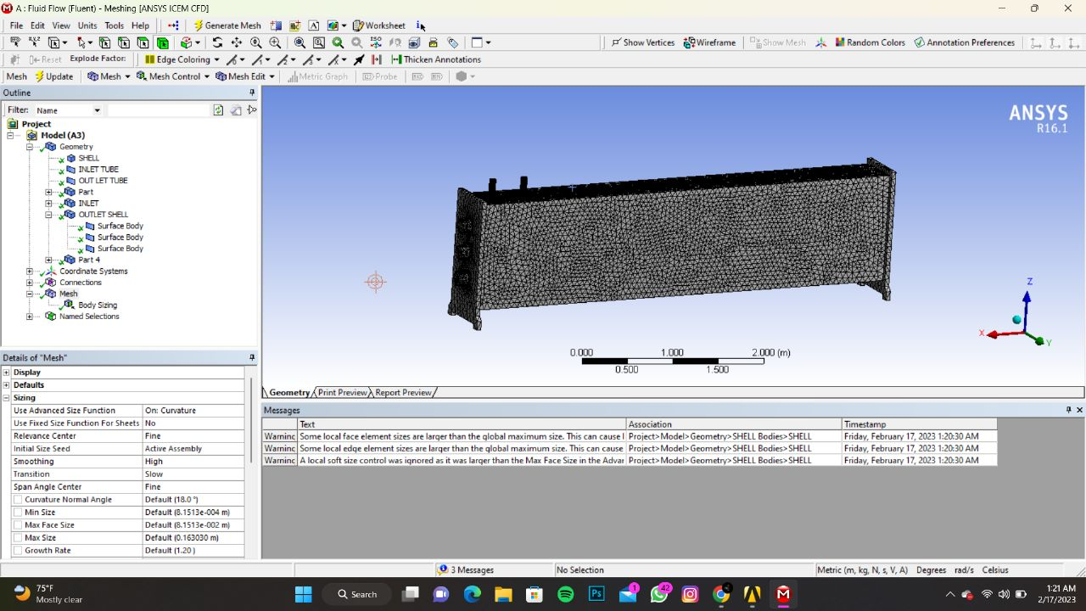
Fig 4.8 Mesh size of 0.005m
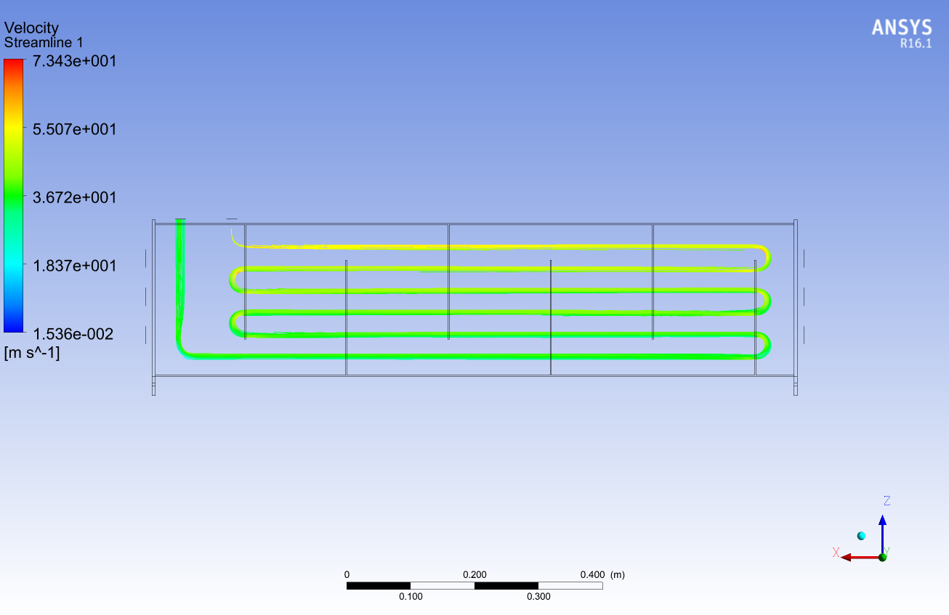
Fig 4.9 streamline of cold flow (SSB)

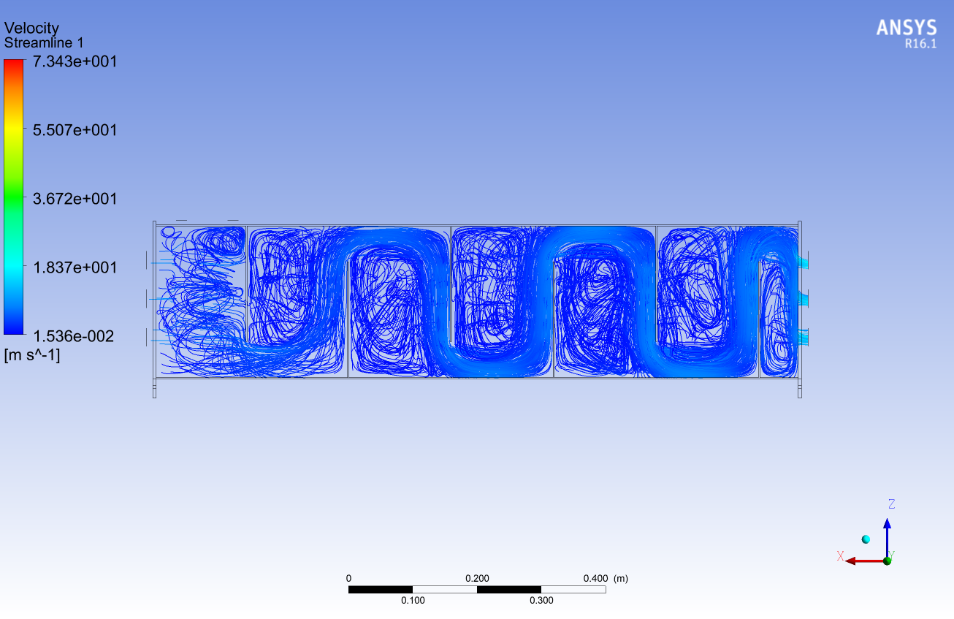
Fig 4.10 streamline flow of hot flow (SSB)
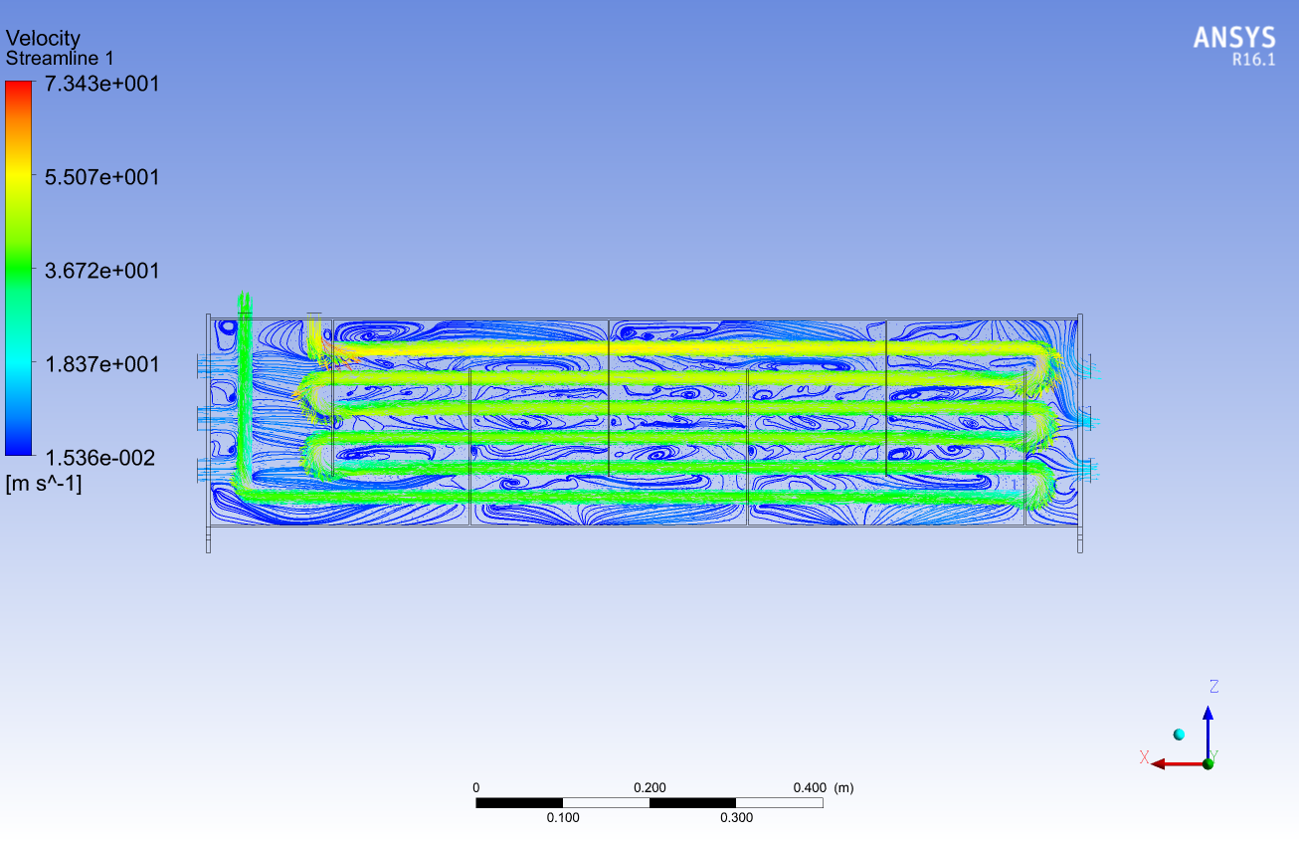
Fig 4.11 vector flow (SSB)

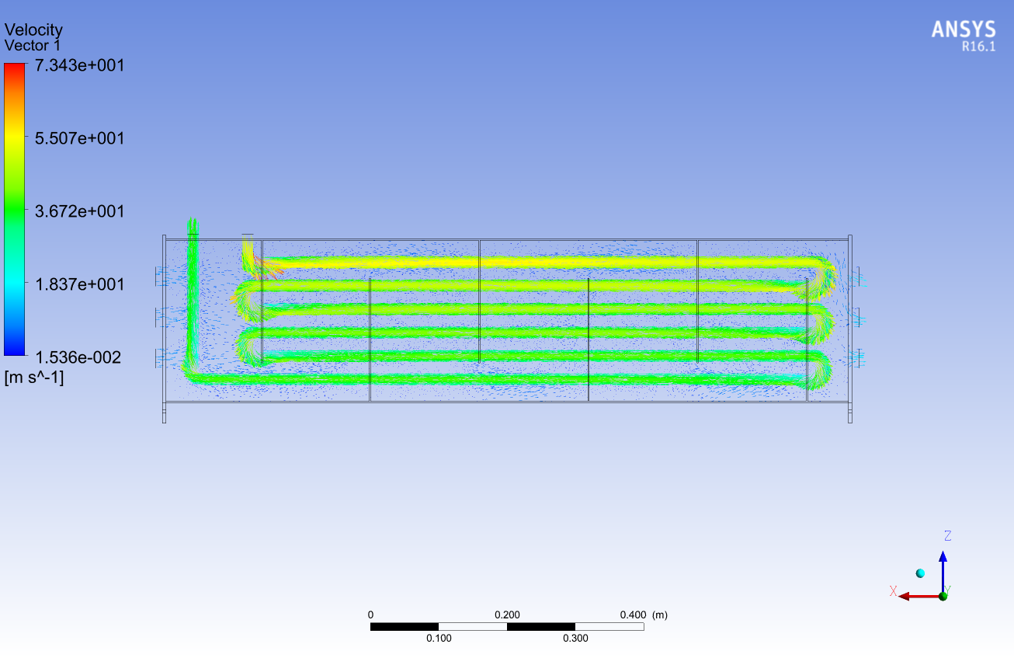

Fig 4.12 vector flow (SSB)
4.5.2 Analysis of Rectangular Shell and Tube Heat Exchanger of double segmental
baffle plate
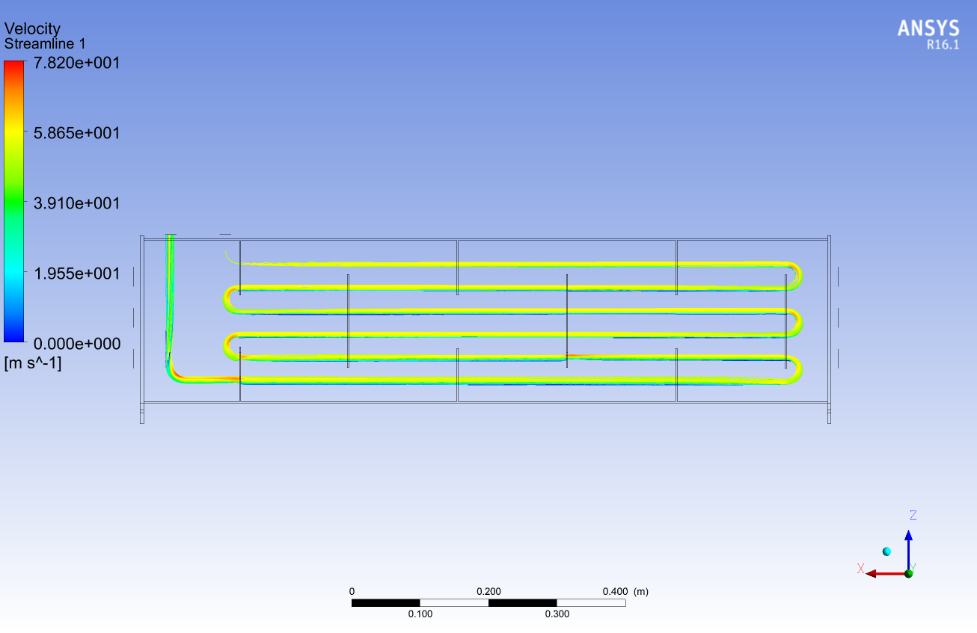
Fig 4.13 streamline flow of cold flow (DSB)

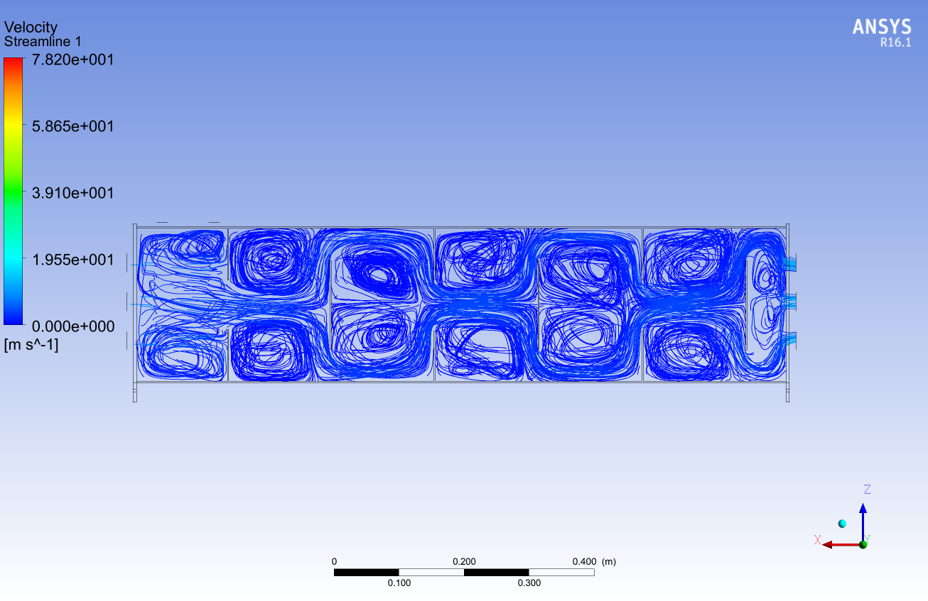
Fig 4.14 streamline flow of hot flow (DSB)
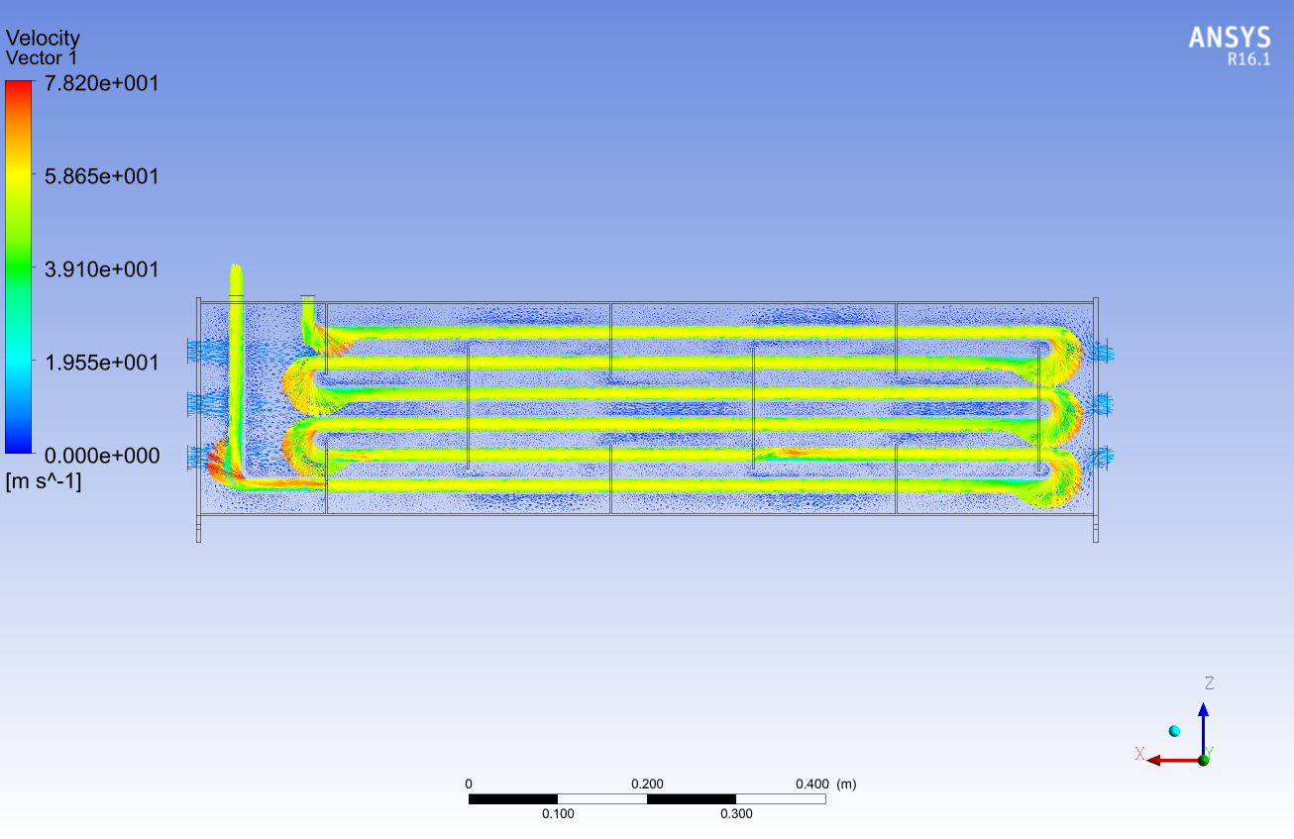
Fig 4.15 vector flow (DSB)

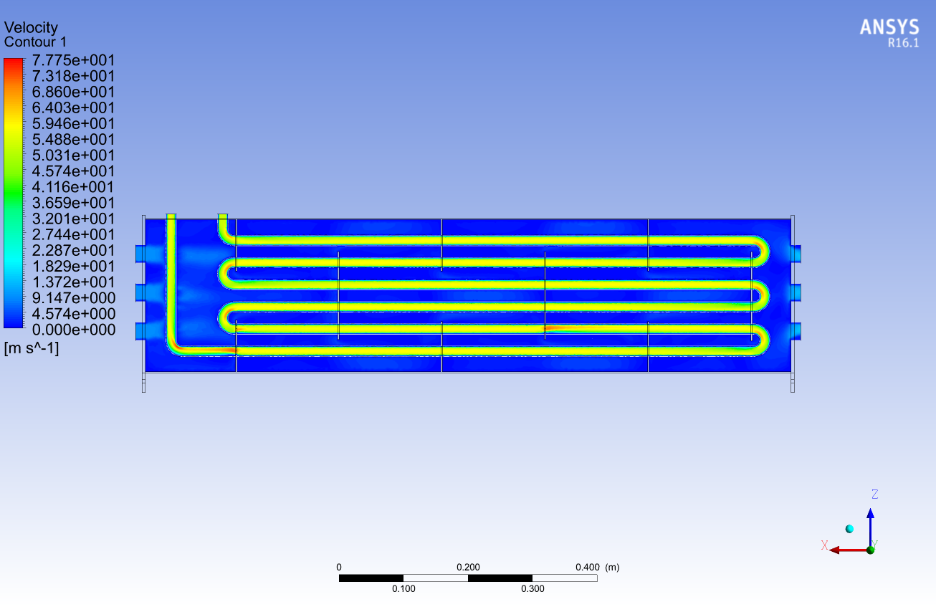

Fig 4.16 contour (DSB)

CHAPTER 5

FABRICATION AND MATERIAL USED
5.1 FABRICATION
- Shell Fabrication:
- Cut the steel sheets into the desired size for the shell.
- Roll the steel sheets into cylindrical shapes using a rolling machine.
- Weld the edges of the steel sheets together to form a seam.
- Use a grinder to smooth out any rough edges or welds.
- Cut and weld flanges onto the ends of the shell to allow for connections to the piping system.
- Tube Fabrication:
- Cut the steel pipes to the desired length for the tubes.
- Bend the steel pipes into the required U-shape using a pipe bending machine.
- Weld the tubes onto the baffles at the desired spacing and angle.
- Cut and weld flanges onto the ends of the tubes to allow for connections to the piping system.
- Assembly:
- Insert the baffles with the tubes into the shell.
- Weld the baffles onto the shell to ensure a tight fit.
- Install the flanges onto the ends of the shell and tubes.
- Perform a pressure test to ensure that there are no leaks.
- It's important to note that these are just general fabrication processes and the actual processes used will depend on the specific design of the heat exchanger and the capabilities of the fabrication facility. It's also important to ensure that all fabrication processes comply with applicable safety and quality standards.

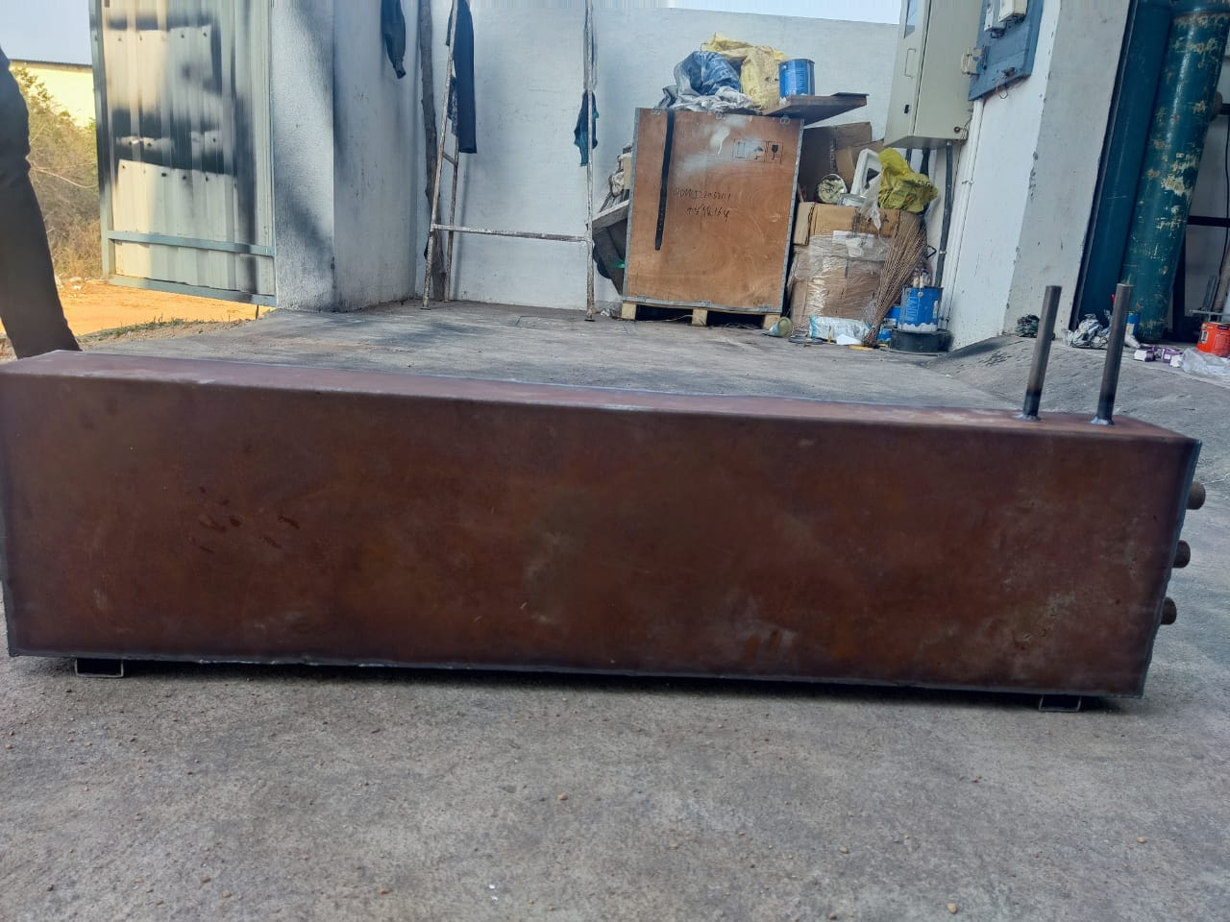
Fig 5.1 front view of fabrication

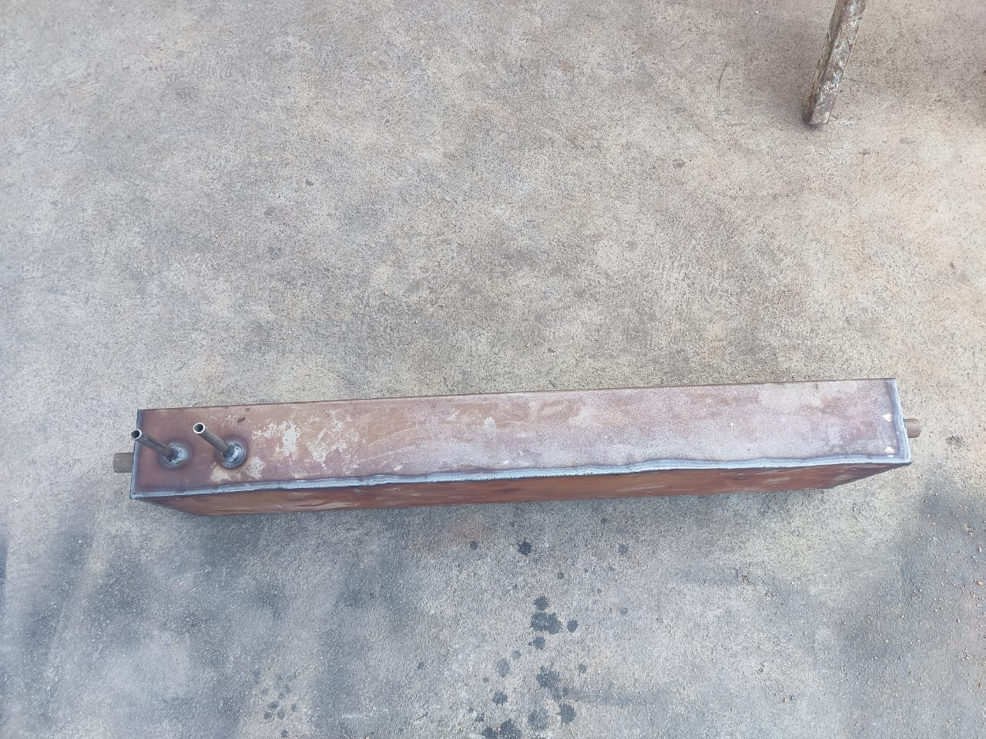
Fig 5.2 top view of fabrication

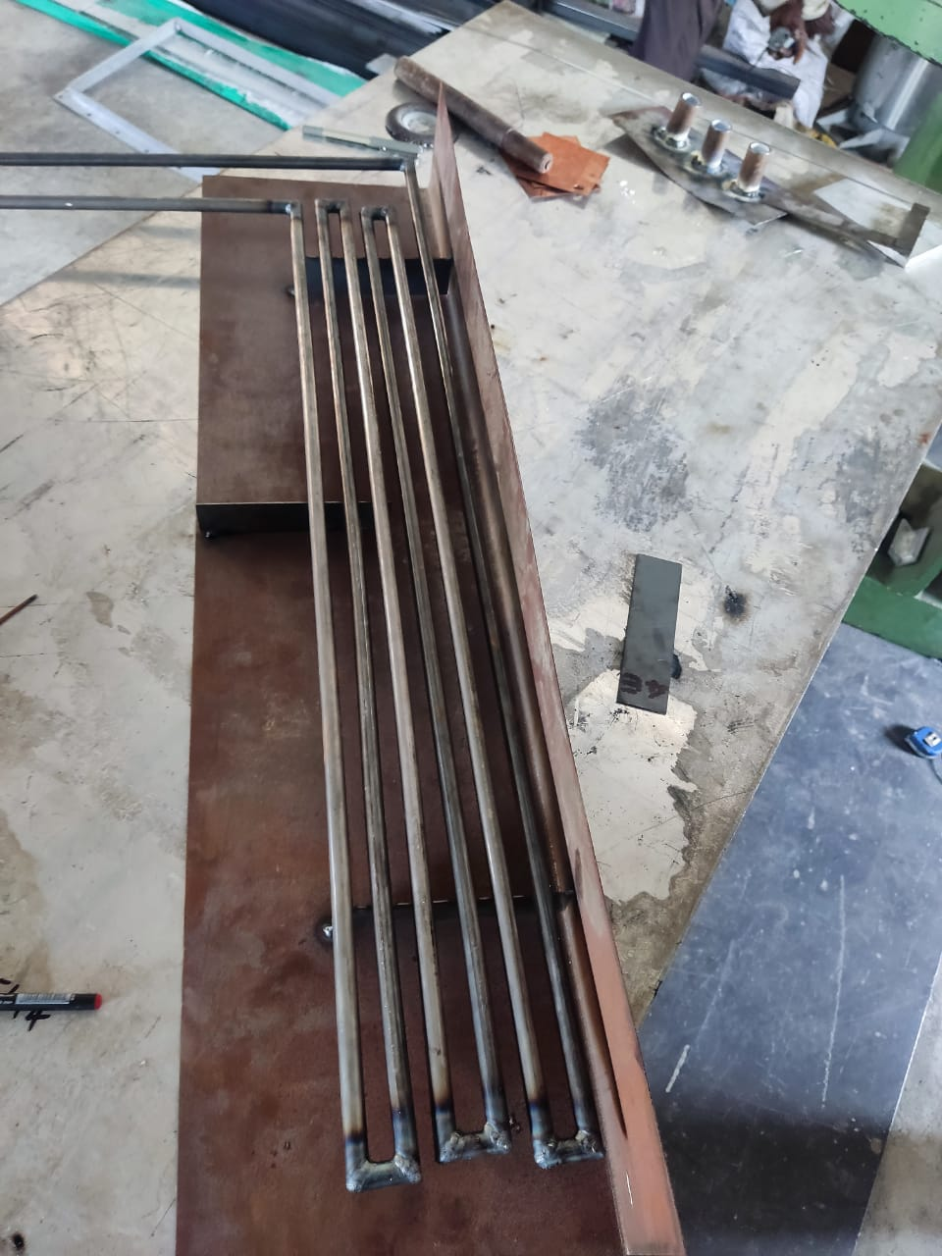
Fig 5.3 tube of heat exchanger

MIG welding, also known as Gas Metal Arc Welding (GMAW), is a type of welding process commonly used in industrial fabrication. It involves the use of a continuous and consumable wire electrode, fed through a welding gun or torch, which melts and fuses with the metal being welded.
In the context of hydrocyclone fabrication, MIG welding is a popular method due to its ability to produce high-quality welds quickly and efficiently. Some of the benefits of using MIG welding for hydrocyclone fabrication include:

Speed and Efficiency: MIG welding is a fast and efficient process, allowing for large volumes of welding to be completed quickly.
High-Quality Welds: MIG welding produces high-quality welds that are strong and durable, with minimal distortion and minimal need for post-weld finishing.
Versatility: MIG welding can be used to weld a variety of metals and alloys, including steel, stainless steel, and aluminium, making it a versatile option for hydrocyclone fabrication.

CHAPTER 6
RESULTS AND CONCLUSION
6.1 RESULTS

The results of the study showed that the double segmental baffle plate configuration had the highest overall heat transfer coefficient and the lowest pressure drop, followed by the single segmental baffle plate configuration. Increasing the mass flow rate had a positive effect on the heat transfer coefficient for both configurations, but the double segmental configuration remained the most efficient design.

The effectiveness-NTU method was used to evaluate the thermal performance of the heat exchanger, and the results were consistent with the CFD simulation results. The results demonstrated that the double segmental baffle plate configuration had a higher overall heat transfer coefficient and a lower pressure drop than the single segmental configuration, indicating that it is the most efficient design for achieving high heat transfer rates and lowpressure drops.

The study highlights the importance of considering mass flow rate when optimizing the design of shell and tube heat exchangers for better performance.

6.2 CONCLUSION
The study investigated the thermohydraulic performance of a rectangular shell
and tube heat exchanger with single and double segmental baffle plate configurations designed using CATIA and CFD simulations. The results showed that both the single and double segmental baffle plate configurations were effective in enhancing heat transfer rates, but the double segmental configuration performed better.

The double segmental baffle plate configuration had a higher overall heat transfer coefficient and a lower pressure drop than the single segmental configuration, indicating that it is the most efficient design for achieving high heat transfer rates and low pressure drops. The results also showed that increasing the mass flow rate had a positive effect on the heat transfer coefficient for both configurations.

The findings suggest that the double segmental baffle plate configuration is a suitable option for industrial applications that require efficient heat transfer and lowpressure drops, especially when high mass flow rates are involved. The study highlights the importance of using advanced simulation tools like CATIA and CFD to optimize the design of shell and tube heat exchangers for better performance, and the results can be used to guide the design of more efficient heat exchangers in the future

CHAPTER 7
REFERENCES
7.1 References
[1] M. Omidi, M. Farhadi, M. Jafari, A comprehensive review on double pipe heat exchangers, Appl. Therm. Eng. 110 (2017) 1075–1090.
[2] T. Chen, J. Kim, H. Cho, Theoretical analysis of the thermal performance of a plate heat exchanger at various chevron angles using lithium bromide solution with nanofluid, Int. J. Refrig. 48 (2014) 233–244.
[3] A.A.A. Arani, R. Moradi, Shell and tube heat exchanger optimization using new baffle and tube configuration, Appl. Therm. Eng. 157 (2019).
[4] J. Chen, X. Lu, Q. Wang, M. Zeng, Experimental investigation on thermal-hydraulic performance of a novel shell-and-tube heat exchanger with unilateral ladder type helical baffles, Appl. Therm. Eng. 161 (2019).
[5] J. Mahendran, Experimental analysis of shell and tube heat exchanger using flower baffle plate configuration, Mater. Today Proc. 21 (1) (2020) 419–424, https://doi. org/10.1016/j.matpr.2019.06.380.
[6] J. Wen, H. Yang, S. Wang, Y. Xue, X. Tong, Experimental investigation on performance comparison for shell-and-tube heat exchangers with different baffles, Int. J. Heat Mass Tran. 84 (2015) 990–997. [7] X. Cao, T. Du, Z. Liu, H. Zhai, Z. Duan, Experimental and numerical investigation on heat transfer and fluid flow performance of sextant helical baffle heat exchangers, Int. J. Heat Mass Tran. 142 (2019) 118437, 2019/10/01/.
[8] M.S. El-Said Emad, M. Abou Alsood, Experimental investigation of air injection effect on the performance of horizontal shell and multi-tube heat exchanger with baffles, Appl. Therm. Eng. 134 (2018) 238–247, https://doi.org/10.1016/j. applthermaleng.2018.02.001.
[9] M.S. El-Said Emad, Abd Elaziz Mohamed, Ammar H. Elsheikh, A machine learning algorithm for improving the prediction of air injection effect on the thermohydraulic performance of shell and tube heat exchanger, Appl. Therm. Eng. 185 (2021) 116471, https://doi.org/10.1016/j.applthermaleng.2020.116471.
[10] S.A. Marzouk, Emad M.S. El-Said, M.M. Abou Al-Sood, Magda K. El-Fakharany, Thermo-hydraulic study in a shell and tube heat exchanger using rod inserts consisting of wire-nails with air injection: experimental study, Int. J. Therm. Sci. 161 (2021) 106742, https://doi.org/10.1016/j.ijthermalsci.2020.106742.
[11] Emad M.S. El-Said, Samir M. Elshamy, A.A. Hegazi, Experimental investigation on thermo-hydraulic performance of a helical plate heat exchanger, Taylor & Francis, J. Exp. Heat Transf. (2022), https://doi.org/10.1080/08916152.2022.2047127.
[12] S. Wang, J. Xiao, S. Ye, C. Song, J. Wen, Numerical investigation on pre-heating of coal water slurry in shell-and-tube heat exchangers with fold helical baffles, Int. J. Heat Mass Tran. 126 (2018) 1347–1355.
[13] X. Wang, Y. Liang, Y. Sun, Z. Liu, W. Liu, Experimental and numerical investigation on shell-side performance of a double shell-pass rod baffle heat exchanger, Int. J. Heat Mass Tran. 132 (2019) 631–642.
[14] X. Wang, N. Zheng, P. Liu, Z. Liu, W. Liu, Numerical investigation of shell side performance of a double shell side rod baffle heat exchanger, Int. J. Heat Mass Tran. 108 (2017) 2029–2039.
[15] X. Wang, N. Zheng, Z. Liu, W. Liu, Numerical analysis and optimization study on shell-side performances of a shell and tube heat exchanger with staggered baffles, Int. J. Heat Mass Tran. 124 (2018) 247–259.
[16] M.S. El-Said Emad, Ammar H. Elsheikh, Hamed R. El-Tahan, Effect of curved segmental baffle on a shell and tube heat exchanger thermohydraulic performance: numerical investigation, Int. J. Therm. Sci. 165 (2021) 106922, https://doi.org/ 10.1016/j.ijthermalsci.2021.106922.
[17] Emad M.S. El-Said, Abdulaziz Mohamed, M.M. Awad, Thermodynamic performance evaluation for helical plate heat exchanger based on second law analysis, Proc. Rom. Acad. Ser A 19 (2018) 237–242, in: http://www.acad.ro/sectii 2002/proceedings/doc2018-1s/continut/237-242.pdf.
[18] Emad M.S. El-Said, Abdulaziz Mohamed, M.M. Awad, A numerical investigation on heat transfer enhancement and the flow structure in a new type plate heat S.A. Marzouk et al. International Journal of Thermal Sciences 179 (2022) 107655 11 exchanger using helical flow duct, Cogent Eng. 4 (1) (2017) 1396638, https://doi. org/10.1080/23311916.2017.1396638.
[19] M.M.A. Bhutta, N. Hayat, M.H. Bashir, A.R. Khan, K.N. Ahmad, S. Khan, CFD applications in various heat exchangers design: a review, Appl. Therm. Eng. 32 (2012) 1–12.
[20] W.I.A. Aly, Numerical study on turbulent heat transfer and pressure drop of nanofluid in coiled tube-in-tube heat exchangers, Energy Convers. Manag. 79 (2014) 304–316.
[21] Y. Lei, Y. Li, S. Jing, C. Song, Y. Lyu, F. Wang, Design and performance analysis of the novel shell-and-tube heat exchangers with louver baffles, Appl. Therm. Eng. 125 (2017) 870–879.
[22] O. Labbadlia, B. Laribi, B. Chetti, P. Hendrick, Numerical study of the influence of tube arrangement on the flow distribution in the header of shell and tube heat exchangers, Appl. Therm. Eng. 126 (2017) 315–321.
[23] S. Shinde, U. Chavan, Numerical and experimental analysis on shell side thermohydraulic performance of shell and tube heat exchanger with continuous helical FRP baffles, Therm. Sci. Eng. Prog. 5 (2018) 158–171.
[24] R. Amini, M. Amini, A. Jafarinia, M. Kashfi, Numerical investigation on effects of using segmented and helical tube fins on thermal performance and efficiency of a shell and tube heat exchanger, Appl. Therm. Eng. 138 (2018) 750–760.
[25] S.A. Marzouk, M.M. Abou Al-Sood, E.M.S. El-Said, M.K. El-Fakharany, Effect of wired nails circular-rod inserts on tube side performance of shell and tube heat exchanger: experimental study, Appl. Therm. Eng. 167 (2020) 114696.
[26] N. Biçer, T. Engin, H. Yas¸ar, E. Büyükkaya, A. Aydın, A. Topuz, Design optimization of a shell-and-tube heat exchanger with novel three-zonal baffle by using CFD and taguchi method, 2020/09/01/, Int. J. Therm. Sci. 155 (2020) 106417.
[27] M.H. Mohammadi, H.R. Abbasi, A. Yavarinasab, H. Pourrahmani, Thermal optimization of shell and tube heat exchanger using porous baffles, 2020/04/01/, Appl. Therm. Eng. 170 (2020) 115005. [28] M.S. El-Said Emad, M. Abou Alsood, Shell and tube heat exchanger with new segmental baffles configurations: a comparative experimental investigation, Appl. Therm. Eng. 150 (2019) 803–810, https://doi.org/10.1016/j. applthermaleng.2019.01.039.
[29] L. He, P. Li, Numerical investigation on double tube-pass shell-and-tube heat exchangers with different baffle configurations, 2018/10/01/, Appl. Therm. Eng. 143 (2018) 561–569.
[30] S.M.A. Naqvi, K.E. Elfeky, Y. Cao, Q. Wang, Numerical analysis on performances of shell side in segmental baffles, helical baffles and novel clamping anti-vibration baffles with square twisted tubes shell and tube heat exchangers, 2019/02/01/, Energy Proc. 158 (2019) 5770–5775.

