FarmAid: An Android Based Application For Crop Disease Detection using Deep Learning
¹Hrushabh Barde, ¹Vinit Joshi, ¹Prajwal Gabhane
²Prof. S.W.Shende
¹Department of Computer science and Engineering,
Government College of Engineering Chandrapur, Maharashtra, India
²Asst. Prof. Department of Computer science and Engineering, Government College of Engineering Chandrapur, Maharashtra, India

Abstract: When we think of crops, we automatically tend to think about the insects because they are the ones which reduces the crop yield rate and has been a nightmare for farmers. With the technology improvement, we still couldn’t find an efficient way to sort these issues and the farmers are struggling with the harmful impacts caused to the crops by the variety of insects. The Present method that the farmers are following for separating the insects from the crops is with the help of man power. But this requires a lot of man power and it also requires a lot of time when there is a huge crop field. This work makes use of convolutional neural network model to identify and classify the insects. The proposed model is an android app and thus it helps effectively for farmers for identifying diseases and appropriate solutions. This model also provide e-commerce platform for selling and buying farming related products.
I. INTRODUCTION
Convolutional Neural Networks (ConvNets or CNNs) are a category of Neural Networks that have proven very effective in areas such as image recognition and classification. CNN have been successful in identifying faces and it is done by taking the image, pass it through a series of convolutional, nonlinear, pooling (downsampling), and fully connected layers, and get an output. The output can be a single class or a probability of classes that best describes the image. The pre-processing required in a ConvNet is much lower as compared to other classification algorithms. While in primitive methods filters are hand-engineered, with enough training, ConvNets have the ability to learn these filters/ characteristics. The architecture of a ConvNet is analogous to that of the connectivity pattern of Neurons in the Human Brain and was inspired by the organization of the Visual Cortex.A ConvNet is able to successfully capture the Spatial and Temporal dependencies in an image through the application of relevant filters. The architecture performs a better fitting to the image dataset due to the reduction in the number of parameters involved and reusability of weights. In other words, the network can be trained to understand the sophistication of the image better. Here inorder to help farmers from pests , we use CNN to capture the insects in the field . From the image captured it processes the data with the samples and gives an output. With that output we suggest the right pesticide for the farmer.
II. LITERATURE SURVEY
In paper[ 1],the authors Lingqiao Liu, Chunhua Shen, Anton Van Hengel discussed about cross convolutional pooling and 2 types of methods to create image representation. The first method is ,the image is directly feeded into DCNN. The second method is, applying the DCNN to the input image to subregions . DCNNs is very much helpful in extracting local features of the input image.The issue is While using k value for pooling method and when k becomes too large, retrieval performance will start to drop.
In paper[2],the authors Rahul Chauhan, Kamal Kumar, R.S.Joshi discussed the as Relu non linearity activation function that has been used for training neural network models . Relu activation function has been widely used to train larger neural networks and it is also relatively easier activation function when compared to sigmoid, tanh, and leaky activation functions. The issue is, In case of high bias which results in underfitting ,the network needs to be trained longer Variance error will occur and it affects the resultant value.
In paper[3],the authors Ann-Katrin Fattal, Michelle Karg, Christian Scharfenberger, and Jürgen Adamy discussed about the region proposal networks . The RPN is used as slider over the feature maps of a convolutional layer, then it computes each anchor scores by using bounding box regression at each different level. Small ZF-Net is used that consists of five convolutional layers, two pooling and two fully connected layers. The two pooling layers makes sure the input image is not down-sampled, so small objects is detected. The issue is prior maps which are relying on Visual Attention might produce inconsistent results.
In paper [4] Ke Gu discussed about smoke detection. They used a new deep dual-channel neural network (DCNN) which is made by selective-based batch normalization network(SBNN) and skip connection-based neural network(SCNN) for feature fusion and feature extraction for classification of smokes. So the DCNN consist of two layers the first is multiple convolutional layer and max pooling layer which is used to extract the detail information of smoke and the second layer is the batch normalization layer which is used to improve the feature propagation. These two layers can be used in our project for feature identification.
In paper [5] Yang Ji discussed about automatic classification of spider image in natural background based on Convolutional Neural Network and transfer learning. So here they used inspection v-3 and feature vector for transfer learning model which is used to solve domain problems with existing knowledge. The image pro processing is done with contour detection and data expansion. And CNN is used to extract effective feature of spiders from complex images with natural background.
In paper [6], Shaoqing discussed about real time object detection using faster R-CNN. The R-CNN is a classifier that identify the regions on image. It mainly consit of two modules the deep fully convolutional network which is used to propose regions and the second model which is faster r-cnn that detects the proposed regions. Here the rcnn uses a shared convolutional layer to get rectangular object proposal. It is an unified, deep learning based object detection that runs at 6-17 frame per seconds.
In paper [7], Sangdi Lin and George C.Runger discussed about a new end to end deep neural network model for time-series classification ( TSC) with emphasis on both the accuracy and the interpretation. This model consists of a convolutional network component to extract high level features and a recurrent network component to enhance modeling of the temporal Characteristics of TS data . It also uses sparse group lasso (SGL) to generate final classification. This model gives good interpretability through the SGL.It outperforms traditional CNN.
In paper [8] , Fok Hing Chi Tivive and Abdesselam Bouzerdoum discussed about some efficient training algorithms based on first order , second order and conjugate gradient optimization methods. This is a hybrid method derived from the principles of quickprop, rprop and LS . Alll these methods are combined to give a better recognition pattern of the image .
In paper [9], R Amog Shetty Rishab F TatedSunku Rohan Triveni S Pujar use CNN and train a neural network model that predicts whether the crop is going to get any pest and disease attacks. The model developed by these authors gave up to 99% classification ability which satisfies the required efficiency as Neural Network is used. It highly depends on the colour and shape features that are extracted from the input image the prediction occurs .
In paper [ 10] ,Hoo- Chang Shin , Holger R Roth, Mingchen Gao , Le Lu , Ziyue Xu , Isabella Nogues , Jianhua Yao , Daniel Mollura , Ronald M summers discussed about factors of employing deep convolutional neural networks to computer aided detection problems Here the different CNN architectures are explored and evaluated .It contains 5 thousand to 160 million parameters and finally the examination of transfer learning is done .This is more efficient than normal CNN methods.

II. ARCHITECTURE
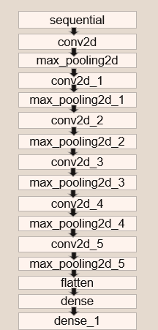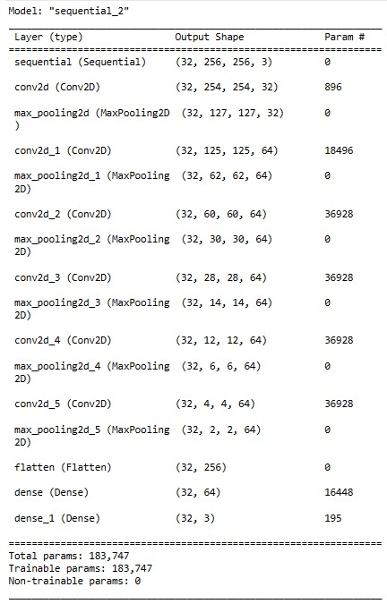
Fig.1: Architecture of Model Fig.2: screenshot of layers of our model

The architecture takes an input as an image of size 256 X 256 pixels. Data preprocessing and Data Augmentation is done to filter the images.
We define the architecture as follows:
1. Sequential layer : first layer
2. Number of convolutional layers : six, 32 filters for first layer and 64 filters for remaining five layers.
3. Number of pooling layers : six, Max pooling is used
4. Flatten layer : Between the final pooling layer and the first dense layer
5. Number of dense layers : Two, 64 units for the first layer, 6 units for the second layer.

III. METHODOLOGY
Step 1: Data preprocessing: all the images in dataset are resized to 256 x 256 pixel format.
Step 2: Data is divided into two parts 80% training set, 20% test set.
Step 3: Data augmentation: augmentation process is applied of Training set to rotate, resize and adding some random noise to images in order to avoid over fitting.
Step 4: Feature extraction: Features would be extracted in starting layers of CNN architecture using convolutional operation.
Step 5: Training the model: In our case we will use LeNet based architecture. Once architecture is developed we will train the model with Training set features.
Step 6: Evaluation: Accuracy of model would be evaluated with the help of Test set.
Step 7: Tuning: If results are not satisfactory tune the model by changing the parameters of architecture such as kernel size, Nodes in last fully connected layer.
Step 8: Store the weights: final model which has trained save it in model_name.h5 configuration file so that it can be used for new data.
Step 9: Application android: application would be developed using kotlin for android to upload images on server and display the results.
Step 10 Server Side application: this application responsible for preprocessing the image uploaded by user and classify it based on its features and give the results in the form of JSON objects.
Step 11: Capture image, resize image and upload to the server.
Step 12: extract the features and evaluate with trained model.
Step 13: Sending back the results to application.
Step14: Display the results on smartphone.

IV. RESULTS AND PERFORMANCE ANALYSIS
Training Accuracy: It is the percentage of successful classification in the training dataset means the amount of correctly identified images from dataset.
Training Loss: The average mistakes of the model in the training dataset. This means the average loss per batch, out of batches of the training dataset.
Validation Accuracy: It is the percentage of successful classification of classes in the validation dataset.
Validation Loss: This indicates the average loss per batch, out of batches of the validation dataset.

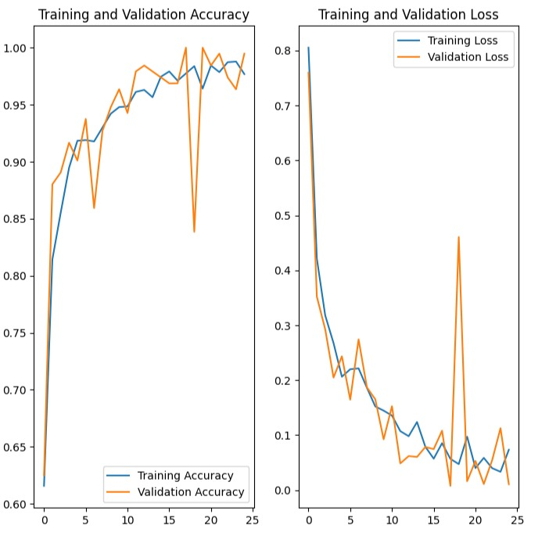
Fig.3 : Accuracy and loss graph

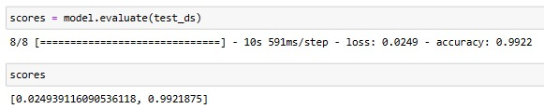
Fig.4 : screenshot of accuracy test
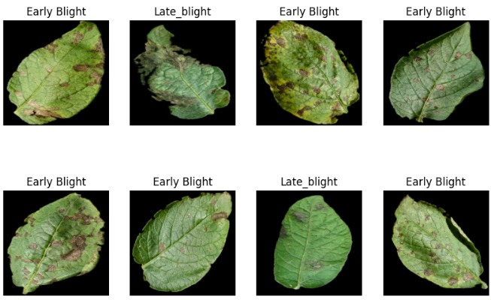
Fig.5 : some training dataset

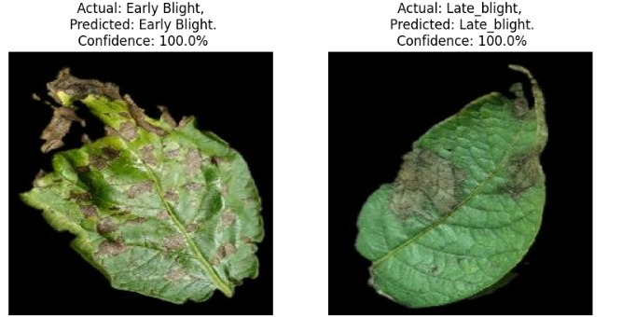
Fig.6 : Performance of DL model

V. CONCLUSIONS
CNN can be used to give high accuracy in detection and classification of insects compared to other algorithms. A variety of insects detected and thus generalizing for a number of diseases. The insects images provided as input can be in any of the classes of pest images included in the training set. The model trained as a result can classify a number of diseases by CNN to give high accuracy unlike other algorithms as high upto 99%.
VI. REFERENCES
[1] Liu, L., Shen, C., & Hengel, A. van den. (2017). Cross-Convolutional-Layer Pooling for Image Recognition. IEEE Transactions on Pattern Analysis and Machine Intelligence, 39(11), 2305–2313.
[2] Chauhan, R., Ghanshala, K. K., & Joshi, R. . (2018). Convolutional Neural Network (CNN) for Image Detection and Recognition. 2018 First International Conference on Secure Cyber Computing and Communication (ICSCCC).
[3] Fattal, A.-K., Karg, M., Scharfenberger, C., & Adamy, J. (2017). Saliency-guided region proposal network for CNN based object detection. 2017 IEEE 20th International Conference on Intelligent Transportation Systems (ITSC).
[4] K. Gu, Z. Xia, J. Qiao and W. Lin, "Deep Dual-Channel Neural Network for Image-Based Smoke Detection," in IEEE Transactions on Multimedia, vol. 22, no. 2, pp. 311-323, Feb. 2020.
[5] Y. Jian, S. Peng, L. Zhenpeng, Z. Yu, Z. Chenggui and Y. Zizhong, "Automatic Classification of Spider Images in Natural Background," 2019 IEEE 4th International Conference on Signal and Image Processing (ICSIP), Wuxi, China, 2019, pp. 158-164
[6] Faster R-CNN: Towards Real-Time Object Detection with Region Proposal Networks Shaoqing Ren, Kaiming He, Ross Girshick, Jian Sun
[7] Lin, S., & Runger, G. C. (2017). GCRNN: Group-Constrained Convolutional Recurrent Neural Network. IEEE Transactions on Neural Networks and Learning Systems.
[8] Tivive, F. H. C., & Bouzerdoum, A. (2005). Efficient Training Algorithms for a Class of Shunting Inhibitory Convolutional Neural Networks. IEEE Transactions on Neural Networks,
[9] Suma V R Amog Shetty, Rishab F Tated, Sunku Rohan and Triveni S Pujar “CNN based Leaf Disease Identification and Remedy Recommendation System” , Proceedings of the Third International Conference on Electronics Communication and Aerospace Technology [ICECA 2019] IEEE Conference Record , Vol.,pp:395-399
[10] H. Shin et al., "Deep Convolutional Neural Networks for Computer-Aided Detection: CNN Architectures, Dataset Characteristics and Transfer Learning," in IEEE Transactions on Medical Imaging, vol. 35, no. 5, pp. 1285-1298, May 2016.

