Mental Health Assessment and Tracking Solution
Vijaya Bhoi¹, Ruchika Patil², Vaishnavi Patil³, Shaikh Aaftab Shaikh Shakeel⁴
Information Technology Department
Shram Sadhana Bombay Trust College of Engineering and Tecnology, Jalgaon
(An Autonomous Institute Affiliated to KBC North Maharashtra University ,Jalgaon )
---------------------------------------------------------------------***--------------------------------------------------------------------

-
Abstract - :- Mental Health problems are a growing public health concern. Resources and services for mental disorders are disproportionately low compared to disease burden. In order to bridge treatment gaps, The Systematic Medical Appraisal, Referral and Treatment (SMART) Mental Health Project was implemented across 12 villages in West Godavari district of the southern Indian state of Andhra Pradesh. This paper reports findings from a process evaluation of feasibility and acceptability of the intervention that focused on a mental health services delivery model to screen, diagnose and manage common mental disorders (CMDs).
Key Words: Common mental disorders (CMDs)

1. INTRODUCTION
According to the World Health Organization, there is a global shortage of health workers trained in mental health. Many mental health interventions do not reach those in need, with approximately 70 Chatbots are systems that are able to converse and interact with human users using spoken, written, and visual languages. Chatbots have the potential to be useful tools for individuals with mental disorders, especially those who are reluctant to seek mental health advice due to stigmatization In our daily life, mental health is need of life. Mental health means a state of mind in which the person understands his/her own abilities and disabilities, but mental health will be metal illness, and it can affect our whole life. Because of mental person’s relationship, theirs work environment and others also get influenced. Peoples can’t speak about their mental health openly. They have fear that anyone will judge them and tease them. We applied a sentiment analysis strategy in this project’s model. It focuses mostly on text data sentiment analysis
Mental disorders are usually treated by psychotherapists. However, there is a global shortage of human resources for delivering such mental health services. In developed countries, there are nine psychiatrists per 100,000 people available, while in developing countries there is one psychiatrist per ten million people. According to the WHO, about 45% of people in developed countries and 15% of people in developing countries have access to psychiatric services. This shortage and expense issues have made the AI industry take matters into its hand. Building conversational AI systems to create a humanlike AI has been one of the leading research topics to date. Creating a virtual psychotherapist AI is one step closer to a humanlike AI dream. The chatbot simulates a realistic conversation partner by giving the user appropriate answers in a language that he or she understands. Chatbots were mainly used in marketing to enhance customer experiences

2. LITERATURE SURVEY
Adomakoh CC. [1] developed the model aims to identify, analyze and characterize the current state of person by mood tracker, Chatbot, test were provided. Python and machine learning technology was used for this model.
Andrews and Titov, in[2] described the promotion of Internet-based treatment programs (a virtual clinic) connected to a hospital in Sydney, Australia. The programs are considered to be cost-effective alternatives to medication or face-to-face CBT treatment. Programs are offered for major depression, social phobia, panic disorder, and generalized anxiety disorder. They suggest that the programs could be the first level of treatment for the proportion of the population that desires Internet based treatment; however, with the support of a small team, individuals who need more support could be identified and referred for more intensive intervention.
Woltmann, in[3] a classification approach includes a useful summary of the work of Bodenheimer et al. (2002) and Badamgarav et al. (2003) which outlines the core elements of collaborative chronic care models. There are also fourteen randomized controlled trials focusing on primary care and mental health and a range of case studies, surveys and articles debating the need and usefulness of enhanced model development for mental health

3. METHODOLOGY
Dataset Data was collected from Kaggle, Reddit and many other websites. 883 lines of a total of 36 intents were collected. Stories building is a very important task of building a Rasa Chatbot. A total of 24 stories based on happy, sad, depressed, anxious, stressed and many such moods were created.
RASA Chatbot The most important task of this project is to create the chatbot. With the help of the Rasa Framework, we classified intents and played stories over and over to check if the chatbot was correctly answering the user. We also made the chatbot a little humourous so that if the user might be feeling stressed the chatbot would help relieve those feelings and make a normal happy atmosphere for the user.
Web Application The web app consists of two parts i.e a front-end that only has information about the chatbot viz. Features, about and blogs and the other part is the chatbot. We've hosted the chatbot on the website using a react based chatroom component provided by scalable minds. The web app currently runs on localhost.
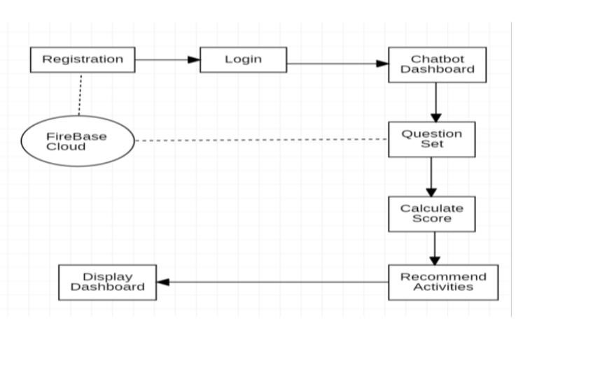

4. IMPLEMENTATION
Software testing is a critical element of software quality assurance and represents the ultimate review of specification , design and coding. In fact, testing is the one step in the software engineering process that could be viewed as destructive rather than constructive. A strategy for software testing integrates software test case deign methods into a well-planned series of steps that result in the successful construction of software. Testing is the set of activities that can be planned in advance and conducted systematically.
Rasa Configuration
Let me explain about files, which are created as Initial project structure of Rasa.
__init__.py: an empty file that helps python find your actions.
actions.py: code for your custom actions. If you need the bot to write specific
config.yml: configuration of your NLU and Core models.
credentials.yml: details for connecting to other services. Remember that you need to host Rasa over https domain.
data/nlu.md: your NLU training data. Here you define Intents. Like depression or anxiety. You need to add related Sentences for that Intent. Remember if you are using Rasa-X, your training Intent and Data will be added automatically.
data/stories.md:This is required for Rasa Core. There is something called “Dialog Flow in Rasa” where Rasa Core controls the flow of the conversation between you and the chatbot, so for that flow, you need to train the chatbot using these stories. So in case you want your chatbot to be very perfect in different contexts (stories) you can add those stories here.
domain.yml: your assistant’s domain. This file combines Different Intent which chatbot can detect and list of Bot replies. Remember you can define your Custom Action Server Python method name here, so that Rasa will call that python method for you.
endpoints.yml: details for connecting to channels like FB messenger. This is mainly used for production setup. You can configure your Database like Redis so that Rasa can store tracking information.
Algorithm
1. Firstly, User will provide Input.
2. After providing the data the model will trained.
3. The data will goes to the Rasa Framework
4. The provided Input checked from the database.
5. In data augmentation the provided input will compared with the dataset.
6. Provide the Solution

5. RESULT AND DISCUSSION
The Mental health assessment and tracking solutionis done in an effective manner. Mental health assessment and tracking solution is an efficient, time saving and easy way to report, view and control the version of a file. All the operations are done efficiently. To use one, start by registering a collection of source files — that is, telling your DMS to start archive files describing their change histories. Thereafter, when you want to edit one of these files, you have to check out the file — assert an exclusive lock on it.

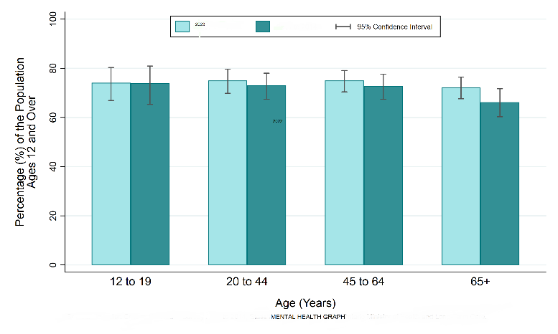
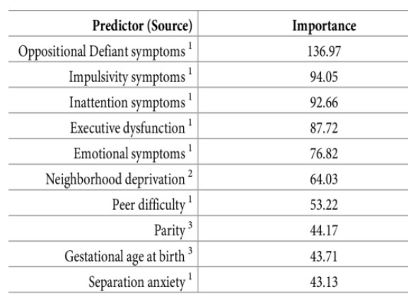

6. CONCLUSION
We are overcoming the drawback of existing system, and providing a smart system that will not only monitor user mental health with security but also show recommendation whenever necessary. The undertaking centers around building an emotional wellness tracker. We will attempt to find out about the psychological condition of our client, see whether they are enduring and afterward propose measures they can remove to get from their current condition. According to the answer given with the aid of a person, a task and activity will be generated. As per the user’s temper, a task is assigned. A weekly graph will also be generated so that someone can see the mental health growth through the use of proposed system.

7. REFERENCES
- Adomakoh CC. Mental hospital patients: A Castle Road profile. Ghana Med. J. 1972;2:65–71.
- Andrews and Titov Scaling up community-based services and improving quality of care in the state psychiatric hospitals: the way forward for Ghana. African Journal of Psychiatry. 2010;13:109–115.
- Woltmann Common understandings of women's mental illness in Ghana: Results from a qualitative
study. International Review of Psychiatry. 2010;22(6):589– 598.
- Sinha, R., Sivaraman, K., Agrawal, A., Jain, R., Srivastava, R., and Jain, A. (1995). ANGLABHARTI: a multilingual machine aided translation project on translation from English to Indian languages. In IEEE International Conference on Systems, Man and Cybernetics.
[5] Madhu, Chithra, Anu George, and Leena Mary. ”Automatic language identification for seven Indian languages using higher level features.” In 2017 IEEE International Conference on Signal Processing, Informatics, Communication and Energy Systems (SPICES), pp. 1-6.
IEEE, 2017.
- Venkatesan, Hariraj, T. Varun Venkatasubramanian, and J. Sangeetha. ”Automatic language identification using machine learning techniques.” In 2018 3rd International Conference on Communication and Electronics Systems (ICCES), pp. 583-588. IEEE, 2018.
- S. Saini and V. Sahula, ”A Survey of Machine Translation Techniques and Systems for Indian Languages,” 2015 IEEE International Conference on Computational Intelligence Communication Technology, 2015, pp. 676-681, doi: 10.1109/CICT.2015.123

- Python.com, Python programming language. https://www.python.org/

- Quinn: Medical Assistant for Mental Counseling using Rasa Stack, Sandra V A, Vinitha V Master of Computer Applications, College of Engineering, Trivandrum, Kerala, India https://www.irjet.net/archives/V6/i6/IRJETV6I629 7.pdf.

- Schawbel, D. (n.d.). Robots and chatbots can help alleviate the mental health epidemic. Retrieved February 23,2021, https://www.weforum.org/agenda/2020/11/menta lhealth-technology-robots-chatbots/

- Introduction to Rasa X. (2021, February 18). Retrieved February 23, 2021, from https://rasa.com/docs/rasa-x/

- Weizenbaum, J. (n.d.). Eliza, the Rogerian Therapist. Retrieved February 24, 2021, from http://psych.fullerton.edu/mbirnbaum/psych101/El iza.htm.

- Rasa architecture overview. (2021, February 11). Retrieved February 25, 2021, from https://rasa.com/docs/rasa/arch-overview/.

