Forecasting the Weather and its Visualization using Augmented Reality

Dr.Sandip S. Patil, Vivek Patil¹, Pritesh Pawar², Harshal Patil³, Vaibhav shimpi⁴
Information Technology Department
Shram Sadhana Bombay Trust College of Engineering and Tecnology, Jalgaon
(Affiliated to KBC North Maharashtra University ,Jalgaon )
---------------------------------------------------------------------***-------------------------------------------------------

-
Abstract -In the recent period, many real-world applications and institutions generates a huge amount of data which is unstructured i.e., in the form of images containing data, receipts, invoices, forms, statements, contracts etc. This rich and detailed information presented in the text is of great significance in computer vision-based applications (driverless cars, assisting blind and visually impaired people, detecting labels and packages, automatic number plate recognition etc.). Recently, there has been a hike in the efforts, This project presents AR Weather, a simulation application, which can simulate three types of precipitation: rain, snow, and hail. We examined a range of weather phenomenon and how they may be simulated in a mobile augmented reality system. AR Weather was developed and deployed on the Tinmith wearable computer system to enable autonomous and free movement for the user. The user can move freely inside the simulated weather without limitation. The result of this work, the AR Weather application, has been evaluated with a user study to determine the user’s acceptance and draw conclusions to the applicability of augmented reality simulated weather
Keywords- Mobile augmented reality, environmental sensor networks, mobile visualization

1.INTRODUCTION
Weather forecasting has been one amongst the foremost scientifically and technologically difficult issues around the world within the last century. Weather Forecast systems are among the foremost advanced equation systems that computer needs to solve. Weather forecasting is the application of science and technology to predict the conditions of the atmosphere for a given location and time. People have attempted to predict the weather informally for millennia and formally since the 19th century.
National weather forecasting is well resourced and the subject of much discussion. However it is only able to give indicative forecasts at broad scales and with a relative lack of detail. To improve decision making farmers need to know what the weather will be doing on their properties in 2, 12, 22 or 32 hour time. Access to detailed ‘customized’ weather forecasting was expected to enhance cropping farmers’ ability to optimize use of irrigation, agrochemicals and fertilizers and plan other farm operations. The project investigated the opportunity to coordinate a regional weather station network, use computer modelling to predict disease risk, irrigation need, and crop yields. This would reduce unnecessary expenditure on hardware, reduce weather related risks, increase profitability and save farmers and the environment from wasteful application of chemicals and/or water. Surveys of participants were conducted at the beginning and end of the project to determine the uses to which weather and climate information is currently being used, and to document the benefits that accrue to those acting on the information provided. This also helped identify gaps and priorities future development goals.Additional features are as followings: operation without 3D environmental information, precipitation rendering in a continuous area, different precipitation densities, image preprocessing to change light under different precipitation, a stochastic model for particle calculation, sound integration, multiple textures, and ground behavior of hail bouncing.

2. LITERATURE SURVEY
Weather Forecasting Using Sliding Window Algorithm by Piyush Kapoor, Sarabjeet Singh Bedi (Jan 2013), gives basic idea of weather prediction using sliding window algorithm. This citation gives us knowledge about weather prediction.
An Interactive Framework for Apparition of Weather Forecast Ensembles by Dr. G. Aravind Swaminathan, V. Achutha , P. ArockiaVijila Rani, C. Christia Ruby(Mar 2021), citationprovides us with knowledge of weather prediction using functional and linear regression.
An Augmented Reality Weather System is citation by Stefan Mueller, Bruce H. Thomas, Marko Heinrich that gave us information about weather prediction using AR (augmented reality). This paper provides us with knowledge about how to implement the simulation (augmented reality) in the application.

3.METHODOLOGY

1. Assess the effectiveness of the AR thunderstorm visualization to communicate weather.
2. Assess the usability of the interfaces for learning and task completion The Institutional Review Board (IRB) approved the study. The CFI and expert reviews were conducted to assess the accuracy and effectiveness of thevisualization for training. The expert review provides meaningful qualitative validation if a specified set of explicitly qualified subject matter experts reviewing a [model or simulation] conclude that specified characteristics show expected responses for specified portions of the [application domain]. [58, p. 12] An AR usability study supports effective educational material design [59] and was conducted to assess the usability of the visualization with instructors and students.

4.IMPLEMENTATION
The work proposes to predict weather conditions. For this the previous days weather is taken into consideration along with fortnight weather conditions of past years. The sliding window used for predicting the “𝑛”number of weather conditions (WC1,WC2,WC3,...,WC𝑛)is shown in algorithm. The main logic behind using sliding window approach is that the weather conditions prevailing at some span of day in the year might not have existed in the same span of days in previous year. The probability of finding the similar weather conditions are maximum at the considered fortnight spam.

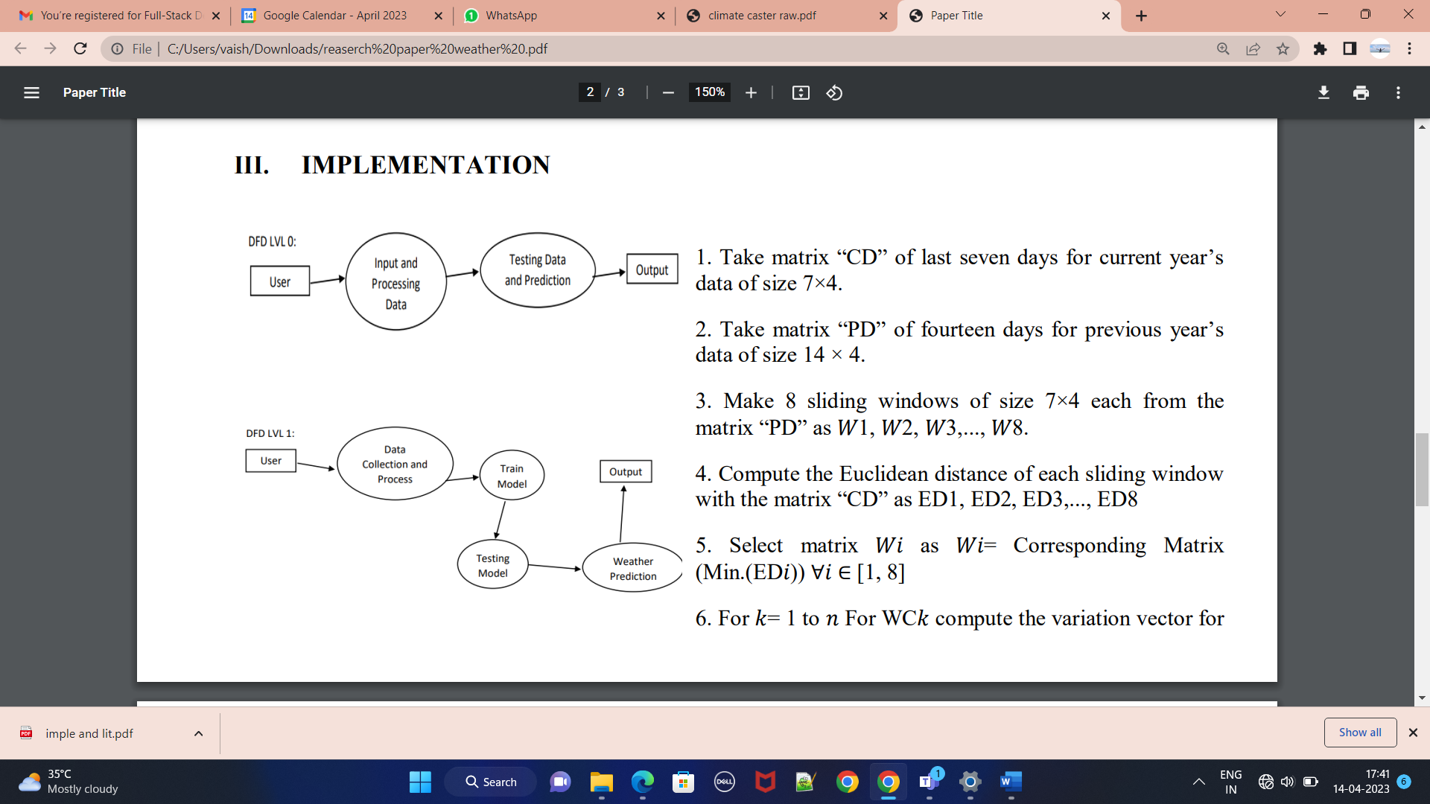
Algorithm:
1. Take matrix “CD” of last seven days for current year’s data of size 7×4.
2. Take matrix “PD” of fourteen days for previous year’s data of size 14 × 4.
3. Make 8 sliding windows of size 7×4 each from the matrix “PD” as 𝑊1, 𝑊2, 𝑊3,..., 𝑊8.
4. Compute the Euclidean distance of each sliding window with the matrix “CD” as ED1, ED2, ED3,..., ED8
5. Select matrix 𝑊𝑖 as 𝑊𝑖= Corresponding Matrix (Min.(ED𝑖)) ∀𝑖 ∈ [1, 8]
6. For 𝑘= 1 to 𝑛 For WC𝑘 compute the variation vector for the matrix “CD” of size 6×1 as “VC”. For WC𝑘 compute the variation vector for the matrix “PD” of size 6×1 as “VP”. Mean1 = Mean(VC) Mean2 =Mean(VP) Predicted Variation “𝑉”=(Mean1+Mean2)/2 Add “𝑉” to the previous day’s weather condition in consideration to get the predicted condition.
7. End

5. RESULT AND DISCUSSION

The future scope of weather forecasting apps is very promising. With advancements in technology and data analysis, weather forecasting apps can become even more accurate and personalized to individual users. The weather prediction application will be design in such a way that user will be able to know not only about the climatic changes of a particular day but also weather prediction and climatic changes of days.

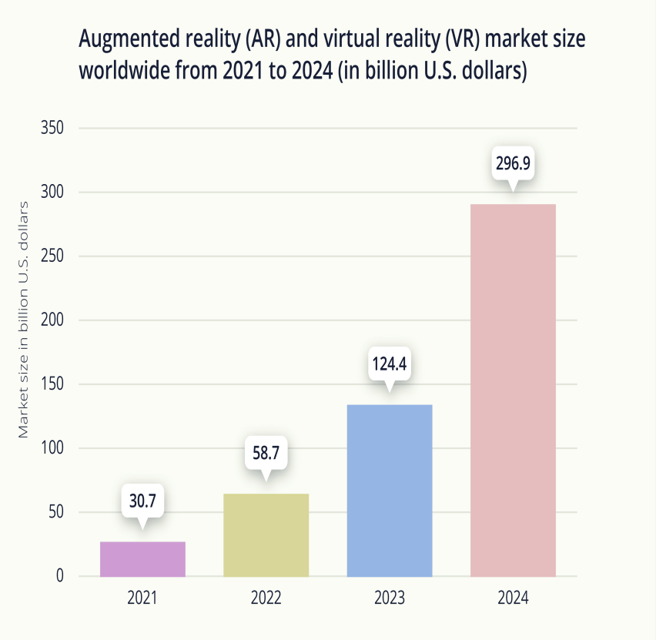
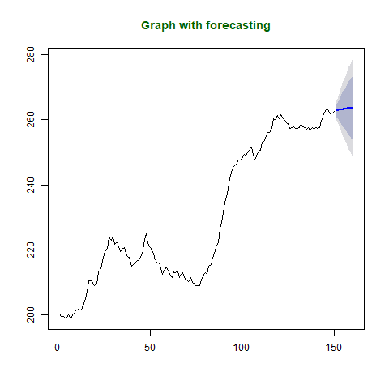

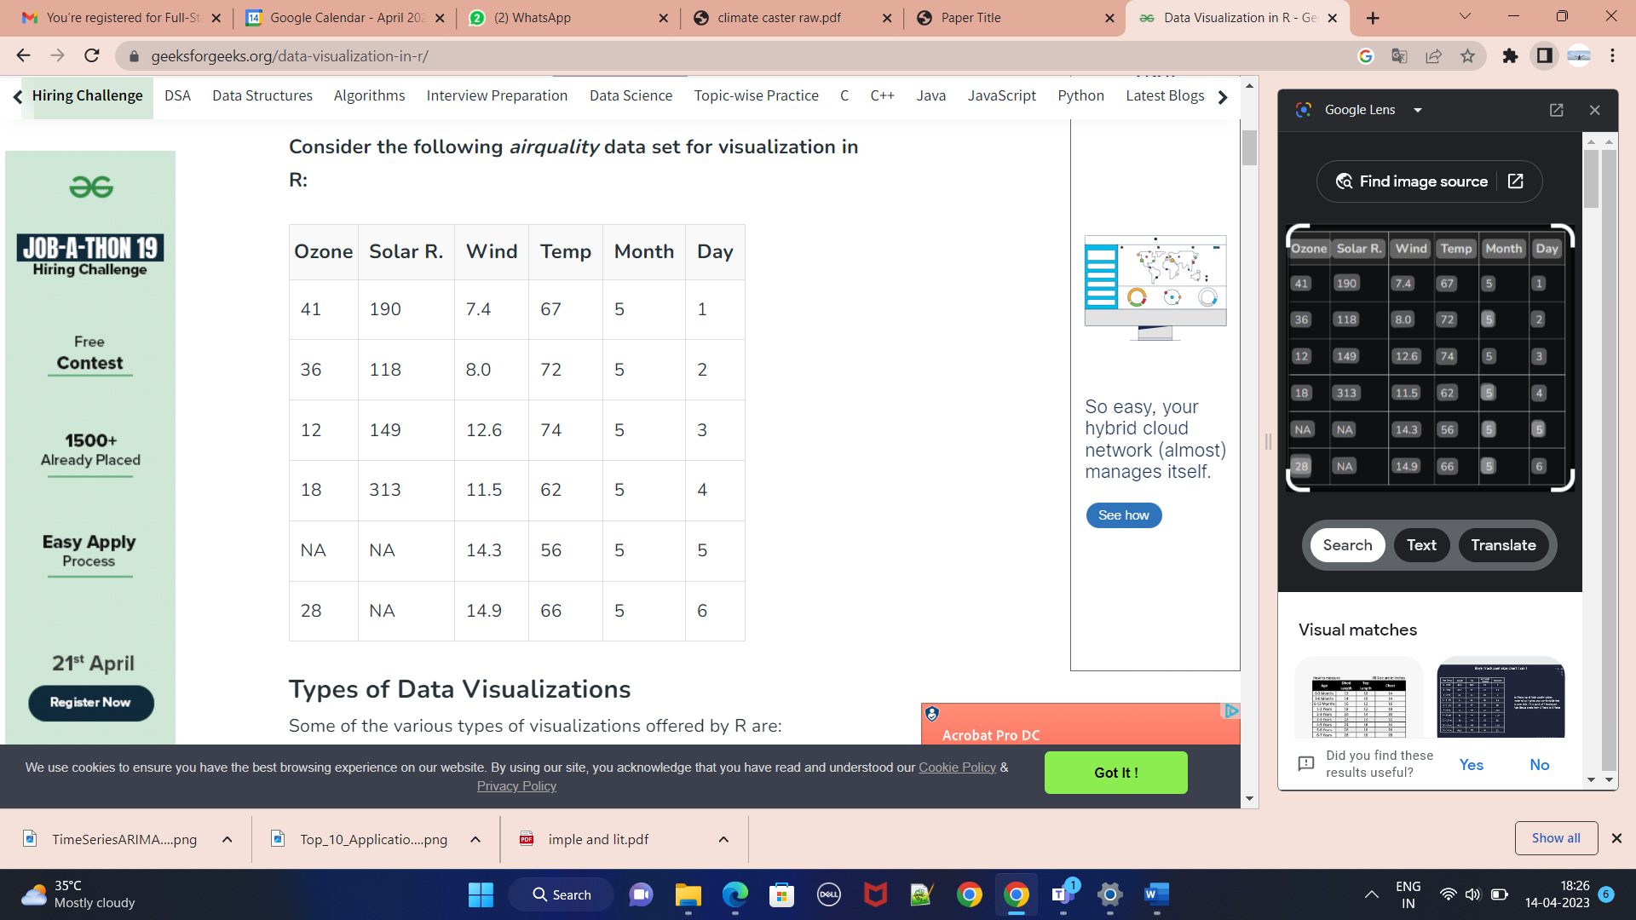

6.CONCLUSION

We expect that it will mature in next years and position itself among the fun- damental techniques of environmentally aimed scientific inquiries The model will be further improved by more and more training over different weather related data and improving the augmented reality visuals.
Weather forecasting is a complex and challenging science that depends on the efficient interplay of weather observation, data analysis by meteorologists and computers, and rapid communication systems. Meteorologists have achieved a very respectable level of skill for short range weather forecasting. Further improvement is expected with denser surface and upper air observational networks, more precise numerical models of the atmosphere, larger and faster computers and more are to be realized. However, continued international cooperation is essential, for the atmosphere is a continuous fluid that knows no political boundaries.

7. REFERENCES
1. K. Aberer, G. Alonso, G. Barrenetxea, J. Beutel, J. Bo- vay, H. Dubois-Ferri`ere, D. Kossmann, M. Parlange, L. Thiele, and M. Vetterli. Infrastructures for a Smart Earth - The Swiss NCCR-MICS initiative. Prax der In- formationsverarbeitung und Kommun, 30(1):20–25, 2007.

2. S. Baggi and J. Schweizer. First results on
characteristics of wet snow avalanche activity in a high alpine valley. Nat Hazards, 50(1):97–108, 2009.

- H. Beyer and K. Holtzblatt. Contextual design: defining customer-centered systems. Morgan Kaufmann, Burling- ton, 1998.
- R. Bogue. Environmental sensing: strategies, technolo- gies and applications. Sens Rev, 28(4):275–282, 2008.

- M. Burns, J. Klawe, S. Rusinkiewicz, A. Finkelstein, and

- Rasa architecture overview. (2021, February 11). Retrieved February 25, 2021, from https://rasa.com/docs/rasa/arch-overview/.

