Accident Detection and GPS Location to Carer
Logeshwaran M, Rajesh V, Anantha Kumar M, Bharath J
Department of Bio Medical Engineering
V.S.B Engineering College Karur-639 111.
Email Id: karthilalogesh@gmail.com

Abstract – With vehicles becoming increasingly affordable, there has been a surge in the number of vehicles on the roads on an average all over the world. The swift development of technology and infrastructure has made our lives easier nowadays. The initiation of technology has likewise increased the traffic hazards and road accidents take place regularly, which causes massive loss of life and property because of the poor emergency facilities. Accidents bring devastation upon victims, causing the loss of precious time and money. It has been established, after extensive research, that a majority of accidents become fatalities because of a lack of communication to the concerned medical authorities and the consequent lack of immediate medical support. An accelerometer can be used in this research as a rollover or crash detector of the vehicle during and after a crash. Likewise, the vibration sensor can be used in research in order to check the vibration rates of any car. By monitoring the information from the accelerometer and the vibration sensor, a severe accident can be recognized. It then sends the alert message through the GSM Module, including the latitude and longitude data provided by the GPS module, to the police control room, any rescue team, or to the car owners. So, the police can immediately trace the location where the accident has occurred and necessary action can be taken after receiving the emergency message. This system can prove to be a lifesaver in isolated areas where an accident has occurred and no one is around in order to report the accident. Through this system, an accident can be detected and a life can be saved by the quick response from the emergency services. In this research, I have reviewed many papers related to the accident detection system and its impact of application.

Keywords – Accelerometer, Acceleration sensor, Arduino Uno, GSM Module, Thermistor, and GPS Module.

- INTRODUCTION
Vehicles have great importance in our daily lives today. We utilize them to go to our workplaces, keep in touch with our friends and families, and deliver our goods. But it can likewise bring disaster to us and even kill us through accidents. Speed is one of the most important and basic risk factors in driving. It not only affects the severity of a crash but also increases the risk of being involved in a crash or accident. Despite the many efforts made by various non-governmental and governmental organizations all around the world through various programs to create awareness against careless driving, accidents are still taking place every now and then. However, many lives could have been saved if the emergency services could have gotten the crash data in time. This will aid in the detection and alert of the accident, potentially saving the lives of the injured. This system could be used to deal with accidents in remote areas where no one is available to report them. The usage of vehicles has increased linearly over the past era, which has increased the risk of human life. This is due to the inadequate emergency facilities. Consequently, in order to overcome this situation, we are using an alert system that aids in improving the emergency system of the accident system. The system detects the accident occurrence and the co-ordinates of the accident, i.e., the longitude and latitude of the location, are messaged to the rescue team. When there is an unexpected acceleration in the accelerometer and a severe change detected by the vibration sensor, the system will consider it an accident. Henceforth, it will alert the GSM and GPS modules, which will further detect the location and send a message indicating the accident with the location where it has occurred. This research aids in providing a feasible solution to the poor emergency it enables. The existing system mostly focuses on the safety of the passenger but not on the immediate help after an accident. The system implemented by us aims at automatically detecting an accident and alerting the nearest hospital or medical services about the exact location of the accident. Within seconds of an accident, this system sends basic information to the medical rescue team. This device can detect accidents and send an alert message to rescue teams in significantly less time, which will help in saving the lives of people. The alert message contains the geographical coordinates, time, and angle in which the accident has occurred. When an accident occurs, it is detected with the help of a sensor that activates the device. The sensor gives its output to the microcontroller. The microcontroller sends the alert. Nowadays unmanned aerial vehicle (UAV) is an attractive idea in the aeronautical field, which is used in almost all the fields. The ultra-light UAVs are meant to perform complex makeovers in the combat field as they give better performance compared to the others. Due to this fact, the usage of UAVs is getting more and more important in both the commercial fields and combat, with the capability to do tasks at a feasible cost. They can also be used in the tracking of accidents in vehicles.
- RELATED WORKS
In this system, the Arduino Uno is used as a microcontroller that controls the whole research. It also includes components like infrared sensors and LEDs. It uses two IR sensors placed on the side of the road. These sensors are mutually exclusive and are connected to microcontrollers (ATmega328P) through wires. Based on the output of sensors, the position of the vehicle is detected, which is provided as an input to the microcontroller. And then LEDs placed on either side warn the drivers, thus controlling the movement of vehicles at the bend. In this research, a vibration sensor is used to detect an accident with an Arduino as the microcontroller. It also includes components like the GSM module and GPS module. The vibration sensor and GPS module work together to give information to the Arduino, which in turn sends the information to the GSM module. It proposes to have Bluetooth or Wi-Fi networks in a set of clusters across the street to identify the user by a unique MAC address to identify drivers from their Smartphone application. When the vibration sensor detects the accident, the GPS module works in sync with it and provides the latitude and longitude details of the accident area. This information, when sent to the GSM module, is sent to other drivers connected to Wi-Fi in a 20meter radius. In this research, the Arduino Uno is the heart of the system, which aids in moving the message to different devices in the system. The vibration sensor will be activated when the accident occurs and the data will be transferred to the registered number through the GSM module. Using GPS, the location can be sent through a tracking system to cover the geographical coordinates of the area. An accident can be detected by a vibration sensor, which is used as a major module in the system. It can be extended by providing medication to the victims at the accident spot. By increasing technology, we can also avoid accidents by providing alert systems that can stop the vehicle to overcome accidents. The vibration sensor used in the research senses the obstacle, and then it sends an interruption to the Raspberry Pi. The GPS module receives the location of the vehicle that was in an accident and gives the data back. A WhatsApp message.

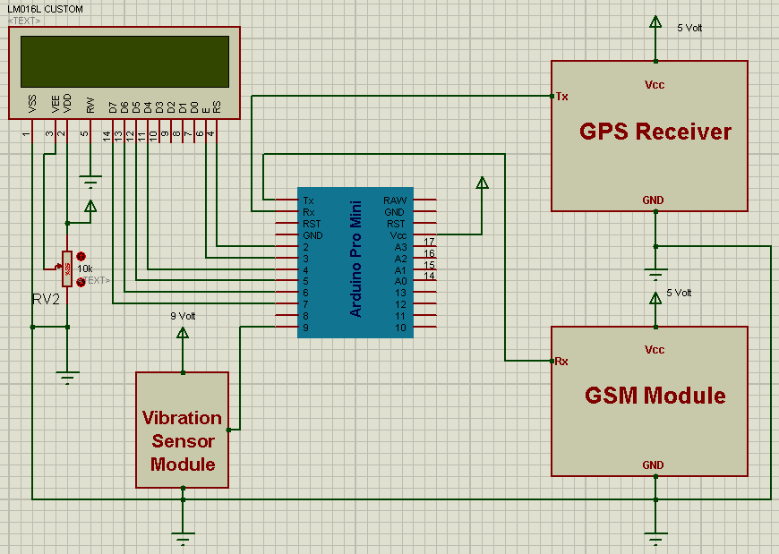
Aim’s to alert the nearby medical centre about the accident to provide immediate medical aid. The attached accelerometer in the vehicle senses the tilt of the vehicle, and the heartbeat sensor on the user’s body senses the abnormality of the heartbeat to understand the seriousness of the accident. Thus, the systems will make the decision and send the information to the smartphone, connected to the accelerometer and heartbeat sensor, through Bluetooth. The Android application on the mobile phone will send text messages to the nearest medical centre and friends. The application also shares the exact location of the accident, which can save time. This application helps sense the possible occurrence of an accident on the road with the help of sensors attached to the vehicle. This occurrence will be immediately communicated to the concerned people so that further action can be taken without any further delay. This paper proposes a real time accident detection and alerting system that uses smartphones. Every smartphone has a number of sensors embedded in its design. Our system makes use of a few of these commonly available sensors across all smartphones to build a web application for remote monitoring. The system will provide victims with a faster response time in locating and mobilizing emergency services. When the system detects an accident, it alerts the nearest emergency station like police administration, healthcare service, and ambulance operators of the same. It also provides real-time tracking for these emergency service providers. The proposed system will check whether an accident has occurred and notify the nearest medical centres and registered mobile numbers about the place of the accident using GSM and GPS modules. The location can be sent through a tracking system to cover the geographical coordinates over the area. An accident can be detected by a vibration sensor, which is used as a major module in the system. Our proposed system consists of two phases; the detection phase, which is used to detect car accidents with location; and the notification phase, which will notify the respondents or rescue team. We will also add a "HELP ME" button that will be used in an emergency situation other than an accident (like being stuck in bad circumstances or having an attack of medical disease etc.). In the case of using this button, a predefined message will be sent to the appropriate responder. In this research, an intelligent accident detection system has been developed to detect accidents on the road. Intelligent accident detection involves location tracking as well as notification systems that detect accidents immediately through GPS location. The sensor connected to the vehicle gets activated in the case of any accident. Phone calls and notification messages will be sent to the nearby hospital, police station, and family members through the Global System for Mobile Communication GSM. The research aims at finding the vehicle where it is and locating the vehicle using a computer within the vehicle's system to send a message. Most of the time, we might not be able to locate the accident because no one knows where it will take place. Our Real-Time Vehicle Tracking and Accident Detection project with GPS is designed to avoid these circumstances. A Vehicle Accident Emergency Alert system is proposed for immediate attention, which could save their lives. As soon as an accident occurs, the vibration sensor or the accelerometer present in the system transmits the signals to the Arduino controller. The GPS system collects latitude and longitude data, which is then transmitted to the emergency centre via the GSM module and sent as a text message to everyone on the emergency list. Getting the exact location would help the ambulance reach the spot with the shortest route and time. The proposed alert system could be implemented with less cost and incorporated into all vehicles in the near future so that the rate of life-loss could be minimized. The system consists of a microcontroller, GPS, and a group of sensors to determine different physical parameters related to vehicle motion. In addition, different types of machine learning classifiers were examined with the developed system to determine the most accurate classifier for the system. The classifiers are the Gaussian Mixture Model (GMM), Naive-Bayes Tree (NB), Decision Tree (DT), and Classification and Regression Trees (CART). The implementation of the system showed that GMM and CART models were better in terms of precision and recall. It was also shown that the severity of accidents depends mainly on the g-force value and fire occurrence.

- ACCIDENT DETECTION AND ALERTING SYSTEM BENEFITS
- They are cost-effective in implementation.
- They have a high tendency to assure safety.
- The victim's life can be saved quickly involved in the accident.
- It has low power consumption.
- It has better accuracy.
- There is efficient time consumption.
- It reduces the chance of human error.
IV. DISADVANTAGES OF ACCIDENT DETECTION AND ALERTING SYSTEM
- There is a possibility of false reporting of an accident at low speed.
- Damage to the sensor cannot be detected.
- In some places where there is no provision of GSM networks, it is difficult for communication. 4. The application does not have an offline mode.
5. The biggest problem is the blockage of signal transmission by mountains, high buildings, and tunnels.
V. COMPONENTS USED
- The Accelerometer (ADXL335)
This is a small, thin, low-power, complete 3-axis accelerometer with signal-conditioned voltage outputs. The product measures acceleration with a minimum full-scale range of 3 g. It can measure the static acceleration of gravity in tilt-sensing applications as well as dynamic acceleration resulting from motion, shock, or vibration.

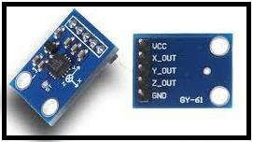
Fig. 1: Accelerometer (ADXL335)

- Acceleration Sensor
A acceleration sensor is a device that measures the amount and frequency of motion in a given system, machine, or piece of equipment. Those measurements can be used to detect imbalances or other issues in the assets and predict future breakdowns.

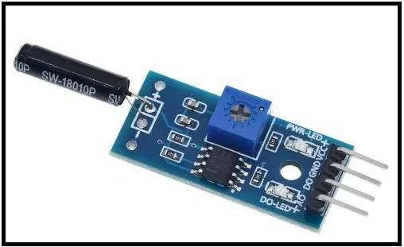
Fig. 2: Acceleration Sensor

- GPS Module
GPS modules contain tiny processors and antennas that directly receive data sent by satellites through dedicated RF frequencies. From there, it'll receive timestamps from each visible satellite, along with other pieces of data.

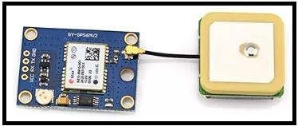
Fig. 3: GPS Module

- Thermistor
A thermistor is a resistance thermometer, or a resistor whose resistance is dependent on temperature. The term is a combination of "thermal" and "resistor". It is made of metallic oxides and pressed into a bead, disk, or cylindrical shape and then encapsulated with an impermeable material such as epoxy or glass.

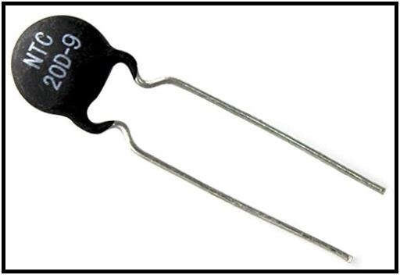
Fig. 4: Thermistor

5. GSM Module
A GSM modem or GSM module is a device that uses GSM mobile telephone technology to provide a wireless data link to a network. GSM modems are used in mobile telephones and other equipment that communicates with mobile telephone networks. SIM cards are used to identify their devices to the network.

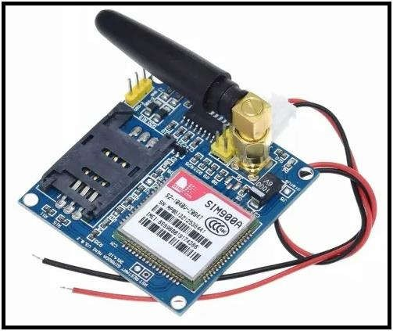
Fig. 5: GSM Module
6. Arduino Uno
ATmega328P it has 14 digital input/output pins (of which 6 can be used as PWM outputs), 6 analog inputs, a 16 MHz ceramic resonator
(CSTCE16M0V53-R0), a USB connection, a power jack, an ICSP header, and a reset button. It contains everything needed to support the microcontroller; simply connect it to a computer with a USB cable or power it with an AC-to-DC adapter or battery to get started. You can tinker with your Uno without worrying too much about doing something wrong. Worst case scenario, you can replace the chip for a few dollars and start over again.

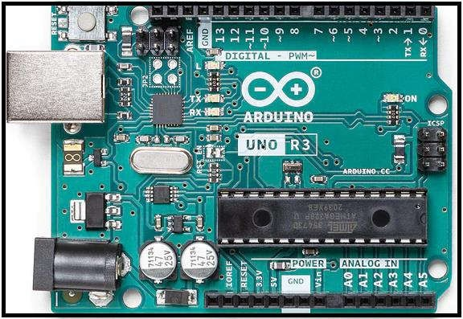
Fig. 6: Arduino Uno
CONCLUSION
The Vehicle Accident Alerting and Detecting System could be a safer system, saving approximately two-thirds of the lives lost in dangerous road accidents, particularly in remote areas with low human activity. The GPS tracker attached to the system gives information about the exact geographical location that could specify the latitude and longitude. The SMS alert is immediately sent to nearby hospitals, ambulances, and police stations, as well as the victim's family members. The ambulance could arrive at the accident spot immediately by using the location details and quick medical help could be provided to the victim involved in the accident. Thus, a simple way is achieved to reduce the frequency of accidents and immediate alert systems, a low-cost way to save high-cost lives. Also, the impact, challenges, and components used in the implementation are discussed in detail.

REFERENCES

- J. White, C. Thompson, H. Turner, B. Dougherty, and D. C. Schmidt, "Wreckwatch: Automatic traffic accident detection and notification with smartphones," Mobile Networks and Applications, vol. 16, no. 3, pp. 285-303, 2011.

- J. Zaldivar, C. T. Calafate, J. C. Cano, and P. Manzoni, "Providing accident detection in vehicular networks through OBD-II devices and Android-based smartphones," in 2011 IEEE 36th Conference on Local Computer Networks, 2011: IEEE, pp. 813-819.

- S. R. Sontakke and A. Gawande, "Crash Notification System for Portable Devices," INTERNATIONAL JOURNAL OF ADVANCE COMPUTER TECHNOLOGY, vol. 2, no. 3, pp. 33-38, 2013.

- H. M. Ali and Z. S. Alwan, "Car accident detection and notification system using smartphone". LAP LAMBERT Academic Publishing Saarbrucken, 2017.

- W. Linli, "Difference analysis of GPS data base sources based on vehicle location system," in 2011 3rd International Conference on Computer Research and Development, 2011, vol. 1: IEEE, pp. 421-425.

- J. A. Soni Kumari, M. Ghosh, and G. Ghosh, "Review of Automatic Speed Control of Vehicle using RFID Technology," International Journal of Advanced Research in Electronics and Communication Engineering (IJARECE) Volume, vol. 5.
- M. S. Amin, M. A. S. Bhuiyan, M. B. I. Reaz, and S. S. Nasir, "GPS and Map matching based vehicle accident detection system," in 2013 IEEE Student Conference on Research and Developement, 2013: IEEE, pp. 520-523.

- S. Tang and H. Gao, "Traffic-incident detection-algorithm based on nonparametric regression," IEEE Transactions on Intelligent Transportation Systems, vol. 6, no. 1, pp. 38-42, 2005.

- N. Virtanen, A. Schirokoff, and J. Luom, "Impacts of an automatic emergency call system on accident consequences," in Proceedings of the 18th ICTCT, Workshop Transport telemetric and safety. Finland, 2005, pp. 1-6.

