Government Fund Allocation and Tracking System over Blockchain

Aditi Kachi  Student,  Dept of Computer Engineering,  Rajgad Dnyanpeeth’s Shri Chhatrapati Shivajiraje College of Engineering, Bhor, India | Mrs. Bhakti Bhatti  Professor ,  Dept of Computer Engineering,  Rajgad Dnyanpeeth’s Shri Chhatrapati Shivajiraje College of Engineering, Bhor, India | Pooja Gaikwad  Student,  Dept of Computer Engineering,  Rajgad Dnyanpeeth’s Shri Chhatrapati Shivajiraje College of Engineering, Bhor, India
Abhinav Walhekar  Student,  Dept of Computer Engineering,  Rajgad Dnyanpeeth’s Shri Chhatrapati Shivajiraje College of Engineering, Bhor, India | Harshad Jadhav  Student,  Dept of Computer Engineering,  Rajgad Dnyanpeeth’s Shri Chhatrapati Shivajiraje College of Engineering, Bhor, India

Abstract : Now a days Governments need to handle huge amount of responsibilities. The working involves large number of transactions towards various operations that need to be carried out. This includes maintenance works, new projects, repair and awarding contracts. It is virtually impossible to track low-level corruption, which is major risk to the top government. In the current system tracking is very difficult. This problem can be overcome by creating a smart system that tracks and allocates government funds as they go throughout the government process. Here we make use of blockchain to secure the transaction at every stage, while maintaining transparency in each transaction sealing every transaction with proofs as the funds move ahead. Our goal in this paper is to create a system that allocates and tracks government funds at each stage of the process. Here we use blockchain technology to maintain the transparency and security throughout the process as the funds move ahead. By doing this, we are able to keep track of the records in the chain and process the data accordingly. In this system, encryption is used to secure transactional data, and hash values are used to maintain a chain of transactions. By using these blocks, the data can be saved in a transparent fashion while being verified and maintained. As a result, the system provides a secure and authentic fund allocation and fund tracking system that helps to form an incorruptible government procedure.
Keywords: Blockchain, Security, Transparency, Encryption, Government funds, Cryptography, Hashing
Introduction:
Blockchain is a technology which helps to create and maintain a secure, shared and distributed ledger for transaction using cryptography. Blockchain is a decentralized, distributed ledger of all the exchanges or occasions which takes put as it were after including different parties. This is acknowledged to be the public ledger for all transactions. Blockchain Technology has been acknowledged to be the public ledger for all transactions and resolved the double-spending hassle by way of combining peer to peer technology [7]. The value of the block can be tracked and traded on a blockchain network, reducing risk and cutting costs for all involved. Blockchain provides immediate, shared and completely transparent information stored on immutable ledger [8].
Fund Tracking:
Due to a transparent and public nature of the blockchain, we can use to disputes between participating parties and cause delays in processing. Changes should be approved and validated by all involved parties because each transaction is distributed, peer to peer. The process leads to a transaction performance and the time of completion is high. All transactions between source and destination are recorded there and maintained properly. The existing system lacks the proper maintenance of the records. Lack of proper planning, the problem of pricing, cost of capital, the problem of inventory holding are some common problems. In this paper will have brief study of papers which are related to fund tracking and online transactions. These papers considered have used blockchain in various fields from governance tendering to donation of a charitable trust.
Related Work:
[1] This paper involves two modules in which first module aims towards to allocate and track the public funds in a visualized manner. Then second module is the e-tendering framework which will be carried out at the department level.
[2] This paper offers the outline about a prototype which became evolved using Hyperledger composer. It then discusses the future improvement of this prototype and subsequently, concludes with the applicability of the blockchain.
[3] it's also referred as digital ledger, same because the ledger maintained via economic institutions for tracking of records. In similar fashion, blockchain is essentially digital ledger is maintained in a decentralized and allotted environment.
[4] A system has been proposed in this paper to track funds allocated to the government as they travel through each stage using key generation algorithm. Blockchain technology is used in this system to ensure transparency at all stages.
[5] In this paper, the blockchain technology solution was explained, which enables us to create a record of all transactions in which each transaction is preserved as a connected block. They made use of technologies, such as hashing, graph databases, platforms, etc., that enabled them to create a methodical technique for tracking all the records while placing the highest importance on security.
[6] In this paper, discussed a full proof, secure government fund allocation and tracking system, the allotted funds are tracked at each level until it reaches the destination. The proposed system is added to assist of the functions of blockchain like immutability, proof of work, and the security.
Proposed System:
Our proposed system will be used to allocate and track funds to the state government as they progress through the government process. To protect the transaction in this case at every level, we will employ blockchain technology. As the money is transferred, this maintains transparency in every transaction and secures each one with documentation. Using hashes, this technique secures the data in order to maintain a block of transactions in a blockchain. It enables a complete secure, proof and authentic financial allocation and tracking mechanism, that contributes to the formation of an incorruptible government. In our system there are two modules i.e., Admin (Government) module and user module.
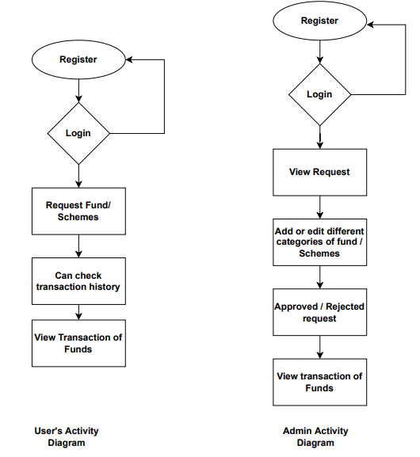
Fig : Activity Diagram
Admin (Government) Module: In this, we introduced login and registration of government which enables view the request of the funds. Admin can approve or rejects the fund request and then can provides the requested funds to the user. Government can add or edit different categories of funds. This also enables to view transactions of funds. User Module: In this module, we included login and registration of the user. For registration purpose we are going to use user’s Adhar ID (A unique ID). The user must be a citizen of India. So this will be checked using Adhar ID’s Database . Apart from this, user can request the fund or schemes. Also user can check previous transaction history and view transaction of funds.
Conclusion:

This proposed system is added to reduce the corruption and offers transparency in all transactions because of function of blockchain like immutability, security, proof of work. This offers the right governance and transparency. As the Blockchain Technology is used to transaction as soon as made cannot be modified or changed and if there is any try of tampering, we can get to recognize accordingly. Our system is used to help to reduce human errors. This will make the general public authority framework activity appreciably extra stable as well as productive.

References :
[1] K Bhole, K Bhatijia, T Saini, A Bhosale “Allocation and tracking of public funds using blockchain” 2021 International Conference on Nascent Technologies in Engineering (ICNTE 2021), Mumbai, India, doi:10.1109/ICNTE51185.2021.9487782
[2] A mohite and A. Acharya, “Blockchain for government fund tracking using Hyperledger”, International Conference on Computational Techniques, Electronics and Mechanical Systems (CTEMS), Belgaum, India, doi: 10.1109/CTEMS.2018.8769200
[3] A. Katore and S. Choubey, “Government scheme and funds tracker using blockchain”, International Journal of Engineering Research and Technology (IJERT) ISSN: 2278-0181, 05, May 2021, Pune, India
[4] S. Jambhulkar and V. Ratnaparkhi, “Government fund distribution and tracking system using blockchain technology” , Published Paper ID: JETIR2009190, September-2020, Pune, India.
[5] U. Ansari, S. Patodia, Z. Mirza, “Government fund’s allocation and tracking system using blockchain technology” , International Journal of Advanced Research in Computer and Communication Engineering, 3 March 2022, Mumbai, India.
[6] R. Gawde, A. Kale, S. Mane, A Koli, “Government fund allocation and tracking system using blockchain” , International Journal of Multidisciplinary Innovative Research, April 2022, PP 50-60, Noida, India.
[7] Lisa, April 2020, “History of Blockchain”,tokenizexchange.zandesk.com, 360047103973.
[8] What is blockchain technology? https://www.ibm.com/in-en/topics/what-is-blockchain.

