FLOOD DETECTION SYSTEM USING IOT
Ruturaj Patil, Pratham Singh, Prerna Polji, Rupali Salve, Prof. Sayali Karmode
‘Degree Student, Department of Information Technology, MGM’S College of Engineering and Technology, Navi Mumbai, Maharashtra, India
‘Assistant Professor, Department of Information Technology, MGM’S College of Engineering and Technology, Navi Mumbai, Maharashtra, India

- ABSTRACT:
Everyone and everything needs to be connected to the internet because we are living in the age of computing technology. IOT is a technology that moves us closer to this objective every day. Our research consists of a small-scale prototype for a smart flood detection and avoidance system called a smart water monitoring system. This essay describes how each of the parts of our project functions and how their processes flow. The users can view and receive this data via their mobile device after the sensors sense the surroundings and send real-time data to the cloud (Firebase cloud). After the water level reaches a certain height, the model issues a warning. The functioning of this model is good given that it is a small-scale prototype for a flood warning and avoidance system. Real-time updates to the mobile application are made possible by the precise uploading and updating of the data in the cloud. Using this approach, the number of casualties in a catastrophic flood can be significantly reduced.
Key words: Internet of Things, Arduino UNO module, Ultrasonic sensor.
- INTRODUCTION:
Over the past few decades, science and technology have undergone a number of dramatic developments. Our lives have

been revolutionised by the contemporary industrial period, which has also given us many comforts and conveniences. However, the cost of this economic growth in terms of global warming and other natural disasters like floods, earthquakes, etc.

Additionally, there is a tremendous loss of life and property as a result of such catastrophes. The imbalance and disruptions in the seasonal cycle of rain and flooding are directly related to rising carbon footprints and greenhouse gas emissions. As a result, we are now more at risk than ever from sudden and unexpected floods. Technology is a critical component in the prompt detection and avoidance of floods. We can foresee impending disasters and get ready for them with the aid of modern technological advances. Studies demonstrate how useful such an effort may be. Due to the emergency measures in place, loss of life and property damage in a recent US floods brought on by storms in the Midwest were kept to a minimum. However, North Korea struggled to deal with the displacement of over 300,000 people, approximately 221 fatalities, and a cost of $6 million, the majority of which was spent on feeding the homeless survivors. This was due in part to the lack of warning systems and information about the impending flooding at the local level. The flooding that occurred in the Indian states of Tamil Nadu and Kerala was similar. We can infer from the aforementioned illustrations that emerging and underdeveloped nations truly face severe challenges in implementing an efficient warning system. . There are no resource usage restrictions in a country like the US because of its robust economy. Given the countries' limited resources, warning people of an impending flood is consequently an expensive proposition. The existing approaches necessitate costly machinery and centralised, computationally challenging flood detection techniques. This presents an opportunity to solve the problem using the most recent developments in information and communication technology and sensor networks in a way that balances the need for high system and computation reliability with the need for minimal cost and computational power.
- NEEDS AND MOTIVATION:
Flash Floods happen every two to three years, particularly in Bangladesh's northeast.
"Haor" is regarded as a significant agricultural source in Bangladesh's northeast. It spends more than half the year submerged in water.
According to the Department of Agriculture Extension (DAE), more than 200,000 hectares of mature paddy were destroyed by water each time.
Therefore, there is a dire need for dedicated early flash flood detection systems.

- EXISTING SYSTEM:
In 2017, Swapnil Bande and Dr. Virendra V. Shete created a model that uses environmental parameters such as humidity, temperature, pressure, and rainfall from an array of sensors. The data generated from this model is compared using artificial neural network (ANN) techniques, and the results from different machine learning techniques are evaluated to obtain the best outcome. This model is advantageous because it uses the Levenberg Marquardt algorithm, which utilizes momentum learning and yields 88% accurate results. In 2019, Ni Komang Ega Kartika, Muhammad Ary Murti, and Casi Setianingsih created an android application that predicts outputs for the next three months using Radial Basis Function Neural Network and Antares, which uses a RESTful approach for developing an API. The application processes data through three steps: testing, training, and prediction, using datasets. In the same year, Jayashree S, Sarika S, Solai A L, and Soma Prathibha developed an alert application for floods using ZigBee technology. This application works even when the network is absent and enables the user to send SMS or make emergency calls to family members. It allows users to register, displays dam water levels and safe zone mapping, provides regular updates of the water level, and facilitates the user's movement to a safer place. In 2019, Arjun N, Prof. Nikhil Binoy C, Keerthi C, Sreerag S, and Ashwin H Nair developed a flood prediction model for water levels at two different locations, Dam and Canal, using Multilayer Perceptron as a neural network with Backpropagation and Tan-Sigmoid function for the network's activation function. The model yields 78% accuracy. In the Flood Alert system with Android Application, developed by Mohamad Nazrin Napiah, Ismail Ahmedy, Mohd Yamani Idna Idris, and Md Asri Ngadi, the system provides real-time warnings to the user regarding flood disasters and other related information. The user is notified with an alarm on their mobile phone when there is danger, and the system provides the user's location. Zigbee protocol facilitates free communication frequency, uses low power consumption, and saves hardware costs. However, the system has some limitations because the devices are built for peer-to-peer connectivity and not designed for mesh networking. Finally, Tibin Mathew Thekkil and Dr. N. Prabakaran developed a real-time wireless sensor network (WSN) based early flood detection and control monitoring system that allows remote monitoring to identify environmental threats before they occur. The mobile clients can examine the data, sight the condition of the monitoring area by browsing, mails, and short message service. The system is cost-effective, has user-friendly programming, and uses low power. Disadvantages: Climatic changes, Network connectivity.

- PROBLEM STATEMENT:
Town planning is an integral part of a country's development process since urbanization contributes to economic progress and modernity. However, a poorly designed and controlled urban development can lead to negative consequences such as traffic congestion, environmental pollution, and an increased risk of floods or flash floods. Efficient drainage management and proper techniques can help mitigate the risk of floods. The modernization process has led to the conversion of lowland areas by reclaiming land from hills and burying tributaries, which are factors that contribute to floods. When streams and valleys are used as channels and covered with soil, water flows from the hills to the lower areas and causes stagnation leading to floods. Flood victims do not typically blame the authorities for the occurrence of floods, especially during the monsoon season. However, the lack of early warning and information can aggravate the situation by increasing the likelihood of property and equipment destruction, particularly electrical equipment, which can become even more severe if the floods occur at night..
- PROPOSED SYSTEM:
The Smart IoT Flood Monitoring System is designed to notify people in the nearby areas about upcoming floods. The system begins by using an ultrasonic sensor to measure the water level in the river. The data collected from the sensor is then sent to a microcontroller and displayed on a web server. The data is also analyzed and compared to determine if the flood status is dangerous. As a user, one can wirelessly control the stepper motor and buzzer. The LCD and web server display the water level status and the LED indicates the water level. If the water level reaches the highest threshold value, the stepper motor will be activated to allow the excess flood to pass through, and the alarm will be triggered to alert the public. This will enable people to be well-prepared for evacuation before the flood occurs.
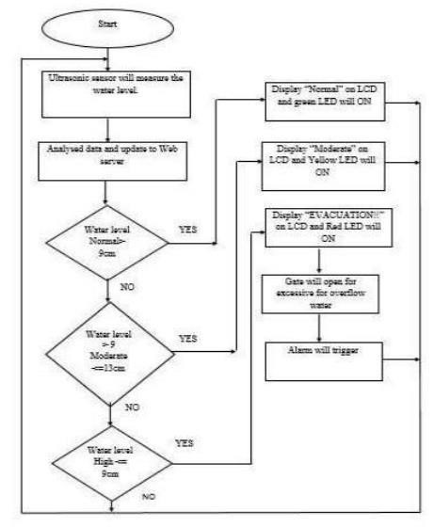

- ARCHITECTURE:
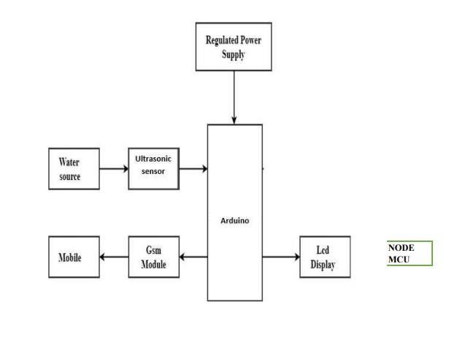
Fig. Architecture of Flood Detection using IoT

WORKING: The block diagram presented in the passage shows the components and their connections in a project designed to monitor water levels and control a dam's doors. The project starts with a 230V 50Hz AC supply voltage that is stepped down by a transformer to 9V. The output of the transformer is rectified and filtered to obtain a regulated output of 5V using an IC 7806. The 5V output is fed into an Arduino board along with an ultrasonic sensor that measures the water level and sends ultrasonic waves at a time interval of 10ms. The Arduino board is programmed to analyze the signal transmitted by the ultrasonic sensor and display the data on an LCD display and NodeMCU module connected to the board.
The GSM module is used to connect the circuit to the internet and cloud services, and data from all relevant sensors will be logged. If the sensor values exceed critical limits, the data will be updated on the cloud, and the user will be alerted through push notifications on the Android app. The doors of the dam will be opened by the servo motor to release water if necessary. If the values are within safe limits, the data will only be updated on the cloud, and the information will be displayed on the LCD display and Android app interface.
- CIRCUIT DIAGRAM:
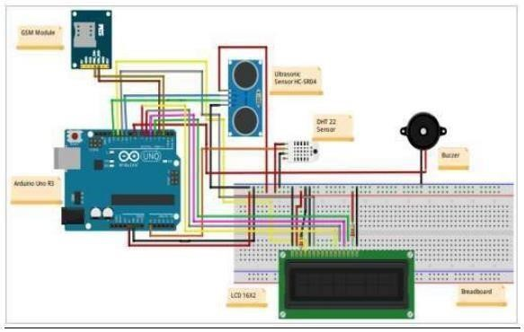
- RESULT:
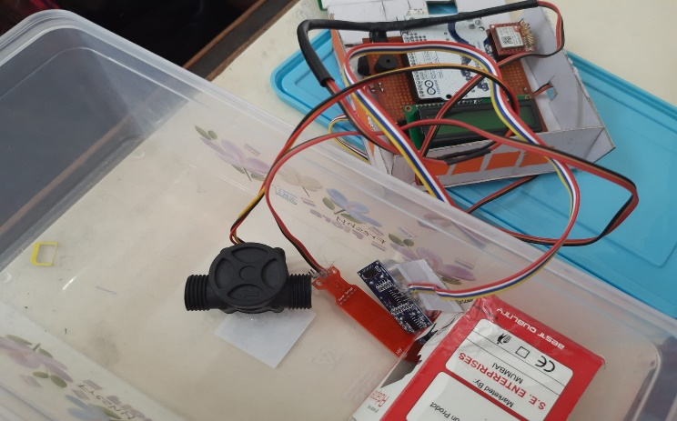
These are good directions for future work on the floodwater detection system. Here are some additional suggestions:
- Integration with weather forecasting data to provide early warning before floods occur
- Adding a real-time communication feature that allows users to receive flood alerts and updates via SMS or social media
- Incorporating machine learning algorithms to enhance flood prediction accuracy
- Developing a mobile application for users to access flood information and alerts
- Improving the durability and reliability of the system's hardware to withstand harsh weather conditions
- Exploring the use of satellite imagery to monitor flood-prone areas and enhance flood prediction capabilities.

- Hardware requirements
  - GSM Module
  - Arduino uno
  - Breadboard- 400 tie points
  - Buzzer
  - 16×2 LCD Display
  - HC-SR04 Ultrasonic Sensor
  - WaterFlow sensor
  - Water level sensor
  - Water Moisture Sensor
  - Some Jumper Wires,
  - 9v Battery and Snap Connector
  - USB Cable Type B & Laptop.

- Software requirements
  - Windows/Linux OS
  - Arduino IDE
  - Python 3.7 IDLE
  - Bolt IoT Cloud
  - Bolt IoT Android App
  - Twillo SMS Messaging API
  - Mailgun EMAIL
Messaging

- CONCLUSION:
Flood incidents are very hard to manage during heavy rainfalls and affect people living close to flood-prone areas. This study aims to contribute to disaster risk reduction by alleviating the effects of floods on society. This can be achieved by detecting floods and alerting the community in flood-prone areas. The developed system proved that the information on flood status can be provided within 15 seconds. The results from the system’s functionality showed that the effects of flood incidents can be mitigated through an early warning system that is user-friendly and does not require complex maintenance. Flood incidents can occur in different water bodies and other floodprone areas. Thus, a deep understanding of flood management is required. This system will display the data of the water level measured on lcd display. This project can be very helpful to the Meteorological Department to continuously monitor the dams and river beds water level. With this project it can save many people lives by giving alerts.
REFERENCES:
Journal Papers:
- Pierce, J., & Paulos, E.
(2012).Beyond Energy
Monitors: Interaction, Energy, and Emerging Energy
Systems, 665–674.
- Erickson, T., Li, M., Kim, Y., Deshpande, A., Sahu, S., Chao, T., Naphade, M. (2013).

- The dubuque electricity portal. Proceedings of the SIGCHI Conference on Human Factors in Computing
Systems - CHI '13.
doi:10.1145/2470654.2466155
Lobaccaro, G., Carlucci, S., & Löfström, E. (2016). A Review of Systems and Technologies for Smart Homes and Smart Grids. Energies, 9(5),
348. doi:10.3390/en9050348

- Oliveira,C.C.,Oliveira,D.C.,& Gonçalves,J.C. (2016). Pratical
Introduction to Internet of Things : Practice using Arduino and Node .js,
17–18.

- Hall, J. S., Fromme, P., & Michaels,J.E. (2013).Guided Wave
Damage Characterization via Minimum Variance Imaging with a Distributed Array of Ultrasonic Sensors. Journal of
Nondestructive Evaluation,33(3),299-
308. doi:10.1007/s10921-013-0212-x
Cannon, 4(9), 1630-1637.
- Kuantama,E.,Setyawan,L.,&Darm a,J.(2016).Early Flood Alerts Using Short Message Service (SMS),
(September).https://doi.org/10.1109/ ICSEngT.2012.6339359.
- Azlina, N., Aziz, A., &Aziz, K.A. (2011).Managing Disaster with Wireless Sensor Networks,
(December 2008), 202–207.
- Parade, D., Group, B., & Dublin, C. (2015). LowPower Wireless Liquid Monitoring System Using Ultrasonic Sensors, 8(1), 26–44.
- Turk,D.,France,R.,&Rumpe,B.(20 02).Limitations of agile software processes. Third International
Conference on eXtreme
Programming and Agile Processes in Software Engineering
(XP2002),4.https://doi.org/10.1.1.7. 19

[11] Sayali Karmode Yelpale. (2022). IOT Technology for Pandemic Situation. NOLEGEIN- Journal of Information Technology &Amp; Management, 4(2), 25–27. Retrieved from https://mbajournals.in/index.php/JoITM/article/view/806

[12] Sayali Karmode, Security Challenges for IoT Based Applications & Solutions Using Fog Computing: A Survey, Journal of Cybersecurity and Information Management, Vol. 3 , No. 1 , (2020) : 21-28 (Doi : https://doi.org/10.54216/JCIM.030103

