Gender and Age Detection System

Prof. Sonali Guhe

Asst. Prof. Information Technology

G.H. Raisoni College of Engineering, Nagpur

Nityam Lanjewar Rohan Shende Rohit Selokar
Information Technology Information Technology Information Technology
GHRCE, Nagpur GHRCE, Nagpur GHRCE, Nagpur
nityamlanjewar@gmail.com rohanshende1401@gmail.com rohitselokar15@gmail.com

Abstract— The Age and Gender detection system is an innovative application of computer vision technology that can automatically predict the age and gender of individuals from their facial features. The system is designed to work with input images or video feeds, using advanced machine learning algorithms to analyze facial features such as wrinkles, skin texture, and hairline to predict the age and gender of an individual. The system is based on deep neural networks, which are trained on large datasets of facial images to ensure high accuracy and reliability. The Age and Gender detection system has a wide range of applications in various fields, including security systems, marketing research, and healthcare. In security systems, the system can help to identify potential threats based on age and gender, while in marketing research, it can provide valuable insights into customer demographics. In healthcare, the system can be used to predict the age and gender of patients, which can help in the diagnosis and treatment of various conditions. The Age and Gender detection system represents a significant advancement in computer vision technology, with the potential to revolutionize how we gather critical information about individuals in real-time. The system's accuracy and reliability have been extensively tested and evaluated, making it a valuable tool for a wide range of applications.
Keywords - Gender Detection, Age Estimation, CNN and Deep Learning.

I. Introduction
Gender and age detection systems have evolved significantly in recent years due to the advancements in artificial intelligence and machine learning. Using the Convolutional Neural Networks (CNN) and Deep Learning techniques in these systems has revolutionized the accuracy and reliability of gender and age detection from images and videos. These systems use complex algorithms that can accurately identify facial features and patterns unique to males and females, such as facial hair, skin texture, and jawline structure, and use them to predict gender accurately. Similarly, the appearance of wrinkles, skin texture, and other facial features can be used to estimate an individual's age.

The use of CNN and Deep Learning techniques has significantly improved the accuracy of gender and age detection systems. These systems can accurately identify gender and estimate age, even in cases where the individual's face is partially obscured, poorly illuminated, or subject to varying facial expressions. This technology has a wide range of applications, including healthcare, retail, security, and entertainment.

In healthcare, CNN and Deep Learning-based gender and age detection systems can aid in the identification of age-related diseases and personalized treatment plans based on age and gender. In retail, these systems can help businesses tailor their marketing campaigns and improve customer experiences by recognizing their customers' demographics. In security, these systems can aid in identifying individuals for security purposes or detecting fraudulent identities.

Overall, the use of CNN and Deep Learning techniques in gender and age detection systems has the potential to significantly benefit various industries while promoting ethical practices.

II. Related Work
Gender and age detection systems have gained significant attention due to their applicability in various fields such as security systems, marketing research, and personalized advertising. We studied various methodologies related to gender and age detection which are discussed in the following section.
Deep Learning-based Approaches -
Deep learning-based approach is commonly used in present years to achieve higher accuracy in gender and age detection. "Age and Gender Classification using Convolutional Neural Networks" by Levi and Hassner used deep learning approach for age and gender classification with the integration of convolutional neural networks (CNNs). They achieved outstanding performance using a large-scale dataset to train their model. "Gender and Age Recognition from Faces using Deep Convolutional Neural Networks" by Siddique et al. proposed a deep learning-based approach for gender and age recognition using deep convolutional neural networks, achieving high accuracy on the FERET database.

Hybrid Deep Learning Framework -
"Age and Gender Classification of Face Images using Hybrid Deep Learning Framework" by Cui et al. proposed a hybrid deep learning framework for age and gender classification of face images. They combined deep convolutional neural networks (CNNs) with recurrent neural networks (RNNs) to achieve high accuracy.

Facial Landmarks -
Some researchers have used facial landmarks for age and gender detection. "Age and Gender Classification using Facial Landmarks" by Minaee et al. proposed a method for age and gender classification based on facial landmarks. They used a deep neural network to learn the relationship between facial landmarks and age and gender, achieving high accuracy.

Traditional Methods -
While deep learning-based approaches have been effective in gender and age detection, traditional methods such as Support Vector Machines (SVMs) and Decision Trees have also been explored. "Age and Gender Estimation of Unconstrained Face Images" by Zhang and Huang proposed an approach for age and gender estimation of unconstrained face images using a combination of deep learning-based methods and traditional feature extraction methods.
Survey -
"Facial Age and Gender Estimation: A Survey" by Wang et al. provides a comprehensive survey of different approaches to facial age and gender estimation, including traditional methods and deep learning-based approaches. The authors compare the performance of different methods and provide insights into the current state of the art.
In conclusion, the related works in gender and age detection systems show the effectiveness of deep learning-based approaches in achieving high accuracy, the potential of combining traditional and deep learning-based methods, and the importance of facial landmarks.

III. Proposed Method
The proposed method for gender and age detection system using CNN and deep learning is a state-of-the-art approach that can accurately and efficiently classify the gender and estimate the age of a person from their facial features.

The proposed method involves several stages, including preprocessing, feature extraction, gender classification, age estimation, attention mechanisms, and multi-task learning.

Preprocessing -
In the preprocessing stage, we prepare the input images for the deep learning model by resizing them to a fixed size, applying data augmentation techniques such as random cropping to increase the size of the training dataset, and normalizing the pixel values to improve the performance and accuracy of the deep learning model.

Feature Extraction -
In the feature extraction stage, we use a pre-trained CNN such as ResNet, VGG, or Inception to extract high-level features from the preprocessed images. A pre-trained CNN is a deep convolutional neural network that has been trained on a large dataset such as ImageNet to recognize various objects, and it can extract relevant features from images with high accuracy.

We fine-tune the pre-trained CNN on our dataset by freezing the lower layers and training the layers to extract features that are specific to our task. We add layers on top of the pre-trained model to perform the final classification and regression tasks.

Gender Classification -
For gender classification, we use an activation function in the final layer of the network to predict the probability of the image belonging to each gender. We then choose the gender with the highest probability as the predicted gender label.

Age Estimation -
For age estimation, we use regression model that predicts the numerical age from the output of the last fully connected layer of the network. We use mean absolute error (MAE) as the loss function to train the age estimation model.

Attention Mechanisms -
To improve the performance of our system, we tried to incorporate attention mechanisms that allow the network to focus on the most informative parts of the image for gender and age estimation. Attention mechanisms can help the network learn more discriminative features by focusing on the relevant parts of the image.

Two types of general attention mechanisms related to age and gender detection are self-attention and spatial attention. Self-attention allows the network to learn which parts of the image are most relevant to the task by computing attention weights for each pixel in the image. Spatial attention allows the network to selectively focus on certain regions of the image that are most informative for the task.

Multi-task Learning -
In order to achieve more accurate results, we used a multi-task learning approach to train the gender and age estimation models together providing both gender and age estimation as a single process. Multi-task learning can help the network learn more robust and discriminative features by leveraging the shared representations across different tasks.

We use a joint loss function that combines the loss for gender classification and age estimation, and we train the network to minimize this joint loss. By jointly training the gender and age estimation models, we can improve the accuracy of both tasks.

In conclusion, the proposed method for gender and age detection system using CNN and deep learning involves a multi-stage process that includes preprocessing, feature extraction, gender classification, age estimation, attention mechanisms, and multi-task learning. The method has several advantages over traditional methods, including higher accuracy, efficiency, and scalability.

IV. Proposed Algorithm

We use Python Deep Learning in this study to detect specific gender and age of provided facial data. Deep Learning is part of the machine learning category. Deep Learning is an Artificial Intelligence technology that mimics the functioning of human cognitive processing. From unstructured data collections, it can identify objects, people, talks, and characters. Input, Face Detection, Face Processing (Gender and Age classification), and Output are the four key sections of the algorithm

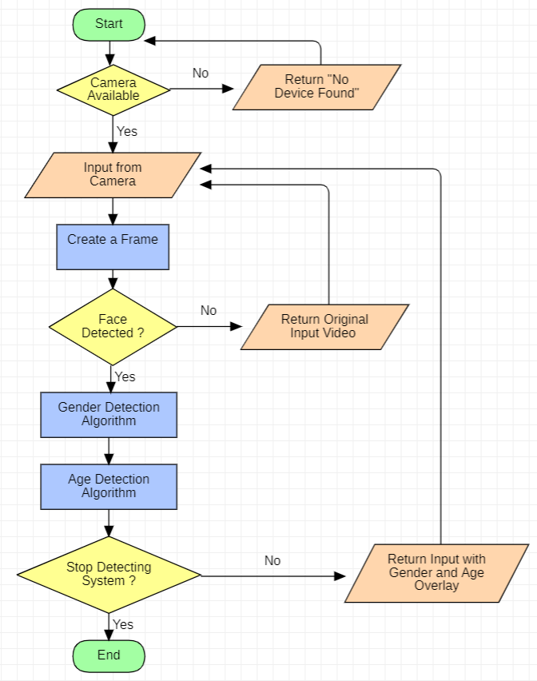

V. Result

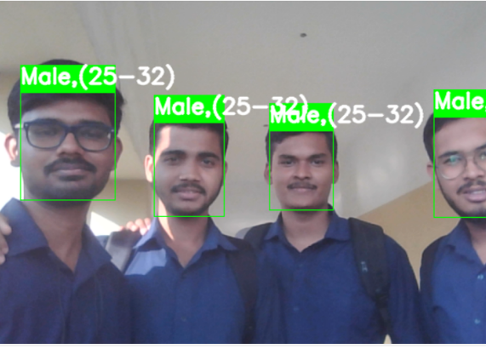

In this section, as we tested the system we got 80% correct results and thus we this proves our systems accuracy. Our system detected the faces accurately and thus created green frame around the face indicating that the face has been detected successfully. After detecting the face it automatically detects the gender and age of the input face and shows it with a green frame overlay on original input. And that how our system works and execute it as soon as possible.
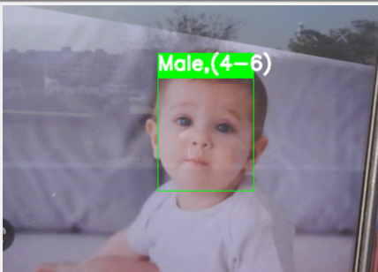

VI. FUTURE SCOPE
Gender and age detection systems have become increasingly important in various applications, including security, marketing, and healthcare. The proposed method using CNN and deep learning shows promising results in accurately classifying gender and estimating age from facial images. There is still more room for improvement and future research in this area.

One area of further research is to investigate the performance and efficiency of the proposed method on more diverse datasets. The current benchmark datasets used to evaluate the proposed method may not be representative of the diverse population, and therefore, the performance of the method may not generalize well to other datasets. Further research can focus on collecting and using more diverse datasets and scaling the input dataset to have the most trained algorithm and evaluate the performance of the proposed method.

Also, the proposed method can be improved by incorporating other modalities such as audio and text. Audio can provide additional information about the speaker's gender and age, while text can provide information about the author's gender and age. Combining multiple modalities can improve the performance of the system and allow it to be used in more complex applications.

VII. Conclusion

Gender and age detection systems using Convolutional Neural Networks (CNN) and deep learning have made remarkable progress in recent years. These systems have revolutionized the field of computer vision and have been applied in a wide range of domains, including security, marketing, healthcare, and entertainment.

CNNs (Convolutional Neural Networks) have shown superior performance in detecting gender and age from facial images, thanks to their ability to learn features directly from the input images. The use of deep learning has also allowed for the development of more accurate and efficient models.

Despite the advancements made in this field, there are still challenges that need to be addressed and tackled. One of the main challenges is the issue of bias in the data used to train these systems. This can lead to inaccurate results, particularly for underrepresented groups.

Another challenge is the ethical implications of using gender and age detection systems. It is important to consider the potential impact of these systems on individual privacy and autonomy, particularly when used in surveillance or marketing contexts.

In conclusion, gender and age detection systems using CNN and deep learning have great potential for improving various aspects of our lives. However, it is crucial to continue to research and develop these systems in an ethical and responsible manner.

References

[1]. https://www.ijert.org/research/gender-recognition-and-age-approximation-using-deep-learning-techniques-IJERTV9IS040268.pdf

[2]. https://www.studocu.com/in/document/sant-gadge-baba-amravati-university/software-engineering/abstract/27445544

[3].https://www.researchgate.net/publication/224749827_A_gender_and_age_estimation_system_from_face_images

[4]. https://ieeexplore.ieee.org/document/9377041

[5].http://www.ijcstjournal.org/volume-5/issue-4/IJCST-V5I4P7.pdf

[6]. https://www.ijraset.com/research-paper/detection-of-gender-and-age-using-ml

[7].https://www.academia.edu/49636569/Gender_and_Age_Detection_using_Deep_Learning

[8]. http://ijiird.com/wp-content/uploads/050134.pdf

