Medical Report Management And Distributed System Using
Blockchain
Lokesh Dalvi, Suraj Kadukar, Ketan Parab , Yash Satelkar
Lokesh Dalvi Computer Engineering & SSPM
Suraj Kadukar Computer Engineering & SSPM
Ketan Parab Computer Engineering & SSPM
Yash Satelkar Computer Engineering & SSPM

---------------------------------------------------------------------***---------------------------------------------------------------------
Abstract - The management and distribution of medical reports has become increasingly complex due to the integration of various hospital services, such as pathology and pharmacy management. This complexity has made it challenging to keep track of every transaction, leading to concerns about the authenticity and security of medical reports. To address this issue, we propose a blockchain-based system that ensures the integrity and security of medical reports. Our system leverages the hyper ledger concept to store all associated medical documents and transactions, ensuring that all reports are verified and cannot be tampered with. This approach allows for 100% authenticity of each report and prevents unauthorized modifications. Our system uses the Ethereum platform and is implemented using Solidity programming. This system has the potential to revolutionize the way medical reports are managed and distributed, providing an efficient and secure way to manage patient information.

Key Words: Medical Report Management, Blockchain Technology, Hyper Ledger, Ethereum platform

1.INTRODUCTION

In recent years, hospitals have expanded their business by incorporating various services like pathology and pharmacy management in their operations. However, this has led to an increase in operational complexity, making it difficult to manage and track every transaction. The traditional system of managing medical reports using a centralized server has also become outdated and prone to errors and manipulation. To address these challenges, blockchain technology has emerged as a potential solution to keep track of every single transaction with 100% authenticity. Blockchain technology enables secure, encrypted storage of data in the form of blocks, thereby eliminating the need for a centralized server. In this paper, we propose a Medical Report Management and Distribution System using blockchain technology. The system stores all associated medical documents and transactions with a date stamp, ensuring authenticity and traceability. The use of blockchain technology for medical report management can improve the efficiency, accuracy, and security of the system, ultimately leading to better patient care.

2. Body of Paper
The healthcare industry is becoming increasingly complex and hospitals are struggling to keep up with the growing amount of medical data that needs to be managed. With the inclusion of pathology, pharmacy and other test labs, the operational complexity has increased significantly. This has led to difficulties in managing patient admissions, management, and hospital expense management. To address this issue, we propose the use of blockchain technology to keep track of every single transaction with 100 percent authenticity through the hyper ledger concept.

The blockchain is a distributed ledger technology that enables secure and transparent transactions between parties without the need for intermediaries. It is based on a peer-to-peer network that is maintained by a group of users. Each transaction on the blockchain is stored as a block and is secured by encryption. The hyper ledger concept is used to store all the associated medical documents associated with each transaction with the date stamp.

By using blockchain technology, we can ensure the authenticity of each medical report. Each report is stored on the blockchain with a unique identifier that can be used to verify its authenticity. In addition, any changes made to the report will be detected and recorded on the blockchain, making it easy to identify any tampering.

We have implemented the blockchain using Solidity on the Ethereum platform. Our system allows hospitals to manage their medical reports more efficiently and securely. With our system, hospitals can manage patient admissions, management, and hospital expense management with ease. Our system also enables the easy and secure sharing of medical reports between hospitals, doctors, and patients.

In conclusion, the use of blockchain technology in medical report management and distribution systems can improve the efficiency and security of healthcare operations. By providing a secure and transparent system for managing medical reports, we can ensure the highest levels of authenticity and accuracy in patient care.

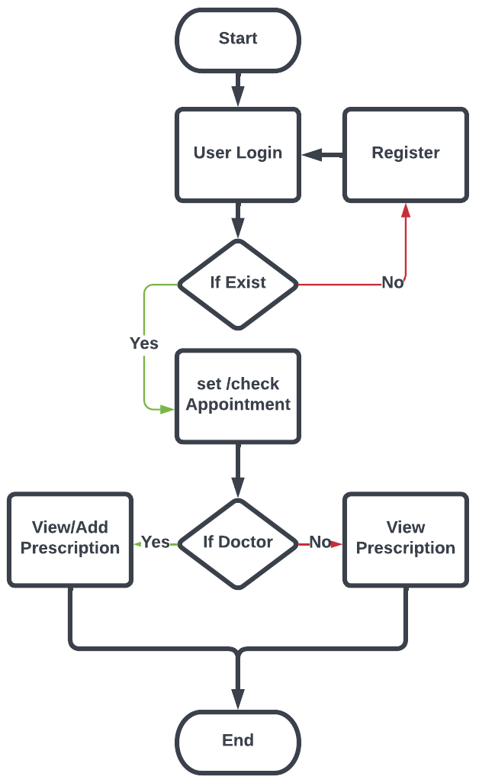
Fig -1: Flow of System

3. CONCLUSIONS

We bring this project forward using blockchain to reduce the gap between existing systems and real-life implementation. There are several applications for this project. It will improve the security of the patient’s data through EMR. Also, it will improve the interoperability between all the hospital departments. It will remove the intermediaries among hospital that increases the complexity of the whole hospital system and also leaves some loopholes in the system which if exploited can disrupt the basic principles upon which the system is based. So removing these intermediaries can secure the core functionalities of the whole hospital ecosystem. The inclusion of blockchain technology in the construction of the project as a core component of design makes it even more robust and uncompromising in terms of securing the patient’s data and preventing it from getting tampered with by unknown/unauthorized persons.

ACKNOWLEDGEMENT

We sincerely acknowledged with deep sense of gratitude to Prof. S. M. Melsagare and the project coordinator, Dr. N. M. Shivsharan for their valuable guidance, genuine suggestion and constant encouragement during preparation of project synopsis work without which completion of this task would be a difficult task. We are also thankful to all of our faculty members of Computer Engineering Department especially our head of the department Prof. D. P. Mhapasekar and our respected principal Dr. A. C. Ganagal who give us idea of significant cooperation during completion of this work. We are immensely grateful to all who involved in this project work because without their cooperation, inspiration, constant promoting and useful suggestion it would be impossible to complete this task and synopsis report within this allotted time..

REFERENCES

1] A. Azaria, A. Ekblaw, T. Vieira, and A. Lippman. Medrec: Using
blockchain for medical data access and permission management. In 2016 2nd International Conference on Open and Big Data (OBD), pages,25–30,2016.
[2] P. Dr. Chun Chen. Blockchain: Research and applications.
https://www.journals.elsevier.com/blockchain-research-and-applications, May 2019.
[3] A. Haddad, M. H. Habaebi, M. R. Islam, and S. A. Zabidi. Blockchain for healthcare medical records management system with sharing control. In 2021 IEEE 7th International Conference on Smart Instrumentation, Measurement and Applications (ICSIMA), pages 30–34, 2021.
[4] S. Khezr, M. Moniruzzaman, A. Yassine, and R. Benlamri. Blockchain technology in healthcare: A comprehensive review and directions for future research. Applied Sciences, 9:1736, 04 2019.
[5] P. Lakshman, D. Kumar, N. Ramesh, and K. Pranathi. Medical records management using cloud technology. In 2021 Second International Conference on Electronics and Sustainable Communication Systems (ICESC), pages 1005–1009, 2021.
[6] B. Natarajan, A. V, and K. Balaji. Medical data management using blockchain. Journal of ISMAC, 2:222–231, 12 2020.
[7] M. N. Thippeswamy, B. M. Sai Kiran, P. R. Tanksali, M. Hegde, and P. R. Naik. Block chain based medical reports monitoring system. In 2020 Fourth International Conference on I-SMAC (IoT in Social, Mobile, Analytics and Cloud) (I-SMAC), pages 222–227, 2020.

[8] H. L. Wang, S.-I. Chu, J.-H. Yan, Y.-J. Huang, I.-Y. Fang, S. Y. Pan, W.-C. Lin, C.-T. Hsu, C.-L. Hung, T.-C. Lin, and T.-T. Shen. Blockchain-based medical record management with biofeedback information. In E. D.-Y. Liao, editor, Smart Biofeedback, chapter 6. IntechOpen, Rijeka, 202

