IMPROVEMENT OF ROAD SAFETY SYSTEM

P.Sasireka¹, Magesh kumar. N², Sankaran. B ³, Rithiesh. C⁴
Assistant Professor¹, UG Students^{2,3,4}
Department of ECE, S.A. Engineering College, Thiruverkadu, Chennai, Tamil Nadu, India

Abstract: Road accidents continues to be a major issue in India and it ranks first in the number of road accidents deaths across 199 countries. It is important to monitor the driver health condition before driving. We propose a model that can monitor the Driver health condition while driving. “Improvement Of Road Safety System” is designed to continuously track and monitor driver’s vital health parameters such as (BODY TEMPERATURE, HEART BEAT, ALCOHOL LEVEL). The proposed system can monitor the state or condition of the driver using Sensors with Arduino, TWILLO to send location as SMS in IOT using NODEMCU and WIFI. which is the major reason for road accidents and if any . This project explores the potential of technology to improve public health and safety. Health monitoring and road safety systems are two key areas that have received significant attention in recent years, and have shown great promise in improving the lives of individuals. The platform analyze the drivers with comprehensive health monitoring tools and advanced road safety systems that can help prevent accidents, improve health outcomes, and enhance overall well-being.

Keywords- IOT(Internet of things), TWILLO API, Arduino, NODEMCU(ESP8266).

- INTRODUCTION

The problem of road accidents has become a major concern for governments and societies worldwide. Despite efforts to improve road conditions and enforce traffic laws, the number of accidents continues to be high. One of the reasons for this is the driver's health condition, which is often overlooked or not properly addressed. This is where the driver health monitoring system comes into play, providing a potential solution to the problem.
The Improvement Of Road Safety System uses IoT technology to continuously monitor the driver's vital signs before they start driving. This includes measuring temperature, heart rate, pulse rate, and alcohol levels using LM35 and alcohol sensors that are interfaced with an Arduino controller. The system is designed to detect any potential health issues that could affect the driver's ability to drive safely. If any abnormal readings are detected, the system initiates a timer and attempts to get a response from the driver. If the driver does not respond within the allotted time, the system takes action to alert nearby people and shut down the vehicle to prevent any accidents.
The system's key feature is the use of location-based services to help locate the driver quickly in the event of an emergency. By using a GPS module, the system can accurately determine the vehicle's location and send it to family members or emergency services if necessary. This feature is particularly important in cases where the driver is unable to respond or is incapacitated.
Overall, the driver health monitoring system has the potential to significantly impact road safety by detecting potential health issues that could affect the driver's ability to drive safely. It could help prevent accidents caused by driver health issues, potentially saving lives and reducing the economic and social impact of road accidents. The use of IoT technology and location-based services also makes the system highly effective in detecting and responding to emergency situations, further increasing its potential impact

- LITERATURE SURVEY

Tyagi [1] presented the various applications of IOT and also mentioned some important parameters and functionalities of each of the applications in IOT. They mainly concentrated on the roles and features of IOT in healthcare. Also discussed on the technologies that make this IOT possible in healthcare. In this paper, they have even proposed how cloud is also used for healthcare industry.
Darshan, K. R [2] addressed the various uses of IOT in the healthcare system and also explained the challenges faced by IOT in the healthcare. They have also performed a review on various works done in the research area of this field. They have explained how to detect any disorders at the early stage and the necessary medical aid to be taken before hand. They have provided the status of IOT in some of the various well-known technology firms like how Google, Microsoft, Intel, IBM, cisco and the government sector are using IOT for healthcare.
Yeh, Kuo-Hui [3] introduced how security is implemented in IOT based on healthcare system. They succeeded it by using BSN (Body Sensor Networks). In these infrastructures, they have used two processes of Authentication that satisfies the security for IOT in securing the healthcare. They have developed this model using the raspberry pi-2 development platform. They say that the system efficiency can be further enhanced if the crypto-has - modules are replaced by SHA-2 techniques. They have proved the robustness of their methodologies.
Gupta [4] developed a health monitoring system that is robust and intelligent to monitor the patient’s health and collect the information like blood pressure, heartbeat rate and ECG using IOT. The patient or users can send these data to the doctor
rather than visiting the doctor directly in the hospital. The hardware used by them is 2nd generation Intel Galileo board. This is an Intel quark based single board. It is an embedded board and Arduino certificated. This is an embedded system as it is designed to act as hardware and software and also pin compatible.This Intel Galileo board provides a Linux platform and supports SD card. The details are transferred to the database server. This data can then be accessed from any part of the world.
Jimenez [5] discussed on building an ad-hoc extensible monitoring system of patient’s health. They have used low cost sensors and also used existent IOT technology as a platform for establishing a communication. They developed this monitoring system concerning to help elderly people. Their system is mainly on alerting patient’s guardian or the physician if the any aged people is in need of medical aid. Also, they performed performance testing if the system is capable of handling multiple request at a time and also if the number of sensors are increased.
Ling et al [6] A survey of driver distraction detection systems: This paper by Ling et al. (2019) surveys the existing driver distraction detection systems. The authors discuss various sensors and algorithms used for detecting distraction, such as eye tracking, head movement tracking, and physiological signals. They also review the challenges in developing an accurate distraction detection system and suggest possible solutions.
Ferrandez-Pastor [7] A systematic review of driver monitoring systems: This paper by Ferrandez-Pastor et al. (2020) presents a systematic review of driver monitoring systems. The authors discuss various aspects of these systems, such as their architecture, sensors used, and algorithms for data processing. They also review the existing literature on the effectiveness of driver monitoring systems in improving road safety. Zheng [7] A survey of wearable technologies for driver monitoring: This paper by Zheng et al. (2021) surveys the wearable technologies used for driver monitoring. The authors discuss various wearable sensors, such as smartwatches, headbands, and earbuds, and their potential for monitoring driver health. They also review the challenges in developing a wearable-based driver monitoring system and suggest possible solutions.
Alam [8] A literature review of driver fatigue detection techniques: This paper by Alam et al. (2019) reviews the literature on driver fatigue detection techniques. The authors discuss various physiological signals used for detecting fatigue, such as heart rate variability, electroencephalography, and electromyography. They also review the advantages and limitations of these techniques and suggest future research directions.
Awais [9] A review of driver drowsiness detection systems: This paper by Awais et al. (2020) provides a comprehensive review of driver drowsiness detection systems. It covers various techniques used for detecting drowsiness, such as eye tracking, heart rate monitoring, and brain activity monitoring. The authors also discuss the advantages and limitations of these techniques and provide recommendations for future research.
Ling [10] A survey of driver distraction detection systems: This paper by Ling et al. (2019) surveys the existing driver distraction detection systems. The authors discuss various sensors and algorithms used for detecting distraction, such as eye tracking, head movement tracking, and physiological signals. They also review the challenges in developing an accurate distraction detection system and suggest possible solutions.
III. COMPONENTS USED

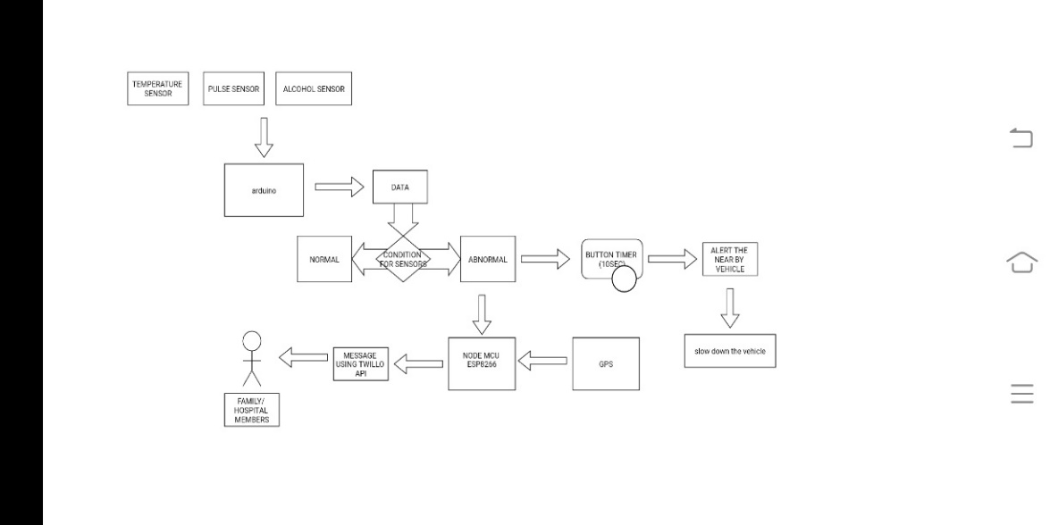
Figure 1: Block Diagram
- ARDUINO UNO : The Arduino Uno is a type of Arduino board that is provided as an open-source board that uses an ATmega328p microcontroller in the board. The Arduino Uno contains a set of analog and digital pins that are input and output pins which are used to connect the board to other components. There are a total of fourteen I/O pins placed inboard in which six are analog input pins. The board has a USB connection that can be used to a power supply to the board. The board is used for electronics projects and used to design the circuit.
- ESP8266: The NodeMCU ESP8266 is an open-source development board that is designed for IoT projects. It is based on the ESP8266 WiFi module, which has an embedded 32-bit MCU and Wi-Fi capabilities, making it a popular choice for IoT applications. The NodeMCU ESP8266 also includes a USB-to-serial converter for easy programming and debugging, as well as GPIO pins for connecting sensors and other devices. It can be programmed using the Arduino IDE or with Lua scripting language. Overall, the NodeMCU ESP8266 is a cost-effective and versatile option for building IoT projects.
- Power Supply: A power supply is a device that converts electrical power from one form to another in order to supply electrical energy to an electronic device. In general, power supplies can be classified into two categories: AC (alternating current) and DC (direct current) power supplies.
- Temperature Sensor(LM35): The LM35 is a precision integrated circuit temperature sensor that provides an analog output voltage proportional to the temperature in Celsius. It operates over a temperature range of -55°C to 150°C, with an accuracy of ±0.5°C at room temperature.
- Alcohol Sensor (MQ-3): The MQ-3 is a gas sensor module designed to detect alcohol vapors in the air. It is commonly used in breathalyzers, automotive systems, and other applications where alcohol detection is required. It operates on a voltage of 5V DC and has a low power consumption, making it suitable for use in battery-powered systems.

- Pulse Sensor : The Pulse sensor is an integrated pulse oximetry and heartrate monitor sensor solution. It combines two LEDs, a photodetector, optimized optics, and low-noise analog signal processing to detect pulse oximetry and heart- rate signals. The Pulse sensor operates from 1.8V and 3.3V power supplies and can be powered down through software with Negligible standby current, permitting the power supply to Remain connected at all times.

- Neo-6m GPS: The NEO-6M GPS module is a compact and low-power GPS receiver module that is widely used in various navigation and location-based applications. It is based on the u-blox 6 GPS chipset and is capable of receiving signals from both GPS and GLONASS satellite constellations.
- Dc Motor: A DC (Direct Current) motor converts electrical energy into mechanical energy using the principles of electromagnetic induction. It operates by passing an electric current through a coil of wire, which creates a magnetic field that interacts with a stationary magnet or another coil of wire, resulting in the rotation of a shaft.
- 2-Channel Relay: A 2-channel relay is an electronic device that allows you to control two separate circuits with a single control signal. It consists of two channels, each with a coil and a set of contacts. The relay can switch the power supply to connected devices, such as lights, motors, or other electrical loads.
- Twillo API; Twilio is a cloud communication platform that provides APIs for developers to build and integrate communication services into their applications. Twilio APIs allow developers to send and receive SMS and voice messages, make and receive phone calls, and handle other communication tasks.
- Embedded C; Embedded C is most popular programming language in software field for developing electronic gadgets. Each processor used in electronic system is associated with embedded software. Embedded C programming plays a key role in performing specific function by the processor. In day-to-day life we used many electronic devices such as mobile phone, washing machine, digital camera, etc. These all-device working is based on microcontroller that are programmed by embeddedC.

- IMPLEMENTATION

The main component of the system is the sensor, which is responsible for providing the values of the health conditions.
Connect the LM35 temperature sensor, MQ-3 pulse sensor, and MQ-3 alcohol sensor to the Arduino Uno microcontroller.
Upload the Arduino code to read the sensor values and define
the normal and abnormal sensor reading values. Implement a timer function in the Arduino code that will initiate a 30-second countdown if abnormal readings are detected for 60 seconds. Connect a button to the Arduino that the driver can press to indicate they are conscious and in a normal state. Implement a response function in the Arduino code that will stop the timer and reset the system if the button is pressed within the 30-second countdown. If the button is not pressed within the 30-second countdown, activate the buzzer alarm and blink the vehicle's lights to alert nearby people. Implement a shutdown function in the Arduino code that will turn off the vehicle if the button is not pressed within the 30-second countdown. Connect the ESP8266 microcontroller to the Arduino and the NEO-6M GPS module. Implement a location function in the ESP8266 microcontroller that will determine the vehicle's location using the GPS module. Use the Twilio API to send an SMS message with the vehicle's location to the family members if abnormal readings are detected and the button is not pressed within the 30-second countdown.

- WORKING PRINCIPLE
The LM35 temperature sensor, MQ-3 pulse sensor, and MQ-3 alcohol sensor are used to measure the driver's health conditions. These sensors are connected to an Arduino Uno microcontroller, which reads the sensor values. The predefined normal and abnormal sensor reading values are fetched by the microcontroller. If abnormal readings are detected for 60 seconds, a timer is initiated with a 30-second condition. The microcontroller has a button that can be pressed within the duration to ensure that the driver is conscious and in a normal state. If the button is not pressed within the given duration, the microcontroller will trigger an alert by activating a buzzer alarm and blinking the vehicle's lights. The microcontroller will also turn off the vehicle and send the vehicle's location to the family members using the TWILLO API. The microcontroller uses an ESP8266 microcontroller connected with NEO-6M GPS to find the vehicle's location and sends the location as an SMS to the family members. This system can help avoid collateral damage caused by health issues while driving and alert nearby people for help. In the event of a driver falling ill while driving a vehicle with nobody nearby, this system can help locate the driver quickly and reduce damage to nearby people and physical property.

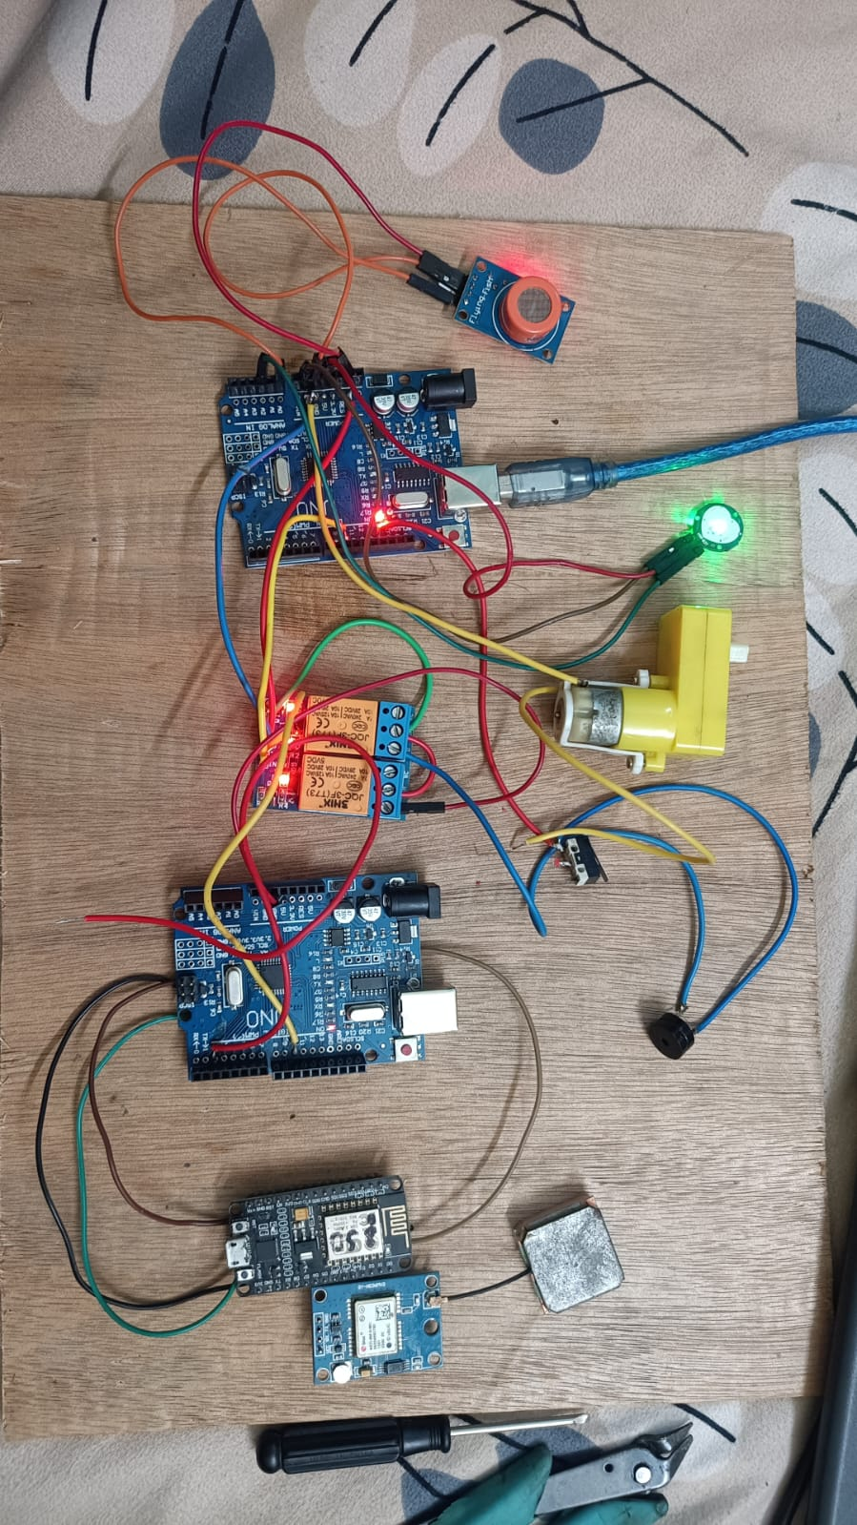
Figure 2: Working Model

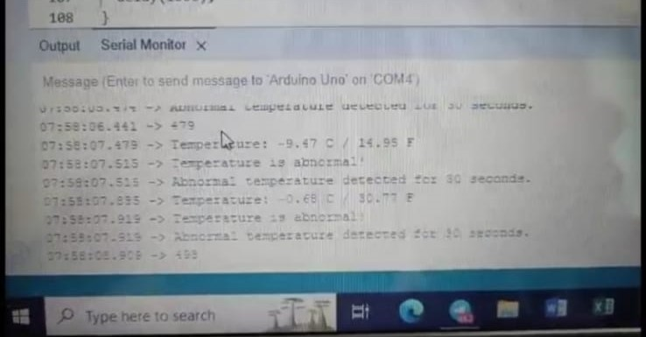
Figure 3: Serial Output

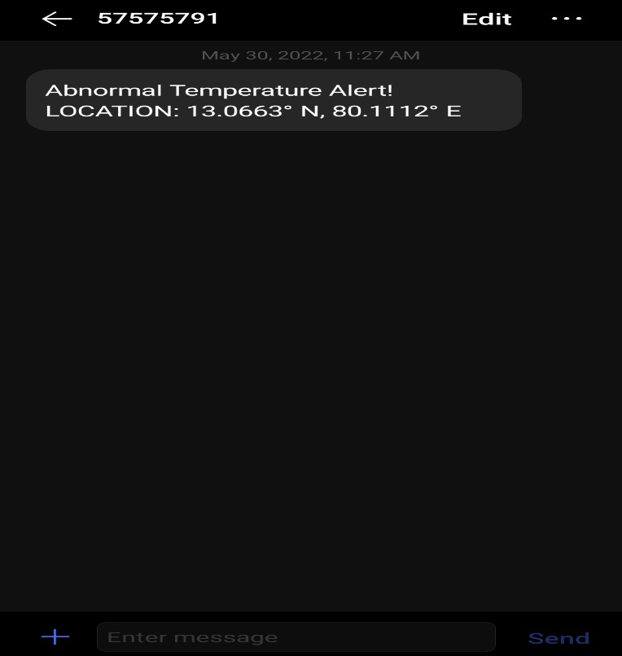
Figure 4: SMS Output Of The Location

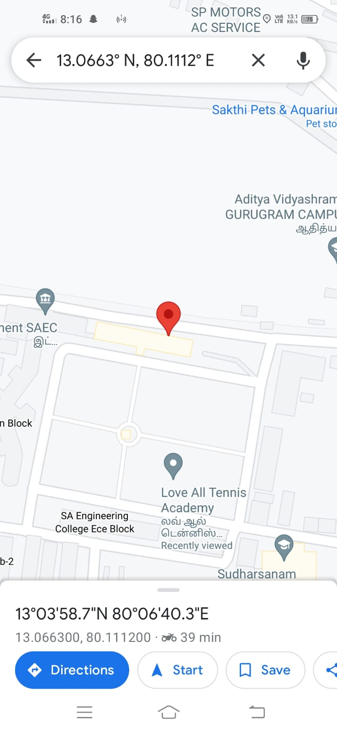
Figure 5: Live Location Output

  - CONCLUSION AND FUTURE SCOPE
The system described above is designed to help ensure the safety of both the driver and other people on the road. By using sensors to measure the driver's vital signs, the system can detect if the driver is experiencing a health issue that could affect their ability to drive safely. If an abnormal reading is detected, the system will initiate a timer and attempt to get a response from the driver. If the driver does not respond within the allotted time, the system will take action to alert nearby people and shut down the vehicle to prevent any accidents. One of the key features of the system is the use of location-based services to help locate the driver quickly in the event of an emergency. By using a GPS module, the system can accurately determine the vehicle's location and send it to family members or emergency services if necessary. This can help speed up the response time and reduce the risk of any further accidents or injuries. Overall, this type of system could have a significant impact on road safety and help prevent accidents caused by health issues while driving. By detecting potential issues early and taking action to alert nearby people, the system could help save lives and reduce the risk of collateral damage.
REFERENCES
[1] Tyagi, S., & Kumar, A. (2016). Internet of things: A survey on technology, applications and challenges. International Journal of Innovations & Advancement in Computer Science, 5(10), 374-380.
[2] Darshan, K. R. (2017). Internet of Things (IoT) in healthcare: A comprehensive review. International Journal of Computer Science and Mobile Computing, 6(3), 6-12.
[3] Yeh, K. H., Lin, C. C., & Wu, J. L. (2016). A secure architecture design of internet of things for healthcare system. In 2016 IEEE International Conference on Consumer Electronics-Taiwan (ICCE-TW) (pp. 157-158). IEEE.
[4] Awais, M., Imran, M. A., & Hussain, M. (2020). A review of driver drowsiness detection systems. IEEE Access, 8, 47138-47156.
[5] Gupta, V. K., & Shrivastava, P. (2017). IoT based health monitoring system: A review. In 2017 2nd International Conference for Convergence in Technology (I2CT) (pp. 784-788).
[6] Awais, M., Imran, M. A., & Hussain, M. (2020). A review of driver drowsiness detection systems. IEEE Access, 8, 47138-47156.
[7] Ling, Y., Du, Y., & Wu, C. (2019). A survey of driver distraction detection systems. IEEE Transactions on Intelligent Transportation Systems, 20(5), 1735-1752.
[8] Ferrandez-Pastor, F. J., Garcia-Chamizo, J. M., Nieto-Hidalgo, M., & Martinez-Sala, A. S. (2020). A systematic review of driver monitoring systems. Sensors, 20(23), 6823.
[9] Zheng, S., Zhu, Z., Song, L., & Fan, Z. (2021). A survey of wearable technologies for driver monitoring. IEEE Transactions on Intelligent Transportation Systems, 22(5), 3095-3114.
[10] Alam, M. M., Rahman, M. A., Alghazzawi, D. M., & Alsharif, M. H. (2019). A literature review of driver fatigue detection techniques. Transportation Research Part F: Traffic Psychology and Behaviour, 65, 319-342.

