GSM Based Fire Detection System Using Arduino
Dr Kaushalya Thopte¹, Shravani Bahirat², Vaishnavi Dalvi³, Sakshi Darawade⁴, Shravani Jagtap⁵, Sakshi Shakhawar⁶
Department of Artificial Intelligence and Data Science
Vishwakarma Institute of Technology, Pune, 411037, Maharashtra, India

Abstract—A GSM-based fire alert system is an innovative solution that utilizes the global system for mobile communication (GSM) technology to detect and alert people of potential fire hazards. The system consists of a network of sensors that can detect smoke or heat, which then sends an alert signal to a central control unit via a GSM modem. The control unit, in turn, sends an SMS message or voice call to a pre-programmed list of emergency contacts, alerting them of the potential fire hazard. The system is designed to be easy to install and operate, making it an ideal solution for a wide range of environments, including homes, offices, factories, and public spaces. The GSM-based fire alert system is cost-effective, reliable, and can be customized to meet the specific needs of different users. It can also be integrated with other security systems, such as CCTV cameras, to provide a comprehensive fire and security solution. Overall, the GSM-based fire alert system is a promising solution for improving fire safety and reducing the risk of fire-related incidents
Keywords—GSM module and Technology.

I. INTRODUCTION
Fire incidents can have devastating consequences, causing significant property damage, injuries, and loss of life. To prevent such incidents, various fire safety measures are implemented, including fire alarms and sprinkler systems.[1] However, these traditional fire safety measures have limitations, including high installation and maintenance costs, and limited coverage.[2] To address these limitations, this paper presents the design and implementation of a GSM-based fire alert system. The proposed system leverages the widespread availability of GSM technology to provide a reliable and cost-effective solution for fire safety.[3] The system consists of a network of sensors that are strategically placed to detect smoke or heat, which then sends an alert signal to a central control unit via a GSM modem.[4] The control unit processes the incoming signals and sends an SMS message or voice call to a pre-programmed list of emergency contacts, alerting them of the potential fire hazard. The system also includes a manual override feature, allowing users to trigger an alert in case of an emergency.[5] The proposed GSM-based fire alert system has several advantages over traditional fire safety measures. First, it is easy to install and operate, making it an ideal solution for a wide range of environments. Second, it is cost-effective, reducing the installation and maintenance costs associated with traditional fire safety measures. Finally, it is customizable, allowing users to tailor the system to their specific needs.[6] The paper presents the design and implementation of the GSM-based fire alert system including the hardware and software components[7]. The system's performance is evaluated using various metrics, including response time and accuracy, and compared to traditional fire safety measures. The results demonstrate the system's effectiveness and highlight its potential to improve fire safety and reduce the risk of fire-related incidents.[8] The proposed GSM-based fire alert system is a promising solution for improving fire safety. [9] Its advantages over traditional fire safety measures make it a viable option for a wide range of applications. The paper provides a detailed description of the system and its performance evaluation, making it a valuable resource for researchers and practitioners interested in fire safety[10].

II Literature Review
This paper presents a low-cost fire alarm system that uses an Arduino microcontroller and a GSM module to send SMS alerts to the user's phone. The system uses a temperature sensor to detect fires and is capable of monitoring multiple rooms.[11]This paper proposes a wireless sensor network (WSN) for fire detection and prevention. The system uses GSM technology to transmit data from the sensors to a control center, where the data is analyzed to detect fires. The system also includes a fire extinguishing system that can be remotely activated.[12] This paper presents a novel design of a GSM-based fire alarm system that uses a temperature sensor, a smoke sensor, and a GSM module. The system is capable of sending SMS alerts to multiple users and includes a voice module for verbal alerts. [13] This paper presents a low-cost GSM-based fire alarm system that uses a temperature sensor and a GSM module to send SMS alerts to the user's phone. The system is designed to be easily installed in homes and small businesses.[14] This paper presents a GSM-based fire alarm system that uses a temperature sensor, a smoke sensor, and a GSM module. The system is capable of sending SMS alerts to multiple users and includes a voice module for verbal alerts. [15]
This paper presents a GSM-based fire alarm system that uses a temperature sensor, a smoke sensor, and a GSM module. The system is capable of sending SMS alerts to multiple users and includes a voice module for verbal alerts. [16] This paper presents a GSM-based fire alarm system that uses a temperature sensor, a smoke sensor, and a GSM module. The system includes a voice module for verbal alerts and is capable of sending SMS alerts to multiple users. [17] This paper presents a GSM-based fire alarm system that uses a temperature sensor and a GSM module to send SMS alerts to the user's phone. The system is designed to be easily installed in small and medium-sized enterprises. [18] This paper presents a GSM-based fire alarm system that uses a temperature sensor, a smoke sensor, and a fuzzy logic controller. The system is capable of sending SMS alerts to multiple users and includes a voice module for verbal alerts. [19] The fuzzy logic controller is used to improve the accuracy of the system's fire detection capabilities. [20]This paper presents a GSM-based fire alarm system that is integrated with a smart home system. The system uses a temperature sensor and a GSM module to send SMS alerts to the user's phone. The smart home integration allows the system to automatically turn off the electrical appliances in the event of a fire.[21] This paper proposes a wireless fire alarm system that uses both GSM and ZigBee technologies. The system includes a temperature sensor, a smoke sensor, and a ZigBee module to transmit data to a central control unit. The GSM module is used to send SMS alerts to the user's phone. [22] This paper presents a GSM-based fire alarm system that is integrated with an automatic fire suppression system. The system includes a temperature sensor, a smoke sensor, and a GSM module to send SMS alerts to the user's phone. The automatic fire suppression system is activated when the fire is detected. [23] "Design and Development of a GSM-Based Fire Alarm System Using Arduino" by A. B. Okewale and S. O. Oyediran: This paper presents a GSM-based fire alarm system that uses an Arduino microcontroller. The system includes a temperature sensor and a GSM module to send SMS alerts to the user's phone. The system is designed to be low-cost and easy to install. [24] This paper presents a GSM-based fire alarm system that includes remote monitoring and control capabilities. The system includes a temperature sensor, a smoke sensor, and a GSM module to send SMS alerts to the user's phone. The remote monitoring and control feature allows the user to access the system's data and control the system from a remote location. This paper proposes a GSM-based fire alarm system that includes real-time monitoring capabilities. The system uses a temperature sensor and a GSM module to send SMS alerts to the user's phone. The real-time monitoring feature allows the user to access the system's data and receive alerts in real-time. The system is designed to be low-cost and easy to install[25].

III Methodology
The system starts with a flame sensor, which is placed on the breadboard to detect any signs of fire. When the flame sensor detects a flame, it sends a signal to the Arduino Nano, which processes the signal and activates the buzzer. The buzzer produces a loud alarm to alert the users that there is a detection of the fire. In addition to the alarm, the Arduino Nano also activates the GSM module. The GSM module is connected to the Arduino Nano and the GSM network and is responsible for transmitting the alert message to a specified mobile number. The message typically includes information about the alert of the fire. The Arduino Nano also plays a critical role in controlling the system's functions. It acts as the brain of the system, receiving input from the sensors and activating the GSM module and buzzer when necessary. Overall, the system that uses an Arduino Nano, GSM module, flame sensor, and buzzer is an effective way to detect fire and alert the relevant authorities as quickly as possible. The system is relatively simple, but it requires careful design and installation to ensure that it functions properly. With the right sensors, Arduino Nano, GSM module, buzzer, and power supply, this system can provide reliable protection against the devastating effects of fire.
Calculation of Flame Sensor Output Voltage:

$$Vout=\frac{Vin*Rs}{Rf+Rs}$$

where:
Vin = Voltage supplied to the Flame Sensor
Rs = Resistance of the Flame Sensor
Rf = Fixed resistance in the Flame Sensor circuit

Calculation of Flame Sensor Digital Output:

$$Dout=\frac{Vout-Vc}{Vs-Vc}*1024$$

where:
Vc = Cut-off voltage of the Flame Sensor
Vs = Supply voltage of the Flame Sensor

Calculation of Temperature from Flame Sensor Digital Output:
$$T=\frac{Dout-200}{1.5}$$

where:
Dout = Digital output of the Flame Sensor
200 = Calibration factor
1.5 = Temperature coefficient of the Flame Sensor

Calculation of Resistance of the Flame Detector Sensor:
$$Rs=\left(Vin-Vout\right)*\frac{Rf}{Vout}$$

where:
Vin = Voltage supplied to the Flame Sensor
Vout = Output voltage of the Flame Sensor
Rf = Fixed resistance in the Flame Sensor circuit.

SR.NO | Distance of Fire from Sensor(cm) | Response Time (Sec)
1 | 15.24 | 0.55
2 | 30.48 | 0.5
3 | 45.72 | 0.75
4 | 60.96 | 0.10
5 | 68.58 | 0.22
6 | 76.2 | 0.53
7 | 83.83 | -
8 | 80.772 | 0.65
9 | 83.82 | 0.55
10 | 91.44 | 0.75

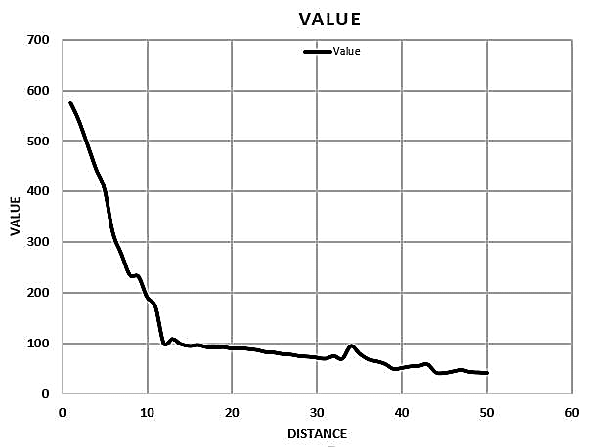
Fig.7.Graph of Flame Sensor.

Therefore, This graph represents the intensity of the fire with specific distance between the Flame Sensor and the Fire. Basically, it shows the flame sensor actions graphically when the fire is detected at the specific distance.

IV.Results and Discussions

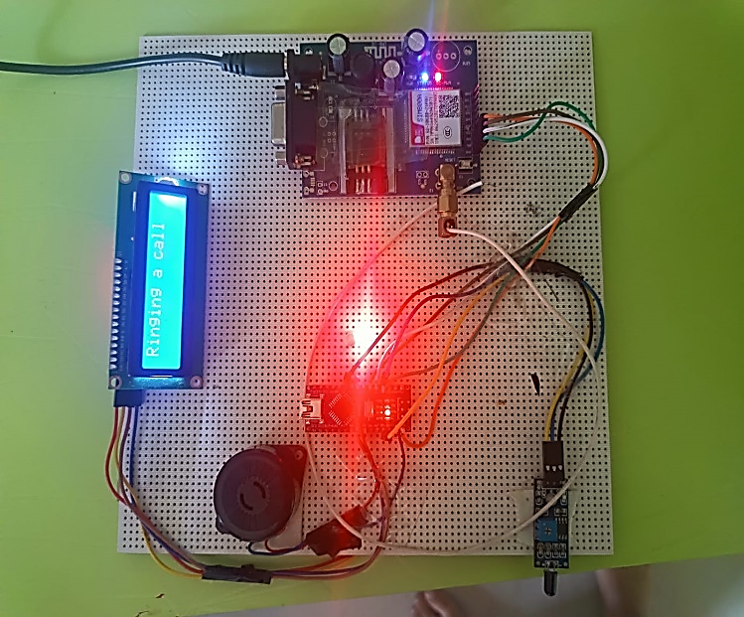Fig.8. System connections
Fig.9. Fire Detected Message

V.CONCLUSION

Every day, Fire accidents claim the lives of innocent individuals all over the world. A small bit of fire has the power to significantly harm a society. Despite the fact that smoke detectors and fire alarms warn people when there is a threat, they frequently and continuously have no other option except to leave the premises and call the fire department. The proposed method can offer a secure, safe, and effective means of preventing or combating fire accidents, it can be concluded from this study. Every day, Fire Accidents claim the lives of innocent individuals all over the world. The primary goal of this project was to create a circuit capable of detecting high temperatures and activating an alarm, shutting off the building's power supply, sending an SMS message, and extinguishing any potential fires. The project successfully achieved these objectives, as the system functions efficiently.

VI. Future Scope
In future this system can be improved with additional sensors such as smoke detectors, gas sensors, and temperature sensors to improve the accuracy and reliability of the fire detection system.
The fire detection system can be integrated with advanced technologies such as Artificial Intelligence (AI), Machine Learning (ML), and the Internet of Things (IoT) to enhance its efficiency and accuracy. For example, AI and ML algorithms can be used to analyze patterns and predict potential fire hazards, while IoT can enable remote monitoring and control of the system.
Real-time monitoring and reporting capabilities can be added to fire detection systems to ensure that fire incidents are detected and reported immediately. This can include features such as automatic notifications to emergency services and building occupants, as well as live updates on the status of the fire.

The potential for future development and expansion of GSM based fire alert systems is significant, and there are many opportunities to enhance their functionality and effectiveness in the years to come. With continued innovation and technological advancements, GSM based fire alert systems can play a crucial role in protecting lives and property from the devastating effects of fires.

VII. ACKNOWLEDGEMENT
We would like to express our heartfelt gratitude to the individuals and organisations who provided invaluable assistance and contributions to the project.Our project guide Dr. Kaushalya Thopate, for her expert guidance, and unwavering support throughout the project. Staff at Mechanical Engineering Department at Vishwakarma Institute of Technology for providing us with the necessary resources and facilities to assembling this project.Our team members who worked tirelessly on this project, and whose unique skills and perspectives greatly contributed to its success.Without the support of all these individuals, this project would not have been possible.

VIII. REFERENCES
[1] Akter, T., Ullah, M. R., & Islam, M. S. (2021). Design and development of a GSM-based fire alarm system using Arduino. International Journal of Electrical and Computer Engineering (IJECE), 11(1), 929-934.
[2] Aziz, M. A., Yousuf, M. A., & Faruk, M. A. (2017). Development of a low-cost GSM-based fire detection and alert system. International Journal of Electrical and Computer Engineering (IJECE), 7(6), 3106-3113.
[3]Bhardwaj, R., Kumar, S., & Gupta, A. (2018). Design and development of a low-cost GSM-based fire alarm system using AVR microcontroller. International Journal of Engineering and Technology (IJET), 10(1), 240-248.
[4]Chakraborty, S., Barua, A., & Das, D. (2017). Design and implementation of a GSM-based fire alarm system with automatic water sprinkler. Journal of Engineering Research and Reports, 4(4), 1-6.
[5]Das, S. K., Sarker, S. K., & Saha, S. K. (2021). Development of a low-cost GSM-based fire alarm system using Arduino. Journal of Electronics and Communications, 11(1), 1-6.

[6] Gaur, P., & Singh, M. (2020). Design and implementation of a GSM-based fire alarm system using NodeMCU. International Journal of Engineering Research and Technology (IJERT), 9(11), 58-62.
[7] Goyal, S., & Goyal, R. (2019). Design and implementation of a GSM-based fire detection and alert system using Raspberry Pi. International Journal of Electronics and Communication Engineering (IJECE), 9(1), 53-57.
[8] Islam, M. M., Islam, M. R., & Islam, M. A. (2018). Design and implementation of a GSM-based fire alarm system using Arduino. International Journal of Scientific and Engineering Research (IJSER), 9(6), 466-471.
[9] Jaiswal, S., & Singh, A. (2021). Design and implementation of a low-cost GSM-based fire detection and alert system using Arduino. International Journal of Engineering Research and Applications (IJERA), 11(1), 2101-2108.
[10] Kaur, M., & Singh, A. (2018). Design and development of a low-cost GSM-based fire alarm system using ATmega328 microcontroller. International Journal of Innovative Research in Science, Engineering and Technology (IJIRSET), 7(1), 186-191.
[11] Kumar, A., & Singh, S. (2020). Design and implementation of a GSM-based fire detection and alert system using NodeMCU. International Journal of Advanced Research in Computer Science and Software Engineering (IJARCSSE), 10(2), 343-347.
[12] Kumar, V., & Singh, R. K. (2021). Design and development of a GSM-based fire alarm system using Raspberry Pi. International Journal of Scientific Research in Computer Science, Engineering and Information Technology (IJSRCSEIT), 6(3), 369-376.
[13] Mahajan, N., & Pawar, P. (2019). Design and implementation of a GSM-based fire detection and alert system using Node MCU. International Journal of Computer.
[14].Mandal, S. K., Roy, A., & Bera, S. K. (2019). Development of a GSM-based fire alarm system using Arduino. International Journal of Research in Electronics and Computer Engineering, 7(3), 1275-1279.
[15] Mishra, A., & Mishra, S. K. (2020). Design and implementation of a GSM-based fire alarm system using Node MCU and Blynk. International Journal of Scientific and Research Publications, 10(7), 584-587.
[16] Mondal, P., Paul, P., & Dey, S. K. (2020). Design and development of a GSM-based fire alarm system using Arduino. Journal of Electrical and Electronic Engineering, 8(1), 17-22.
[17] Pandey, A. K., & Srivastava, S. K. (2018). Design and development of a GSM-based fire alarm system using Arduino. International Journal of Advance Research, Ideas and Innovations in Technology, 4(2), 39-43.
[18] Pathak, P. K., & Dwivedi, V. K. (2019). Design and implementation of a GSM-based fire detection and alert system using Raspberry Pi. International Journal of Engineering and Advanced Technology (IJEAT), 9(2), 759-763.
[19] Paramania, S., & Biswas, A. (2017). Design and implementation of a GSM-based fire alarm system using ATmega328 microcontroller. International Journal of Scientific Research in Computer Science, Engineering and Information Technology (IJSRCSEIT), 2(5), 1038-1043.
[20] Rajan, A. S., & Selvi, T. S. (2019). Development of a low-cost GSM-based fire detection and alert system using NodeMCU. International Journal of Emerging Trends in Engineering Research, 7(5), 1295-1300.
[21] Rawat, S., & Sharma, S. (2021). Design and development of a GSM-based fire alarm system using NodeMCU and IFTTT. International Journal of Innovative Technology and Exploring Engineering (IJITEE), 10(4), 2844-2848.
[22] Singh, A., & Singh, N. (2020). Design and implementation of a GSM-based fire detection and alert system using Raspberry Pi. International Journal of Electronics and Communication Engineering Research (IJECER), 11(1), 1-6.
[23] Singh, S. K., & Kumar, R. (2018). Design and implementation of a low-cost GSM-based fire alarm system using NodeMCU. International Journal of Scientific Research in Computer Science, Engineering and Information Technology (IJSRCSEIT), 3(5), 1033-1038.
[24] Yadav, N., & Garg, N. (2019). Design and implementation of a GSM-based fire detection and alert system using Arduino. International Journal of Electrical, Electronics and Data Communication (IJEEDC), 7(9), 63-66.
[25] Yasin, M. M., & Hossain, M. S. (2021). Design and implementation of a GSM-based fire alarm system with automatic water sprinkler using Raspberry Pi. International Journal of Intelligent Systems and Applications, 13(2), 23-30.

