IOT BASED HEALTH MONITORING AND SAFETY SYSTEM FOR SOLDIERS USING ARDUINO UNO AND MPU6050
AUTHORS:
Pooja S Ranjitha M V Varsha
School of CSE School of CSE School of CSE
REVA UNIVERSITY REVA UNIVERSITY REVA UNIVERSITY
r19cs233@cit.reva.edu.in r19cs247@cit.reva.edu.in r19cs256@cit.reva.edu.in

Palak Sharma Dr. M Prabhakar
School of CSE Associate Prof., School of CSE
REVA UNIVERSITY REVA UNIVERSITY
r19cs225@cit.reva.edu.in prabhakar.m@reva.edu.in

---------------------------------------------------------------------***---------------------------------------------------------------------
ABSTRACT - This project is an Internet of Thing (IOT) based health monitoring and tracking system for soldiers. This system can be mounted on the soldier’s body to collect their health condition, fall detection and current location using GPS. This project helps for health monitoring system based on IoT that helps the medical staff to monitor heart rate/pulse rate and body temperature remotely. If a soldier falls due to any medical issue or due to any obstacles it detects and send a notification to the control room. If there is any emergency other than medical issues, they can use the button which send a notification to the control room with location.

The information collected will be transmitted to the control room through IoT and the ThingSpeak. ThingSpeak is an IOT analytics platform service that allows you to aggregate the data which is collected through system, visualize, and analyze the live data streams in the cloud. The system comprises of tiny wearable equipment’s, sensors, transmission modules. The information collected by the system can be visualized with the help of graphs. Hence, with the use of the system equipment, it is possible to implement a low-cost mechanism to protect the soldier’s life on the war field.

Key Words: Arduino board, Biomedical sensors, GPS, IoT, Remote health monitoring, Tracking, Fall detection, ThingSpeak.

- INTRODUCTION:

The Indian military is one of the largest armies in the world which stands in top third-largest army. As an Indian geographical area army works in different area which is very difficult to handle and track the information of the army. The army suffers greatly from the lack of information regarding injuries to its members, which could increase the number of fatalities and lasting disabilities. It has been noted that injuries rather than direct assaults on the battlefield are what lead to casualties. If the control room has access to real-time information on the soldier's condition and whereabouts, these numbers can be reduced.

The safety of soldiers is a complicated subject. The ability to know where soldiers are at any given time, the inability to maintain constant communication with the control room while conducting operations, the lack of access to immediate medical care, and conducting operations in various geographic locations are a few of the major safety concerns.

Therefore, a portable, low-cost tracking device with excellent dependability is urgently needed to safeguard the soldiers' precious lives on the battlefield. In this paper, a portable real-time tracking technique is suggested in response to these problems. Existing systems for tracking soldiers' positions and monitoring their health are available, although most of them are inefficient and heavy, but these systems can convey information to the appropriate soldiers and will require regular upkeep. The suggested solution is built on the IoT idea. The real-time continuous monitoring of a soldier's position and health characteristics will be made easier by the suggested system.

Pulse rate and body temperature can be monitored along with the location tracking of the soldiers using GPS can be monitored using the proposed system. The transmission of these parameters to the control room is carried out by IoT and online cloud platform called Thingspeak. The control room receives the notification which contains the information of the position of soldier from GPS and health condition of the soldier with the help of IFTTT.

2. LITERATURE REVIEW:
- “Health Monitoring and Tracking System for Soldiers Using Internet of Things (IoT)”, this paper reports an IOT based health monitoring and tracking system, where the system is directly mounted on the soldier’s body. Raspberry Pi based approach is used for monitor all other sensors. ARM processor is used to collect the data from the sensors. ZigBee and GSM wireless technology used to update the data to the doctor with the location. Panic button and buzzer is provided for emergency.
- “Smart Portable Patient Monitoring System”, this paper presents the portable health monitoring system. System collects the data like humidity, heart rate, temperature, oxygen level and ECG of the patient and stored in the database. It is Raspberry Pi based model. It user interface is build on different platforms, an Android application, a website, and hand-held module. Node-MCU is used to active the sensors, code filters the noise from the sensors input and only uploads the reasonable readings by writing the vales to ‘Virtual Pins’. NEO-6m is used to track the current location of the patient. BLYNK servers are used to upload the data in server.
- “Covid-19 Patient Health Monitoring System Using IOT”, in this testing was conducted using Arduino IDE software and ESP32 webserver. The instrument used to obtain the information needed are biosensor module MAX30100, body temperature sensor DS18B20 and humidity sensor DHT11. ESP32 webserver is used to displays the information collected by the sensors.
- “Patient Health Monitoring System using IOT”, this is a project which track the pulse and temperature of the patient. DS18B20 temperature sensor, DHT11 Room humidity temperature, ESP32 WIFI module, pulse oximeter AD8232 sensor are used to build the module. GSM is used for communication. Favoriot platform is used to motor the temperature levels and e Ubidots platform is used that intimation to the nearest ambulances, visualize and it delivers the message.
- “IOT based Healthcare Monitoring and Tracking System for Soldiers using ESP32”, this project contains an extra module bomb detector. The system also monitors the health of the soldier and the data is saved in the cloud. They use the ESP32 CAM which helps to record the video and other hardware components which just sense and send a notification
- “IOT COVID-19 Portable Health Monitoring System using Raspberry pi, Node-Red and ThingSpeak”, in this project the system is firstly connected to the Node-RED and MQTT broker from the Wi-Fi. Messaging portal MQTT is used for notification. Health of the patient can be monitored using phone and ThingSpeak website through graphs. The data collected by the sensors are stored in the database.
- “Development of a Real Time Wearable Fall Detection System in the Context of Internet of Things”, Java Web application was deployed on Tomcat server to implement data queries in the form of web pages. NB-IoT supported BC-95 chip in communication module is used for real-time monitoring of the device status. MEMS sensor and a microcontroller unit (MCU) are used as monitoring node. The MPU-6065 sensor module used for motion monitor. This system monitor using the multi-level threshold algorithm.
- “A Review on Internet of Things (IoT) Based Pulse Rate, Blood Pressure, Body Temperature Monitoring System”, it is a project which is web-based patient health management framework. It is a E-Healthcare system where the collected data is processed through the gateway called Fog layers and the data is stored in a cloud platform. It delivers the care to the patients by being at home, families will feel secure for knowing that they are being monitored by the doctor.

3. IMPLEMENTATION METHODOLOGY:
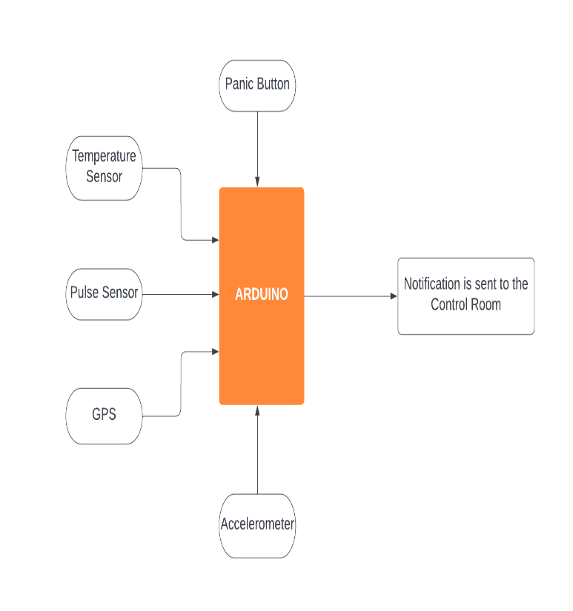
Fig (1). Block Diagram of Proposed System

This project shows Internet of Thing (IoT) based health monitoring and safety system for soldiers. Fig (1). shows the system records the heart beat rate, body temperature and sends an alert message whenever the readings go beyond critical values. If a soldier fell-down into certain depth, immediately this system will send a notification to the control room. Also, it helps the soldier to contact control room using an emergency button (Panic button) which sends a standard alert message to control room to provide the necessary assistance to the soldier.

4. CLASS DIAGRAM:
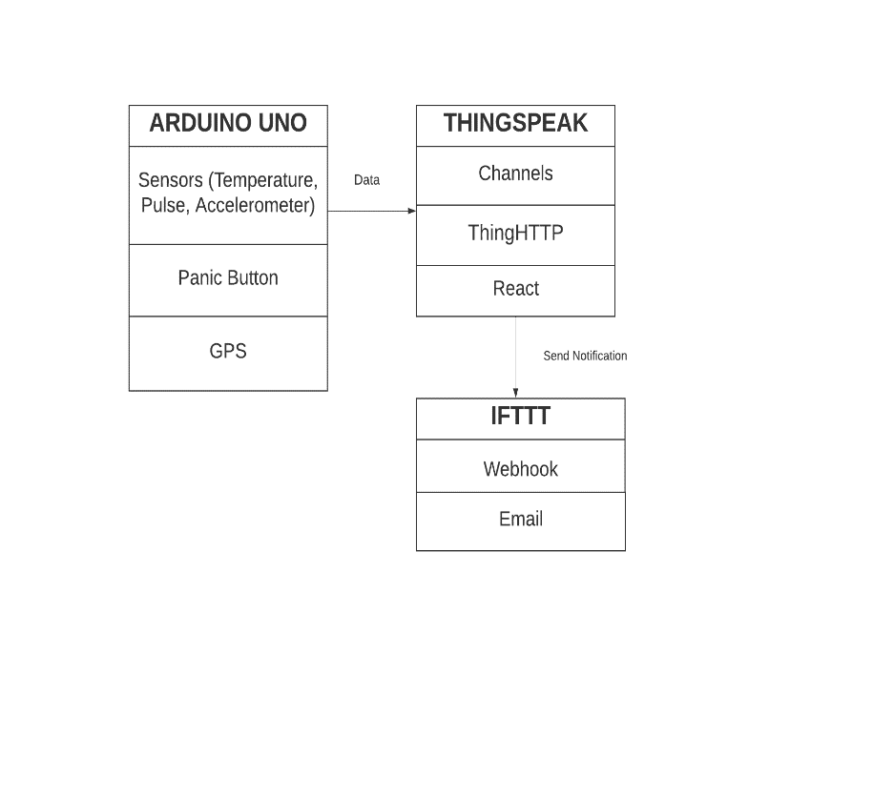Fig (2). Class Diagram of Proposed System
5. DATA FLOW DIAGRAM:

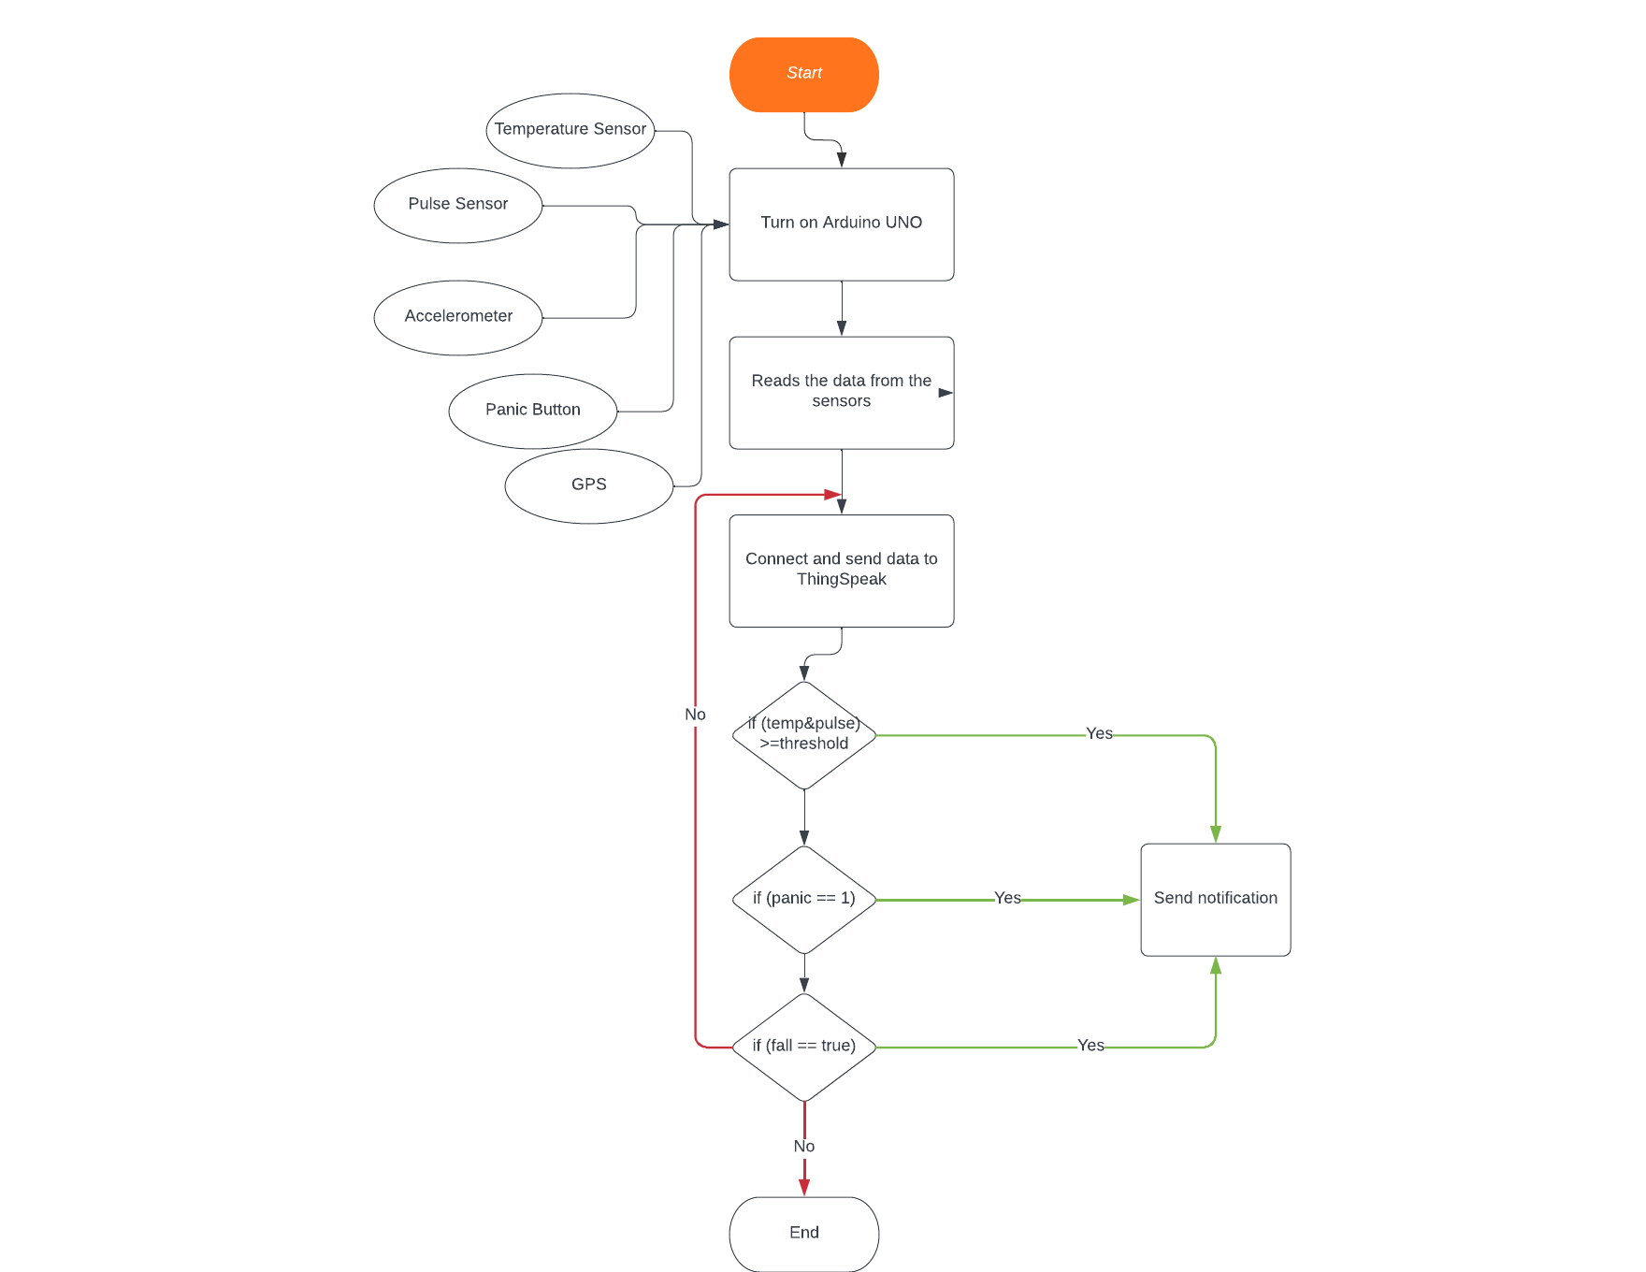
Fig (3). Data Flow of Proposed System

6. SEQUENCE DIAGRAM:
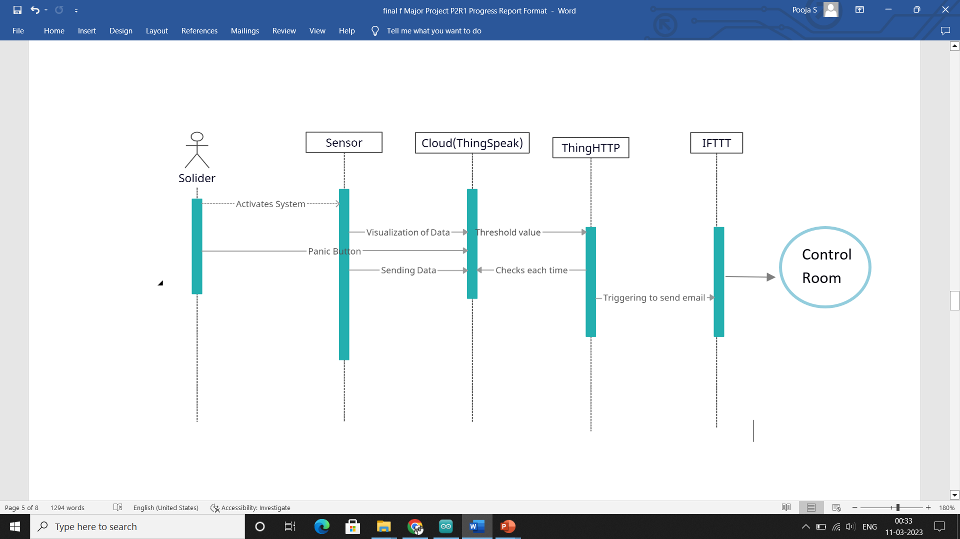

Fig (4). Sequence Diagram of Proposed System

1. SOLDIER: Who is source of the data, where The Pulse Rate Sensor clips are kept onto a fingertip or earlobe which is used to measure the heart rate of the patient and temperature sensor to measure the body temperature. Accelerometer is attached to find the motion of the solider and panic button for emergency.
2. THINGSPEAK: All the data collected from the soldier is send
to the Thingspeak where all the data is collected. It also measures the threshold values and trigger the IFTTT.
3. IFTTT: When the IFTTT is triggered the Email (Notification) is sent to the control room (for registered email) address.

7. COMPONENTS USED:
Hardware:
- Arduino UNO: Arduino is an open-source electronics platform based on easy-to-use hardware and software. Arduino boards can read inputs Data originating from sensors and GPS receiver is processed and collected using Arduino (ATmega328P) processor.
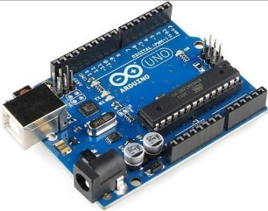
Fig (5). Arduino UNO Board

- NEO-6M GPS Module: The GPS unit is installed in addressing system so that base camp can track their movements and real time information in all weather, at all times form anywhere on globe.
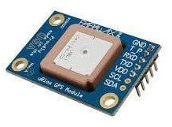
Fig (6). NEO-6M GPS Module

- Panic Button: Panic button is one kind of switch which is provided to soldiers to help in panic situation.
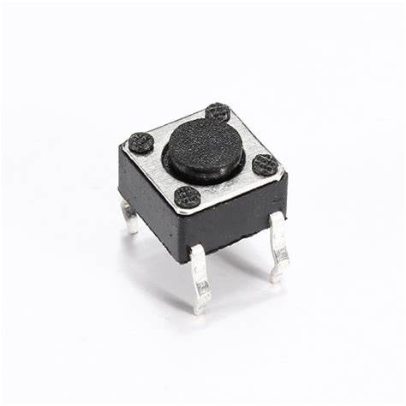
Fig (7). Panic Button

- ESP8266 Serial ESP01 WIFI Module: The ESP8266 is a low-cost Wi-Fi board, that you can easily wire to a microcontroller, and connect any project you build to the internet (of things).
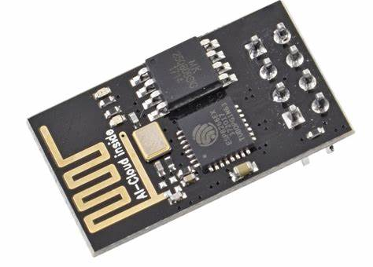
Fig (8). ESP8266

- DS18B20 Temperature sensor: It is a temperature sensor, which senses the body temperature Measures temperatures from –55°C to +125°C (–67°F to +257°F) ±0.5°C accuracy from –10°C to +85°C.
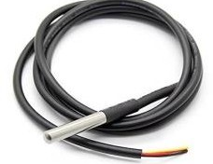
Fig (9). DS18B20

- MPU6050: Triple axis accelerometer, gyro and magnetometer combined, allowing a very deep motion detection and analysis.
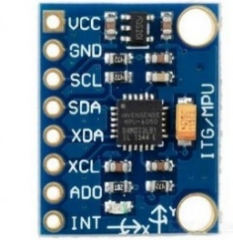
Fig (10). MPU6050

- Heart Rate Sensor: An analog heart rate pulse sensor. It can be used to measure the heart bpm. Returned values: 0 to 1023 analog reading.
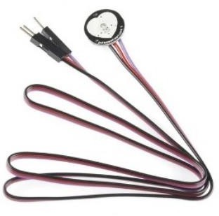
Fig (11). Heart Rate Sensor

- Battery(9V): Power supply for the components.

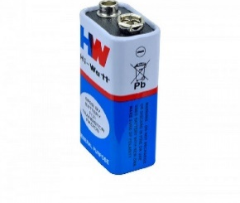
Fig (12). Battery
- Registers: 1K ohm registers to control the flow of voltage.
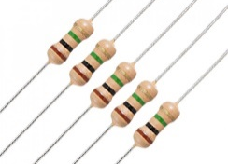
Fig (13). Registers

- Jumper wire: Wires like Male-Male, Female-Female and Male-Female are used to connect the components.
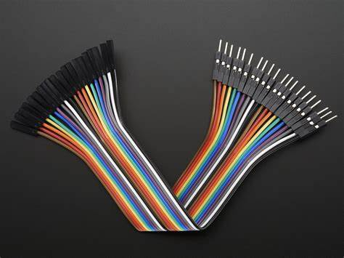
Fig (14). Jumper Wires

Software:
1. Arduino IDE: It is used for writing the code for the functioning of the device, here we are using library for Pulse Rate Sensor which has to be downloaded online, along with that we need Timer library for using timer to set interval to take readings.
2. ThingSpeak: It will collect the data, analyze it and acts on it by triggering a reaction using internet, channels and web pages. It will be used to monitor patient’s heart beat and temperature online using internet. It will be connected to the IFTTT platform to send alert message when observed condition is abnormal.
3. IFTTT(if,this,then,that): It is a software platform that connects devices from different developers to trigger the automations involving the devices. In the project IFTTT platform is to connect ThingSpeak to email/SMS service so that alert message can be sent whenever the patient is in critical state.

8. CIRCUIT DIAGRAM:

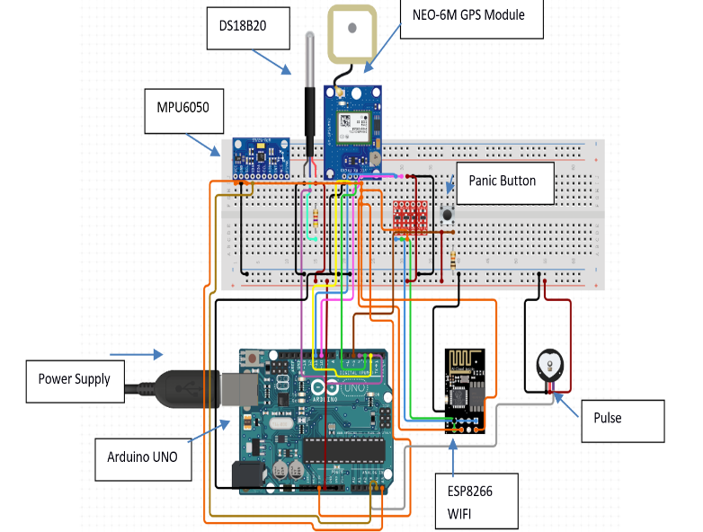
Fig (15). Circuit Diagram of Proposed System

The Fig (15) shows the connection of the system equipment to the Arduino UNO board.

9. HARDWARE SETUP:

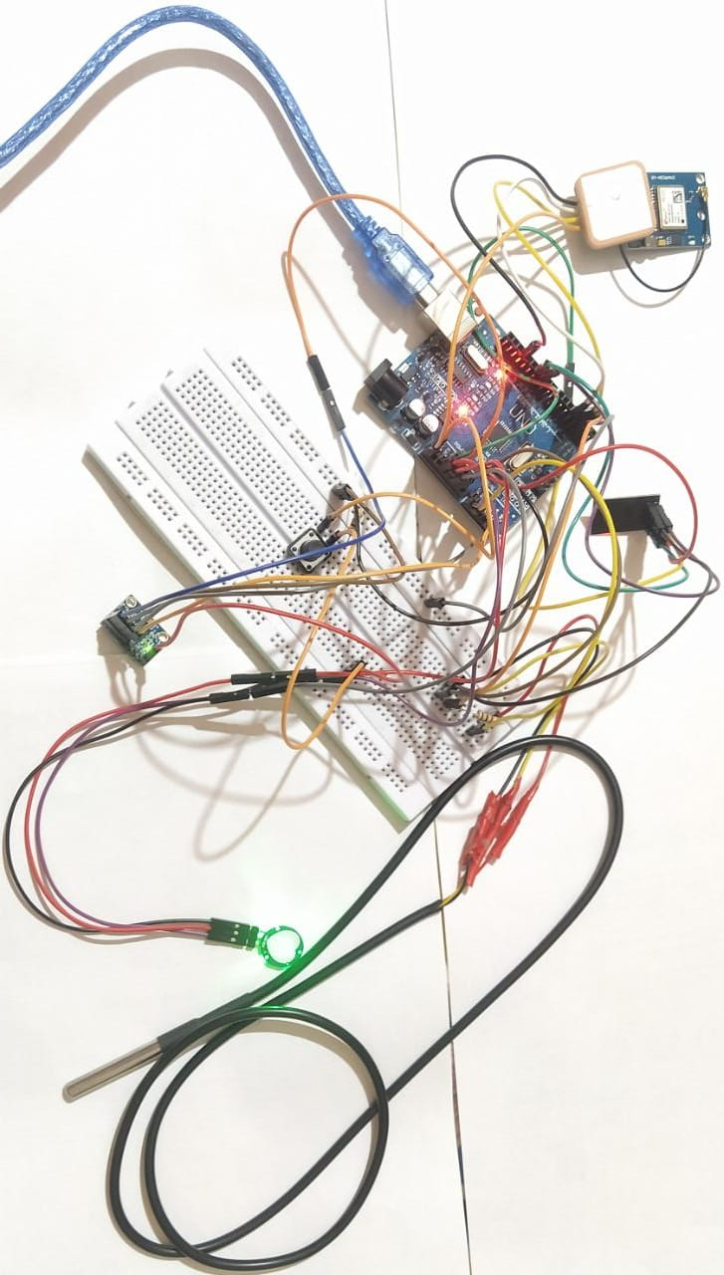
Fig (16). Hardware Setup

Above figures shows the structure of our model. It depicts how the connection are done with all other components

10. RESULT:

- Data visualization of pulse and body temperature of the solider.

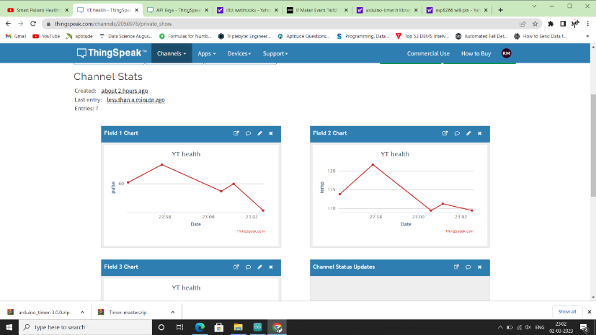
Fig (17). Health monitoring of the sensors through desktop view

- The notification sent to the control room when emergency had occurred.


Fig (18). Alert System

11. CONCLUSION:

This project provides heartbeat and body temperature of every soldier to control room through message/notification. This technology can be helpful to provide the accurate location of missing soldier in critical condition and overcome the drawback of losing soldiers due to lack if immediate aid. The addressing system is also helpful to improve the communication between control room to soldier in emergency. A fall detection system is designed for the safety of the soldier and if soldier presses panic button, then the system will generate an alert by which the control room will come to know soldiers are in difficult situation and the location is shared through GPS.

12. REFERENCES:

- Mohammad Jamjoum Emad Abdelsalam, Saif Siouf, “Smart Portable Patient Monitoring System” ,IEEE ASET, Jordan, March 2022.
- Muhammad Irsyad Abdullah, Lilysuriazna Raya, Mohamad Adib Akmal Norazman, “Covid-19 Patient Health Monitoring System Using IOT”,13th ICSGRC, 23 July 2022.
- M.Vijay Kumar Reddy, Konda Sai Achyuth, Dr.S.Babu, “Patient Health Monitoring System using IOT”, 8 th ICSSS , 2022.
- Sujitha V, Sudarmani R, Aishwarya B, “IOT based Healthcare Monitoring and Tracking System for Soliders using ESP32” ,6 th ICCMC,2022.
- Nurazamiroz Bin Kamarozaman, Aziati Husna Awag, “IOT COVID-19 Portable Health Monitoring System using Raspberry pi, Node-Red and ThingSpeak”, IEEE Symposium on Wireless Technology and Application, Dec2021.
- Zhiqin Qian, Yuchen Lin, Weiji Jing, Zhekai Ma, Hao Liu, Ruixue Yin, Zezhi Li, Zhuming Bi, Wenjun Zhang, “Development of a Real Time Wearable Fall Detection System in the Context of Internet of Things”, IEEE,09 June 2022.
- Mr.T.Mohanraj, Dr.B.Arunkumar, Mr.S.ShahulHammed, Dr.R.Santhosh, “A Review on Internet of Things (IoT) Based Pulse Rate, Blood Pressure, Body Temperature Monitoring System”, Proceedings of the Fourth International Conference on I-SMAC (IoT in Social, Mobile, Analytics and Cloud) (I-SMAC) IEEE Xplore Part Number:CFP20OSV-ART; ISBN: 978-1-7281-5464-0,2020
- Niket Patil, Brijesh Iyer, “Health monitoring and tracking system for soldiers using Internet of Things (IoT)”, Greater Noida, India, 2017.

