LPG GAS DETECTOR USING ARDUINO
Wasimuddin Mallick, Arshad khan, Sabir khan, Shamimurraza khan
Computer Engineering Department & Rizvi College of Engineering
Computer Engineering Department & Rizvi College of Engineering
Computer Engineering Department & Rizvi College of Engineering
Computer Engineering Department & Rizvi College of Engineering

---------------------------------------------------------------------***---------------------------------------------------------------------
Abstract - LPG leak detector model is a compact electronic device which detects the presence of LPG in the air. Gas leak detection is the detection of gas leaks with a sensor specially designed to identify the leaks. To detect gas leaks with traditional methods, the gas itself must either be near the detector or within a pre-defined area. Outdoor environmental conditions such as changing wind directions and quick dispersion of a potential gas cloud, which can be found e.g., on an offshore platform, can result in undetected gas leaks, leading to extremely dangerous situations.

Key Words: microcontroller, LCD, leakage sensor, 555 timers. LPG

1.INTRODUCTION
LPG leak detector model is a compact electronic device which detects the presence of LPG in the air. Gas leak detection is the detection of gas leaks with a sensor specially designed to identify the leaks. To detect gas leaks with traditional methods, the gas itself must either be near the detector or within a pre-defined area. Outdoor environmental conditions such as changing wind directions and quick dispersion of a potential gas cloud, which can be found e.g. on an offshore platform, can result in undetected gas leaks, leading to extremely dangerous situations.

Gas is intentionally odorized so that the average person can perceive it at a concentration well below the explosive range. That odorant concentration is generally between 0.5 to 1.0 percent by volume or as local applicable codes dictate. Gas odor is a common and effective indication of a leak. A report of gas odor should be investigated immediately. If a leak is found, the migration pattern of the gas should be determined. If an immediate hazard is determined to exist, the hazard potential should be eliminated, and the leak repaired immediately. Odor is not always totally reliable as an indicator of the presence or absence of gas leaks. For this reason, all gas leak reports should be investigated using a leak detection instrument. Gas personnel should remember that the primary purpose of the gas odor is to provide a warning to the public, who do not have gas detection instruments.
LPG gas detection projects’ main idea is to implement a security system for detecting leakage of gas in closed environment. In this project gas leakage is identified by using sensors which work only in closed environments. In the present situation there are many cases related to gas leakage which cause innocent people’s lives and property damage. Implementing this application can be useful for companies and houses, which can save lives of people.

We use 8-bit microcontroller to perform the desired task by interfacing Gas sensor, Buzzer and LCD to display. The output of the Gas sensor is in analog form which can be converted into digital form using MCP3201 which is an ADC (Analog to Digital Converter). Initially when there is a leak the Gas sensor detects it and gives voltage related to the amount of gas that is getting escaped from the apparatus. We create a set-point to the microcontroller so as if the Gas sensor gives the output above the set-point the controller drives the buzzer ON as an indication to the user.

This can be used as an application in chemical and hazardous industries where there is a continuous need to monitor the gas leaks. By using different kinds of sensors for every gas we can identify leaks for every kind of gas. So many incidents that may threatened people’s lives, one factor of it are fire and explosions caused by the leaking of LPG gases just like the incident happened on June 7, 2013 as reported in GMA news, “The explosion is more likely to have been caused by combustion or reaction of chemical substances,” Roxas said. “In view with the foregoing, the blast was consistent with a gas explosion, most likely LPG (Liquefied Petroleum Gas)”. Another related incident also happened at Ramanathapuram last May 11, 2013 where a girl was killed and three members of her family were seriously injured in a blaze caused by a leak in LPG cylinder at their house. These are just one of the million reported incidents caused by LPG gas leakage if not detected and notified and in this chapter the researchers present some related literature, studies, and prior arts.

2. Body of Paper
A few reviews about gas leakage detection techniques were done in the past either as part of research papers/technical reports on a certain leak detection method or other gas related subjects. Ch. Manohar Raju and N. Sushma Rani, 2008; they introduce an android based automatic gas detection and indication robot. They proposed a prototype depicting a mini mobile robot which is capable of detecting gas leakage in hazardous places. Whenever there is an occurrence of gas leakage in a particular place the robot immediately reads and sends the data to android mobile through wireless communication like Bluetooth. We develop an android application for android based smart phones which can receive data from robots directly through Bluetooth. The application warns with an indication whenever there is an occurrence of gas leakage, and we can also control the robot movements via Bluetooth. by using text commands as well as voice commands. Previous mobile robots were based on heterogeneous technologies like GSM, GPS, internet based etc., but the main disadvantage of those prototypes was the absence of communication in particular areas. So, with the rapid developments and tremendous changes in technology we have lots of techniques to eradicate previous problems. Wireless communication protocols play a vital role in present trends. Bluetooth, Wi-Fi, Zigbee etc., we use one of the best features of smart phones, i.e., the Bluetooth technology to control and monitor parameters driven by a robot. LPG Gas Leakage Detection Control System by Hitendra Rawat et al (2014) which they use the same concept but only valve is shut off while on D. Hari Priya and Lalith Babu (2014) uses only a sound alarm as an alertness to users when leak is detected in their system Gas Leakage System.
COMPONENTS ARE IN USE:
- Hardware Components:
- Arduino Nano
- 16X2 (1602) LCD Display
- MQ2 gas sensor
- Active Buzzer
- 10K Potentiometer
- Female header pins
- Perfboard or dotted board
- For power
- 5v charger or power bank
- Software Components:
- Arduino IDE 2.1.0: The open-source Arduino Software (IDE) makes it easy to write code and upload it to the board. This software can be used with any Arduino board.

- Connection Details:
- LPG gas leakage detector using Arduino circuit.
- Connect all parts according to circuit diagram.
- Mq2 gas sensor D0 pin connected to Arduino D7 pin & gas sensor Vcc is connected to Arduino 5v & GND to Arduino GND.

- LCD connection details
- LCD pin 1 VSS is connected to Arduino GND

- LCD VCC is connected to Arduino 5V

- LCD VEE/ Vo is connected to 10K Potentiometer middle pin

- LCD RS is connected to Arduino D12

- LCD R/W is connected to Arduino GND

- LCD E is connected to Arduino D11

- LCD D4 is connected to Arduino D5

- LCD D5 is connected to Arduino D4

- LCD D6 is connected to Arduino D3

- LCD D7 is connected to Arduino D2

- LCD LED A pin is connected to Arduino 3.3v

- LCD LED K pin is connected to Arduino GND

- Buzzer + is connected to Arduino pin D13 & buzzer (-) pin is connected to GND.

Working Principle:
The LPG leakage detection and alert system presented in this section is simple as shown in Figure 1, yet reliable. It is battery operated and hence portable. It is designed in such a way that it can also be operated with ac power supply. To support the latter case, it has a bridge rectifier with a capacitor filter. This is followed by a regulator designed with IC7805 which provides +5V regulated power supply. To detect the LPG, MQ-6 gas sensor is employed. This sensor can be operated at +5V. The sensitivity of this sensor is very high, and it has quick response time. It can detect the LPG concentration in the range of 200-10000ppm. The gas sensing layer of this sensor is made of Tin Dioxide (SnO2) and gold (Au) electrodes. The output of the gas sensor is given to LM358 dual operational amplifier where it is compared with the threshold value for gas density which is set using preset potentiometers and amplified. If the sensed voltage is greater than the preset threshold voltage, the operational amplifier output fires the driver circuit for LED and Buzzer. As a result, the LED will glow and the buzzer starts to produce an alarm sound.
PROPOSED WORK:
We have concluded from these existing and above discussed technology. We shall use a new technology, IOT (Internet of Things) to get fastest notification of gas leakage. We shall use a stepper motor to OFF the knob of cylinder regulator to avoid accidental cases due to gas leakage. We will also use a website or application under the IOT technology to get the fastest response from the module. The other module and things which are used in this project are microcontroller, exhaust fan, LED for indication, a buzzer to notify local peoples and MQ 5 or MQ 6 gas sensor module to sense the gas leakage [6].
In this proposed model we want to achieve five aspects:

To Design an Embedded System
In this we use the AVR microcontroller that controls all the module and things.
Accident Avoiding Feature
In this we use the exhaust fan to reduce the gas from the place, a stepper motor that OFF the cylinder knob and for notify the local people automatically weeping the buzzer.
IOT Module Sensor Module
This module is used to sense gas leakage. In this module we use a sensor MQ 2 or MQ 6 to perform the leakage detection operation.

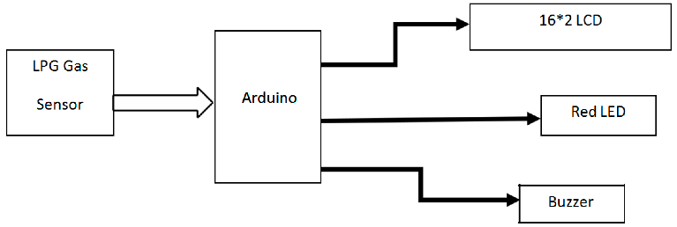

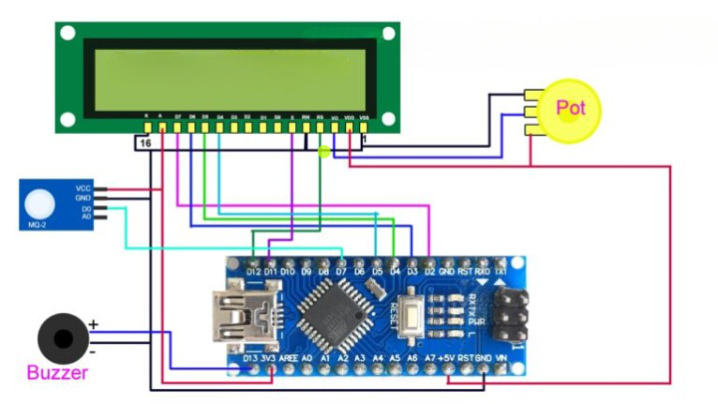
Fig -1: Figure

Charts
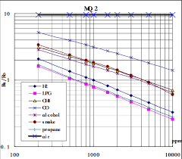
3. CONCLUSIONS

Finally, we conclude in recent households, the use of LPG is taking a big troll. From the use of cylinders up to the use of petroleum pipelines. The biggest threat to using this technology is security. And our project will prove to be boom for households and industries. A wide variety of leak detection techniques is available for gas pipelines. Some techniques have been improved since their first proposal and some new ones were designed because of advances in sensor manufacturing and computing power. However, each detection method comes with its advantages and disadvantages. Leak detection techniques in each category share some advantages and disadvantages. For example, all external techniques which involve detection done from outside the pipeline by visual observation or portable detectors can detect very small leaks and the leak location, but the detection time is very long. Methods based on the mathematical model of the pipe have good results at high flow rates while at low flow rates a mass balance-based detection system would be more suitable. Hybrid systems benefiting from the real-time detection capability of a software-based method and the high localization accuracy of a hardware-based technique, along with other specific advantages of both approaches, seem to be the future trend in gas leak detection. Selecting from the wide variety of commercial solutions available is ultimately an action that must be taken after assessing the needs of the system in which gas leak detection is needed. Gas leakage leads to severe accidents resulting in material losses and human injuries. Gas leakage occurs mainly due to poor maintenance of equipment’s and inadequate awareness of the people. Hence, LPG leakage detection is essential to prevent accidents and to save human lives. This paper presented LPG leakage detection and alert system. This system triggers LED and buzzer to alert people when LPG leakage is detected. This system is very simple yet reliable.

ACKNOWLEDGEMENT

I am profoundly grateful to Prof. ANUPAM CHOUDHARY for his expert guidance and continuous encouragement throughout to see that this project rights its target.

I would like to express deepest appreciation towards Dr. Varsha Shah, Principal RCOE, Mumbai and Prof. SHIBURAJ PAPPU HOD Computer Department whose invaluable guidance supported me in this project.

At last, I must express my sincere heartfelt gratitude to all the staff members of Computer Engineering Department who helped us directly or indirectly during this course of work.

- Wasimuddin Mallick
- Arshad Khan
- Shamimurraza Khan
- Sabir Khan

REFERENCES

[1] Mahalingam, A., R. T. Naayagi, and N. E. Mastorakis. "Design and implementation of an economic gas leakage detector." Recent Research in Applications of Electrical and Computer Engineering, pp. 20-24, 2012.
[2] Attia, Hussain A., and Halah Y. Ali. "Electronic Design of Liquefied Petroleum Gas Leakage Monitoring, Alarm, and Protection System Based on Discrete Components." International Journal of Applied Engineering Research, vol. 11, no. 19, pp. 9721-9726, 2016.
[3] Apeh, S. T., K. B. Erameh, and U. Iruansi. "Design and Development of Kitchen Gas Leakage Detection and Automatic Gas Shut off System." Journal of Emerging Trends in Engineering and Applied Sciences, vol. 5, no. 3, pp. 222-228, 2014.
[4] T.Soundarya, J.V. Anchitaalagammai, G. Deepa Priya, S.S. Karthick kumar, “C-Leakage: Cylinder LPG Gas Leakage Detection for Home Safety,” IOSR Journal of Electronics and Communication Engineering, vol. 9, no. 1, Ver. VI, pp. 53-58, Feb. 2014.
[5] Ashish Shrivastava, Ratnesh Prabhaker, Rajeev Kumar, Rahul Verma, "GSM based gas leakage detection system." International Journal of Emerging Trends in Electrical and Electronics, vol. 3, no. 2, pp. 42-45, 2013.
[6] Ch. Manohar Raju, N. Sushma Rani. An android based automatic gas detection and indication robot. In International Journal of Computer Engineering and Applications. 2014; 8(1).
[7] Zhao Yang, Mingliang Liu, Min Shao, Yingjie Ji Research on leakage detection and analysis of leakage point in the gas pipeline system. In Open Journal of Safety Science and Technology; 2011.
[8] S Shyamaladevi, V G Rajaramya, P Rajasekar, P Sebastin Ashok. ARM7 based automated high performance system for lpg refill booking & leakage detection. 2014; 3(2).
[9] Pal-Stefan Murvaya, Ioan Sileaa. A survey on gas leak detection and localization techniques.
Falohun A.S., Oke A.O., Abolaji B.M. Dangerous gas detection using an integrated circuit and MQ-9. In International Journal of Computer Applications. 2016; 135(7).
[10] Ashish Shrivastava, Ratnesh Prabhaker, Rajeev Kumar, Rahul Verma. GSM based gas leakage detection system. In International Journal of Technical Research and Applications. 2013; 1(2).

