Self Ordering System For Restaurants( Foodera)
Aroma Sinha¹, Pallavi Vishwakarma², Abhishek Yadav³ , Dr. Prachi Janrao⁴
¹Department of Computer Engineering, Thakur College Of Engineering and Technology (Student)
²Department of Computer Engineering, Thakur College Of Engineering and Technology (Student)
³Department of Computer Engineering, Thakur College Of Engineering and Technology (Student)
⁴Department of Computer Engineering, Thakur College Of Engineering and Technology (Mentor)

---------------------------------------------------------------------***---------------------------------------------------------------------
Abstract - Modern technology is expanding daily with new characteristics in the corresponding fields. Even today, in this era of technology, many restaurants still use the old-fashioned pen and paper method to take orders, which wastes a lot of time for both the restaurant and the customer. Several prior initiatives were made to introduce technology to the food service industries. After examining them, we came up with a solution that, in addition to helping restaurants save time and be more accurate, also collects customer feedback. With the help of the digital menu, which is included in this system, people may make orders electronically that will be sent directly to the chef, eliminating the need for waiters.

Key Words: Restaurants, Self-ordering, automation, less waiting time, digital menu, contactless ordering

1.INTRODUCTION

The standard of living has advanced along with the advancement of technology. Our lives are made easier and more convenient by technology, which has advanced in practically every industry. The food business is still behind other industries in adopting new technology, especially when it comes to process automation. Since restaurants and hotels continue to use a manual method involving paper and pens, table turnover has grown easier to manage despite the fact that everyone is aware that it can be challenging to maximize table turnover in the foodservice sector. As a restaurant owner, you want to serve the most customers and turn tables as frequently as you can. There are numerous strategies for a restaurant to increase table turnover.
Self-Ordering systems are becoming increasingly popular in restaurants due to the convenience and efficiency they provide. By using QR codes, restaurants can quickly and easily deploy self-ordering systems and begin reaping the many benefits. The most obvious benefit of self-ordering systems is the convenience they offer to customers. Instead of waiting in line to order food, customers can now scan a QR code and immediately place their order. This makes it easier for customers to get the food they want quickly and efficiently. Another benefit of self-ordering systems is that they can help to reduce customer wait times. When customers place their orders directly, restaurants are able to begin preparing the food faster than they would be able to if they had to manually take orders.
This can help to reduce customer wait times and help to improve customer satisfaction. Self-ordering systems can also help to reduce costs associated with human resources. By eliminating the need for a waitstaff, restaurants can save money on labor costs. Additionally, self-ordering systems can help to increase customer accuracy by making sure that orders are placed correctly and that customers receive exactly what they ordered. Finally, self-ordering systems can help to provide a more personalized customer experience. By allowing customers to customize their orders and view nutritional information, customers can make informed decisions about their orders and get exactly what they want. In conclusion, self-ordering systems can offer a wide range of benefits to restaurants. By using QR codes to deploy self-ordering systems, restaurants can begin to reap the benefits of convenience, reduced wait times, cost savings, and a more personalized customer experience quickly and easily.
When wait times get too long, customers may start to leave the restaurant, and the waitstaff may become impatient, which causes the area to become cluttered. This system offers a solution to all of these issues because, in today's society, everyone uses their phone for everything. As a result, we are suggesting an application that will allow users to order food using only their phone, without even interacting with a waiter. It improves the user experience while placing a meal order by giving the user a visual depiction of the item and allowing them to base their selection on the opinions of others.
QR Codes also allow restaurants to track customer orders, so they can identify trends in customer preferences and use this data to optimize their menus and improve customer service. Overall, QR Codes are a great way for restaurants to provide a better customer experience and increase efficiency. By leveraging the power of technology, restaurants can make ordering faster, easier, and more convenient for customers.

2. LITERATURE REVIEW

There are number of research papers which uses these technologies introduced in market to automate this system such as:
A. Robots as waiters
This system includes robots in the place of waiters to take orders it provided contactless services which is very much needed in this covid situation and also attracted customers but it has the same disadvantage as seen with waiters such as lack of robots, process becomes solve, maintenance and installation of robot is very costly and cannot be afforded by small restaurants, order get changed, customization not possible etc.
B. Converting table into screen
This process included converting the table into the screen in this when a customer wants to order something he just simply click on their touch screen table and can place the order from their itself but this system also had drawback as installation is costly and it required proper maintenance and since it is a restaurant, table damage is common and due to which it damage the screen placed on table as well.
C. Computer based ordering
In this process the customer goes to the cashier place the order do the payment and then wait for their order to get ready, but this system fails during rush hours since there is a big line to place the order and it takes time for a person to decide their order it increases the waiting time for others as well and also if a customer needs to order something new he needs to go again to the cashier and do the same process again.
We have a conducted a survey in the form of multiple choice to find out what is the expectation of the customer .

Survey questions and their individual analysis:

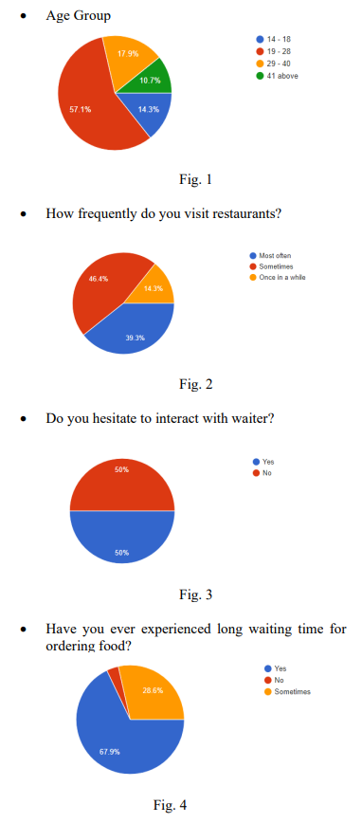

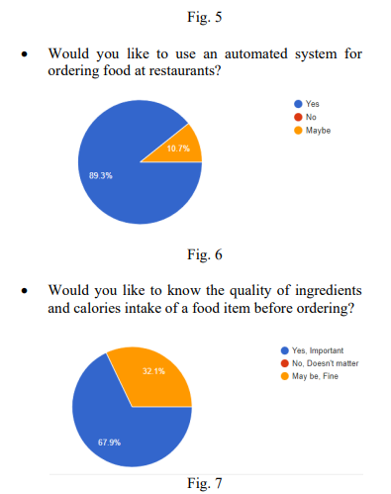
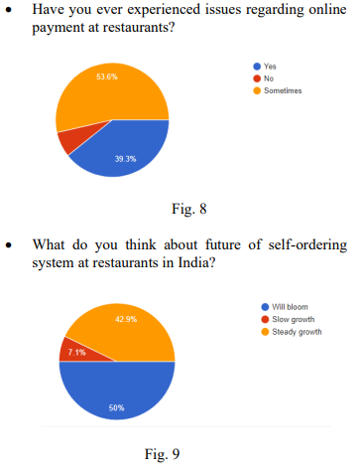

3. PROBLEM STATEMENT
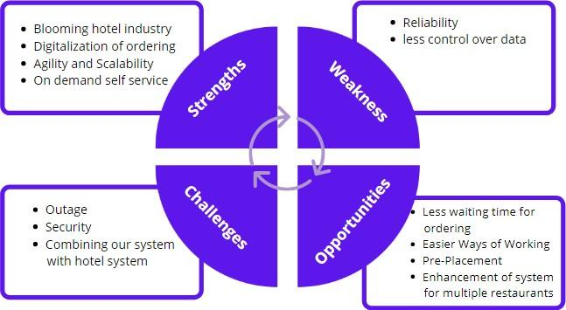
As the technology is increasing but still in restaurant, we use the same old-fashioned way of ordering food were waiter write the orders from customers, takes these orders to the kitchen, updates them in records, delivers the ordered of food items at the exact table and then makes the bill and as we all know It doesn’t matter where your table is within a restaurant, you can never find a waiter when you want your bill or when you want to order another drink.
Key issues
- ● In this Covid situation people wants contactless service.
- ● Fewer Staff increases waiting time for ordering food.
- ● While ordering large amount of food in restaurants people don't have an idea of bill amount which can create problem at the end.
- ● Introverts’ interaction problem with waiters.
- ● Getting orders wrong mistake is a classic.
- ● customized orders are often neglected by waiters.
- ● Allergic/Vegan etc. people face problems while ordering food because waiters don't know the exact ingredients in the food.

4. METHODOLOGY

This project proposes a solution to design a self-ordering system named as foodera using an android application for ordering the food. This system works when a user scans the QR code placed on the table and download the application and after login he will be able to see the digital menu and through that he can place the order and can also see the description, calories, ingredients and can choose the best dish by seeing ratings and feedback and if he wants, he can customize it as well once the order is decided customer needs to pay to place the order once the payment is not done E-Bill will get generated.
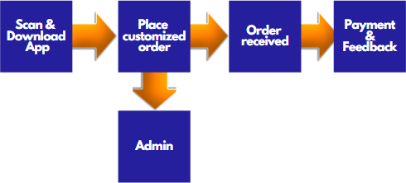
Fig. 10 System Architecture
The process begins with the arrival of the customers. If there are available seats, the waiter will assist the customers to the available table. But if not, the customer will have to wait until seats become available. When seated, waiter will hand the menu and ask for their orders The customers will then choose their orders from the menu and the waiter will give them to the kitchen staff and to the cashier, so that the cashier will be able to initially process the customer’s bill. The kitchen staff will prepare the orders that the waiter will serve. Once finished, the customer will ask for the bill from the waiter, and the waiter will get it form the cashier. After receiving the bill, the customer will then pay the bill.

Fig. 11 SWOC Model
Upon sending of customer orders, the kitchen staff can be notified by the system as to the table number, order quality and descriptions. Once the orders are completed, the kitchen staff will notify the waiter thru the app. Payment Module The customer may use the app in viewing his bill for payment. The cashier can print an Official Receipt if the customer wants a copy. Below is the screenshot of the Payment Module
The results show some areas for improvement in the quality of their service and Responsiveness maybe considered as critical factor.
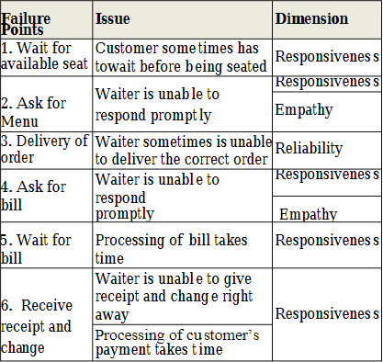
Table no: 1 Failure Points of the Restaurant’s

5. RESULT AND DISCUSSION
This system has developed a user friendly which can be used by anyone very sufficiently. The customer will scan the QR Code which is placed on the table. Then the customer will be redirected to the ordering site and may choose the order from the menu. The menu indicates the quantity of the customer’s order and the customer must click the “add to cart” option to complete the order. The app will show if the order is successfully added to the cart. If the notification of the successful ordering does not pop up, then the order is not added to the cart. When the customer accesses their cart, it will show the summary of their order. When a customer is ready to submit order, he
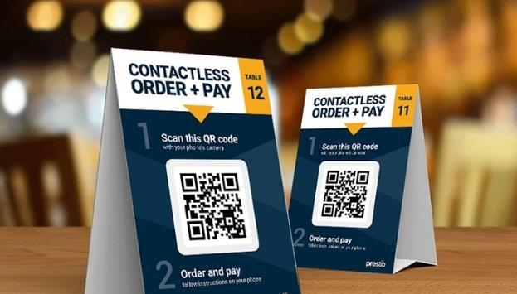
then clicks “Submit Additional Order”. System will ask for confirmation (Figure 4) since customer is not allowed to cancel their order once submitted. These orders will be received by kitchen staff.

Fig. 12 QR Code Scanner
Design Prototype
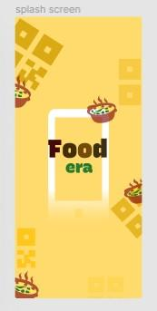
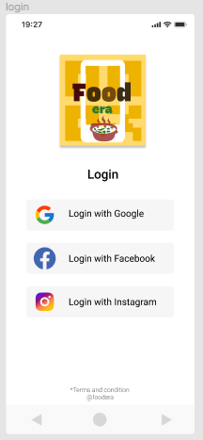

Fig. 13 Splash Screen Fig. 14 Login Page

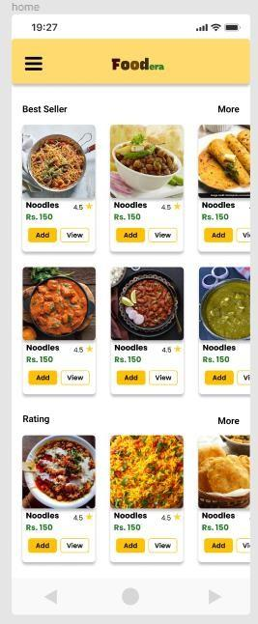
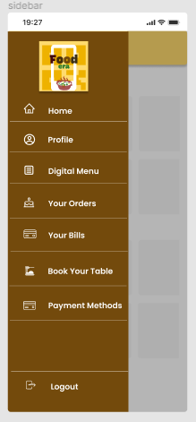

Fig. 15 Home screen Fig. 16 Side Drawer

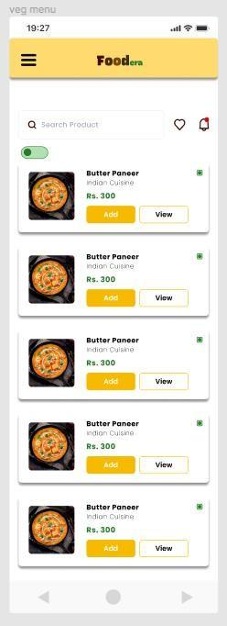
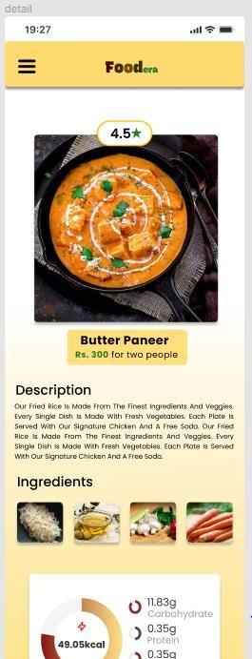

Fig. 17 Digital Menu Fig. 18 Detail view of item

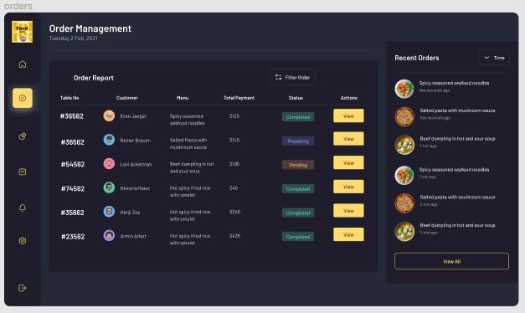
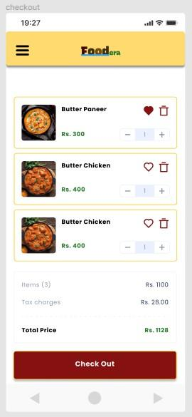
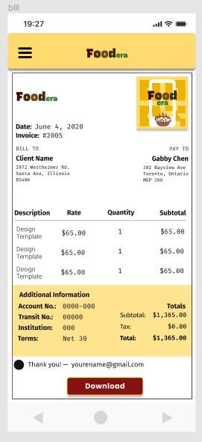

Fig. 19 Checkout Fig. 20 Bill
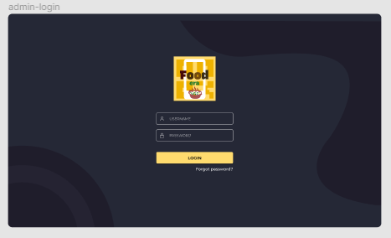
Fig. 21 Admin Login Page
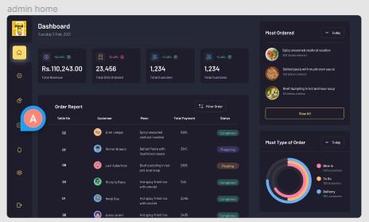
Fig. 22 Admin Home Page

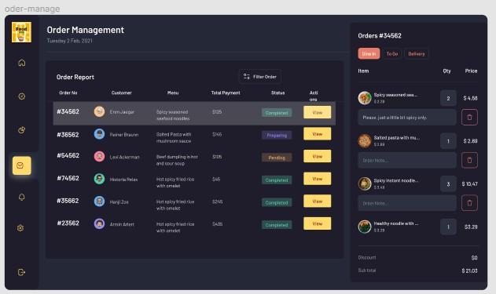
Fig. 23 Admin Order Management

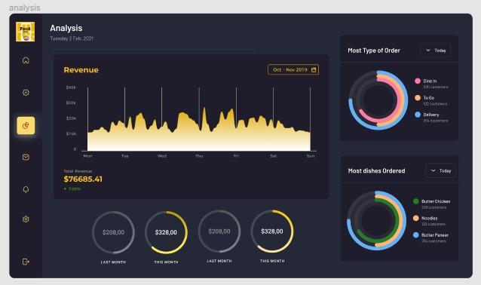
Fig. 24 Detail Order View

Fig 25. Analysis Charts
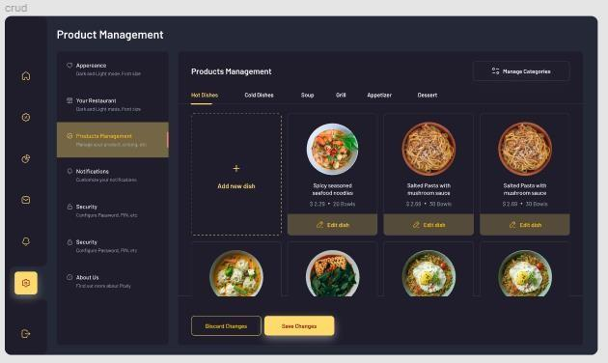
Fig. 26 Menu Management

6. FUTURE SCOPE

The future scope of self-ordering systems for restaurants using QR codes is quite promising. Here are some potential benefits and opportunities:
1. Improved efficiency: Self-ordering systems can increase efficiency by reducing wait times and allowing customers to order at their own pace. This can lead to an increase in customer satisfaction and a decrease in labor costs for the restaurant.
2. Contactless ordering: In the wake of the COVID-19 pandemic, many customers are looking for contactless ordering options. Self-ordering systems that use QR codes can provide a safe and hygienic way for customers to order without having to touch a menu or interact with a server.
3. Personalization: Self-ordering systems can allow customers to customize their orders based on their preferences and dietary restrictions. This can lead to increased customer satisfaction and loyalty.
4. Data collection and analysis: Self-ordering systems can collect data on customer orders, preferences, and behavior. This data can be used to optimize menu offerings, improve customer service, and increase revenue.
5. Upselling opportunities: Self-ordering systems can suggest additional menu items or promotions to customers based on their order history or preferences. This can lead to increased sales and revenue for the restaurant.
Overall, the future of self-ordering systems for restaurants using QR codes is bright, with potential benefits for both customers and businesses. As technology continues to advance, we can expect to see more sophisticated and seamless self-ordering systems in the restaurant industry.
7. CONCLUSION
This suggested method has the potential to bring people into the restaurant and improve their dining experience. It would also assist in realising the vision of a digital India. It will facilitate this process and make the task at the restaurant much simpler and more effective. Although it won't be cost-effective for restaurants to reduce the amount of staff needed for order taking, they will be more efficient with table turnover and be able to serve more customers in a shorter amount of time.
Additionally, a feature for inventory control should be included to prevent overstock and understock. The experts advise adding a feature that can keep track of employee salary and tips. The manual monthly payroll recording will be automated thanks to this feature. This can cut down on errors and ensure that documenting absences and calculating leaves can be done quickly. Due to the restaurant's centralised tipping policy, this function will assist in calculating the tips based on the days and hours that each employee works to ensure a fair distribution of tips. Additionally, for further advancements, data visualisation techniques that make it simpler for analysts to understand data and make informed decisions must be incorporated.

ACKNOWLEDGEMENT
We gratefully acknowledge the support, guidance, and encouragement of my Dissertation Guide Associate Professor Dr. Prachi Janrao ma’am for this novel work.

REFERENCE

[1] http://www.ijasret.com/VolumeArticles/FullTextPDF/33 9_2.DIGITAL_WAITER_AND_ROBOTIC_DELIVERY_SYSTEM.pdf

[2] http://oaji.net/articles/2017/1992-1525780576.pdf

- https://www.researchgate.net/publication/351600639_Service_digitalization_a_marketing_tool_for_post_Covid- 19_competitiveness_among_fast_food_restaurants_in_Port_Harcourt_Innovative_Journal_of_Accounting_and_Manage ment_Research_71_1-10

- https://steelkiwi.medium.com/restaurant-automation-top- 4-ways-to-increase-table-turnover-at-a-restaurant- b2a72e8f5e2b

- https://www.restaurantindia.in/article/the-rise-of-digital-waiters-why-voice-based-ordering-is-next-big-trend.13988

- H.Kristin (July 14, 2014) “Most Common Restaurant Complaints Include Dirty Forks, Wrong Checks”. Retrieved from https://www.thrillist.com/eat/nation/most-common-

- Ramini, P. C. (2016). Restaurant Guest Service System And Method. Retrieved from https://patentimages.storage.googleapis.com/db/84/dd/a12e6 05f30bad6/US20160055598A1.pdf

- Cox, S., & Shiffler, R. (2014). Extent of QR Code Adoption by Consumers. Internation Journal of Business, Humanities and Technology, 4(6).

- Rodgers, D. M., & Forbes, R. (2015). Ordering method and system for restaurants. Retrieved from https://patentimages.storage.googleapis.com/11/18/e6/01ba0 f0a13300f/US9117231.pdf

- Gagić, S. (2016). Restaurant innovativeness: A case study of Vojvodina. The European Journal of applied economics, 13(2), 57-69.

- H. C. Wu and Z. Mohi, “Assessment of Service Quality in the Fast-Food Restaurant,” J. Foodserv. Bus. Res., vol. 18, no. 4, pp. 358–388, 2015.

- Gagić, S. (2016). Restaurant innovativeness: A case study of Vojvodina. The European Journal of applied economics, 13(2), 57-69.

- J. Torres Fragoso and I. Luna Espinoza, “Assessment of banking service quality perception using the SERVPERF model,” Contaduría y Adm., vol. 62, no. 4, pp.1294-1316, 2017.

- J. R. Groff, P. N. Weinberg, and M. Osborne, SQL :
The Complete Reference , Second Edition

- What is Bootstrap and How Do I Use It? Retrieved from https://www.taniarascia.com/what-is-bootstrap-and- how-do-i-use-it/

- What Is Windows Communication Foundation Retrieved from https://docs.microsoft.com/en- us/dotnet/framework/wcf/whats-wcf

