Design And Fabrication of Power Hacksaw Machine
Prof R. S. Gadakh¹, Prof. P. G. Londhe², A. S. Sonawane³, P.R. Sonawane⁴, N. R. Gogawate⁵,
A. J. Dhanwate⁶
¹ Principal S.S.M.A.P. Chas Ahmednagar
² HOD of Mechanical Department S.S.M.A.P. Chas Ahmednagar
³,^{4,5,6} Students of S.S.M.A.P. Chas Ahmednagar

---------------------------------------------------------------------***---------------------------------------------------------------------
Abstract - The hacksaw machines, which are operated by human operators as for mentioned, have the demerit of required more time for cutting the work-piece. In industries these machines are used to cut the motor shafts to the required lengths. It will be difficult for the operator if he has been assigned to cut a motor shafts and he has to measure the lengths each time for cutting. Since humans are not as versatile as machines, there is a possibility that there may be inaccuracies. Besides, if there is a slight time delay in between every cycle of cutting a piece, the cumulative delay in time will be found to have a considerable magnitude, which might have been utilized properly if the proposed machine were in use there. Also pneumatic hacksaw is costly and require more maintenance. Hence by consuming electrical energy we run our project.

Key Words: hacksaw, electrical energy etc.

1.INTRODUCTION
1.1 POWER HACKSAW
The Power hacksaw machine though being able to cut the shaft or rod without requiring any human effort to cut, it does require a human intervention to feed the work-piece many times with measurements being taken each time before feeding. Therein, arose a need to completely automate the process of cutting, and here we are with a proposal which will aid in eliminate the effort of the people associated with it.
1.2 OBJECTIVE OF THE PROJECT
The manual hacksaw machines, which are operated by human operators having limitation of size of work-piece many times. In industries these machines are used to cut the motor shafts to the required lengths. It will be difficult for the operator if he has been assigned to cut a huge quantity of motor shafts and he has to measure the lengths each time for cutting.

2. SLIDER CRANCK MECHANISM
Slider-crank chain inversion arises when the connecting rod, or coupler, of a slider-crank linkage becomes the ground link, so the slider is connected directly to the crank. This inverted slider-crank is the form of a slider-crank linkage that is often used to actuate a hinged joint in construction equipment like a crane or backhoe, as well as to open and close a swinging gate or door.
A slider-crank is a four-bar linkage that has a crank that rotates coupled to a slider that the moves in straight line. This mechanism is composed of 3 important parts: The crank which is the rotating disc or link, the slider which slides inside the tube and the connecting rod which joins the parts together. As the slider moves to the right the connecting rod pushes the wheel round for the first 180 degrees of wheel rotation. When the slider begins to move back into the tube, the connecting rod pulls the wheel round to complete the rotation.

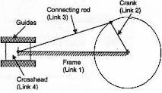
Fig -1: Slider crank mechanism

3. CONSRUCTION AND WORKING
3.1 CONSTRUCTION
The project consist of following main parts.
- Frame
- battery
- wiper motor
- slider Crank mechanism
- Hacksaw
- Guide Mechanism
- Bench Vice
3.2 WORKING
When we start the wiper motor then crank of wiper motor gets rotates. Due to this slider crank mechanism oscillates the connecting rod and hacksaw acts as slider. Hence due to rotation of crank hacksaw gets reciprocating motion in the guide pipe.
This reciprocating motion of hacksaw cutter is useful for cut the work-piece which held in the bench vice.
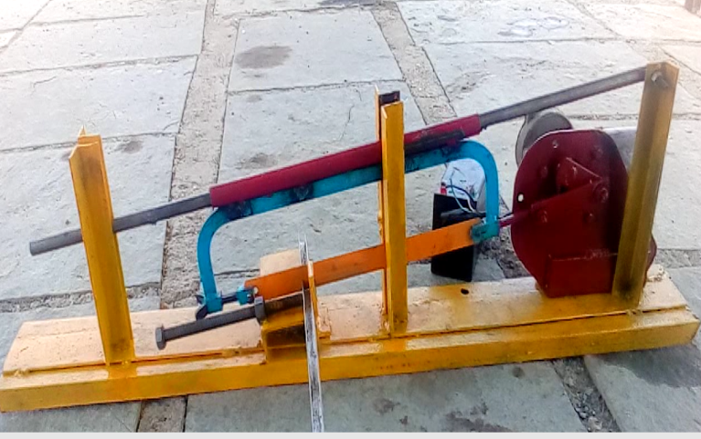
Fig -2: Power Hacksaw
4. DESIGN OF PROJECT
4.1 MATERIAL SELECTION
The proper selection of material for the different part of a machine is the main objective in the fabrication of machine. For a design engineer it is must that he be familiar with the effect which the manufacturing process and heat treatment have on the properties of materials. The choice of material for engineering purpose depends upon the following factors.
1. Availability of the materials.
2. Suitability of materials for the working condition in service.
3. The cost of materials.
4. Physical and chemical properties of material.
5. Mechanical properties of material.
The mechanical properties of the metals are those, which are associated with the ability of the material to resist mechanical forces and load. We shall now discuss these prosperities as follows. Required properties for the selection of material are Strength, stress, stiffness, elasticity, plasticity, ductility, brittleness, toughness, resilience, creep, hardness. The science of the metal is a specialized and although it overflows in to realms of knowledge it tends to shut away from the general reader. The knowledge of material and their properties is of great significance for a design engineer. The machine elements should be a material which has properties suitable for the conditions of operations. In addition to this a design engineer must be familiar with the manufacturing processes and the heat treatments have on the properties of the materials. In designing the various part of the machine it is necessary to know how the material will function in service. For this certain characteristics or mechanical properties mostly used in mechanical engineering practice are commonly determined from standard tensile tests. In engineering practice, the machine parts are subjected to various forces which may be due to either one or more of the following.
1. Energy transmitted
2. Weight of machine
3. Frictional resistance
4. Inertia of reciprocating parts
5. Change of temperature
6. Lack of balance of moving parts
The selection of the materials depends upon the various types of stresses that are set up during operation. The material selected should with stand it. Another criterion for selection of metal depends upon the type of load because a machine part resist load more easily than a live load and live more easily than a shock load. Selection of the material depends upon factor of safety which in turn depends upon the following factors.
1. Reliabilities of properties.
2. Reliability of applied load.
3. The certainly as to exact mode of failure
4. The extent of simplifying assumptions.
5. The extent of localized.
6. The extent of initial stresses set up during manufacturing.
7. The extent loss of life if failure occurs.
8. The extent of loss of property if failure occurs.
9. Materials selected in machine.
5.MANUFACTURING PROCESS SHEET
5.1 Frame
Row Material: angle 1’’
Plate 2” width
Table 5.1 Process sheet of Frame
Sr. No. | Process | Machine tool | Time | Cost
01 | Angle and plate cutting | Grinding Cutter | 10 min. | 80
02 | Holes on angle for motor | Drilling machine | 10 min. | 40
03 | Fabrication of all above | Arc Welding | 20 min | 200
Total |  |  | 40 min. | 320

5.2 slider crank mechanism
Row Material: link plate 1” width
Table 5.2 Process sheet of slider crank mechanism
Sr. No. | Process | Machine tool | Time | Cost
01 | Link plate | Grinder Cutter | 5 min. | 50
02 | Holes on link | Drilling m/c | 5min. | 20
Total |  |  | 25 min. | 70

5.3 Holding and guiding device
Row Material: pipe, shaft13mm and 1” angle
Table 5.3 Process sheet of holding and guiding
Sr. No. | Process | Machine tool | Time | Cost
01 | Pipe, Shaft and angle cutting | Grinding cutter | 15min. | 100
02 | Fabrication of pipe to hacksaw | Arc Welding | 5 min | 20
03 | Fabrication of angle to frame | Arc welding | 10 min. | 50
04 | C channel cutting | Grinding cutter | 10 min. | 50
05 | Fabrication of c channel to frame | Arc welding | 10 min. | 50
06 | Fabrication of nut and plate to C channel | Arc welding | 10 min. | 50
Total |  |  | 1 hr. | 320

6. OUTCOMES
6.1 ADVANTAGES
Some of the basic merits of the Pneumatic powered hacksaw are as follows:-
1. Semi automatic machine, no need of man power during its working.
2. It can work efficiently in the work environment which is not suitable for workers, like heated zone in industry, smoky gas area, toxic gases. Hence reduces life risk.
3. Very helpful for the manufacturing industries having mass production.
4. Reduces labour cost as only one worker can operate two or three machines simultaneously.
5. Less power consumption as compared to other motorized power hacksaw.
6. No need of compressed air.
7. Less costly than other power hacksaw.
6.2 LIMITATIONS
1. Large cross section work piece takes more time.
6.3 APPLICATIONS
Applications of motor powered hacksaws are:-
1. Power hacksaw can be used in used in mass production industries for quick cutting operations.
2. It can be used in automating the industry.
3. It can also be used in the workshops.
4. It can be used in locations where regular power cuts are seen.
5. It can be used to reduce the labour cost and in areas where less labour is available.

6. CONCLUSIONS

In that way for reducing labor effort we have introduced power hacksaw run by wiper motor which consumes electrical energy. It can work efficiently in the work environment which is not suitable for workers, like heated zone in industry, smoky gas area, toxic gases. Hence reduces life risk. It Very helpful for the manufacturing industries for mass production. It reduces labour cost as only one worker can operate two or three machines simultaneously also Less power consumption as compared to other motorized power hacksaw.

REFERENCES

1. “Experimental Investigation of Pedal Driven Hacksaw” 1Sreejith K., 2Aravind K., 3Danie Davis, 4Farish K.A., 5George Johnson , Vol.4, Issue 7 (July 2014), International Journal of Engineering And Science
2. “Design and Fabrication of Automated Hacksaw Machine”, D.V.Sabariananda1, V.Siddhartha1, B.Sushil Krishnana1, T.Mohanraj2, Volume 3, Special Issue 2, April 2014, IJIRSET
3. “Automated Double Hacksaw Cutter”, Tanuj Joshi, IJERT, Vol. 7 Issue 07, July-2018
4. R. S. Khurmi and J. K .Gupta, “A textbook of Machine Design”, S Chand Publication

