Implementation of Web of Things based Smart Grid

Megha C. Gambhire
Student
Department of Electronics and Telecommunication
Government College of Engineering, Karad, INDIA
gambhiremegha10@gmail.com

Utkarsha J. Desai
Student
Department of Electronics and Telecommunication
Government College of Engineering, Karad, INDIA
utkarshadesai1308@gmail.com

Abstract: The search for sustainable energy models is the main factor helping research on smart grid technology. This paper describes a Smart Grid architecture implemented with the help of Web of Things. The goal of the Smart Grid architecture using Web of Things (WoT) is to provide the switching of power sources to the consumers by making maximum use of solar energy source. The Web of Things comprise of a set of Web services provide along with number of Internet enabled Embedded devices. The Web browser on any computer can act as an interface to the services provided by this Web of Things. The Embedded devices are NodeMCU ESP8266 with internet capabilities. The Web interfaces provide us information on status of power source in use and communicate to the embedded internet devices using WiFi.

Keywords: Smart Grid, Web of Things, NodeMCU, Power switching, Solar energy

I.INTRODUCTION

Rising energy demands, depletion of natural resources and increasing costs make energy conservation a universal problem with tremendous environmental, political and social implications. The future of energy in the world today is focusing more and more on alternative energy sources instead of fossil fuels which are becoming more and more costly. renewable energy is promising to become the future energy source around the world and National renewable energy markets are motivated to continue to grow increasingly in the upcoming years. Also, they do not generate any hazardous forms of pollution that affect the environment. But these resources are dependent on environmental condition and Location. Use of renewable energy sources in household electrification has always proved as the
Priyanka B. Agwan
Student
Department of Electronics and Telecommunication
Government College of Engineering, Karad, INDIA
priyankaagwan2017@gmail.com

Shrushti C. Langore
Student
Department of Electronics and Telecommunication
Government College of Engineering, Karad, INDIA
shrushtilangore@gmail.com

useful method to reduce the amount of CO2 emissions. The use of alternatives like solar energy at home help to reduce individual carbon emission footprint upon the environment. When we consider power "Grid," they're referring to the transmission system for electricity. The electricity grid is a complex, hard to implement and maintain but one of the important systems. Power generated at a variety of facilities and also fed towards end users, often over long distances. It provides electricity to a
Commercial buildings, High-Schools, industrial Sector Agricultural & homes. And it does so every minute of every day, year-round.
Web of Things (WOT), explicitly “the Internet in which all the things parallel to each other”, is the huge extension and expansion of Internet network Building the smart grid means using workstation to work in more efficient way for the reliability. It can also accommodate more solar power and wind power, which are uneven sources of energy that can become more efficient with better controls. A smart grid system uses mostly because of its flexibility and Reliable to use and maintain (both economic and energy efficient) of the electric system from large production through the delivery systems to Customers as well as Consumers.

II.RELATED WORK

As n number of devices are working together along with the Internet, the next logical thing to do is to use the World Wide Web and its associated technologies as a platform for smart things. In this type of architecture using infrared interfaces or bar codes on objects, users could reacquire the URI of the page simply by connecting with the thing. Another way to use the Web for practical world things is to embed smart things into a standardized Web service architecture.
In practice, this would often be too complicated and heavy for simple objects. In the Web of Things concepts, smart things and its services are completely integrated in the Web by reusing adapting technologies and patterns regularly used for traditional Web content. More precisely, very small-scale Web servers are integrated into smart things and the REST architectural method is applied to resources in the actual world.
The smart grid is expected to spread the information of the energy distribution and control system from central core to many end nodes, thus enabling more precise monitoring of energy losses as well as more accurate control and adaptation. The concept and objectives of such intelligent nodes are also used in a smart home in Melbourne, Victoria, Australia that has installed solar panels on the roof for local electricity generation and batteries for energy storage.
The architecture for the cyber-physical system considered with smart grid consists of three layers. Layer 1 has physical appliances and their control and sensing using Low Pan smart plugs. The smart plugs connect with a router which acts as the Gateway Layer. Application Layer enables householders to acquire required information from the web and visualize their power consumption in various formats on various devices. The smart home network is connected to a smart meter and smart grid. In particular, the ZigBee, Bluetooth, RFID and Home plug appliances are working on the definition of wireless and wired interoperable profiles suitable for the smart grid. The academic interest toward smart grid is spinning up as well: IEEE recently introduced conferences and journals specifically addressing SG-related topics.

III. FLOWCHART

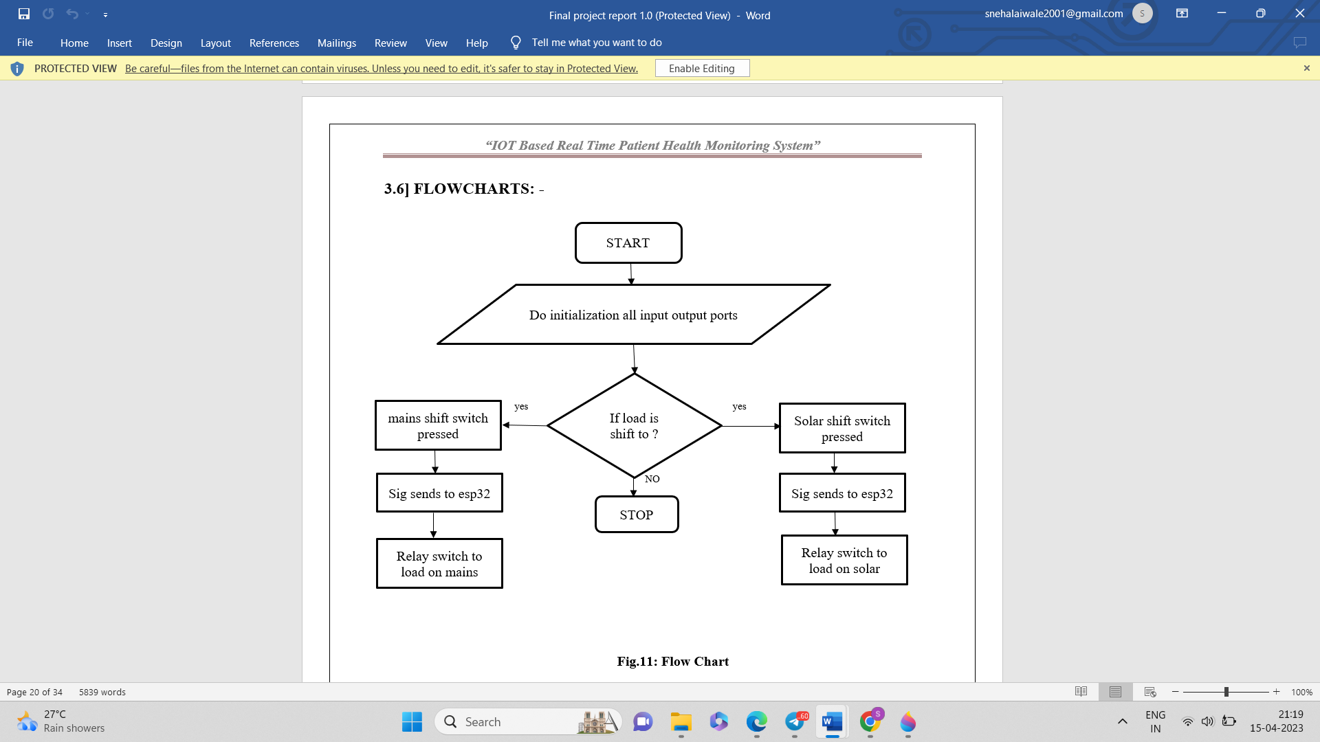

IV. BLOCK DIAGRAM

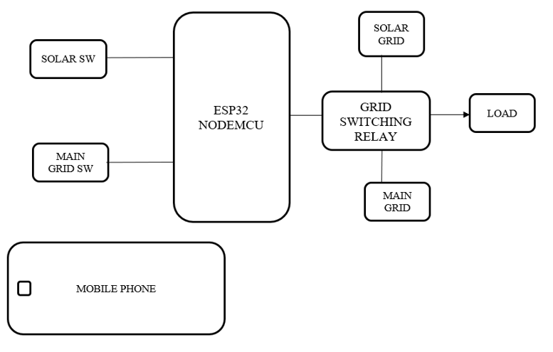
Above block diagram we are using ESP32 NodeMCU microcontroller for controlling all the aspects. At input section we are used virtual pins to sense input from mobile device.
- Block 1 – Mobile device with Blynk. By using mobile device, we are monitoring the system on the field at any ware. Also, we are using mobile as display.
- Block 2 – ESP32 NodeMCU. In this device we are connecting all inputs and outputs to this controller. This is WIFI device which is connected directly to the pre-set Wi-Fi connection. By using this we are connecting our all device to cloud.
- Block 3 – physical switch for solar grid shifting it connected to ESP32 at input side.
- Block 4 – physical switch for main grid shifting it connected to ESP32 at input side.
- Block 5 – Is for solar grid representation.
- Block 6 - Is for main grid representation.
- Block 7 – Grid switching relay it will switch grit to solar either main grid.
- Block 8 – this block is representing load.

V. CASE STUDY
CASE 1: Solar grid switching:
In this case when we want to switch our load on solar grid then we are pressing button which is solar grid shift button. Then it sends signal to ESP32. ESP32 will process the signal and send high pulse to relay module to switch solar grid from previous on. In solar side solar panel will generate electricity and store in battery and inverter will convert that DC supply into AC.
CASE 2: Solar grid switching Web based Notification:
After we switching that grid on solar for notification, we are sending alert mail on email. When is grid turn on then “solar grid ON” mail will be sent to respective person. When we switching another grid the it sends “solar grid is OFF” on email.
CASE 3: MSEDCL mains grid switching:
In this case when we want to switch our load on MSEDCL mains grid then we are pressing button which is MAINS grid shift button. Then it sends signal to ESP32. ESP32 will process the signal and send high pulse to relay module to switch MSEDCL mains grid from previous on.
CASE 4: MSEDCL mains grid switching Web based Notification:
After we switching that grid on MSEDCL mains for notification, we are sending alert mail on email. When is grid turn on then “MSEDCL mains grid ON” mail will be sent to respective person. When we switching another grid the it sends “MSEDCL mains grid is OFF” on email.
CASE V: Both grids switching power measuring:
We demonstrating on single phase supply then we use 230v – 250v AC supply from MSEDCL and by generating. Here is the measured power while demo. As per our requirements we turn on our MSDECL supply from evening only that’s why our power will save.
VI. CONCLUSION
By using solar grid along with traditional grid, we not only reduce CO2 emission but also cut down our expenses for electricity. While the switching is performed by basic relay modules it can be easily implemented wherever required. Further improvement that can be done in this project is synchronising with 3 phase AC supply. Also, automatic switching can be done using voltage and current sensors by calculating the electricity supply from solar grid.
VII. REFRENCES
[1] Saswat Mohanty, Bikash Narayan Panda, Bhawnani Shankar Pattnaik, “Implementation of a Web of Things based Smart Grid to remotely monitor and control Renewable Energy Sources.”, 2014 IEEE Students’ Conference on Electrical, Electronics and Computer Science
[2] Andreas Kamilaris, Yiannis Tofis, Chakib Bekara, Andreas Pitsillides and Elias Kyriakides “Integrating Web-Enabled Energy Aware Smart Homes to the Smart Grid”, Department of Computer Science, Networks Research Laboratory, University of Cyprus, International Journal on Advances in Intelligent Systems, Vol. 5 no 1&2, year 2012.
[3] Mahesh Hiremth, Prof: Manoranjan Kumar, “INTERNET OF THINGS FOR ENERGY MANAGEMENT IN THE HOME POWER SUPPLY”, International Journal of Research in Science and Engineering e-ISSN: 2394-8299 Volume: 1 Special Issue: 2 pISSN: 2394-8280
[4] Sita Ramakrishnan, Subramania Ramakrishnan “WoT (Web of Things) for Energy Management in a Smart Grid-Connected Home: Issues in Informing Science and Information Technology Volume 10, 2013
[5] N Bui, A.P. Castellani, P. Casrani and M. Zorzi, “The internet of energy: a web-enabled smart grid system,” Network, IEEE, vol.26, no.4, pp.29,45, July-August2012
[6] Dominique Guinard, Vald Trifa and Erik Wilde, “A Resource Oriented Architecture for the Web of Things”, Proc. Of IoT 2010 (IEEE International Conference on the Internet of Things), Tokyo, Japan Nov. 29 2010-Dec. 1 2010, ISBN:9781-4244-7413-4

