Theft detection in shopping cart using IR sensor.

Shobhit Kumar Chinmay Chinchole
Department of Computer Technology Department of Computer Technology
K. K. Wagh Polytechnic, Nashik, India K. K. Wagh Polytechnic, Nashik, India
skumarmmr225@gmail.com chinmaychinchole10@gmail.com

Prasad Loanre Kunal Bagade
Department of Computer Technology Department of Computer Technology
K. K. Wagh Polytechnic, Nashik, India K. K. Wagh Polytechnic, Nashik, India
prasadlonare321@gmail.com bagadekunal4@gmail.com

Prof. R.Y.Thombare
Department Of Computer Technology
K. K. Wagh Polytechnic, Nashik, India rythombare@kkwagh.edu.in
Abstract  The advent of wireless technology along with other communication techniques has helped in making electronic commerce very popular. A modern forward-looking product aids comfort, convenience, and efficiency in everyday life. In this paper, we discuss an innovative concept of electronic Shopping. The key idea here is to assist a person in everyday shopping in terms of reduced time spent while purchasing a product. The main goal is to provide a technology-oriented, low-cost, easily scalable, and rugged system for aiding shopping in person. Electronic Shopping is equipped with an RFID reader for product identification; it also has an LCD that informs customers about product prices, offers |  | and the total bill. The RFID reader identifies the product and updates the bill. When the customer is done with shopping, he can just press the End shopping button, and the details are displayed on display then the customer has to pay just the amount and leave.  These units are integrated into a smart enclosed system and are tested to satisfy the functionality. The customers will be able to scan the items themselves and the LCD screen on the shopping trolley will keep updating the total. This will turn out to be very beneficial for the retail stores as more people will enjoy the shopping experience and come more often to shop.  Keywords: IoT Based Smart Trolley Cart, Smart shopping cart, Advanced
Shopping Trolley

- Introduction:
The electronic shopping system intends to assist shopping in person which will minimize the time spent shopping as well as intended to aid the store management with real-time updates on the inventory. The emergence of new technologies, such as RFID scanners and wireless networks, makes the shopping processes faster, more transparent, and more efficient. We aim to develop a shopping system that can be used in shopping malls to solve the problem mentioned above. The Shopping system is equipped with an RFID scanner for product identification. Besides, it also has an LCD that informs customers about product prices, discounts, offers, and the total bill. As soon as the object is purchased, the RFID reader identifies the product and updates the bill. When the customer is done with shopping, he can just press the 'End shopping' button, and the details are displayed the customer has to pay online just the amount and leave.
The proposed system is easy to use and does not need any special training. In this system, there is an inbuilt automatic billing system that makes shopping a breeze and has other positive spin-offs such as freeing staff from repetitive checkout scanning, reducing the total number of staff required, and increasing the operational efficiency of the system, an excellent way to help customers reduce the time spent in shopping by displaying the list of products, their cost, the best deals/rates on the products and automatic billing. The system helps the store manager with an automatic update of the inventory on every purchase of an item shopping system has the potential to make shopping more pleasurable and efficient for the shopper and the inventory control easier for the store management. The shopping system has the potential to make shopping more pleasurable and efficient for the shopper and the inventory control easier for store management.
- Proposed Working:
The proposed system is easy to use and does not need any special training. We aim to develop a shopping system that can be used in shopping malls to solve the problem. The Shopping system is equipped with an RFID scanner for product identification. Besides, it also has an LCD that informs customers about product prices, discounts, offers, and the total bill. As soon as the object is purchased, the RFID reader identifies the product and updates the bill. When the customer is done with shopping, he can just press the ‘End shopping’ button, and the details are displayed the customer has to pay online just the amount and leave.
In this system, there is required, and increasing the operational efficiency of the system is an excellent way to help customers reduce the time spent shopping by displaying the list of products, their cost, the best deals/rates on the products, and automatic billing. The system helps the store manager with an automatic update of the inventory on every purchase of an item shopping system has the potential to make shopping more pleasurable and efficient for the shopper and the inventory control easier for the store management. The shopping system has the potential to make shopping more pleasurable and efficient for the shopper and the inventory control easier for store management.

- Overview:

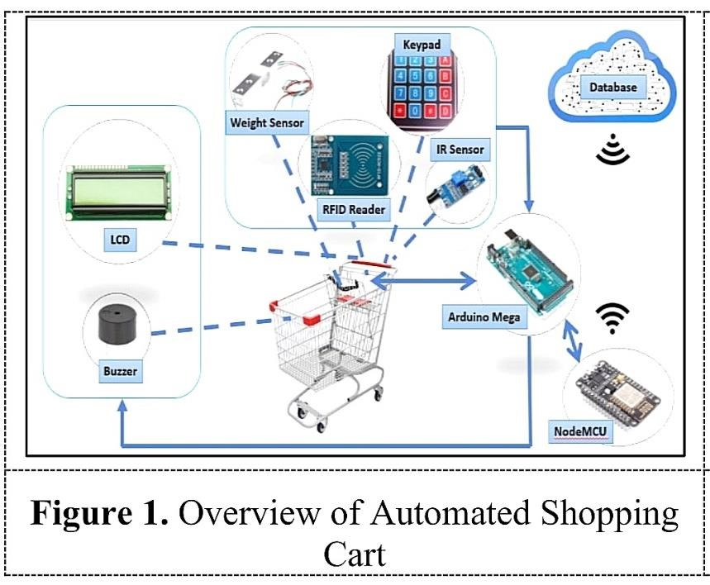

- System Prototype:

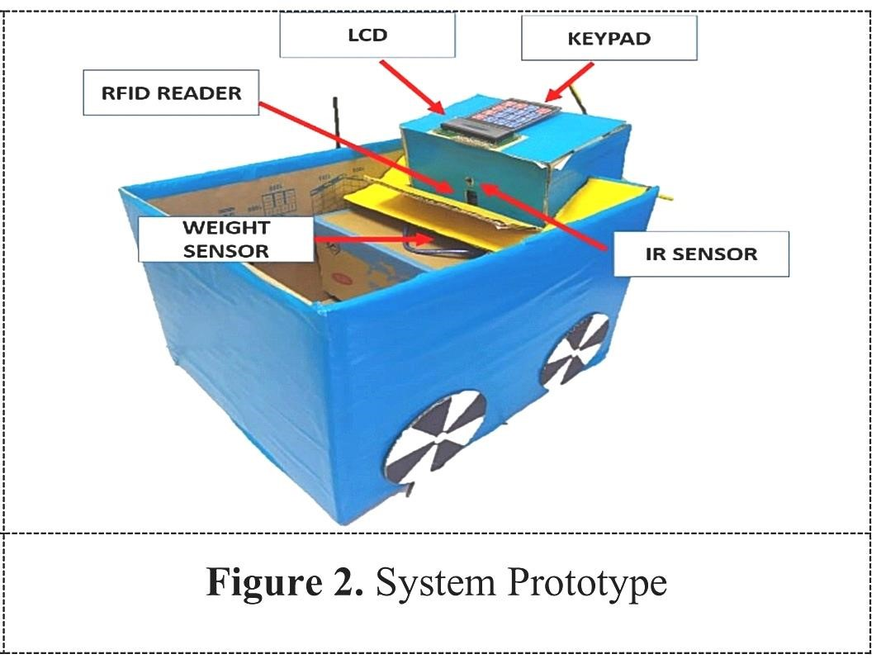
The Shopping system is equipped with an RFID scanner for product identification. Besides, it also has an LCD that informs customers about product prices, discounts, offers, and the total bill. We have added IR sensors to detect the total count of items added to the shopping cart. It will be displayed on LCD. Besides the LCD, we have added a Keypad which contains 2 buttons, ADD and REMOVE. If any Threat occurs, we have also added a BUZZER and LED to make it more secure.

- Conclusion
This secure smart shopping system utilizing RFID technology is employed in enhancing shopping experiences and security issues. The smart carts can read and retrieve information about the items inside the carts and finally, the checkout points can validate the purchase made by a customer.

Future Scope
The movement of the cart can be made automatic by making use of sensors. In this way, there is no need to pull a heavy cart. Cart with LCD screens can be built which displays discount offers and total counting of the products then and there automatically. Also, the LCD can be provided with a layout of the shopping market through which the customer can get the exact information of the products present at different places. Thus increasing user-friendliness. The communication medium can be replaced with Li-Fi which covers a large area for the transmission of information, making it more efficient.

VII. References
- Hiba Sadia, Shubhansu Jee, Krishnendu Pal,
Shikhar Singh, Mebansharai Marbaniang,” Iot Application Based Advanced Shopping
Trolley”, International Journal of Engineering and Advanced Technology (IJEAT) ISSN: 2249 – 8958, Volume-8 Issue-4, April 2019
- Manan Rao, ” RFID Based Smart Trolley
Using IOT”, International Journal of Science and Research (IJSR) ISSN: 2319-7064
ResearchGate Impact Factor (2018): 0.28 | SJIF (2018): 7.426
- Bala Krishnan.s , Shiyam Sundaran.S,
Dharun Prasath S, Guna Kishore. V, " RFID
BASED ON SMART SHOPPING KART”,
International Research Journal of Engineering and Technology (IRJET) e-ISSN: 2395-0056
Volume: 05 Issue: 01 Jan- 2018 p-ISSN: 23950072
- MOBEEN SHAHROZ, MUHAMMAD FAHEEM MUSHTAQ, MAQSOOD AHMAD, SALEEM ULLAH, ARIF
MEHMOOD3 AND GYU SANG CHOI" IoT-based Smart Shopping Cart Using Radio Frequency Identification”, IEEE ACCESS 2017
- Ms. Rupali Sawant, Kripa Krishnan, Shweta Bhokre, Priyanka Bhosale, ” The RFID Based Smart Shopping Cart”, International Journal of Engineering Research and General Science Volume 3, Issue 2, March-April, 2015 ISSN
2091-2730

