SMART SAFETY HELMET FOR COAL MINE WORKERS
Gomathi M¹, Dhivakar R², Harish Kumar A³, Harikrishnan R⁴
Assistant Professor¹, UG Students^{2,3,4,}

Department of ECE, S.A. Engineering College, Thiruverkadu, Chennai, Tamil Nadu, India.

ABSTRACT - A smart helmet that can recognize dangerous situations that mine employees can encounter has been developed for the coal mining sector. We took into account the three primary categories of dangers when developing the helmet, including air quality, temperature, and humidity, as well as accidents. A Node MCU microcontroller board is configured with a gas sensor, DHT sensor, and GPS module during this operation using the appropriate pins. By reading data from each sensor on this Node MCU board on a regular basis, the data is scaled and normalized, and sensor-specific metrics, such as temperature or gas concentration, are calculated. The Node MCU board will access Wi-Fi or cellular network to send the sensor data to a distant server or cloud platform. The GPS location data may be used to track the movements of miners in the mining field, and the emergency button is configured in the helmet for the miners to get notified about their emergency situation to the working station. The gas sensor data may be analyzed to detect patterns or anomalies in gas concentrations. Make decisions based on the information from the data analysis, such as changing mining operations, making the best use of resources, or enhancing compliance and safety. Overall, the use of Node MCU to integrate gas sensor, DHT sensor, and GPS location detection can enable real-time monitoring and analysis of mining operations, resulting in increased worker safety.

Keywords: Node MCU, GPS, Gas Sensor, DHT Sensor, IoT

I. INTRODUCTION

Safety has long been a major concern in the mining industry, especially in underground mining. Mining accidents can happen at any stage of the extraction process. Every year, mining accidents claimed the lives of thousands of miners, notably those engaged in the extraction of coal and difficult rocks. One of the main causes of most of these incidents is collapsing mining slopes.

Every miner wears a safety helmet as an accessory. Therefore, by showing the data collected through the sensors in the helmet to the Telegram app or web server, we will use this helmet to determine the well-being of the person who is confronted with dangers or emergency situations and to make it easier to communicate the knowledge to the office outside the mines. With this endeavour an analogous misuse of the Internet of Things is attempted. Each helmet used by the miners has a sensor device. Workers from nearby rooms or sectors should voluntarily notice and assist the miner in danger. The Centre will dispatch a team to help as soon as they learn that a specific manual labourer is in need. If more miners are in trouble, the area can be deemed unsafe, in which case the Centre will sound the siren at the area's doorway. As a result, the nearby manual labourer may be aware not to enter that region. By using this strategy, we will reduce the number of victims. Giving rapid assistance and designating a certain area as dangerous are 2 other innovative notions introduced by this initiative. The major objectives of this effort are observation, a decrease in casualties, and prompt assistance. The three primary types of hazards—air quality, temperature and humidity, and collisions or accidents in the mining field—have been considered in the development of a smart helmet that can detect dangerous occurrences within the mine's operations. The concentration of hazardous gases including Carbon monoxide, hydrogen sulphide, excess amounts of carbon dioxide and. The second risky situation is involved monitoring the temperature and humidity, which could have an impact on the miners' health. The third risky event is described as occurring any time an object strikes the top of the mine with enough force to strike a miner. An instrument was used to measure the top's acceleration, and as a result, if any of the workers were to collide or have an accident, a push button was installed to notify the office that assistance was needed. Three sensors—gas, below red, and proximity—are used in the experimental paradigm, and the usage and device knowledge are tracked in a computer via Node MCU. Smart helmet for detecting

hazardous events, keeping an eye on the environment, and sending GPS location and sensor data to a central console for simple tracking of dangerous gases. The flexible solution for the safety of underground miners is the focus of this project. employing a DHT11 sensor to measure the temperature and humidity of the miners. The emergency button and bandwidth-based tracking devices that are embedded into the miners' helmets work in tandem with the Node MCU system to help deliver data over the internet. The automatic progression of measurement data through the wireless communication technique is proposed with high accuracy, smooth control, and reliability. Gas sensors are used for underground environment monitoring. When the emergency button is pressed, a warning about the worker's emergency and temperature is displayed on the Telegram interface. Thus, this technology guarantees preventative actions for the security of online usage by mine workers. With the help of this technology, it will be possible to keep an eye on the conditions inside the mines and alert the workers in an emergency. Recently, data was collected for evaluating the presence of hazardous gases and for monitoring worker safety by measuring the surrounding environment's temperature and humidity. Life can be saved by spotting a dangerous gas leak, which can happen in a mine. The coal miner accident indicates an unforeseen occurrence that could harm the worker by utilising Node MCU to send a signal to the base station over the internet.

II. EXISTING SYSTEM

There isn't a good helmet in use among the many mines, but some research has been done on the idea of using Bluetooth technologies instead, which have a number of drawbacks in terms of power and property. The current approach ensures that the mining helmet protects the miner's head from several injuries. The existing structure makes paying attention to the standing a difficult task. Because wearing the helmet is so painful and dangerous, miners often feel pressured to remove it from their heads. Simply said, miners would be exposed to dangerous conditions in the event of its removal. There is currently no smart helmet that can research the environment and develop other solutions to maintain worker protection. For the sole purpose of protecting the miners from dangerous gas leakage, no element supply is offered. The biggest issue that mining organizations must overcome is creating a communication environment free from obstacles. The other technologies in use allow for base station-based real-time mine observation. The emergency button and RF-based tracking technologies work with the tracker RF system to help deliver data over IoT.
Gas sensors are used for monitoring the underground environment, and it is suggested to automate the progression of measurement data through the IoT communication technique with high accuracy, smooth control, and reliability when the emergency button is pressed. The microcontroller ARDUINO- UNO is used to gather data and make decisions, on the basis of which the miner is notified via the server. The other existing system makes use of Zig-Bee wireless technology, with the transmitter unit being mounted on the worker's helmet and the receiver unit being mounted on the lowest station possible. From coal mines to the base station, data is transmitted via Zigbee wireless technology. The two-way communication capability of the Zigbee network implies that data can be sent both from base stations to miners and from mines to base stations. The air quality sensor, helmet removal sensor, and person fall detection sensor are all part of the transmitter unit. The sensors that measure air quality keep an eye on the temperature as well as the number of dangerous gases like LPG, methane, and CO.

III. SYSTEM REQUIREMENTS

NODE MCU: It is also known as the ESP8266, a microcontroller created by Espressif Systems. The ESP8266 is a self-contained Wi-Fi networking system that can execute standalone programmes and serves as a bridge between existing microcontrollers and Wi-Fi. Ai-thinker Team created the ESP-12E Wi-Fi module. Core processor ESP8266 in smaller sizes of the module incorporates Tensilica L106, an industry-leading 32-bit MCU micro with 16-bit short mode, support for RTOS, integrated Wi-Fi MAC/BB/RF/PA/LNA, and an on-board antenna. The module supports the whole TCP/IP protocol stack and IEEE802.11 b/g/n standard compliance. The ESP8266 Node Mcu is a well-known and frequently used development board that is based on the ESP-12E Wi-Fi Module and combines features of simple programming with the Arduino IDE (C++). A self-contained SOC with an integrated TCP/IP protocol stack, the ESP8266 Wi-Fi Module allows any microcontroller to connect to your Wi-Fi network. With the use of Hayes-style commands, this tiny module enables microcontrollers to join a Wi-Fi network and establish straightforward TCP/IP connections. The ESP8266 is capable of offloading all Wi-Fi networking tasks from another application processor or hosting an application.

MQ7 GAS SENSOR: The MQ-7 is a particular kind of gas sensor that is frequently used to find carbon monoxide (CO) gas in the atmosphere. It is an analog sensor that measures the amount of CO gas in the air in parts per million (ppm) and outputs an analog voltage proportionate to that amount.
A tiny ceramic sensing device covered in a metal oxide layer makes up the MQ-7 sensor. The metal oxide substance in the detecting element goes through a chemical reaction when the CO gas comes into touch with it, changing the sensing element's electrical conductivity. A microcontroller or other device can read the analog voltage output produced by the sensor once it has measured the change in conductivity. The resistivity of the detecting element changes each time CO gas comes into contact with it. The concentration of the gases present is then determined by measuring the change. A tiny heating element is contained in the MQ7 Sensor and is used to pre-heat the sensor before inserting it into the working window. Between 10 PPM and 10,000 PPM of carbon monoxide gas can be detected by it in the atmosphere.

DHT 11 SENSOR: It is a temperature and humidity sensor, the DHT sensor is employed in a number of settings, such as weather monitoring, industrial control systems, and home automation. Digital Humidity and Temperature Sensor is what the abbreviation "DHT" stands for. A thermistor temperature sensor and a capacitive humidity sensor make up the DHT sensor. Because these two sensors are combined into one unit, it is possible to monitor temperature and humidity at the same time. A digital protocol, such as 1-Wire or I2C, is used by the sensor to connect to a microcontroller. In the lab, the DHT11 element is meticulously calibrated, resulting in incredibly accurate humidity calibration. The calibration coefficients are needed by the sensor's internal signal-detecting process and are stored as programmes in the OTP memory. System integration is quick and simple thanks to the single-wire serial interface. It is the finest option for a variety of applications, even the most demanding ones, because to its small size, low power consumption, and up to 20-meter signal transmission range. The component is packaged as a 4-pin, single-row pin. The ability to connect is simple, and users can request certain packages.

PUSH BUTTONS: Push buttons are a sort of switch that closes the circuit as soon as they are pressed. Because it functions, it is used extensively in most systems to trigger inputs. A push-button is a type of circuit that operates on the straightforward "push to make" principle. The push button initially remains in the off state, often known as the normally open state.
When the button is pressed, a circuit is created, allowing current to flow. Typically, their bodies are made of plastic or a few metals. Push-button switches are electrical actuators; by depressing the switch, a circuit is closed or opened. A variety of electronic circuits are managed using a push button switch. This switch comes in the shape of a key or a button. The push button is the most common type of momentary switch, though they can also be maintained.

PIEZO BUZZER: The reverse piezoelectric effect is the basis for Piezo Buzzer's sound production. The fundamental idea is to apply an electric voltage across a piezoelectric material to generate pressure fluctuation or strain. When a sensor input, counter signal, or switching action occurs, these buzzers can be utilized to notify the user of the event. In between the two conductors are piezo crystals. These crystals pull on one conductor and push on the other when a potential is placed across them. This pushing and pulling produce a sound wave. Most buzzers emit sound between 2 and 4 kHz.

GPS SENSOR MODULE: A GPS (Global Positioning System) sensor uses a system of satellites in orbit around the Earth to ascertain the position, speed, and time of an object or person. The GPS sensor employs trilateration to determine its precise location on the surface of the Earth by combining signals from many satellites. Typically, an antenna, a receiver, and a microcontroller make up a GPS sensor. The receiver analyses the signals after they are processed by the antenna, and to determine the location, velocity, and time information.

IV. WORKING

The complete system program is stored in the Node MCU. The Node MCU digital pin is connected to the humidity sensor. The rectifiers, regulators, and power supply are connected to a Node MCU Wi-Fi microcontroller, which is configured to operate the system. The DHT11 temperature and humidity of the worker's environment are measured by the humidity sensor and it is connected to the D4 pin of Node MCU. Hazardous gases like methane, carbon monoxide, and excess CO2 gases are detected with the gas MQ7 sensor. It is attached to the Node MCU's A0 pin. The D5 pin of the Node MCU is attached to a piezo buzzer, which warns mine workers of dangerous gases and high temperatures. When miner personnel encounters emergencies, GPS is attached to track their precise location if a worker presses the emergency push button, the system alerts the appropriate external authority by sending ‘HELP ME’, latitude and longitude message in the app and it is attached to the D2 pin of the Node MCU.

The piezo buzzer will produce a sound to notify the miner when toxic gases are found. The Telegram app will receive the data from the temperature and humidity sensor. The data from the DHT11 and MQ7 gas sensor the state of gas detection from the gas sensor, and the emergency button that has been pressed will all be displayed in the Telegram app or web server when the external supervisor or field officers generate a start message in the app. As a result, the worker's emergency situation is constantly monitored. Additionally, a GPS module is attached to the Node MCU to track the miners' whereabouts in the mining area, and this information will be shown on the Telegram app.
PUSH BUTTON
MQ 7
GAS SENSOR
PIEZO BUZZER
DHT11
SENSOR
POWER SUPPLY
ESP 8266
NODE MCU
MOBILE APP
GPS MODULE

BLOCK DIAGRAM

TELEGRAM BOT: IoT using Telegram Bot involves integrating the Telegram messaging platform with an IoT system to allow remote monitoring and control of IoT devices using a Telegram Bot. This integration is achieved by creating a Telegram Bot and connecting it to the IoT device, which is then controlled by commands sent through the Telegram Bot. To implement IoT using Telegram Bot, you will need to create a Telegram Bot using the Bot Father service and obtain an API key. Next, you will need to develop a program that interfaces with the IoT device and communicates with the Telegram Bot using the Telegram API. The program should be designed to receive commands from the Telegram Bot and perform specific actions on the IoT device based on those commands.

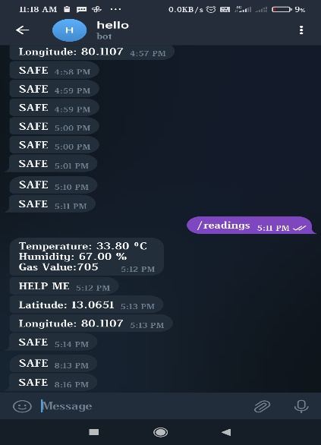

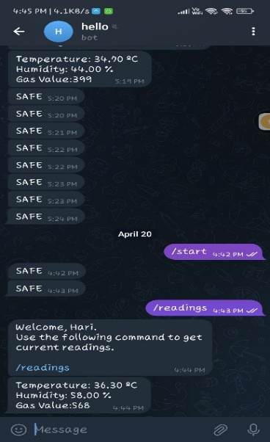,

OUTPUT

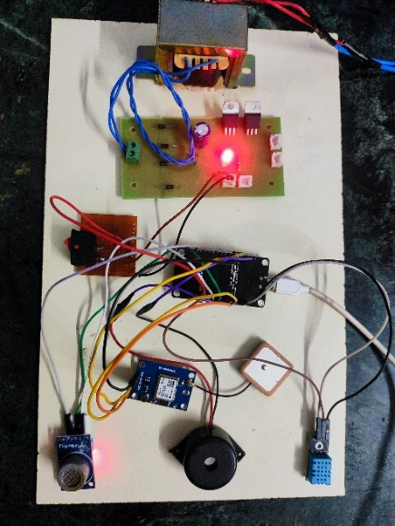

V. CONCLUSION

In conclusion the main objectives of this project were to monitor the casualty rate, reduce it, and immediately assist any miners in need. A wireless device network was created on the miners' helmets using Node MCU. The Telegram application or server will display the miners' assistance needs as a message to the supervisor whenever the Push button is pushed. In order to prevent the intake of poisonous gases, it is proposed to provide a sensible helmet for detecting and alert the workers by generating sound through the buzzer for unsafe events, monitoring the surrounding environmental conditions, and changing data like GPS location and device information to the central console for easy pursuit. With the adoption of the Internet of Things (IOT).

VI. ACKNOWLEDGEMENT

We wish to express our gratitude to Prof. Dr. Gomathi M, M.E., PhD., Assistant Professor, S.A. Engineering College Chennai for providing the facilities of the Institute and for his encouragement during the course of this work. We also express our deep gratitude to Prof. Dr. Tapas Bapu B R,
M.E., PhD., Head of the Department of Electronics and Communication Engineering, S.A. Engineering College, Chennai for his guidance and support.

REFERENCES:

[1]. S. R. Deokar, V. M. Kulkarni, J. S. Wakode, “Smart Helmet for Coal Mines Safety Monitoring and Alerting” Vol. 6, Issue 7, July 2017.

[2]. Kumar, V.S.P., Krishna, M.S.R. & Shambavi, K. (2021). A Smart Helmet For Coal Miners Technology (IJEET), 12(5): 128-136.

[3]. Abdulla, R., Eldemerdash, T., Nataraj, C., & Al-Adilee, M.K.A., (2020). IoT Based Smart Helmet for Mining Industry Application. International Journal of Advanced Science and Technology. 29(1): 373 – 387.

[4]. Kodali, R.K., & Sahu, S., (2018). IoT Based
Safety System for Coal Mines. IEEE Internet of Thing Journal.:147-150.

[5]. Gaidhane, Mahendra Dhame and Prof. Rizwana Qureshi “SMART HELMET FOR COAL MINERS USING ZIGBEE TECHNOLOGY” Imperial Journal of Interdisciplinary Research (IJIR) Vol-2, Issue-6, 2016 ISSN: 2454-1362.

[6]. Jesudoss, A., Vybhavi, R. and Anusha, B., 2019, April. Design of smart helmet for accident avoidance. In 2019 International Conference on Communication and Signa Processing (ICCSP) (pp. 0774-0778).

