Abstract - Due to the increasing challenges of parenting, particularly for working mothers, continuous monitoring of a child has become difficult. To address this issue, a smart baby monitoring system based on IoT and machine learning has been developed to provide real-time intimation to parents. The system monitors room temperature, humidity, cry detection, and facial recognition using various sensors, and the data is transmitted to the Adafruit server through controllers with an Internet connection. The machine learning model is used to detect the facial emotions of registered babies. Parents can monitor the live activities and emotions of their child through an external web camera and remotely swing the baby cradle upon cry detection using their web application. Real-time room temperature and humidity levels can also be checked. In case of abnormal actions, the system sends notifications to the parent's web application, providing a relief for all working parents to efficiently manage their time while taking care of their babies.

- INTRODUCTION

In today's world, parents face a significant challenge in balancing their professional responsibilities and taking care of their children. With both parents working, it becomes increasingly difficult to monitor and care for infants continuously. While childcare is essential, it can be a costly and time-consuming endeavor that can strain working parents. Childcare facilities and babysitters are not always affordable, and many parents are not satisfied with the available options. However, an IoT-based smart baby monitoring system may offer a solution that can bridge the gap between babies and parents.

The Internet of Things (IoT) is a network of smart devices that connect to the internet and collect data from the physical environment. These devices and sensors are designed to reduce human intervention and expand automation to daily life. They can be used in various smart industries, such as smart homes, smart cities, intelligent transport systems, smart healthcare, and smart agriculture. Machine learning also plays an important role in the field of IoT, particularly in smart homes, bioinformatics, computer vision, and agriculture. Taking into account the progress of IoT and machine learning, a real-time smart baby monitoring system has been proposed using machine learning to overcome the challenges faced by working parents.

Many research works have been done in the past, focusing on adding sensors to existing designs. However, there is still a lot of room for improvement. The proposed smart baby monitoring system is a notification system that can detect the

activities of babies in real-time and send updates to registered parents. The system focuses on vital parameters that are important in maintaining the comfort of the baby. The camera is also attached for live streaming and live updates of the baby using real-time facial expressions. The web application allows registered parents to control the hardware remotely, detect crying sounds, and monitor the humidity and temperature of the surroundings. The control system of the proposed system is equipped with a NodeMCU, a Raspberry Pi with a camera, a DC motor, a mic, and a DHT11 sensor for reading vital parameters to monitor the condition of the infant. These connected sensors send the values to the controllers and immediately notify the parents about abnormal conditions. The proposed system also identifies the unknown face and detects the real-time emotion of a baby.

While many previous studies have focused on adding sensors to existing designs, this proposed system offers an advanced solution that can provide a comprehensive monitoring system for infants in real-time. The system is designed to help parents balance their work responsibilities and childcare duties, ensuring that their infants are well-cared for at all times. The proposed system can be a valuable tool for working parents who need to keep track of their infants' condition and well being.

In summary, the proposed IoT-based smart baby monitoring system offers a comprehensive solution for working parents who need to balance their professional responsibilities and childcare duties. The system uses machine learning and IoT to provide real-time monitoring of vital parameters such as room temperature, humidity, cry detection, and face detection. The system is also capable of detecting the facial emotions of the registered babies using the Deepface. With this system, parents can monitor the live activities and emotions of their child through an external web camera and can swing the baby cradle remotely upon cry detection using their web application. The system can also send notifications to the parent's web application in case an abnormal action is detected, allowing parents to take action promptly. Overall, this proposed system can be a valuable tool for working parents to manage their time efficiently while taking care of their babies simultaneously.

LITERATURE SURVEY

Harshad Suresh Gare et.al., [1] author proposed a system which is used to monitor whether the baby is crying or not. This system has various sensor such as Sound sensor, DHT11, Wetness sensor, PIR, LM35, Gear motor, GSM module all are controlled by the Arduino microcontroller. Sound sensor is used to detect whether baby is crying or not. If baby is crying gear motor is used to swing the cradle. Wetness sensor is used for finding wetness. Addition to this, system has the ability to monitor baby body temperature, room temperature and detect the motion of an object by using PIR sensor. All the data from various sensor is collected from the sensor and transferred to the controller. If baby cries or cradle is wet alert message is sent to parents by using GSM module. Limitation of this system are there is no camera attached to this system, so parent cannot see the baby movement.

Toshaljeet Kaur et.al., [2] author proposed a
system which uses various sensors and a microcontroller. This system uses PIR sensor to monitor the movement

with the particular range. Here Gas sensor is used to detect smoke, methane and other dangerous and flammable gases. It is an analog gas sensor. Microphone module is used to detect the sound and gives a digital input to Arduino. All these data are passed to Arduino microcontroller and processed. if anything happens alert message is passed to the parents by using GSM module. This system uses entire room to monitor the baby. This system has some drawbacks such as this system don’t have camera to record the activity of a baby. This system does not check the wetness of the baby.

Savita P. Patil et.al., [3] author proposed a system which monitors baby temperature, pulse rate, Moisture and its movements using various sensors. All those sensors connected to microcontroller and GSM module. Two pairs of copper electrodes are placed under the baby’s bed to detect the moisture. The temperature sensor and motion sensor are position in the shock of a baby. The output from all the sensors is displayed continuously in LCD screen. Pulse rate sensor is measured from the baby finger using optical sensor. If the bed moves or if the baby moves away from the bed or move the sensor from the finger the system will not work properly

Aslam Forhad Symon et.al., [4] author proposed a system which monitors the baby activity and ensures the safety. This system can detect the baby’s motion and sound; especially crying and video output of baby’s present position can be displayed on a display monitor so that the parents can see the activity of the baby. They don’t need to stay near to the baby. This system is also powered by raspberry pi which controls all the sensors attached to it. This system has cry detection and motion detection. MIC is used to detect the baby crying and PIR sensor is used to find the moment of the baby. This system has PI camera which gives us the video of the baby. This proposed system can provide an easier and convenient way for busy parents in terms of taking care of their babies.

Prof.P. Rekha et.al., [5] author proposed a system which consist of various sensors such as the moisture sensor, the temperature sensor and the sound sensors are used which senses the wetness, temperature, and the sound, this data either weak signal get amplified through the amplifiers this data gets stored in the raspberry pi and gets processed. In addition, this system is given with web camera which provides the live video of the baby. LCD display is used here to display the sensor values and WIFI sever unit provides a live update. All the sensor values are shown in web page. To provide additional support the buzzer unit is used which consists of the RF Transmitter, Receiver, Encoder Decoder and an Alarm. Trough cloud forecasting and Wide Area Network the resulting data of the baby conditions can be monitored using web applications and also can control the situation from a remote area anywhere from the world.

Rachana Palaskar et.al., [6] author proposed a system which swings automatically when baby cries, it has a cry analyzing system which detects the baby cry voice and accordingly the cradle swings till the baby stops crying. The cradle swings right rotate in right-handed direction for three seconds and then in anticlockwise direction for three second. If mattress is wet or the cries continuously then parents get intimated that baby needs attention by sending message. The baby is monitored by web camera and the parent can have video recorded activity of the child. It detects facial expressions (Crying and laughing), temperature and automatically sends message about baby is safe or not.

Madhuri P. Joshi et.al., [7] author proposed a system which supports video monitoring. This system swings the cradle when baby cries. This happens for some time and the cradle stops and again check for the baby sound. Alert message is sent to the parents if baby cries continuously. Rotating Toy is attached to make baby calm. Baby cradle is a bed for an infant which sways as it is connected to motor. Noise Sensor is used measures the intensity of sound. Signal Conditioning id used for Amplification of electrical signal. Moisture Sensor, Buzzer, Driver Circuit and motor is also used. Android application is used for monitoring the baby movements.

Dina M. Ibrahim et.al., [8] author proposed a system which monitors the baby using raspberry pi device. This system shows the live video and play some audio and room temperature and humidity is also detected in this system. A TensorFlow open-source library based on machine learning used for sleepy or awake feature. Cry detection feature is used in which the pain score must be within range 0.02 (68%) to 0.01 (89%) to results that the baby is crying. Firebase Real-time Database stores and synchronizes the measured data with NoSQL cloud database.

EXISTING SYSTEM

There are few existing products like Intelligent baby cradles those products are a kind of conventional model where they use a constant mechanism to soothe the baby's distress. The method of swinging the cradle follows an East to West mechanism which leads to Shaken Baby Syndrome. This creates a shearing and tearing motion between the tissues of the white matter and grey matter of the brain serves as the major cause for the damage of Intelligent quotient and cognitive function. Many existing baby monitoring systems in the market are not comfortable and they are costly so it is not affordable by all the people and the system developed for the entire room has some drawbacks. It does not have live video footage. The parents can only get text message if anything happens. Most of the system are wearable it makes child to feel uncomfortable and this disturbs the baby from sleeping. The existing system mainly focus on the cradle part. This system will be helpful for the baby below 2 to 3 years. Existing system has various advantages and disadvantages.

PROPOSED SYSTEM

The paper proposes a smart baby cradle system that combines machine learning and IoT to overcome limitations in existing systems. The methodology used for this project was the waterfall technique, which involves a series of processes in a certain sequence, starting with planning and analysis, moving on through implementation, testing, and ultimately assessing the finished product. Before any

development was started, qualitative research interviews with parents were conducted to better understand the needs and expectations of the project. The hardware and software components used to design and implement the proposed system are discussed, including a Raspberry Pi and NodeMCU for processing data from sensors, a camera, condenser mic, DHT11 temperature sensor, and 12V DC motor. Communication platforms include the Adafruit server and application. The cradle is designed to be automatic and equipped with necessary sensors for monitoring the baby remotely in real-time. The cradle has a rectangular shape with boundaries that protect the baby from falling off, and a DC motor is attached, which is used to swing the cradle whenever the cry sound is detected and can also be initiated by the user. The control system of the smart cradle is equipped with a NodeMCU, a Raspberry Pi with the camera, a DC motor, a condenser mic, and a DHT11 sensor for reading vital parameters to control and monitor the current status of the baby. The complete hardware setup is shown in Figure 1(c). The memory of the Raspberry Pi is limited, so the proposed system incorporates two controllers to divide the computational task between them to reduce processing time. The DC motor and DHT11 are attached to the NodeMCU, while the camera and microphone are attached to the Raspberry Pi, and both of these controllers are linked together with the help of the Adafruit application. The system architecture is shown in Figure 1.

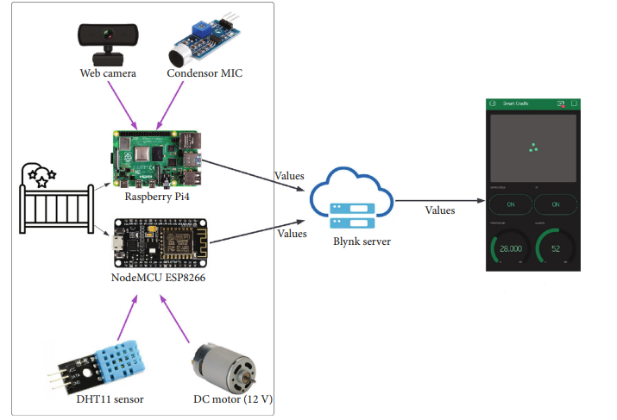
Fig -1: System Architecture

WORKING PRINCIPLE

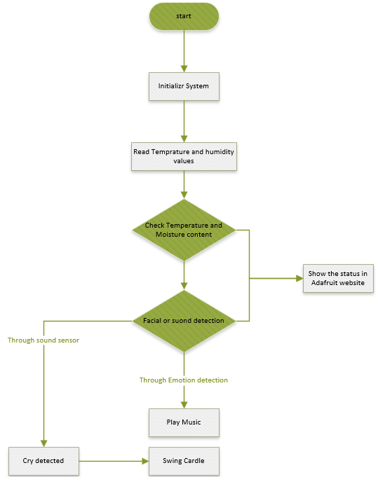

Fig -2: Flow Chart

Our project aims to develop a smart baby monitoring system with several key features that enable parents to monitor their baby's well-being remotely. These features include:

- Cry detection: A microphone connected to the cradle detects the baby's crying sound and sends a signal to the Raspberry Pi. Parents receive a notification through the Adafruit application, alerting them that the baby is crying.

- Swing cradle: The NodeMCU controls a relay coupled to a DC motor that swings the cradle. Parents can remotely control the cradle's swinging motion using the application.

- Room temperature and humidity: The DHT11 sensor measures the surrounding air, records the sensor values in the NodeMCU, and uploads them to the Adafruit server.

- Face and emotion detection: We use a machine learning model for infant facial and emotion recognition. The system sends a notification to the parent's Adafruit application to notify them of the baby's current emotional state.

- Web application: Parents can observe normal sensor data such as ambient temperature and humidity, as well as live video of the baby, through the web application. The system also alerts parents to any abnormal conditions.

SYSTEM IMPLEMENTATION

The implementation details of a system that monitors a baby's cry level, emotion, and environment and sends real-time information to the parent's web application. The system has three modules: the connection of the controller with the sensors, emotion recognition, and the web application module.

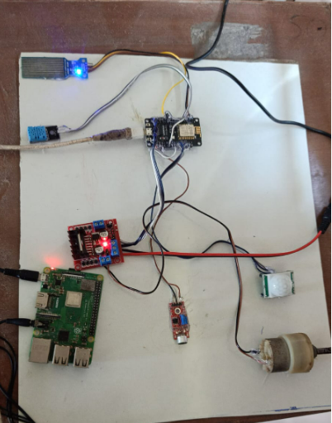

Fig -3: Hardware components

In the first module, the controllers are connected to the Wi-Fi network, and the Raspberry Pi and NodeMCU are powered by a 5 V power connection. The Raspberry Pi collects information about the baby's cry level and emotion from the feedback from the camera, and the NodeMCU receives information from the DC motor and temperature sensor. A mic is used to detect the baby's crying, and a Micmon script continuously checks the baby's crying level. If the sound is detected, the system sends notifications to the user's Adafruit application and automatically activates the DC motor for swinging the cradle.

In the second module, the system uses machine learning techniques to detect the emotion of the baby using live stream data. The Viola-Jones algorithm is used to detect the baby's face from a live webcam feed. The captured images are resized and converted to grayscale, and Dlib is used to extract the face from the image. In the second phase, the captured image data is passed to the classifier, and the support vector machine (SVM) is used for the recognition and classification of emotions from the captured face.

In the third module, the system creates a server and assigns the IP address of the server to the Adafruit application. Parents can see a live video of their baby at any time and any place using this application. The system also continuously measures the real-time surrounding humidity change and temperature, and if the temperature degree is higher than 23C or less than 16C, a notification is sent to the parents about the irregular temperature level.

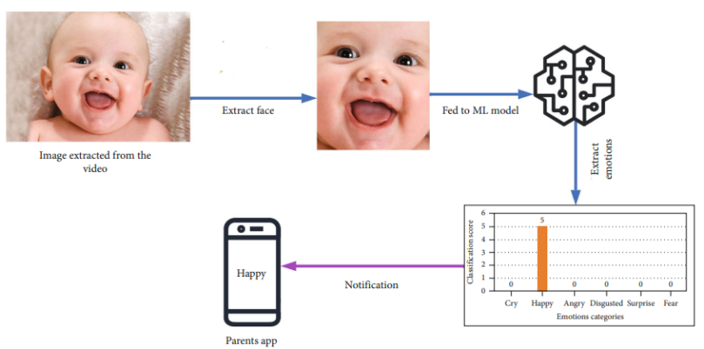
Fig -4: Classification results of input demo image by machine learning model.

RESULT

The experimental results of the proposed smart baby monitoring system are presented in this section, where various experiments were performed to test the feasibility of the system design. The following are the key findings:

- All the sensors were successfully connected to the controllers and the server, and the sensor data were updated on the Internet and accessible through the Adafruit server and web application.

- The Adafruit web application interface includes buttons to swing the cradle, check the temperature, and live stream the baby's activities.

- Real-time humidity and temperature of the baby's surroundings were determined, and a notification was sent to the user's application if the measured temperature was not within the specified threshold.

- The system's function to detect and notify the parent when the baby cries was tested by playing a baby-crying ringtone. The sensor connected acquired the sound level, and a notification was sent to the parent's mobile phone to notify them of the baby's crying.

- The smart cradle swings automatically when a crying sound is detected.

- An external web camera is used for real-time baby monitoring. The implemented face recognition algorithm checks if the recognized baby is in the cradle or not. If not, it generates a notification and sends it to the user application.

- The system includes a machine learning (ML) technique for emotion detection. For experimentation, a YouTube video of a baby was played, and different baby emotions were recorded. The captured video frame is taken as an input image, and then the face region of the baby is detected from the input image after every 10 seconds. Finally, the facial emotion of the baby is identified in front of the web camera connected to the baby's cradle, and different emotions were captured by the system.

- The user application receives notifications of different emotions detected by the system, as shown in Figures 5.

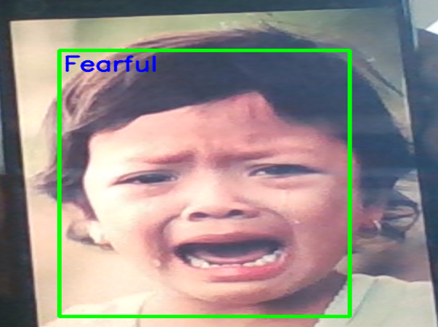

Fig -5: Emotion detection of the baby

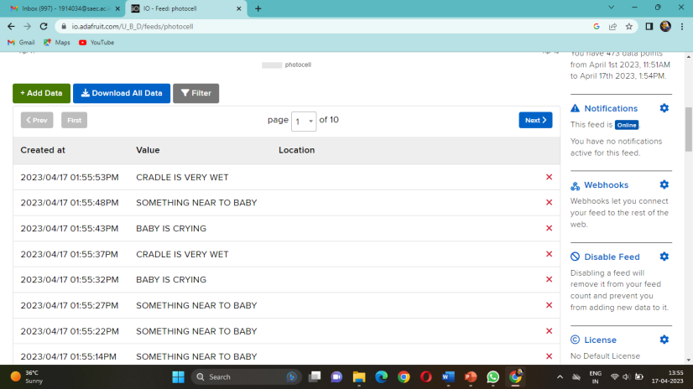

Fig -6: Live updates in Adafruit Web Application

Overall, the proposed smart baby monitoring system has been successfully tested and demonstrated its effectiveness in monitoring the baby's activities and detecting abnormal events. The user application provides features such as live streaming, swing cradle, temperature and humidity monitoring, and notifications for different events.

CONCLUSION & FUTURE SCOPE

The task of continuously monitoring a baby can be challenging for parents, especially when they have work responsibilities. To address this issue, an IoT-based smart baby monitoring cradle system with emotion recognition was designed to enable parents to monitor their babies remotely and at any time. The system employs two controllers, the NodeMCU and Raspberry Pi, to connect sensors that measure crying, humidity, and ambient temperature. The system notifies parents through their web application when abnormal activity is detected, such as crying. The prototype was tested by playing a crying baby ringtone near the cradle, which triggered the system to swing the cradle and send a notification to the mobile app. The system can detect the faces and emotions of registered babies, but it notifies parents only of happy, sad, and surprise emotions. The system allows parents to monitor their baby through online streaming via a camera, without any restrictions on the network for the mobile app or external camera. Future work includes reducing the system's cost and complexity by connecting all sensors to a single controller, improving the user interface by developing new dashboards, and implementing other machine learning algorithms to detect the actual cause of baby crying. Wearable sensors can also be coupled with the system to provide accurate detection of various health conditions. Overall, the proposed system provides an effective solution for parents to monitor their babies remotely and with ease.

REFERENCES

- Harshad Suresh Gare, Bhushan Kiran Shahane, Kavita Suresh Jori, Sweety G. Jachak, “IoT Based Smart Cradle System for Baby Monitoring,” International Journal of Creative Research Thoughts (IJCRT), Volume 8, Issue 3 March 2020.
- Toshaljeet Kaur, Meenakshi Mittal, Harpreet Singh, “The Baby Monitoring Room Prototype Model Using IOT”, International Journal of Advanced Research in Science and Engineering, Volume No-2, April 2018.
- Savita P. Patil, Manisha R. Mhetre, “Intelligent Baby Monitoring System”, ITSI Transactions on Electrical and Electronics Engineering (ITSI-TEEE), Volume -2, Issue -1,2014.
- Aslam Forhad Symon, Nazia Hassan, Humayun Rashid, Iftekhar Uddin Ahmed, S M Taslim Reza, “Design and Development of a Smart Baby Monitoring System based on Raspberry Pi and Pi Camera”, 4th International Conference on Advances in Electrical Engineering, 28-30 September, 2017.
- Prof.P. Rekha, K. Suganya, “Smart Baby Monitoring Cradle System Using IOT,” International Journal of Innovative Research in Science, Engineering and Technology, Vol. 9, Issue 3, March 2020.
- Rachana Palaskar, Shweta Pandey, Ashwini Telang, Akshada Wagh, Ramesh M. Kagalkar, “An Automatic Monitoring and Swing the Baby Cradle for Infant Care,” International Journal of Advanced Research in Computer and Communication Engineering Vol. 4, Issue 12, December 2015.
- Madhuri P. Joshi, Deepak C. Mehetre, “IoT Based Smart Cradle System with an Android App for Baby Monitoring”, Third International Conference on Computing, Communication, Control and Automation (ICCUBEA), 2017 .
- Dina M. Ibrahim, Mohammed Ali A. Hammoudeh, Sadaf Ambreen and Sajid Mohammadi, “Raspberry Pi-Based Smart Infant Monitoring System”, International Journal of Engineering Research and Technology, Volume 12, Number 10, 2019.
- Hemant Prakash Shanbhag, Rajat Vivekanand Gajinkar, Vishal Vaman Kamat, Anal Ballullaya, “IoT based Baby Monitoring System using Raspberry Pi,” International Research Journal of Engineering and Technology (IRJET), Volume: 07 Issue: 04, APR 2020.
- Muhammadu Sathik Raja M.S, Dhaksinamoorthi S,Elavarasan V,Gokul A, Manju R, “Advanced Monitoring Of Incubator Using IOT Based Automated Alert System,” International Journal of Innovative Research in Advanced Engineering (IJIRAE), Issue 03, Volume 6, March 2019.
- Samson Dauda Yusuf , Lumbi Williams Lucas , Umar Ibrahim , Maleshesh, Markus Jones , Loko Abdulmumini Zubairu, “Construction and Implementation of Raspberry Pi Based Baby Monitoring System,” International Journal of Research and Innovation in Applied Science (IJRIAS), Volume IV, Issue II, February 2019, ISSN 2454-6194.
- Suman Maloji, S. Malakonda Sai Lokesh, K. Nikhil Sai,
M. Vasavi Prasanna, M. K. Ashwaq and 6S. Arunmetha, “An Innovative Approach for Infant Monitoring System Using Movel S.Odi Based Iot System,” International Journal of Advanced Science and Technology Vol. 29, No. 6, (2020), pp. 3623 – 3630.
- Dr.P.P.Halkarnikar ,Rutik Bankar ,Vishal Salve ,Tejas Gavali, “IOT based intelligent baby care system with a web application for baby monitoring,” International Journal of Engineering and Techniques, Volume5, Issue6, December2019.
- Prof. A.B. Tupkar, Prajwal. Chahare, Shubham. Rade, Rushikesh. Wakade, Snehal. Bahirseth, “Development of IoT Based Smart Baby Cradle,” International Advanced Research Journal in Science, Engineering and Technology Vol. 7, Issue 1, January 2020.

