Abstract. Fruit diseases are important in agriculture worldwide. In this project, a neural network based on image processing is proposed to detect passion fruit disease. According to the CNN algorithm, the fruit image details are extracted from the first row used in this project by the existing package. However, it may take some time. Thus, the proposed system can be used for rapid and automatic identification of fruit diseases.
The proposed approach consists of the following main steps, including input image acquisition, image processing, affected area detection, affected area labeling, training set validation, and output display. Several types of fruit diseases such as bitter rot, puffball and powdery mildew are used for this approach. This approach was tested based on the type of fruit disease and the new and affected stages.
This algorithm is used to determine the type of fruit disease. Images are provided as sharp decay images, soft color images, and dust decay images. Before processing the image, it is converted to a color model to find the most suitable color model for this approach. Local binary patterns are used to extract features and support erosion methods are used to generate models. According to this approach, fruit diseases can be identified with an average accuracy of 79% and stages with an average accuracy of 66%.

I. INTRODUCTION
The best way to detect and diagnose fruit diseases is based on expert analysis [1]. In some developing countries, consulting with experts is time-consuming and time-consuming. Automatic detection of fruit diseases is very important to know the early signs of fruit development [2]. Fruit diseases occur during harvest, causing poor quality and yield. It is important to understand the situation and understand what leaders must do in the coming years to avoid failure.
For example, some apple diseases are black rot and black rot. Apple rot causes small, sunken circular brown or black spots covered with a red halo [3]. Apple fruit blight is a fungal disease that causes black, irregular spots or cracks on the fruit. Apple's vision is unleashed by great business and visionary technology.
However, since the skin is different from different fruits, there are many different varieties and problems in the diagnosis due to the presence of the disease [4].
Fruit studies can identify different patterns in different fruits, so it is important to monitor fruit health and disease detection. pesticides, herbicides, insecticides [5]. With proper management, this can be facilitated and thus the quality of workers can be improved.
Deep learning, also known as neural networks, is a branch of machine learning that uses computational models derived primarily from models of the brain [6]. Currently working on Deep Learning, Google Search and Image Search; Lets you search images for keywords like "cover". Used to enable Smart Reply and Gmail.
It is in words and vision. I believe it will soon be used in machine translation. said Jeffrey Hinton, considered the master of neural networks deep learning models and various methods (see above) are effective for extracting complex information from input images. Grids cannot be used to reduce calculation time.
Image classification is best done with CNNs.
First, you need a set of images. In this case, we use beautiful pictures and medical products as our first experience[7]. The most common attributes for image files are image, image length, number of channels, and pixel pitch.
The classic way to find and check fruit is by a doctor. Consultants are expensive and time-consuming in some developing countries because of the distance. Automatic detection of fruit diseases, early detection of fruit development symptoms is very important [8]. Fruit diseases occur during harvest, causing poor quality and yield. Understanding the situation is important to understanding what managers need to do next year to avoid failure. Some diseases spread to other parts of the tree, infecting branches, leaves and twigs [9].
For example, some apple diseases are gum disease, apple rot and apple blight. Gray or brown, like apple skin. Apple rot causes small, sunken circular brown or black spots covered with a red halo. Apple fruit blight is a fungal disease that causes black, irregular spots or cracks on the fruit. Apple's vision is unleashed by great business and visionary technology.
However, the detection of defects is still challenging due to the different colors of different fruits, the different height of the type of defects and the presence of stalks/calyxes.
Fruit studies can identify different patterns in different fruits, so it is important to monitor fruit health and disease detection. Pesticides, insecticides, insecticides, etc. It can be easily managed with appropriate management, for example, there are many techniques such as spectroscopy and imaging to identify plant diseases and better management. Agriculture is always looking for ways to reduce labor in ways that don't affect productivity [10]. One thing to be careful about automatic cutting machine that saves the whole process.
Important applications for fruit detection in robotic picking. However, the technology can be developed for other applications such as disease detection, growth detection, tree care, and similar tasks. With the development of refrigeration and transportation, many fruits are exported around the world.
This is usually set by specialists and is necessary for production quality control.
The price is high and long because the farm is far away.
The fruit industry is one of the main drivers of economic growth in the country. Due to the lack of review books and good inspection knowledge, there are errors in the sorting and packing of the fruit. Farmers are increasing their demand for inputs due to lack of skills and rising labor costs. In this case, automation can reduce costs by increasing production efficiency.
Much research has been done on fruit diagnosis, disease detection and evaluation in agriculture.
Most previous studies rely on C-Mean, K-Mean and KNN for fruit identification and quality analysis. In this post, the farmer publishes a time-saving and cost-effective program that can determine the type and quality of fruit.

II. LITERATURE REVIEW

Nandi, C. S., et al.[11] proposed a machine vision-based system for classification of
mangoes by predicting maturity level, and aimed to replace manual sorting system.Once the model is fully trained, it can be used to identify fruit based on the validation set.
Moonrinta, J., et al. [12] proposed a digital image processing technique to determine fruit freshness. There are also different algorithms for exploring and analyzing, to extract the features used in the captured digital images. Fruit quality is based on parameters such as size, color and weight. All these algorithms are implemented using a standalone RASPBERRY PI development board.
Kaur, S., et al., [13] proposed an automatic fruit quality detection system for fruit sorting, grading and defects. This helps improve accuracy, processing speed and efficiency, and reduce time. Image processing based on fruit characteristics such as color and size
Patil, D. et al. al., [14] here K-means clustering method is used and for identification of fruit diseases purpose Artificial Neural Network (ANN) and GLCM used.Here there are two databases, one for training and another for testing purpose.
Velappan, C.,et. al., [15] Methodology utilized in this system is machine vision system which includes the Vision box hardware and Digital Image Processing for fruit detection.
Roberts et al., [16] K-Denotes clustering is utilized for segmentation of images, and features extracted from the segmented images are relegated into a single class using a Multi-class Support Vector Machine.
Rupam Thakur et al., [17] The main objective is to identify fruit diseases using the concept of artificial neural networks. Fruit diseases are automatically identified based on disease symptoms seen in developing fruit. Sunshine Fruit defines quality, quantity and sustainability.
Kumar, Y. R., et. Al., [18] diesel method used in automatic fruit inspection. There are estimates based on color, shape and size. Machine vision techniques provide automated analysis and ready-made image analysis.
Devi, P. V., et.al., [19] provided a system using SVM for the detection of Indian mangoes falling short and defective. KMean clustering and FCM algorithms are used for disease detection.
Kumari, N., et al. [20] During this project, we learned some of the deep learning algorithms and were able to compare their strengths and weaknesses.

III. FRUIT DISEASE CLASSIFICTAION

There are six phases in this methodology. Those are Image Acquisition, Image Preprocessing, Image Segmentation, Applying training dataset, Experimental results.

Processing
image
i/p

Training set
Acquisition &Segmentationon

Image(Affected/fresh)
Analyzing affected section
Identifying type of disease
Result
Views detected disease name

Figure 1: Block of disease detection

3.1 Image Acquisition
In this phase, the sample images are collected, which are required to train the classifier algorithm and build the classifier model. Yellowish or Reddish passion fruit variety was selected to take sample images. Because the yellowish variety is widely cultivated in our site. Healthy and diseased passion fruit images were taken by using mobile phone digital camera and used for both training and testing the classifier algorithm. Images were taken in different angles, under the different environmental and lighting conditions. The standard JPG format was used to store these images. In this study, images were collected from farms in different regions. Passion fruits infected by scab disease and woodiness virus that had been included in collected images.
3.2 Image Preprocessing
After image acquisition, image processing was performed to improve image quality. All original passion fruit images were stored in one folder. Those images were named because we like that our wish numbers can take on any value. Only horizontal images were rotated by 90 degrees and resized by 200x300 pixels. Vertical images were resized by 200x300 pixels and when the image width and height were the same, the image was resized to 250x250 pixels. When the image size is very large, the processing task takes more time. After that, a noise reduction method was used to remove the noises from the images and increase the sharpness of the images. Later, all the pre-processed images were saved in a folder.

3.3 Image Segmentation
The third phase of the methodology is image segmentation. As the first step, all preprocessed images were converted into L*a*b, HSV, Grey color models and kept one in the original way (RGB). Because the identifying suitable color model for preprocessing is one of the outcomes of this research. After that, the image was converted to binary format. This format values were clustered using the CNN algorithm. According to the algorithm used an image segmentation were done.
3.4 Applying training set
The fifth phase of the methodology is applying training set images. The segmented output were done, which were created using feature extraction. However, three image sets were created to do experiments. Preparation of those image sets is discussed here. Field expertise support was taken for the categorization of images and each image were selected from the categorized sets of an image randomly.
3.5 Experimental Results
After applying the education set pix, 3 base folders have been used for identifying passion fruit sickness consistent with its call. these files are known as as “3 training dataset”. another way is counting number of affected locations to become aware of ardour fruit diseases consistent with its level. This technique is referred to as as opportunity method. each training and trying out time, rows of schooling documents have been shuffled randomly for growing the accuracy of the model. every education report turned into established and examined in 5 instances and accuracy become taken. average of these accuracies become taken as the accuracy of every model. the usage of this picture dataset, three forms of sicknesses had been located. such as bitter rot, powdery mold and sooty blotch.

EXAMPLE TRAINING SET IMAGES

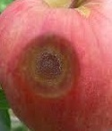
Figure 2– Bitter Rot
In Figure 2: Bitter rot is identified by a sunken circular lesion in the apple flesh with a conical infiltration that appears V-shaped when the apple is cut in half through the center of the lesion.
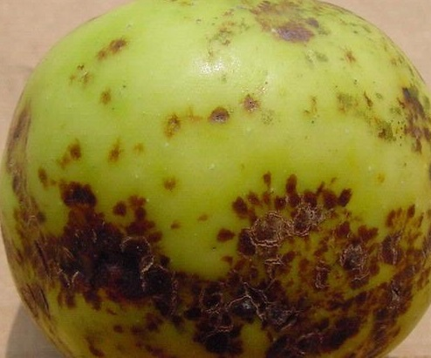
Figure 3 – Sooty Blotch
In Figure 3: Sooty Blotch appears on fruit surfaces as sooty oy cloudy blotches with indefinite borders. It usually appear in august or september and are sometimes called the ‘‘ summer disease‘‘ of apples.

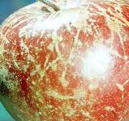
Figure 4 – Powdery Mildew
In Figure 4: Powdery mildew is easily recognized on most plants by the growth of white to gray powdery mycelium and spores that form on both sides of leaves, sometimes on flowers and fruits, and on shoots.

IV.RESULT AND DISCUSSIONS
In this section, we discuss about the data set of apple fruit diseases and present a detailed result of the fruit disease identification problem. We also discuss various issues regarding the performance and efficiency of the system.

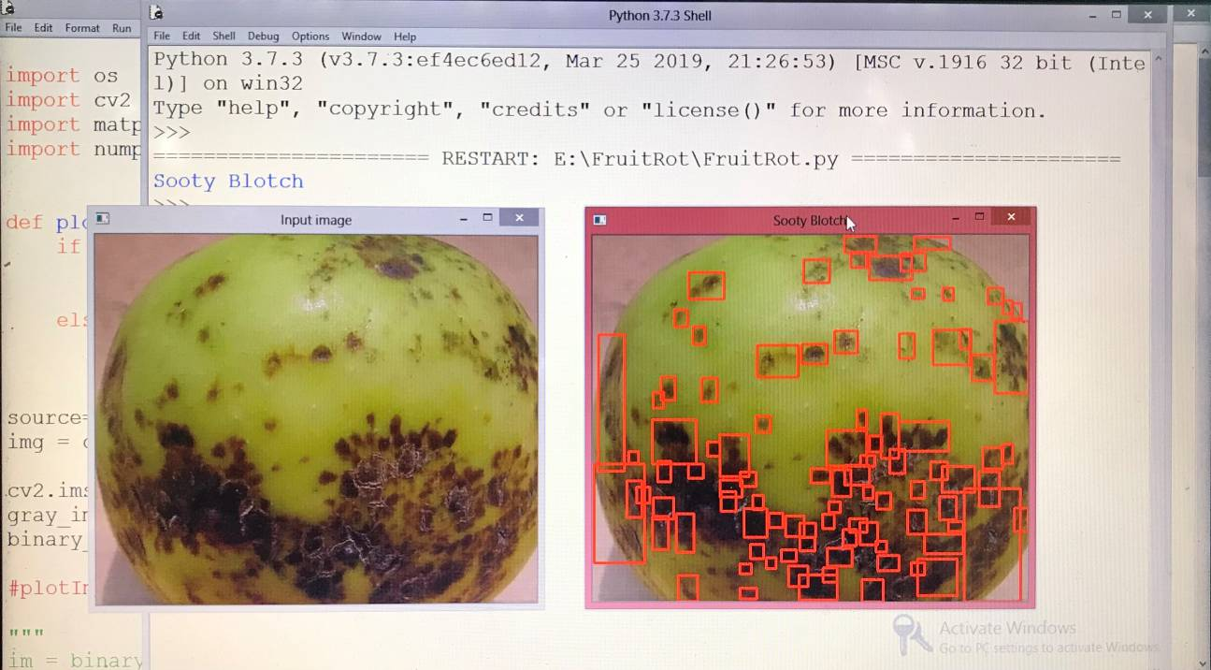
Figure 5: Sooty Blotch
In Figure 5:Sooty Blotch is a disease complex caused by a large number of different fungi. Fly speck is caused by Zygophiala jamaicensis.

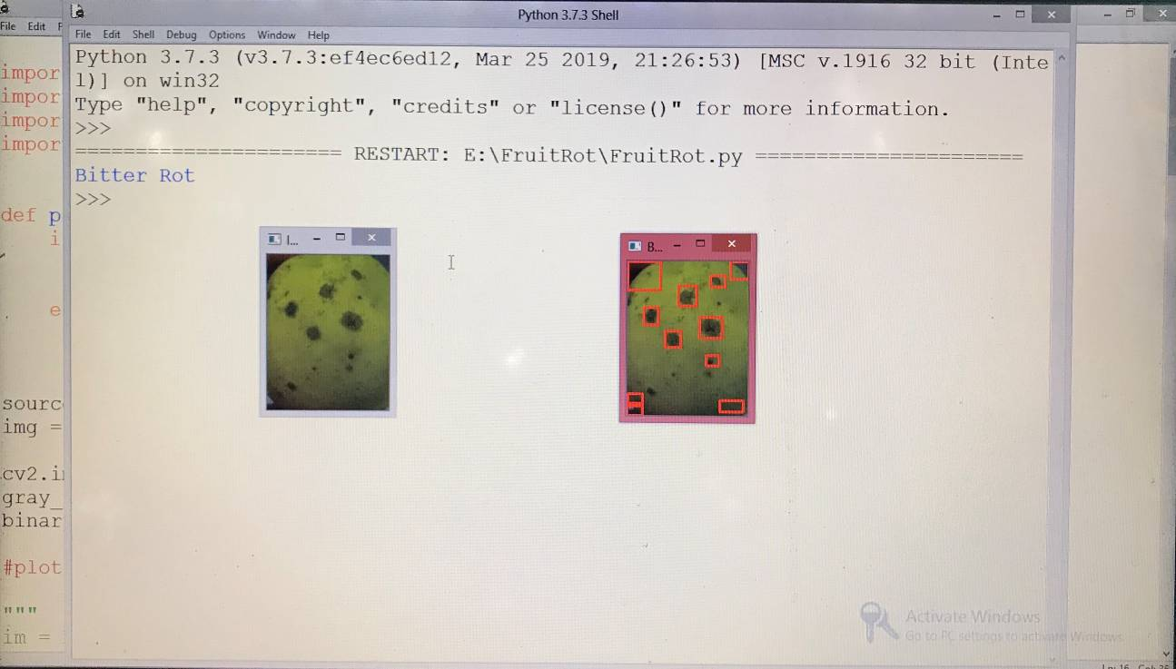
Figure 6: Bitter Rot
In Figure 6: Bitter Rot lesions begin as small, sunken, localized areas on outer surfaces of fruit. As lesions mature, they remain sunken and circular, and some spots may develop red halos.

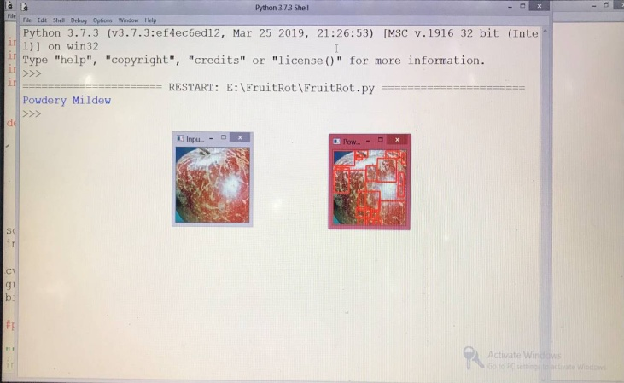
Figure 7: Powdery Mildew

In Figure 7: Powdery Mildew are easily recognized by the white, powdery growth of the fungus on infected portions of the plant host.

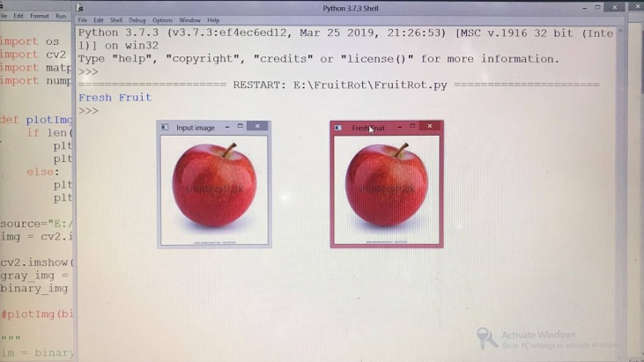
Figure 8: Fresh Fruit
In Figure 8 Fresh fruit is detected, disease can’t be affected in this part it shows fresh fruit as output.

V. Results discussion:
Accuracy:
In Figure 9: Accuracy (%) for k-means and CNN algorithms used for fruit disease identification.

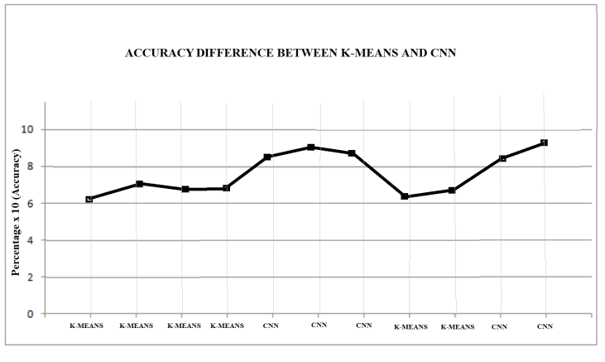Figure 9.1: shows the Difference between K-means and CNN

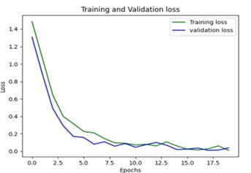

Figure 9.2(a)Training and Validation loss
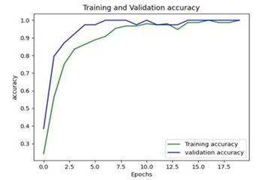Figure9.2(b)Training and Validation accuracy

The loss graph shows that 15 percent loss is encountered in both training and validation with a sparsity range of 70-90% in model pruning as shown in Figure 9.2 (a) and the training and validation graph approaching 92.35 percent. The initial level of sparsity starts at 80 percent and the sparsity ends at 90 percent shown in Figure 9.2 (b).

VI. CONCLUSION

An image processing primarily based answer is proposed and evaluated in this undertaking for the detection and category of fruit sicknesses. The proposed method is composed of specially 3 steps. inside the first step image segmentation is completed the usage of convolutional neural network technique. inside the 2d step affected locations are determined. within the 1/3 step training and type are completed. it would also promote Indian Farmers to do clever farming which helps to take time to time choices which additionally store time and decrease loss of fruit due to illnesses. The leading objective of our challenge is to beautify the fee of fruit disorder detection.

Scope for future development

Future of this project can be easily updated. To achieve the benefits that expected from the user must understand the overall system and they must be able to carry out their specific tasks effectively. The successful implementation depends upon the right people at the right time.

The application become useful if the below enhancements are made in future.
- If the application is designed as web service, it can be integrated in many web sites.
- More accuracy can be detected using various machine learning algorithms
The application is developed such that above said enhancements can be integrated with current modules.

REFERENCES

[1] Bhange, M., & Hingoliwala, H. A. (2015). Smart farming: Pomegranate disease detection using image processing. Procedia computer science, 58, 280-288. [2] Dubey, S. R. (2012). Automatic recognition of fruits and vegetables and detection of fruit diseases. Master’s theses.
[3] Alagu, S., & BhoopathyBagan, K. Apple Fruit disease detection and classification using Multiclass SVM classifier and IP Webcam APP.
[4] Dheir, I., & Abu-Naser, S. S. (2019). Knowledge based system for diagnosing guava problems. International Journal of Academic Information Systems Research (IJAISR), 3(3), 9-15. [5] ] Donkor, A., Osei-Fosu, P., Dubey, B., Kingsford-Adaboh, R., Ziwu, C., & Asante, I. (2016). Pesticide residues in fruits and vegetables in Ghana: a review. Environmental Science and Pollution Research, 23, 18966-18987.
[6] Sujatha, R., Chatterjee, J. M., Jhanjhi, N. Z., & Brohi, S. N. (2021). Performance of deep learning vs machine learning in plant leaf disease detection. Microprocessors and Microsystems, 80, 103615.
[7] Hughes, D., & Salathé, M. (2015). An open access repository of images on plant health to enable the development of mobile disease diagnostics. arXiv preprint arXiv:1511.08060.
[8] Doh, B., Zhang, D., Shen, Y., Hussain, F., Doh, R. F., & Ayepah, K. (2019, September). Automatic citrus fruit disease detection by phenotyping using machine learning. In 2019 25th International Conference on Automation and Computing (ICAC) (pp. 1-5). IEEE. [9] Matsui, T., Kamata, T., Koseki, S., & Koyama, K. (2022). Development of automatic detection model for stem-end rots of ‘Hass’ avocado fruit using X-ray imaging and image processing. Postharvest Biology and Technology, 192, 111996.
[10] Shaikh, T. A., Rasool, T., & Lone, F. R. (2022). Towards leveraging the role of machine learning and artificial intelligence in precision agriculture and smart farming. Computers and Electronics in Agriculture, 198, 107119.
[11] Nandi, C. S., Tudu, B., & Koley, C. (2014). A machine vision-based maturity prediction system for sorting of harvested mangoes. IEEE Transactions on Instrumentation and measurement, 63(7), 1722-1730.
[12] Moonrinta, J., Chaivivatrakul, S., Dailey, M. N., & Ekpanyapong, M. (2010, December). Fruit detection, tracking, and 3D reconstruction for crop mapping and yield estimation. In 2010 11th International Conference on Control Automation Robotics & Vision (pp. 1181-1186). IEEE.
[13] Kaur, S., Girdhar, A., & Gill, J. (2018). Computer vision-based tomato grading and sorting. In Advances in Data and Information Sciences: Proceedings of ICDIS-2017, Volume 1 (pp. 75-84). Springer Singapore.
[14] Patil, D. (2018). Fruit Disease Detection using Image Processing Techniques. International Journal for Research in Engineering Application & Management (IJREAM), 2454-9150.
[15] Velappan, C., & Subbulakshmi, K. (2015). Analysis of fruits by image processing algorithms. International Journal of Advanced Research in Electrical, Electronics and Instrumentation Engineering, 4(8), 6805-6811.
[16] Roberts, M. J., Schimmelpfennig, D., Ashley, E., Livingston, M., Ash, M., in Communication, Computing and Electronics Technology [ACCET-2016] held at M. E.
[17] Rupam Thakur, 2Priyanka Mehta ”Automatic detection of fruit diseases: A Review” 2017 IJEDR — Volume 5, Issue 3 — ISSN: 2321-9939.
[18] Kumar, Y. R., Narayanappa, C. K., & Dayananda, P. (2020). Weighted full binary tree-sliced binary pattern: An RGB-D image descriptor. Heliyon, 6(5), e03751.
[19]Devi, P. V., & Vijayarekha, K. (2014). Machine vision applications to locate fruits, detect defects and remove noise: a review. Rasayan J. Chem, 7(1), 104-113.
[20] Kumari, N., Bhatt, A. K., Dwivedi, R. K., & Belwal, R. (2019). Performance analysis of support vector machine in defective and non defective mangoes classification. International Journal of Engineering and Advanced Technology (IJEAT), 8(4), 1563-1572.

