Design and Analysis of Solidworks and Ansys using the
Replacement of robotic body parts in Humans.
K.Karthikeyan¹, V.Sugan².
^{1.} Department of Mechanical Engineering, Mahendra Engineering College.
2.Associate Professor, Department of Mechanical Engineering, Mahendra Engineering College
---------------------------------------------------------------------***---------------------------------------------------------------------
Abstract – The replacement of robotic body parts in the human beings willing to done in the necessary of every year people lost their human parts in various aspects like accident or injury or surgical due to any multiple causes such as blood vessel disease, cancer, infection, excessive tissue damage etc. The paper is all about design and analysis of AI, Solid works and Ansys using the replacement of robotic part in humans. Background research was conducted to ensure we were making well informed decisions are prosthetic devices, non-anthropromorphic devices, prosthetic hand with myoelectric sensor, sensing technology, object recognition. And main aim of this research would be upgraded version of artificial heart Investigating the biomechanical behaviour of a soft artificial heart is a hard task as such things are very complicated in terms of both material properties and geometry. Numerical simulation and investigation of the artificial heart were implemented using Solid Works 17 and ANSYS15.7, with a. The simulation results showed that as maximum levels of absolute pressure were applied on the ventricles and air pressurized chambers, the performance of the heart remained secure. The results also showed that strain energy, total deformation, maximum principal elastic strain, stress and fatigue safety factors, and fatigue life all reached their SIBSTAR103Twithpolyetherimide/silicone(PSN4)Nano-composite elastomers.

Key Words: -Prosthetic devices, Artificial hand, Soft Artificial hand, Solid works Modelling, Ansys fluid fluent flow(CFX)Simulation, silicon based non-composites, silicon rubber(elastomer), zinc Dimathacrylate, hydroxyapatite.

1.INTRODUCTION ( Size 11, Times New roman)
Design and analysis of AI, Solid works and Ansys using the replacement of robotic part in human’s uses to the various amputation who were disabled and deformed. The injuries can greatly hinder an individual’s ability to perform even a basic daily tasks. Replace the body parts by using bionic upgrades in this session of this occusion . How close we are pretending the perishability of our own flesh. Are we are nearing the time The human heart beats about 100,000 times each day, around 30 million times annually, and 2.5 billion times in an average lifetime [1]. It is thus capable of pumping 7,000 litres of blood per day, that is, 2.5 million per year, and 200 million throughout an individual’s life. The total blood volumes in the average human body are about 5 to 6.5 litres [2]. The cardiovascular system is thus a complex structure, as required to manage this constant blood circulation within the human body [3], and cardiovascular disease, which includes heart failure, is the number one cause of death worldwide. The need for replacement hearts is thus continually growing, while the number of donor hearts available for transplant remains flat. To save adults from dying of end-stage biventricular heart failure, medical teams around the world have thus developed 13 different types of artificial hearts since 1969 that have been implanted into patients. Every year there are about 6,000 (McGimpsey) upper limb amputations in the United States alone, leaving tens of thousands of individuals disabled and deformed. Aside from the discomfort caused by curious stares from onlookers, these injuries can greatly hinder an individual’s ability to perform even basic daily tasks. Past attempts at a replacement limb, referred to as a prosthetic, have included mechanical hooks and pincers that grant the user some functionality.

2. Body of Paper
The result of the Design and analysis of AI, Solid works and Ansys using the replacement of robotic part in human’s. Anthropomorphic robotic hand capable of determining the most appropriate grip for grasping an object and executing that grip with minimal human input. The hand was able to correctly identify objects in varying lighting conditions. The modelling and analysis of a new generation soft artificial heart to replace the living heart permanently can be supported by establishing 3D projections for curvature, ordinary formation, inner diaphragms, the right and left ventricles, and the drag and air pressure zone sections necessary for the soft artificial heart mechanisms. The model geometry implemented showed that the maximum total volume of the soft artificial heart = 2.6663x105 mm³ and the net weight was 293gm, while the total weight filled with blood and air was 577 gm, close to the measurements of a living heart, making this artificial heart s candidate for being a true permanent replacement. To simulate the modelled soft artificial heart, different mechanical (ANSYS) analysis systems were used to determine the dynamic response during the activity of the blood flow cycles. . The ANSYS Fluent analysis system can be used to solve the computational fluid dynamics (CFD) of the blood flow simulation, with a maximum level of absolute pressure applied on the ventricles and air pressurized chamber and the whole artificial heart; the displayed and animated graphs both showed that the performance of the heart is adequate at all stages.
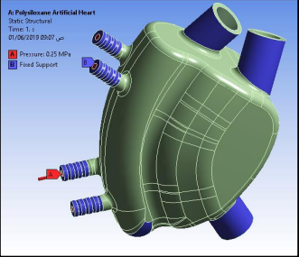
Fig 1 Result of ANOVA for 2FI power transform model of strain energy ANSYS R18.0.
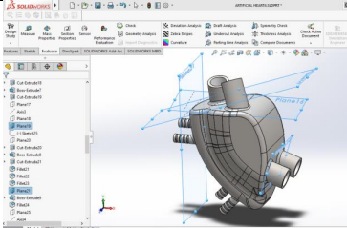

Fig 2 Result of soft artificial heart geometry was created using 3D SolidWorks 2017.

Fig 3 Result of artificial finger was created using 3D solidworks 2017.
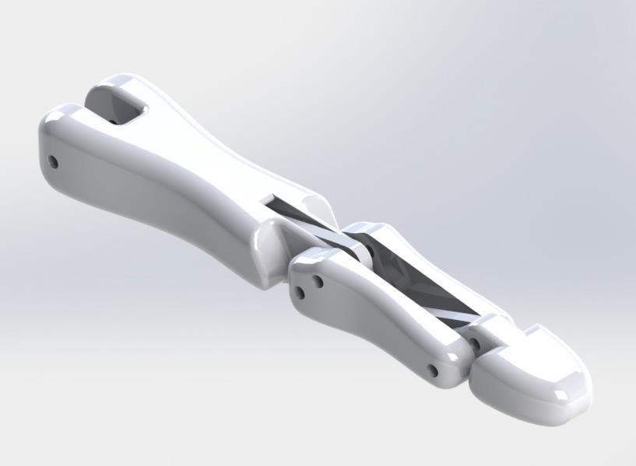
Simulation of absolute pressure over the whole soft artificial heart.
Shows the velocity of air mass at the flow inlet for the pressurised air chamber; the performance of the heart is adequate here, too. Six advanced silicon-based composite elastomers materials were chosen for testing alongside Polysiloxane silicone rubber to identify the best choice for fabrication of the soft artificial heart. The selections were based on obtained material properties, including material strength, the stresses generated, the percentage elongation, fatigue life, the minimum amount of strain energy required for heart performance, and the safety factor. The first selected material was a 20% hydroxyapatite (HAp) powder mixed with the poly(dimethylsiloxane) (PDMS). The composite was fabricated by pressing between two metal plates to obtain samples about 3 mm thick, which were then cured at 185 °C for 35 min. The nanocomposite elastomer contained 0.15% Vinyl subsitituent obtained from Chenguang chemical research instituite , Sinchuan China while zinc dimethacrylate(ZDMA) grade saret 634 was purchased from sartomer co. The third found composite material was reinforced with 30% Nano-SIO2 particles( modified by the Hexamethyldisilazane (HMDA), supplied by the Evonik Degussa(Dmga), on volcanized silicon (RTV-1 SiR) matrix, prepared by using the polydimethylsiloxane(PDMS,Walker&chemie),anilinomethyltriethoxysilane (ND42) titanium complexes (D-60, Hubei Lantian Chem.ical Co, and HMDS-modified SiO2 particles. The fourth selected composite material was magnetic rubbery silicone (superparamagnetic elastomers), containing s silicone rubber matrix and 12% chemically co-precipitated nano-crystalline magnetite particles. Any air bubbles that appeared during mixing were removed by performing degassing under a primary vacuum bell at ambient temperature so that silicon polymerization could take place
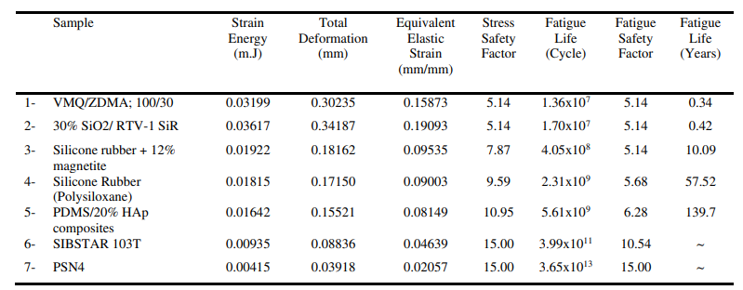
3. CONCLUSIONS
I. The modeling and analysis of a new generation soft artificial heart to replace the living heart permanently can be supported by establishing 3D projections for curvature ordinary formation, inner diaphragms, the right and left ventricles, and the drag and air pressure zone sections necessary for the soft artificial heart mechanisms. The ANSYS Fluent analysis system can be used to solve the computational fluid. The ANSYS Fluent analysis system can be used to solve the computational fluid dynamics (CFD) of the blood flow simulation, with a maximum level of absolute pressure applied on the ventricles and air pressurized chamber and the whole artificial heart; the displayed and animated graphs both showed that the performance of the heart is adequate at all stages. The results show that the strain energy, the total deformation, and the maximum principal elastic strain values were decreased with increases in the tensile strength and decreases the percentage elongation reaching minimum values as 0.00415 m.J, 0.03918 mm, and 0.02057mm/mm, respectively, when using polyetherimide/silicone (PSN4) nano-composite elastomer.
II. Modeling and analysis of artificial hand concept prototype for the IRIS platform an anthropomorphic robotic hand capable of determining the most appropriate grip for grasping an object and executing that grip with minimal human input non-subscribers can only read as far as the abstracts. If they try to go ready there this point, they are routinely asked, whether they would like to order the pdf, and are given directions as to how to do so.

ACKNOWLEDGEMENT

The satisfaction that the one gets on completion of a task cannot be fully enjoyed without mentioning the people who made it possible. We are very much grateful to the almighty, who helped us all the way and who molded us into what we are today. We remain indebted to our parents who have sacrificed many things for our success. We submit our heartfelt regards and sincere thanks to them.
Honorable Chairman, Thirumigu. M.G.BHARATHKUMAR, M.A., B.Ed., M.I.S.T.E. and Managing directors Er. Ba.MAHENDHIRAN and Er. B.MAHA AJAY PRASAD for all the help they have provided in accomplishing this task.
Principal Dr. R.V. MAHENDRA GOWDA, M.Tech., Ph.D.(IITD) who motivated us to take up this project work.
Head, Department of Mechanical Engineering, Dr. M.SRINIVASAN, M.E., Ph.D., for his valuable guidance.
Project coordinator Mr.R.SOUNDARARAJAN, M.E., Assistant Professor, Department of Mechanical Engineering who initiated me to do my project work and helped till the completion of my work.
Supervisor V.Sugan, M.E., Associate Professor, Department of Mechanical Engineering for his valuable and precious guidance throughout the period of our work.
REFERENCES

- Eleftherakis, Christine Connolly, (2008) "Prosthetic hands from Touch Bionics", Industrial Robot: An International Journal, Vol. 35 Iss: 4, pp.290 – 293.
- Smith, Matt. "New BeBionic Hand Almost Doubles Its Grip-strength, Steered by User's Electrical 'skin Signals' Alt." Engadget. N.p., 7 Sept. 2012. Web. 15 Oct. 2013.
- "i-Limb Ultra." Home. N.p., n.d. Web. 1 May 2014.
- <http://www.touchbionics.com/products/active-prostheses/i-limb-ultra>.
- Brian B, Nuno R, David D, Robert L T and Ellen K, 2014 The Living Heart Project: A robust and integrative simulator for human heart function, European Journal of Mechanics A/Solids, 48, 38-47.
- Davy K P and Seals D R, 1994 Total blood volume in healthy young and older men, J. Appl. Physiol., 76(5), 2059-62
- Sophie Collin, 2018 Preoperative planning and simulation for artificial heart implantation surgery. Signal and Image processing, Ph.D. thesis, University of Rennes.
- Robert E and Michler M D, 2013 Stem Cell Therapy for Heart Failure, Methodist Debakey Cardiovasc J., 9 (4), 1-8,.
- Martha S Lundberg, Timothy B J, and Denis B B, 2017 Building a bioartificial heart: Obstacles and opportunities, The Journal of Thoracic and Cardiovascular Surgery c, 748-750.
- Akshay P, Lianjun W, and Yonas T, 2014 Artificial heart for a humanoid robot, Electroactive Polymer Actuators And Devices,1, 1-16.
- Mohammed E S, Ali M A, 2016 Study of an Artificial Heart: Design and Simulation, Research Gate publication, No.297013927, 1-9.
- Stenberg M, 2006 Concept design and In Vitro evaluation of a novel dynamic displacement Ventricular Assist Device, A thesis in Technology and Health, University of Florida, USA..
- Slepian M J, Marvin J S, Yared A, Silva S, Richard G S, Shmuel E, Danny B, 2013 The Syncardia ™ total artificial heart: in vivo, in vitro, and computational modeling studies, Journal of Biomechanics, 46, No.2, 266-275.
- Italian Man Surpasses, 1,000 Days of Support with SynCardia’s Total Artificial Heart,https://www.businesswire.com/news/home/20101012005771/en/Italian-Man-Surpasses-1000-Days-Support-Syn Cardia%E2%80%99s.
- Langer R M, Vladimir P and Demikhov, 2011 A pioneer of organ transplantation, Transplant Proc., 43 (4), 1221-1222.
- Gino Gerosa, Silvia Scuri, Laura Iop, Gianluca Torregrossa,2014 Present and future perspectives on total artificial hearts, Ann Cardiothorac Surg, 3 (6), 595-602.
- Silvay G and Castillo J G, 2013 Heysham Gibbon and the 60th anniversary of the first successful heartlung machine: brief notes about the development of cardiac surgery in Europe and Slovakia, Bratisl Lek Listy., 114 (5), 247-50.
- Marvin J and Slepian M D, 2011 The SynCardia Temporary Total Artificial Heart- Evolving Clinical Role and Future Status, Heart Failure, 39- 46.

