AUTOMATIC LAND USE LAND COVER
¹Patil Shambhuraj, ² Shete Shravani, ³ Desai Karan, ⁴ Vahagaonkar Kajal, ⁵ Associate Professor P. Kinikar,

sENTC Department,
Dr. Daulatrao Aher College of Engineering, Karad, India

¹ pshambhuraj150@gmail.com , ² sheteshravani@gmail.com ,³ karandesai.ig@gmail.com ,
⁴ kajalvahagaonkar@gmail.com , ⁵ parvin.entc@gmail.com

Abstract: Land Use and Land Cover is the most uniform and primary apparatus for the government bodies. Manual mapping areas for land, water, and forest bodies is a difficult process. The main objective of this project is to analyze undistributed urban areas, for socio-economic development, calculate the total area covered in water, land, and forest, and study the effect of natural and human influences on the urban area.

Keywords: Land Use Land Cover, Image Processing, Remote Sensing, Website.

- INTRODUCTION
In India, due to the rapid increase in the population, there is a drastic change in land use, water body, environment, etc Analysis of land use land cover for urbanization is a key factor. Due to rapid urbanization near coastal areas, urban areas have changed in most parts of the world. Urban areas are changing in various degrees over time due to both natural and human influences Man made activities such as deforestation, land clearance for cultivation, construction of buildings, construction of aquaculture farms, alteration of water bodies by constructing dams, etc. Natural hazards such as cyclones, landslides, floods, and tsunamis are some of the catastrophic events which can trigger the alteration of land-use types. Therefore, consideration of social, economic, and environmental preservation in these regions is very important from the sustainable development point of view.[1][2][3]

- LITERATURE SURVEY
Remote Sensing (RS) and Geographical Information Systems (GIS) play an important role in mapping the land-use changing pattern over a large period. This study will be cost-efficient and compared to the comprehensive field surveys as they are highly expensive, time-consuming, and required more human power. In addition, the lack of historic data hinders the studies which are based on the only field data to map land-used pattern changes. As the solution for this problem, it is possible to use satellites images to map those land-use types for many years back and understand the changing pattern, Land-use map is a valuable tool for agricultural and natural resources studies and remotely sensed satellite images provide a synoptic overview of the terrain or earth in a very short period, Both visual interpretation and digital analysis is possible by satellite remote sensing techniques to produce land-use maps. By identifying the pattern of Land use growth, a practical approach in planning, can be adopted which will be primarily directed at the preservation, conservation, management, and exploitation of the natural resources of the city region for benefit of the people. A continuous process of planning and development involves residents, developers, administrators, and investors.

Since the inception of optical satellites, the use of remote sensing has been widely used in the extraction of LULC data. Numerous techniques and improvements have been made in this field through the years. Newly advancement of RS and higher spatial resolution of satellite images and wide-ranging spectral and repetitive coverage, the field of research of change detection has been growing strongly. Coupled with the availability of historical RS data, the reduction in data acquisition and processing as well as higher spatial, spectral, and temporal resolution, the application of RS greatly impacts the growing development of change detection techniques.
To successfully utilize remote sensing (RS) for land-use/land-cover (LULC) change detection, a comprehensive understanding of the study area, the satellite imaging system, and the various information extraction methods for change detection is necessary. This understanding must be thorough to effectively fulfill the aim of the present study. Large numbers of authors have established and performed various techniques for extracting meaningful LULC change from satellite data. However, it is still sometimes appeared difficult in practice to select a good change detection method. Moreover, the choice of methods depends on the RS data available, the performed time limit, and the objective of the study. The determination of suitable LULC change detection techniques from the various methods is a problem in the present research. There are several challenges in applying a suitable set of techniques from change detection considering a series of dynamic factors ranging from the selection of input data and their classification algorithm to accuracy assessment to the ultimate aim of the study. As per discussed by Lu et al., 2004. However, change detection methods have their own merits (and demerits as well) and no single method has been proven as optimal for all cases. As part of the current study, one of the major challenges is to evaluate the efficacy of different methods, selected based on existing case studies, available resources, and the objectives of the study.
- METHODOLOGY
Image for our database will be captured through the drone at the specified height which is then passed on to our website for processing. By applying image processing classification and segmentation techniques various objects like water bodies, vegetation, roadsides, and buildings will be identified. After the identification of these objects, respective areas will be automatically computed. For data acquisition, digitization, and processing open-source software will be designed. Data transmission will be carried out by using IOT. This will provide the exact utilization of lands for urbanization. This technique will provide less time for analysis of the urban area and accurate evaluations of various areas of the city. This data will be helpful for various government bodies, land utilization, agriculture department, water management department, etc.

Block diagram:

Pre-processing of Image
using IOT

Image Database

Image classification boundary band combination
Image Segmentation

Area computation of classified objects of the image

Pixel analysis

Data Acquisition using IOT

Helpful for various government sectors for urbanization

Data Allocation

Figure 1: Flow diagram of proposed work

- Image Database:
An image database system is used to store and access digital pictures. It can be used to manage various types of images and allows users to search, upload, or share them.

- Pre-processing of Image:
Pre-processing improves the image data that suppresses unwanted distortions or enhances a few images features important for further processing, although geometric transformations of images (e.g. scaling, translation, rotation) are classified among pre-processing methods.

- Image Classification:
A supervised learning problem is image classification, which involves creating a set of target classes and training a model to identify objects in images.
- Image Segmentation:
An image segmentation process is used in the analysis and processing of images to break them down into multiple parts. It can be done by comparing the characteristics of the various parts of the image. For instance, it can split the foreground into two or more regions based on the similarities in their shape and color. Mask or labeled images represent the pixels in an image segmentation process, which converts the image into collections of regions. It saves processing time and allows us to focus on the important parts of the image.

- Image Saturation:
Saturation is the purity of the color and represents the amount of gray in proportion to the hue.

- Image Masking:
In image masking some pixel intensity values are zero and others are non-zero.
Where the pixel intensity values are zero in the mask image, then the pixel intensity of the result from the masked image will be set to the background value (normally zero). Binary image.

- Pixel Analyzer:
Pixel Analysis analyzes single and multiple pixels, or the entire image, and compares color values between Viewers. The analyzer stores current, minimum and maximum, average, and median values.

- Data Acquisition:
Data acquisition samples signal that measure real-world physical conditions and convert the resulting samples into digital numeric values that can be manipulated by a computer. Data acquisition systems is an abbreviation of the acronyms DAS, DAQ, or DAU, typically converting analog waveforms into digital values for processing.

- Data Allocation:
Allocation request access to the data set. Allocate a data set that exists, the system allows opening the data set. Similarly, if the non-existing data set is accessed it creates a space on it and allows it to access.
The images of the area will be allocated and then further processes are done. The data will be held in our database and the result for specific images will be displayed on our created and privately owned website.

- Front-end of Website:

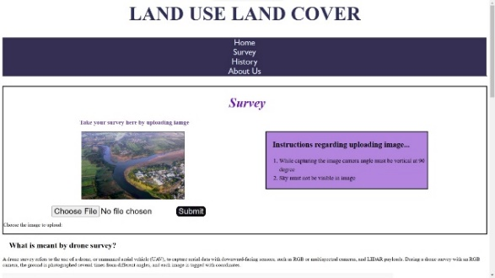
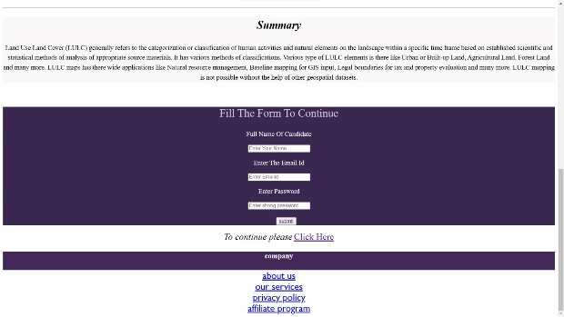
Figure 2: Front-end of the website

- Criteria:
There are some criteria:
- Whenever the images are to be captured the sky should not be included. It may be open sky or overcast.
- The drone must have coincided. The angle of the drone matters as water bodies creates reflection, which may include sky reflection or surroundings, resulting in garbage values.

- Drone:
A drone is an unmanned aircraft. Drones are more formally known as Unmanned Aerial Vehicles (UAVs) or Unmanned Aircraft Systems. Essentially, a drone is a flying robot that is remotely controlled or flies autonomously using software-controlled flight plans in its embedded systems, that work in conjunction with onboard sensors and a Global Positioning System (GPS).

- RESULT

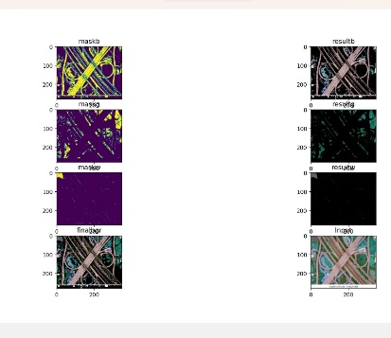
sss

- CONCLUSION:
The prototype of Land Use and Land Cover is designed successfully. It is integrated using drones and software. The user integrates on the website and the result is displayed on the same. The website access the data, stores, process, and display the result. Website process only one image at a time. The proposed system can be used in Government bodies.

REFERENCES

[1] Shi Peijun, Gong Peng, Li Xiaobing, et al. The Methods and Practice of Land Use/Land Cover Change Research [M]. Beijing: Science Press, 2000.
[2] Jincai Zhao, Heli Lu, and Chao Sun report on " Land Use Change Monitoring on the Process of Urbanization in the Central Plains Economic Zone Based on Remote Sensing and GIS Technologies".
[3] Bumsuk Seo, Christina Bogner, Thomas Koellner, and Björn Reineking,” Mapping Fractional Land Use and Land Cover”, IEEE JOURNAL OF SELECTED TOPICS IN APPLIED EARTH OBSERVATIONS AND REMOTE SENSING.
[4] T.W.S. Warnasuriya,” Mapping Land-use Pattern Using Image Processing” 2015 International Conference on Advances in ICT for Emerging Regions (TCTer): 106-111.
[5] A. Rajeshwari and N. D. Mani, "Estimation of the land surface temperature of Dindigul district using Landsat 8 data," International Journal of Research in Engineering and Technology., vol. 3, pp. 122- 126, May. 2014.
[6] T. R. Loveland et al., “Development of a global land cover characteristics database and IGBP DISCover from 1 km AVHRR data,” Int. J. Remote Sens., vol. 21, nos. 6–7, pp. 1303–1330, 2000.
[7] P. Singh and S. Singh, "Land-use pattern analysis using remote sensing: A case study of Mau district, India," Archives of Applied Science Research, vol. 3, pp. 10-16, 20 II.
[8] U. S Geological Survey, Ed., USGS Unnumbered Series: Landsat 7 science data users handbook. Maryland, USA: General Interest Publication, 1998.
[9] M. A. Reddy, Test book of Remote Sensing and Geographical Information System, 3,d ed., M. A. Reddy, Jr., Ed. Hyderabad, India: BS Publications, 2008
(b) Institutional and Departmental facilities available for the proposed work:
Software Tool: Visual Studio Code.

