DESIGNING FOR THE COMMONS: AN ARCHITECTURAL APPROACH TO MANAGE PUBLIC SPACE
Mayur Rathore, Ar. Ratima Dagaonar

ABSTRACT
Shared space has served as a meeting place for social interaction and urban life. It has a huge socio-physiological impact as well as emotional impact on audience which includes social interaction and community engagement, evoking a sense of pride, awe, or inspiration, or they can make audience feel unwelcome or uncomfortable. Overall, public buildings can have a profound impact on people's lives. By considering the socio-physiological and physical impacts of public buildings, architects and planners can design buildings that are inclusive, welcoming, and beneficial for the community.
These spaces were once considered the heart of the city, but functionalism has led to a dramatic change in public buildings. Another building is now used as a public space, creating congestion, rush, visually inaccessible spaces and dead zones. These issues led to poor visitor experience and should be addressed at the planning stage. This paper explores the aspects of construction facilities for communal use, from zoning regulation to design and aims to show that proper check-in and the sightseeing for the people in public buildings can be efficiently achieved through site planning, landscaping, and architectural design. Building design can have a profound impact on activities, opportunities and patterns, and each space is approached differently depending on its purpose. This study focused on identifying efficient visitor management methods in public buildings by examining visitor infrastructure, site planning, landscaping, and building design. Data were collected through case study. Based on the data collected, analysis of techniques for improving site planning, landscaping, building design strategies, and visitor management was conducted. The study ultimately concluded by providing tools and techniques for public administration, as well as conclusions and recommendations. Different methods of site planning are proven, depending on the function of the building. Proper management for the audiences in public buildings can be achieved through proper site planning and landscaping. Careful planning of these buildings can eliminate many problems associated with the audience and check in.

KEY WORDS: Audience, Shared Space, Landscape, Planning, Socio-Physiological Impact.

INTRODUCTION
Publicly accessible and supported by public funds is a form of building known as a communal building. Despite the fact that this fundamental idea is frequently ignored, true beauty in architecture lies in its capacity to benefit and enhance the human experience. We see "public" structures all too frequently, yet they rarely contribute to the vibrancy and quality of life of a city because they do not fit into the urban fabric, is not related to their surroundings, or any of these things. Even if they are fairly attractive on the outside, certain public places lose much of their value if they are not also useful, cosy, and friendly to the people they are intended to serve. Public buildings have the ability to link spaces and people. As significant as public buildings are, it is remarkable that their quality has sometimes been overlooked and that they have frequently been given little thought. With the advent of functionalism, telecommunication made it feasible for people to engage and converse without really meeting in person. Public spaces are places where culture can flourish. It provides an opportunity for people of many ethnicities, cultures, and social groups to come together and promote their respective cultures while also experiencing new, foreign communities. It is a setting where social and creative growth is possible. People coming from different societies have different ways of dressing, different languages, customs, and beliefs.

SHARED SPACES
Throughout human history, streets and squares have been integral to urban life, serving as gathering places for people to meet, socialize, and be part of a larger community. These public spaces were once considered the focal points of cities and played a crucial role in facilitating public interaction. However, with the rise of functionalism in architecture, the importance of streets and squares began to diminish. Instead, emphasis was placed on roads, paths, buildings, and green spaces.
As architecture evolved, communal buildings became the new focal points of public interaction. Over time, a variety of communal buildings were constructed with different styles and concepts, all aimed at managing people and providing unique experiences. Today, these buildings continue to play a vital role in urban life, providing a diverse range of spaces for people to come together and engage with their communities.
SIGNIFICANCE OF SHARED SPACES
Open access to spaces in a city or neighbourhood can facilitate social interaction and provide opportunities to observe and engage with others in a variety of settings. These simple but important "see and hear contacts" should be viewed as part of a broader range of social activities, from basic and reserved interactions to more complex and meaningful relationships.
In addition to providing information about the social world, the chance to observe and listen to others can also inspire and motivate action. We are often motivated by watching others in action, such as when children observe their peers playing and are inspired to join in or come up with new games based on what they see.

IMPORTANT KIND OF ACTIVITIES
Necessary Activities:-These activities go beyond just moving around in space. Daily chores like getting the mail, walking the dog, or walking to work or school are examples. As individuals have no choice but to participate in this category of activities, Gel asserts that these activities would take place in all weather conditions and throughout the entire year.
Optional Activities:-Activities that are optional take happen when there is a willingness to participate and a time and location that are conducive to doing so. Examples include playing catch or relaxing outside. Optional activities are less likely to take place in bad weather than required ones. Instead, extracurricular activities take place when the weather and other outdoor factors are ideal.
Social Activities:-The third method that people energise public space is through social activities. People engage in these activities when they socialise and gather in one location. These types of activities include children playing, friends gathering to chat, and onlookers making fleeting eye contact. These actions can take place in a variety of contexts and are frequently spontaneous in character.

TYPES OF USERS IN PUBLIC BUILDING
Public buildings accommodate various visitors, including passersby, occasional visitors, and regulars. Visitors come for different reasons such as attending events or personal preference. The main types of visitors include
Types of users 
- Family,
- Children
- Infants
- Couples
- Senior citizens
- Handicapped people
- Foreigners.

ISSUE RELATING TO CIVIC BUILDINGS
- Poor entrances and areas that is difficult for the blind.
- Long roads and paths that don't lead where people wish to go.
- The chaos and stampede.
- Dead areas.
- Defective characteristics.
- Circulation and orientation issues.
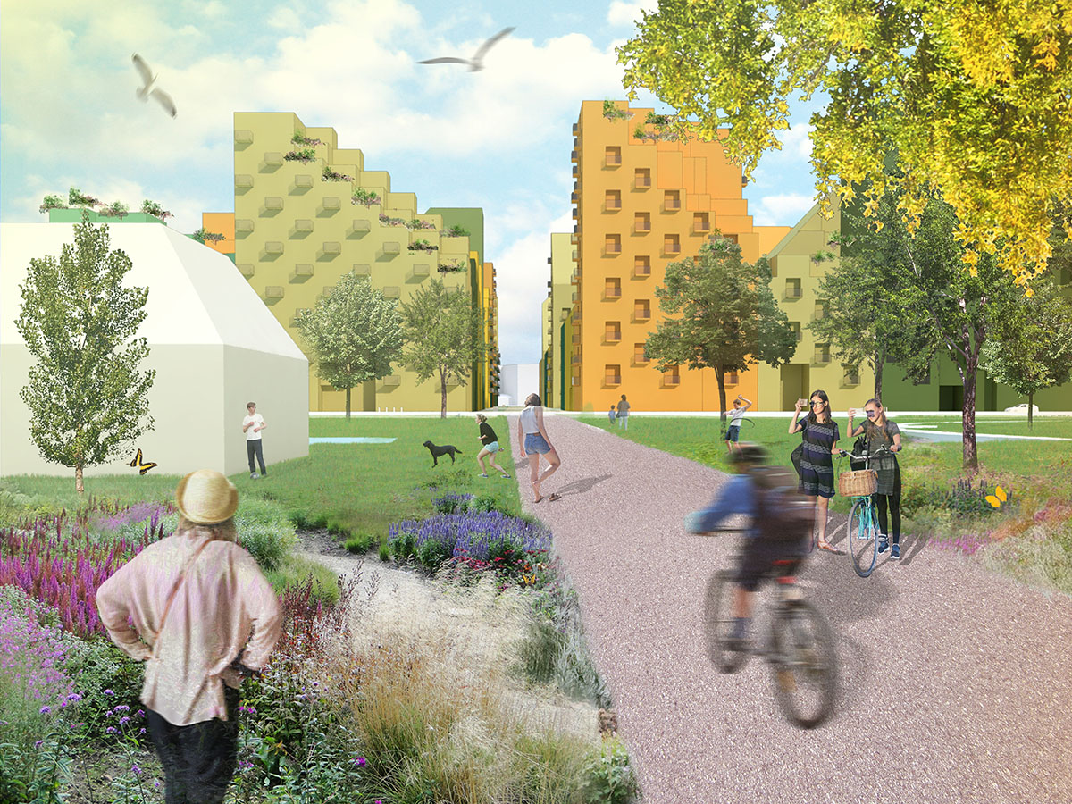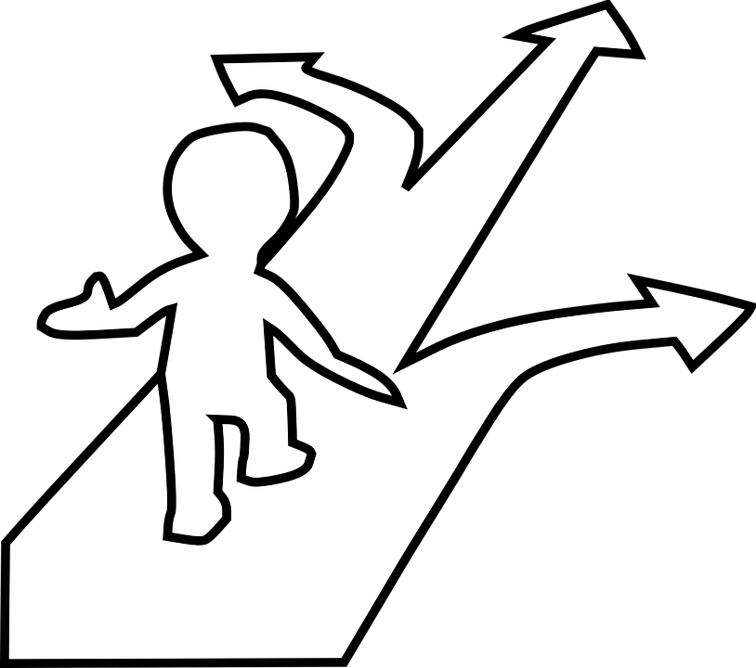

CROWD CONTROL BASED ARCHITECTURE
Site planning and landscaping are the major elements of this type of management. This approach is used during the planning and design phases. By way of traffic patterns, zoning, signage, street designs, open areas, etc. When developing a building, various aspects like site planning and landscaping are taken into account. Through thoughtfully planning building routes, this type of management assists in bridging disparate locations.
Additionally built into the building is a signpost system that helps visitors find various areas without getting lost. The main emphasis is on landscaping because it offers numerous options to connect these places and provide numerous eye-catching aspects. These landscaping elements offer a lot of scope as they also improve the visual appearance of the building. Orientation, surface quality, and spatial organization are also considered in the design of public buildings and directly aid architectural control.

USER’s MANAGEMENT IS DONE THROUGH
1. Site Planning
2. Landscaping
3. Proper Infrastructure
4. Proper Technology

PLANNING AND DESIGNING OF SHARED SPACES
A site plan is a finely detailed technical drawing of the proposed changes to a specific property, landscape architecture plans, and construction plans. Building footprints, driveways, parking spaces, drainage systems, sewers, streams, paths, lights, and landscaping and garden features are frequently included in site plans site plan is "a graphic representation of the layout of buildings, parking lots, driveways, landscaping, and other structures forming part of the development project." Site plans are detailed diagrams that depict how the whole perimeter of a property will be used for either present or future development. Site study is typically the first step in site planning, which involves assessing potential development locations. Slope details. The evaluation and mapping of soils, hydrology, vegetation, plot ownership, orientation, etc.
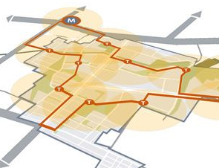
Site planning
MAPPING ACTIVITY
In site planning, activity mapping is used to describe how people are distributed within a place according to their levels of activity.
Activity mapping aids in:
• Understanding the location's identity.
• To be aware of the many activities taking on in the area.
• The various user groups present.

ZONING
Zoning is primarily used to separate uses that are deemed to be incompatible. Zoning is the deliberate process of arranging various buildings and spaces on a site while taking into account site elements including access and exit points, drainage, levels, power and water supplies, setbacks, parking, and all other site features. The placement of the blocks on the site is completed only when all aspects have been considered and balanced. The term "zoning" refers to the entire process of place-making.
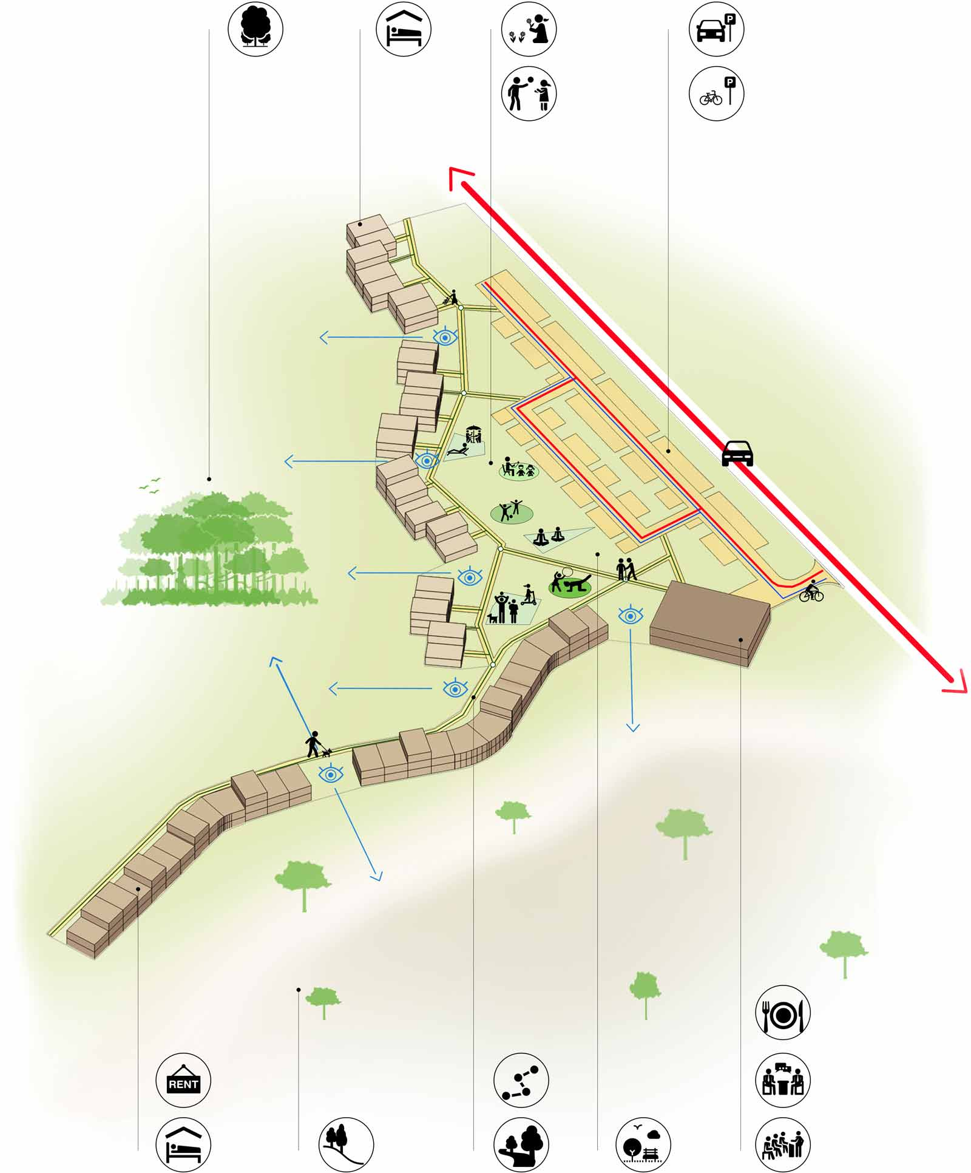
Zoning diagram

People and vehicle movement
Orientation and circulation issues will be separated into distinct problem categories. Each will be covered separately. These are the issues:
- Entering the building
- Locating resources for assistance
- Circulation and orientation while watching an exhibit
- Leaving the building or facility
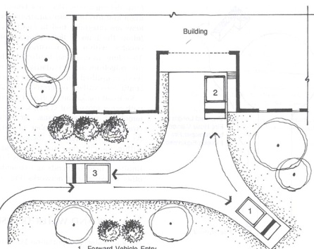

LANDSCAPING ELEMENTS
Public squares
Land form
Streetscapes
Signage system
Lights and shadows
CASE STUDIE

JAWAHAR KALA KENDRA, JAIPUR
In the Indian city of Jaipur, there is a multicultural centre called Jawahar Kala Kendra. The Rajasthan government constructed it with the intention of preserving Rajasthan handicrafts. In the eight blocks that make up the complex are museums, amphitheatres, and other empty auditoriums, as well as libraries, art galleries, cafeterias, modest hostels, and studios for artists. Along with three of his other galleries, there are two permanent art galleries. Every year, it holds a theatre festival on its own. Components of visitor infrastructure are-
- Entrance
- Reception
- Waiting area
- Lobby
- Shops
- Cafeteria

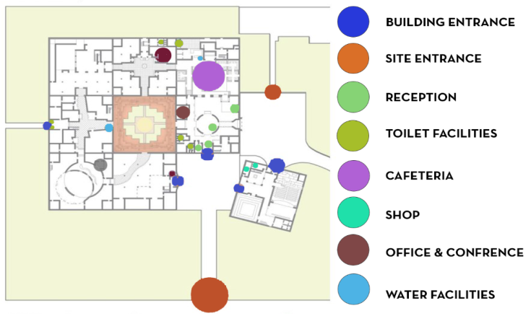

JAWAHAR KALA KENDRA ACTIVITY SITE PLAN MAPING
The Jawahar Kala Kendra is a gathering place for artists, thinkers, and admirers of the arts. JKK frequently offers artistic performances and exhibitions. The JKK facility has an amphitheatre, café, library, exhibition hall and auditorium. There are galleries, studios, cafeterias, museums, libraries, tiny youth hostels with amphitheatres, and auditoriums with closed doors.

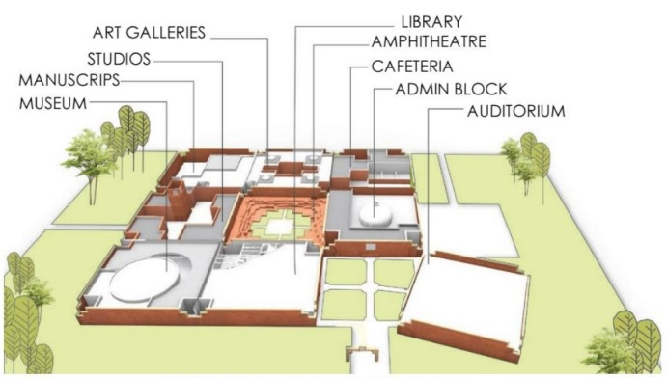

CONCEPTION OF FORM
Axis identification: The primary axis for identifying movement patterns is established.
Establishing nodes central node established at the axis' junction
Observed from the nodes: designed blocks near the main node.
Fracturing a bulk to produce porosity Movement between spaces is made possible by gaps in the masses.

LANDSCAPING
Landscaping plays an important role in connecting different spaces and helps manage the public within a building. Helps create gates, waits, and intersections, and helps manage visitors. The top three landscape design elements that help manage visitors include walkways that connect different spaces, open spaces or city plazas that act as focal points and facilitate entry and interaction, and buildings that guide people within the building. IT includes a labelling system.
Landscaping should be done in such a way that it should invoke one’s senses. It can greatly benefit from the application of the five senses. Here are some ways you can incorporate the senses into public space design:
Sight: Use colour and texture to create visually appealing spaces. Incorporate a variety of plants, trees, and flowers that bloom at different times of the year to create interest and variety. Also, consider adding art installations or sculptures to add visual interest to the space.
Sound: Use elements such as fountains or water features to create a calming and relaxing environment. Incorporate wind chimes or other sound-producing elements that can create a peaceful sounds cape.
Smell: Incorporate fragrant plants and flowers into the landscape design to add an element of scent. Herbs such as lavender, rosemary, and thyme are great options as they release pleasant aromas when brushed or crushed.
Touch: Incorporate different textures and materials to create a tactile experience for visitors. Use materials such as wood, stone, and gravel to create paths, seating areas, and other elements that invite visitors to touch and explore.
Taste: Create a tasting room where visitors can sample different foods or beverages. This could be incorporated into a museum or gallery or any public building to offer audience a unique way to engage with the exhibits.

Open-ended construction
Urban public squares are open areas that are enclosed by other buildings and constructions. They so have a significant impact on the makeup of a space's mass and vacuum.
VERDANT AREAS
Buildings can be more functionally and aesthetically effective by having spaces that are constructed with some grew eland open spaces and some landscaping.
PUBLIC AREAS
The layout of the eight surrounding squares is such that they are well connected to the central open plaza, which is intended to be an outdoor theatre.

SIGNAGE TYPES: JAWAHAR KALA KENDRA

BULLETIN BOARDS AND MAPS
At the building's entrance, there are maps and notice boards. On a wall near the reception, there is a floor map with a legend and a bulletin board with flyers for various events so that people can see what's happening next. Using maps and notice boards keeps visitors around.
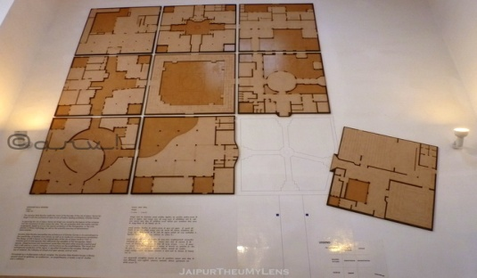
DIRECTIONAL SIGNS
Directional Signs on the walls of jawahar kala Kendra are present that helps people navigate around the buildings.
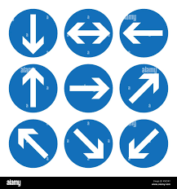

DESIGNING A SPATIAL ORGANISATION: JAIPUR'S GENESIS
The original grid layout of Jaipur, which consisted of nine squares with the central square left open, served as the model for the entire core. A novel idea of nine squares known as "Navarra" is in the centre. According to the traits of each planet and its astrological values, each square of the complex is connected to a planet.
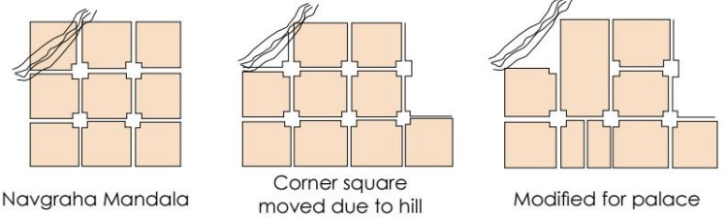
RELATIONSHIP SPATIAL
The complex has "Spaces linked by a common space" as its spatial relationship. The relationship or connectivity between all the major areas or blocks depends on this centre area. All of the blocks have the same dimensions. The open air theatre serves as the primary core area in the complex, with the other spaces spinning around it.
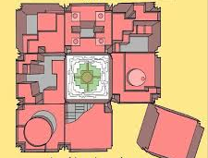
CENTRAL BLOCK CONNECTING ALL BLOCKS
INFERENCES
- The areas have a narrative flow that alters the user's mood, but the lack of continuous covered walkways in the general circulation renders the area unsuitable in the summer and when it rains.
- The open-air theatre is only attractive from a distance; nevertheless, when crowded, its high walls and lack of ventilation make it unusable.
- The structure is not accessible for people with disabilities. In particular, the absence of suitable ramps in the art gallery renders the area useless.
- Some locations lack signage.
- The site planning leads to effective visitor management. Separating the spaces into distinct blocks allows for effective crowd control and improves accessibility to the building. (6) The paths and open areas offer several rest stops and seating areas. The crowd is guided into various locations via the direct and indirect channels.
- The environment features a stunning combination of light, shadows, and colours that evokes the user's emotions and entices him to explore more.
- The movement of visitors is significantly influenced by the central square. It serves as a significant meeting place and permits people to disperse into various areas.

ANALYSIS OF CASE STUDY

STRENGTHS
- Providing all necessary amenities inside the structure.
- Amenities are easily accessible.
- Amenities including restrooms and water fountains are available on every block.
- A strong aspect is the cafeteria with the seating area and patio.
- Small plaza with seating for guests housing a cafeteria and a gift shop.
- Parking plaza with allocated guest parking.
- WEAKNESS
- Inadequate signage for accessing the facilities.
- The absence of steps and ramps for accessing the facilities.
- Insufficient space for the people to wait and wait
- Security hazards may result from a lack of security checks.
- Heat exposure due to the absence of covered paths.

OPPORTUNITIES
- Proper ramps and signage for easy accessible.
- Informal seating places and guest waiting rooms might be given more emphasis.

CONCLUSION
We all know that designing public buildings is a big challenge. It also faces countless limitations. The biggest challenge in communal spaces is managing the public in such spaces. The success of any public building depends on the efficiency of the building's visitor management system. Communal buildings are designed entirely for the general public, as the main crowd within the building will be users Therefore, maintaining public control for such buildings is very important. Major challenges for public buildings include congestion, confusion, long routes, and visually inaccessible spaces, routes that do not fit where you want to go, dead zones and malfunctions. Problems with public buildings have never been greater and are the starting point for improving the quality life for people. These are the most common problems faced by user inside the building. These issues lead to highly maladaptive commons management. There are several risks associated with inconsistent commons management. As such, the theme focuses on the importance of user’s management, rethinking the entire process, making management a priority, and engaging architects, policy makers, and governments in the design and maintenance of public spaces. It showed that it was time to raise it. This research focused on the study of site planning, landscaping, and design of communal buildings. These are three main parameters that were central to his design. The research revolves around various targets identified at the beginning of the study, studying communal buildings, discovering problems associated with these buildings, analyzing activity patterns and circulations through comparative studies, and finally proposing guidelines for better communal building management. Research consists of studying the parameters of the study. This research was primarily focused on site planning, public building landscaping, and finding the most efficient techniques of visitor management through architecture.

