NEURAL STYLE TRANSFER USING DEEP LEARNING
Mr.Inavolu Avinash , Mr.Alla Venu sai , Mr.B.Taraka Ramu , Mr.K.V.RangaRao
Department of Computer Science and Engineering
Vignan’s Foundation for Science, Technology & Research, Vadlamudi,522213, AP, India
*Corresponding author: kvrrvignan@gmail.com
avinashinavolu2002@gmail.com,venusaireddya@gmail.com, btramu2001@gmail.com

Abstract-We can use the Neural Style Transfer technique to build a picture with the same "content" as the beginning image but the "style" of the picture we've chosen.Neural style transfer is a technique for merging the style of one image into another while retaining its original information. The only change is how the image is formatted to give it an additional artistic sense. The content image depicts the plan or drawing, as well as the colors of the drawing or paintings used to portray the style.It is a computer vision programme that learns and processes images through deep convolutional neural networks..To implement software we used to train deep learning models with the train data and whenever user takes an image and a styled image the output will be as the style gets transferred to the original image and it will be shown as the output.
Literature survey:
A deep learning approach called neural style transfer enables us to adapt the look of a particular picture to the content of other. In recent years, it has grown in popularity as a subject of study, with several techniques and variants. Here is a review of a few of the key publications in the area:
Gatys et al. (2015)'s "A Neural Algorithm of Artistic Style": In this study, convolutional neural networks, also known as CNNs, and optimisation are used to present the neural style transfer approach. It suggested a technique to use representations of features in a trained CNN to distinguish between between the layout and the information within a picture.
Ulyanov et al. (2016)'s "Texture Networks: Feed-forward Synthesis of Textures and Stylized Images": In order to create stylised visuals, this research developed a feed-forward neural network. It makes use of a texture synthesis method in which a texture is first applied to one picture after being learnt from another using a CNN.
Johnson et al. (2016) published a paper titled "Perceptual Losses for Real-Time Style Transfer and Super-Resolution": This study suggested an instantaneous style transfer approach that aligns the representations of features of the content and style pictures utilizing a feed-forward network and a perceptual loss function.
Huang and Belongie's (2017) "Arbitrary Style Transfer in Real-Time with Adaptive Instance Normalization": The approach described in this study employs adaptive instance normalisation (AdaIN) to instantly transfer the style of one image to another. It makes use of a feed-forward network, a VGG-16 encoder, and a residual block decoder.
Johnson et al. (2018)'s "Fast Photo Style Transfer Using Convolutional Neural Networks": In order to replicate the style of one picture to another in real-time, this research developed a rapid style transfer technique that makes use of a network of feed-forward neurons with a structure consisting of an encoder-decoder and a feature translation module.
According to Luan et al. (2017)'s paper, "Exploring the Structure of a Real-time, Arbitrary Neural Artistic Style Transfer System," The AdaIN approach was expanded in this paper to provide arbitrary style transfer. It employs a multi-scale design that gives the style process of transfer greater leeway.
According to Liu et al.'s (2018) paper, "Multimodal Transfer: A Hierarchical Deep Convolutional Neural Network for Fast Artistic Style Transfer," For quick creative style transmission, this article developed an ordered deep convolutional neural system. It employs a multi-modal transfer methodology that enables the incorporation of several aesthetics into a single picture.
These are but a few of the numerous studies in the area of neural style transmission. Numerous more strategies and modifications, such as adversarial techniques, models that generate, and attention-based techniques, have been put forth. With the constant development of new methods and applications, the discipline is continually evolving.
I.INTRODUCTION
Styled Photos have grown in popularity in modern times as a result of the work required to enhance cameras, particularly mobile cameras. Today's typical user records movies on their mobile device rather than with a costly equipment. On the other side, entertainment producers employ specialised hardware and editing programmes to build CGI-powered picture-queue scenarios. There are several tools, strategies, advancements, and applications. Nowadays, NST is frequently used to alter photographs and produce a variety of effects. The paper describes the current state of the art in Generative Adversarial Networks (GANs) advances. It also outlines the fundamental methods currently employed to modify films before moving on to NST-based methodsWe have 2 concepts for doing this Neural style transfer:
1.Transfer learning
2.Style transfer
1.Transfer Learning:
A machine learning approach called transfer learning uses a model developed for one task as the basis for a model for another. It is an established approach in deep learning to use previously trained models as a foundation for learning on the natural language and vision the processing task because of the immense amount of computation and time needed for developing neural network models on every one of these challenges and the immense boost in skills from all of these problems. The technique through which what is learned in one sitting is built onto and generalised in a future sitting is referred to as transfer learning and is described in the suggested method.

2.Style transfer:
This indicates that the uniqueness of the deep learning strategy is to harvest the style of a picture using extracted characteristics of the pre-trained model paired with instead of just looking at the stylized image's pixels, consider its content. Hence, in order to determine the picture style, we analyse the pixels in the image and then feed this data to the layer of a pre-trained model to categorise the inputs as objects. The fundamental concept to grasp is as follows:
1.Taking content of image
2. Style of image to be applied.
Convolutional Neural Networks are the majesty of Deep Neural Networks that are most strong in image processing jobs, Convolutional Neural Networks are actually hierarchical, feed-forward structures that interpret visual data. They are made up of layers of small computer units. The several layers of devices may be compared to a set of photo filters for each of which abstracts a particular aspect of the incoming image. As a result, a particular layer's output is made up of function maps, which are filtered representations of the input picture.
Convolutional neural networks increase visual representation when trained on item relevance, making important regions of attention more obvious as the computation hierarchy rises. 8 The network's filtered hierarchy transforms the input photo into a representation that is more interested in the actual content of the photograph than its distinctiveness. By rebuilding the image utilizing the traits that were gathered from that Layer9, we will immediately reveal the information that each layer has regarding the input images. The photographs' objects and connections are detailed in great detail by higher levels of the network, but they are unconstrained in terms of the reconstruction's exact pixel values. Reconstructions from the decline levels, in contrast Simply duplicate the original photo's precise pixel numbers. Due to the substance, we subsequently verify with the feature replies in higher levels of the network.
We make use of a function area that was originally created to record material data in order to obtain a depiction of the design of an input photo.The community's eight choice region is built on top of each layer's filter answers. The connections between the various clean out answers are also included. Over the feature maps' geographic range (see techniques for information). which also incorporates the quality We acquire a stable, multi-scale depiction of the input image through the correlations of a few layers that catches its material data but not the global layout.=
By creating a graphic depiction that reflects the fashion representation, we can show the data collected by these style characteristic areas built on Special levels of the community. Ten input photos are provided, and eleven replicas from the clothing are made. Features create texturized iterations of the original image that accurately reproduce its well-known colour and regional system look. Additionally, as the hierarchy grows, the size and complexity of adjacent picture systems from the input image will also expand. This outcome can be characterised by the increasing responsive subject areas and feature complexity. This multi-scale portrayal serves as a resource for us in terms of design portrayal.The key result of this article is the fact that the Convolutional Neural community distinguishes between models of substance and style. To create novel, perceptually significant images, we will separately manipulate both forms. To illustrate this result, we create images from two excellent source images that combine text and fashion art.
In particular, we modify the textual description of a picture showing the "Neckarfront."In Tubingen, Germany, and the stylistic depictions of many famous works of art chosen from "Unique periods of art," the photographs are compiled by locating an image that complements the material. Illustration of the artwork's image as well as its stylistic illustration. The initial image has been retained in its entirety.
The artworks provide the colours and neighbourhood networks that make up the global landscape.This effectively depicts the picture within the style of the artwork, such that the appearance of The synthesised picture mimics works of art, despite having the same substance as the Photo.As previously stated, the stylistic depiction is a multi-scale image that incorporates multiple neural network levels. The design depiction Protected levels from the entire network structure is shown in the snap photos shown in Fig 2. Photographic substance and design are inextricably linked. During the synthesising process An image that blends the substance of one image with the manner of another; there is rarely an image that precisely fits both restrictions at the same time. However, the Loss feature that we reduce during image creation includes two lines for substance and design. Which can be neatly divided, respectively (see methods). As a result, we can easily shift the emphasis to either rebuilding the substance or the trend. (Fig three, along the columns). A heavy focus on style leads to in pictures that fit the introduction of the painting, accurately giving a texturized model of it, but rarely display any of the picture's substance.While putting a strong focus on substance, you may notice the picture, but the style of the artwork isn't always as well-matched. To create aesthetically appealing Pics, you'll control the trade-off between substance and style for a particular set of Source images.
In this paper, we present an artificial neural system which separates photo content from style, allowing us to recreate the placement of one image's content within another's aesthetic. We demonstrate this by producing new, inventive pictures that combine the style of numerous renowned works of art with the substance of a randomly chosen photograph. We obtain the Neural models for an image's substance and style, in particular, from the feature replies on high performing Deep Neural Networks learned on object appeal. To the best of our knowledge, this is the first display of picture abilities distinguishing substance from style in complete botanical photographs.In this example, we create a provided picture in the manner of a number of well-known works of art. This issue is typically addressed in a branch of machine vision known as nonphotorealistic graphics. Strategies that use material transfer to achieve innovative fashion change are conceptually most closely related.15-19, however, these prior methods depend on non-parametric tactics to modify the pixel depiction of a photograph at the same time. In comparison, we carry out changes in function domains that directly reflect the substantial content of an image using Deep Neural Networks trained on object reputation.
In order to categorise works of art according to the time period in which they were created, Deep Neural Networks trained on item prominence were previously used.20 There, classifiers were trained on top of the not cooked community activations, which we refer to as content representations. In general, our method of synthesising images that combine content and fashion from unique Resources provides a new, engrossing tool to examine the faith and neural representation of artwork, style, and content-unbiased picture look in general. We hypothesise that a change into a stationary function space With the fashion illustration may reap even better performance in style type. We can create novel cues that add objective, perceptually significant version components, such as the appearance and substance of an image. This could be useful for a broad range of experimental investigations on visual perception, from psychophysics to focused imaging to even electrical brain recordings. Actually, our study provides mathematical details of how brain models can separately grasp both the substance of a picture and its presentational manner. The mathematical structure of our fashion models, which is significant, produces a clear, verifiable theory about the portrayal of picture appearance all the way into to the solitary neuron level. The connections between particular types of neurons in a community are absolutely computed by the fashion models. Our results suggest that acting a complex-cell like calculus at specific processing levels throughout the ventral motion might be a likely way to gain a content-impartial example of the appearance of a visual input. Overall, it's definitely fascinating that a neuron can perform a biologically feasible computation like extracting correlations among neurons, which is, for example, implemented by so-called complicated cells in the primary visual system (V1).21 The network must become stable to all image variations in order to master item reputation, which maintains object identity. For this project, representations that take both the Variant in an image's substance and the Variation in its appearance may be incredibly useful. As a result, our capacity to produce and enjoy art as well as our ability to summarise content from fashion are presumably frequently a Preeminent hallmark of our visual system's strong reasoning abilities.

Neural style transfer Sample Image:
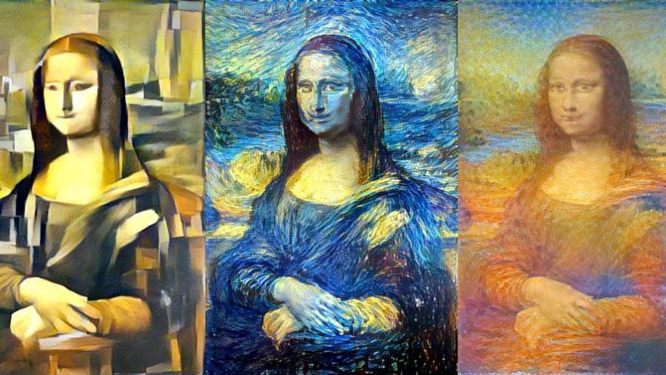

Existing system:

A transfer networking and a have been trained feature the generator must be used to train a style transfer model.NST makes use of a pre-trained ImageNet-VGG TensorFlow model.The model cannot understand the photos on its own. These must be transformed into raw pixels and transmitted to the model, which converts the raw pixels into a collection of attributes using convolutional neural networks.As a result, the model acts as a sophisticated feature extraction midway between the layers of pixels that generate the final result and the different levels wherever the input image is fed into the model. The model's intermediary levels are all necessary to use to characterise the substance and aesthetic of the incoming pictures.The raw picture is changed into depictions that focus more on the image's substance than on its precise pixel values.The characteristics we obtain from the upper layers of a model can be seen as being more closely linked to the image's substance.The current system is built on VGG19, a convolutional neural network that has 19 layers, 16 convolution layers, and 3 completely linked layers that can categorise pictures into 1000 different object categories, which was suggested by Simonyan and Zisserman (2014). ImageNet is used to teach the VGG19 algorithm.We use the association between various filter results to reflect the manner of a reference picture.

Content loss
Establishing parallels between the produced picture and the content image is helpful. It seems reasonable that higher tiers of models would focus more on the qualities the image already has, or the image's overall content.
Content loss is measured by the Euclidean distance that exists between intermediate more advanced feature representation of the content of the image (p) and the raw image (x) at layer l.

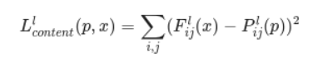
When several elements are available, it is typical to a model to create a variety of feature maps at higher levels.This allows us to conclude that images with identical content should have comparable activations in the upper layers.

Style loss
Conceptually, style loss and content loss are two distinct things.The stylistic loss cannot be determined by simply comparing the intermediary characteristics of the two pictures.For this reason, we coin the phrase "Gram matrices."Gram matrices, which display the general spread of characteristics in a particular layer, can be used to understand the stylistic information in a picture. It is determined by how closely the feature images in a particular stratum correlate with one another.
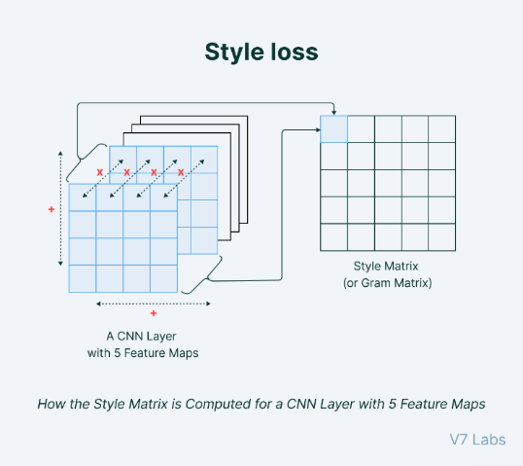

The difference between the produced picture's gramme vectors (or, in other words, style representation) and the style comparison image is used to compute style loss.The following algorithm calculates the amount of each component in the design information:
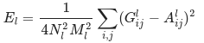
As a result, the overall style loss for each layer is stated as follows:
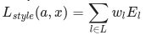
where wl is the total amount that each layer contributed to this style loss.

Existing system Architecture:
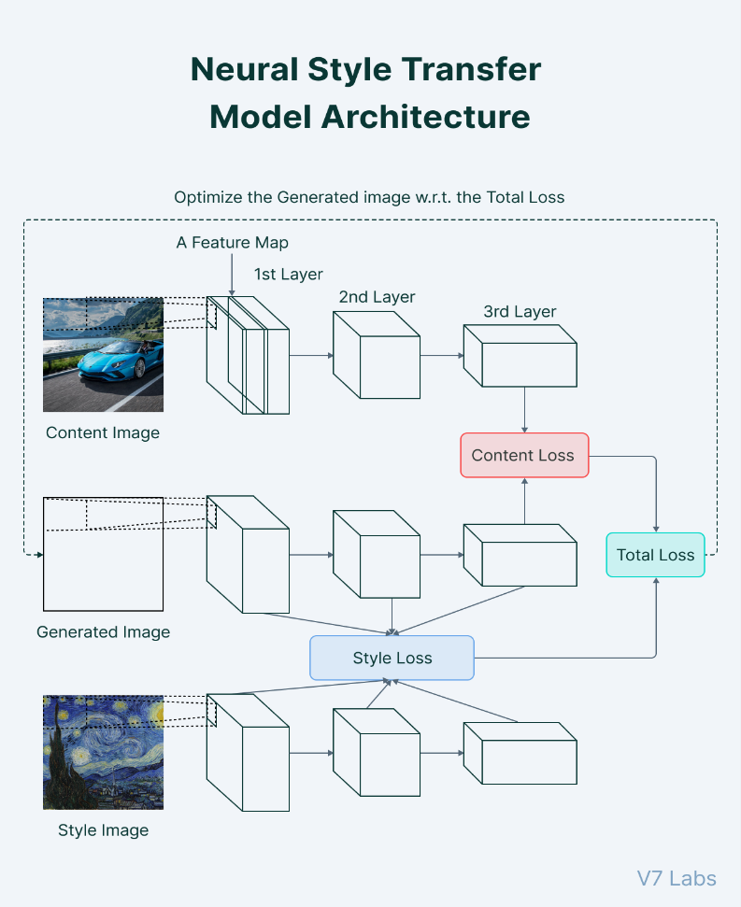

When he applies the VGG network and He utilises the output of the high-level activation function of the VGG network to represent the material properties of the picture and the Gram matrix to identify its stylistic attributes. NST can be achieved by keeping the created image's content and aesthetic elements as close to the original as is practical.
The Gatys and Co. As a result of CNN features' ability to momentarily stop and dispose of some lower-level information, algorithms are unable to consistently retain fine structure and detail during stylization. And Gatys and others have expanded on Gatys by incorporating a Markov structure alongside cutting-edge features for global symmetrical texture generation and picture season change. This has made the creation of images constant over time. The method, however, overstylizes the picture because it ignores the image's shifts in outline, meaning data, or depth location information. Rissuer et al. addressed additional factual histogram mishap with characterise the allocation data of picture outlines in order to addressEven though the answer to the problem of gramme lattice instability is fairly challenging, it has been achieved. Li et al. noticed that the low-level data from the content image had been removed. Introduce The lower-level information included in the content image is defined using the Laplace matrix by the Laplace loss, which imposes additional constraints on the underlying features and offers a complete contrast to the more advanced semantic information that the VGG network was able to retrieve. Describe how to move patterns to certain zones using Gatys et al.'s approaches for semantic segmentation of events. Luan et al. prevent the overuse of hinder styles in every area and permit style mobility in sub-regions with the same meanings by transferring the semantic properties of content photos and style images. To increase efficiency, it has been enhanced by the addition of automatic picture semantic segmentation. Li and colleagues' research has supported an alternative theory for NST, which is viewed as an issue with region variance. Assume that knowledge about the exam and The planning originates from several places. A model that has been trained on labeled training information from a source domain is modified as part of domain adaptation in order to forecast labels representing unregistered testing data coming from a target domains. Minimizing the distribution discrepancy among a sample from the starting realms and one from the objective domain is one method for domain adaptation. MMD, or maximum mean discrepancy, is a popular method for contrasting two distributions. The approach, which demonstrates that combining style pictures and images that create Gram matrices are essentially MMDs that optimise the assignment of pixels across two domains, officially explains how L and co.'s Gram matrix matching works. You may comprehend the idea of NST better by applying the MMD approach with various nuclear functions. The aforementioned methods have enhanced Gatys et al.'s algorithms, but they didn't address the issues of a stroke's shift and losing depth location information, and this must be taken into account due to their effect on the quality of the image, in order to deal with the issues of security, loss of particulars, and insufficient semantic information.
Johnson et al., Ulyanov, and others who use the same principles and pre-train the a feed-forward styled model, which has an entirely distinct framework from the model, in order to stylize the image are examples of the feed-forward condensed model technique. Although Ulyanov and colleagues built a network using a multi-scale architecture, Johnson and other Radford's model framework, which he suggested, utilised leftover blocks and step-by-step convolution. Johnson and others established the debut of a forward feedback generalised model-based rapid style migration technique and the feeling of loss function based on Gatys' optimisation algorithm. In order to make images with more elaborate detail, Ulyanov and others use a multiple scales design to become acquainted with the characteristics of data pictures in different aspects. Then, it was found by Ulyanov and others that, in the initial model, using instance normalisation (IN) rather than sequence normalisation (BN), or normalising each picture individually, could greatly enhance image clarity. The fact that their algorithms remain to use Gatys et al.'s designs means that they are subject to the same limitations as they are, and the resulting pictures are of slightly poorer qualityJohnson et al., Ulyanov, and others who use the same principles and pre-train the a feed-forward styled model, which has an entirely distinct framework from the model, in order to stylize the image are examples of the feed-forward condensed model technique. Although Ulyanov and colleagues built a network using a multi-scale architecture, Different image translation network architectures in 32 may be achieved by changing simply the IN layer's properties. Chen and colleagues proposed the Style layer, exchange of content characteristics, connection of style features to a group of parameters in the Style layer, and unique training of a new Style layer to execute a fresh style move. Li et al. propose a style choice model that uses image pixels as signals data to control the development of styled pictures and contains a range of styles, with a rise in the number of learnt models and an ever-increasing degree of the model's limitations. By allowing the model to recognise many styles while utilizing targeted style picture features as NST signal sources, Zhang, Dana, and others first put forth the concept of the style layer.
Proposed System:-
We proposed that our Hybrid model project is made by combining two models named VGG19 and INCEPTION V3. In this project by using hybrid models like VGG19 and INCEPTION V3 we are going to transfer the style of styled image to the content image by using this models.
VGG19 is a model which is present in CNN.
This VGG19 is present in both deep learning and machine learning but we used deep learning model only.By using VGG19 model we get the good quality of the picture and we can transfer the style from one image to other.VGG19 model has 19 layers.
The eight-step configuration of my best-performing VGG19 model is shown in the diagram below. Layers of the Complex CNN VGG19 have been previously taught, and the characteristics are thoroughly understood. that define a photograph, including its form, color, and structure. With the aid of numerous complex categorization jobs and millions of unique pictures, VGG19 has undergone intensive training. Instead of further preparing VGG19, I simply paused its layers and added a thin 2-layer system on top of it to carry out my clustering task of differentiating between images without or with trees.
1. The essential equipment for executing neural style transfer is provided by libraries like TensorFlow and Keras, which are imported. To simplify and improve the process, these libraries offer pre-built tools and functionalities.
2. The reading and processing of the textual and visual content that will be utilised to facilitate neural style transfer. This entails deciding on the output picture size as well as the content and style images.
3. To handle various parts of the neural transfer of style procedure, such as preparing the input pictures and estimating both style and content losses, effective Neural Style Transfer utilities are provided.
4. This Neural Style Transfer VGG model, a deep learning model that has already been trained and is frequently used for image identification tasks, is loaded.
5. By describing the content as well as the style lost that will be utilized in educating the model to produce the desired output picture, the expenses to neural style transfer can be determined.
6. It is possible to calculate the color gradient of the outcome picture with reference to its loss function using the Evaluator class, which is defined.
7. The entire loss function, which combines both content and style losses, is minimised in order to train the neural network for style transfer method.
8. The results of the neural transfer of style are shown by visualising the output picture that was created and contrasting it with the source content and style pictures.
To improve your model's performance and teach it to recognise your goal even in improbable circumstances, introduce adversity:
To improve model efficiency by lowering model load, reverse the picture orientation, include images that resemble your goal, and use fuzzy and blurred versions:
Try early stopping to prevent overfitting; try an alternate activation function, which only activates particular neurons and is more effective than sigmoid or tan; try dropout, meaning that that selected neurons are left out during training, which leads to less network computation; avoid big pixel images because increasing image clarity does not substantially enhance learning (the standard is 224 by 224 pixels). After a certain number of epochs, if your model achieves its optimum accuracy, it will cease searching for an even greater accuracy.
The Inception V3 is merely a more advanced version of the Inception V1 concept. The Several methods were employed by the Inception V3 model to tune the network and improve model adaption.
Compared with the Inception V1 as well as V2 models in general, it is more efficient and has a dense network, but its overall efficiency is unaffected. It is more cost-effective at a high degree of processing. As there are sufficient regularizers, it also uses supplementary Classifiers.
The genesis v3 model from 2015 has 42 levels and a reduced mistake rate than earlier iterations. Let's look at the different improvements to the genesis V3 model. The following are the Inception V3 model's most important modifications: transformation into more minimal convolutions; incorporating spatial variables into asymmetric convolutions; use of assistant classifiers; and effectively reduced grid size.
An picture identification algorithm dubbed Inception v3 was discovered to have a reliability of more than 78.1% on the ImageNet collection. The paradigm is the end product of numerous theories that various scholars have created over time. It is based on the initial article, "Reevaluating the Inception Model for Computers Vision," by et al.
Convolutions, normal pooling, maximum pooling, concatenations, grads, and entirely connected layers are some of the symmetric and asymmetric building components of the model. The model makes significant use of routine normalization, which is also utilized by the data for activation.
Two major areas of the inception-V3 network may be enhanced. The Inception Module is first optimised using the branch structure. In order to create two small one-dimensional convolution kernels, the larger 2--dimensional convolution kernel is then unpacked. This asymmetrical structure can handle more complex spatial data with less processing.
Xception has improved Inception-V3. They are arranged in a column by the innovative Depthwise Separable Convolution that network suggests using space transition and channel change as its main ideas. In comparison to Inception, Xception is faster and has fewer parameters.
Although Xception and MobileNets use similar ideas, they have different objectives. MobileNets is a small model that aspires to strike a balance among model reduction and accuracy, whereas Xception aims for high precision. In MobileNet-V2, an innovative unit inversion remnant with a linear limit is employed. Prior to increasing the total number of channels and following convolution, the opposite of the residual causes the first climb. As a consequence, more RAM might be conserved.
In response to MobileNet, ShuffleNet receives a few improvements.
The 1-1 convolution method, a well-known conventional convolution approach, is used by MobileNet. ShuffleNet, on the opposite hand, combines and shuffles 1-1 convolution. This procedure enables pointwise group convolution and channel swap. Additionally, precision is maintained while being significantly reduced by this operation's model computations [21].
The Inception-ResNet network uses ResNet as its model, and the Inception module adds ResNet's residual structure. The influence of the model is not significantly enhanced by the residual structure. However, the residual structure accelerates closure and enhances computing efficiency.. While Inception-ResNet v1 and Inception-V3 both have the same number of calculations, the latter's closing pace is sluggish.

Working :
Step 1 – Libraries must be imported in order to transfer neural styles.
Step 2 – Read the written material and visual images.
Step 3 – defining some practical Neural Style Transfer functions.
Step 4 – loading the Neural Style Transfer VGG model.
Step 5 – Calculating the model's costs for neural style transfer.
Step 6 – Evaluator class definition.
Step 7 – Our Neural Style Transfer algorithm is being trained.
Step 8 – Displaying the outcomes of neural style transfer.

Applications:
1. Photo and video editors
2.Art and entertainment
3.Gaming
4.Virtual reality
Conclusion:
By using the artistic "Style" of the photograph that we select, our suggested approach makes it possible to create a new image with the same core "Content" as the initial image.

References:
1. J. Johnson, A. Alahi, and L. Fei-Fei. Perceptual losses for real-time style transfer and super-resolution. In European Conference on Computer Vision, 2021
2. X. Huang and S. Belongie. Arbitrary style transfer in realtime with adaptive instance normalization. In ICCV, 2020.
3. J. Deng, W. Dong, R. Socher, L.-J. Li, K. Li, and L. Fei-Fei. ImageNet: A Large-Scale Hierarchical Image Database. In CVPR09, 2019.
4. L. Chen, G. Papandreou, I. Kokkinos, K. Murphy, and A. L. Yuille. Deeplab: Semantic image segmentation with deep convolutional nets, atrous convolution, and fully connected crfs. IEEE Trans. Pattern Anal. Mach. Intell., 40(4):834– 848, 2018.
5. A. Gupta, J. Johnson, A. Alahi, and L. Fei-Fei. Characterizing and improving stability in neural style transfer. ICCV, 2017.
6. V. Dumoulin, J. Shlens, and M. Kudlur. A learned representation for artistic style. ICLR, 2017.
7. S. Desai. Neural artistic style transfer: A comprehensive look.,2016
8. L. A. Gatys, A. S. Ecker, and M. Bethge. A neural algorithm of artistic style. CoRR, abs/1508.06576, 2015.

