Object Oriented Analysis on Crop Recommendation using weather and soil content

Swetaswa Basak
School of Computer Science and Engineering
Vellore Institute of Technology,Chennai Campus
Kolkata, India
swetaswabasak@gmail.com
Balraj Agarwal
School of Computer Science and Engineering
Vellore Institute of Technology,Chennai Campus
Karnataka, India
agarwalbalraj@gmail.com
Rihana Zainab S
School of Computer Science and Engineering
Vellore Institute of Technology,Chennai Campus
Tamil Nadu, India
srihanazainab@gmail.com

Abstract— Crop recommendation is a critical task for agricultural productivity, and weather and soil conditions play a significant role in determining the suitable crop to grow. In this project, an object-oriented approach is used to develop a crop recommendation system that considers the weather and soil content of a particular region. The system uses weather and soil data to create objects that represent the conditions, and then applies a set of rules to determine the optimal crop for the given conditions. The approach allows for flexible and modular design, making it easy to modify and extend the system. The results demonstrate the effectiveness of the proposed system in providing accurate and timely crop recommendations, which can help farmers to make informed decisions and improve their yield.
Moreover, the object-oriented design of the crop recommendation system facilitates code reusability and scalability. The system can be easily extended to incorporate additional weather and soil parameters or to consider other factors such as pest management, water availability, and market demands. The modular design of the system enables seamless integration with other agricultural applications, such as farm management systems or precision agriculture tools.
The proposed system is built using advanced machine learning techniques and algorithms, including decision trees, random forests, and gradient boosting, to predict the optimal crop based on the input parameters. The system is trained using historical data, and the predictions are continuously updated with real-time weather and soil information, ensuring the accuracy and timeliness of the recommendations.
In conclusion, the proposed crop recommendation system based on an object-oriented approach is a powerful tool for farmers and agricultural professionals. It helps to optimize the crop selection process, reduce risks, and increase yield, ultimately leading to improved food security and economic growth in the agricultural sector.
Keywords—CART, KNN, SVM, LDA, Analysis, GUI

Introduction
Crop recommendation is an essential aspect of modern agriculture that plays a critical role in achieving high crop yield and profitability. Farmers and agricultural professionals need to make informed decisions regarding crop selection based on a wide range of factors, including weather conditions, soil quality, and crop demand. The use of technology and data-driven approaches in agriculture has gained popularity in recent years, and crop recommendation systems based on machine learning techniques have emerged as a promising solution.

In this context, this project proposes a crop recommendation system based on an object-oriented concept that uses weather and soil data to determine the optimal crop for a given region. The system is designed to be flexible, modular, and scalable, allowing for easy customization and adaptation to specific regional needs. The use of advanced machine learning algorithms and techniques enables the system to provide accurate and timely recommendations, reducing risks and increasing yield.

The objective of this project is to develop a crop recommendation system that leverages weather and soil data to improve crop selection and yield in agriculture. The system is designed to be user-friendly, accessible, and adaptable, providing farmers and agricultural professionals with a powerful tool to optimize their farming operations. The project aims to demonstrate the effectiveness of the proposed system through real-world testing and validation, highlighting its potential for widespread adoption in the agricultural sector.

LITERATURE SURVEY
The article "Crop Recommendation and Yield Prediction for Agriculture using Data Mining Techniques" by Aakunuri Manjula and Dr. G. Narsimha discusses the use of data mining techniques to predict crop yield and recommend crops for cultivation based on soil and weather conditions.
The article explains that data mining techniques are used to analyze historical data on crop yield, weather patterns, and soil quality to develop predictive models that can forecast crop yields for different regions and seasons. The authors also discuss the use of machine learning algorithms, such as decision trees, neural networks, and support vector machines, to make crop recommendations based on the analysis of data from multiple sources.
The article highlights the importance of accurate data collection and analysis for crop prediction and recommends the use of remote sensing technology, such as satellite imagery and drones, to collect data on crop health, moisture levels, and nutrient content.
Overall, the article provides valuable insights into the use of data mining techniques in agriculture and emphasizes the importance of leveraging technology to improve crop yields and maximize agricultural productivity.

The article "Crop Recommendation using Machine Learning Techniques" by Shwetha R B, Shafiulla Shariff, and Ramya O G discusses the use of machine learning algorithms to recommend suitable crops for cultivation based on soil, weather, and other environmental factors.
The authors explain that the traditional method of crop recommendation based on soil tests and expert knowledge can be time-consuming and often results in suboptimal crop yields. In contrast, machine learning algorithms can analyze large amounts of data and generate accurate crop recommendations in a fraction of the time.
The article discusses the use of several machine learning algorithms, including decision trees, k-nearest neighbors, and artificial neural networks, to develop predictive models for crop recommendation. The authors highlight the importance of feature selection and data preprocessing in improving the accuracy of these models.
The authors also discuss the importance of data collection and recommend the use of sensors and remote sensing technologies to collect data on soil moisture, temperature, and other environmental factors. They also suggest the use of crowdsourcing to collect data on crop yields and other relevant factors from farmers.
Overall, the article provides a useful overview of the application of machine learning techniques in crop recommendation and emphasizes the importance of accurate data collection and analysis in improving agricultural productivity.

The article "Crop-Yield Prediction And Crop Recommendation System" by Dishant Israni, Kevin Masalia, and Tanvi Khasgiwal discusses the development of a system that combines crop-yield prediction and crop recommendation based on machine learning techniques.
The authors explain that the system uses historical data on crop yields, weather patterns, and soil quality to predict future crop yields for different regions and seasons. The system also provides crop recommendations based on the predicted yields and the suitability of different crops for the local soil and weather conditions.
The article discusses the use of several machine learning algorithms, including decision trees, random forests, and support vector machines, to develop predictive models for crop yield and crop recommendation. The authors emphasize the importance of data preprocessing and feature selection in improving the accuracy of these models.
The authors also highlight the importance of data collection and recommend the use of sensors and remote sensing technologies to collect data on soil moisture, temperature, and other environmental factors. They also suggest the use of mobile apps to collect data on crop health and yield from farmers.
Overall, the article provides a useful overview of the development of a system that combines crop-yield prediction and crop recommendation based on machine learning techniques. The authors emphasize the importance of accurate data collection and analysis in improving agricultural productivity and suggest several strategies for collecting data from farmers and other sources.

The article "Crop Recommendation and Fertilizer Purchase System" by Mansi Shinde, Kimaya Ekbote, Sonali Ghorpade, Sanket Pawar, and Shubhada Mone discusses the development of a system that combines crop recommendation and fertilizer purchase based on data mining and machine learning techniques.
The authors explain that the system uses historical data on crop yields, soil quality, and weather patterns to predict the suitability of different crops for local conditions. The system also recommends the appropriate fertilizer for each crop based on the nutrient requirements of the soil.
The article discusses the use of several data mining techniques, including association rule mining and decision trees, to analyze data on crop yield and soil quality and develop predictive models for crop recommendation and fertilizer purchase. The authors emphasize the importance of data preprocessing and feature selection in improving the accuracy of these models.
The authors also highlight the importance of data collection and recommend the use of mobile apps and crowdsourcing to collect data on crop health, soil moisture, and other environmental factors. They also suggest the use of sensors and remote sensing technologies to collect data on crop yield and soil quality.
Overall, the article provides a useful overview of the development of a system that combines crop recommendation and fertilizer purchase based on data mining and machine learning techniques. The authors emphasize the importance of accurate data collection and analysis in improving agricultural productivity and suggest several strategies for collecting data from farmers and other sources.

The article "Artificial Neural Networks Based Integrated Crop Recommendation System Using Soil and Climatic Parameters" by J Madhuri and M Indiramma discusses the development of an integrated crop recommendation system based on artificial neural networks (ANNs) that uses soil and climatic parameters to recommend suitable crops for cultivation.
The authors explain that the system uses data on soil type, soil fertility, temperature, humidity, and rainfall to predict the suitability of different crops for local conditions. The system also recommends the appropriate crop varieties based on the environmental factors.
The article discusses the use of ANNs to develop predictive models for crop recommendation. The authors emphasize the importance of feature selection and data normalization in improving the accuracy of these models.
The authors also highlight the importance of data collection and recommend the use of sensors and remote sensing technologies to collect data on soil moisture, temperature, and other environmental factors. They also suggest the use of mobile apps to collect data on crop health and yield from farmers.
Overall, the article provides a useful overview of the development of an integrated crop recommendation system based on artificial neural networks. The authors emphasize the importance of accurate data collection and analysis in improving agricultural productivity and suggest several strategies for collecting data from farmers and other sources.

NOVELTY
There are several potential novelties for a crop recommendation system using soil and weather content, including
Integration of multiple data sources: One novelty could be the integration of multiple data sources, such as satellite imagery and drone data, to provide a comprehensive view of soil and weather conditions. This could improve the accuracy of the recommendations and allow for more precise and targeted recommendations.
Machine learning algorithms: Another novelty could be the use of machine learning algorithms to analyze the data and provide recommendations. These algorithms could be trained on large datasets of historical weather and soil data to identify patterns and make predictions about which crops are best suited for conditions.
Customizable recommendations: A third novelty could be the ability to customize recommendations based on the user's specific needs and preferences. For example, farmers could input information about their land, such as soil type and irrigation methods, to receive tailored recommendations that consider their unique circumstances.
Real-time updates: A fourth novelty could be the use of real-time data to provide up-to-date recommendations based on changing weather and soil conditions. This could allow farmers to make more informed decisions about planting and harvesting, and could help them to adapt to rapidly changing conditions.
Overall, a crop recommendation system that integrates soil and weather content has the potential to revolutionize agriculture by providing farmers with more accurate and targeted recommendations, enabling them to make more informed decisions and improve crop yields.

METHODOLOGY
Research question: Develop a crop recommendation system that integrates soil and weather data to provide accurate and personalized recommendations for farmers.
Data collection: Collect soil and weather data for a specific region or set of regions, using a combination of publicly available datasets and field surveys or remote sensing techniques.
Algorithm selection: Select appropriate machine learning algorithms for generating crop recommendations based on the available data, considering the strengths and weaknesses of various approaches as discussed in the literature.
Model development: Develop a model for generating crop recommendations using the selected algorithm(s), incorporating features such as crop suitability, climate suitability, and soil fertility. Train the model on historical data and evaluate its performance using metrics such as accuracy, precision, recall, and F1 score.
Comparison with traditional methods: Compare the performance of the machine learning-based crop recommendation system with traditional methods such as expert knowledge or rule-based systems. This could involve conducting experiments or surveys with farmers or other stakeholders to assess the effectiveness and usability of the different approaches.
Customization and scalability: Develop methods for customizing recommendations based on user input, such as soil type and irrigation methods. Consider the scalability of the system to different regions and types of crops.
Interpretation and analysis: Interpret the results of the study and analyze the implications for agriculture and food security. Consider the potential benefits and drawbacks of using machine learning-based crop recommendation systems and the importance of ongoing research and development in this area.
Conclusion and recommendations: Summarize the key findings of the study and provide recommendations for policymakers, farmers, and other stakeholders based on the results. Highlight the potential benefits of using data-driven approaches for crop recommendation and the importance of ongoing research and development in this area.

OVERVIEW
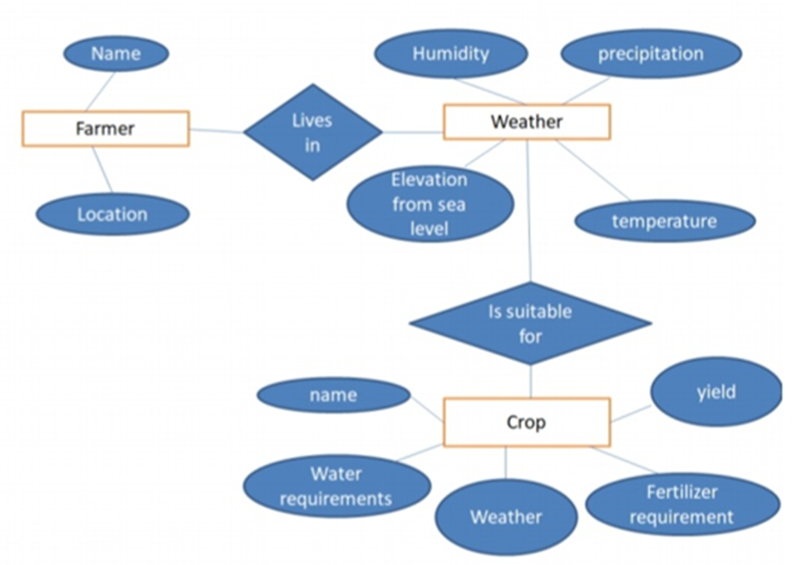
- Flow Diagram
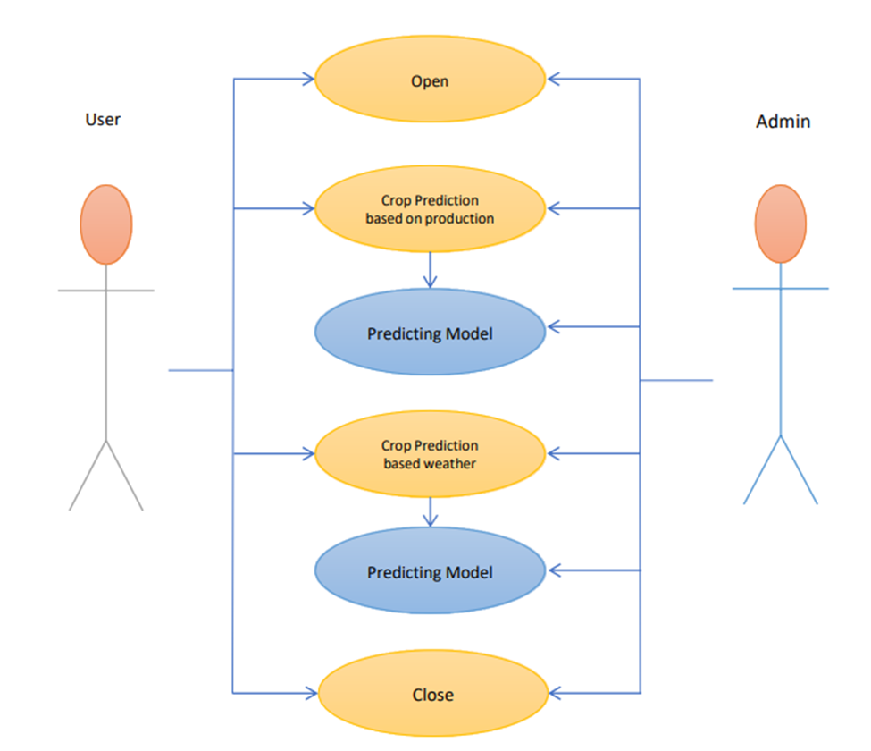
- Use Case Diagram
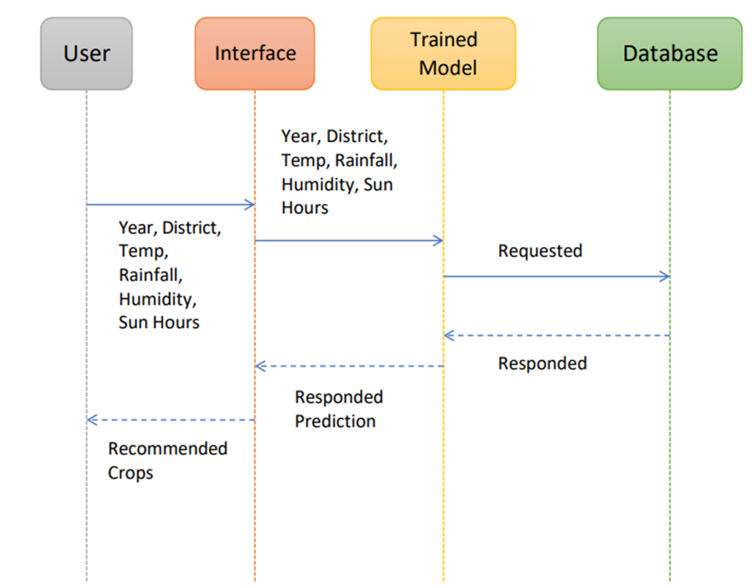
- Sequence Diagram

RESULT

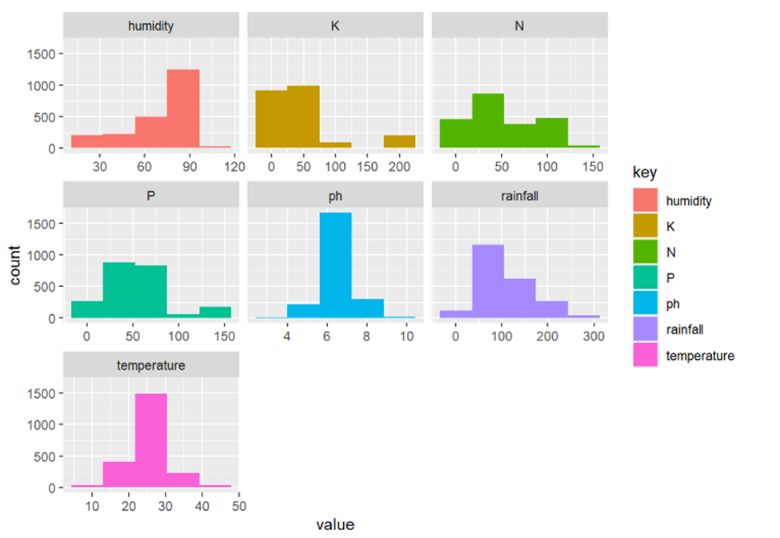
- Comparative Analysis
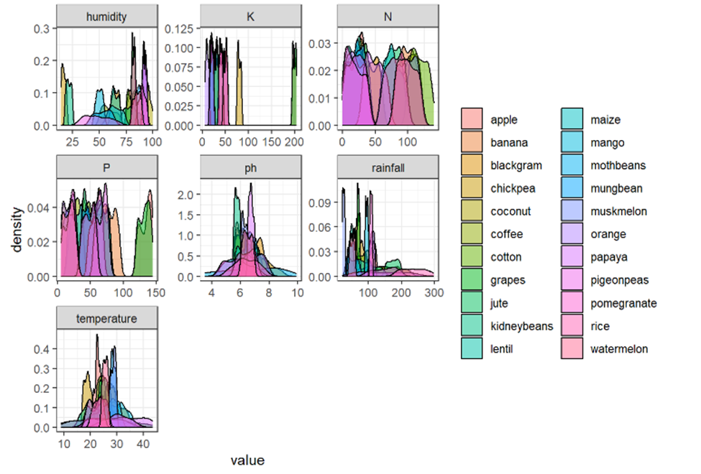
- Comparative Analysis
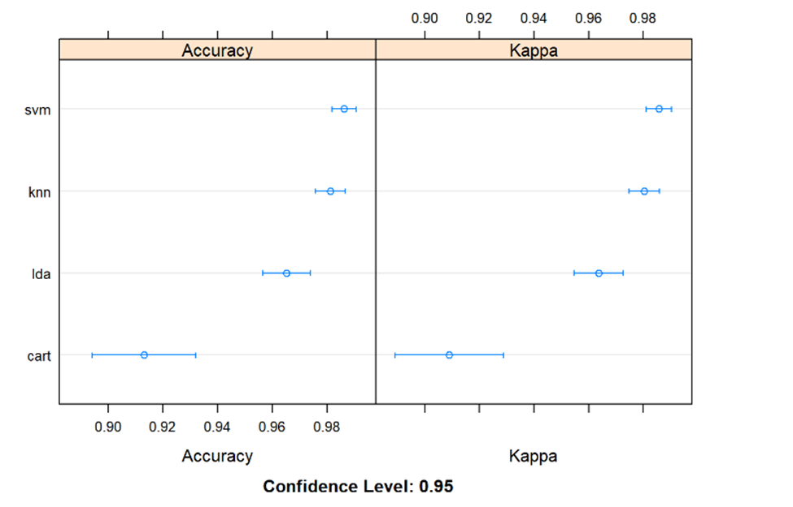
- Accuracy Comparison
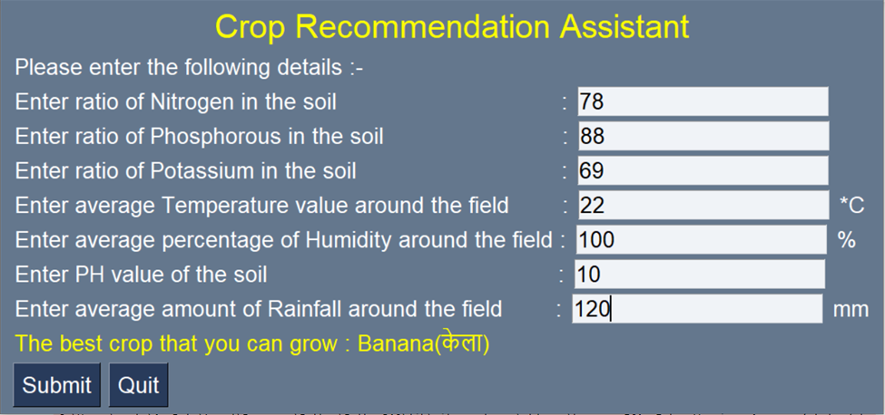
- GUI

Acknowledgment
I would like to express my sincere gratitude to everyone who contributed to the successful completion of this project. Your hard work, dedication, and support throughout the entire process have been instrumental in achieving our goals.
Special thanks to Prof.Jeya Mala, who provided invaluable guidance, expertise, and feedback. Your input has been critical to the project's success, and I could not have done it without you.
I also want to acknowledge the efforts of the rest of the team members, who worked tirelessly to ensure that all tasks were completed on time and to the best of their abilities.
Thank you all once again for your hard work, dedication, and support. It has been a pleasure working with such a great team, and I look forward to working with you all in the future.

References
- Aadithya U, Anushya S, Bala Lakshmi N and Rajeswari Sridhar, “FUZZY LOGIC BASED HYBRID RECOMMENDER OF MAXIMUM YIELD CROP USING SOIL, WEATHER AND COST,” ICTACT JOURNAL ON SOFT COMPUTING, JULY 2016, VOLUME: 06, ISSUE: 04
- Dhruvi Gosai, Chintal Raval, Rikin Nayak, Hardik Jayswal, Axat Patel, “Crop Recommendation System using Machine Learning”, International Journal of Scientific Research in Computer Science, Engineering and Information Technology, June 2021, Volume 7, Issue 3
- Pradeepa Bandara, Thilini Weerasooriya, Ruchirawya T.H., W.J.M. Nanayakkara, “Crop Recommendation System”, International Journal of Computer Applications (0975 – 8887),Volume 175– No. 22, October 2020
- Gouravmoy Baneerjee, Uditendu Sarkar, Indrajeet Ghosh “A fuzzy-logic based Crop Recommendation System”, 2021
- Shafiulla Shariff, Shwetha R B, Ramya O G, “Crop Recommendation using Machine Learning Techniques”, International Journal of Engineering Research & Technology (IJERT), Special Issue 2022
- Prof. Meena Ugale, Nimeesha Venkatavelu, Pranay Patil, Suraj Rane, “Review of Machine Learning Techniques for Crop Recommendation System”, International Journal for Research in Applied Science & Engineering Technology (IJRASET), Volume 10 Issue III Mar 2022
- Aakunuri Manjula, Dr. G.Narsimha, “Crop Recommendation and Yield Prediction for Agriculture using Data Mining Techniques”, 2019 JETIR March 2019, Volume 6, Issue 3
- Rohit Kumar Rajak, Ankit Pawar, Mitalee Pendke , Pooja Shinde, Suresh Rathod, Avinash Devare, “Crop Recommendation System to Maximize Crop Yield using Machine Learning Technique”, International Research Journal of Engineering and Technology, Volume: 04 Issue: 12 , Dec-2017
- Atharva Jadhav, Nihar Riswadkar, Pranay Jadhav ,Yash Gogawale, “Crop Recommendation System Using Machine Learning Algorithms”, International Research Journal of Engineering and Technology (IRJET), Volume: 09 Issue: 04, Apr 2022
- Dishant Israni, Kevin Masalia, “Crop-Yield Prediction And Crop Recommendation System”
- Google. (n.d.). Overview of hyperparameter tuning | ai platform training. Google.
- Bhosale, S. V., Thombare, R. A., Dhemey, P. G., & Chaudhari, A. N. (2018). Crop yield prediction using data analytics and hybrid approach. 2018 Fourth International Conference on Computing Communication Control and Automation (ICCUBEA).
- Bang, S., Bishnoi, R., Chauhan, A. S., Dixit, A. K., & Chawla, I. (2019). Fuzzy logic Based crop Yield prediction using temperature and rainfall Parameters predicted Through arma, SARIMA, AND ARMAX MODELS. 2019 Twelfth International Conference on Contemporary Computing (IC3).
- T.R. Lekhaa, "Efficient Crop Yield and Pesticide Prediction for Improving Agricultural Economy using Data Mining Techniques", International Journal of Modern Trends in Engineering and Science (IJMTES), vol. 03, no. 10, 2016.
- S. P. RAJA , BARBARA SAWICKA , ZORAN STAMENKOVIC, (Senior Member, IEEE), AND G. MARIAMMAL, “Crop Prediction Based on Characteristics of the Agricultural Environment Using Various Feature Selection Techniques and Classifiers”, 10.1109/ACCESS.2022.3154350, March 7, 2022

