DETECTION OF COMPLEX SEMANTICS FROM UNSTRUCTURED DATA USING NLP & CONVOLUTION NEURAL NETWORK TECHNIQUE.

¹Shankarayya Shastri, ²Dr.Veeragangadharaswamy T.M
¹Research Scholar, Dept. of CSE, RYMCE, Ballari -583104
²Professor, Dept. of CSE, RYMCE, Ballari -583104
¹shan.shas@gmail.com

ABSTRACT: The majority of data on computers nowadays still takes the form of unstructured text. The inherent ambiguity of natural language makes it incredibly difficult but also highly profitable to find hidden information or comprehend complex semantics in unstructured text. In this paper, we present combination of Natural Language Processing (NLP) and Convolution Neural Network (CNN) hybrid architecture for detection of complex semantics from unstructured data that enables different users to make understand formal semantic knowledge to be extracted from an unstructured text corpus.
Keywords— Convolution Neural Network, Natural Language Processing, Controlled Natural Language, Text Mining, Information Extraction.
I.INTRODUCTION

Unstructured text which does not conforms to a data model and has no easily identifiable structure such that it cannot be used by a computer program easily. Unstructured text is not organised in a pre-defined manner or does not have a pre-defined data model, thus it is not a good fit for a mainstream relational or any other database models. Challenges of unstructured text data are it is difficult to store and manage due to lack of schema and indexing the data is difficult also error prone due to unclear structure. Unstructured text is not having pre-defined attributes due to which search results are not very accurate.
In today’s digital world there has been an increase in the amount of diverse unstructured text from many sources including web pages, normative texts, research papers, articles, mailing lists, and e-books. This observable expansion is the result of the advancement of Web technologies and other text extraction tools. While detecting, linking and searching text to formal knowledge for effective retrieval and management can be accomplished in large part by semantic technologies and text mining

systems, unambiguous processing of natural language, in particular the capacity to capture complex knowledge statements, is still a problem that needs to be addressed. By locating references to named things and recognising some relationships between these entities, Information Extraction (IE) algorithms can play a significant role in extracting knowledge from text. However, other Natural Language Processing (NLP) techniques with deep learning methods are also required in order to extract more nuanced insights from the text. Convolutional Neural Networks (CNNs) are the most widely used deep learning architectures in image processing and text classification methods.
What is complex semantics?
Using NLP & CNN techniques we can detect or analyse complex semantics from unstructured text documents and followings are some important elements of semantic analysis
- Hyponymy
It could be explained as the connection between a generic term and its occurrences. Here, the generic term is referred to as a hypernym, while its examples are referred to as hyponyms. For instance, the term "colour" is a hyponym, as are the colours blue, yellow, etc.
- Homonymy
It might be described as words with the same form or spelling but a completely distinct meaning. For instance, the term "Bat" is a homophone since it can refer to both a nocturnal flying mammal and a tool for hitting a ball.
- Polysemy
The Greek term "polysemy" implies "many signs." This word or phrase has a distinct but connected sense. In other words, polysemy has a similar spelling but a distinct meaning that is connected to it. As an illustration, the term "bank" is a polysemy with the following definitions.
- A financial institution.
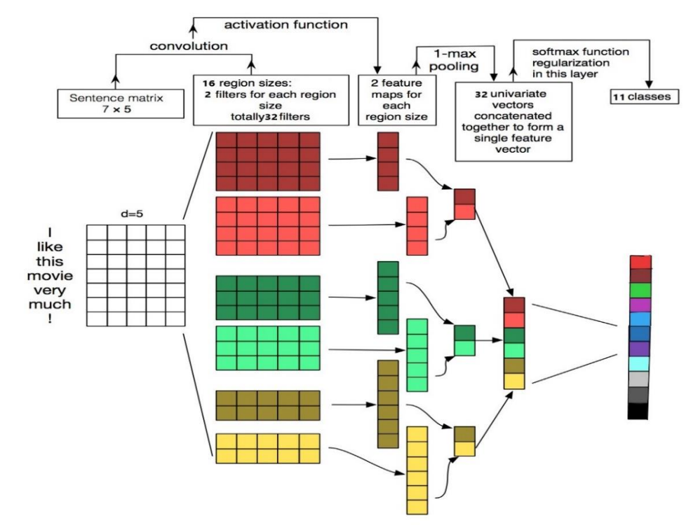
Figure 1: Existing Methodology for text processing using CNN Technique.

- The building in which such an institution is located.
- A synonym for “to rely on”

- Synonymy
It is the relationship between two lexical items that represent the same or a similar meaning despite having distinct forms. For instance, "author/writer" and "fate/destiny."
- Antonymy
It is the relationship between two lexical elements that are symmetrical in reference to an axis throughout their semantic components.

Few top applications of semantic analysis are
- Conversational chatbots
- Automated ticketing support
- Sentiment analysis
- Search engine results
- Language translation
- Question and answering systems
- Finding grammar in languages
In NLP, CNNs can be applied to a variety of categorization problems. A convolution is a sliding window that focuses on a portion of a larger input matrix of data. For every learning method, having the correct dimensions for your data is crucial. Hence in this paper we are presenting detection of complex semantics from unstructured data using NLP and CNN techniques (Hybrid approach). The performance of presented approach is evaluated in terms of Precision, Recall and F1-scores.

II. LITERATURE SURVEY

Convolutional Neural Networks (CNNs), originally invented for computer graphics have been shown to achieve strong performance on text classification tasks (Bai et al., 2018; Iyyer et al., 2015) as well as other traditional Natural et al., 2014; Wang et al., 2015; Zhang et al.2015;
Johnson and Zhang, 2015 Language Processing
(NLP) tasks Kalchbrenner; (Collobert et al., 2011), even when considering relatively simple one-layer models (Kim, 2014).
As with other architectures of neural networks, explaining the learned functionality of CNNs is still an active research area. The ability to interpret neural models can be used to increase trust in model predictions, analyse errors or improve the model (Ribeiro et al., 2016). The problem of interpretability in machine learning can be divided into two concrete tasks: Given a trained model, model interpretability aims to supply a structured explanation which captures what the model has learned. Given a trained model and a single example, prediction interpretability aims to explain how the model arrived at its prediction. These can be further divided into white-box and black-box techniques. While recent works have begun to supply the means of interpreting predictions (AlvarezMelis and Jaakkola, 2017; Lei et al., 2016; Guo et al., 2018), interpreting neural NLP models remains an under-explored area. Accompanying their rising popularity,
CNNs have seen multiple advances in interpretability when used for computer vision tasks (Zeiler and Fergus, 2014). These techniques unfortunately do not trivially apply to discrete sequences, as they assume a continuous input space used to represent images. Intuitions about how CNNs work on an abstract level also may not carry over from image inputs to text—for example, pooling in CNNs has been used to induce deformation invariance (LeCun et al., 1998, 2015), which is likely different than the role it has when processing text.
The general block diagram to handle text classification using Convolution Neural Network architecture is given in Figure 1.

III. Detection of Complex Semantics from Unstructured Data Using NLP and CNN Technique.

In this two phase proposed work we are trying to detect complex semantics from unstructured text using NLP and CNN Techniques. In first phase (NLP related part) we are pre-process, filter and classify unstructured text to specific data domains. In Second Phase (CNN related part) we are attempting to understand how CNNs process text, and then implementing this information for detection of complex semantics from unstructured text using convolution neural network technique.

The main aim is to satisfy the objectives that are listed as follows:

- To classify unstructured text into their respective domains using NLP method.

2) As n-gram detectors, 1-dimensional convolving filters are employed, each of which focuses on a certain family of closely related n-grams.

3) The appropriate n-grams are extracted for decision-making through max-pooling over time.

4) Based on data from Max-pooling, the rest of the network extracts hidden or complex semantics from unstructured text.

In this experiment setup, we are taking sample input datasets from computer science domain such as Database, Operating system and Data mining unstructured text files in .txt format.
Tokenization, stop word removal, and rare word removal functions must be applied to the input unstructured documents as part of the pre-processing step. Pre-processing eliminates missing or inconsistent data values brought on by human or technological faults. Pre-processing can make a dataset's accuracy and quality more precise, dependable, and consistent.
The proposed work is divided into two phases. Phase 1 and Phase 2 step by step operations are given below. The detailed block diagram of proposed architecture is given in Figure 2.
Phase 1: Pre-Processing and Filtering candidate Concepts
 | Given a set of unstructured text documents $D=\left\{d_{1},d_{2},d_{3},…d_{m}\right\}$ that describes a set of concepts $C=\left\{c_{1},c_{2},c_{3},….c_{m}\right\}$ where n>1 and m>1, Goal is to identify and classify most relevant concepts from C.
Step 1: | Unstructured textual documents $d_{i ∈ }D$ are tokenized into n-grams representing the initial candidate concepts $c_{i }∈C$.  $$d_{i }∈D>Tokenization\left\{c_{1},c_{2},c_{3},…,c_{m}\right\}$$  to form n-grams
Step 2: | In n-grams, stop words are removed using a stop word list comprising common terms and Count the occurrences of the remaining candidates c_{i} in D yields a set of tuples  $s =\left\{ \left(ci,fi\right),….\right\}$  Comprising a candidate c_{i} and its respective frequency f_{i}.
Step 3: | Remove short, infrequent n-grams from T (and therefore also from C) according to a frequency threshold f_{t} to reduce noise.
Step 4: | Retain only meaningful unigrams (n>=1)  if and only if it occurs at least f_{t} times more often than any larger n-gram which contains this unigram somewhere. (Refer Figure 2)
Step 5: | If there are multiple n-grams c_{j} of higher order that contain ci,f_{i} refers to most frequently occurring c_{j}.  The remaining n-grams from C are merged according to two rules, s.t. only a single n-gram is present for semantically similar n-grams.
- First, a plural token is filtered out if it is also present in singular form. (Refer Figure 2)
- Second, the present participle of a regular verb is discarded, if a version without it exists.
Step 6: | From the remaining candidates in C, filter out those with no matching DBpedia entry.
Step 7: | Generate initial context information $C_{info}$ and classify $d_{i}$ based on specific domain.

Phase 2: Detection of Complex Semantics
The working of CNN for text processing is as follows. The implemented Convolution Neural Network model has three layers. Basic functionality of convolution neural network resembles to the visual cortex of the animal brain. In text classification task convolution neural network gives promising result. Criteria for text classification is similar to image classification only difference is that instead of pixel values we have matrix of word vectors.

3.1. Target Function
Target Function employed includes neurons with learnable weights and biases. Each neuron receives several input, takes weighted sum over them and pass it through an activation function and responds with an output. Whole network has a loss function calculated by spreading output to softmax layer. Softmax is a fully connected layer which also performs function of down sampling for the output.

3.2. Representation
The first layer in convolution neural network is embedding layer which maps vocabulary word indices to low dimensional vectors. It is essentially a lookup table that we learn from data. Vocabulary size is decided by getting the maximum sentence length $V^{wrd}$ given a sentence of N words W every word is transformed into its respective embedding. After transformation of all the words to vectors these are than fed to the convolution layer.

3.3. System Structure
The model implemented includes three layers. First is the Embedding layer which convert the words to its respective embedding vectors, second is the convolution layer in which main processing of the model takes place. Predefined filters roll over the sentence matrix and reduce it into low dimensional matrix. Third layer is softmax layer which is a down sampling layer capable of reducing sentence matrix and calculating loss function. Embedding lookup function is used to get the word embedding of the sentence. The matrix generated as a result of embedding layer is than padded to equalize all the sentences. The defined filters will than start
reducing the matrix and generate convolved features. These convolved features are than further reduced. The output generated as a result of convolved features is than spread over the max pooling layer for further down sampling of output. Filters of different sizes and shapes are defined. The shape of the filters use in the proposed model is (3, 4, 5). Embedded sentences are than padded to make all the sentence matrices of same size and shape. For an n-words input text $w_{1},…,w_{n}$ we embed each symbol as d dimensional vector, resulting in word vectors $w_{1},…,w_{n} ∈R^{d}$ .

The resulting $d×n$ matrix is then fed into a
Convolutional layer where we pass a sliding window over text. For each l-words ngram:
$$u_{i}=\left[w_{i},…, w_{i+l-1}\right] ∈R^{d×l} ;0≤i≤n-l$$

Matrix$F ∈ R^{n×m}$. Applying max-pooling across the ngram dimension results in $p∈R^{m}$
$R^{m}$ Which is fed into ReLU non-linearity. Finally, a linear fully connected layer

$W∈R^{c×m}$ Produces the distribution over classification classes from which the strongest class is outputted. Formally:

$$u_{i}=\left[w_{i},…, w_{i+l-1}\right]$$
$$F_{ij }=〈u_{i,}f_{i}〉$$
$$p_{j}=ReLU\left(maxF_{ij}\right)$$
$$o=softmax(W_{p})$$
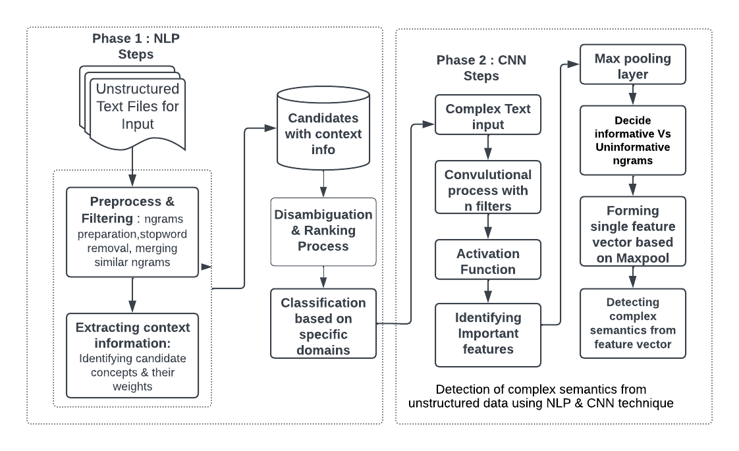
Figure 2: Proposed block diagram for NLP & CNN for Text classification and detection of complex semantics

In practice, we use multiple window sizes $l∈L,L∈N$, by using multiple convolution layers in parallel and concatenating the resulting $p^{l}$ vectors. We note that the methods in this work are applicable for dilated convolutions as well.
Identifying Important Features
Current common wisdom posits that filters serve as ngram detectors: each filter searches for a specific class of ngrams, which it marks by assigning them high scores. These highest-scoring detected ngrams survive the max-pooling operation. The final decision is then based on the set of ngrams in the max-pooled vector (represented by the set of corresponding filters). Intuitively, ngrams which any filter scores highly (relative to how it scores other ngrams) are ngrams which are highly relevant for the classification of the text.
In this section we refine this view by attempting to answer the questions: what information about ngrams is captured in the max-pooled vector, and how is it used for the final classification?
Informative vs. Uninformative Ngrams
Consider the pooled vector $p∈R^{m}$ on which the classification is based. Each value
$p_{j}=ReLU(\max_{i} 〈u_{i},f_{j}〉 )⁡$stems from a filter-ngram interaction, and can be traced back to the ngram $u_{i}=\left[w_{i},…, w_{i+l-1}\right]$ that triggered it. Denote the set of ngrams contributing to p as $S_{p}$. ngrams not in $S_{p}$ do not influence the decision of the classifier. But what about the ngrams that are in $S_{p}$?

Previous attempts in prediction-based interpretation of CNNs for text highlight the ngrams in $S_{p}$ and their scores as means of explaining the prediction. We take here a more refined view. Note that the final classification does not observe the ngram identities directly, but only through the scores assigned to them by the filters. Hence, the information in p must rely on the assigned scores.
Conceptually, we separate ngrams in $S_{p}$ into two classes, deliberate and accidental.
Deliberate ngrams end up in $S_{p}$ because they were scored high by their filter, likely because they are informative regarding the final decision.
In contrast, accidental ngrams end up in $S_{p}$ despite having a low score, because no other ngram scored higher than them. These ngrams are likely not informative for the classification decision. Can we tease apart the deliberate and accidental ngrams? We assume that there is threshold for each filter, where values above the threshold signal informative information regarding the classification, while values below the threshold are uninformative and can be ignored for the purpose of classification.
We thus search for the threshold that separate the two classes. However, as we cannot measure directly which values $p_{j}$ influence the final decision, we opt instead for measuring correlation between $p_{j}$ values and the predicted label for the vector p.

The linearity of the decision function Wp allows to measure exactly how much $p_{j}$is weighted for the logit of label class k. The class which filter $f_{j}$ contributes to is $c_{j= }{argmax}_{k}W_{kj}$. We refer to class $c_{j}$ as the class identity of filter$f_{j}$.

By assigning each filter a class identity $c_{j}$ and comparing it to the predicted label we arrive at a correlation label—whether the filter’s identity class matches the final decision by the network. Concretely, we run the classifier over a set of texts, resulting in pooled vectors $p^{i}$ and network predictions${ c}^{i}$. For each filter j we then consider the values $p_{j}^{i}$ and whether$c_{i }= c_{j}$. For each filter, we obtain a dataset
$(p_{j}^{i}, c^{1}= c_{j}$)…$(p_{j}^{D}, c^{D}= c_{j}$), and we look for a threshold $t_{j }$that separates $p_{j}^{i}$for which $c^{i}= c_{j}$ from those where $c^{i} ≠ c_{j}$.
$${\left(X,Y\right)}_{j}=\left\{\left(p_{j}^{i}, c^{1}= c_{j}\right) | j <m \& i <D\right\}$$

In an ideal case, the set is linearly separable and we can easily separate informative from uninformative values: if $p_{j}^{i }> t_{j}$ then the classifier’s prediction agrees with the filter’s label, and otherwise they disagree. In practice, the set is not separable. We instead work with the purity of a filter-threshold combination, defined as the percentage of informative (correlative) ngrams which were scored above the threshold.

Formally, given threshold dataset (X,Y ):

$purity\left(f,t\right)=$

$$\frac{| \left\{\left(x,y\right) ∈ {\left(X,Y\right)}_{f }| x ≥t \& y=true \right\}|}{| \left\{\left(x,y\right) ∈ {\left(X,Y\right)}_{f }| x ≥t \right\}|}$$

We heuristically set the threshold of a filter to the lowest value that achieves a sufficiently high purity (we experimentally find that a purity value of 0.75 works well).

Threshold Effectiveness

We described a method for obtaining per-filter threshold values. But is the threshold assumption—that items below a given threshold do not participate in the decision—even correct? To assess the quality of threshold obtained by our proposal and validate the thresholding assumption, we discard values that do not pass the threshold for each filter and observe the performance of the model. Practically, we replace the ReLU non-linearity with a threshold function:

$$threshold\left(x,t\right)= \left\{\begin{aligned}x, &if x≥t \\ 0, & otherwise\end{aligned}\right.$$

The slot activation vector captures how much each word in the ngram contributes to its activation.
We can now move from examining the activation of an ngram-filter pair
$〈u≔\left[w_{1};….;w_{l}\right],f〉$to examining its slot activation vector: $(〈w_{l},f\left(l\right)〉,…〈w_{l},f\left(l\right)〉)$
We distinguish naturally occurring or observed ngrams, which are ngrams that are observed in a large corpus, from possible ngrams which are any combination of l words from the vocabulary. The possible ngrams are a superset of the naturally occurring ones. Given a filter, we can find its top scoring naturally occurring ngram by searching over all ngrams in a corpus. We can find its top scoring possible ngram by maximizing each slot value individually.
4. Experimental Evaluation
We conduct series of experiments on Phase 1 and Phase 2. In this approach three different datasets namely Database, Data Mining and Operating System datasets are used for experiment purpose. The performance of presented approach is investigated with different existing available approaches.
For Phase 1 the result analysis of presented approach is evaluated using the parameters like, precision, recall and F1-score.

Precision: The precision is employed to calculate the positive patterns which are predicted correctly from the total predicted patterns in a positive class.
$$Precision= \frac{{Key}_{corrected }}{{Key}_{predicted }} \left(1\right)$$

where Key_{corrected} is the total correctly predicted key-phrases that are matched with standard key-phrases and Key_{predicted} is the total predicted key-phrases from a document.

Recall: It can also known as Sensitivity. It is the ratio of accurately expected positive values with respect to the actual positive values; and can be calculated as

$$Recall = \frac{{Key}_{corrected }}{{Key}_{predicted }} \left(2\right)$$

F1-Score: F1-score is one of the most important evaluation metrics in machine learning. It elegantly sums up the predictive performance of a model by combining two otherwise competing metrics precision and recall.
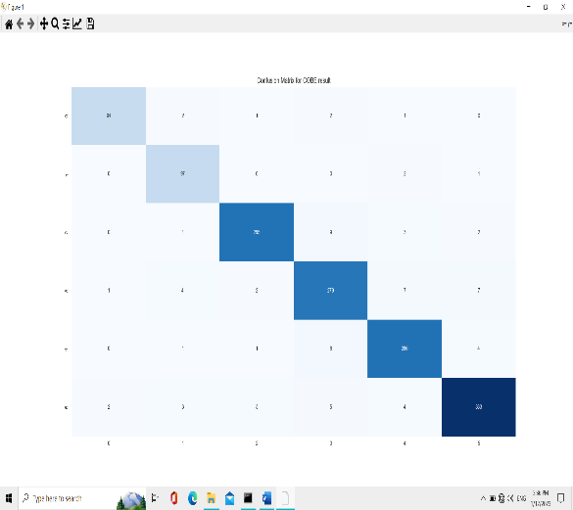
$$F1-Score= \frac{2 ×Precision ×Recall}{Precision+Recall}$$

The Fig.3 shows the confusion matrix for presented approach.
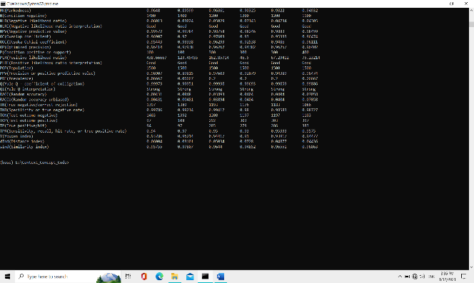
Figure 4: Shows the output screen of NLP & CNN technique for detection of complex semantics from unstructured text.

The table 1 shows the performance evaluation of KCFA method and presented approach on OS dataset.

Methods | F1-score | Precision | Recall
KCFA | 0.9051 | 1 | 0.8627
Proposed approach using NLP & CNN | 0.9248 | 1 | 0.8863
Table 1: Performance Evaluation on OS dataset
Compared to KCFA, presented approach has better results in terms of precision, recall and F1-score.

The table 2 shows the performance evaluation of KCFA method and presented approach on Data mining dataset.

Methods | F1-score | Precision | Recall
KCFA | 0.6146 | 1 | 0.4437
Proposed approach using NLP & CNN | 0.8347 | 1 | 0.8652
Table 2: Performance Evaluation on DM dataset
The table 3 shows the performance evaluation of KCFA method and presented approach on Database management system (DBMS) dataset.
Methods | F1-score | Precision | Recall
KCFA | 0.7146 | 1 | 0.4437
Proposed approach using NLP & CNN | 0.8613 | 1 | 0.8652
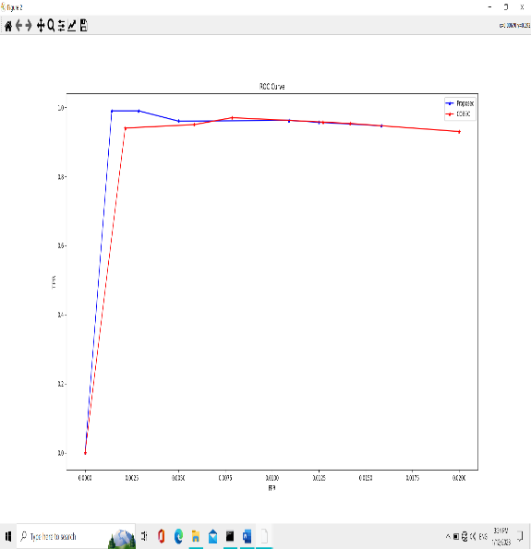
Table 3: Performance Evaluation on DBMS dataset
Figure 5: ROC for presented approach

In Figure. 5, the red colour curve line indicates the ROC of Presented approach whereas blue colour line indicates the ROC of KCFA approach. Compared to KCFA approach, presented technique for unstructured data using NLP & CNN has better ROC.

V. CONCLUSION
In this work, detection of complex semantics from unstructured data using Natural language processing and convolution neural network techniques has been presented. In this analysis, different datasets namely Database, Data mining and Operating systems datasets are used.
We have refined several common wisdom assumptions regarding the way in which CNNs process and classify text. First, we have shown that maxpooling over time induces a thresholding behaviour on the convolution layer’s output, essentially separating between features that are relevant to the final classification and features that are not. We used this information to identify which ngrams are important to the classification. We also associate each filter with the class it contributes to.
We also show that filters sometimes opt to assign negative values to certain word activations in order to cause the ngrams which contain them to receive a low score despite having otherwise highly activating words. Finally, we use these findings to suggest improvements to model-based and predictionbased interpretability of CNNs for text.
This approach has classified different documents and their domains where they belong to. The performance of presented approach is measured in terms of Precision, Recall and F1-score. Different datasets are used to investigate the performance of presented approach. The performance of presented approach is compared with three datasets namely Operating systems, Data Mining and Database Management systems. However better results are achieved through OS dataset.
VI. REFERENCES

Understanding Convolutional Neural Networks for Text Classification by Alon Jacovi,Oren Sar Shalom and Yoav Goldberg

David Alvarez-Melis and Tommi S. Jaakkola. 2017.A causal framework for explaining the predictions of black-box sequence-to-sequence models. In Proceedings of the 2017 Conference on Empirical Methods in Natural Language Processing,EMNLP 2017, Copenhagen, Denmark, September 9-11, 2017, pages 412–421. Association for Computational Linguistics.
Shaojie Bai, J. Zico Kolter, and Vladlen Koltun. 2018. An empirical evaluation of generic convolutional and recurrent networks for sequence modeling. CoRR, abs/1803.01271.
Yizong Cheng. 1995. Mean shift, mode seeking, and clustering. IEEE Trans. Pattern Anal. Mach. Intell., 17(8):790–799.
Ronan Collobert, Jason Weston, L´eon Bottou, Michael Karlen, Koray Kavukcuoglu, and Pavel P. Kuksa. 2011. Natural language processing (almost) from scratch. Journal of Machine Learning Research,12:2493–2537.
Keinosuke Fukunaga and Larry D. Hostetler. 1975.The estimation of the gradient of a density function,with applications in pattern recognition. IEEE Trans. Information Theory, 21(1):32–40.
Yoav Goldberg. 2016. A primer on neural network models for natural language processing. J. Artif. Intell.Res., 57:345–420.
Pei Guo, Connor Anderson, Kolten Pearson, and Ryan Farrell. 2018. Neural network interpretation via fine grained textual summarization. CoRR, abs/1805.08969.
Mohit Iyyer, Varun Manjunatha, Jordan L. Boyd-Graber, and Hal Daum´e III. 2015. Deep unordered composition rivals syntactic methods for text classification. In Proceedings of the 53rd Annual Meeting of the Association for Computational Linguistics and the 7th International Joint Conference on Natural Language Processing of the Asian Federation of Natural Language Processing, ACL 2015, July 26-31, 2015, Beijing, China, Volume 1: Long Papers, pages 1681–1691. The Association for Computer Linguistics.
Rie Johnson and Tong Zhang. 2015. Effective use of word order for text categorization with convolutional neural networks. In NAACL HLT 2015, The 2015 Conference of the North American Chapter of the Association for Computational Linguistics: Human Language Technologies, Denver, Colorado, USA, May 31 - June 5, 2015, pages 103–112. The Association for Computational Linguistics.
Nal Kalchbrenner, Edward Grefenstette, and Phil Blunsom. 2014. A convolutional neural network for modelling sentences. In Proceedings of the 52nd Annual Meeting of the Association for Computational Linguistics, ACL 2014, June 22-27, 2014, Baltimore, MD, USA, Volume 1: Long Papers, pages 655–665. The Association for Computer Linguistics.
Yoon Kim. 2014. Convolutional neural networks for sentence classification. In Proceedings of the 2014 Conference on Empirical Methods in Natural Language Processing, EMNLP 2014, October 25-29, 2014, Doha, Qatar, A meeting of SIGDAT, a Special Interest Group of the ACL, pages 1746–1751. ACL.
Yann LeCun, Y Bengio, and Geoffrey Hinton. 2015. Deep learning. 521:436–44.
Yann LeCun, Leon Bottou, Y Bengio, and Patrick Haffner. 1998. Gradient-based learning applied to document recognition. 86:2278 – 2324.
Tao Lei, Regina Barzilay, and Tommi S. Jaakkola.2016. Rationalizing neural predictions. In Proceedings of the 2016 Conference on Empirical Methods in Natural Language Processing, EMNLP 2016,Austin, Texas, USA, November 1-4, 2016, pages 107–117. The Association for Computational Linguistics.
Julian J. McAuley and Jure Leskovec. 2013. Hidden factors and hidden topics: understanding rating dimensions with review text. In Seventh ACM Conference on Recommender Systems, RecSys ’13, Hong Kong, China, October 12-16, 2013, pages 165–172. ACM.
Julian J. McAuley, Christopher Targett, Qinfeng Shi, and Anton van den Hengel. 2015. Image-based recommendations on styles and substitutes. In Proceedings of the 38th International ACM SIGIR Conference on Research and Development in Information Retrieval, Santiago, Chile, August 9-13, 2015, pages 43–52. ACM

