Abstract. Virtual Learning Environments (VLEs), Learning Management Systems (LMS), and Massive Open Online Courses (MOOCs) are just a few of the online learning platforms that make it possible for thousands or even millions of students to learn according to their interests and without being restricted by time or space. Online learning platforms have many advantages, but they also face a number of disadvantages, such as students' lack of interest, high dropout rates, low engagement, self-regulation, and being forced to set their own goals.

In this study, we propose a predictive model that looks at the issues that at-risk students face and then makes it easier for teachers to intervene quickly to get students more engaged in their studies and better performing. Various machine learning (ML) and deep learning (DL) algorithms are used to train and test the predictive model to determine how students learn based on their study variables. The accuracy, precision, support, and f-score are used to compare the performance of various ML algorithms.

In the end, the ML algorithm with the highest f-score metric, accuracy, precision, recall, and support is chosen to create the predictive model at various percentages of course length. Instructors can use the predictive model to identify students who are at risk early in the course, allowing for prompt intervention and avoiding student dropout. Our findings demonstrated the significance of time-dependent variables, students' assessment scores, engagement intensity, or click stream data, and online learning.

- INTRODUCTION

Statistics are used in predictive modeling to predict outcomes. Predictive modeling can be applied to any kind of unknown event, regardless of when it occurred, despite the fact that the event one wishes to predict is typically in the future.

For instance, crimes are frequently detected and suspects are identified using predictive models after they have occurred. A lot of the time, the model is chosen based on detection theory to try to figure out the likelihood of an outcome given a certain amount of input data. For instance, if an email is given, how likely is it to be spam? Classifiers can be used by models to try to figure out how likely a set of data is to belong to another set. For instance, a model may be utilized to decide if an email is spam or "ham" (non-spam). Predictive modeling is more commonly referred to in academic or research and development contexts as either synonymous with or largely overlapping with the field of machine learning, depending on definitional boundaries. Predictive modeling is frequently referred to as predictive analytics when it is used for business purposes.

- LITERATURE REVIEW

[1] Xyang et al., Mushtaq Hussain, has suggested. The student's performance prediction is an important research topic in this system because it can help teachers identify students who require additional assistance and prevent students from dropping out before final exams. Predicting the challenges that students will face during a subsequent digital design class session is the goal of this study. Using machine learning algorithms, we looked at the data that was recorded by the digital electronics education and design suite (DEEDS) technology-enhanced learning (TEL) system. Artificial neural networks (ANNs), support vector machines (SVMs), logistic regression, naive bayes classifiers, and decision trees were among the machine learning algorithms. Students can log input data while completing digital design exercises of varying difficulty using the DEEDS system. The average time, total number of activities, average idle time, average number of keystrokes, and total related activity for each exercise in the digital design course were the study's input variables. The grades of the students for each session were the output variables.

[2] Ouafae EL AISSAOUI and coworkers, has suggested. The construction of an effective student model that represents the characteristics of the student is necessary for the implementation of an effective adaptive e-learning system in this system. One of these characteristics is the learning style, which refers to the manner in which a student prefers to learn. By providing students with materials that are tailored to their learning preferences, adaptive e-learning systems benefit from an understanding of learning styles. Using web usage mining methods and machine learning algorithms, we have proposed a method to automatically identify a learner's learning style in this work. This method is based on the current learners' actions. The log file extracted from the e-learning environment was pre-processed and the learners' sequences were captured using web usage mining techniques. The K-modes clustering algorithm was used to group the captured learners' sequences into 16 learning style combinations based on the Felder and Silverman learning style model. The naive Bayes classifier was then utilized to predict a student's learning style in real time. We used a real dataset taken from the log file of an e-learning system to carry out our strategy. The confusion matrix method was used to assess the classifier's performance. The outcomes show that our method produces excellent results. Versatile E-learning has turned into a promising answer for upgrade the productivity of online schooling systems. In order to provide well-adapted learning materials, this solution requires the automatic detection of learners' learning styles. In this context, we have proposed an automated method for identifying learners' learning styles by utilizing web usage mining techniques and machine learning algorithms.

[3] Sunbok Lee and others, has suggested. Schools can use a dropout early warning system to identify students who are at risk of dropping out of school, respond quickly to them, and ultimately assist students who might drop out to continue their education for a better future. However, accurate predictive modeling for a dropout early warning system may be challenging due to the inherent class imbalance between dropout and non-dropout students. The purpose of this study was to enhance the effectiveness of a dropout early warning system: a) by utilizing ensemble machine learning methods and synthetic minority oversampling techniques (SMOTE) to address the issue of class imbalance; and (b) by utilizing receiver operating characteristic (ROC) and precision–recall (PR) curves to evaluate the trained classifiers. 165,715 South Korean high school students' big data samples were used to train random forest, boosted decision tree, random forest with SMOTE, and boosted decision tree with SMOTE. Our analysis of the ROC and PR curves revealed that the best performance was achieved with the boosted decision tree. Due to the diverse nature of performance metrics, this study's findings should be interpreted with caution. While positive and negative predictive values are influenced by the prevalence of positives in the population, sensitivity and specificity are independent of the prevalence of positives in the population.

As a result, the positive predictive value would rise because the positive predictive value reflects the population, while the sensitivity would remain the same if our predictive modeling were applied to a population with a higher frequency of dropouts. Predictive models' efficacy in machine learning is heavily influenced by the quality of the training data.

For a number of reasons, the NEIS is an excellent database for the South Korean dropout early warning system. First, the NEIS database contains information about the basic information of over six million students, including their health, attendance, and academic achievement, among other things.

[4] et al., Antonio Hernández-Blanco, has suggested. In this system, the study of Educational Data Mining (EDM) focuses on how to use statistical, data mining, and machine learning techniques to find patterns in large amounts of educational data. While a variety of machine learning methods have been used in this area over the years, Deep Learning has recently received more attention in the educational sector. Deep Learning is a method of machine learning that has been successfully applied to a wide range of issues in the fields of image recognition and natural language processing.

It is based on neural network architectures that have multiple layers of processing units. From its inception to the present, the research on Deep Learning techniques applied to EDM is examined in this paper. The primary objectives of this research are to identify the EDM tasks that have benefited from Deep Learning and those that remain to be investigated, to describe the primary datasets used, to provide an overview of the key concepts, primary architectures, and configurations of Deep Learning and its applications to EDM, and to discuss the current state of the art as well as potential future directions in this field of study.

EDM uses e-learning platforms like Learning Management Systems (LMS), Intelligent Tutoring Systems (ITS), and, more recently, Massive Open Online Courses (MOOC) to collect rich and multimodal data from students' educational activities.

- ABDELKADER, HANAN E., et al., has suggested. In this system, every educational organization primarily aims to raise students' academic performance to raise education quality as a whole. In this regard, the rapidly expanding field of research known as Educational Data Mining (EDM) makes use of the fundamental ideas of Data Mining (DM) to assist educational establishments in locating useful information regarding the Student Satisfaction Level (SSL) associated with Online Learning (OL) during the COVID-19 lockdown. EDM has been used in a variety of ways to predict student behavior and find the best educational settings. As a result, the method known as Feature Selection (FS) is typically used to select the subset of features with the least cardinality that is most relevant. The FS process has a significant impact on a satisfaction model's predictive accuracy, so the effectiveness of the SSL model is thoroughly examined in this paper in relation to FS methods. In this regard, a dataset was first gathered online by means of a questionnaire about how students rated OL courses. The fitness values of wrapper FS techniques in DM and classification algorithms were analyzed with this dataset. By measuring the quality of 11 wrapper-based FS algorithms and the k-Nearest Neighbor (k-NN) and Support Vector Machine (SVM) as base-line classifiers, the goodness of subsets with various cardinalities is ultimately evaluated in terms of prediction accuracy and the number of selected features. The best method and the optimal dimensionality of the feature subset were discovered through the experiments. Evidently, the present study's findings support the well-known connection between an increase in predictive accuracy and the existence of a minimum number of features.

- MODULE DESCRIPTIONS

3.1 INPUT DATASET

All instances of missing variables in the form of nulls or noise were replaced by the OULAD's mean values to improve the predictive models' performance. For instance, the assessments table lacked the date values, which indicate when the assessments were taken and submitted. All date instances with N/A, null, or missing values were replaced by the date mean value because the date is an important variable in the early prediction of at-risk students.

3.2 PREPROCESSING
In machine learning and data mining, data preprocessing is used to make input data easier to work within the preprocessing technique training set, which is a subset used to train a model. Test set to divide the prediction of the trained method, a subset is used to test the trained model. Is sufficiently huge to yield genuinely significant outcomes. is a good representation of the entire data set. To put it another way, you shouldn't select a test set that differs from the training set. Your objective is to develop a model that effectively adapts to new data, assuming that your test set satisfies the previous two conditions. New data can be compared to our test set.
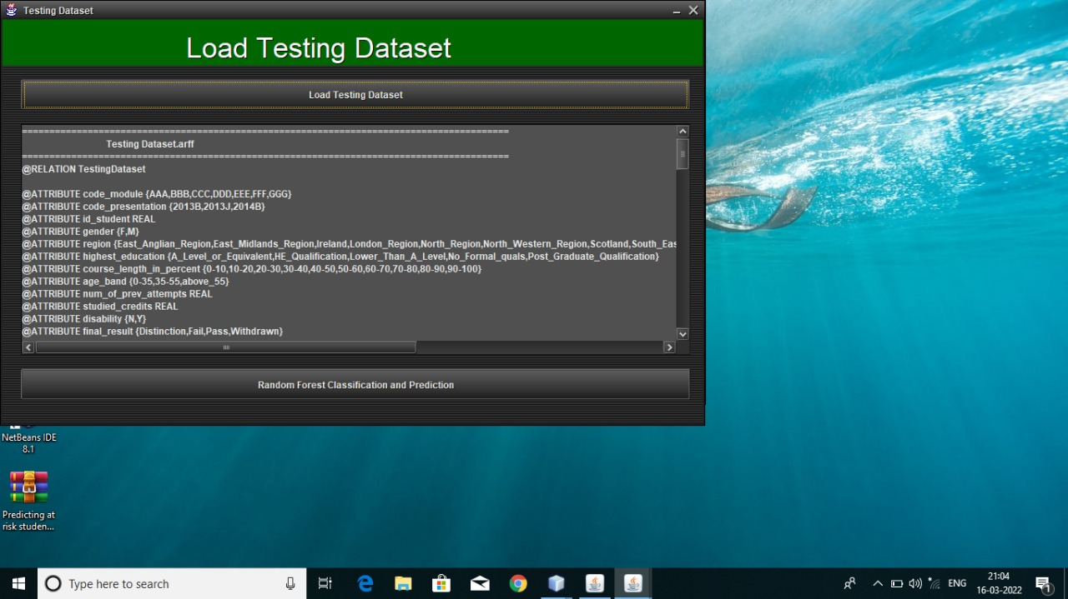
Fig.3.2 LOAD TESTING DATA

3.3 CLASSIFICATION OF ML ALGORITHMS

Classification is a term used in machine learning to describe a predictive modeling problem in which a class label is predicted for a specific piece of input data. Problems with classification include: Classify an example to determine whether or not it is spam. Classify a handwritten character as one of the known characters given the situation. A model will use the training dataset to figure out the best way to map input data examples to particular class labels. In our case, the models for the dataset attributes provide the results for the dataset, and the classification result will be either the candidate is pass, fail, or withdrawn, etc., so the training dataset must be sufficiently representative of the problem.

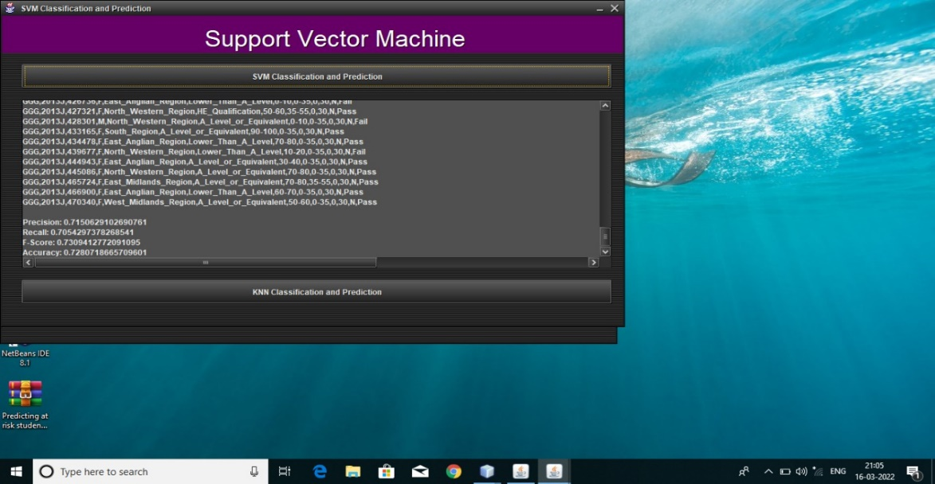

Fig.3.3.1 SUPPORT VECTOR MACHINE

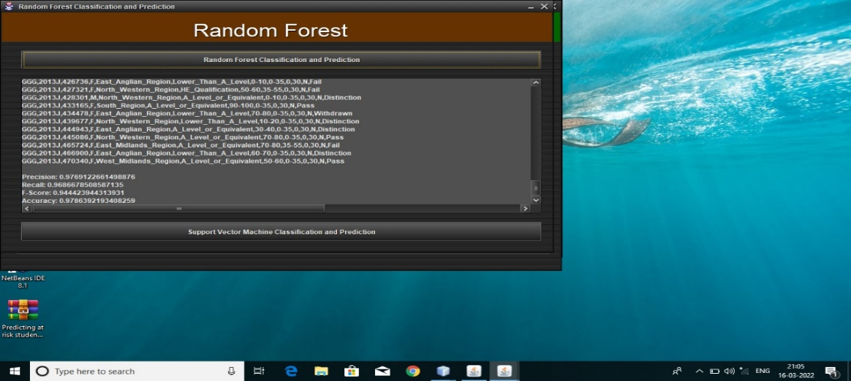
Fig.3.3.2 RANDOM FOREST

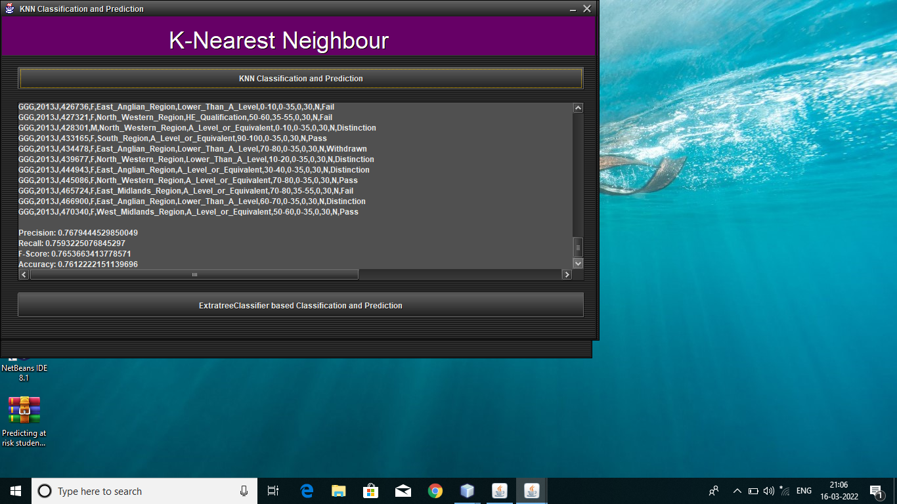
Fig.3.3.3 K-NEAREST NEIGHBOUR

3.4 COMPARISION CHART

Examination or looking at is the demonstration of assessing at least two things by deciding the important, equivalent qualities of every thing, and afterward figuring out which qualities of each are like the other, which are unique, and how much. When two things have different characteristics, the differences can be looked at to see which one is best for a particular job. A comparison is also the description of the similarities and differences between two things. Comparison can take many different forms, with the attributes and parameters used to make each algorithm produce the desired character result varying by field. The obtained result is promoted and represented when the various field-specific machine learning models are compared.

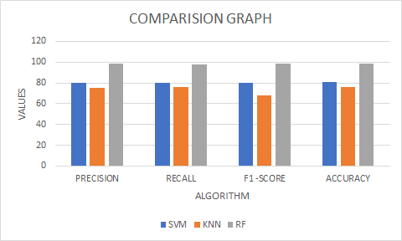
Fig.3.4 COMPARISION CHART

- DATA FLOW DIAGRAM

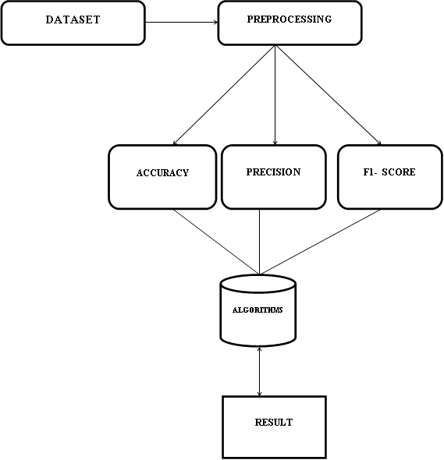

4.1 ACCURACY
The most straightforward performance metric is accuracy, which is simply the ratio of correctly predicted observations to total observations. One might believe that our model is superior if it has high accuracy. Yes, accuracy is an excellent metric, but only when working with symmetric datasets where the values of false positives and false negatives are nearly identical. In order to evaluate your model's performance, you must therefore examine additional parameters.

Accuracy = TP+TN/TP+FP+FN+TN

4.2 PRECISION
Precision is the ratio of correctly predicted positive observations to total predicted positive observations; precision is measured in this way. The question that this metric addresses is how many of the passengers who reported having survived actually did so. The low number of false positives is related to the high precision. We have a pretty good precision of 0.788.

Precision = TP/TP+FP

4.3 RECALL
The ratio of correctly predicted positive observations to all actual class observations is called recall (sensitivity). The responses to the question are: How many of the actual survivors among the passengers did we label? We have a recall of 0.631, which is above 0.5 for this model.

Recall = TP/TP+FN

4.4 F1 SCORE
F1 Score is the weighted average of Precision and Recall. Therefore, this score takes both false positives and false negatives into account. Intuitively it is not as easy to understand as accuracy, but F1 is usually more useful than accuracy, especially if you have an uneven class distribution. Accuracy works best if false positives and false negatives have similar cost. If the cost of false positives and false negatives are very different, it’s better to look at both Precision and Recall. In our case, F1 score is 0.701.

- CONCLUSION
Both students and instructors benefit from anticipating and intervening with students at various stages of the length of the course. It gives teachers a chance to help students who are at risk of dropping out and make an intervention at the right time to help them study better. For predicting students' performance based on demographics, demographics + clickstream, and demographics + clickstream + assessment variables, we developed a number of predictive models that were trained on a variety of ML and DL algorithms in this study. In the end, the RF predictive model with the highest performance scores was chosen to predict students' performance across course lengths. A predictive model of this kind can make it easier for teachers to make timely interventions and convince at-risk students to do better in school. The clickstream and assessment variables had the greatest impact on the students' final score out of all the variables. According to the findings of this study, predictive models can noticeably benefit from methods like feature engineering. Students' performance was predicted at the very beginning of the course module timeline using only demographic variables.

- REFERENCES
- "A clustering methodology of Web log data for learning management systems," by S. Valsamidis, S. Kontogiannis, I. Kazanidis, T. Theodosiou, and A. Karakos, published in J. Educ. Technol. Soc., vol. 15, no. 2, pp. 154–167, 2012.

- Artif, "Using machine learning to predict student difficulties from learning session data," by M. Hussain, W. Zhu, W. Zhang, S. M. R. Abidi, and S. Ali. Intell. Vol., Rev. 52, no. 1, pp. 381–407, Jun. 2019.

- "Combining supervised and unsupervised machine learning algorithms to predict the learners' learning styles," ProcediaComput, O. E. Aissaoui, Y. E. A. El Madani, L. Oughdir, and Y. E. Allioui. Sci., vol. 148, pp. 87–96, Jan. 2019.

- Dropout early warning systems for high school students using machine learning, J. Y. Chung and S. Lee, Children and Youth Services Rev., vol. 96, pp. 346–353, Jan. 2019.

- "Mining in educational data:" by S. A. Salloum, M. Alshurideh, A. Elnagar, and K. Shaalan, In Proc., "Review and future directions" Joint European-US Application Workshop Calculus of Invariance Vis. Egypt's Cairo: Pages, Springer, 2020 92–102.

- G. Kőrösi and R. Farkas, ‘‘Mooc performance prediction by deep learning from raw clickstream data,’’ in Proc. Int. Conf. Adv. Comput. Data Sci. Valletta, Malta: Springer, 2020, pp. 474–485.

